FUNDING PROPOSAL
Tristram Thomas (2014419)

Supporting hands on learning: non-academic youth and young offenders


FUNDING PROPOSAL

PROPOSAL TITLE
Supporting hands on learning: non-academic youth and young offenders
Through hands on learning, the frustration that non-academic youth face, will be eliminated and aid towards eradicating the need for self-destruction; therefore, decreasing the number of young offenders we have in our society.

FOR UnLtd
Submitted by

Bobs Body Shop 808

The Garage
Maesgwyn
Whitemill
Carmarthen
SA31 2DS


Contact Person: Tristram Thomas

SUMMARY OF PROPOSAL
Bobs Body Shop 808 (BBS808) Is going to address the need for self-achievement and self-worth, through hands on learning, for non-academic youth including young offenders.
The co-founders understand, on a personal level, how disheartening and frustrating it is not to be academically minded, and this has now become the main driving force behind this venture, as the passion that is shown through the hands on approach to teaching will undoubtedly be passed on to anyone. 25 years ago, as a 15-year-old struggling with education had a then unbeknown mentor pull him in to become a volunteer at a local body shop so he now understands he has to do the same on a larger scale to help more than just the one.
With the need to be solely involved with the service users and for it to be possible to increase their numbers, BBS808 are looking for funding to be able to employ a full time business manager to oversee the day to day running. With this increase of service users, there will be (in around 12 months) the possibility to fund this inhouse through the increased number of vehicles passing through the workshop due to the full time and part time hours given out to the proposed.
The project, will emphasise
- Development
- Learning skills, (including life & social skills)
- Rehabilitation
- Resilience
- Self-worth/self-achievement
- Future goals

With the overall cost at around £30,000 it is felt that a lot of lives will be changed for the better and forever.

CONTENTS
PAGE
COVER PAGE 1
FUNDING PROPOSAL TITLE 2
SUMMARY OF PROPOSAL 3
CONTENTS PAGE 4
PROPOSAL 5
Past and Precent 5
Accomplishments so far 5
Short term goals 5
Long term goals 6
Risks 6
Justification 6
Statistics 7
CONCLUSION 8
BUDGET SUMMARY 9
RESOURCES 10

CONTEXT
Past and Present
Over the past 7 years BBS808 has trained youngsters through apprentice schemes and has found it to be very rewarding for both ourselves and the trainee. Some have stayed with us and some have moved on, but all stay in touch.
We have found that in all these cases the apprentices were non-academic and were therefore suffering through their secondary school education. They found that they were reserved with low mood and self-esteem, which in turn became bouts of frustration with bad behaviour becoming apparent at home and out socially.
All that have passed thorough BBS808 have now become successful in their own right, all holding down jobs and some have even started family’s and all report to be enjoying their jobs and new meaningful lives which makes what we do worth it.

Accomplishments so far
So many goals:
Each year a goal is set and has so far been achieved
- year 1 rent unit, buy equipment, build spray booth.
- year 2 take on apprentice.
- year 3 move to bigger unit, build new spray booth, take on experienced person.
- year 4 employ apprentice, take on two new apprentices
- year 5 sustain what has been built so far.
- year 6 branch out into another venture (Plasti Dip).
year 7 employ apprentices. Employ a business manager. Take on more apprentices

short-term goal
Expansion is now of the upmost importance here at BBS808.
This proposal will be of great benefit to so many who will pass through BBS808. With being able to employ a business manager, our aim is to go from 2 apprentices at any one time up to 8, that is an increase of 300% in social help. Now that is impressive! And to be able to achieve this with the help and support that UnLTD can offer is just overwhelming.

Long term goals
With the need for hands on learning so apparent BBS808 would like to branch out into other trades such as mechanics, carpentry, building and the list goes on…….
We feel that step by step is the best way to go as it ensures that if any problem were to arise it can be dealt with quickly ensuring a speedy recovery and getting back on course to our goals

Risks
As with any investment there are risks, and no more so here at BBS808. It is crucial that we get it right by employing the right person for the position of business manager. Once selected and employed through our recruitment process there will be a weekly review with the co-founder to ensure that progress is being made in taking BBS808 forward to achieve its social and business goals.

Justification
The need for these projects within the idea of managing hands on learning, are needed throughout the UK for non-academic youth and young offenders. Justice Minister Andrew Selous said:” Too often young people leave custody without the skills and qualifications they need to get on in life and turn their backs on crime. This has to change if we want them to become hardworking, law-abiding members of society.” (Ministry of Justice, 2014) These youngsters are our future and need to see that they are valued not only by society but by themselves.
A reform to the criminal records system has seen the government put legislation in place to allow offenders not having to disclose their criminal past, this does not count for serious offenses including violent, terrorism, serious sexual and life. They have noted that breaking the cycle of crime is managed by regular work, but only 17% manage to get employment within a year after their release from prison and this difficulty is recognised as 50% of employers admit to not being willing to employ an ex-offender. MP David Lammy recognises the current rules are “trapping offenders in their past, denying dependants an income, and costing the tax payer money”. (Ministry of Justice, 2019)

Statistics
Ministry of Justice performed an; Analysis of the impact of employment on re-offending following release from custody using propensity score matching. (Ministry of Justice, 2013).
With this analysis, see figure 1 below with the main findings. These were that offenders with a P-45 employment spell within a one-year period were less likely to re-offend than those that did not enter P-45 employment

Figure 1: One year proven reoffending rates after matching. Custodial sentences less than one year and sentences of one year or more .
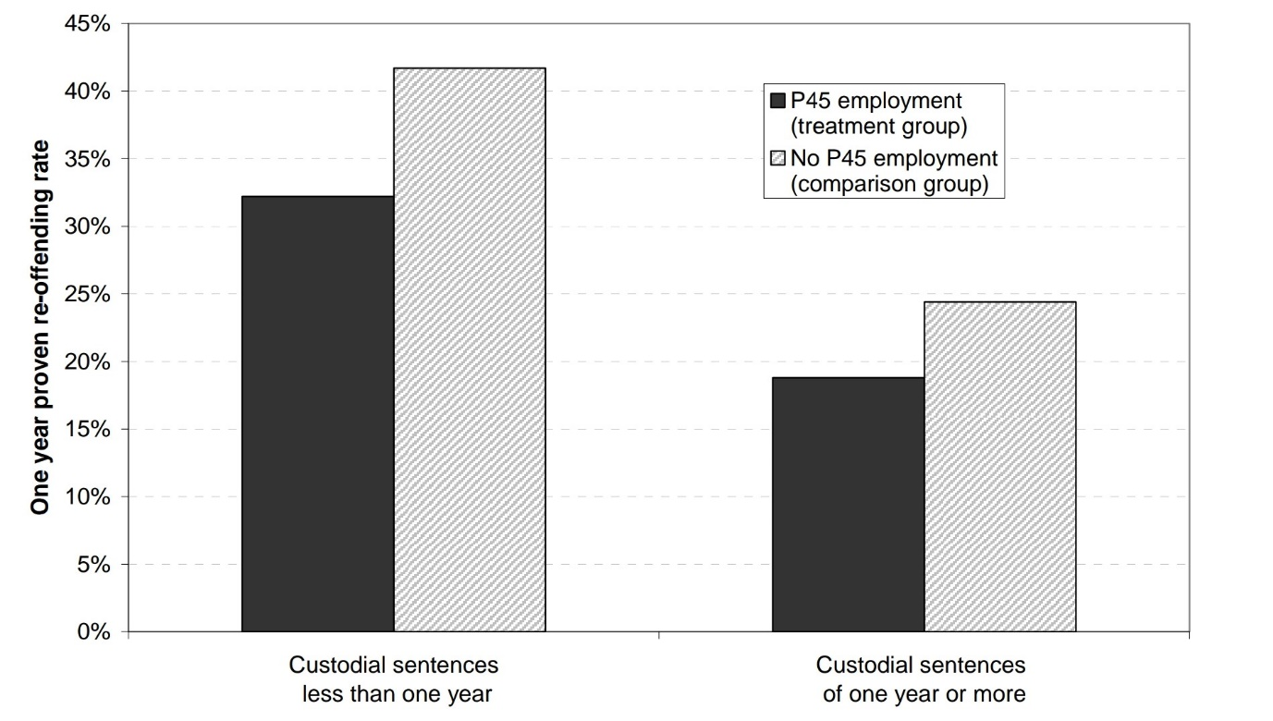
Figure 1 (Ministry of Justice, analysis of the impact of employment on reoffending following release from custody using propensity score matching Ministry of Justice March 2013 page 24, 3.1, Figure 4)
As you can see by the findings that the chart shows above Figure 1 it is vital that employment opportunities are available for young offenders thus keeping re-offending statistics lower than when there are no employment opportunities.

Conclusion
- Request of financial Support with intended stability of an employee for one year.
- Our intention is aimed at giving work and life skills to non-academic youth and young offenders.
- It is a system that is needed in this country to help lower crime and stop young from offending in the first place and reduce re-offending.
- With the initial project aimed at the youth in our local community sustainability is inevitable due to there not being a shortage in work in our area for 7 years alongside there being enough youth that need our help.
- We already have a long founded working relationship with local colleges for and during the apprentice schemes we currently run.
- All that will pass through or stay on at BBS808 will gain qualifications if they involve themselves in learning.
- With our co-founder having a background in mental health and disabilities he has access to professionals for support if needed.
- With these qualities we feel it is made quite apparent, that this project will succeed at this level and beyond, and feel that with UnLtd key values they will support this opportunity to be one of the main building blocks in this projects success and future.

Budget summary
BBS808 are inviting UnLTD in the securing of £30,000 of funding.
This would cover the following:
Full time employment of a business manager £30,000

This is an average cost of £14 per day per youth to attend learning at BBS808 obtaining a more promising future for themselves.
Additional funding for youths will come via the apprenticeship scheme with the insight for them to be able to attend financially.
BBS808 would like to take this opportunity to thank you UnLTD for your dedication in the social enterprise sector and for your time spent reviewing our proposal.

Resources
Ministry of Justice (2013) Analysis of the impact of employment on re-offending following release from custody using propensity score matching, page 24
Ministry of Justice (2014) Young offenders given work experience by top businesses. [online: 21/11/2020 (Young offenders given work experience by top businesses - GOV.UK (www.gov.uk))]

Ministry of Justice (2019) Criminal record reform to help ex-offenders into work. [online: 21/11/2020 (Criminal record reform to help ex-offenders into work - GOV.UK (www.gov.uk))]

