

University of Wales Trinity Saint David
School of Engineering

Motorcycle Geometry Analysis and Dynamic Handling Investigation
BEng Motorcycle Engineering
ACHA4003

Mya Jane Johns
2103212
December 2021

Figure 1 – University of Wales Trinity Saint David Logo (UWTSD, 2017)
Contents

Contents
Research 4
Centre of Gravity 4
Geometry 6
Gearing 9
Modern Bikes 11
Conclusion 13
References 14

Introduction

This report is based on analysing the geometry and dynamic handling for the Honda CBR1000RR and the EM ePure. This will consist of how the shape and centre of gravity positioning will affect how the bike handles and why it is best suited for the bikes’ terrain.
This report will also talk about 2 other modern bikes and how their geometry helps with their handling and performance.

Research

Centre of Gravity

To help understand the geometry of a bike, both Honda and ePure was measured to find their centre of gravity. Below shows the data collected for both and the positioning of the centre of gravity.
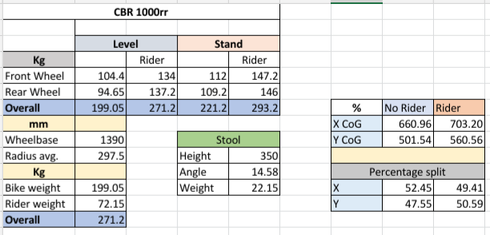
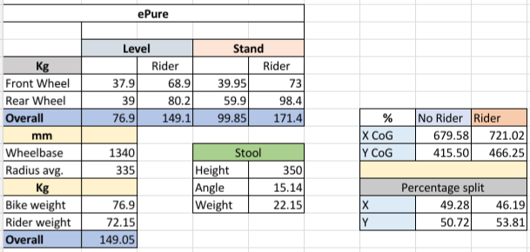
Table 1- CoG of both bikes
It shows that both bikes have a daily similar spot, but there is a distance due to what the bike is best tailored to. The data shows that without the rider, the Honda is further away from the centre of the bike, compared to the ePure is closest to 50% for both x and y. Compared to when the rider is on the bike, the added weight moves the point and makes the Honda closer to having the point in the centre rather than the ePure.

The equations which were used to find the data:
Stool angle- sin-1 (stool heightwheel base)
Finding X - (load on rear wheel x wheelbase)total bike weight
Finding Y - Wheelbase (Load on rear x Load on rear lifted)total bike weight x tan + average wheel radius
X percentage split - (Wheelbase - Xcog)wheelbasex100
Y percentage split – Xcogwheelbasex100

Geometry

Rake and trail help with the stability of a bike. Before when bikes were poorly designed for road use, the forks would be straight creating “an uncontrolled oscillation around the wheel’s vertical axis” (M Zimmerman, 2016). Both rake and trail have been improved with bikes to help improve the handling and riding experience. With the improvement, the different types of bikes and styles have their own angles which is best suited for the design. This changes the wheelbase, such as for sports bikes, they have a shorter wheelbase meaning that they are better for corners but are more likely to do wheelies and be less stable in a straight line. However, bikes with longer wheelbases such as bikes used for drag races are more stable in a straight line at fast speeds but struggle to do cornering as well.

Rake is the angle of the steering head against a vertical line going through the centre of the wheel. There are ways in which this can be changed such as, written by M Zimmerman (2016):
“Sliding tubes up the clamp (this creates a steeper angle)”
Put a large tyre on the front (decreases rake)
Changing to a longer rear shock on the back” (decreases rake)

Bikes that are used in racing tend to have a smaller rake angle as it helps them turn and go through the corners on a track.

Trail is the distance between the line going through the headstock to the ground and the line going through the wheel. This affects the steering of the bike and how it is handled. If the trail is smaller, this means it is better at low speeds but becomes less stable when it is faster. Whereas, the longer the trail, the harder it is to steer making it seem heavier. Ways in which this can be changed is:
Raising or lowering the front
Changing the wheel diameter
Decrease offset distance

The wheelbase is the distance between the centre of the wheels. This determines the stability of the bike and what the bike is used for. With the drag bikes the wheelbase is long as it reduces wheelies happening, whereas for sportbikes they are shorter to help get around corners easier.

Systematic Diagram
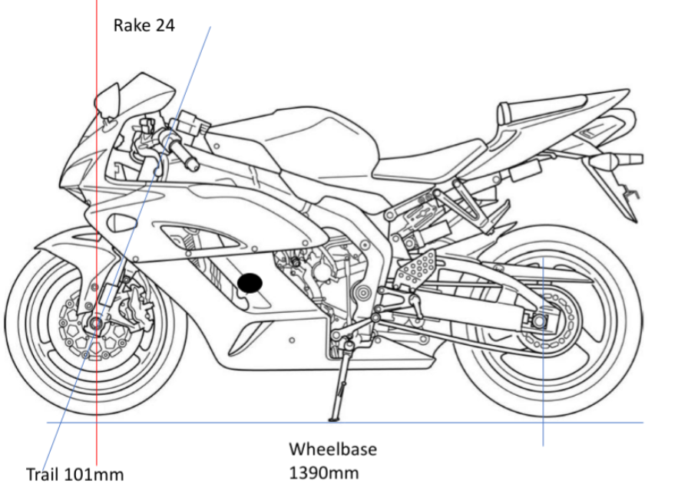
°

Rake 22°
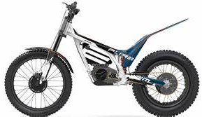
Wheelbase 1340mm
Trail 86mm

Figure 1– systematic diagram

As shown above the rake and trail for both bikes are different because of their designated use. When riding the Fireblade, it would act differently compared to how the ePure would ride. This is due to how aerodynamic the Fireblade is when it is building up speed. Whereas the ePure is not built for speed meaning it would be uncomfortable to ride at higher speeds. The stability for the bikes are different due to the ePure being more for rough terrain and climbing up rocks, but if a Fireblade was to try and do the same, it would not be able to make it as it is made for roads. The handling would be different for both bikes as they are built for different terrains. This is because of how the rake and trail are on the bike. The wheelbase will also affect the bike as it will change the centre of gravity within the bike.

Gearing

As there are many conditions that affect the bike to reach the top speed, using calculations, it shows the theoretical data of the bike. This means by using the gearing of the Honda, it gives an idea of how fast the bike should reach.

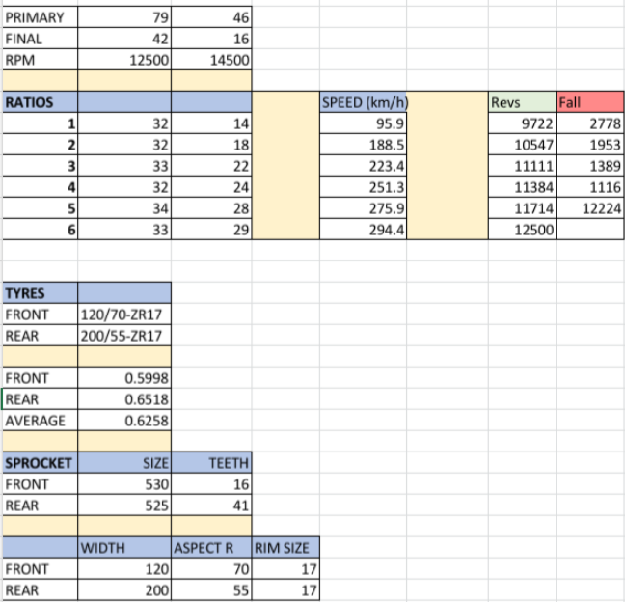 Table 2- shows the gearing ratios

The equations which were used:
Wheel diameter - (((width24.5) x (height100) x (rim2) x 2 x 𝝅) x 25.4)𝝅 1000
Speed - ((RPM x 60 x (mainshaftcountershaft) x (primary inprimary out) x wheel diameter x 𝝅 1000 x (front sprocketrear sprocket)
Next gear RPM - RPM x (mainshaftcounterhaft) x (countershaft of next gearmainshaft of next gear)

To find the power and torque of the Honda, it was put onto a dynamometer. This helped to obtain the results of power in both Hp and Kw but also the torque in Nm. below shows a graph and the results in every 500Rpm.

When relating the bike to the resistance of motion, according to Honda writer M McCabe Brown (2019) the Honda CBR1000RR was made to “create a class-leading drag coefficient and restrict lift under acceleration while improving braking stability.” The value of the drag coefficient is 0.207, this is due to how the bike has been shaped and designed. Below shows the frontal rea of the bike using a grid to work it out. Even though it is not the most accurate way of doing it, it does give a close result.

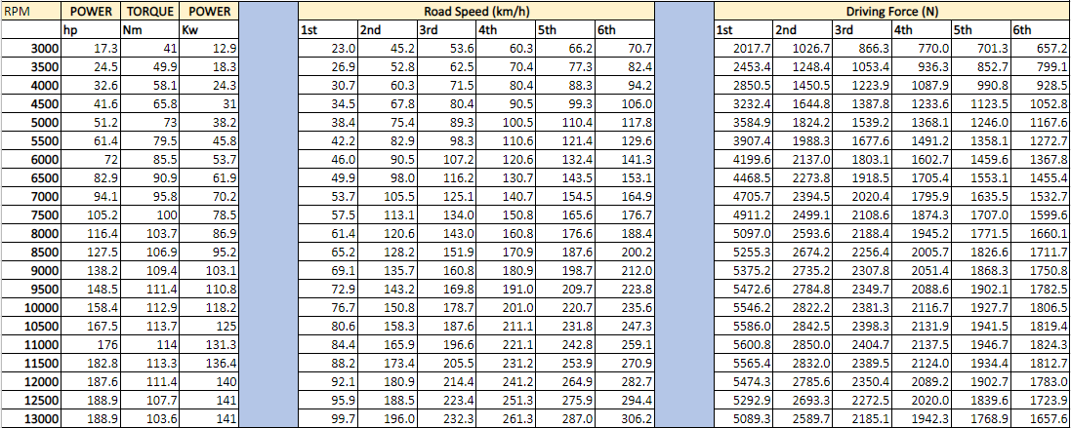
Table 3- dynamometer results
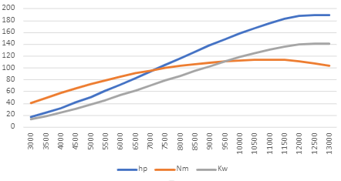
Table 4- power, toque graph

Modern Bikes

The bikes used in the racing industry are built differently to how they are on the road. Two examples are:
Ducati Desmosedici
BMW R1250RS
These bikes are used in two different types of scenarios. The Ducati Desmosedici is used for MotoGP racing compared to the BMW R1250RS is used for the road. It is classed as a sports tourer.
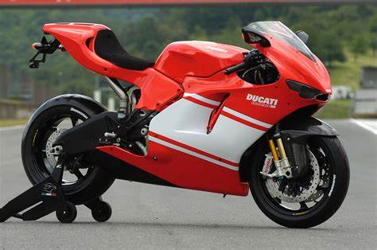
Figure2 -Desmosedici

The Ducati is faster when it comes to being in a straight line. The design of the bike has not changed as much, except for the wheels. A cover has been added onto the wheels to help with airflow and they help with the downforce during lean. Gigi Dall’Igna (2021) has said that the Ducati’s “bodywork has been designed to reduce wheelies, to allow the rider to use more throttle exiting corners, and increase braking stability”. This shows that the Ducati engineers have found the best way to increase the stability of the bike whilst being at high speeds, as well as having to slow down for corners. The rake angle is 24.5°, 9.7cm trail and 1430mm wheelbase.

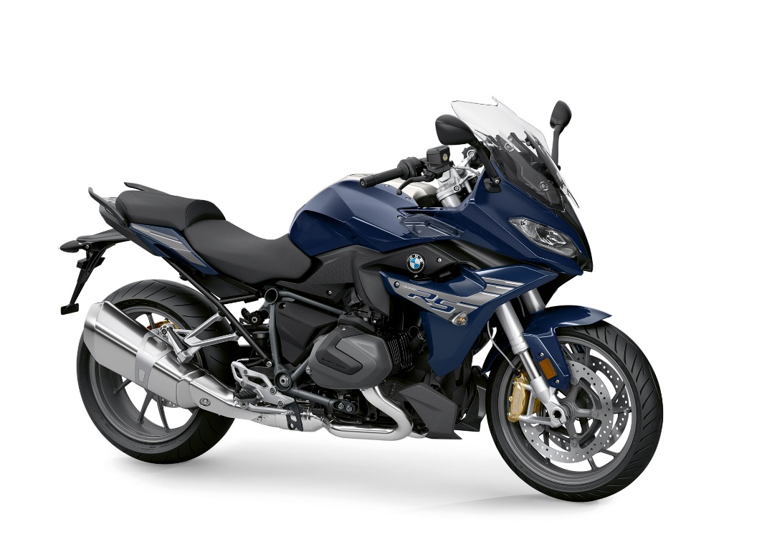
Figure3 – R1250RS
The BMW is a sports tourer bike which means that it is not best used for track. It has been designed to be able to handle speed but be comfortable to be sat on rather than having to lean down. The positioning of the handlebars is used to help with the sitting position whilst not changing the dynamics of the bike. This bike is not the lightest bike, as it is designed for distance and for pleasure by being able to gain speed for roads. It has torque which is carried throughout the “entire speed range” (Bob’s BMW, 2021), giving it a racing experience but without the whole power. The rake angle is 27.6°, 12.4cm trail and wheelbase is 1513mm.

Conclusion

To help with riding, both the Honda and ePure can have alterations. This mean by helping to improve the bikes, is by changing the rake and trail to be a little bigger to help improve the handling. This is by moving the front wheel forward and would affect the wheelbase. It would change the CoG of the bike which would give it more stability.

References

Kevin, (2021) - 2021 Honda CBR1000RR-R SP Fireblade Review / Specs + NEW Changes Explained! (hondaprokevin.com) accessed 27th November 2021

CBR1000RR 2008-2014 Service Manual.pdf accessed 27th November 2021

UltimatSpecs, (2019) Honda CBR1000RR-R Fireblade Technical Specifications (ultimatespecs.com) https://www.motorsportmagazine.com/articles/motorcycles/motogp/is-ducati-using-ground-effect-for-more-grip-in-motogp accessed 27th November 2021

M Zimmerman, (2016) https://www.motorcyclecruiser.com/playing-angles/ accessed 29th November 2021

(2019) Horsepower/Torque Curve for 2019 Honda CBR1000RR Fireblade (model up to late-year 2019). Detailed engine characteristics. (motorbikecatalog.com) accessed 29th November 2021

P Patole, (2015) https://www.bikesmedia.in/reviews/significance-of-wheelbase-in-motorcycling-explained.html accessed 29th November 2021

RideApart , (2017) https://www.rideapart.com/features/253963/unravelling-the-mysteries-of-rake-and-trail/ accessed 3rd December 2021

Messner, (2019) http://www.motorcyclemetal.com/gpage20.html accessed 7th December 2021

Bennetts, (2021) https://www.bennetts.co.uk/bikesocial/reviews/bikes/bmw/2019-bmw-r1250rs-review-price-spec accessed 7th December 2021

BobsBMW, (2021) https://www.bobsbmw.com/motorcycle-inventory/new-motorcycles/2022-bmw-r1250rs/ accessed 9th December 2021

