

University of Wales
Trinity Saint David
Student: Dominic Artiom
ID: 2027538
Module Name: Data Analysis & Visualization
ACCB4002
TESTING HYPOTHESIS USING THE T-TEST
Reference Standard: IEEE
Professor: Dr.Anupam Mazumdar
Data: 07/09/2021

Table of Contents
Introduction 3
Description of the data set 5
Visualization of data set 8
Outliers in the data set 9
Factors affecting hypotheses testing 9
Results 10
Conclusion 11
References 13

Testing Hypothesis Using the t-Test

Introduction
The t-test is used when comparing the means of two groups. The hypothesis test may be used to evaluate the effect of a given intervention on a specific population and whether two groups vary significantly from one another [6]. A t-test on the difference between a group and a control group is performed using the combined standard error of both group media to identify group differences. The t-value indicates the difference between the averages and the likelihood that they will occur by chance; thus (p-value).
A t-test is always in favor of the null hypothesis. If you are unable to provide evidence in opposition to it, you must keep the document. When stating the alternative hypothesis (H1), it's preferred to use the term "complementary hypothesis," which is just the complement of the null hypothesis — for example, if H0: = V, then H1: V. The three types of T-tests are one-sample t-tests, independent samples t-tests, and paired-samples t-tests [9].
The one-sample test determines if the mean of a single variable deviates from the expected constant value. For example, a scientist may want to ascertain if the average IQ of students exceeds 90. What percentage of the time does the middle grade for Assignment 1 vary from 30 (an A average)? It is necessary to evaluate the validity of comparative research topics using the independent sample t-test (I-S-T). In other words, it searches for differences between the means of two sets of examples or compares the means of two groups of occurrences to see whether there is a pattern—t-Test for independence [8]. Consider the following scenario: a statistics professor wishes to determine if the average score on Assignment 1 in one of her statistics courses differed significantly from the average score on Assignment 1 in her second statistics course. Paired Samples t-Test is necessary to compare the means of two variables within a single group [6]. Using this method, you may detect whether the average deviates from zero by calculating the differences between the two variables' values for each occurrence.
When a researcher makes a hypothesis, they express their expectation or prediction regarding the connection between the variables under investigation. It is the hypothesis that acts as the starting point and ending point of the research process. It is critical to the whole process and, as such, is very important. A hypothesis serves as the primary thesis of the research [10]. The research will not be able to operate effectively until hypotheses are developed. As the anticipated response to the researcher's query, which defines the study's subjects and inquiries about their connection, a hypothesis is defined as follows: Three fundamental components of the hypothesis are critical: the differentiation that is being sought, the relationship that is being made, and the interactions that are taking place.
To comprehend statistically significant relationships, which shows that the difference in results did not occur by chance but was driven by statistical factors, we must first understand what statistical significance is. It indicates whether the findings are statistically significant. If the difference is due to chance, the results will not be statistically significant, and vice versa. We usually include an independent and a dependent variable in our hypothesis formulations. The independent variable is the factor that causes something, while the dependent variable is the factor that is the consequence of that factor. A hypothesis guarantees that the whole research process is conducted scientifically and reliably. H0 is true if no statistically significant difference exists between a parameter's value and its value (or between two parameters). An alternative statistical hypothesis is one in which two parameters are either different or identical (H1). A frequently used hypothesis is that two or more variables are linked. Making a hypothesis begins with deciding on a study topic to investigate. As part of your study, you should pose a clear, well-defined issue that can be thoroughly examined.

Description of the data set
According to the findings, Covid-19 infection rates vary between white and BAME individuals in the United Kingdom. A total of fifty single White and BAME patients were chosen for the study to assess both the percentage and validity of the results. They are between the ages of 20 and 100 years. The modal age of infection rate between the white and BAME patients is 50, the median age for the white and BAME patients' infection rate is 37 and 50 years, respectively.
According to the test H0:h1=h2 versus HA:h is not equal to h2, both the null hypothesis, that there is no difference in infection rates between whites and Bame in the United Kingdom, as well as the alternative hypothesis, that there is a difference in infection rates between whites and BAME in the United Kingdom, are rejected. In the United Kingdom, the typical infection rates for whites and BAMEs are h1 and h2, respectively. Take into consideration the null hypothesis, which states that infection rates are the same in whites and BAME individuals. A normality test was performed on white (standard probability plot) and BAME participants (skewed likelihood plot). To identify any outliers in each data set, a visual chart was developed. When the two datasets are compared, it is discovered that there are no statistically significant differences between them.

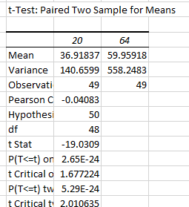
Figure 1: shows a t-test summary for the data set

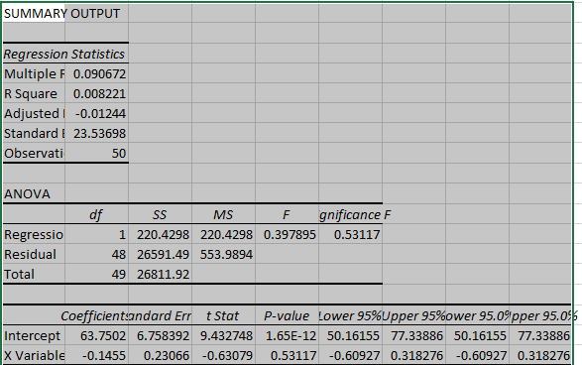Figure 2: show the p-value for the data set
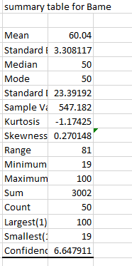

Figure 3: Table 3 above shows the description summary for the Bame patients
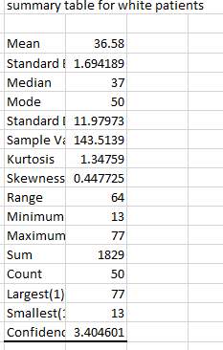

Figure 4: Table 4 above shows the descriptive summary for white patient

Visualization of data set

The chart below shows the visualization chart for the data.
\

Figure 5: visual chart for the data set

Figure 6: standard probability plot of the data

Analysis
While the null hypothesis is 10% true and the alternative is 1% true in this case, it cannot be rejected due to the high p-values. No difference was seen between white and BAME groups in terms of infection rates. For both, it is clear to state that samples are without outliers, as are the usual probability tracks, which means that both instances are likewise without outliers. Comparison between BAME plots and a random sample as the white plot represents the population more than the black plot. Due to the large sample size, no normalcy or non-normality is affected. Typically, data abnormalities are identified in the visual charts [1]. The result of this symmetry is that whites have a mean that is comparatively close to the median. Because of their widespread average BAME, patients' statistics are generally unfavorable.

Outliers in the data set
Increased treatment effect strength is associated with increased test strength. As the sample size rises, the test's power increases proportionately. A drop in the alpha level reduces the test's administration—two-tailed vs. one-tailed tests. The data set has more petite tails when the kurtosis value is less than 3 [2]. One-tailed testing provides more definitive findings than two-tailed testing. Using this metric, you may determine if your data has a significant or short tail by comparing it to the standard normal distribution. Extreme outliers are found in data sets with the greatest kurtosis, which means that they are rare. Due to the low Kurtosis values in our data set, the tables indicate that the tails are short for both samples, implying the absence of outliers.

Factors affecting hypotheses testing
The analysis seemed to be successful because of the high z-value. Three factors may affect the result of a hypothesis test. How dissimilar the sample mean is to the mean of the original sample population, as determined by orcan (2020) [6 As the gap between selection and average population values grows, as seen in Table 3, a significant treatment impact becomes more likely. If different variables vary by a certain amount, it substantially affects the standard deviation's size. Increased variability reduces the probability of a significant treatment effect. It has an impact on the magnitude of the standard error of the mean [3]. It is possible to minimize common errors by increasing the sample size, which increases the chance of receiving a significant result. Since the sample size is large, the standard errors have been minimized.

Results
Consequently, the null hypothesis may lead to one of two possible outcomes. This decision must be taken as soon as the mean sample reaches the crucial zone. From the data, we can see sufficient evidence to support the claim that there is a disparity in the infection rate between the white and BAME patients [4]. It is not rejected if the sample means do not fall within a specific range of crucial area values. As a result, the patient experiences no benefit from the treatment. Excessive random fluctuation, or noise, may result in null effects. A dependent variable may cause this variance among groups with low dependability or a shortage of data collecting.
A more significant number of t-values, also known as "t-scores," indicates a greater number of statistically significant differences between the two sample sets [1]. We found that the lower the t-value in our data set, the more similar the two patient groups are when comparing white and BAME patients in our study. A t-score that is statistically significant indicates that the groups are distinct. To conclude, it is possible to make comparisons between groups with low t scores.

Conclusion
From the analysis, it's clear that the disparity in infection rates between white and BAME patients requires appropriate and meticulous measures to curtail the infection rate among BAME communities less privileged in the UK. In an ideal world, this would be created in collaboration with impacted communities and adapted to culturally appropriate concerns such as avoiding transmission into overcrowded families or protecting vulnerable individuals in multigenerational settings [1]. By abolishing all NHS costs during this moment of a public health emergency, discrimination against migrants, COVID-19, and minority ethnic groups may be avoided can help reduce the rate of infection. Due to their fear of getting reimbursed for NHS therapy, the BAME community is putting itself at risk of mortality by delaying care.
Senior management should incorporate ethnic groups as part of this plan's health disparities activities [6]. To better understand the requirements of the local community, data should be gathered and reported by ethnic group, if applicable. Along with promoting cultural and religious understanding, it is necessary to identify and eradicate group stereotypes. In addition to conducting periodic equity audits, BAME groups should adequately represent staff and leadership positions.
Minority ethnic groups should be fully integrated into all facets of their services. Because of long-standing racial fault lines, BAME communities in the United Kingdom are already in danger of infection, according to the data set. The pandemic has heightened the link between socioeconomic factors (money, social status, occupational background, and education) and poor health outcomes. These potentially catastrophic problems have been persistently ignored for an extended time. To overcome these widespread and complicated racial disparities, intersectional solutions are needed.

References
[1] R. England, "Ethnicity and covid-19: working locally to reduce inequalities", BMJ, p. m2748, 2020. Available: 10.1136/bmj.m2748.
[2] A. Elkadry and G. McDonald, "Hypothesis Testing when Data Sources are Uncertain", Journal of Statistical Theory and Practice, vol. 14, no. 4, 2020. Available: 10.1007/s42519-020-00132-5.
[3] C. Harms, D. Lakens, "Making 'null effects' informative: statistical techniques and inferential frameworks", Journal of Clinical and Translational Research, 2018. Available: 10.18053/jctres.03.2017s2.007.
[4] Q. SUN, H. TENG, M. SONG and Y. FANG, "Optimal pool size and pooled sample size for hypothesis test of critical threshold of infection rates based on fixed sample size and pooled sampling method", Academic Journal of Second Military Medical University, vol. 31, no. 12, pp. 1353-1356, 2012. Available: 10.3724/sp.j.1008.2011.01353.
[5] R. Mathur et al., "Ethnic differences in SARS-CoV-2 infection and COVID-19-related hospitalisation, intensive care unit admission, and death in 17 million adults in England: an observational cohort study using the OpenSAFELY platform", The Lancet, vol. 397, no. 10286, pp. 1711-1724, 2021. Available: 10.1016/s0140-6736(21)00634-6.
[6] F. ORCAN, "Parametric or Non-parametric: Skewness to Test Normality for Mean Comparison", International Journal of Assessment Tools in Education, pp. 236-246, 2020. Available: 10.21449/ijate.656077.
[7] Z. Raisi-Estabragh et al., "Greater risk of severe COVID-19 in Black, Asian and Minority Ethnic populations is not explained by cardiometabolic, socioeconomic or behavioural factors, or by 25(OH)-vitamin D status: study of 1326 cases from the UK Biobank", Journal of Public Health, vol. 42, no. 3, pp. 451-460, 2020. Available: 10.1093/pubmed/fdaa095.
[8] A. Scheel, L. Tiokhin, P. Isager and D. Lakens, "Why Hypothesis Testers Should Spend Less Time Testing Hypotheses", Perspectives on Psychological Science, vol. 16, no. 4, pp. 744-755, 2020. Available: 10.1177/1745691620966795.
[9] P. Schober, S. Bossers and L. Schwarte, "Statistical Significance Versus Clinical Importance of Observed Effect Sizes", Anesthesia & Analgesia, vol. 126, no. 3, pp. 1068-1072, 2018. Available: 10.1213/ane.0000000000002798.
[10] Q. Yu, C. Salvador, I. Melani, M. Berg, E. Neblett and S. Kitayama, "Racial residential segregation and economic disparity jointly exacerbate COVID‐19 fatality in large American cities", Annals of the New York Academy of Sciences, vol. 1494, no. 1, pp. 18-30, 2021. Available: 10.1111/nyas.14567.

