

Student name: Erkan Paca
Student ID: 2010132

Module name: Living with Care: Older Person
Module code: BMHP 6009
Lecturer name: Diola Bijlhout

Table of contents
Contents
Table of contents 2
1. Introduction and Statistics on the ageing population and how these have changed in recent years (UK and China). 3
3. Comparison between two countries 9
7. Recommendations 14
8. Conclusion 15
9. References 17

1. Introduction and Statistics on the ageing population and how these have changed in recent years (UK and China).

In general, a person who is above the age of 65 deemed to be an older person. Nevertheless, it is not that simple to identify someone biologically because they may look younger than their fellow age groups. The frailty is the major risk that elderly need support and care in due course. Therefore, NHS works collaboratively in partnership to assist the elderly with health obstacles. (NHS, 2022).
Population rapidly growing in the UK and forecasted as by 2050 one in every four people will reach 65 years or over. (Office for National Statistics, 2019). The effect on the economy and the services that assist the elderly community will have a significant impact, thus preventing them to have healthy lives.
The impact of the ageing population is complicated. This is due to the elderly living longer than before and changing society in due course. Therefore, new measures and perspectives are needed. Currently, the worry in the community suggests the perception of that young workers still assist the elderly whilst they are not working, but in reality, this is not the manifestation at all, on the contrary, they still play their parts in the population contributing to our economy till later in life. (ONS, 2019).
Growing numbers of migrants assist in working age to the population which decreases the level of our population ageing, but this is not due to increasing numbers of older workers that are receiving the most impact.
The forecast suggests that in the next ten years, the UK will have a population be approximately 65.6 million by 2016 to 69.2 million by 2026, a %5.5 escalation of growth in population. (ONS, 2019).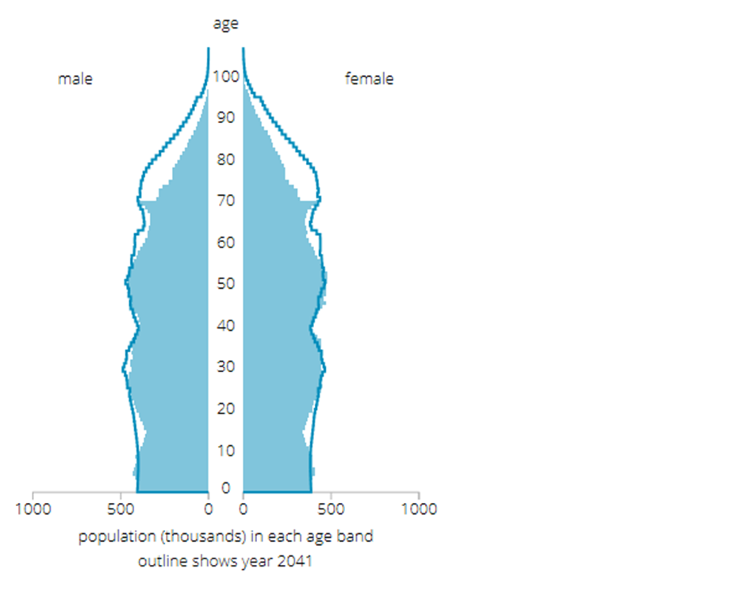
The study was carried out and evaluated around 80 countries globally on “quality of death” component suggesting that in China the end of life care was not sufficient in fact they ranked bottom 10, on the contrary the UK came the number one country. All these due to insufficient hospice resources, costly hospital care and insufficient community assistance overall. (BBC, 2015).
China, not only the biggest population in the world also have a rapidly growing ageing population. This is due to the decreased fertility rates as well as sharply rising life expectancy. As a result, the Chinese economy will suffer prospectively in the coming years.
‘The graph shows the population share aged 60 and older in China from 1950 to 2020, with a forecast up until 2100. In 2020, about 17.8 per cent of the population in China had been 60 years and over. This share was estimated to reach nearly 40 per cent by 2050.’ (Statista, 2022). For many years China had an unchecked increasing population under the Maoist government. In order to control the population a new policy was implemented in 1979 called the ‘one-child policy which in fact was a success and minimised the birth rate in 1970 from five children to 1.6 in 2000-2010. Nevertheless, the reduced birth rate combined with a longer life expectancy had a knock-on effect on the economy causing disruption in the growing population. The forecasted population of over 60’s in 2020 will increase from 17.4 to 30 % by 2040. (Statista, 2022). The cost of health in China has risen from 500 billion yuan in 2000 to 6.5 trillion in 2019. Due to the cost of living and the ageing population in the country.

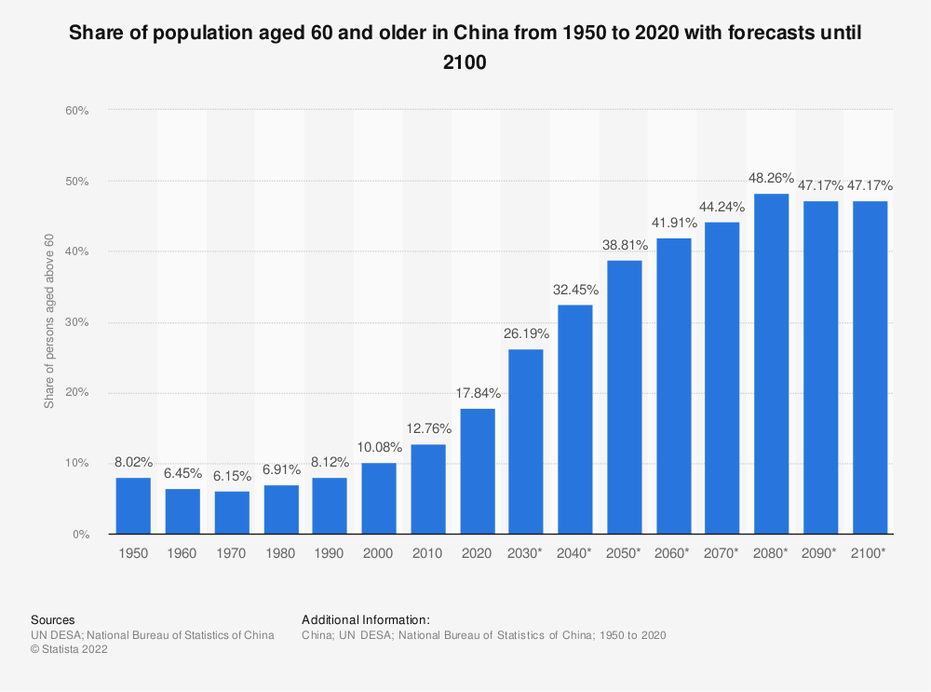

As UK perspective elaborates ‘What has caused the population ageing’?
Currently, the population depends on age formation both from a historical perspective and present figures of fertility and mortality rates, going back to 50 years of time-span states that the death rates have reduced both worldwide and in the UK. 1960 onward birth rates also decreased by roughly 1.9 fertility per female. (ONS, 2019).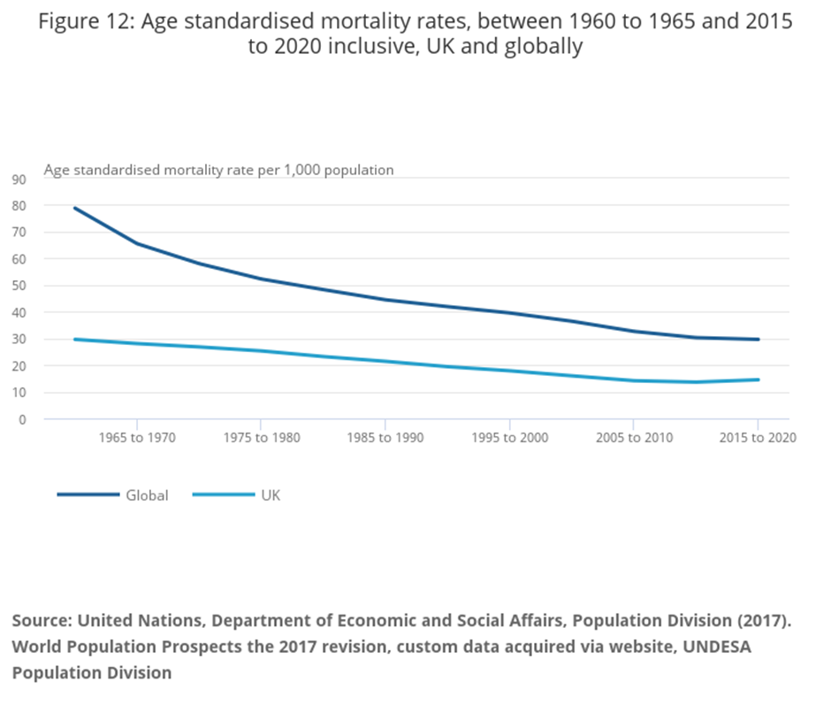

2. Relevant theories of loneliness and isolation and concepts associated with loneliness, alluded to in literature:
Research shows that, social relationships have significant impact on mortality threat that is comparable to well-known risks like smoking and alcohol consumption, making loneliness and social isolation a public health concern. (WHO, 2022).

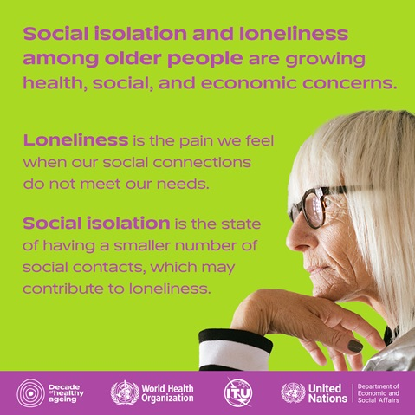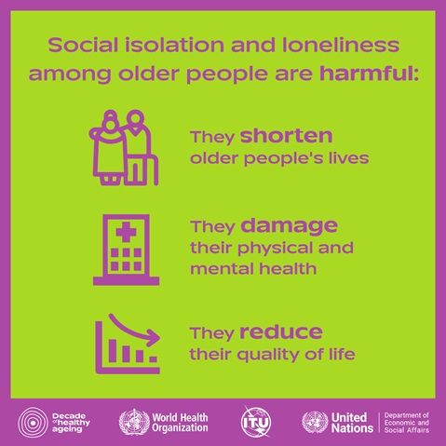(WHO,2022 Image 1,2).
The theories related in accordance with ageing;
Disengagement theory states that as we become older, we tend to pull ourselves from the society, it is a mutual disengagement that society too withdraw elderly from engaging. As elderly become less connected from society, they tend to progress to be a more self-absorbed and concentrate on the inner world which makes them happy and would maximise their life contentment. (Larkin, 2009).
On the contrary, the activity theory is quite an opposite concept that older adults engage in activities and are more connected with a society which makes them fully contented and pleased. But there can be challenges such as physical impairment related to ageing as well as accessibility to insufficient social and economic facilities. (Mauk, 2010).
Continuity theory seems the same as activity theory where older adults are willing to keep the same habits, satisfactions and routines adopted from earlier times. Weak physical health and capabilities are connected with reduced social engagement. (Wang, 2012).
The social breakdown and reconstruction concept rely on individuals’ negative perception of the elderly and the providing insufficient support for them. The social formation would be obtained If we can change the negative perception of people and provision of better-tailored services. (Tornstam, 2005).
The modernisation concept states that as communities become contemporary elderly social position reduces. In the old days within rural communities, the elderly population was in charge of the dryland. Gentrification in the elderly posed a great risk and destruct their social position. (Morgan and Kunkel, 2011).
Gerotranscendence theory implies that as the elderly become more aware and satisfied with themselves, they are able and happier physically and emotionally. (Tornstam, 1994).
Age is a social formation and being old or young is also considered a socially constructed concept and symbolised in certain resembled and identified as social interactivities. Because every culture identifies age differently and behaves accordingly such as hiking or not wearing swimsuits. (Settersten and Angel, 2012; Fung, 2013).
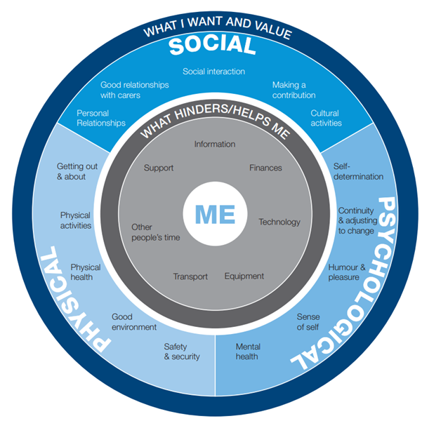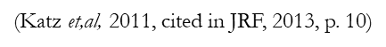

3. Comparison between two countries
The impact of loneliness and isolation on an older person living within a care setting. (UK and China).
Many of us at some point in our lives will suffer some degree of loneliness. The majority of people find that loneliness a passing stage, but for some individuals, this can persist, jeopardising their health and negatively affecting their quality of life.
Age UK's work has included addressing loneliness among older people as a crucial component for a number of years.
In order to advance our understanding of what works, we have been at the forefront of integrating approaches to addressing loneliness into our regular services and testing novel approaches.
If we don't address loneliness, by 2026 there will be 2 million people over 50 in England who will end up lonely, according to our most recent research, which has been devoted to understanding loneliness among people aged 50 and over. (Age UK, 2022).
Furthermore, the threat of loneliness has a significant effect on developing heart and cardiovascular ailments. (Steptoe et al, 2004).
Additionally, having weak social ties puts your health at risk. People with strong social ties have a 50% higher chance of surviving after an average follow-up period of 7,5 years. (Bolton, 2012). Additionally, residents of nursing homes who admit to feeling lonely emotionally pass away sooner than those who do not. (Drageset et al, 2013).
Loneliness also has a direct effect on your mental health such as feeling in a depressive mood, anxiousness, agitation, easily getting angry, bitterness, being weak either physically or emotionally and negativity. (Griffin, 2010).
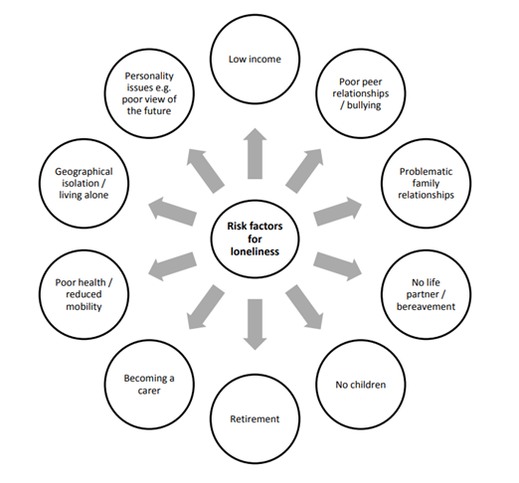
Moreover, some researched studies have shown that loneliness has an impact on individuals leading to adopting poor lifestyle behaviour such as alcohol consumption, smoking and drug abuse which replace their sense of emptiness. (Wadd et al, 2011), (Imonen et al, 2011). On the other in China, the definition of social isolation is having insufficient quality or quantity of social connection. (Delisle, 1988). Social isolation also potentially minimises social connectivity and eradicates the sense of integrity or the motives in their lives. (Chaiklin, 1989). As a result of these associated factors, many health conditions occur in elderly lives such as stroke, heart disease and mental health issues. (Boden,2005), (Berkman, 1984). Social isolation is also divided into two components objective and subjective. The objective ones are considered as having no family around, no children or no contact to connect or participate in community integration, thus causing insufficient social relationships whereas subjective ones affect the ones having none or less quality of social connectedness. Objective ones can lead to adopting an unhealthy lifestyle with family encouragement, whereas subjective ones totally have an impact on physiological ailments cumulative heart, immune or other disorders such as strokes. (Mcewen, 2010), (Seeman et al, 2002).
A change in demands and needs will result from the demographic shift in China. Less than 2.1 million of China's more than 200 million elderly people are currently receiving care in nursing homes spread throughout the country. This predicts the need for a quick readjustment and ranks the elderly Chinese population as one of the most underserved market segments. (Daxue Consulting, 2015).
4. Current legislation and policies that deal with or aim to raise awareness or reduce loneliness and isolation in the elderly population (UK and China).
In China, approximately 28% of the population forecasted a rise in 20 years among the 65’s, longer life span, and reduced birth rates pushing rapid ageing communities globally.
Overall, this can have an impact demographically as obstacles and windows of opportunities in public health especially the progression of an incorporated system that assist the health and social needs of elderly people, %75 of whom endure non-communicable ailments equally accessing healthcare despite geographical changes.
‘National Centre of Gerontology (NCG) confirm China’s action to promote and assist better health, particularly in elderly care in the coming years of two decades. Improving better accession for the elderly into incorporated care such as community base approach which covers preventative methods of care and controlling ailments by spreading along with enhancing health services and training medical professionals. The Institute also provide nationwide training, care, and network connection in the country, particularly in relation to poor health in the rural areas where ageing occurs demographically. (WHO, 2022).
As far as The UK concern:
During the coronavirus outbreak and the subsequent period of social isolation, the government undertook a significant campaign to combat loneliness. The scheme, which was highlighted by the former Culture Secretary Oliver Dowden, aimed to guarantee that being at home would not necessarily result in loneliness for individuals of all ages and backgrounds.

It contained:
Let's Talk Loneliness is a public awareness initiative to encourage open discussion about loneliness and provide advice on securely supporting both yourself and others. Align with a guaranteed £5 million boost for regional groups fighting social isolation and fostering relationships to support them in carrying out and modifying their vital work. Also, the Age UK and other anti-loneliness organisations received funding to collaborate with NHS Volunteer Responders in their local communities, as well as several prominent charities, companies, and public individuals who joined the "Tackling Loneliness" campaign.
Along with these initiatives, the government will continue to push other government agencies and other groups in society to make a commitment to addressing loneliness in their own work, which will help advance the causes.
The government is also dedicated to improving and disseminating evidence on loneliness and what works to combat it in keeping with our mission to build up the evidence base. This will help people and organisations know how best to act. The evidence deficiencies are highlighted in the 2022 publication, "Tackling Loneliness: An Evidence Review." (GOV UK, 2022).

5. Local, national and global provision of services for the older person in line with current initiatives and policy (UK and China).
The percentage of the elderly population who require home medical assistance and relevant competent care providers is persistently in demand due to the lack of mobility or limited capabilities to look after themselves and also suffering from multimorbidity. Current research indicates that community-based health care is needed by 16.30% of the majority for caring at home by 19.80% and for recuperation care by 14.90%. (Tao, 2018). The present research also indicates that individuals over the ’80s who need care are approximately 69.1, 46.7% in need of life-long care and 31.2 need assistance in their own homes. (Wu JL et al, 2013). Additionally, there is a need for care demand for a large proportion of older people who have limited abilities to walk. Research completed in Beijing stated that those suffering from chronic illness in the elderly within the community are in need of home care assistance but the services are very behind schedule and lack the provision to those accordingly. (Wang et al, 2020).
In an analysis obtained including 6.997 older adults, 89.1% prefer to receive home care and 8.2% have chosen to have cared for in care homes which significantly states that a large volume of people’s choice was to be cared for in their own homes by their spouses, relatives mainly by their siblings in China. (Liu HJ, 2019).
Two challenges still persist for older persons who are in poor health, such as those who have debilitating chronic diseases and comorbidities, when they desire to obtain a facility for care most of the nursing care provided today medical and nursing care are provided separately at facilities, or they provide inadequate medical care, failing to older people's essential medical requirements are met; as a result, elderly health care and long-term care are critically underfunded and restricted. (Zhou et al, 2021).
In the UK, technological advancement support individuals to have a longer life span. In the next two decades, the population will rise dramatically. This can create obstacles and medical ailments for NHS to overcome, consequently tailoring further health and social care provisions needed. In order to manage these difficulties, we need to work in partnership to assist and enhance individuals’ health and well-being. Frailty is a big issue concerning the elderly along with multimorbidity as a long-term illness. Monitoring those who suffer from chronic ailments in the early stages is essential via ‘healthy ageing and caring’ within the frame. Involving public health services to provide incorporated care and services. Also, a suitable intervention model minimises frailty with provided tools, evaluations and trained staff to do work, particularly over 65’s align with personalised care is very fundamental along with personal and community centre care which is to encourage and empower them where necessary. (NHS, 2022).

6.The prospective future of the care of the older person; what changes could be made to the programmes aimed at addressing the problem of loneliness among the elderly (UK and China) Use of technology for the provision of care provided to lonely older persons. (UK and China).
China’s version of the use of "Internet+ medicine" can improve the continuity and innovation of medical care, offer home care to help with the issues of older people's limited mobility and negative hospital experiences, and also drastically lower the total medical expenditures. (Shi et al, 2021).
China's Internet-based senior care is still in its early phases, and the country's population is ageing quickly. In order to stimulate the integration of the Internet into elder care, the government has developed a new idea of community-based care for the elderly.
However, the development of infrastructure is somewhat behind schedule, and the use of "big data" threatens individual privacy. (Price & Cohen. 2019).
UK version suggesting that:
The acceptance and usage of technology can affect older adults and society by a large proportion. Utilizing technology can help older individuals maintain their independence, and improve their sense of the quality of life (Mynatt & Rogers, 2002). Technology has the ability to help with daily living tasks and medical care by encouraging older individuals' independence, which will also lower the strain on family and paid carers. Older persons may also benefit financially by decreasing their reliance on paid caretakers. Therefore, it is crucial that we comprehend how to create technologies that meet the demands and preferences of older adults as the population ages and technology advances. However, there are obstacles attached when utilising technology which is lack of guidance, cognitive inability, physical impairment such as eyesight issues, arthritis in the joint, tremor, anxiety, privacy and trust challenges. Consequently, the government should handle these issues holistically. (Wilson et al, 2021).

7. Recommendations

In China, community integrated model of care for the elderly effectively resolves the structural issues faced by the conventional model of care, and its distinct advantages will allow it to become a major trend in the future development of care. It does this by incorporating the knowledge of facilities for the elderly in community home care, offering professional at-home care and community care for the elderly, and opening up community care centres to provide comprehensive care to the active elderly.
Whereas, in the UK, healthy ageing is fundamental to supporting the elderly to lead a happy and pleasant life by being more active. Therefore, tackling health inequalities are essential. Encouraging and empowering them in line with the integrated partnership. This will be achieved by providing them with financial security, better social connectivity, assistance and resources alongside better overall health, particularly helping these supporting carers and those living with disability and chronic medical conditions.
Social connection via the use of technology is also fundamental along with creating a family network. Better accession to transport, engaging communities in an adaptable way considering cultural bias, barriers and language.
In order to control our health, education and enhancing consciousness and self-enablement are the key aspects.
Provision of better nutrition, no smoking or alcohol consumption alongside more vaccination and screening programmes to those in need of the services.
Provision of holistic care and tools utilised to identify the local and regional needs with regard to healthy ageing.
Evaluating the effect of your input will enable us to support local individuals with a better sense of professional progression. (GOV UK, 2022).
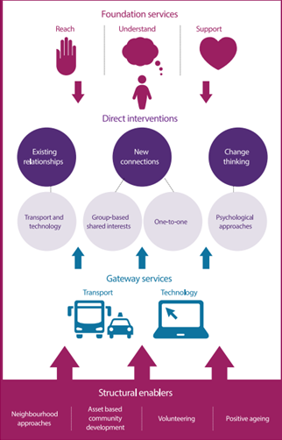

8. Conclusion

In conclusion, there is a growing demand for elderly care and pensions related issues due to the ageing of China's population. Additionally, there is a greater demand than ever for fundamental pensions, illness prevention, and medical treatment and a community-based integrated approach that will facilitate the elderly to have cared for in rural and urban areas of China with enough resources and elite workforces.
Additionally, because China's aged insurance system is developing slowly, pension services cannot satisfy the expectations of older people. The Chinese government has looked at several aged care models in order to better the health and quality of life of the elderly while also adjusting to the ageing population's development.
As for the UK, it seems that ageing is a problem in the UK, China and globally. To be able to overcome the challenges that the elderly suffer we need to work collaboratively to create more sufficient resources within the country reaching everyone regardless of where they are located with trained professionals who can assist them both in-home care or care homes with the provision of better income, particularly those caregivers and care receivers such as elderly population.

9. References

BBC News, (2015) Who will take care of China's elderly people? Available at: https://www.bbc.co.uk/news/magazine-35155548. (Accessed:27/12/2022).
Berkman LF. (1984) Assessing the physical health effects of social networks and
social support. Annu Rev Public Health. 1984;5(1):413–32.
Boden-Albala B, Litwak E, Elkind M, et al, (2005). Social isolation
and outcomes post stroke. Neurology. 2005;64(11):1888–92.
Bolton, M. (2012) Loneliness: the state we're in: a report of evidence compiled for the Campaign to End Loneliness. Abingdon: Age UK Oxfordshire. 95
Centre for Ageing Better, (2018) Transforming Later Lives. Available at: https://www.ageing-better.org.uk/sites/default/files/2018-07/Ageing-Better-Transforming-Later-Lives.pdf (Accessed: 21/12/2022).
Chaiklin H, (1989) Unravelling the Mystery of Health: How People Manage Stress
and Stay Well. Journal of Nervous and Mental Disease - J NERV MENT DIS.
1989177:439–40.
Daxue Consulting (2015) Elderly care in China: Available at: https://daxueconsulting.com/elderly-care-in-china/#:~:text=There%20are%20today%20more%20than%20200%20million%20elderly,and%20forecasts%20the%20need%20of%20a%20fast%20readjustment. (Accessed: 24/12/2022).
Delisle M-A. (1988) What does Solitude Mean to the Aged? Canadian Journal on
Ageing. 1988;7(04):358–71.
Drageset, J., Eide, G. E., Kirkevold, M., & Ranhoff, A. H. (2013). Emotional loneliness is associated with mortality among mentally intact nursing home residents with and without cancer: a five‐year follow‐up study. Journal of clinical nursing, 22(1-2), 106-114.
Fung, H. (2013) ‘Aging in Culture’ The Gerontologist, 53(3), pp. 369–377.

Griffin, J. (2010) The lonely society? London: Mental Health Foundation. British Journal of Mental Health Nursing. Available at: doi.org/10.12968/bjmh.2018.7.5.209. (Accessed:22/12/2022).
GOV UK, (2022) Office for Health Improvement and Disparities: healthy ageing: applying all our health. Available at: https://www.gov.uk/government/publications/healthy-ageing/healthy-ageing-applying-all-our-health#taking-action. (Accessed: 26/12/2022).
GOV UK, (2022) Government’s work on tackling loneliness: Available at: https://www.gov.uk/guidance/governments-work-on-tackling-loneliness. (Accessed: 27/12/2022).
Imonen, S., Valvanne, J., and Pitkala, K.H. (2011) ‘Older adult: Available at: https://doi.org/10.12968/bjmh.2018.7.5.209s' own reasoning for their alcohol consumption’. International Journal of Geriatric Psychiatry, 26(11), pp. 1169-1176. (Accessed: 23/12/2022).
Larkin, M. (2009) Vulnerable Groups in Health and Social Care: London: Sage Publications Ltd.
Liu HJ. 92019) Analysis of the intentions of the elderly in Shandong Province and factors influencing them. Shandong University 2019. (in Chinese).
Local Government Association (2016) Combatting Loneliness: Available at: https://www.local.gov.uk/sites/default/files/documents/combating-loneliness-guid-24e_march_2018.pdf. (Accessed: 26/12/2022).
Maulk, K. (2010) Gerontological Nursing: Competencies for Care 2nd edn. London: Jones and Bartlett Publishers International.
Mcewen, BS (2010) Stress, adaptation, and disease. Allostasis and allostatic load.
Annals of the New York Academy of Sciences 2010, 840(NEUROIMMUNOMODULATION: MOLECULAR ASPECTS):33-44.
Mynatt, E.D., Rogers, W.A. (2002) Developing technology to support the functional independence of older adults. Ageing Int. 27, 24–41 (2001). https://doi.org/10.1007/s12126-001-1014-5. (Accessed:26/12/2022).
NHS England (2022) Improving care for elder people: Available at: https://www.england.nhs.uk/ourwork/clinical-policy/older-people. (Accessed: 26/12/2022).
Office for National Statistics, (2019) Living longer and old-age dependency – what does the future hold? Available at: https://www.ons.gov.uk/peoplepopulationandcommunity/birthsdeathsandmarriages/ageing/articles/livinglongerandoldagedependencywhatdoesthefuturehold/2019-06-24. (Accessed: 21/12/2022).
Price WN, Cohen IG (2019) Privacy in the age of medical big data. Nat Med. 2019; 25:37-43.
Seeman TE, Singer BH, Ryf CD, et al, (2002) Social Relationships, Gender, and Allostatic Load Across Two Age Cohorts. Psychosomatic Medicine. 2002;64(3):395.
Settersten, R.A., Angel, J.L. (2012) Handbook of Sociology of Aging. New York: Springer.
Shi A, Zhou X, Xie Z, Mou H, Ouyang Q, Wang D. (2021) Internet Plus Health Care's Role in Reducing the Inequality of High-Quality Medical Resources in China. Asia: Pac J Public Health. 2021; 33: 997-998.
Statista (2022) Share of population aged 60 and older in China from 1950 to 2020 with forecasts until 2100: Available at: https://www.statista.com/statistics/251529/share-of-persons-aged-60-and-older-in-the-chinese-population/. (Accessed: 21/12/2022).
Steptoe, A., Owen, N., Kunz-Ebrecht, S.R., et al (2004) ‘Loneliness and neuroendocrine, cardiovascular, and inflammatory stress responses in middle-aged men and women’, Psychoneuroendocrinology, 29(5) pp. 593-611.
Tao T, Yuan DY, Liu WL, (2018) The influence of children's support on the intention to pay for elderly care in urban and rural areas based on an analysis of the 2018 China Elderly Social Tracking Survey. Population Journal. 2021; 43:78-95. (in Chinese).
Tornstam, L. (1994) Gerotranscendence: A Theo­retical and Empirical Explora­tion. Westport: Green­wood.
Wadd, S., Lapworth, K., Sullivan, M., et al (2011) Working with older drinkers. Alcohol Research UK: London. Available at: http://alcoholresearchuk.org/2011/12/02/working-with-olderdrinkers/.
WHO, (2022) Social isolation & Loneliness: Available at: https://www.who.int/teams/social-determinants-of-health/demographic-change-and-healthy-ageing/social-isolation-and-loneliness. (Accessed:21/12/2022).
World Health Organisation (2022) Caring for the health of the elderly in China: Available at: https://www.who.int/news-room/feature-stories/detail/caring-for-the-health-of-the-elderly-in-china. (Accessed:24/12/2022).
Wang, M. (2012) The Oxford Handbook of Retirement: Oxford: Oxford University Press.
Wang S, Xiao P, Wu X, et al (2020) Study on the 116: current state of the use of and demand for on-site medical care for the home-based elderly with chronic diseases in Chaoyang District, Beijing. BioScience Trends. 2022; 16(2):107-118. Chinese Nurs Res. 2020; 34:1070-1073. Available at: www.biosciencetrends.com (in Chinese). (Accessed: 25/12/2022).
Wilson, J., Heinsch, M., Betts, D. et al (2021) Barriers and facilitators to the use of e-health by older adults: A scoping review. BMC Public Health 21, 1556 (2021). Available at: https://doi.org/10.1186/s12889-021-11623-w. (Accessed: 26/12/2022).
Wu JL, Wang JQ, Lu ML. (2013) A survey on the need for and satisfaction with home-based care among the elderly. J Nurs Surg. 2013; 28:3. (in Chinese).
Zhou Y, Li Y, Zhu X, Ma L. (2021) Medical and Old-age Care Integration Model and Implementation of the Integrated Care of Older People (ICOPE) in China: Opportunities and Challenges. J Nutr Health Aging. 2021; 25:720-723.

