

Module: Enterprise Network Security

Module Code:ACCA7032

Submitted to:
Mr. Munyaradzi Murira
Associate Professor
University of Wales Trinity Saint David

Submitted By:
Rezaul Haque
ID: 2507164

1. Introduction
The study, design, and implementation of a business network security solution utilizing Check Point GAIA appliances are documented in this report. Deploying a safe, centrally managed firewall architecture that could safeguard the Swansea enterprise network while adhering to industry best practices was the implementation's goal.
A Security Management Server (A-SMS), a Security Gateway (A-GW), and a management workstation (A-GUI) were deployed to implement the system, which was created utilizing a tiered security strategy. The report, which is backed up by configuration screenshots, connectivity tests, license management records, and firewall policy validation, acts as proof of the practical job finished.

2. Overview of Network Security Design
To keep administration, internal user traffic, and inter-site communication apart, the corporate network is divided into segments. Granular control over traffic flows is made possible by this segmentation, which also lessens the attack surface.

2.1 Design Goals
The main goals of the design were:

- Centralized administration of security
- Safe internal communication between parts
- Enforcement of least-privilege firewall policies
- The management and data planes should be clearly separated.
- Enterprise-level control and auditability

3. Architecture and Implementation of GAIA
3.1 A-GUI Management Workstation
Check Point SmartConsole R81.20 was installed on the A-GUI workstation in order to centrally control all security components. After a successful installation, SmartConsole was utilized to:

- Manage and create gateway objects
- Establish policies for access control.
- Keep an eye on server and gateway health
- Oversee contracts and licenses

Secure HTTPS access and SmartConsole login were used to verify connectivity between the A-GUI and A-SMS.

3.2 A-SMS, or Security Management Server
Check Point GAIA R81.20 was used to deploy the Security Management Server, which was set up as the Primary Security Management Server.

Important setup information:

- IP address: 10.1.1.101/24
- Open Server as the platform
- R81.20 is the version
- Function: Security Management alone

Hostname, DNS, NTP, and administrator credentials were set up using the First Time Configuration Wizard. SmartConsole connectivity was successfully established after configuration.
The A-SMS was functioning, with steady CPU and memory utilization, according to system health indicators. The management services were confirmed to be fully functional by the API readiness test, which gave a successful status.

3.3 Security Gateway (A-GW)
GAIA R81.20 was used to deploy the Security Gateway as an Open Server platform. Enforcing security regulations and managing traffic between network segments are the responsibilities of the gateway.
Configuration of the interface:

- eth0 (Management): 10.1.1.1/24
- Internal SWANSEA network (eth1): 192.168.1.254/24
- Inter-site link (eth2): 20.0.0.1/30
- DHCP on eth3 (External)
Clear separation of management traffic, internal user traffic, and external or inter-site communication is made possible by this multi-interface design.

4. Internal Communication Security (SIC)
A one-time activation key was used to create Secure Internal Communication (SIC) between the A-SMS and A-GW. SIC facilitates communication between Check Point components in an encrypted and authenticated manner.
Confirmation of SIC status:

- Established trust
- Validity of the certificate
- "Communicating" is the status displayed.
This guarantees the safe transmission of all policy installations, logging, and management operations, shielding them from manipulation or interception.

5. Licence Management
SmartUpdate in SmartConsole was used to manage licenses. The Security Management Server and Security Gateway license files were imported, attached, and checked.
5.1 The Process of Activating a License

- Files containing licenses were imported into the repository.
- A-SMS and A-GW had licenses associated with them.
- The status of the license changed from Not Activated to Activated.
- Dates of expiration were confirmed.

To verify that the necessary blades and entitlements were active, a licensing inventory report was created and exported. This stage verifies that all security features are available and guarantees adherence to enterprise licensing requirements.

6. Security Policies and Firewall Rules
6.1 Principles of Policy Design
Enterprise security best practices were followed in the construction of the firewall policy:

- The least privilege
- Rules that explicitly permit
- Posture of default denial
- Clearly defined rules for name and ordering

6.2 Implemented Firewall Rules
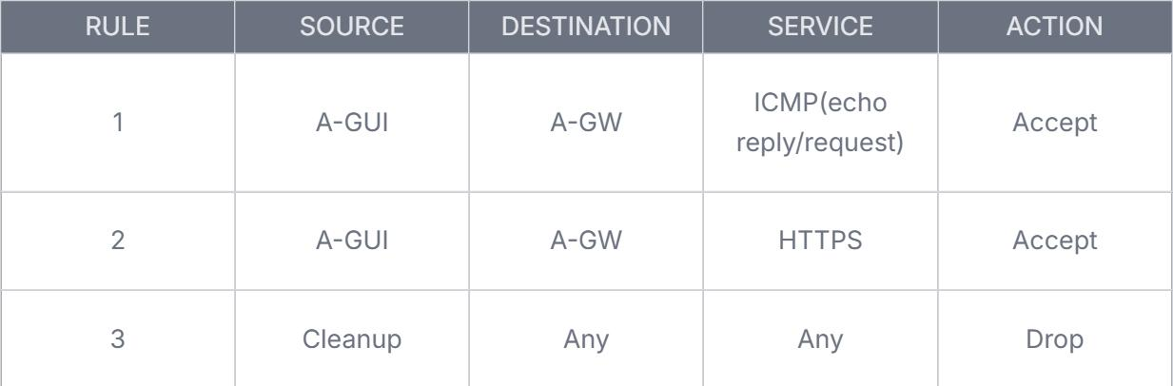
Controlled connectivity testing between the gateway and the management workstation is made possible by the ICMP rule. The Gaia Web Portal can be accessed securely by administrators thanks to the HTTPS rule. The clean-up rule specifically drops all other traffic.

6.3 Validation of Policies
ICMP traffic was blocked prior to policy installation, verifying default deny behavior. ICMP traffic specifically allowed by the rule was successfully accepted once the policy was installed. This shows that the gateway is correctly processing rules and enforcing policies.

7. Extra Security Elements
7.1 Features Put in Place

- Internal Communication Security (SIC)
- A-SMS-based centralized management
- HTTPS-based encrypted management access
- Firewall posture of default-deny

7.2 Suggested (Unimplemented)Features

- Intrusion Prevention System (IPS)
- URL filtering and application control
- Site-to-Site VPN connecting networks in Swansea and London
- Integration of logging with SIEM for sophisticated monitoring

These features are appropriate for enterprise deployment and readily integrate with the current design, however they were not implemented due to time and scope constraints.

8. Enterprise Relevance and Security Justification
Real-world enterprise firewall installations are reflected in the implemented solution by:

- Keeping management and enforcement responsibilities apart
- Using routes of communication that are authenticated and encrypted
- Using access control with the least privilege
- Implementing a security posture of default-deny
- Encouraging scalability with centralized administration

This approach guarantees uniform security policy enforcement throughout the network, lowers the attack surface, and enhances auditability.

9. Conclusion
Using Check Point GAIA appliances, this project effectively produced an enterprise-grade network security system. The implementation of A-SMS, A-GW, and A-GUI offered a centrally managed, secure architecture that could enforce fine-grained firewall rules.
The solution's functionality is verified through connectivity testing, license management, and policy validation. In addition to providing a solid basis for further improvements like IPS, VPN, and sophisticated threat protection, the design conforms to enterprise security best practices.

