MARKETING ESSENTIALS BMIH4005

Table of Contents
Introduction 1
Situation Analysis 2
5 C’s 2
Objectives 7
Strategy 8
Ansoffs Matrix 8
Tactics 9
Conclusion 10
Reference 10

Introduction
A marketing plan outlines the specific goals and strategies of a business. It helps a business, such as Hilton Hotels, to promote its brand, attract customers and increase revenue. The plan emphasises improving customer satisfaction and loyalty by considering the Hotel's unique characteristics, potential customers and competition. Achieving long-term success is the ultimate goal of the marketing plan. To create and develop the marketing strategy of Hilton Hotel and its future development, proper analysis of the situation, customer, company, current market, competition, and other vital aspects is necessary (www.googleadservices.com).

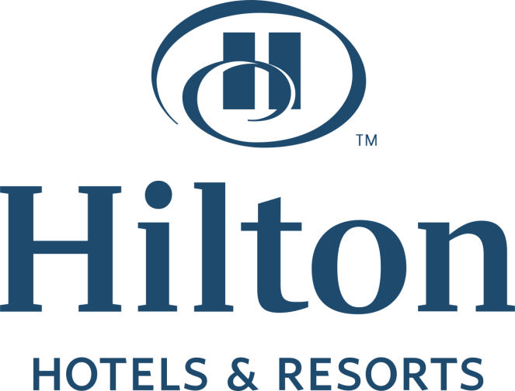
Figure: Hilton Hotels & Resorts,
Source: The Economic Times (2019)

Situation Analysis

5 C’s
Customer
According to the number and preferences of the target customers and understanding their needs, behaviours and motivations, the hotel chain has to provide various offers and facilities to meet the expectations of the customers (Liu, 2022).
STP analysis

Segmentation | Hilton Hotel segmented its target market based on customer demographics, psychographics, and geographic location to include business, luxury and family travellers.
Targeting | Hilton targets customers willing to pay a premium for high-quality service and amenities at the expense of luxury, comfort and convenience.
Positioning | Hilton positions itself as a premium hotel brand emphasising customers' luxury, comfort and convenience by offering world-class services and amenities.

Company
Using the Hotel's global brand recognition, award-winning loyalty programs and strong network of partners, the company will differentiate itself from competitors in the market (Panteleiev, 2023).
SWOT Analysis:

Strength | Weakness | Opportunity | Threats
- High-quality global reputation  - More than 6000 hotels in over 100 countries  - Offers best customer schemes by Hilton Honours Program. | - Overdependence on the US market  - Limited presence in some countries  - High level of debts  - Traditionally older than new hotels | - Expansion into the global market  - Increasing focus on eco-friendly  - Enhance online marketing and technology for better customer service  - Collaborate with others to develop new services and products. | - Political and economic instability  - Large competitive market and challenges  - Regular changes in customer demand and behaviour

Competitors
Hilton Hotels improve its market position by analysing its competitors' strengths and weaknesses, such as Marriott, Hyatt, Rosewood Hotels and Ritz Carlton (Deng, 2022).
High Quality

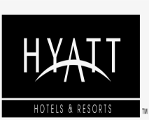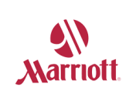
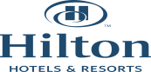
High price
Low price

Low Quality
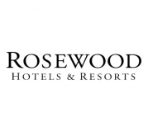

Collaborators
Hilton Hotels works with various merchants and partners, including travel agencies, airlines and event planners, to expand their channels and reach all customers (Curley, Garber, Krishnan, et al. 2020). These collaborators include prominent travel bloggers, social media influencers, online travel agencies, local business and tourism, event management teams and credit card and airline booking companies. They help hotels expand their reach, increase bookings and attract potential customers.

Context
Hilton Hotels considers economic trends, regulatory changes, and technological advancements affecting the hospitality industry and its marketing strategy to enable the company to stay ahead and adapt to the market.

Climate
PESTLE (macro analysis)

Political | Economical | Sociological | Technological | Legal | Environmental
Government regulations, acts, taxation policies, political stability, and international relationship significantly influence Hilton Hotel's marketing strategy. | Inflation rates, economic growth, exchange rates, disposable income, pricing strategies, target market and consumer selection, and target location selection reflect the company's economic condition. | Specific marketing social activities like demographics, consumer lifestyle preferences, present days cultural trends, and customer behaviour impact Hilton's marketing plan to create relevant experiences. | Social media and digital platforms, applications and software, and data analytics tools are essential to make a solid technical strategy to target the right customer and marketing campaign optimisation (Mekhruza, Malokhat, Rustam, et al. 2022). | Hilton adheres to legal matters such as employment laws, intellectual property rights, consumer protection laws, and data privacy regulations to maintain a positive brand image and avoid legal challenges. | Environmental factors like eco-friendly practices, green marketing strategy, and their commitment to sustainable activity help to attract environment-conscious consumers.

Marketing mix

Product | Place | Price | Promotion
Hilton Hotel offers exceptional accommodation and the highest quality of service. They can cater to their customer's diverse needs and preferences by offering various luxurious rooms and top-notch amenities. Hilton provides a memorable and comfortable experience for every visitor. | Hilton strategically selects popular tourist destinations worldwide and significant cities with easy access to business hubs. They provide a seamless booking process through user-friendly websites and mobile applications to prioritise covenants accessibility for their guests. Hilton expands their distribution channels with travel agencies and online platforms. | Hilton Hotels adopt a pricing strategy that reflects the premium nature of its brand and offers competitive rates that align with the value offered by its world-class facilities and services. Additionally, Hilton can offer different packages, exclusive discounts and loyalty programs to attract more customers. | Hilton Hotels conducts various promotional programs to create awareness and attract potential target customers. They use various digital marketing techniques, such as social media campaigns and search engine optimisation, to reach the target audience. Hilton also conducts public relations activities and sponsorship programs to increase the visibility and reputation of their brand in the market.

Objectives
SMART targets: summarise the aims of your marketing plan in one sentence as SMART objectives.

Specific | Measurable | Achievable | Relevant | Time-Bound
Hilton Hotels' marketing strategy caters to specific customer segments such as business travellers, luxury vacationers, and frequent travellers. | The Hotel always notices and measures key performance indicators (KPIs), average daily rate (ADR), revenue per available room (RevPAR) and customer feedback. | Hilton manages to increase market share and brand awareness and drive direct bookings by setting realistic targets with its brand positioning and market potential. | The marketing strategy focuses on Hilton's unique selling points of global presence, premium amenities, personalised customer service and loyalty programs. | Hilton set particular time frames to achieve their goal through good marketing campaigns, promotion, and evaluation, ensuring marketing efforts improvements.

Strategy
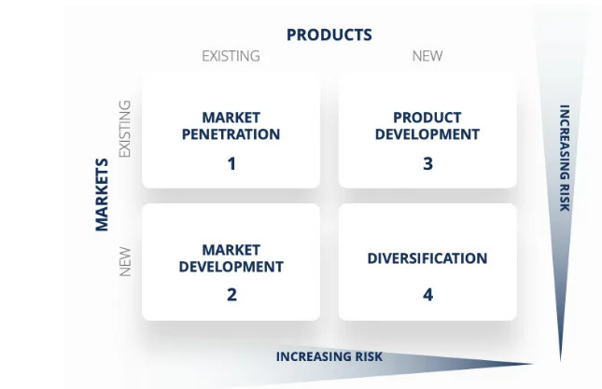

Figure: The Ansoff model [marketing strategy matrix],
Source: Corporate Finance Institute (2023)

Ansoff’s Matrix
Market Penetration
Hilton Hotel should use a marketing strategy to increase its market share in a competitive market. Attractive discounts, loyalty programmes, advertising, and brand campaigning may help reach many target customers.

Product Development
To differentiate itself from other hotels and resorts, Hilton may launch innovative services for luxuries customer. Hilton can attract new customers by continually enhancing offerings and incorporating technological advances such as intelligent room controls or personalised experiences. This strategy helps Hilton stay ahead of the competition and meet customer expectations.

Market Development
Hilton Hotels will strategically explore new geographic markets by opening hotels in different countries (Cardoso, 2022). They identify new customer segments and introduce special packages and amenities to attract eco-conscious travellers or wellness enthusiasts.

Diversification
Hilton Hotel collaborates with airlines or travel agencies by expanding into related sectors, such as vacation ownership programs or timeshares, to diversify revenue streams. Provides integrated travel packages and invests in start-ups.

Tactics
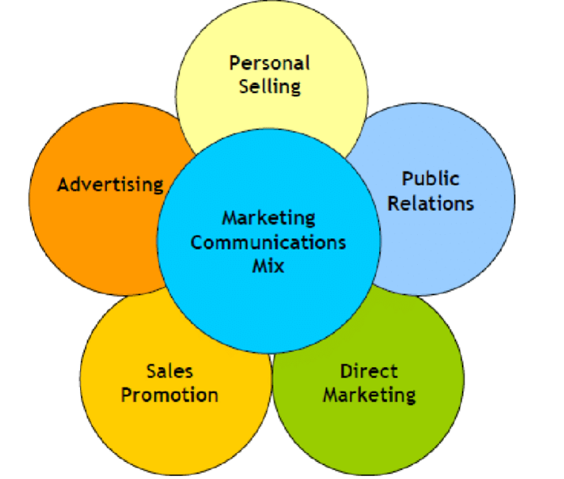

Communication Mix
Source: The elements of the Marketing Communications Mix. (2015)

Hilton Hotels employ targeted advertising campaigns across multiple channels to effectively promote their brand and attract customers, using their loyalty program, the Hilton honours program, to encourage repeat booking (Zhou, Dai, Chung et al. 2021). In addition, they maintain an active social media presence by forcing partnerships with travel agencies and online platforms, offering exclusive promotions and deals, and prioritising customer service by ensuring a user-friendly website.

Hilton Hotel's marketing strategy plan requires situational analysis to identify problems and implement new communication strategies. Social media platforms will enable Hilton to communicate directly with its target audience in a more interactive manner. Platforms like Facebook, Twitter, and Instagram can be used to respond to customer questions and share promotions and exclusive offers. Moreover, both existing and potential customers can be reached by conducting a comprehensive email marketing campaign. Additionally, Hilton Hotels can greatly improve customer satisfaction through its website. This real-time communication channel can facilitate processes by providing recommendations. Finally, collaborations with hospitality industry influences and travel bloggers can increase Hilton’s brand awareness, attracting new customers. Through these new communication techniques, Hilton Hotels can successfully solve problems and improve customer loyalty.

To connect with its target audience Hilton Hotel, use various platforms. Their official website hilton.com display the Hotel's portfolio globally. It is present in more than 200 countries and ranked 7 on the US travel and tourism sector website. To engage with more customers, they need to generate their website in other countries. By analysing website insights, Hilton Hotels can find out their negative aspects and provide better services.

Conclusion
Hilton Hotels expand Hilton's global presence by leveraging digital platforms, implementing personalised marketing initiatives, and forming strategic partnerships to deliver customer experiences and build strong brand loyalty. The Hotel's development plan promotes long-term growth and prosperity in the competitive arena by emphasising innovation, sustainability, and continuous improvement.

Reference
Cardoso, L.E., 2022. Hilton worldwide holdings in the travel & tourism industry (Doctoral dissertation). Available at: https://run.unl.pt/bitstream/10362/145507/1/2021-22_fall_44796_luisacardoso_part2.pdf[Accessed on May 18 2023]
Curley, A., Garber, R., Krishnan, V. and Tellez, J., 2020. For corporate travel, a long recovery is ahead. McKinsey & Company, August13. Available at: https://www.mckinsey.com/~/media/McKinsey/Industries/Travel%20Transport%20and%20Logistics/Our%20Insights/For%20corporate%20travel%20a%20long%20recovery%20ahead/For-corporate-travel-a-long-recovery-ahead-final.pdf [Accessed on May 18 2023]
Deng, J., 2022. Hotel Brands and the Impact of Brand Differentiation on the Success of the Global Hotel Brands. Highlights in Business, Economics and Management, 1, pp.265-276. Available at: https://drpress.org/ojs/index.php/HBEM/article/view/2582/2483 [Accessed on May 18 2023]
Hilton Hotels & Resorts expands India Leadership Team 2019 The Economic Times. Available at: https://economictimes.indiatimes.com/industry/services/hotels-/-restaurants/hilton-hotels-resorts-expands-india-leadership-team/articleshow/71862288.cms?from=mdr (Accessed: 12 June 2023).
Liu, Q., 2022, December. Development Trend of Hilton in the Post Epidemic Era and Development Suggestions Based on Quantitative and Qualitative Analysis Model. In 2022 2nd International Conference on Economic Development and Business Culture (ICEDBC 2022) (pp. 1223-1229). Atlantis Press. Available at: https://www.atlantis-press.com/article/125983726.pdf [Accessed on May 18 2023]
Mekhruza, V., Malokhat, S., Rustam, T. and Bakhora, R., 2022. PERFORMANCE OF HILTON: HOW HILTON TACKLES THE EPIDEMIC COVID-19 DISEASE. Thematics Journal of Business Management, 5(2). Available at: https://thematicsjournals.in/index.php/tjbm/article/download/1180/1190 [Accessed on May 18 2023]
Panteleiev, V., 2023. Application of SWOT Analysis to Justify the Strategy of Hotel Business Enterprises. Technology Audit and Production Reserves, 1(4), p.69. Available at: http://journals.uran.ua/tarp/article/download/274918/270601 [Accessed on May 18 2023]
www.googleadservices.com (no date) Hotels in India, Find Hotels - Hilton. Available at: https://www.googleadservices.com/pagead/aclk?sa=L&ai=DChcSEwizlPrw3P7-AhUO2EwCHST8DUsYABAAGgJ0bQ&ohost=www.google.com&cid=CAESbeD22dg3bK9QnGQlV0hgK9gk6fvSQIXevgsc2ffuji3tOCwWdZt8b_zA-YPwPtvLxqgKZJZw_vBvMM1O27bdRPf0GMi3mceTenGVrfoejPXEO5x9Pz3-jdAIVoCQKkxlghycZFY3m_pQy1zB_-w&sig=AOD64_2doV44ZqEkgjIJLZtIquppSB2K0Q&authuser=1&q&adurl&ved=2ahUKEwiBrPLw3P7-AhUgmFYBHd78ALoQ0Qx6BAgIEAM[Accessed: May 18 2023].
Ansoff matrix (2023) Corporate Finance Institute. Available at: https://corporatefinanceinstitute.com/resources/management/ansoff-matrix/ (Accessed: 12 June 2023).
Zhou, Z., Dai, R., Chung, C., Zhang, Z. and Weng, Y., 2021, July. What Makes a Worthwhile Hotel Loyalty Program? In 2021 International Conference on Economic Development and Business Culture (ICEDBC 2021) (pp. 288-292). Atlantis Press. Available at: https://www.atlantis-press.com/article/125958473.pdf[Accessed on May 18 2023]

The elements of the Marketing Communications Mix. (2015) Available at: https://www.researchgate.net/figure/The-elements-of-the-Marketing-Communications-Mix_fig1_277967846 (Accessed: 12 June 2023).

Appendix:




