

University of Wales Trinity Saint David
Welsh Institute of Sciences and Art (WISA)
Simon Rees (0151968)
MSc Cybersecurity and Digital Forensics
Research Methods and Professional Development (ACFA7004)
Research Project Proposal
An Investigation of Network Security Techniques to Detect Reconnaissance Activity.

V55 (FINAL)

AI Acknowledgement
I acknowledge the use of SciSpace (https://scispace.com/) between January and May 2025 to support my research using the prompt(s):
1. Peer Reviewed papers in PDF format were uploaded to SciSpace.
2. SciSpace was used to extract data in tabulated format with the following column headings:
Methodology, Strategy, Key findings, Datasets, Results, Findings, Conclusions.
I confirm that I have not presented any AI generated text as my own work. I confirm I have copies of my drafts, notes, and other resources I used before, and after the use of AI tools which I may be asked to provide in evidence.

Table of Contents

I. List of Figures 4
II. List of Tables 5
III. List of Equations 6
IV. List of Acronyms 6
1. Introduction 9
1.1. Context and Background 9
1.2. Research Problem 11
1.3. Research Aim and Objectives 12
1.4. Significance of Research 13
2. Literature Review 14
2.1. Literature Review Introduction 14
2.2. NIDS and SIEM Integration 14
2.3. NIDS System Comparison 16
2.4. NIDS Rules 17
2.5. NIDS Implementation & Deployment 19
2.6. Penetration-Testing 24
2.7. Cybersecurity Frameworks 24
2.8. Literature Contribution and Gap 26
2.9. Literature review summary 27
3. Research Design and Methodology 29
3.1. Research Design 29
3.2. Research Methods and Materials 32
3.2.1. Research Methods 32
3.2.2. Research Materials 39
4. Expected Outcome 43
5. Timeline 44
Gantt Chart 44
6. References 45
Appendices 50
Appendix 1: Analysis of Peer Reviewed Papers 50
A1.1 Overview Peer Reviewed Papers within Literature Review 50
A1.2 Peer Reviewed Paper Methodology Analysis. 51
A1.3 Peer Reviewed Papers Record Using PRISMA Methodology 54
A1.4 Additional research 55
A.1.4.1 NIDS and SIEM integration 55
A.1.4.1 NIDS System Comparison 57
Appendix 2: Frameworks, Tools and Reconnaissance/Attack Methods 58
A2.1 Cyber-attack and defence frameworks 58
A2.1.1 MITRE ATT&CK Framework 59
A2.1.2 Cyber Kill Chain Framework 60
A2.1.3 Cyber Security Framework 61
A2.2 Penetration Testing Tools 62
A2.3 Pen-Testing/Reconnaissance/Attack Methods 63
Appendix 3: Example Quantitative Statistical Analysis 64
A3.1 Frequency Distribution 64
A3.2 Mean, Median, Mode, Range, Standard Deviation, Variance 65
A3.2.1 Mean, Median, Mode, Standard Deviation calculated using Excel 65
A3.2.2 Mean, Median, Mode, Standard Deviation calculated using SPSS 66
A3.3 The Normal Distribution Curve 68
A3.3.1 Normal Distribution Curve (Excel) 68
A3.3.2 Normal Distribution Curve (SPSS) 69
A3.4 Pearson Correlation Coefficient 69
A4.3.1 Pearson Correlation Coefficient Calculation (Excel ToolPak) 70
A4.3.2 Pearson Correlation Coefficient Calculation (SPSS) 72
A4.3.2 Pearson Correlation Coefficient Interpretation of Results 73
A3.5 Spearman’s Ranked Correlation Coefficient 74
A3.5.1 Spearman Correlation Coefficient Manual Calculation (Excel) 74
A3.5.2 Spearman Correlation Coefficient Calculation (SPSS) 76
A3.5.3 Spearman Correlation Coefficient Interpretation of Results 77
A3.6 Comparison of Pearson and Spearman Correlation 77
A3.7 Linear Regression 78
A3.7.1 Linear Regression Manual Calculation using Excel 78
A3.7.2 Linear Regression Calculation (Excel ToolPak) 80
A3.7.3 Linear Regression Calculation (SPSS) 81
A3.8 Comparison between Correlation and Regression 84
Appendix 4: Project Management 85
Appendix 5: Written Authorisation from IT Management 86

List of Figures

Figure 1: IDS/IPS Deployment 9
Figure 2: IDS/ML/SIEM flowchart [21] 15
Figure 3: Waleed et al NIDS testbed [7] 16
Figure 4: Flowchart of NIDS Operation [7] 17
Figure 5: A decision tree [22] 18
Figure 6: Suricata rule to detect a HTTP flood attack[22] 18
Figure 7: SCADA Deployment [23] 19
Figure 8: IDS deployment and detection methods[24] 20
Figure 9: Hybrid IDS deployment [24] 20
Figure 10:Packet Analysis [24] 21
Figure 11: Adaptive defence framework [25] 23
Figure 12: MITRE ATT&CK probability [27] 25
Figure 13: Research Onion[28] 30
Figure 14: Modified Research Onion 30
Figure 15: DSR Process 31
Figure 16: Mapping the DSR to project 32
Figure 17: Proposed VE testbed 34
Figure 18:Nvivo Word-cloud 36
Figure 19: Packet Analysis 36
Figure 20: Proposed Gantt Chart of project 44
Figure 21: VE testbed [9] 55
Figure 22: Snort NIDS Architecture [9] 55
Figure 23: Suricata NIDS Architecture [9] 56
Figure 24: Boukebous et al testbed [8] 57
Figure 25: MITRE ATT&CK Framework 59
Figure 26: Cyber Kill Chain [56] 60
Figure 27: The CSF [58] 61
Figure 28: Example of a Histogram of Frequency Distribution (Excel) 64
Figure 29: Normal Distribution Example (Excel) 65
Figure 30:Calculating Mean, Median, Mode, SD and Variance (SPSS) 66
Figure 31: Resultant Mean, Median, Mode, SD (SPSS) 67
Figure 32: Normal distribution curve (Excel) 68
Figure 33: Normal distribution curve (SPSS) 69
Figure 34: Calculating the Pearson Coefficient using the Excel Analysis ToolPak add-in 71
Figure 35:Resultant Pearson Correlation Coefficient Example (Excel ToolPak) 71
Figure 36: Calculating the Pearson Coefficient (SPSS) 72
Figure 37: Resultant Pearson Correlation Coefficient Example (SPSS) 73
Figure 38:Calculating the Spearman Coefficient (SPSS) 76
Figure 39: Resultant Spearman Correlation Coefficient (SPSS) 76
Figure 40: Graph of Linear Regression (Excel ToolPak) 79
Figure 41: Using Linear Regression to solve for Y 79
Figure 42:Using Linear Regression to solve for X 79
Figure 43: Analysis calculating Linear Regression including Standard Error (Excel ToolPak) 80
Figure 44: Result of Analysis linear regression (Excel ToolPak) 81
Figure 45:Calculating Linear Regression (SPSS) 81
Figure 46: Resultant Linear Regression (SPSS) 82
Figure 47: Graph of Linear Regression (SPSS) 83
Figure 48: Trello/Agile Task-board 85
Figure 49: Authorisation email from IT Management 86

List of Tables

Table 1: IDS deployment methods 10
Table 2: ATT&CK and CKC comparison [6] 10
Table 3:Packet Analysis 21
Table 4: Literature Overview 27
Table 5: Research Methodology based on Research Onion 31
Table 6: DSR Phases 31
Table 7: Proposed test methods 33
Table 8: Proposed VMs deployed 34
Table 9: Categories of testing tools 35
Table 10: Phase I Metric 36
Table 11: Quantitative test-plan1 37
Table 12: Quantitative test-plan2 38
Table 13: Phase II Metric 38
Table 14: Sample test-plan 39
Table 15:Phase I data collection procedure 40
Table 16: Phase II Data Collection Procedure 40
Table 17: VM Tools used for project 41
Table 18:List of software for proposed project 42
Table 19:Limitations and Challenges 43
Table 20: Literature Review Overview Table 50
Table 21: Peer Reviewed Paper Methodology Analysis 51
Table 22: Peer Reviewed Paper Screening using PRISMA principles 54
Table 23 Attack and Defence Frameworks 58
Table 24: Penetration Testing Tools [5][15] 62
Table 25: Reconnaissance and Attack Methods 63
Table 26: Example of Statistical analysis Mean, Median, Mode, Range, Standard Deviation, Variance and their relevance to the project. 65
Table 27: Explanation of PCC notation 70
Table 28: Explanation of PCC notation using SD 70
Table 29: PCC Strength Interpretation 74
Table 30: Spearman’s Ranked Coefficient – First step ranking dataset 75
Table 31: Spearman’s Ranked Coefficient Example Calculation 75
Table 32: Spearman Ranked Coefficient Strength Interpretation 77
Table 33: Linear Equation Example 78
Table 34: Explanation of linear regression equation 80
Table 35: Comparison between Correlation and Regression 84
Table 36: Example of Logbook 85

List of Equations

Equation 1: Pearson Correlation Coefficient 70
Equation 2: Pearson Correlation Coefficient using Standard Deviation 70
Equation 3: Linear Regression Calculation 1 78
Equation 4: Linear Regression calculation transposed to solve for X 79
Equation 5: Linear Regression Equation 2, considering Standard Error 80

List of Acronyms

Acronym | Meaning
AD | Active Directory
AI | Artificial Intelligence
APT | Advanced Persistent Threat
ARP | Address Resolution Protocol
ATT&CK | Adversarial Tactics, Techniques and Common Knowledge
AV | Automated Vehicle
BA | Blackboard Analysis
CKC | Cyber Kill Chain
CLI | Command Line Interface
CSS | Cross Site Scripting
CSF | Cybersecurity Framework
CVE | Common Vulnerabilities and Exposures
CVSS | Common Vulnerability Scoring System
DC | Domain Controller
DiD | Defence in Depth
DNS | Domain Name Service
DoS | Denial of Service
DDoS | Distributed Denial of Service
DPI | Deep Packet Inspection
DSR | Design Science Research
FTP | File Transfer Protocol
GUI | Graphical User Interface
HIDS | Host Intrusion Detection System
H-IDS | Hybrid Intrusion Detection System
HTTP | Hypertext Transfer Protocol
HTTPS | Hypertext Transfer Protocol Secure
ICMP | Internet Control Message Protocol
ICS | Industrial Control Systems
IDS | Intrusion Detection System
IoT | Internet of Things
IEEE | Institute of Electrical and Electronics Engineers
IP | Internet Protocol
IPS | Intrusion Prevention System
L2 | Layer 2
L3 | Layer 3
L4 | Layer 4
L5 | Layer 5
LDAP | Lightweight Directory Access Protocol
LH-IDS | Lightweight Hybrid Intrusion Detection System
MAC | Media Access Control
MD5 | Message Digest 5
MSSQL | Microsoft Subject Query Language
NC | Netcat
NCat | Netcat (Developed by Network Mapper (Nmap))
NMS | Network Monitoring System
NIDS | Network Intrusion Detection System
NIPS | Network Intrusion Prevention System
NIST | National Institute of Standards and Technology
NTP | Network Time Protocol
OS | Operating System
OT | Operational Technology
PCAP | Packet Capture
PRISMA | Preferred Reporting Items for Systematic Reviews and Meta-Analysis
SCADA | Supervisory Control and Data Acquisition
SCP | Secure Copy
SDN | Software Defined Networking
SHA | Secure Hash Algorithm
SIEM | Security Information and Event Management
SLR | Systematic Literature Review
SPSS | Statistical Package for Social Sciences
SQL | Subject Query Language
SQLi | Subject Query Language Injection
SUT | Systems Under Test
TCP | Transport Control Protocol
UDP | User Datagram Protocol
VANET | Vehicular ad hoc Networks
VE | Virtual Environment
XSS | Cross Site Scripting

Introduction

Context and Background

This project proposal focuses on Intrusion Detection Systems (IDS) within the field of Cybersecurity.
An IDS passively monitors network traffic and sends an alert if suspicious traffic is detected.
An IDS can be deployed as an Intrusion Prevention System (IPS) by installing it inline, so all network traffic flows through it, actively blocking suspicious traffic.
Figure 1 (Fig.1) illustrates IDS and IPS deployments:
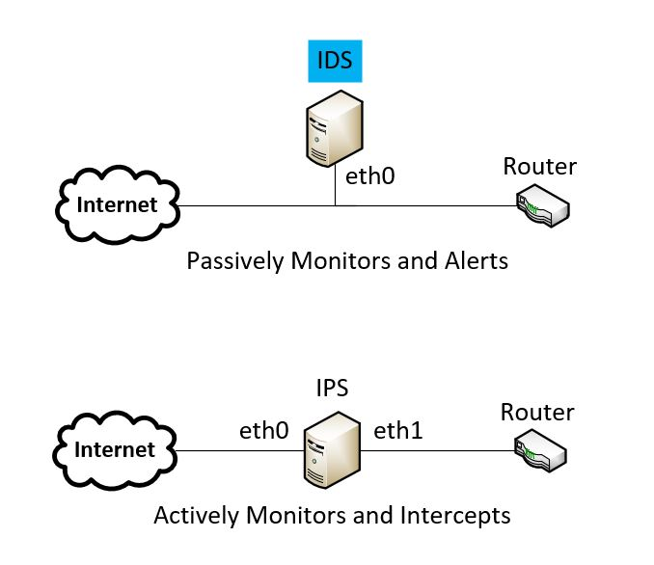
Figure 1: IDS/IPS Deployment

Table 1 shows IDS/IPS deployment methods [1][2][3].

Table 1: IDS deployment methods
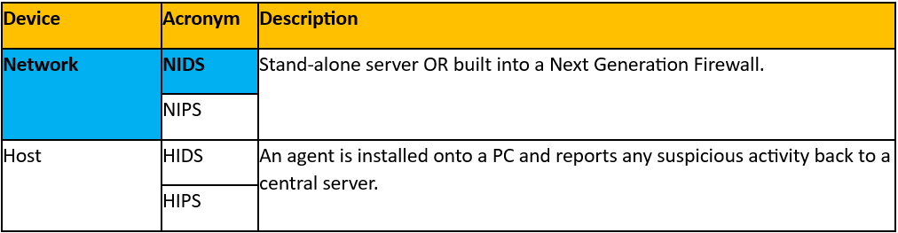

Cyber-attacks begin at the reconnaissance phase, allowing attackers to [4][5]:
- Familiarise themselves with the target network
- Identify potential weaknesses/vulnerabilities
- Discover Usernames/Passwords
- Begin the enumeration phase, identifying user accounts and resources.

Two cyber-attack frameworks used by hackers are the MITRE Adversarial Tactics, Techniques and Common Knowledge (ATT&CK) and the Lockheed Martin Cyber Kill Chain (CKC) frameworks [6], see Table 2.
Table 2: ATT&CK and CKC comparison [6]
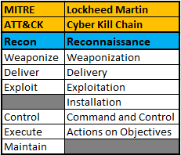

This project will explore network security monitoring utilising Network Intrusion Detection Systems (NIDS). A NIDS is a dedicated server deployed to passively monitor network traffic generating an alert if suspicious activity is detected [7][8].
This project will utilise NIDS, namely Snort and Suricata, in the detection of reconnaissance activity on a network and a comparison will be drawn on their effectiveness in detection capabilities [7][8][9].

The prevalence of Artificial Intelligence (AI), e.g. ChatGPT, CoPilot and Genesis has expedited the advancements in the field of NIDS. The integration of NIDS with AI and Machine Learning (ML) has formed a Hybrid IDS (H-IDS).
The reasons for developing H-IDS are:
- Improved NIDS performance [10]
- Enhance understanding of attack characteristics [11]
- Better classification of network attacks [12]
Cui et al [10] developed a lightweight H-IDS (LH-IDS) that can be applied to Automated Vehicles (AV) which utilise a Vehicular ad hoc Network (VANET) providing network communication and is vulnerable to cyber-attack. The LH-IDS system can detect anomalous network traffic with a high degree of accuracy whilst utilising minimal resource usage such as processor and memory.

Research Problem

Hackers use cyber-attack frameworks to conduct attacks. The first step is the reconnaissance phase whereby the attacker gathers information on their target using evasion techniques to avoid detection [5][6][13][14][15]. Data gathered during this phase can be used at later stages of the cyber-attack framework, ultimately leading to financial loss by means of Data Disclosure, Alteration, or Denial of Service/Data [5].
The challenge for cybersecurity professionals is to comprehend the tools, techniques, and methods used by hackers and the motivations for the attack, to gain a better understanding of the overall attack process [16][17].
NIDS have limitations that hackers exploit to evade detection [5][13][18][19][20]. However, the detection of the reconnaissance phase of an attack and understanding the limitations of NIDS are crucial in network defence.

Research Aim and Objectives

Aim: To develop a testbed to research the tools and techniques used by hackers during the reconnaissance phase and the effectiveness of NIDS to monitor and detect activity on a network alerting cybersecurity staff to cyber-attacks.
Obj1: To design and build a Virtual Environment (VE) testbed based on an enterprise University campus network incorporating two existing NIDS, namely Snort and Suricata to detect reconnaissance activity.
Obj2: To devise a test-plan based on attack-frameworks utilising tools/techniques employed by hackers, to evaluate the effectiveness of NIDS, in detecting reconnaissance activity.
Obj3: To analyse the dataset generated from Obj2, first using qualitative analysis identifying which tools and techniques can and cannot be detected by NIDS, and then quantitative analysis comparing Snort and Suricata determining their effectiveness in detecting reconnaissance activity.

Working Hypothesis:
It is hypothesised that NIDS will not be able to detect all reconnaissance activities. It is anticipated that a Defence in Depth (DiD) approach will be crucial in detecting reconnaissance activity, utilising NIDS as part of a DiD solution.
H₁ = NIDS will not be able to detect all reconnaissance activity.
Null Hypothesis
H₀ = NIDS will be able to detect all reconnaissance activity.

Research Questions:
- RQ1: Can any reconnaissance activity avoid detection by NIDS?
- RQ2: If reconnaissance activity can avoid detection by NIDS, is it possible to create manual rules to detect traffic based on packet analysis?
- RQ3: Which NIDS is most effective at detecting reconnaissance activity?

Significance of Research

The detection of the reconnaissance phase is an important aspect in network defence. If reconnaissance activity is detected, mitigations can be implemented before a potential cyber-attack. If a hacker can successfully conduct reconnaissance they can glean details of the infrastructure, associated vulnerabilities, usernames/passwords, all of which can be used in later stages of the attack-framework. As the attack progresses through the attack-framework, each progressive phase poses additional risk to the organisation.
Investigating which tools and techniques can evade NIDS detection is crucial to better understand the operation of NIDS, their capabilities and limitations.

Literature Review

Literature Review Introduction
A narrative literature review was conducted of peer reviewed journals from credible sources (e.g. Institute of Electrical and Electronic Engineers (IEEE) Xplore and Science Direct). These papers were organised thematically into groups.
To gain knowledge of current trends and identify a literature gap, a review of the literature was undertaken in the subject areas of:
- IDS
- Security Information and Event Management (SIEM)
- Attack-frameworks
- Penetration (pen) testing
Relevant technologies were also reviewed to gain an in-depth understanding of detection methods of NIDS and pen-testing techniques including reconnaissance activity.
See Appendix 1 for analysis of peer reviewed papers, Appendix 2 for Frameworks, Tools and Reconnaissance Methods.

NIDS and SIEM Integration

Muhammad et al [21] developed a system that integrated Zeek IDS with a SIEM based on the Elasticsearch, Logstash and Kibana (ELK) stack. This system leveraged ML to analyse network traffic from Zeek IDS before forwarding it onto the ELK stack SIEM for live analysis. The VE comprised of the IDS, SIEM and an unspecified traffic generator. A DoS attack was simulated, with traffic entering the IDS first, then the ML process. Traffic was sent to the SIEM ELK stack so live analysis could be conducted. Research showed the system successfully detected DoS traffic, with alerts sent by email and telegram, see Fig.2.
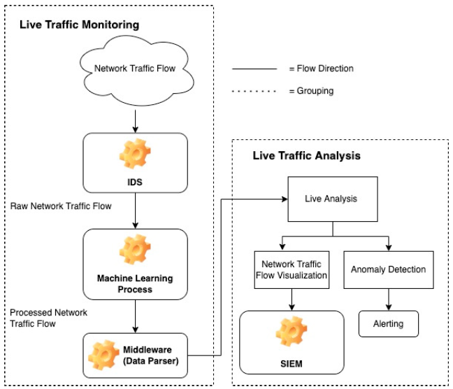
Figure 2: IDS/ML/SIEM flowchart [21]

Zeek is fully customisable, leading to enhanced detection rates and network flow analysis. During testing resource usage of some VMs was raised, requiring configuration optimisation.
If the testbed consisted of additional NIDS (e.g. Snort/Suricata) a larger dataset would have been collected giving more detailed and accurate results.

NIDS System Comparison

Waleed et al [7] used three open-source NIDS: Snort2/Snort3, Suricata and Zeek, to evaluate NIDS performance using a VE testbed with packet loss as a metric to determine which NIDS solution suffered the least packet loss. The Systems Under Test (SUT) comprised of a VM for each device including NIDS, a traffic generator (Ostinato) and target VM (Ubuntu) see Fig.3.
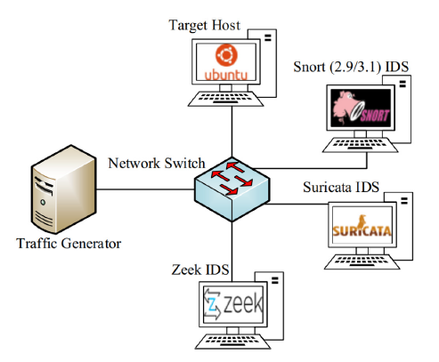
Figure 3: Waleed et al NIDS testbed [7]

Only one NIDS was active during each test improving accuracy but lengthened the time of testing. Network traffic load from the Ostinato generator was increased from 100mbps to 1000mbps to evaluate packet loss. Window and packet sizes were also adjusted.
Suricata outperformed both Snort2/Snort3 and Zeek in every facet. Snort3 and Suricata have multi-threading technology, however, Suricata's was superior. Suricata was able to load balance across multiple cores more evenly, resulting in zero packet loss up to 600 Mbps.
This paper gave, in-depth analysis comparing the system performance of Snort2/Snort3, Suricata and Zeek, presenting the results clearly and concisely. This research also outlined the detection process in a flowchart, see Fig.4.
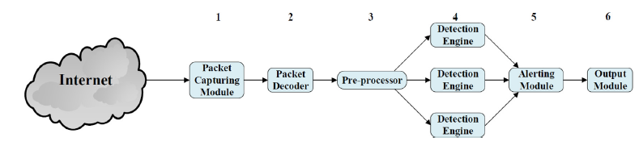
Figure 4: Flowchart of NIDS Operation [7]

As only one NIDS was active during testing it was not exposed to the identical traffic.
As testing was conducted in a VE the underlying hardware may have impacted each of the VM NIDS. Re-conducting the research utilising a physical network and hardware NIDS, may yield more accurate results.
Snort3 was not considered a stable release at the time of testing, this may have had an impact on results.

NIDS Rules

Coscia et al [22] developed a new Anomaly2Sign algorithm to generate Suricata rules automatically to alert or block traffic. Anomaly2Sign was compared with an existing algorithm, Sirius, a state-of-the-art rule generation algorithm for Suricata. NIDS systems perform well with known attacks and recognised signatures, however, finds unknown attacks or the continual variation of DoS/Distributed DoS (DDoS) attacks very challenging. The system utilised a decision-tree algorithm on network traffic for detecting anomalies, see Fig.5:
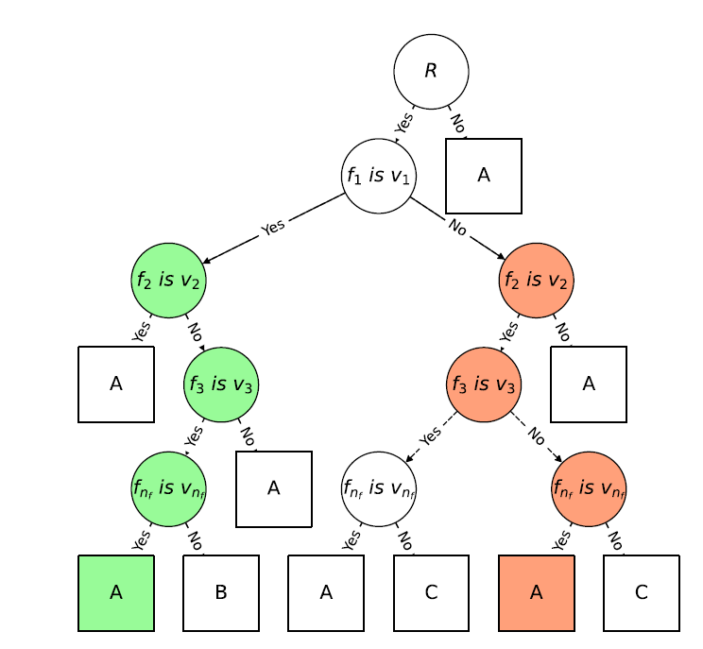
Figure 5: A decision tree [22]

The algorithm was trained on normal and anomalous traffic. During the testing phase the “BOUN-DoS” and BUET-DDoS datasets were used as variable anomalous traffic. Research showed Anomaly2Sign outperformed the Syrius algorithm in both accuracy and speed. Detection rates of Anomaly2Sign were between 99.7-99.9% outperforming ML equivalents.
Anomaly2Sign utilised attack decision trees but does not consider any mitigations deployed, potentially providing inaccurate results.
The research focused on HTTP anomalies, see Fig.6. This does not provide a real-world view as HTTP is not considered a secure protocol as data transmitted in plain text. Other secure protocols were not considered.

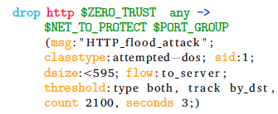
Figure 6: Suricata rule to detect a HTTP flood attack[22]

NIDS Implementation & Deployment

Rakas et al [23] conducted a Systematic Literature Review (SLR) of 26 research papers on IDS relating to network connected control equipment to identify current issues and potential future research areas.
The IDS detection methods e.g. signature-based and anomaly-based were researched. The Signature-based detection techniques were insufficient and not suitable for securing SCADA (Supervisory Control and Data Acquisition) systems. Hybrid-based detection techniques and test environments tailored to SCADA systems was recommended to evaluate effectiveness, see Fig 7:
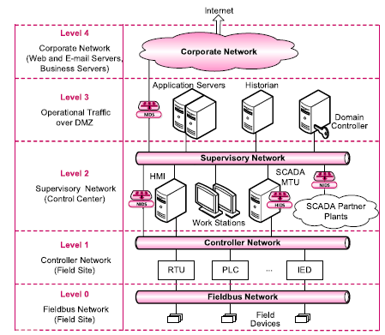
Figure 7: SCADA Deployment [23]
This research focused on identifying IDS solutions for SCADA systems, highlighting the challenges and proposing solutions unique to SCADA.
It identified signature-based techniques cannot handle new, or unknown threats and requires dedicated profiles for each protocol.
This was an excellent paper with no flaws in the research or methodology.

Zohourian et al [24] developed a new profiling method in relation to the Internet of Things (IoT) devices and Packet Representation Intrusion Detection System (PRIDS) to detect network anomalies. IoT devices are prevalent throughout society introducing new cybersecurity risks as they are the weakest link in a network's defence. Traditional and hybrid IDS, outlined in Fig.8-9, are crucial in detecting threats but require labelled data and have associated high computing costs.
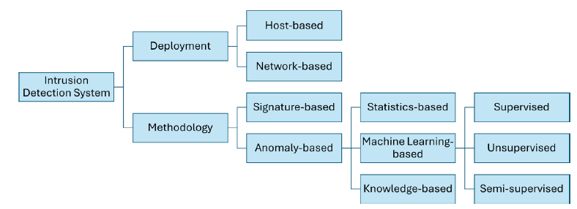
Figure 8: IDS deployment and detection methods[24]
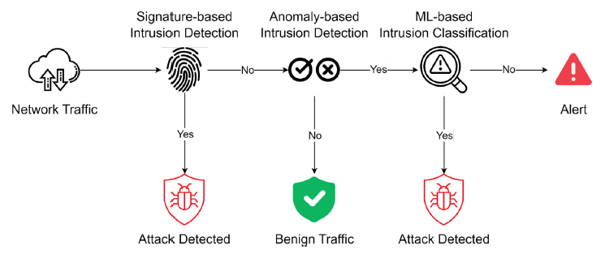
Figure 9: Hybrid IDS deployment [24]

The IoT-PRIDS framework, is a lightweight, host-based IDS which detects anomalous network traffic.

Packet analysis captured the critical attributes header fields creating a baseline of normal traffic using 3 main criteria to determine whether the packet was malicious:
- Communication
- Service
- Header Files
See Table 3 and Fig.10:
Table 3:Packet Analysis
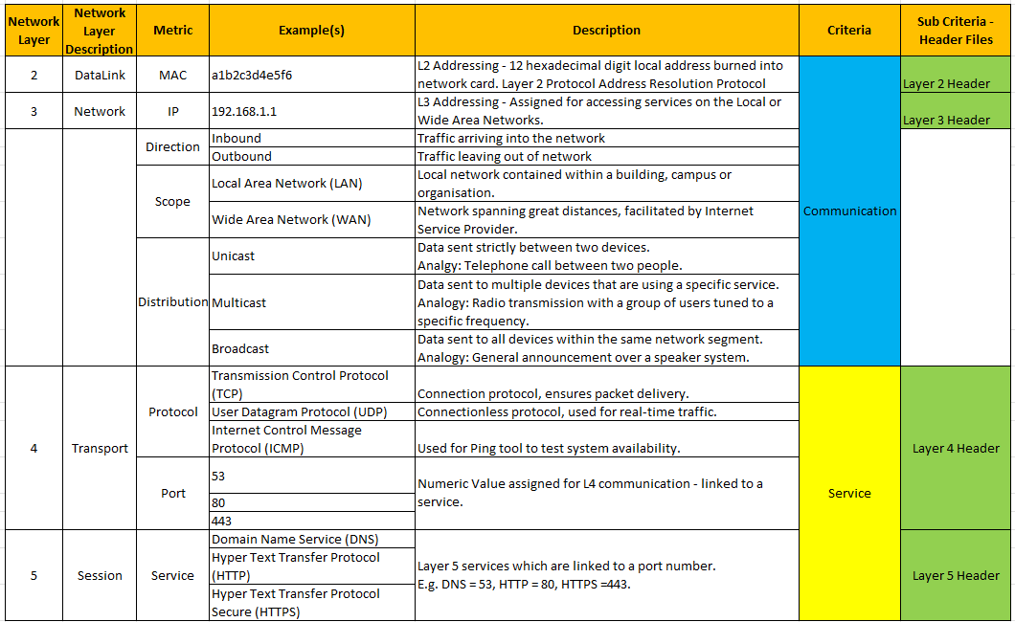
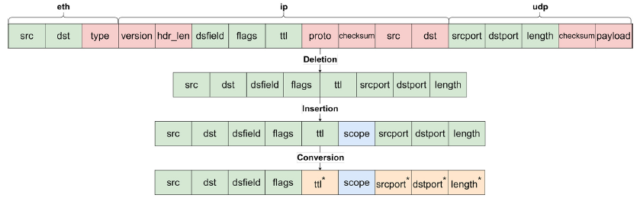
Figure 10:Packet Analysis [24]

The CICIoT2022 and CICIoT2023 datasets were used during the analysis phase. Several attack types were contained within the two datasets that were analysed using the following metrics:
- Accuracy
- Precision
- Recall
- F1-score (provides an average precision score)
29 different attack types spread over 5 categories were analysed:
- Web (e.g. Command Injection)
- Reconnaissance (e.g. Scanning attacks)
- Dictionary Brute Force (e.g. Password attacks)
- DoS Attacks/DDoS (e.g. TCP Flood)
Statistical analysis was conducted on the results. Research Question 1 related to the accuracy and precision of detecting intrusion and anomalies. Results of the IoT-PRIDS showed network anomalies were detectable, and comparative to other studies by other academic researchers.
Being lightweight the IoT-PRIDS, required less time for profiling and monitoring compared to other studies using ML approaches. The IoT-PRIDS outperformed other studies on the recall metric whilst minimising false positives and achieving near real-time speeds.
The host-based method requires prior knowledge of the IoT device and correct profiling to prevent false positives.
This report provides a good overview of IDS, detection methods, and packet analysis. However, during testing of the reconnaissance phase, ping and Address Resolution Protocol (ARP) scans were not conducted despite these scans normally being part of pen-testing/reconnaissance phase attacks.

Qin et al [25] researched Industrial Control Systems (ICS), accessible online making them a target for hackers. This research focused on adaptive defence frameworks utilising cyber deception in the form of Honeynets/Honeypots as a mitigation, see Fig.11.
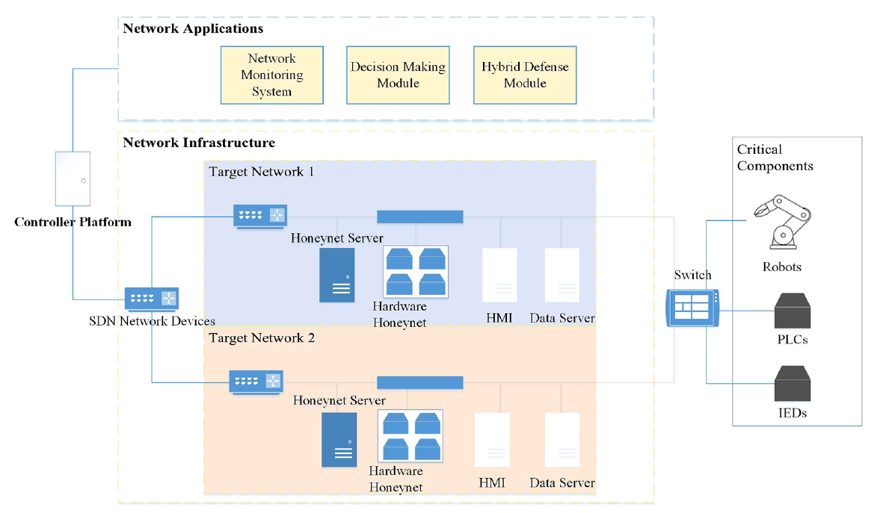
Figure 11: Adaptive defence framework [25]

The hacker’s aim is to disrupt availability of the control system and normal business functions. The research aimed to develop a system that maximised the amount of time hackers spent on a decoy honeynet/honeypot. The system consisted of a Software Defined Networking (SDN) platform. Two honey networks (Honeynets) were developed as a decoy distracting an attacker from the live ICS. The adaptive defence strategy is based on proactive and reactive defence modes. The Network Monitoring System (NMS) used the appropriate mode depending on the inputted data. If an attack is detected the proactive method is utilised maximising the time the hacker spends in the reconnaissance phase within the honeynet. The honeynet dynamically changes its network topology, making reconnaissance scanning more difficult. If an anomaly, or an intrusion alert is detected, the reactive mode is triggered. This isolates the critical node, thereby mitigating the impact of an attack. The benefits are two-fold, the attacker is distracted by the honeynet/honeypot and an alert is sent by the IDS.
The adaptive defence framework implements honeynets/honeypots cyber defence deception techniques to improve ICS system availability.
This framework currently has limited real-world testing within an industrial environment and not encountered live cyber-attacks.
More details on the NMS would be useful, as it performs detection, but no specific details of the IDS were included.

Penetration-Testing

Badarneh et al [26] reviewed pen-tests to assess the effectiveness of security controls and identify vulnerabilities. A SLR was conducted of pen-testing methods and tools.
The reconnaissance phase of an attack was researched, detailing methods e.g:
- Banner grabbing
- Domain Name Service (DNS) queries
- Scanning
Research on the scanning phase was conducted detailing the different types of ping scans, as well as vulnerability scanning. Tools such as Network Mapper (Nmap) and Nessus were researched providing an understanding of methods to identify weaknesses of a network.
This paper provided a good understanding of the pen-testing tools and techniques, and highlights the importance of vulnerability assessment, to proactively seek weaknesses.
This research is theoretical and does not enhance the study with practical application of the techniques discussed. By incorporating a lab simulation screenshot of the tools, would give the reader a better understanding of the techniques.

Cybersecurity Frameworks

Zhang et al [27] researched the impact of Advanced Persistent Threats (APT), in relation to ATT&CK, CKC, and the Cybersecurity Framework (CSF) frameworks. The study correlates these frameworks against the impact of APTs to develop a prediction model. The prevalence of APTs has led to more frequent and complex attacks which impacts the stability of governments and organisations. To counter these attacks, zero trust network architecture is becoming more commonplace. The research focused on 5 cybersecurity entities:
- External Services
- Enterprise Services
- Enterprise Users
- User Devices
- User Credentials

20 individual tests of varying tactics and techniques were used to test the efficiency of the prediction system, see Fig.12.
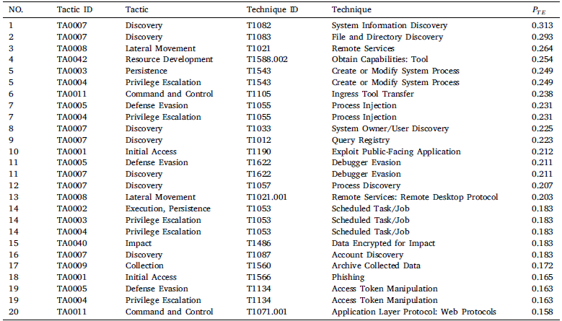
Figure 12: MITRE ATT&CK probability [27]
Statistical analysis was conducted to determine the probability of attack. A Markov chain was generated to predict attack propagation, describing a sequence of possible events culminating in a relationship map of cyber-attacks.
This research enhances the efficiency of the access control decision making process and the performance of zero trust networks against sophisticated APT threats.
However, only 20 individual tests were conducted. Increasing the number of tests, and the sample size may yield more accurate results.

Literature Contribution and Gap

Waleed et al [7] outlined the performance and highlighted the limitations of Snort2/3 and Suricata. Suricata was extolled thus the superior performing NIDS tested.
Coscia et al [22] developed Anomaly2Sign algorithm to generate Suricata rules automatically for anomalous network traffic detected outperforming a current algorithm, Syrius. Anomaly2Sign enabled anomalies to be detected and blocked more efficiently.
Zohourian et al [24] developed a lightweight IoT-PRIDS profiling algorithm to detect and block anomalous traffic more efficiently than current ML systems.
The literature review showed a substantial amount of research into the performance of NIDS e.g. Snort and Suricata, advancement in NIDS rules, implementation of NIDS and particularly implementation within a SCADA system and pen-testing.
However, none of these papers specifically researched the area of detecting reconnaissance activity using NIDS determining their limitations which forms the research gap. This proposed research on reconnaissance detection will give a wider and more in-depth insight into detection of reconnaissance activity using NIDS.
A wide range of reconnaissance tools will be tested giving a better understanding of the tools used, their detectability by NIDS, how they appear at packet level and NIDS evasion techniques commonly used by hackers. In addition, whether manual rules can be generated to detect this reconnaissance activity.
A better understanding of methods used by hackers and improving the knowledge of which mitigation techniques and NIDS rules required to improve cybersecurity will be gained.
Finally, this research will provide insight into the detection capabilities of Snort and Suricata, and whether one is more effective at detecting reconnaissance activity over the other.

Literature review summary

Table 4 show a literature overview:
Table 4: Literature Overview
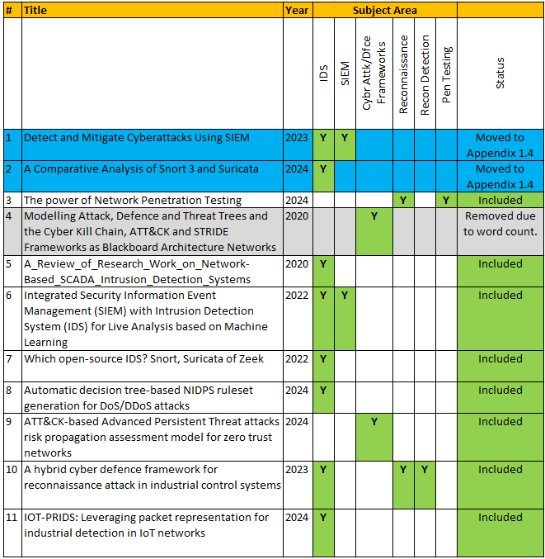

See Appendix 1.4 for additional research.

The literature review showed several of the studies centred on VE testbeds, focusing on the performance of NIDS with respect to resource usage. These were of benefit as they provided an insight into the methodologies used by research academics and the resulting statistical analysis. It is anticipated that Suricata will be more efficient, producing less packet drop, while Snort will require less resource.
A better understanding of NIDS rules, specifically for Suricata, has been gained, giving insight into how they are generated and function.
The pen-testing research paper outlined the methods used in reconnaissance phase of an attack and will help formulate an appropriate test-plan for the project.
The attack frameworks researched, commencing with the reconnaissance phase, identified appropriate techniques and tactics crucial for developing an effective test-plan.
The literature gap identified was that none of the papers reviewed specifically addressed detection of the reconnaissance phase using NIDS.

Research Design and Methodology

Research Design

The research approach will be based upon the modified research onion incorporating Design Science Research (DSR).
It will consist of a testbed to determine how NIDS respond to cyber-attack. The data gathered will be both text and numeric which will be qualitatively and quantitatively analysed.
All strategies of the research onion were considered, but the experiment was the only strategy to meet the requirements of this research proposal. Other strategies focused on previous documented events, required human interaction or focused on social/pedagogy and were discounted.
The experimental research into the detection using NIDS of reconnaissance phase of an attack has not been conducted previously. The induction approach will be adopted as there is no previous data to base this project upon.
See Tables 5-6 for further justification.

Fig.13 original Research Onion:
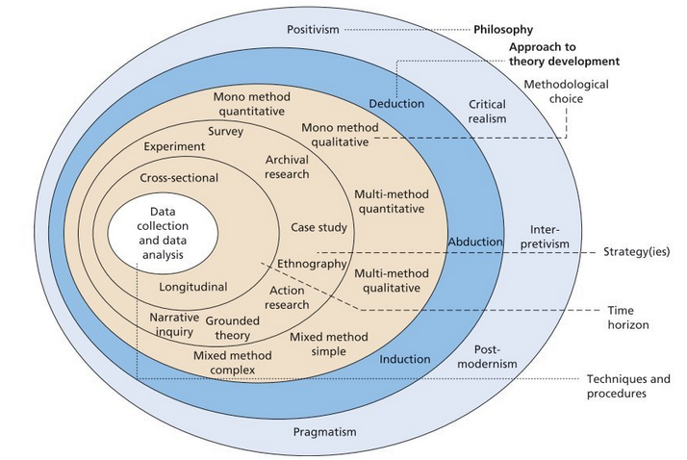
Figure 13: Research Onion[28]
Fig.14 Modified research onion for proposed project.
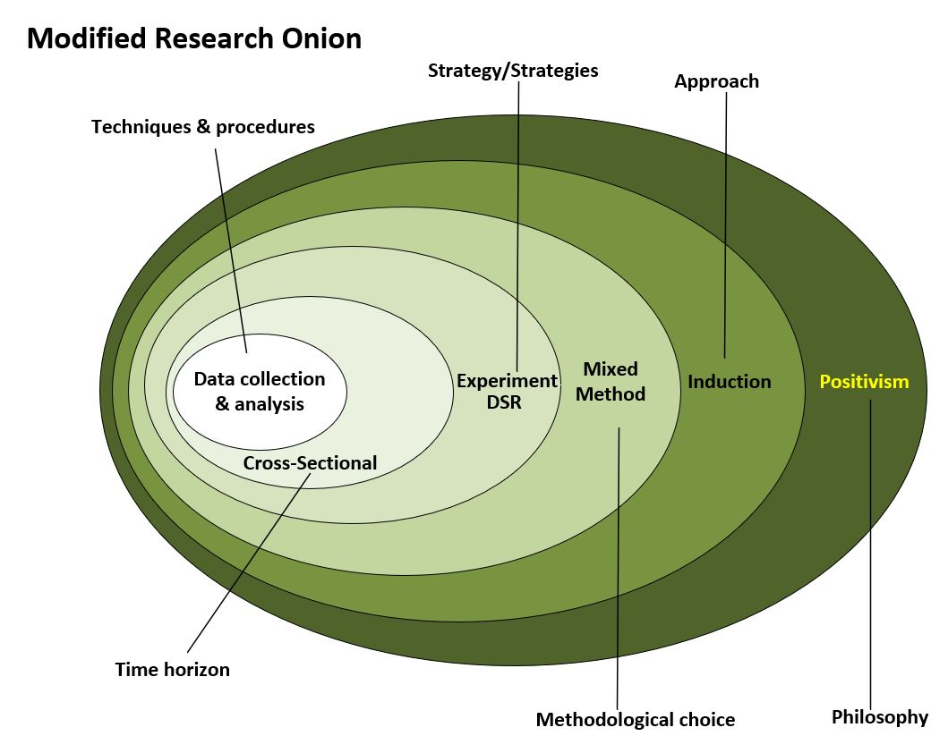
Figure 14: Modified Research Onion

Table 5 Justification for methodologies.
Table 5: Research Methodology based on Research Onion
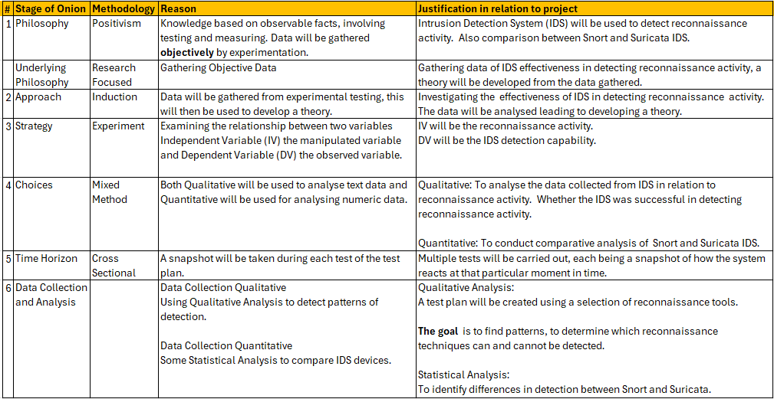

Fig.15 Shows DSR process:
Figure 15: DSR Process
Table 6 maps each DSR phase to the project:
Table 6: DSR Phases
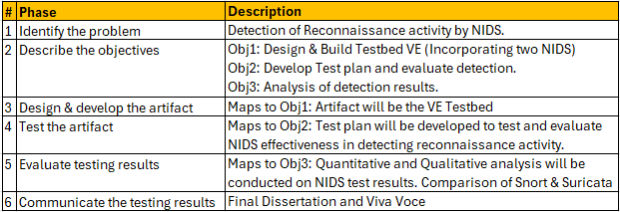

Fig.16 Show DSR process mapped to project.
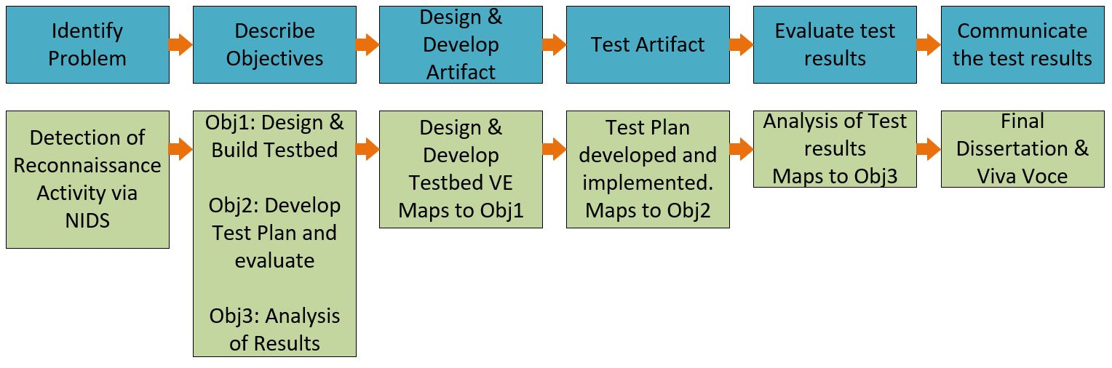
Figure 16: Mapping the DSR to project

Research Methods and Materials

Research Methods

The research strategy will be experiment utilising the DSR to provide a structured process for developing the testbed, test-plan and for carrying out the analysis. The strategy will provide a VE testbed modelling a university campus enterprise network, where tests will be conducted evaluating the performance of NIDS in detecting reconnaissance activity.
Mixed methods will be used to analyse the dataset and conducted over two phases:
Phase I Qualitative:
Identifies which tools and techniques can and cannot be detected by NIDS. This data will be text in the form of alert messages and network traffic packet captures generated by NIDS.
Phase II Quantitative:
Statistically evaluating the detection capabilities of Snort and Suricata providing a side-by-side comparison. The data will be numeric considering the number of alert messages triggered by the reconnaissance activity.
See Table 7 Project test methods:
Table 7: Proposed test methods
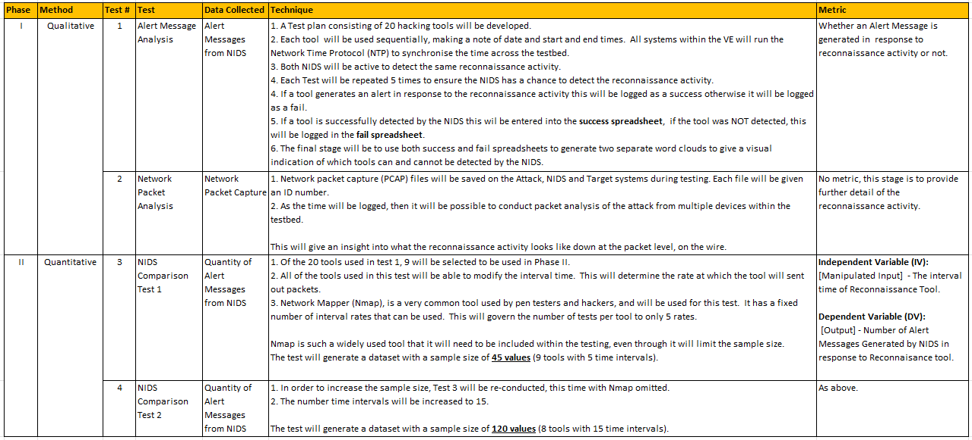

Justification of research methods

Phase I: The ATT&CK and CKC frameworks will be used, in-line with other academic studies and considered standard practice when conducting pen-testing [5][6][15][26][27][29].
Kali Linux has over 70 hacking tools and used to conduct simulated attacks in other academic research and are considered a standard pen-testing tool [5][15][30][31][32][33][34][35][36][37][38][39][40][41][42][43][44][45][46][47].
Phase II: Snort and Suricata will be used and are considered industry standard tools in-line with academic research [7][8].

System Design

A VE will host the testbed to conduct experiments.
Fig.17 Proposed testbed and Table 8 provides further information.
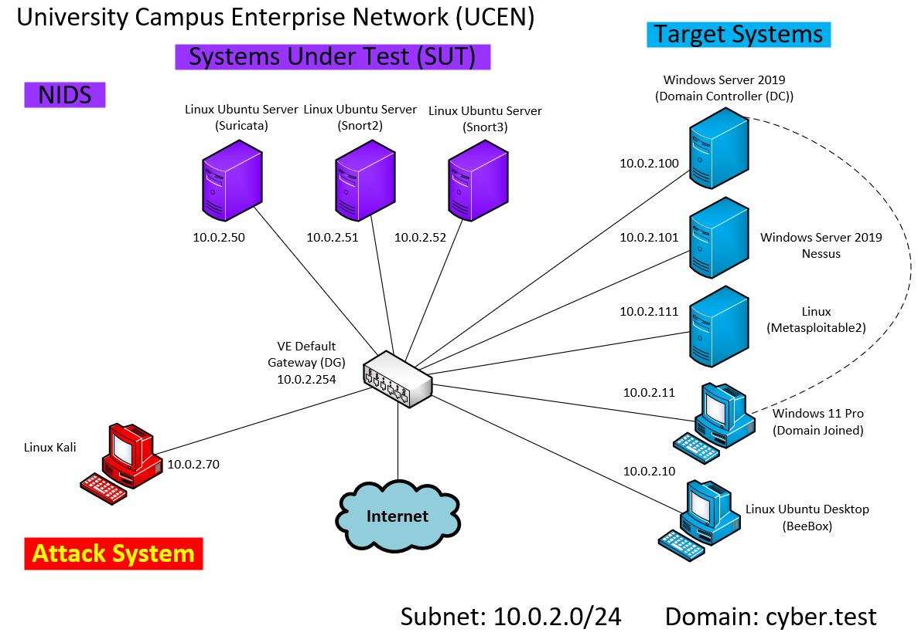
Figure 17: Proposed VE testbed
Table 8: Proposed VMs deployed
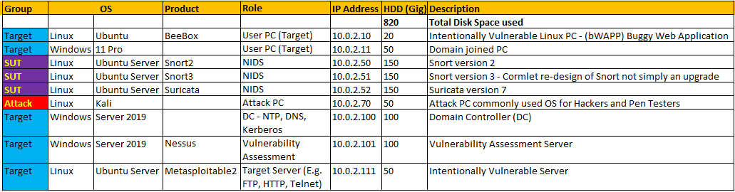

Data Analysis and Evaluation

The analysis process will be two-fold. Phase I will comprise of qualitative analysis and Phase II quantitative analysis.

Phase I: Qualitative Analysis

Qualitative thematic analysis will be conducted outlining categories and subcategories consisting of 23 hacking tools. These are commonly used during the reconnaissance phase of an attack, see Table 9:
Table 9: Categories of testing tools
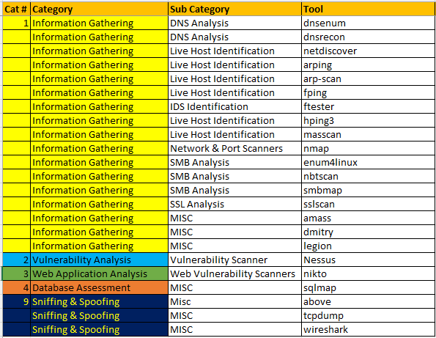

Table 10 Metrics for Phase I:
Table 10: Phase I Metric
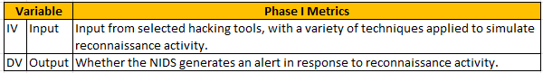
The result of Phase I will be displayed as a word-cloud, highlighting patterns of which tools can and cannot be detected by NIDS. Fig.18 shows an Nvivo word-cloud generated using fictitious data.
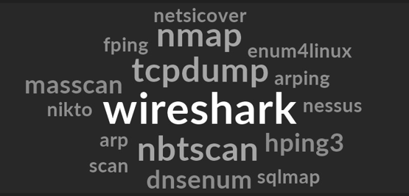
Figure 18:Nvivo Word-cloud
Packet analysis will also be conducted to determine the attack pattern at packet level[48]. Packet capture will be carried out on both the attack and target machine and saved as a pcap file. If NIDS cannot successfully detect the reconnaissance activity, further analysis can be conducted.
Fig.19 illustrates Nmap used on attack PC and packet capture analysis from Target PC. During testing, the NIDS alert generated will be incorporated [49].
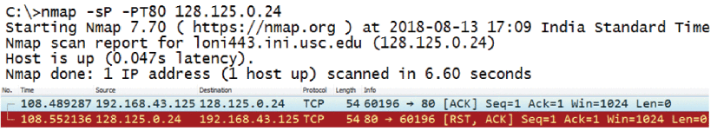
Figure 19: Packet Analysis

The qualitative data will highlight patterns between the attack-tool and whether NIDS can successfully detect the attack.

Phase II: Quantitative Analysis

Quantitative analysis will be conducted by developing a second test-plan. Of the 21 tools tested in Phase I, a selection of 9 tools will be used for Phase II. These have been selected as the interval scan time must be adjustable see Table 11.
Table 11: Quantitative test-plan1
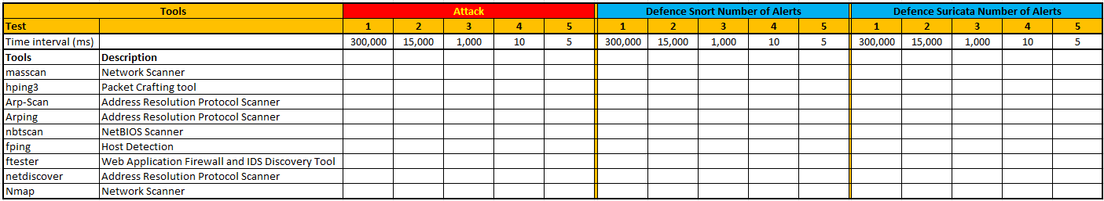
Time will be considered the Independent Variable (IV). The time interval between packets being sent from the attack machine will be altered during testing to determine whether NIDS can detect the reconnaissance activity at each interval time. The number of alerts generated during testing will be considered the Dependent Variable (DV) [18][19][20].
These tools are widely used in industry by pen-testers and hackers to conduct reconnaissance attacks [13][30][40].
Nmap is a commonly used tool during pen-tests but has a limited number of scan interval times. This limits the sample size. However, as an industry standard tool, it is crucial for Nmap to be included in the test-plan [40][50].
As Nmap is limited to 5 time intervals, all 9 tools will be tested for 5 intervals producing 45 results.
To increase the sample size, the test will be conducted again but omitting Nmap so that the remaining 8 tools can be retested with additional interval times thereby increasing the sample size to 120 see Table 12.
Table 12: Quantitative test-plan2
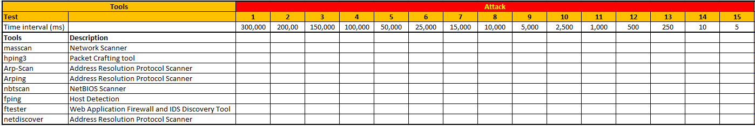

Table 13 Metrics for Phase II:
Table 13: Phase II Metric
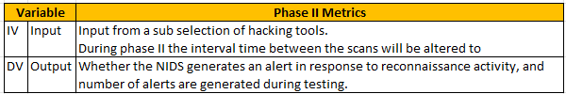

Quantitative analysis will be conducted to determine any correlation between time interval and detection for both NIDS. This data will be used to compare the detection capabilities of these systems using statistical analysis.
See Appendix 3 for examples of statistical analysis used on datasets generated during Phase II.

Research Materials

All data will be sourced from the VE, no actual data (real login credentials) will be gathered during this project ensuring privacy is maintained, reducing risk. The data collection method will be test-plans, requiring no ethical consideration.

Data Collection methods

A test-plan will be developed ensuring a systematic and structured method for conducting tests and recording data to ensure a consistent and identical approach across all tools tested following standard practice.

Table 14 illustrates the proposed test-plan that will record test results at Phase I; this will be developed fully as part of Obj:2:
Table 14: Sample test-plan
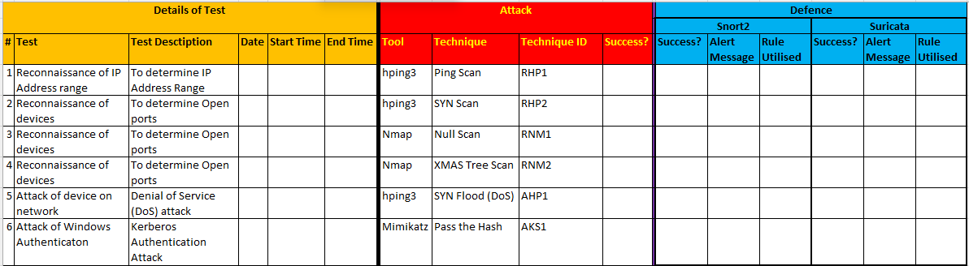

See Table 15 for Phase I data collection procedure:

Table 15:Phase I data collection procedure
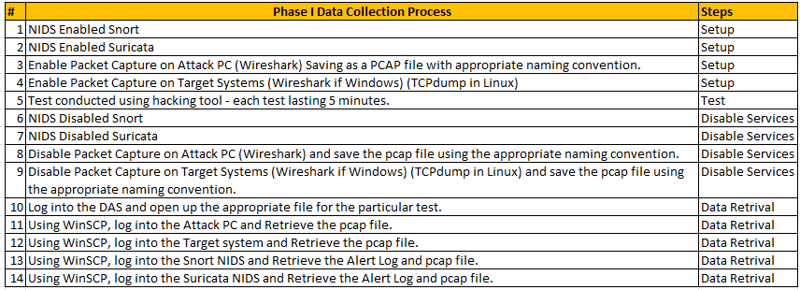
The test-plans for Phase II can be found in Tables 11-12, see Table 16 for Phase II data collection procedure:

Table 16: Phase II Data Collection Procedure
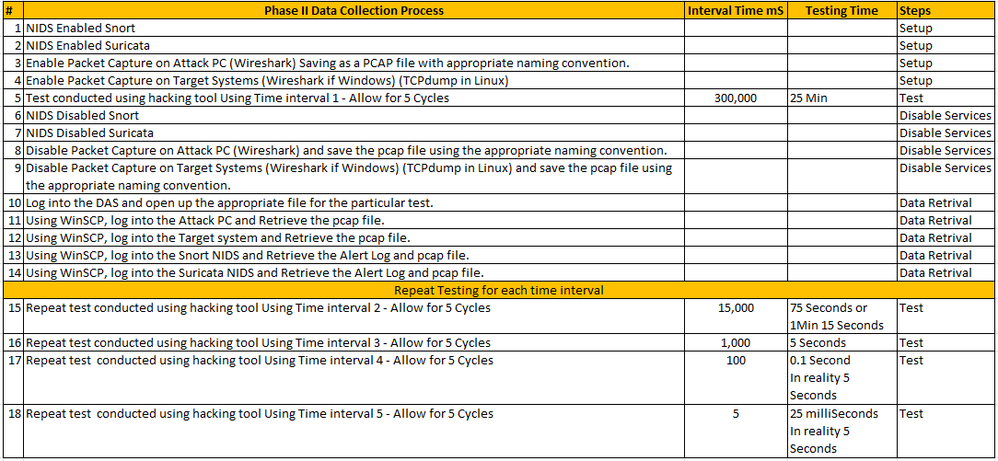

Table 17 outlines the tools deployed in the VE, in-line with academic research [31][32][51][52][34] :
Table 17: VM Tools used for project
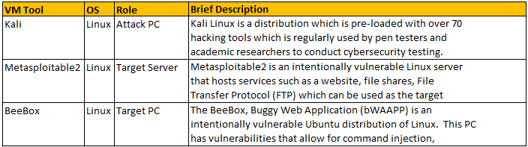
Table 18 provides a list of software that will be used during the project, these are justified in section 3.2.1.1.

Table 18:List of software for proposed project
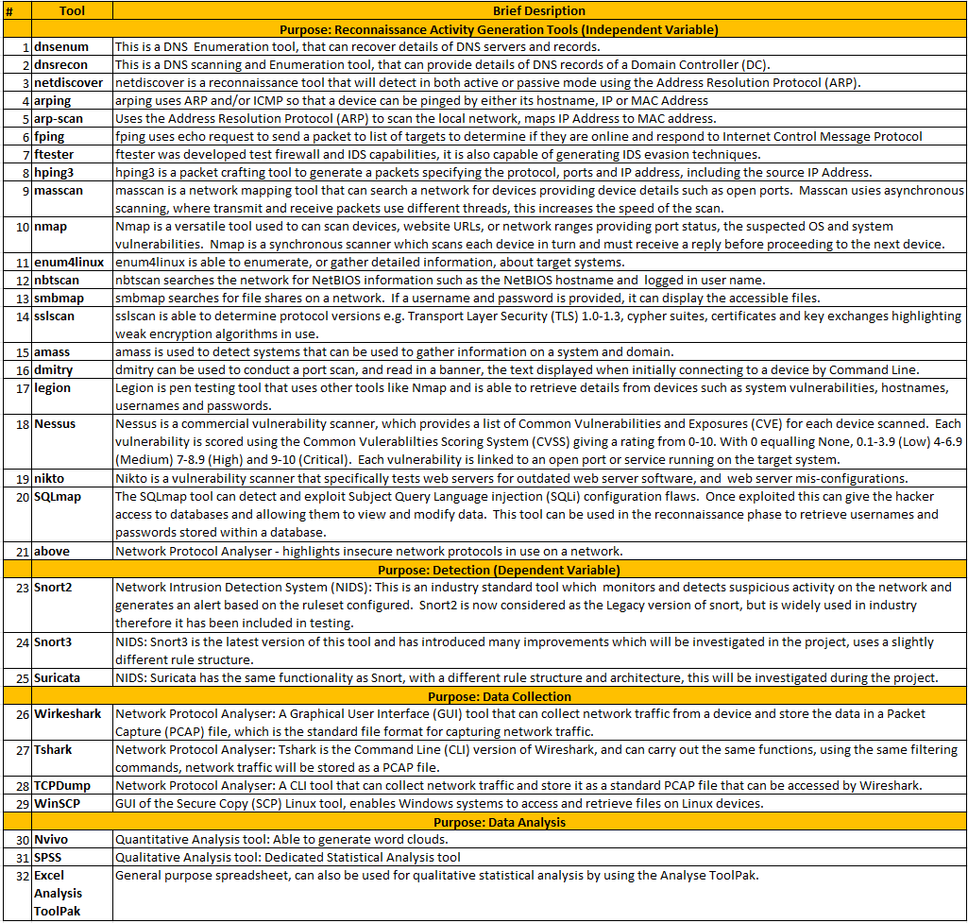
A physical server to host the VE has been acquired and authorisation granted to conduct testing within the University Communications room, see Appendix 5.
A physical firewall will be utilised to provide an air-gapped network ensuring traffic does not escape the testbed.

Expected Outcome
It is anticipated the NIDS system will detect most reconnaissance activity, however, some activity may go undetected. It is crucial to determine, through testing, the limitations of NIDS identifying shortfalls and solutions to enhance the detection of malicious activity improving network security.
By gaining a better understanding of NIDS, their rulesets, deployment and identifying which hacking tools can avoid detection will assist cybersecurity teams to secure a network. Comparative analysis of NIDS will clearly indicate which performs best at detecting reconnaissance activity. Packet analysis will allow the identification of the type of attack and potentially second guess the intentions of the hacker aiding the implementation of mitigations averting a cyberattack.
See Table 19 for limitations and challenges:

Table 19:Limitations and Challenges
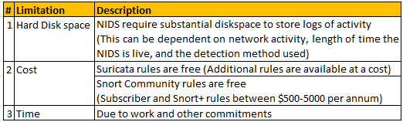

Timeline
A Gantt chart has been developed, see Fig.20. The major tasks and projected milestones have been indicated to provide structure to the project and aid time management.

Gantt Chart
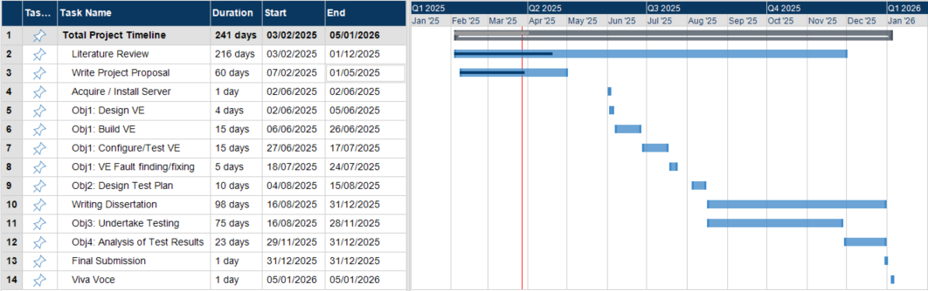
Figure 20: Proposed Gantt Chart of project
See Appendix 4 for further details of project management.

References
References
[1] M. Srinivasan and N. C. Senthilkumar, "Intrusion Detection and Prevention System (IDPS) Model for IIoT Environments Using Hybridized Framework," IEEE Access, vol. 13, pp.26608, 2025. doi: 10.1109/access.2025.3538461.
[2] P. L. S. Jayalaxmi, et al., "Machine and Deep Learning Solutions for Intrusion Detection and Prevention in IoTs: A Survey," IEEE Access, vol. 10, pp.121173, 2022. doi: 10.1109/access.2022.3220622.
[3] M. Nadeem, et al., "Intercept the Cloud Network From Brute Force and DDoS Attacks via Intrusion Detection and Prevention System," IEEE Access, vol. 9, pp.152300, 2021. doi: 10.1109/access.2021.3126535.
[4] V. Rega, et al., "Profiling Running Applications in Connected Devices Through Side-Channel and Machine Learning Techniques," IEEE Access, vol. 12, pp.170923, 2024. doi: 10.1109/access.2024.3491916.
[5] S. Oriyano, Certified Ethical Hacker (CEH) v9, 3rd Ed. Indianapolis: Sybex, 2016.
[6] J. Straub, "Modeling Attack, Defense and Threat Trees and the Cyber Kill Chain, ATT&CK and STRIDE Frameworks as Blackboard Architecture Networks," 2020-11. doi: 10.1109/smartcloud49737.2020.00035.
[7] A. Waleed, A. F. Jamali and A. Masood, "Which open-source IDS? Snort, Suricata or Zeek," Computer Networks, vol. 213, -06-22 2022. doi: 10.1016/j.comnet.2022.109116.
[8] A. A. E. Boukebous, et al., "A Comparative Analysis of Snort 3 and Suricata," 2023-05-19. doi: 10.1109/globconet56651.2023.10150141.
[9] Z. S. Younus and M. Alanezi, "Detect and Mitigate Cyberattacks Using SIEM," 2023-12-18. doi: 10.1109/dese60595.2023.10469387.
[10] J. Cui, et al., "LH-IDS: Lightweight Hybrid Intrusion Detection System Based on Differential Privacy in VANETs," IEEE Trans. on Mobile Comput., vol. 23, no. 12, -12 2024. doi: 10.1109/tmc.2024.3407709.
[11] U. Shahid, et al., "Hybrid Intrusion Detection System for RPL IoT Networks Using Machine Learning and Deep Learning," IEEE Access, vol. 12, pp.113099, 2024. doi: 10.1109/access.2024.3442529.
[12] S. Pavithra and K. Venkata Vikas, "Detecting Unbalanced Network Traffic Intrusions With Deep Learning," IEEE Access, vol. 12, pp.74096, 2024. doi: 10.1109/access.2024.3405187.
[13] H. Sharma, Kali Linux - an Ethical Hacker's Cookbook, 2nd Ed. Birmingham-Mumbai: , 2019.
[14] Roger Kwon, et al., "Cyber_Threat_Dictionary_Using_MITRE_ATTampCK_Matrix_and_NIST_Cybersecurity_Framework_Mapping," Resilience Week (RWS), pp.106–112, 2020. doi: 10.1109/RWS50334.2020.9241271.
[15] D. Seidl and M. Chapple,CompTIA Security+ Study Guide, Eighth Ed. Indianapolis: Sybex, 2021.
[16] E. Filiol, F. Mercaldo and A. Santone, "A Method for Automatic Penetration Testing and Mitigation: A Red Hat Approach," Procedia Computer Science, vol. 192, pp.2039, 2021. doi: 10.1016/j.procs.2021.08.210.
[17] S. Yulianto, et al., "Enhancing cybersecurity resilience through advanced red-teaming exercises and MITRE ATT&CK framework integration: A paradigm shift in cybersecurity assessment," Cyber Security and Applications, vol. 3, -12 2025. doi: 10.1016/j.csa.2024.100077.
[18] H. Wu, et al., "PD-CPS: A practical scheme for detecting covert port scans in high-speed networks," Computer Networks, vol. 231, no. 3, -05-13 2023. doi: 10.1016/j.comnet.2023.109825.
[19] Mehr U Nisa and K. Kifayat, "Detection of Slow Port Scanning Attacks," Islamabad, Pakistan, 2020. doi: 10.1109/ICCWS48432.2020.9292389.
[20] M. Almseidin, M. Al-Kasassbeh and S. Kovacs, "Detecting Slow Port Scan Using Fuzzy Rule Interpolation," Amman, Jordan, December 2019. doi: 10.1109/ICTCS.2019.8923028. [Online]. Available: https://ieeexplore.ieee.org/document/8923028
[21] A. R. Muhammad, P. Sukarno and A. A. Wardana, "Integrated Security Information and Event Management (SIEM) with Intrusion Detection System (IDS) for Live Analysis based on Machine Learning," Procedia Computer Science, vol. 217, pp.1406, 2023. doi: 10.1016/j.procs.2022.12.339.
[22] A. Coscia, et al., "Automatic decision tree-based NIDPS ruleset generation for DoS/DDoS attacks," Journal of Information Security and Applications, vol. 82, -03-06 2024. doi: 10.1016/j.jisa.2024.103736.
[23] S. V. B. Rakas, M. D. Stojanovic and J. D. Markovic-Petrovic, "A Review of Research Work on Network-Based SCADA Intrusion Detection Systems," IEEE Access, vol. 8, pp.93083, 2020. doi: 10.1109/access.2020.2994961.
[24] A. Zohourian, et al., "IoT-PRIDS: Leveraging packet representations for intrusion detection in IoT networks," Computers &amp; Security, vol. 146, -11 2024. doi: 10.1016/j.cose.2024.104034.
[25] X. Qin, et al., "A hybrid cyber defense framework for reconnaissance attack in industrial control systems," Computers &amp; Security, vol. 136, -09-29 2023. doi: 10.1016/j.cose.2023.103506.
[26] H. J. Badarneh, et al., "The power of Network Penetration Testing," 2024 25th International Arab Conference on Information Technology (ACIT), pp.1, December 10 2024. doi: 10.1109/acit62805.2024.1087721.
[27] J. Zhang, et al., "ATT&CK-based Advanced Persistent Threat attacks risk propagation assessment model for zero trust networks," Computer Networks, vol. 245, -03-27 2024. doi: 10.1016/j.comnet.2024.110376.
[28] M. N. K. Saunders, A. Thornhill and P. Lewis,Research methods for business students, 7th Ed. Harlow, England: Pearson Education Limited, 2016.
[29] A. B. Ajmal, et al., "Offensive Security: Towards Proactive Threat Hunting via Adversary Emulation," IEEE Access, vol. 9, pp.126023, 2021. doi: 10.1109/access.2021.3104260.
[30] G. D. Singh, The Ultimate Kali Linux Book, 2nd Ed. Birmingham-Mumbai: , 2022.
[31] F. Rustam, et al., "A Novel Approach for Real-Time Server-Based Attack Detection Using Meta-Learning," IEEE Access, vol. 12, pp.39614, 2024. doi: 10.1109/access.2024.3375878.
[32] S. Samanth, P. K. V. and M. Balachandra, "Adversarial Security Analysis of Cryptographic Protocols for IoD Networks," IEEE Access, vol. 12, pp.183792, 2024. doi: 10.1109/access.2024.3510778.
[33] EC-Council. "Best 100 Ethical Hacking Tools and Software in Cybersecurity." https://www.eccouncil.org/cybersecurity-exchange/ethical-hacking/best-ethical-hacking-tools/ (accessed 17/04).
[34] T. L. Lechkov Petar Bhatt Smriti, "Vulnerability Assessment for Applications Security Through Penetration Simulation and Testing," Journal of Web Engineering, vol. 21, no. 7, pp.2187–2208, October 2022. doi: 10.13052/jwe1540-9589.2178.
[35] V. Nair and K. Yashwin, "FOOTHOLDER: Collection of tools and scripts used to learn and experiment the exploitation of vulnerable machines," Chennai, India, 2023-04-05. doi: 10.1109/icnwc57852.2023.10127486.
[36] Z. Li, et al., "DDoS Mitigation Based on Space-Time Flow Regularities in IoV: A Feature Adaption Reinforcement Learning Approach," IEEE Trans. Intell. Transport. Syst., vol. 23, no. 3, pp.2262, -03-09 2022. doi: 10.1109/tits.2021.3066404.
[37] J. Gomez, V. H. Riano and G. Ramirez-Gonzalez, "Traffic Classification in IP Networks Through Machine Learning Techniques in Final Systems," Access, vol. 11, pp.44932–44940, 2023. doi: 10.1109/ACCESS.2023.3272894. Available: https://ieeexplore.ieee.org/document/10115419
[38] D. Jim Solomon Raja, et al., "Integrated Game Theoretic and Honeypot Based Distributed Denial of Service Attack Detection and Mitigation in Advanced Metering Infrastructure," IEEE Trans. Instrum. Meas., vol. 74, pp.1, 2025. doi: 10.1109/tim.2025.3556910.
[39] M. M. Yamin and B. Katt, "Use of cyber attack and defense agents in cyber ranges: A case study," Computers &amp; Security, vol. 122, no. 3, -08-27 2022. doi: 10.1016/j.cose.2022.102892.
[40] B. Brenner, et al., "Malware communication in smart factories: A network traffic data set," vol. 255, 2024. doi: 10.1016/j.comnet.2024.110804.
[41] M. Borhani, et al., "A critical analysis of the industrial device scanners’ potentials, risks, and preventives," Journal of Industrial Information Integration, vol. 41, -09 2024. doi: 10.1016/j.jii.2024.100623.
[42] O. Abu Waraga, et al., "Design and implementation of automated IoT security testbed," Computers &amp; Security, vol. 88, -10-16 2019. doi: 10.1016/j.cose.2019.101648.
[43] V. Ciric, et al., "Modular deep learning-based network intrusion detection architecture for real-world cyber-attack simulation," Simulation modelling practice and theory, vol. 133, pp.102916, May 2024. doi: 10.1016/j.simpat.2024.102916. Available: https://dx.doi.org/10.1016/j.simpat.2024.102916
[44] O. Alnasser, et al., "Signature and anomaly based intrusion detection system for secure IoTs and V2G communication," Alexandria Engineering Journal, vol. 125, pp.424, -06 2025. doi: 10.1016/j.aej.2025.03.068.
[45] A. Paul, V. Sharma and O. Olukoya, "SQL injection attack: Detection, prioritization & prevention," Journal of Information Security and Applications, vol. 85, -09 2024. doi: 10.1016/j.jisa.2024.103871.
[46] M. M. Rahman, et al., "UNSW HomeNet: A network traffic flow dataset for AI-based smart home device classification," Computers & industrial engineering, vol. 204, pp.111041, June 2025. doi: 10.1016/j.cie.2025.111041. Available: https://dx.doi.org/10.1016/j.cie.2025.111041
[47] F. Heiding, et al., "Penetration testing of connected households," Computers &amp; Security, vol. 126, -12-17 2022. doi: 10.1016/j.cose.2022.103067.
[48] L. F. Sikos, "Packet analysis for network forensics: A comprehensive survey," Forensic Science International: Digital Investigation, vol. 32, no. 3, pp.1–12, -02-20 2020. doi: 10.1016/j.fsidi.2019.200892.
[49] G. Bagyalakshmi, et al., "Network Vulnerability Analysis on Brain Signal/Image Databases Using Nmap and Wireshark Tools," IEEE Access, vol. 6, pp.57144, 2018. doi: 10.1109/access.2018.2872775.
[50] J. M. Redondo and D. Cuesta, "Towards Improving Productivity in NMapSecurity Audits," JWE, vol. 18, no. 7, pp.539, 2019. doi: 10.13052/jwe1540-9589.1871.
[51] V. T. En and V. Selvarajah, "Cross-Site Scripting (XSS)," Tumkur, Karnataka, India, 2022-12-02. doi: 10.1109/icmnwc56175.2022.10031815.
[52] K. Kaushik, et al., "An Advanced Approach for performing Cyber Fraud using Banner Grabbing," 2022-12-14. doi: 10.1109/ic3i56241.2022.10072445.
[53] B. Al-Sada, A. Sadighian and G. Oligeri, "Analysis and Characterization of Cyber Threats Leveraging the MITRE ATT&CK Database," IEEE Access, vol. 12, pp.1217, 2024. doi: 10.1109/access.2023.3344680.
[54] MITRE. "Matrix - Enterprise | MITRE ATT&CK." https://attack.mitre.org/matrices/enterprise/ (accessed 31/03).
[55] Y. Ahmed, A. T. Asyhari and M. Arafatur Rahman, "A Cyber Kill Chain Approach for Detecting Advanced Persistent Threats," Computers, Materials &amp; Continua, vol. 67, no. 2, pp.2497, 2021. doi: 10.32604/cmc.2021.014223.
[56] Lockheed Martin. "Cyber Kill Chain - Lockheed Martin." https://www.lockheedmartin.com/en-us/capabilities/cyber/cyber-kill-chain.html (accessed 31/03).
[57] M. Parmar and A. Miles, "Cyber Security Frameworks (CSFs): An Assessment Between the NIST CSF v2.0 and EU Standards," Noordwijk, Netherlands, December 2024. doi: 10.23919/3S60530.2024.10592293.
[58] National Institute of Standards and Technology. "NIST Drafts Major Update to Its Widely Used Cybersecurity Framework." https://www.nist.gov/news-events/news/2023/08/nist-drafts-major-update-its-widely-used-cybersecurity-framework (accessed 31/03).
[59] W. Lazarov, et al., "Penterep: Comprehensive penetration testing with adaptable interactive checklists," Computers &amp; Security, vol. 154, -07 2025. doi: 10.1016/j.cose.2025.104399.
[60] J. H. Kranzler and C. J. Anthony,Statistics for the Terrified, 7th Ed. Blue Ridge Summit: Rowman & Littlefield Publishers, Incorporated, 2022. [Online]. Available: https://ebookcentral.proquest.com/lib/[SITE_ID]/detail.action?docID=7030939
[61] X. Su, et al., "Assessment of Dependent Performance Shaping Factors in SPAR-H Based on Pearson Correlation Coefficient," CMES, vol. 138, no. 2, pp.1813, -11-17 2023. doi: 10.32604/cmes.2023.030957.
[62] D. Williams, "Mathematical concepts," vol. 12, no. 9, pp.419–422, 2011.

Appendices

Appendix 1: Analysis of Peer Reviewed Papers

A1.1 Overview Peer Reviewed Papers within Literature Review
Table 20 provides an overview of peer reviewed papers researched during the literature review.
Table 20: Literature Review Overview Table

A1.2 Peer Reviewed Paper Methodology Analysis.
Table 21 shows the analysis of the peer reviewed papers used during the literature review.
Table 21: Peer Reviewed Paper Methodology Analysis
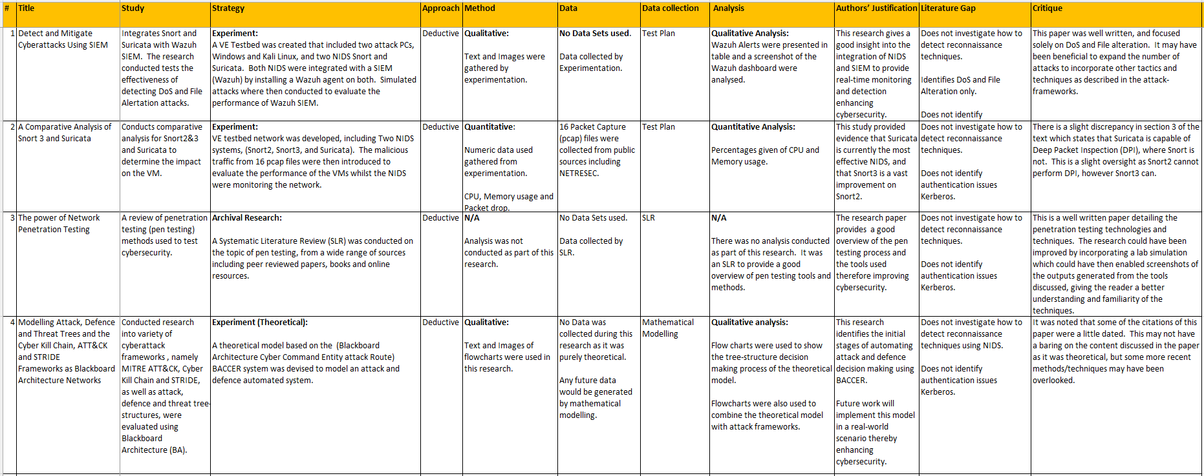

Table 21 continued
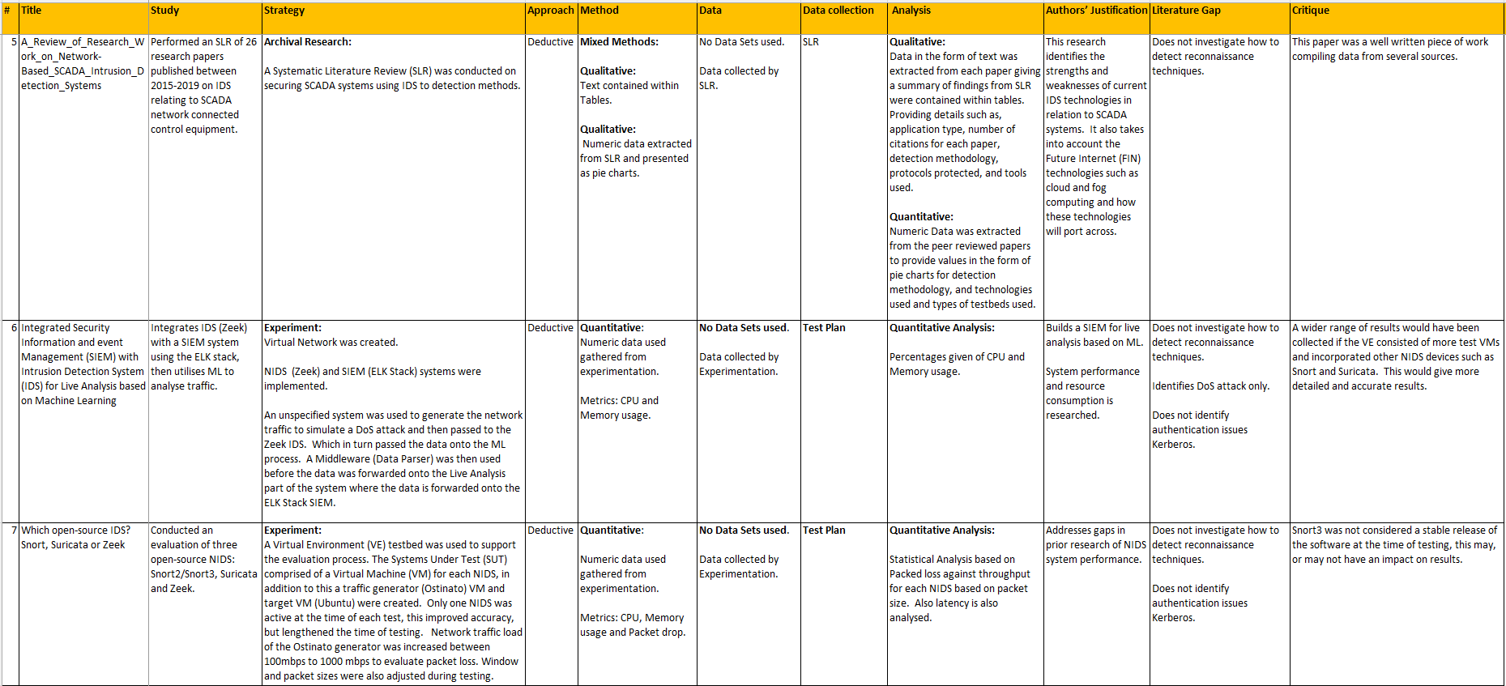

Table 21 continued
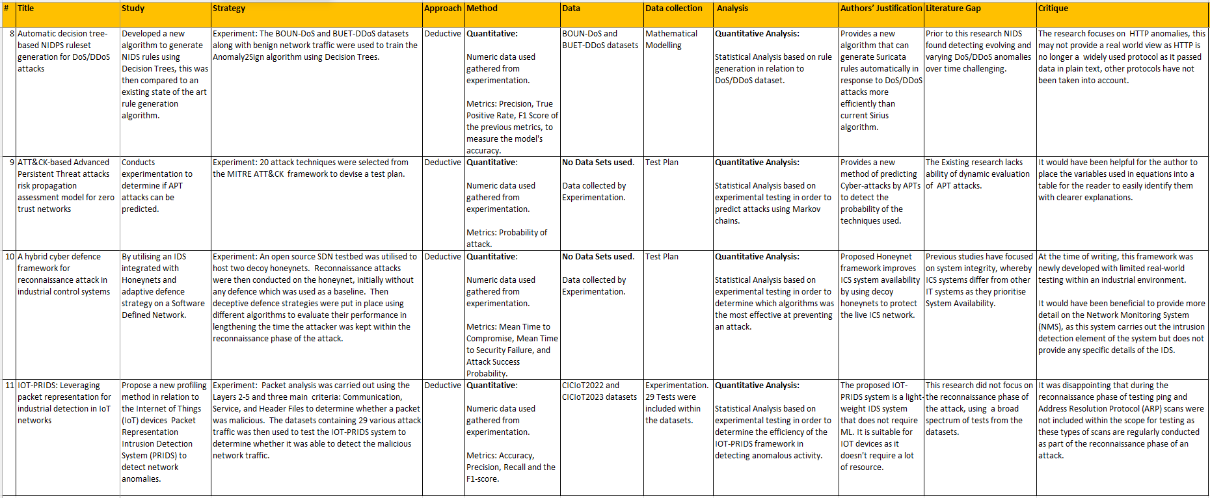

A1.3 Peer Reviewed Papers Record Using PRISMA Methodology
The Peer Reviewed Papers were logged in a spreadsheet, based on the Preferred Reporting Items for Systematic Reviews and Meta-Analysis (PRISMA) method, which facilitated the research and to locate the correct paper for referencing. This spreadsheet was also used for screening the peer reviewed papers prior to citation, see Table 22.
Table 22: Peer Reviewed Paper Screening using PRISMA principles
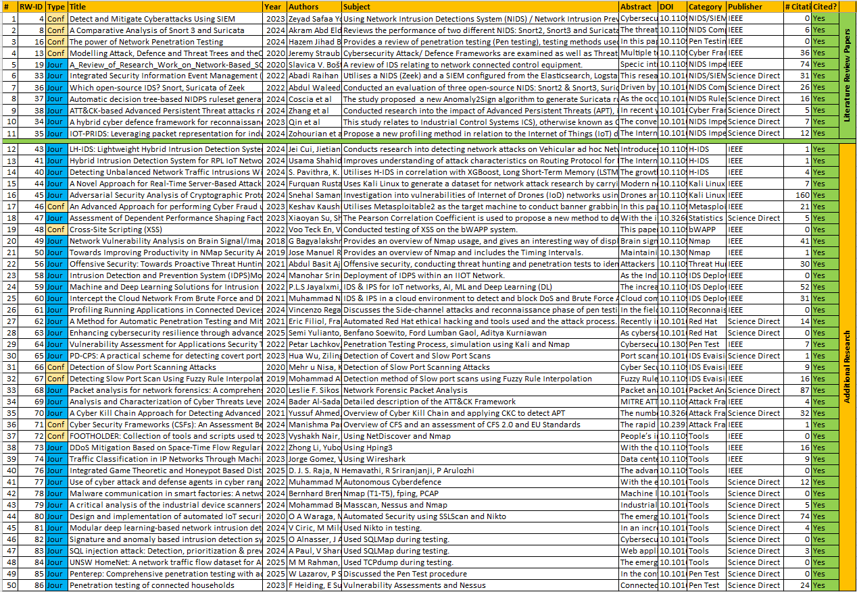

A1.4 Additional research

A.1.4.1 NIDS and SIEM integration
Younus and Alanezi [9] used NIDS and SIEM (Wazuh) to detect Denial of Service (DoS) and file alteration, to evaluate the effectiveness of NIDS and SIEM systems in detecting both DoS and file alteration attacks. A virtual network was created as a testbed consisting of two NIDS, namely Snort and Suricata, see Fig.21. The intrusion detection architecture of both systems were researched to give a better understanding of their operation, see Fig.22-23. These NIDS were used to detect simulated DoS and file alteration attacks. Research showed the IDS and SIEM systems implemented were effective in detecting cyberattacks, in particular the SIEM enhanced detection of DoS attacks.
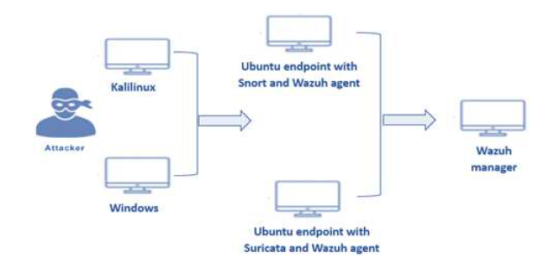
Figure 21: VE testbed [9]

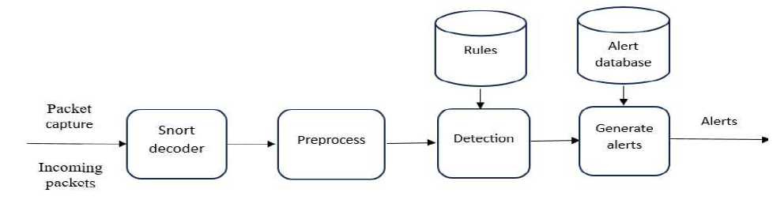
Figure 22: Snort NIDS Architecture [9]

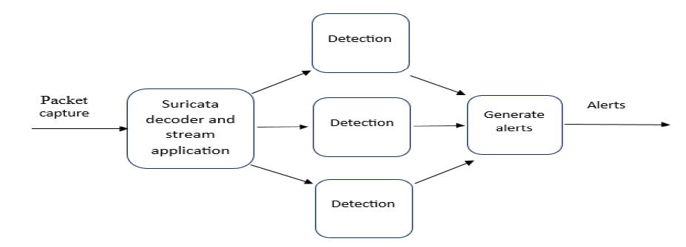
Figure 23: Suricata NIDS Architecture [9]

The integration of Snort, Suricata and Wazuh provides a centralised monitoring solution that effectively detects and alerts cyber-attacks. This solution proactively detects network intrusion attempts enhancing incident response times.
The Wazuh system requires high specification of hardware, considerable CPU, memory, and a substantial amount of hard disk space to be deployed effectively.
This paper was well written focusing solely on DoS and file alteration. Expanding the number of attacks to incorporate other tactics and techniques as described in the attack-frameworks would have been beneficial.

A.1.4.1 NIDS System Comparison

Boukebous et al [8] performed a review of three of the leading NIDS in the field: Snort2, Snort3 and Suricata. The purpose of this study was to evaluate system performance and whether it would impact detection rates. A virtual network was created, using a VM for each NIDS, see Fig.24.
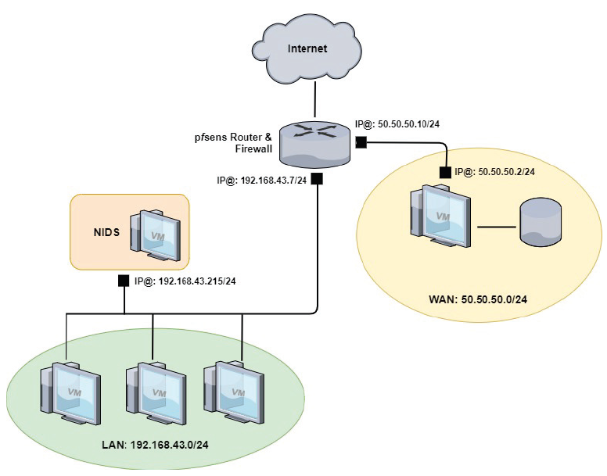
Figure 24: Boukebous et al testbed [8]
16 packet capture (pcap) files containing malicious network traffic was collected from several sources, including the “NETRESEC” repository to evaluate the performance of each NIDS. The metrics used were CPU and memory usage, and packet drop. It was found that Suricata outperformed both Snort2 and Snort3, and that packet loss increased linearly with network traffic volume.
The research showed that Snort3 outperformed Snort2. This was due to the multi-threading capability; it was found that Suricata is also capable of conducting Deep Packet Inspection (DPI) allowing it to better detect packets at the application layer.
Snort2 is limited to only detecting packets via three protocols Transmissions Control Protocol (TCP), User Datagram Protocol (UDP), and Internet Control Management Protocol (ICMP), this is due to its lack of DPI analysis. Only three NIDS were tested. Each NIDS VM was limited to 20 Gig diskspace, this would not have provided a lot of room to capture log files for in-depth analysis.
There is a discrepancy in section 3 of the text which states that Suricata is capable of Deep Packet Inspection (DPI), where Snort is not. This is an oversight as Snort2 cannot perform DPI, however Snort3 can.

Appendix 2: Frameworks, Tools and Reconnaissance/Attack Methods

A2.1 Cyber-attack and defence frameworks
Table 23 provides details of three of the most common attack and defence frameworks discussed in this report.
Table 23 Attack and Defence Frameworks
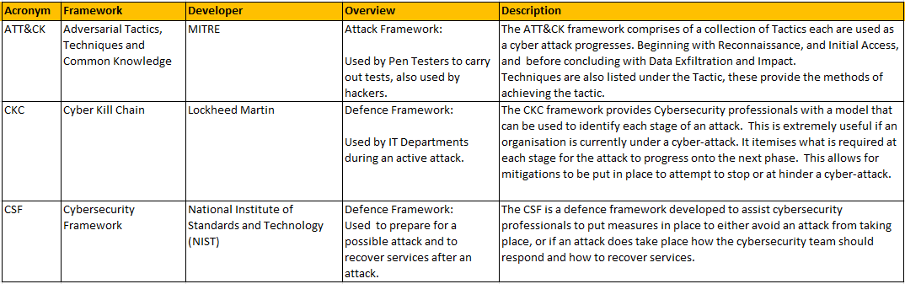

A2.1.1 MITRE ATT&CK Framework
The Mitre ATT&CK framework is a collection of Tactics and Techniques providing a knowledgebase commonly used by hackers [53]. The framework comprises of three matrices, Enterprise, Mobile and Industrial Control Systems (ICS) Fig.25 illustrates the Enterprise matrix [54].
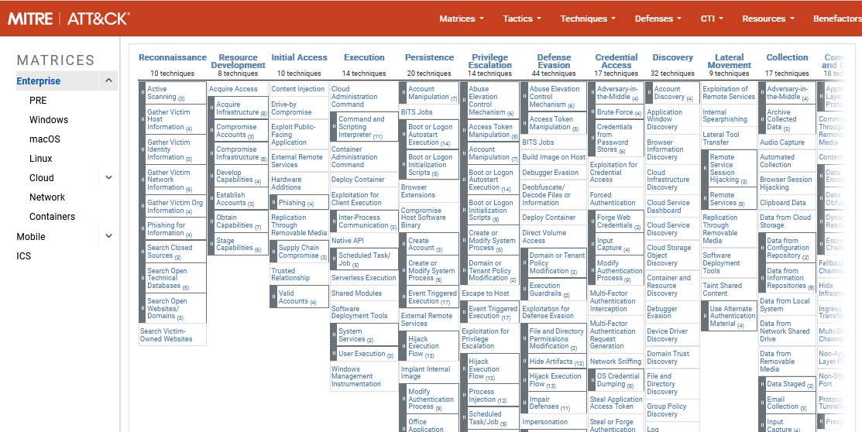
Figure 25: MITRE ATT&CK Framework
The headings of each column are the tactics and follow the flow of the attack sequence from left to right with Reconnaissance Tactic on the leftmost column. Each column contains the techniques, and sub-techniques. For the reconnaissance tactic, the first technique listed is Active Scanning, which includes sub-techniques such as Scanning IP blocks and Vulnerability scanning. This framework is an invaluable tool for Pen testers, Cybersecurity professionals and unfortunately hackers

A2.1.2 Cyber Kill Chain Framework

The CKC outlines the process which hackers use to carry out their attack, the CKC was developed as a defence framework to assist cybersecurity professionals to identify which stage of the attack is currently underway and to help predict the next stage so that mitigations can be put in place[55].
Fig.26 illustrates the CKC, the first phase being reconnaissance is the start of the attack process [56]. 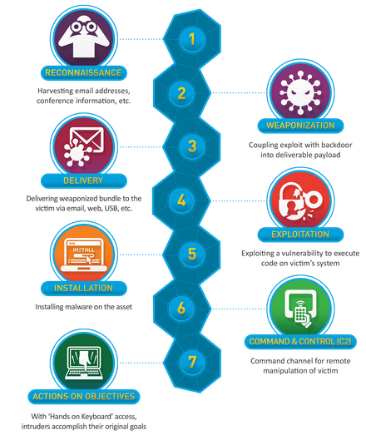
Figure 26: Cyber Kill Chain [56]

A2.1.3 Cyber Security Framework

The Cybersecurity Framework (CSF) is an industry standard framework developed by the National Institute of Standards and Technology (NIST), provides guidance to organisations to improve the cybersecurity posture, by proactively identifying the organisation’s information assets and systems and implementing mitigations to protect them from potential cyber-attack[57]. The next phase is to place measures which can detect potential attacks this is the implementation of IDS/IPS/SIEM DiD approach all of which prepares the organisation for a potential cyber-attack. The latter stages of the framework focus on responding to and recovering from a cyber-attack ensuring that procedures are in place for Incident Response and Disaster Recovery. Fig.27 illustrates the CSF [58]:
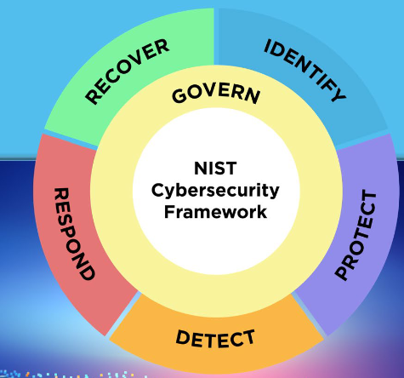
Figure 27: The CSF [58]

A2.2 Penetration Testing Tools
Additional research was conducted into the pen-testing tools discussed by Badarneh et al [26] in their paper. Table 24 lists and describes these penetration testing tools providing further in-depth knowledge to give a more complete picture of their research.
Table 24: Penetration Testing Tools [5][15]
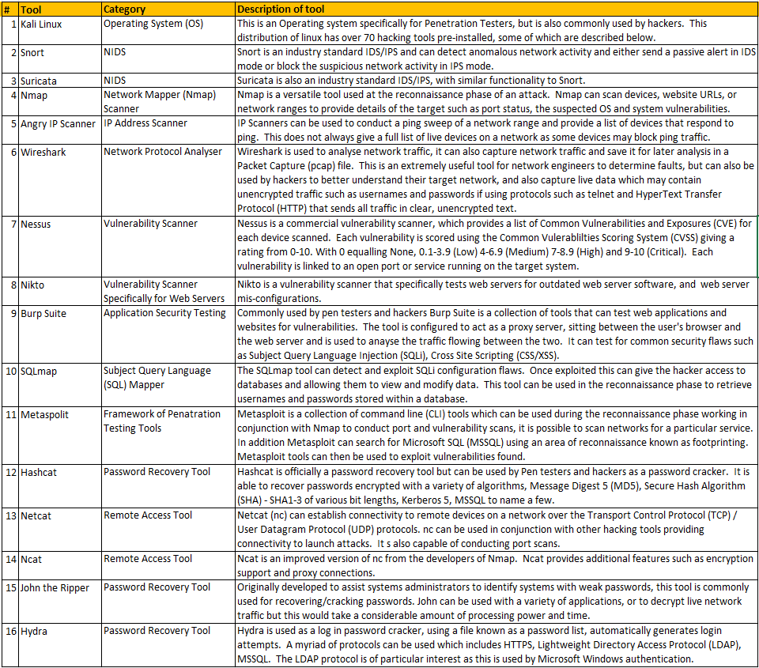

A2.3 Pen-Testing/Reconnaissance/Attack Methods
Table 25 provides a list of a selection of methods used during the reconnaissance phase of an attack and cyber-attacks [5][17][26][34][59][47].
Table 25: Reconnaissance and Attack Methods
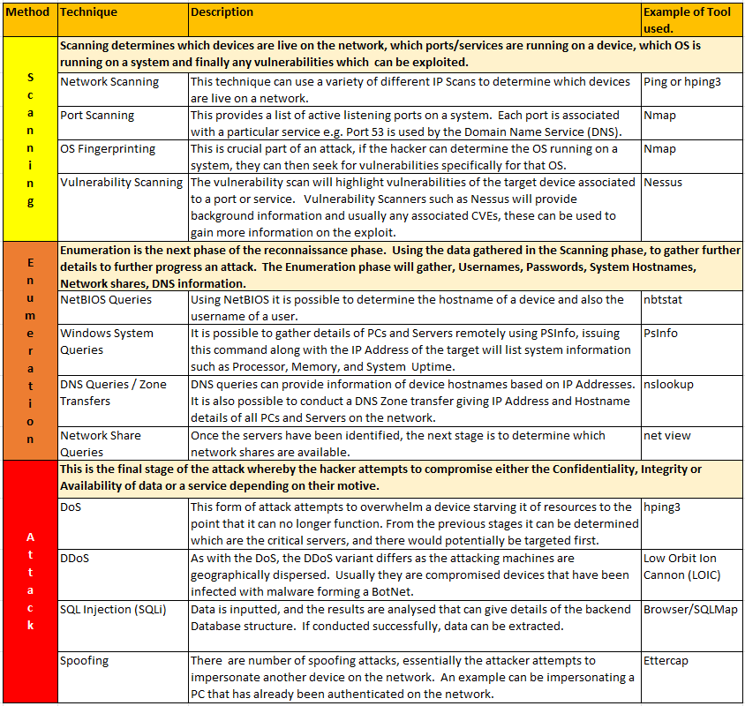

Appendix 3: Example Quantitative Statistical Analysis
To provide an example of the quantitative statistical analysis that will be conducted on the dataset generated while testing, the following examples were created during class exercises.
Two software packages were used to generate the outputs below, namely Statistical Package for Social Sciences (SPSS), and Excel with the Analysis ToolPak add-in feature enabled. SPSS is a dedicated software package specifically designed for statistical analysis and can provide detailed quantitative statistical results. Excel is a general-purpose spreadsheet software, by utilising the Analysis ToolPak add-in provides some basic statistical analysis.

A3.1 Frequency Distribution
Fig.28 Illustration of a histogram of Frequency Distribution.
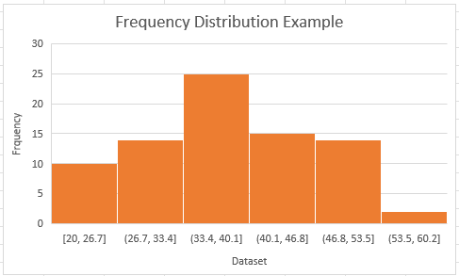
Figure 28: Example of a Histogram of Frequency Distribution (Excel)

A3.2 Mean, Median, Mode, Range, Standard Deviation, Variance

A3.2.1 Mean, Median, Mode, Standard Deviation calculated using Excel
Statistical analysis will be conducted on the dataset generated from the test results using the fundamental statistical principles of Mean, Median, Mode and Standard Deviation [60].
Table 26 shows the results calculated using Excel of an example dataset during lectures with a sample size of 80.
Table 26: Example of Statistical analysis Mean, Median, Mode, Range, Standard Deviation, Variance and their relevance to the project.
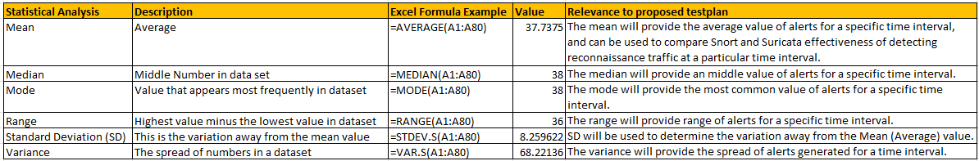
Further to the statistical values generated above, the Mean and SD values will then be applied to the dataset generated from testing to provide the Normal Distribution values, see Fig.29
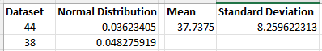
Figure 29: Normal Distribution Example (Excel)

A3.2.2 Mean, Median, Mode, Standard Deviation calculated using SPSS
Using the same dataset, the Mean, Median, Mode, SD were recalculated using SPSS see Fig.30-31[60].
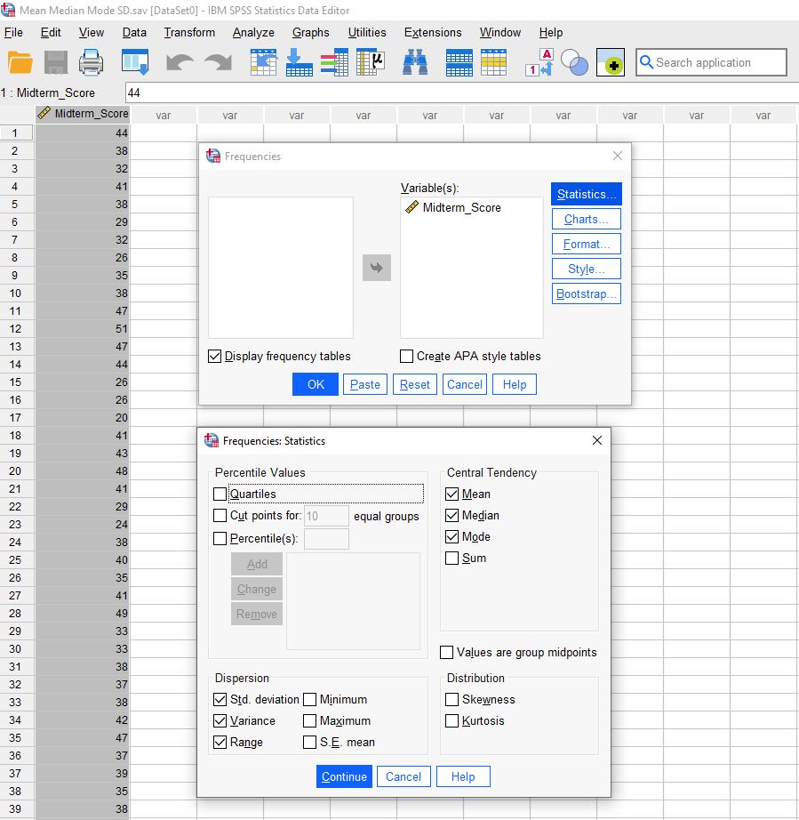
Figure 30:Calculating Mean, Median, Mode, SD and Variance (SPSS)
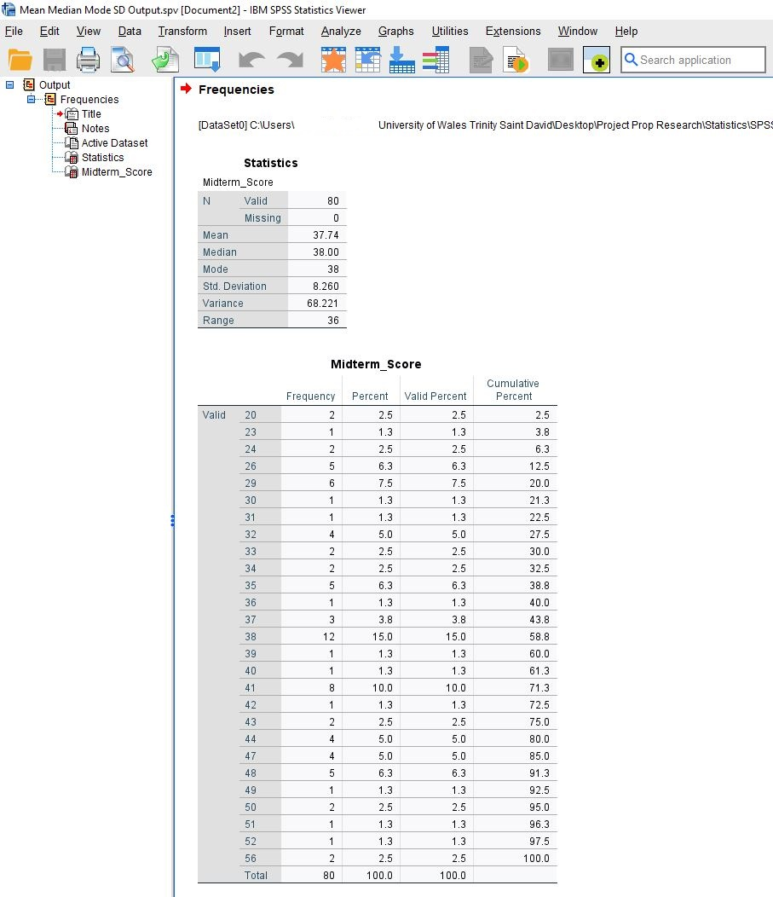
Figure 31: Resultant Mean, Median, Mode, SD (SPSS)

A3.3 The Normal Distribution Curve

A3.3.1 Normal Distribution Curve (Excel)
If the dataset generated from testing is Unimodal, meaning that the dataset only has a single peak, then a normal curve can be produced from the Normal Distribution values generated see Fig.32:

Figure 32: Normal distribution curve (Excel)

Fig.32 shows the relationship between two variables:
X = The values within the dataset
Y = The Normal Distribution
Fig.32 depicts a graph with the Mean (notation of either µ or $\overline{x}$) average value being 37.7357 is the centre point of the graph. The points either side of the mean value are then plotted giving the Normal Curve with most of the sample sitting either side of the Mean value known as 1 Standard Deviation (notation σ) [60].
Therefore, the values within one Standard Deviation are:
µ - σ 37.7375 - 8.2596 29.4779
µ + σ 37.7375 + 8.2596 45.9971

A3.3.2 Normal Distribution Curve (SPSS)
This exercise was repeated in SPSS using the same dataset, Fig.33 shows a histogram was generated with a normal curve superimposed.
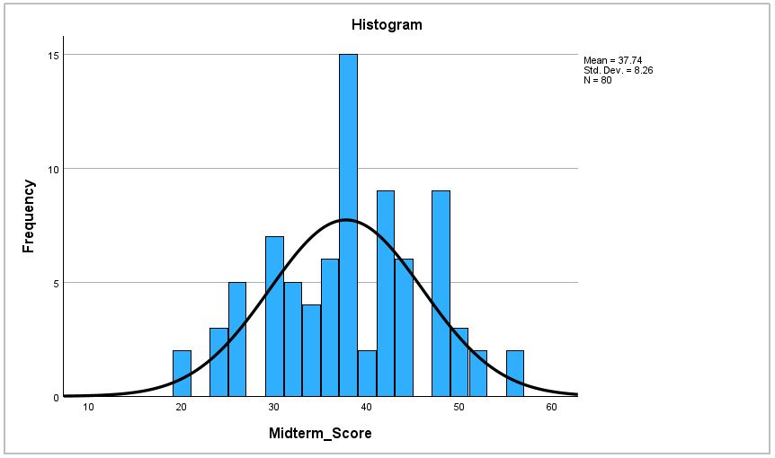
Figure 33: Normal distribution curve (SPSS)

A3.4 Pearson Correlation Coefficient
The three subsequent statistical theories, Pearson Correlation, Spearman’s Correlation and Linear regression are all linked. They all provide statistical information of the relationship between two variables and how they affect each other.
X = The Independent Variable (IV) (Or Input)
Y = The Dependent Variable (DV) (Or Output/Result)
The Pearson Correlation Coefficient (PCC) determines how closely these two variables are linked. For example, the amount of growth of a plan in relation to its exposure to sunlight.
Further statistical analysis of the test results will be conducted to determine the strength of relationship between the time interval of scanning and the detection rate of the NIDS. The Pearson Correlation Coefficient (PCC) will be used.
Once again to give an example of the statistical results that are expected to be generated from this analysis a small dataset has be used.
Equation 1 shows how the PCC is calculated, Table 27 showing the notation used [60][61]:
Equation 1: Pearson Correlation Coefficient
$$r= \frac{Σ(x_{i}-\overline{x})(y_{i}-\overline{y})}{\sqrt{Σ {\left(x_{i}-\overline{x}\right)}^{2} Σ {\left(y_{i}-\overline{y}\right)}^{2}} }$$
Table 27: Explanation of PCC notation
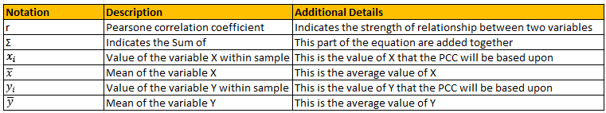

Equation 2 shows how the PCC is calculated using Standard Deviation, Table 28 showing the notation used [60][61]:
Equation 2: Pearson Correlation Coefficient using Standard Deviation
$$r_{xy}=\frac{Cov_{xy}}{σ_{x}σ_{y}}$$
Table 28: Explanation of PCC notation using SD
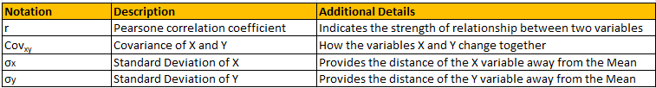

A4.3.1 Pearson Correlation Coefficient Calculation (Excel ToolPak)

Using the Analysis ToolPak add-in feature of Excel, selecting the correlation tool will automatically calculate the Pearson Coefficient by highlighting the dataset sample and selecting Correlation see Fig.34.
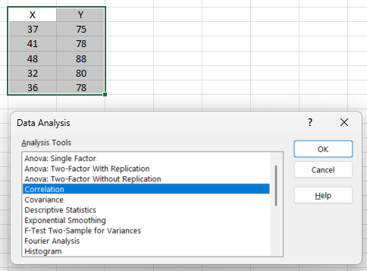
Figure 34: Calculating the Pearson Coefficient using the Excel Analysis ToolPak add-in
The result can be seen in Fig.35

Figure 35:Resultant Pearson Correlation Coefficient Example (Excel ToolPak)

A4.3.2 Pearson Correlation Coefficient Calculation (SPSS)
This exercise was repeated using SPSS, Figs.36-37 show the calculation of the Pearson Coefficient, and results.
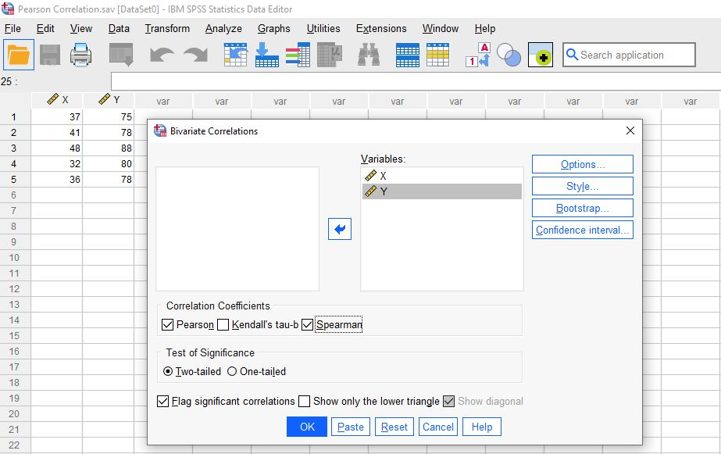
Figure 36: Calculating the Pearson Coefficient (SPSS)

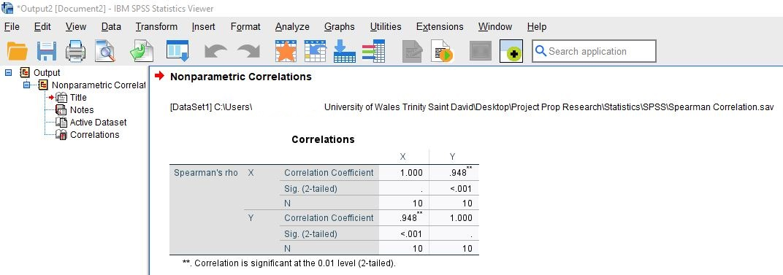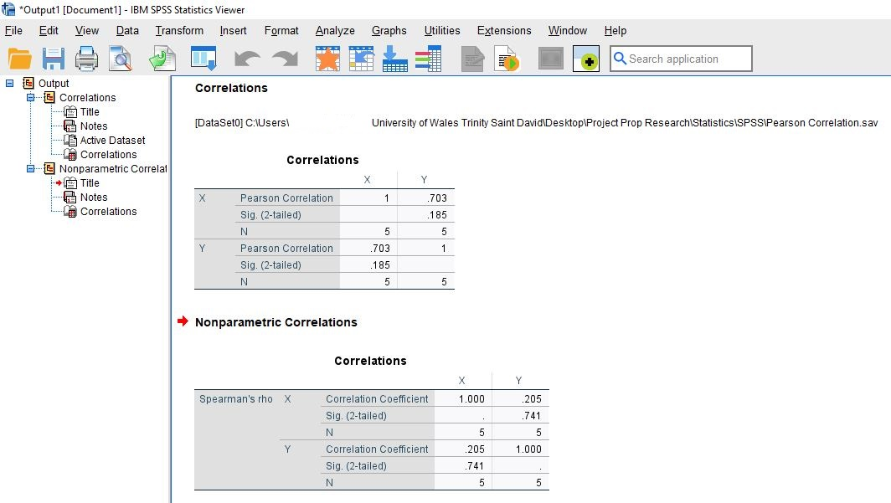
Figure 37: Resultant Pearson Correlation Coefficient Example (SPSS)

A4.3.2 Pearson Correlation Coefficient Interpretation of Results

The resultant value gives the strength of correlation between the two variables X and Y with:
+1 Showing a perfect positive linear correlation
-1 Showing a perfect negative linear correlation
Table 29 provides the interpretation of strength of Pearson correlation:
Table 29: PCC Strength Interpretation
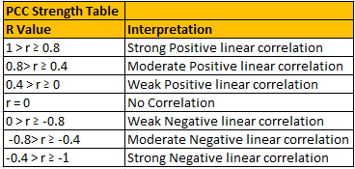

The resultant Pearson coefficient is 0.703, this is deemed to show a moderate positive linear correlation between the two given variables X and Y.
This means that as the independent variable (X) Increases, then the dependent variable (Y) will also increase. This can also be termed as a positive monotonic relationship. However, as the Pearson correlation is 0.73, it is not as strong as a strong positive correlation.
IF this value had been a negative correlation, then as the value of X increases the value of Y would decrease. This can also be termed as a negative monotonic relationship.

A3.5 Spearman’s Ranked Correlation Coefficient
Spearman’s ranked correlation coefficient provides both strength and the direction of two variables and this can be used during the quantitative analysis. The difference between Pearson and Spearman’s correlation is that while PCC focuses on the linear relationship between two variables, Spearman’s correlation considers the rank of the variables.

A3.5.1 Spearman Correlation Coefficient Manual Calculation (Excel)

As an example of what analysis will be conducted, Table 30 illustrates a sample dataset used during the lecture was ranked, using the calculation on the right-hand column for X, the same was done for Y this is has been omitted for brevity.
Table 30: Spearman’s Ranked Coefficient – First step ranking dataset
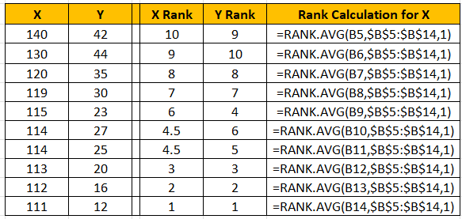
Table 31 shows the Spearman’s correlation calculation conducted using Excel, and shows the notation used:
Table 31: Spearman’s Ranked Coefficient Example Calculation
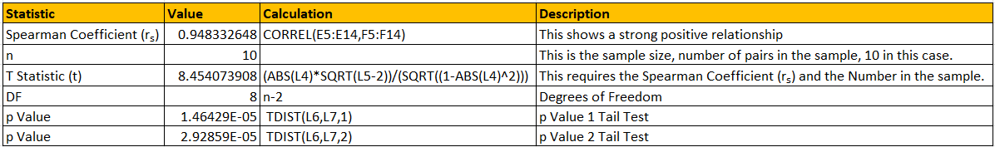

A3.5.2 Spearman Correlation Coefficient Calculation (SPSS)
Figs.38-39 show the calculation of the Spearman Coefficient and results using SPSS.
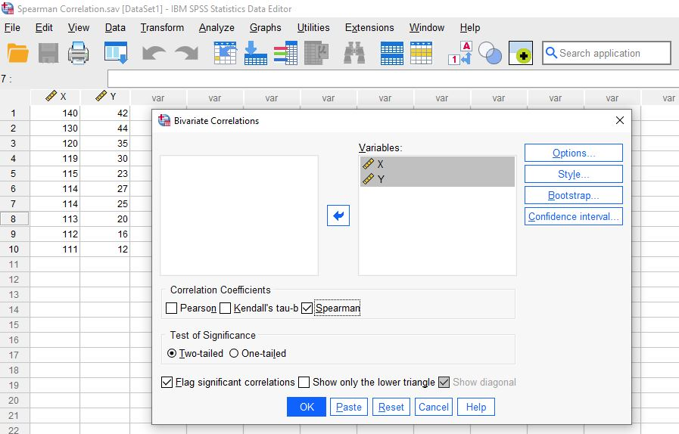
Figure 38:Calculating the Spearman Coefficient (SPSS)

Figure 39: Resultant Spearman Correlation Coefficient (SPSS)

A3.5.3 Spearman Correlation Coefficient Interpretation of Results

Table 32 provides the interpretation of strength and direction of Spearman’s correlation:
Table 32: Spearman Ranked Coefficient Strength Interpretation
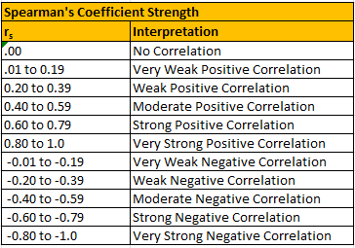
The resultant Spearman’s coefficient is 0.95, this is deemed to show a very strong positive correlation between the two given variables X and Y.
This means that as the independent variable (X) rank Increases, then the dependent variable (Y) rank will also increase. This is the very strongest relationship where the variables are very consistent.
IF this value had been a negative correlation, then as the rank of X increases then the rank of Y would decrease.
This calculation can then be used to provide a 1 Tail or 2 Tail normal curve of the dataset.

A3.6 Comparison of Pearson and Spearman Correlation
The Pearson correlation provides a method of measuring the linear relationship between two given variables. If one variable increases in relation to another then the relationship is seen as a positive correlation. Conversely, if one variable decreases as the other increases this is said to be a negative correlation.
The Spearman correlation shows the increasing or decreasing relationship, irrespective of its linearity.
This means that Spearman correlation focuses on the strength and direction (positive or negative) of the monotonic relationship between two variables.
Spearman correlation can be very useful when the dataset is non-linear or is ranked using ordinal numbers (first, second, third etc).

A3.7 Linear Regression
Linear regression will be used on the dataset to provide a graph as visual representation of the relationship between the independent and dependent variables. Furthermore, linear regression can be used to predict trends and indicate causation.

Equation 3 shows linear regression calculation 1[62].
Equation 3: Linear Regression Calculation 1
$$y=mx+b$$

A3.7.1 Linear Regression Manual Calculation using Excel

An example was conducted during class to become more familiar with the equation, this result can be found in Table 33:
Table 33: Linear Equation Example
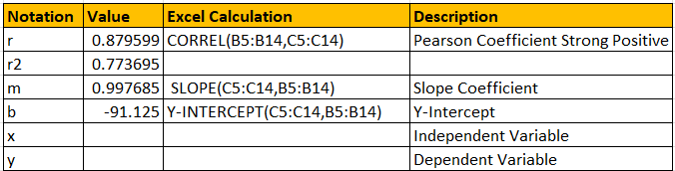
Fig.40 shows the resultant graph from the linear regression calculation using Equation 3.

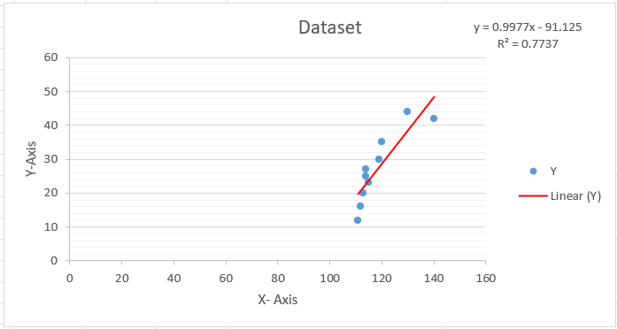
Figure 40: Graph of Linear Regression (Excel ToolPak)

Using equation 3, the value for X, the Independent Variable (IV) and Y, the Dependent Variable (DV) can be predicted, which is an extremely useful tool during data analysis.
Fig.41 shows the usage of equation 3 to solve for variable Y given variable X.
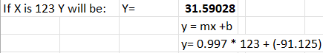
Figure 41: Using Linear Regression to solve for Y

It is possible to also calculate the value of X, given the value of Y by transposing equation 3 to solve for X, see Equation 4:
Equation 4: Linear Regression calculation transposed to solve for X
$$x=\frac{y-b}{m}$$
Fig.42 shows the calculation to solve variable X given variable Y.
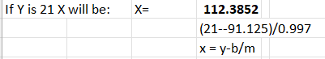
Figure 42:Using Linear Regression to solve for X

This is extremely useful as it is possible to predict the value of the IV, variable X for a given value of the DV variable Y.
A similar linear regression equation can be used with different notation and introduces the concept of standard error, this considers that the predicted and actual figures may differ, see Equation 5 and explanation of notation in Table 34.
Equation 5: Linear Regression Equation 2, considering Standard Error
$$Y= β0+ β1X+ ∈$$
Table 34: Explanation of linear regression equation
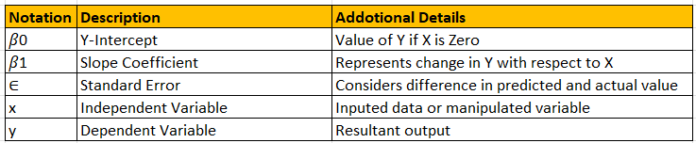

A3.7.2 Linear Regression Calculation (Excel ToolPak)

Using Analysis ToolPak, the dataset was analysed using the regression function to automatically calculate the linear regression of the dataset, including the Standard Error, see Fig.43-44.
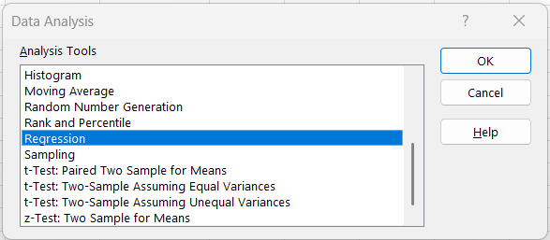
Figure 43: Analysis calculating Linear Regression including Standard Error (Excel ToolPak)
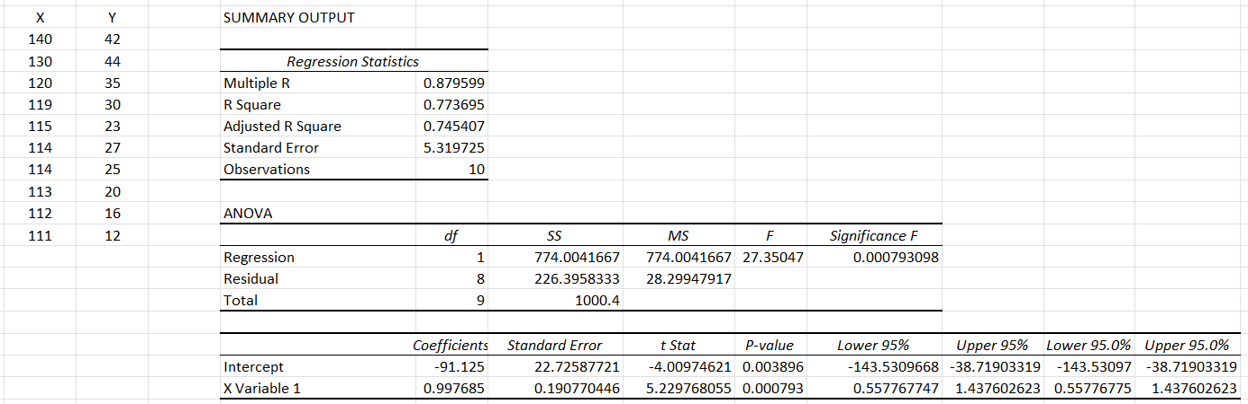
Figure 44: Result of Analysis linear regression (Excel ToolPak)

A3.7.3 Linear Regression Calculation (SPSS)

Figs.45-46 show the Linear regression calculation and results using SPSS.
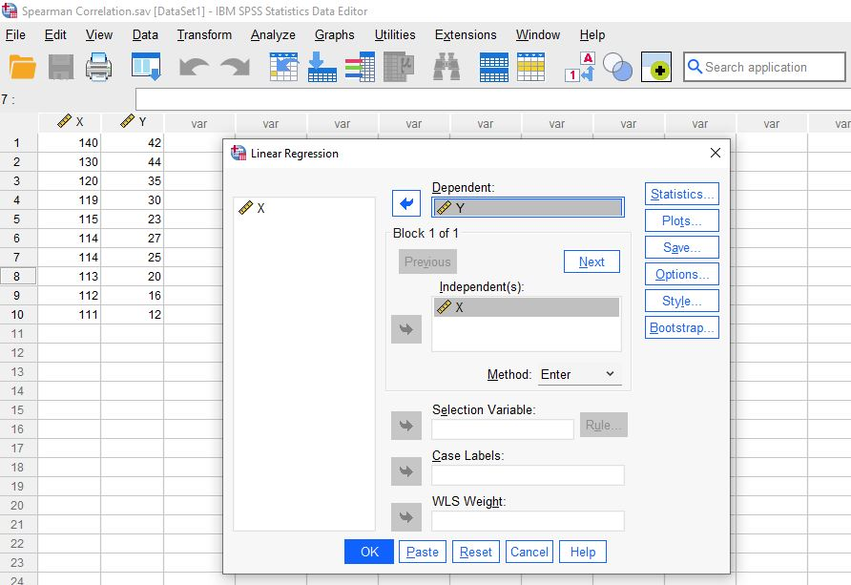
Figure 45:Calculating Linear Regression (SPSS)

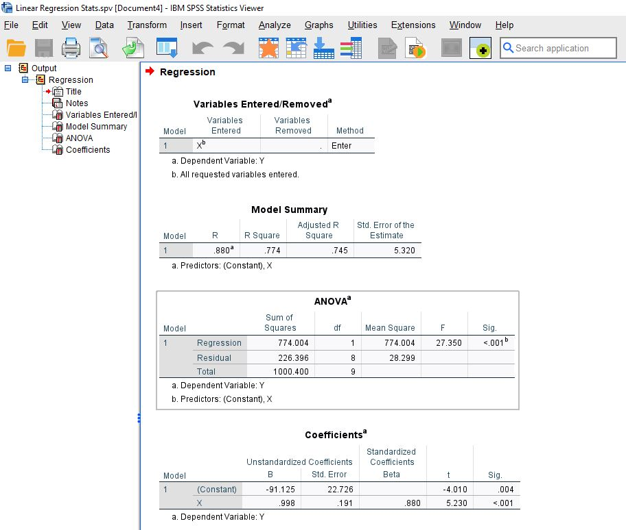
Figure 46: Resultant Linear Regression (SPSS)
Fig.47 shows the resultant graph using SPSS.
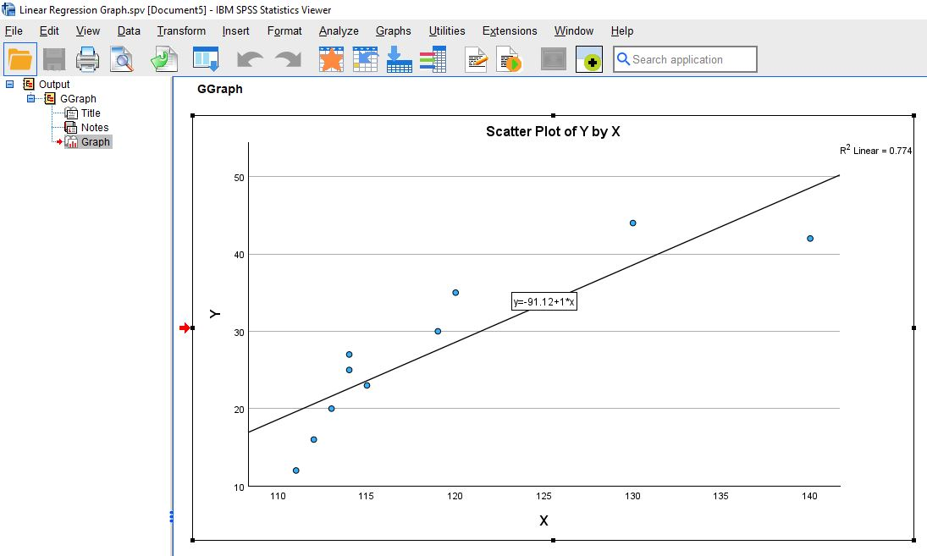
Figure 47: Graph of Linear Regression (SPSS)

A3.8 Comparison between Correlation and Regression

Correlation and regression are both useful statistical methods of analysing the relationship between two variables but serve different purposes, see Table 35.

Table 35: Comparison between Correlation and Regression
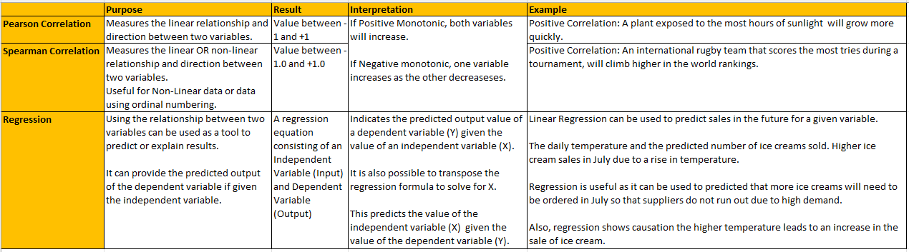

Appendix 4: Project Management
A major project logbook will be used to record all work carried out on the project and the amount of time dedicated to completing the project, see Table 36.
Table 36: Example of Logbook
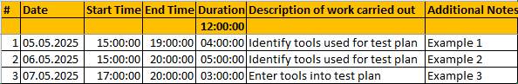
Kanban/Agile methodological approach will be used to organise the project utilising Trello to create a task-board. Task-cards will be created for all tasks will initially be placed in the backlog and put into the “In Progress” area of the task-board. The task can then be moved to either “On Hold”, or “Completed” areas of the task-board. If there is a fault that needs to be addressed, this task will be moved to the ISSUE column.
Fig.48 Illustrates the task-board:

Figure 48: Trello/Agile Task-board

Appendix 5: Written Authorisation from IT Management

Fig.49 lustrates a copy of the authorisation email from IT Management relating to the reconnaissance project. The email has been redacted to maintain the privacy of all involved. A full copy of the underacted email trail is available upon request.

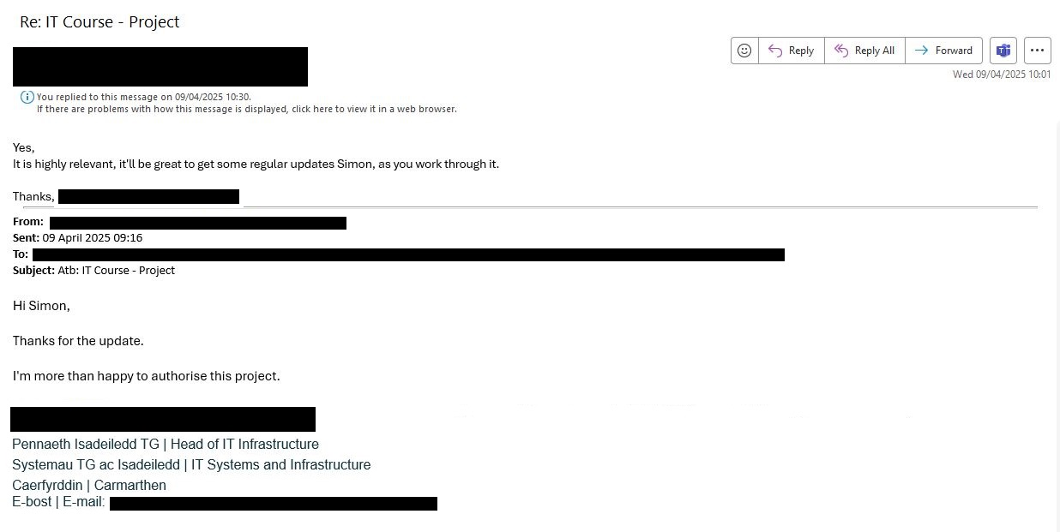
Figure 49: Authorisation email from IT Management

