BSc/HND/HNC Computing Portfolio
ACCA4023 - Introduction to Web and Database Concepts
Database Analysis and Design
Craig Oldham 0501251 – Digital Degree Apprenticeship
20th April 2023

[This page is intentionally blank]
Contents
Annotated Entity Relationship Diagram 5
Evidence of Relationships in Access Database 6
Intended Use of Database Management System 6
Tables in Database 7
Branches 7
BranchDepartments 7
Staff 8
Events 8
Suppliers 9
OfficeSupplies 9
Customer 10
Event Bookings 10
OfficeSupplyOrders 11
User Guide for Northern Lights 12
Opening the System 13
Data Input Forms 14
Amend Branch Departments 14
Amend Branch Database 14
Amend Customer Details 15
View/Amend Event Bookings 15
Order Office Supplies 16
Amend/View Staff Database 16
Amend Supplier Details 17
View/Amend Authorised Office Supply List 17
Queries 18
Branch Managers | Suppliers Charges Queries 18
Reports 19
Supplier Costs 20
Stationery Orders 21
Invoices 22
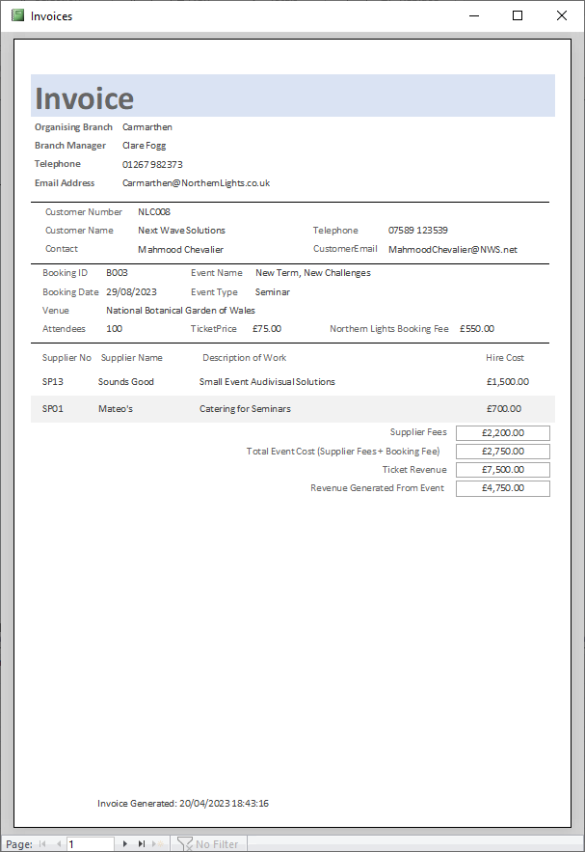 23
Figures 24

Annotated Entity Relationship Diagram
Below is the annotated Entity Relationship Diagram for my Database for Northern Lights.
OfficeSupplyOrders is classed as a Weak Entity as if an item number is deleted from the OfficeSupplies Entity, then it can no longer exist in the OfficeSupplyOrders
EventBookings is classed as a Weak Entity as if any of the fields linked via relationships are deleted from any of the tables it is linked to then it can no longer exist
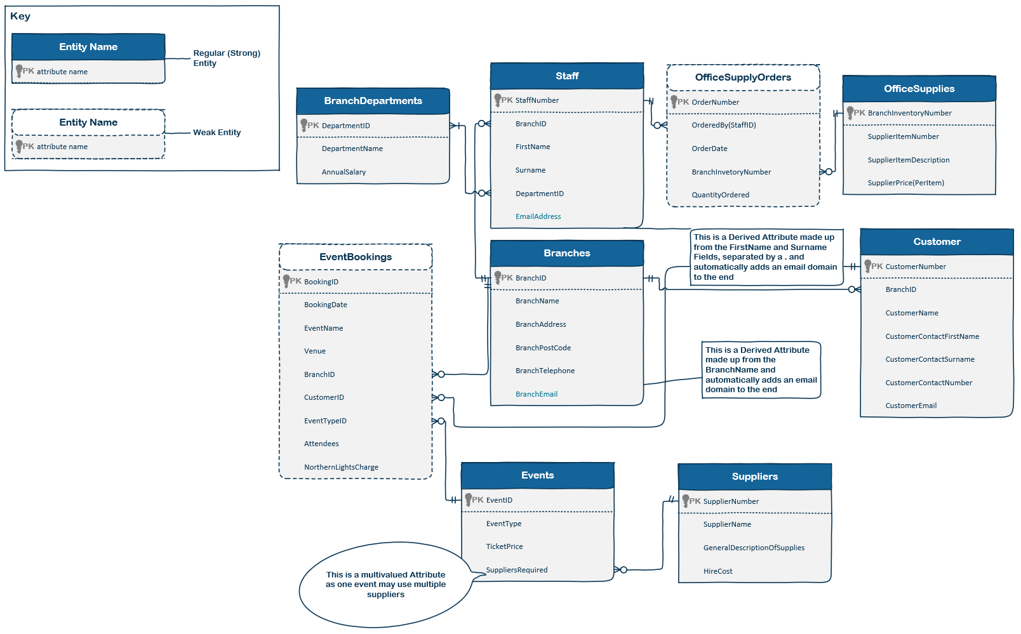
Figure 1: Annotated ERD for Northern Lights Database

Evidence of Relationships in Access Database
Below is the Relationship Model from the Northern Lights Access Database, showing the links between the different tables and where the Primary Key fields are.
Please note, the OrderNumber field in OfficeSupplyOrders is not showing a key, but is the primary key for that Entity as that is the Identifying field but can be repeated as multiple items can be ordered per Order Number, but for ease of calculation, they are recorded as individual records
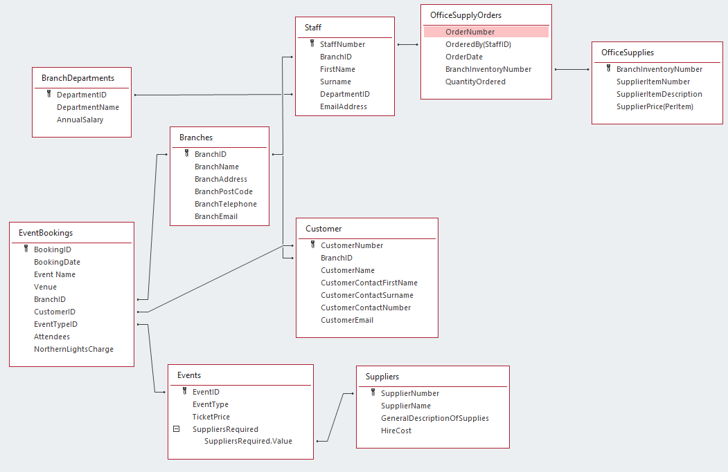
Figure 2: Access Relationship Model

Intended Use of Database Management System
When the final product is delivered to the customer, it would be set so that Employees from all branches would be able to view and update event bookings for any office. The reason for this is so that in the event a customer makes contact with the wrong branch, rather than making them contact again, the details can be captured by the branch they are speaking to and the correct branch can then carry on the handling of the account.
Staff will be able to access the details of staff working in other branches, so that they can make contact with each other if required.
They will be able to generate individual invoices per event booked for each customer as well as reports on what the monthly and annual salary costs are for all branches, the total cost of hiring suppliers for each event and how much has been spent on each stationery order broken down by each branch.
Tables in Database
Below are screenshots of each entity which has been created in the database management system

Branches
This entity stores the data for all of the branches the company currently has with the ability to add more if needed
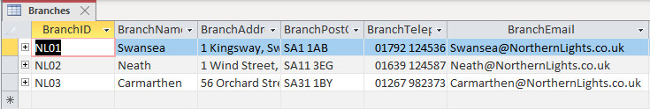
Figure 3: Branch Entity in Access Database
The primary key for this entity is the BranchID attribute and is used as a foreign key in later entities. This entity also stores:
- Branch Name
- Branch Address (Multivalue field)
- Branch Post Code
- Branch Telephone Number
- Branch Email Address

BranchDepartments
This entity stores the data for all the departments within each branch and the salary that people working in that department are paid. These can be altered and added to as required
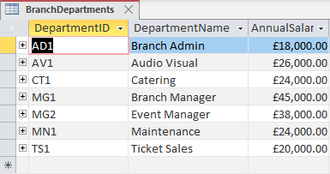
Figure 4: BranchDepartments Entity in Access Database
The primary key for this entity is the DepartmentID attribute and is used as a foreign key in later entities. This entity also stores:
- Department Name
- Annual Salary for Staff working in that department

Staff
This entity stores the staff details and can be viewed by all members of staff to know who to contact in other branches if required
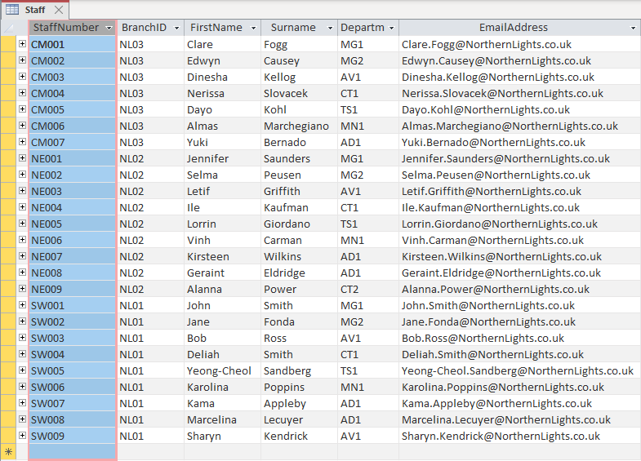
Figure 5: Staff Entity in Access Database
The primary key for this entity is the StaffNumber attribute. This is used as a foreign key in later entities. This entity also stores:
- Branch ID – Foreign Key for Branches Entity
- First Name
- Surname
- Department ID – Foreign Key for BranchDepartments Entity
- Email Address – This is a derived field, created from data entered in to FirstName and Surname, adding a . between them and then an email domain at the end.

Events
This entity stores the list of events that Northern Lights are able to organise, along with the cost per ticket they recommend for each event and which suppliers they need to hire in
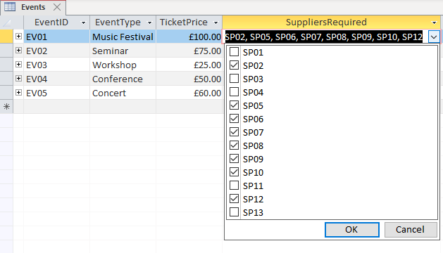
Figure 6: Events Entity in Access Database
The SuppliersRequired field is a Multi-Entry list which is determined by the list of Supplier ID’s in the Suppliers Entity
The primary key for this entity is the EventID attribute. This is used as a foreign key in later entities. This entity also stores:
- The type of event
- The cost, per ticket, for that event
- Which suppliers are required when this event type is booked – Foreign key to Suppliers Entity

Suppliers
This entity contains the list of suppliers and what they offer, along with how much it costs per event to hire them
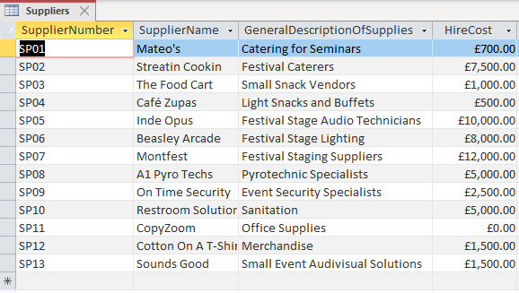
Figure 7: Suppliers Entity in Access Database
The primary key for this entity is the SupplierNumber attribute. This is used as a foreign key in later entities. This entity also stores:
- The Supplier’s Name
- A general description of what services they provide
- How much it costs to hire them for an event

OfficeSupplies
This entity is the list of authorised supplies that the branches are allowed to order from their registered office supplies company
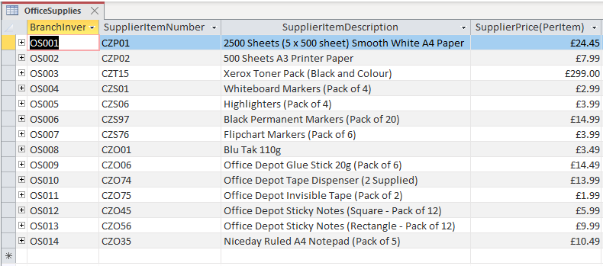
Figure 8: OfficeSupplies Entity in Access Database
The primary key for this entity is the BranchInventoryNumber attribute. This is used as a foreign key in later entities. This entity also stores:
- The Item Code used by the supplier
- A description of the item
- Cost per Item

Customer
This entity stores the details for the customers that Northern Light have on their books
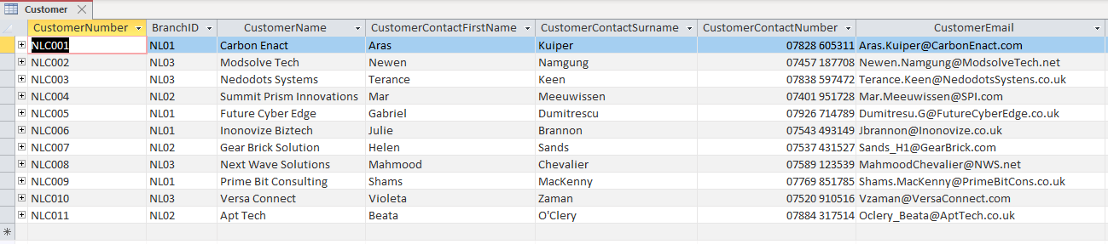
Figure 9: Customer Entity in Access Database
The primary key for this entity is the CustomerNumber attribute. This is used as a foreign key in later entities. This entity also stores:
- The Branch the customer is associated with – Foreign Key to Branches Entity
- The Name of the Customer’s Company
- The First Name and Surname of the contact within the company
- The contact’s telephone number
- The contact’s email address

Event Bookings
This Entity holds the details of events that have been organised through Northern Lights. 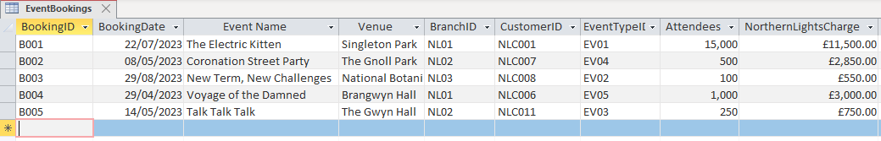
Figure 10: EventBookings Entity in Access Database
The primary key for this entity is the BookingID attribute. This is not used as a foreign key in other entities. This entity also stores:
- Date of Booking
- Name of Event
- Venue
- Organising Branch – Foreign Key to Branches Entity
- Customer ID – Foreign Key to Customer Entity
- Event Type – Foreign Key to Events Entity
- The number of people Attending
- The amount Northern Lights charges for organising the event. This is negotiated by the company when agreeing to take it on

OfficeSupplyOrders
When an order has been placed with the office supplies company, a record is kept of the items ordered in this Entity 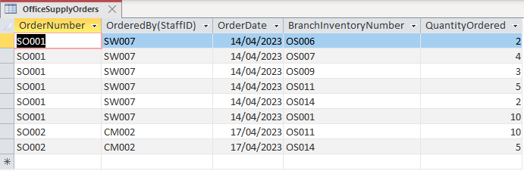
Figure 11: OfficeSupplyOrders Entity in Access Database
The primary key for this entity is the OrderNumber attribute. This is not used as a foreign key in other entities and is not an indexed primary key. Each item ordered is stored separately for easier reporting. This entity also stores:
- The staff member who ordered the items. This is restricted to only the Branch Manager, Event Manager (who is effectively the Branch Deputy Manager) and the Branch Admin
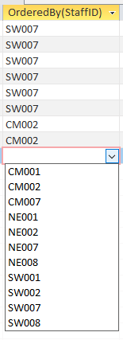
Figure 12: Drop-down list of Staff ID's
- The date the order was placed
- The Branches internal inventory number. This is a prepopulated list from the Supplies Entity
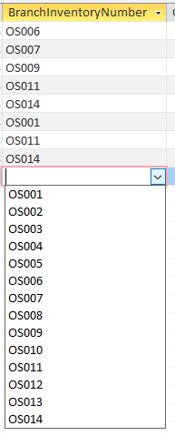
Figure 13: Drop-down list of Inventory Numbers
- The quantity of each item that was ordered

User Guide for Northern Lights
Following this will be a mockup of what a userguide for Northern Lights will look like. This will contain screenshots of the forms, queries and reports viewable in the Database Management System would be.
This would be the minimum required for them to operate and additional features could then be added in at later stages.

Figure 14: Front Page of User Guide
Northern Lights Database Management System
User Guide
Welcome to your new Database Management System.
In this User Guide, we will talk you through navigating through the different forms in the interface and how to complete data in to each of the tables.
PLEASE NOTE: All forms shown in this guide are designed to be filled in from Top left to Bottom Right or they will not work correctly.
Where the method of completion is carried over multiple forms, we will only give an explanation on the first instance.

Opening the System
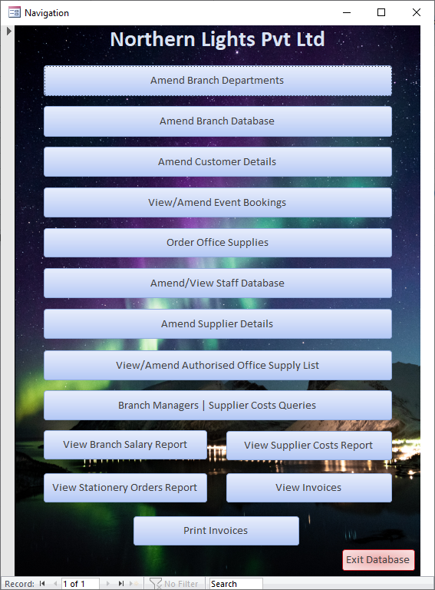
On startup, the following screen will be displayed. This is your main way of navigating through the Database Management System (DBMS):
Figure 15: Main Page of Database Management System
These Options will take you in to the forms used to input/view data stored in the DBMS

This Option will allow you to view pre-defined queries showing the list of Branch Managers or the total Costs of Suppliers By Event

Closes the system down

These options will allow you to view the pre-defined reports. The final option takes you straight in to print preview for ease of generating customer invoices

Data Input Forms

Amend Branch Departments
This form allows you to View, Amend and Add Departments to your organisation’s structure. This form updates the tables live so any changes made are instant.
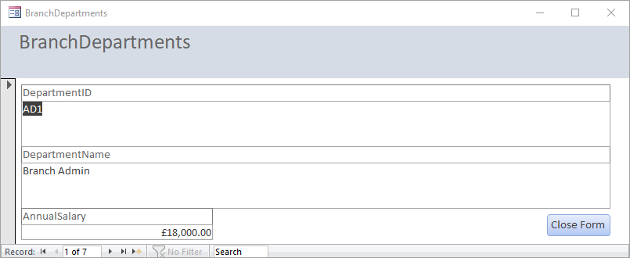
Enter the Yearly Salary for employees working this role
Enter a descriptive Name for what this Department is
Each Department is assigned a unique code. It is recommended they are of the format “AA1”
Figure 16: Branch Departments User Data Entry Form

This Section Allows you to navigate though all existing records. (This will be the same on all Forms)
Return to Main Page (This will be the same on all forms and Reports)

Amend Branch Database
This form allows you to View, Amend and Add Branches to your organisation’s structure. This form updates the tables live so any changes made are instant.
This one allows you to either enter the data via the form or via a table underneath, whichever you find easier to manage.
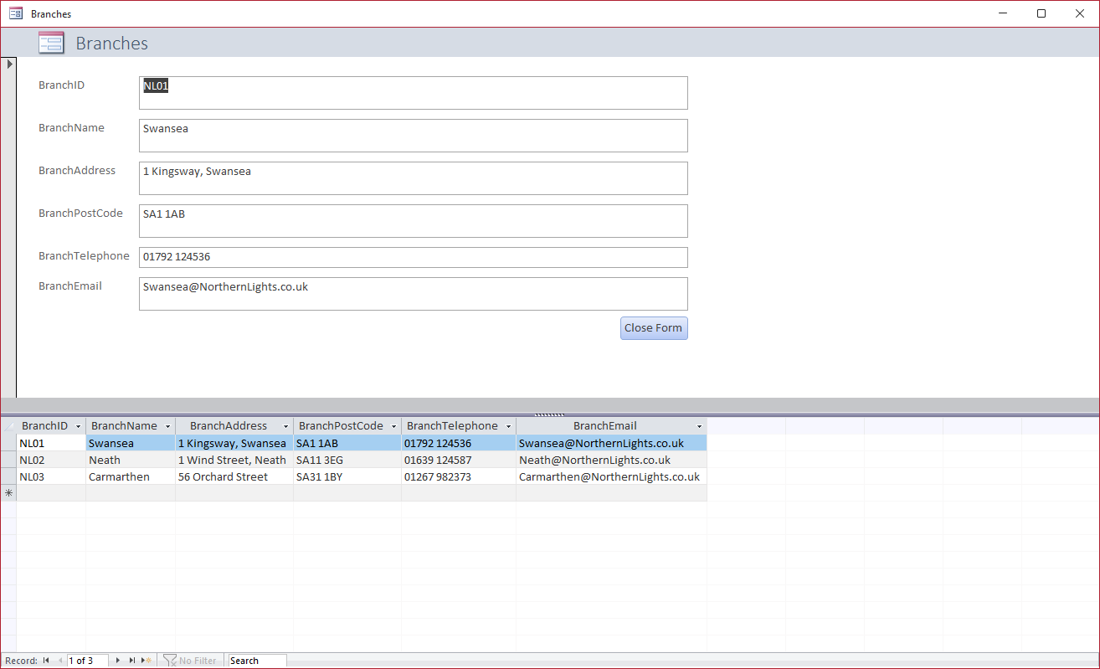
This field will be automatically generated once you’ve entered a Branch Name.
Figure 17:Branches User Data Entry Form

Amend Customer Details
This form allows you to View, Amend and Add Customers to your records. This form updates the tables live so any changes made are instant.
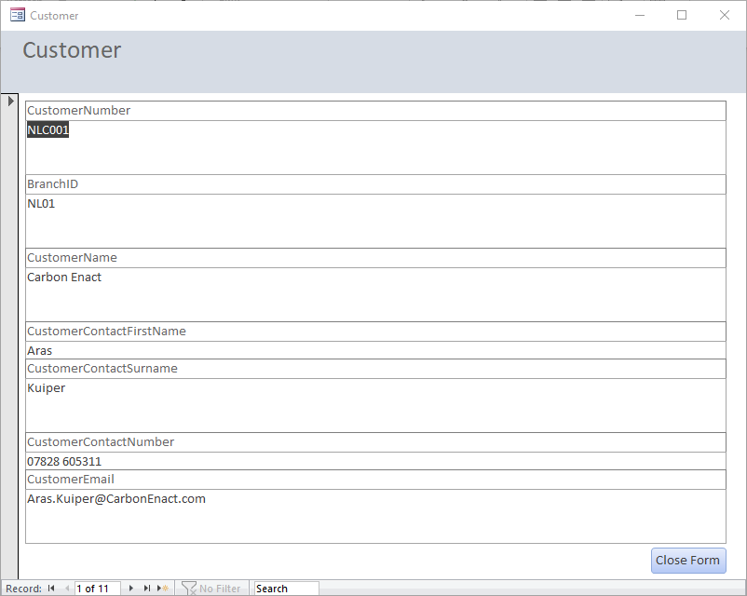
This will need to match the details you entered in your Branches Table
Figure 18: Customer User Entry Form

View/Amend Event Bookings
This form allows you to View, Amend and Add Event Bookings to your system. This form updates the tables live so any changes made are instant.
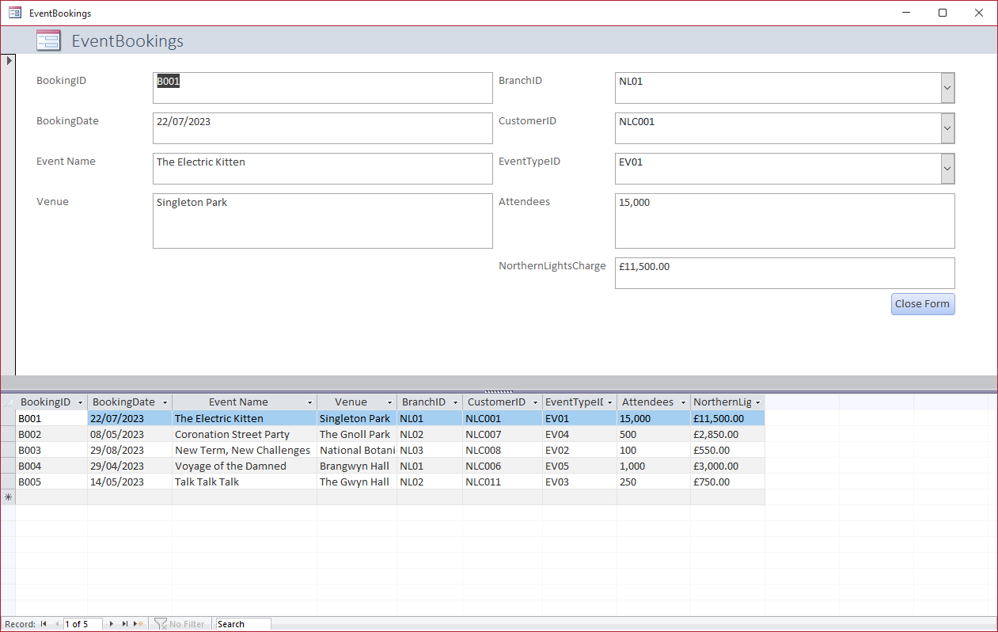
This is a price you have negotiated and will need to be manually entered
This will need to match the details you entered in your Events Table.
Once the Branch ID has been entered, the list will update to show the ID’s of Customers registered with that Branch
This will need to match the details you entered in your Branches Table
Figure 19: Event Bookings User Data Entry Form

Order Office Supplies
This form allows you to View, Amend and Add details of Office Supplies that have been ordered in to your system. This form updates the tables live so any changes made are instant.
Please note with this set of data, each item ordered must be entered individually so the Order Number and the Staff ID of the person ordering will need to be input each time. This allows the calculations for the Reports we will demonstrate later to be made more easily
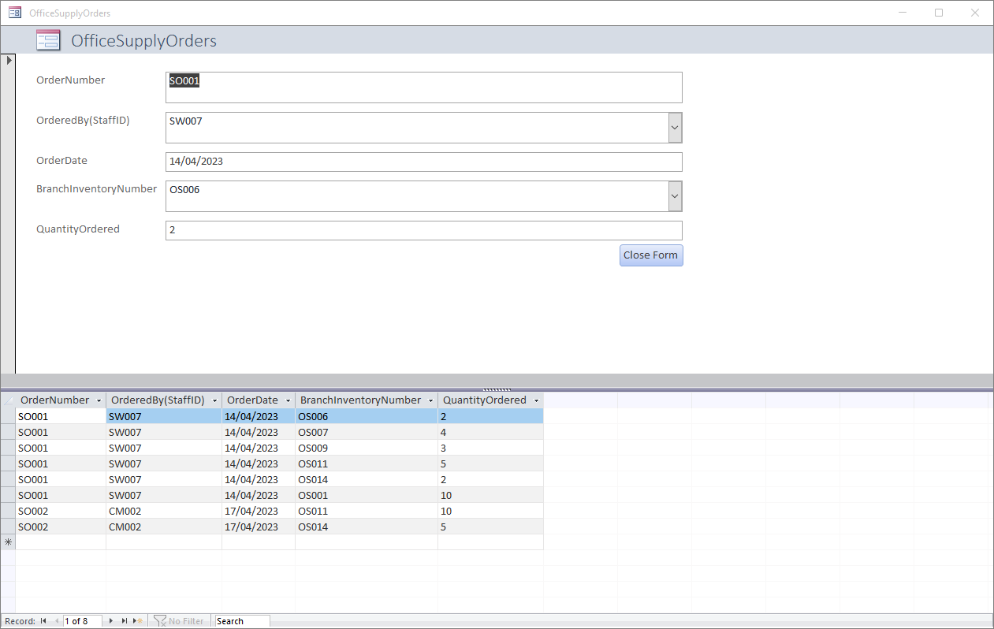
This list is determined by your OfficeSupplies Table which we will be showing the details of further down the guide
This has been set so that only users with the Branch Manager, Event Manager or Branch Admin roles can update
Figure 20: Office Supply Orders User Data Entry Form

Amend/View Staff Database
This form allows you to View, Amend and Add details of the Staff Database. This form updates the tables live so any changes made are instant.
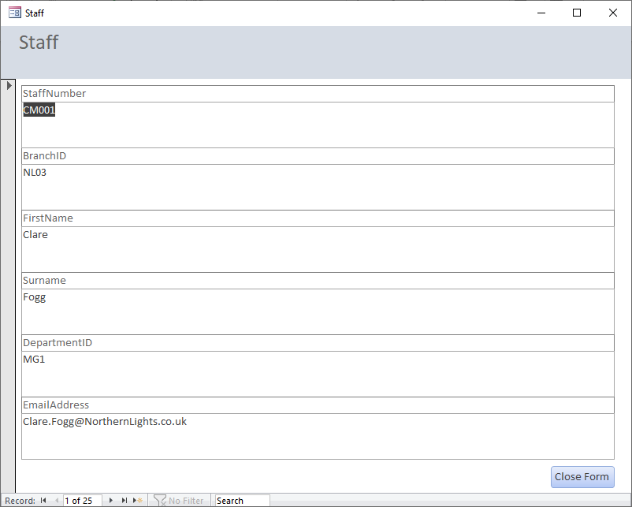
This will need to match the details you entered in your Branches Table
This will need to match the details you entered in your BranchDepartments Table
This field will be automatically generated as you enter the First Name and Surname.
Figure 21:Staff Database User Data Entry Form

Amend Supplier Details
This form allows you to View, Amend and Add details of the authorised suppliers used by your organisation. This form updates the tables live so any changes made are instant.
All the controls on this form are similar to previous forms so we will not provide any further explanations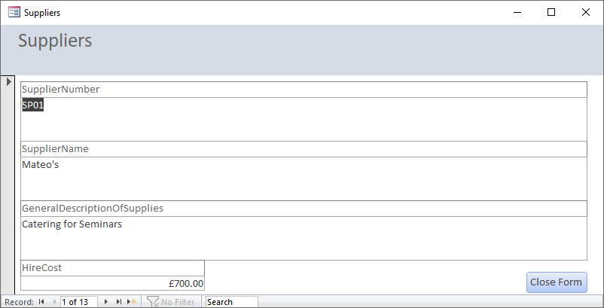
Figure 22: Suppliers User Data Entry Form

View/Amend Authorised Office Supply List
This form allows you to View, Amend and Add details of the Office supplies that are authorised to be ordered by your company. This form updates the tables live so any changes made are instant.
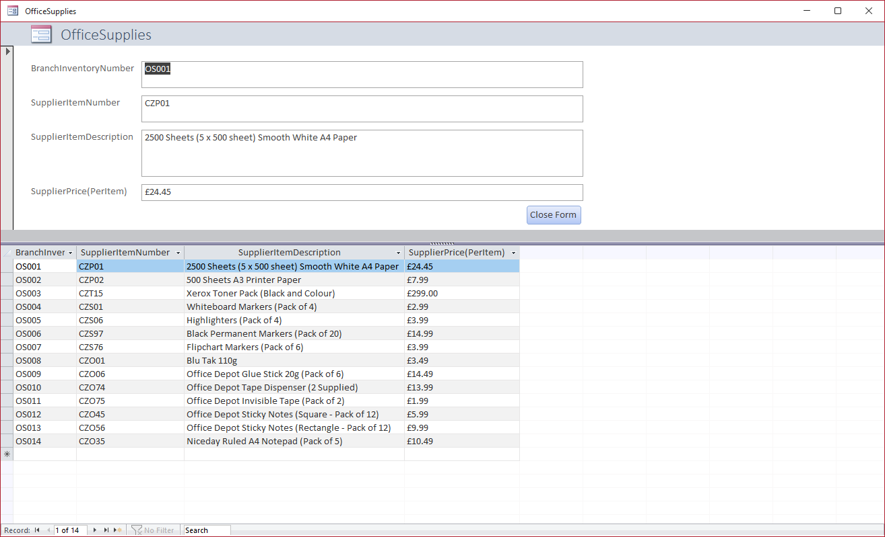
This will need to match the code supplied by your Office Supplies Provider for reference if you need to query anything with them
Figure 23: Office Supplies User Data Entry Form

Queries

Branch Managers | Suppliers Charges Queries
We have set up two queries as an example of the sort of thing you can analyse from your data. Any further queries can be added in by us at a later stage should you wish.
The two queries we have set up is one that displays a list of the Branch Manager for each Branch and then the other is an aggregate view of how much hiring in the different suppliers have cost for each event.
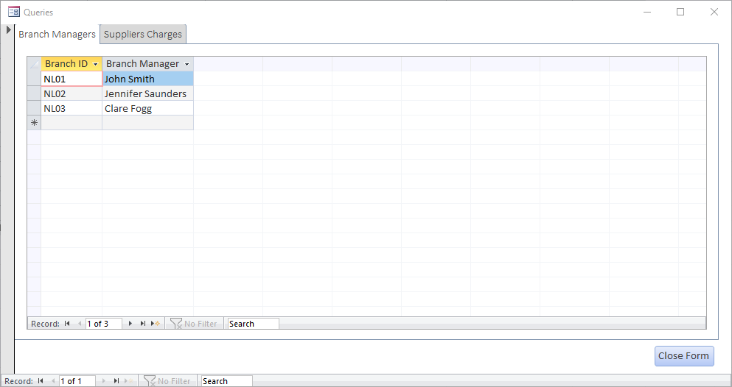
Figure 24: Branch Managers Query Results in Form
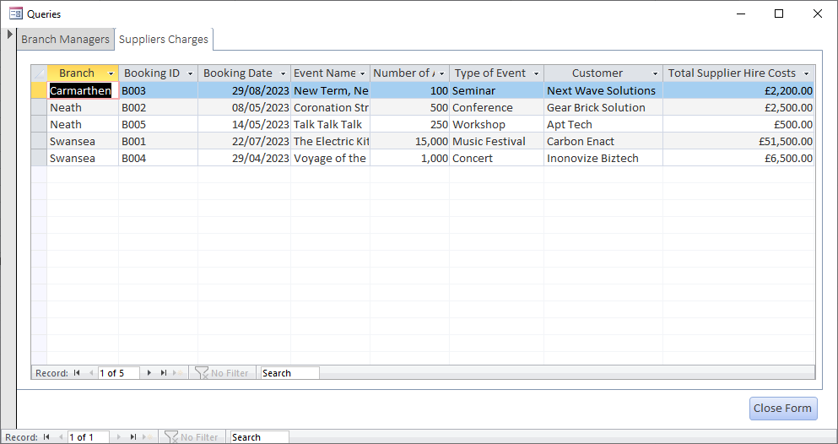
Figure 25: Supplier Charges Query Results in Form

Reports
There are 4 different reports that we have generated, again these are examples and more can be added as required, but these should allow you to run the basic functions you currently run.
View Branch Salary Report
This report will give you a list of all staff working at each branch, their role, their monthly pay and annual salary, as well as the monthly and annual cost per branch and for the entire organisation (these last two are not captured on the screenshot but are at the end of the report.
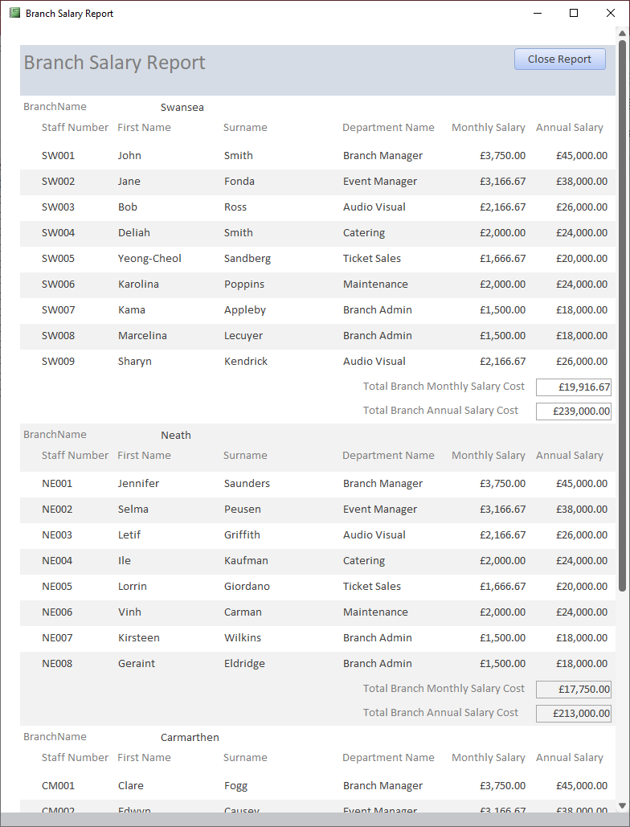
Figure 26: Branch Salary Report

Supplier Costs
This report provides you with an itemised list, by each supplier, of which events they have worked for you and how much it has cost to hire them for each event, along with a total for each one and a final total for all event hire at the end of the report (not pictured in screenshot)
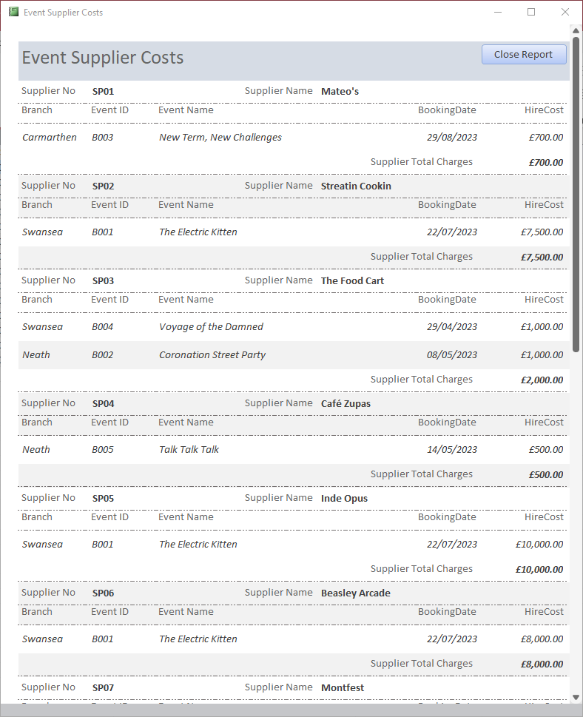
Figure 27: Supplier Costs Report

Stationery Orders
This Report gives you a breakdown of the Stationery Orders made by each branch, grouped by each Order Number. This will be similar to the invoices you get from your Office Supplies Provider but will be displayed based on the internal Item Number you use rather than your providers number. At the end of the report you will have a total of all that has been spent on office supplies by the entire organisation.
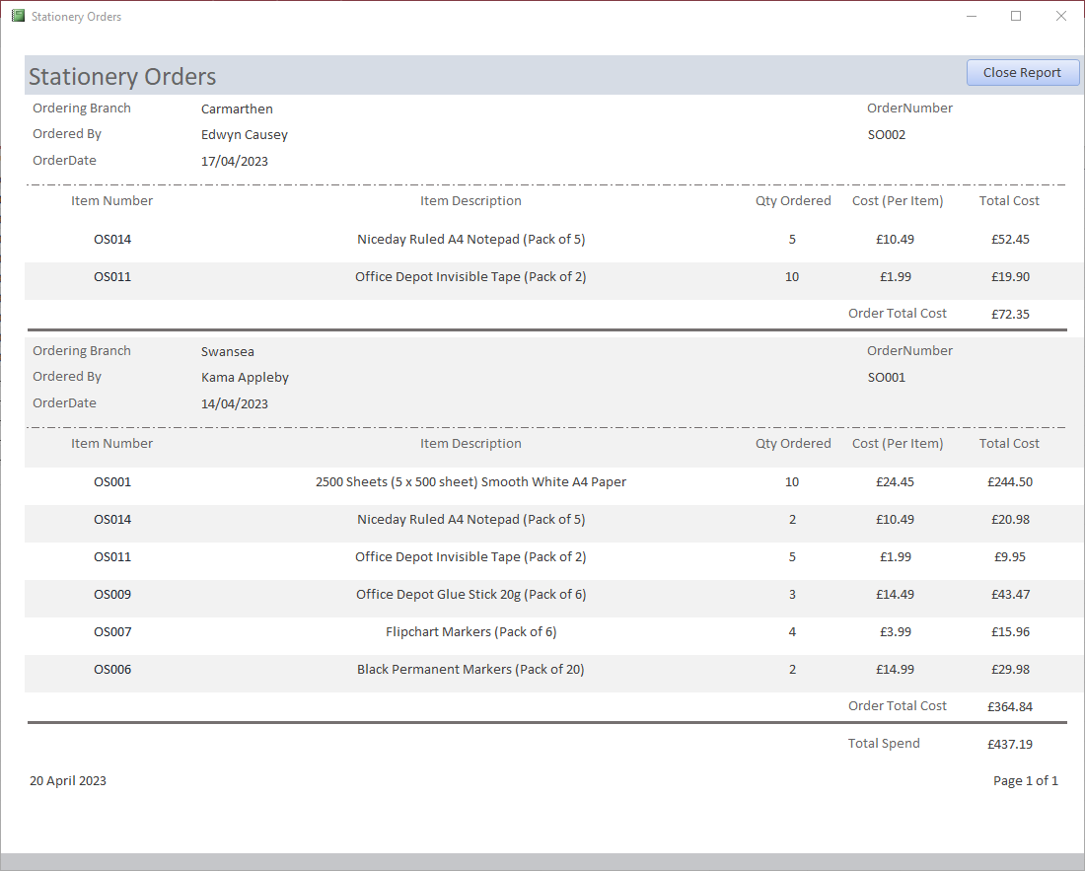
Figure 28: Stationery Orders Report

Invoices
The “View Invoices” button will take you to the view on the left where you can view the itemised invoice for each customer, broken down by the Branch they are associated with. This gives a breakdown of how much you’ve paid for the supplier, how much you charge as a booking fee, how much revenue was generated from ticket sales and how much the customer earned from it.
The “Print Invoices” button takes you straight in to the Print Preview view of the Invoices and will allow you to print one or all invoices depending on your needs.
Each Event will be printed on a separate page so you can print invoices for specific events as required.
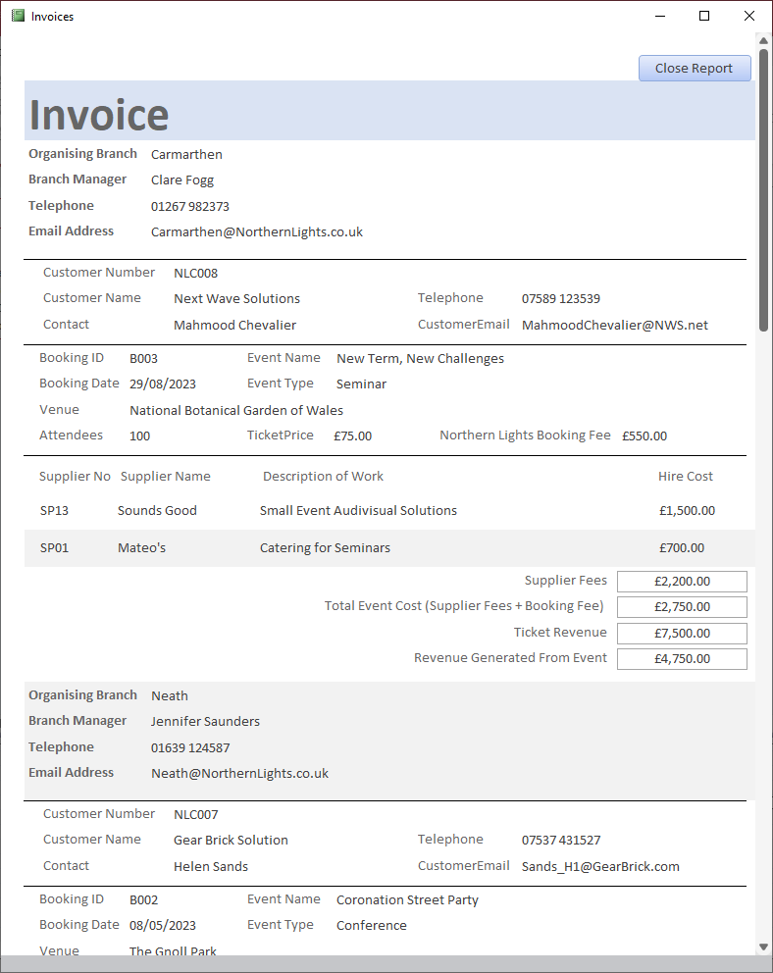
Figure 29: Invoices (Report View)
Figure 30: Invoices (Print Preview View)

Figures
Figure 1: Annotated ERD for Northern Lights Database 5
Figure 2: Access Relationship Model 6
Figure 3: Branch Entity in Access Database 7
Figure 4: BranchDepartments Entity in Access Database 7
Figure 5: Staff Entity in Access Database 8
Figure 6: Events Entity in Access Database 8
Figure 7: Suppliers Entity in Access Database 9
Figure 8: OfficeSupplies Entity in Access Database 9
Figure 9: Customer Entity in Access Database 10
Figure 10: EventBookings Entity in Access Database 10
Figure 11: OfficeSupplyOrders Entity in Access Database 11
Figure 12: Drop-down list of Staff ID's 11
Figure 13: Drop-down list of Inventory Numbers 11
Figure 14: Front Page of User Guide 12
Figure 15: Main Page of Database Management System 13
Figure 16: Branch Departments User Data Entry Form 14
Figure 17:Branches User Data Entry Form 14
Figure 18: Customer User Entry Form 15
Figure 19: Event Bookings User Data Entry Form 15
Figure 20: Office Supply Orders User Data Entry Form 16
Figure 21:Staff Database User Data Entry Form 16
Figure 22: Suppliers User Data Entry Form 17
Figure 23: Office Supplies User Data Entry Form 17
Figure 24: Branch Managers Query Results in Form 18
Figure 25: Supplier Charges Query Results in Form 18
Figure 26: Branch Salary Report 19
Figure 27: Supplier Costs Report 20
Figure 28: Stationery Orders Report 21
Figure 29: Invoices (Report View) 22
Figure 30: Invoices (Print Preview View) 23

