Report

How employability skills been impacted by Covid-19?

Lecturer: Laura James
Student: Alexei Moroz 2115517

Summary

The purpose of this report is to explain why employability skills are important for employees and employers. Also, will explain how these skills were affected by global pandemic, and how job seekers were impacted because of these changes.

1. Introduction

COVID-19 has rapidly affected our day-to-day life, businesses, disrupted world trade and movements. Billions of people were affected during the global pandemic. The impacts of Covid-19 are healthcare, economic and social sector. One of the affected areas was employability.

“Employability is the possession by an individual of the qualities and competencies required to meet the changing needs of employers and customers and thereby help to realise his or her aspirations and potential in work” (CBI, 1999, p. 1).

Most employers are looking for staff with certain qualities and skills in addition to academic performance, known as employability skills. These skills may not be specific for the job you apply for, but they will play an important role in your employability and performance in the workplace. Some of the employers can ignore your academic qualifications, and will prioritise just the skills you need for the current job offer. Every single employee has different skills and aptitudes. As Dave Gilchrist, Graduate Recruitment Coordinator of CGI said in one of his interviews for The Open University, “What is going to make you more employable than somebody else? Things that are going to make you stand out, things that are going to differentiate you from other people. It may be a certain skill or aptitude you have or have demonstrated, where you've perhaps stretched yourself in certain ways and shown that you've really done the best you can with it.”.

During the last 40 years, employability skills lie at the heart of every single Government’s agenda of every single state in the world. From the 1980's many reforms happened across the world, and many of these reforms raised the qualification levels and skills to world standards. Year after year, employees look for different skills which are required for their business to grow. From 2019, a new virus captured all over the world which affected 90% of employees and employers. These factors created a new requirement of skills on the job market.

2. Main findings

2.1 How Employability skills changed since Covid-19

The first case of the coronavirus (COVID-19) was reported to the World Health Organization in December 2019 and was subsequently declared a Public Health Emergency of International Concern. One of the most affected sectors was the labour force. Most humans around the world due to safety reasons and lockdown requirements, started self-isolating at home and businesses were closing down because of a missing labour force.

Employees classify employability skills by soft skills and professional skills. During pandemic time, soft skills never changed. Soft skills relate to how you work. Soft skills include interpersonal (people) skills, communication skills, listening skills, time management, and empathy, among others. (A. Doyle, 2020). Doyle mentioned in her article that hiring managers look for job candidates with soft skills because they are transferable skills and make someone more successful in the workplace. Soft skills characterize how the staff interacts in their relationship to other co-workers.

Pandemic time made a lot of employers furlough, was harder to find a job as many non-essential companies closed down, and many employees which were classified as key-workers were looking for professional skills.

The new technologies of the 21st century and the growing generation, impacted positively on the life of some people. Most people tried and developed new skills at home. They start learning and improving their digital competence in top social media platforms, start trading on Crypto, streaming. “Digital competence is the most recent concept describing technology-related skills. During the recent years, several terms have been used to describe the skills and competence of using digital technologies, such as ICT skills, technology skills, information technology skills, 21st century
skills, information literacy, digital literacy, and digital skills” (L.Ilomaki, A. Kantosalo, M. Lakkala, 2011). Digital competence played a big role for job seekers and old staff during Covid-19. As many companies closed down their branches, all staff started working from home, which relates to digital skills you need to have to continue work. Most of the employees created a new pattern of work process like online meetings, office work shifting from home. Also the teaching sector required “upgrading” their digital skills to continue learning progress of the growing generation. All of us improved their digital competence during Covid-19 pandemic, as we used different platforms such as Facebook, Google Meet, Zoom, Microsoft Teams to see our close friends and family. Companies made a “dramatic shift in digital usage with impacts on all aspects of work and life” (2020, online).

“Resilience is accepting your new reality, even if it's less good than the one you had before. You can fight it, you can do nothing but scream about what you've lost, or you can accept that and try to put together something that's good.” Elizabeth Edwards (2009). Resilience has also been defined as the capacity of individuals to cope successfully with significant change, adversity, or risk. Dean Becker states “More than education, more than experience, more than training, a person’s level of resilience will determine who succeeds and who fails”.(2002) Our world is based on stressful situations which we face day by day. Since Covid-19 started, our days have become more stressful than before. Resilience is one of the most important skills you need to use all the time, not just during a pandemic, but in every job, in every situation, day by day. Most employees are looking for people who possess this skill, as they know that this person will be able to handle the stress Covid-19 created in many workplaces, and can become a good leader and will help businesses to get out of stress.

Emotional intelligence is the capability to use, understand, handle and manage emotions. Terms of Emotional Intelligence appeared in 1964, but for the first time as described by Daniel Goleman in 1995. He described Emotional Intelligence as “an array of skills and characteristics that drive leadership performance”. In one of his survey of more than 2000 senior executives and employees he concluded that “Almost three out of four executives see EI as a “must-have” skill for the workplace in the future as the automatizing of routine tasks bumps up against the impossibility of creating effective AI for activities that require emotional skill” (D. Goleman, 1996). Emotional Intelligence is working with resilience together. Emotions are part of a successful environment at the workplace, and not just for employees, but for employers as well. During Covid-19, Emotional Intelligence has affected most of the people, with all restrictions in place, isolating from close friends and family, not being able to spend time out of work and home.

2.2 Why employability skills changed?

In our days, the world improved a lot in all sectors. Covid-19 pandemic played a big role in fastener this process across all countries. All restrictions and requirements implemented by each country, impacted employability skills to change and transfer. All of companies were classified as essential and non-essential, and shifted their old style to a new style.

The International Labour Organization of US estimated that in 2020, nearly 255 millions of full-time jobs was lost, which is equivalent of $3.7 trillion loss in labour income.

By Office of National Statistics, Total actual weekly hours worked in the UK increased by 25.2 million hours on the quarter, to 1.03 billion hours in July to September 2021. This reflects the further relaxing of coronavirus lockdown measures. However, this is still 25.6 million below pre-pandemic levels (December 2019 to February 2020). Please see picture below. (Office Of National Statistics, 2021, online)
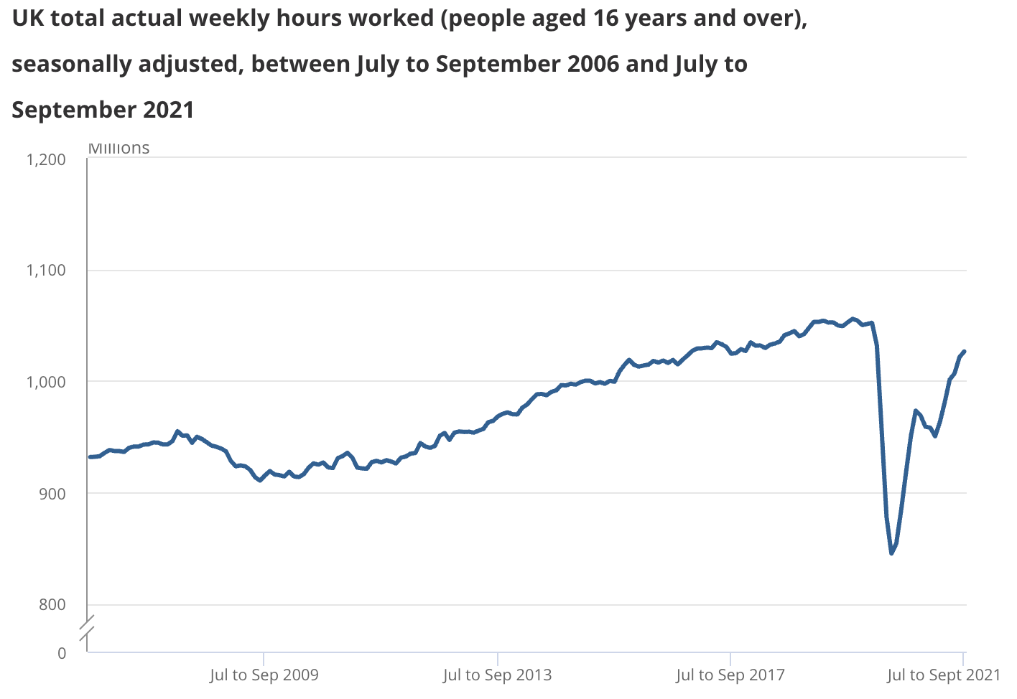
After a record low of 343,000 vacancies in April to June 2020, there has been an estimated record quarterly increase of 144,000 to 488,000 vacancies in July to September 2020; vacancies remain below the pre-coronavirus (COVID-19) pandemic levels and are 332,000 (40.5%) less than a year ago. (ONS, 2021). So by this statement from ONS we can understand that many companies which are classified as essential, tried to help most of the people who lost their job due pandemic crisis, with opening a decent amount of vacancies on Labour Market.

I’m working for last 6 years for a Logistic company, which is classified by Government as an essential company. During pandemic our requirements on labour was higher than expected so we opened another 3100 vacancies on the market. Required skills weren’t professional but soft skills. We were looking for people with flexibility, communication, and digital competence. Me personally meat a lot of people from different industries and sectors, which was seeking for job. One of them was manager of NatWest Bank branch, which I was very surprised, that he chooses a different job in a different sector. A people who possess the most of the skills and qualifications, just decided to change everything. This is why most of the employability skills changed during this pandemic.

Ranjan Das, the founder of MD Apppl Combine, explained in one of his article about 7 skills that will help employees and employers to survive due this crisis. This 7 skills can be classified as the most important at our time: resilience, emotional intelligence, flexibility, communication, digital competence, innovation and critical thinking. This skills are the ones which employees look at the moment, as many companies still working for home. Many people of different age improved their tech competence due pandemic.

2.3 What impact has this had on individuals looking for employment?

Unemployment has consistently been found to have a negative impact on a range of health outcomes. This has a strong relationship with mental health, including depression and anxiety. As stated in an article on The Health Foundation page, “A number of studies find that the health consequences of unemployment increase with duration, for example, on self-rated health, and mental morbidity and life satisfaction.”(THO, 2021). By statistic 350,000 adults or 24% of the total had been unemployed for over 12 months. This is the lowest number before recession. Covid-19 pandemic impacted negative all the humans around world. Younger age groups are generally more likely to experience unemployment. 7.3% for 16-19 year olds, and 6.8% of 20-24 year olds are unemployed, compared to 3.3% for those aged 25-34 (THO, 2021). Most of job seekers, should develop new skills in regard to find a new job. But also some companies didn’t required to many skills to be enrolled. All this is due depression that Covid -19 pandemic brought in. As soon as digital competence was maximum developed, businesses start doing their recruitment online. Some of them also offering virtual training, which will help job seeker to prove himself in workplace. Pandemic influenced on Labour market, with creating new jobs, new opportunities. For example, Amazon UK opened 34000 places for work, which don’t require to many skills. And many companies across UK like DPD, Yodel, UPS, FedEx, Transport companies, Healthcare sector, offered part-time and full-time jobs due pandemic. Due all this unemployment numbers didn’t change, because people get used to it, low mental health and need of upskill for new job place.

3. Conclusion

Employability skills play the main role for all individuals which a looking for a job. All of these have been impacted a lot for last years, but especially during Covid-19 pandemic. From my point of view, Covid-19 played an important role in developing the maximum of digital competence for all age groups. Employees shifted to a virtual workplace, which forced all staff to develop and improve their tech skills. Many factors impacted employability skills to be transferred to a new type of job. Virtual workplace helped businesses from bankruptcy and closing down, also helped their staff to continue their job. Individuals who kept their job and still working nowadays, are mental health and emotional stable. For others, pandemic played a bad period in their life. Anxiety of virus and depressions, local restrictions, made them to self-isolate not just physically, but also psychically. Many businesses closed down due these issues, employees became bankrupted, World economy wasn’t unstable with big losses.
Employers was looking for job seekers with special skills which will help them to rehabilitate their businesses. Due their financial losses, Government of each country implemented many labour schemes and financial support for all job seekers and employers.
Many of job seekers should upskill due high demand of skills required by companies, which created a competition for workplace. People’s mental health are very low, and most of them get used to it and don’t want to upskill.
In this report I tried to show the findings about employability skills and how these were impacted for last 2 years by Covid-19 pandemic across the globe.

References
CBI (CONFEDERATION OF BRITISH INDUSTRY) (1999) Making Employability Work: An Agenda for Action. London: CBI.

A Doyle (2020) Definition and Examples of Soft Skills. https://www.thebalancecareers.com/what-are-soft-skills-2060852
Ilomäki, L., Kantosalo, A., & Lakkala, M. (2011). What is digital competence? In Linked portal. Brussels: European Schoolnet. http://linked.eun.org/web/guest/in-depth3
Impact of digital surge during Covid-19 pandemic: A viewpoint on research and practice (2020) https://www.ncbi.nlm.nih.gov/pmc/articles/PMC7280123/#bib0160

Petrini. (2014). Mitigation, resilience, and nursing. Nursing & Health Sciences, 16(1), 1–2. https://doi.org/10.1111/nhs.12132
Harvard Business Review (2002) How resilience works https://hbr.org/2002/05/how-resilience-works

Daniel Goleman (1996) Emotional Intelligence : 25th Anniversary Edition. London: Bloomsbury Publishing.
Office of National Statistics (2021) Employment in the UK: November 2021. https://www.ons.gov.uk/employmentandlabourmarket/peopleinwork/employmentandemployeetypes/bulletins/employmentintheuk/latest
Office of National Statistics (2021) Labour Market Overview: UK 2021https://www.ons.gov.uk/employmentandlabourmarket/peopleinwork/employmentandemployeetypes/bulletins/uklabourmarket/october2020
The Health Foundation (2021) Employment and unemployment: How does work affect our health? https://www.health.org.uk/news-and-comment/charts-and-infographics/unemployment

