Strategies for Resilience and
Prosperity
Samsung
BMAP6006
Glenn Behenna

Content page
Executive summery ………………………………………………………………………………………3
- Introduction ……………………………………………………………………………………………
  - Background of Samsung ……………………………………………………………….4
  - Business strategy ………………………………………………………………………….5,6
- Main findings
  - Overview of Samsung strategy ………………………………………………………7
  - Strategy analysis of Samsung Porters Generic strategy…………………8,9
  - Strategy analysis of Samsung Bowmans strategic clock …………………10
  - Evaluation of Porter and Bowmans strategy ………………………………….11
  - Strategy analysis of Samsung SWOT AND PESTEL …………….…12,13,14
  - Evaluation of SWOT and PEST ……………………………………………………….15
  - Strategy analysis of Samsung – Stakeholder analysis……………………..16
  - Evaluation of Stakeholder analysis ………………………………………………..17
- Conclusion ………………………………………………………………………………………………18
- References …………………………………………………………………………………………19,20

Executive summary
During the course of this report, it will go through the background of Samsung and into their business strategy. Following this information, the report will then move on to the main findings where it will go into detail on Samsung’s strategies moving into Porters generic strategy. Bowman’s clock will be analysed and there will be a brief description of how Porter and Bowman are connected. Further into the main findings the report will review a SWOT and PEST analysis with am evaluation following. Stakeholder analysis will then be reviewed and a more detailed evaluation will follow leading to the end of the report.

- Introduction

1.1 Background of Samsung
Samsung is a South Korean company which is one of the worlds largest and well-known producers of electronic devices. Samsung specializes in a wide variety of consumer and industry electronics such as memory chips, appliances, digital devices and integrated systems. Samsung was originally founded on March 1, 1938 by Lee Byung-Chull as a grocery trading store with its main focus on noodles. As the years went on Lee Byung-Chull expanded the business and crossed many opportunities that he explored through the years. Such as textiles resulting in him opening the largest woollen mill in Korea, Acquiring three of the largest commercial banks, An oil refinery and department stores. In 1987 Lee Byung-Chull passed away and was succeeded by his son Lee Kun-Hee. Samsung was then split into five independcompanies four of which where then run by Lee Byung-Chulls sons and daughter, Leaving electronics under the leadership of his eldest son Lee Kun-Hee. During the early stages of his leadership Lee Kun-Hee was unprepared for Global competion, later he famously said to Samsung executives “Change everything but your wife and kids.” Under Lee termed a “new management” concept. Samsung then insisted any errors to be pointed out and stressed quality of products over quantity. Driven by Lees new shake up of Samsung in the 1990s the company thrived and continued to expand into the Global electronics market making advancements on technology including its LCD screens and computer monitors soring into the top five positions in the Global market. In the 2000s Samsung introduced the Galaxy smartphone series which quickly become the best-selling smartphone in the world making it Samsung’s greatest smartphone creation yet. Along-side the release of the Galaxy series Samsung also supplied Apple with microprocessors for their earliest iphone. Since 2006 Samsung has been the top selling manufacturer of televisions and the Galaxy series had expanded into tablets and smart watches (Bondarenko 2021).

1.2 Business strategy
Mintzberg 5 P’s

Mintzberg developed his five P’s of strategy as five different definitions of developing strategy. Mintzberg first wrote about these in 1987. The diagram below shows the five P’s of strategy.

Plan

Perspective Play

5 P’s of
Strategy

Position Pattern

Most companies take a very simplistic approach to strategy which is unlikely to give good results. Many believe its about competing to be the best where as like Samsung its about competing to be unique. Mintzberg recognised that strategy is difficult to get right and to help others in developing a better strategy he developed the five P’s which are explained lightly below.
Plan – A plan is a course of action you intend to take to lead the organisation forward. Tools to identify opportunities include SWOT and PEST analysis.
Ploy – A ploy tends to be short term tactics to try and out-smart or disrupt competitors to gain an advantage this could be achieved by dropping prices for example. The main tool to help an organisation apply this is planning.
Pattern – Strategy comes from actions we take every day. Analysing what has worked in the past and what behaviours need to be adopted for the future.
Position – Position enables you to determine where you currently stand compared to your competitors. Examples of positions are being the cheapest or having the best customer service. Tools to help gain the knowledge of your current position include PEST analysis and Porters diamond model.
Perspective – The man aim is to try and make everyone share the same perspective. Perspective looks internally at the shaping, personality and culture of the organisation (2018).

2.0 Main findings
2.1 Overview of Samsung’s strategy

Samsung business strategy focuses on providing

- Differentiation
- Cost leadership
- Product development

Differentiation - Samsung’s strategy of differentiation enables them to generate value for their customers by offering them unique products and characteristics. For Samsung this not only applies to products but also to customer service, warranty and general enquiries. Differentiation is important for Samsung to achieve positive customer loyalty and customer satisfaction (Hill&Jones, 2012).

Cost leadership – Cost leadership involves delivering a product or service at a lower price than competitors. Samsung target a much broader audience, Samsung has managed to reduce costs by pursuing vertical integration, Samsung also manages to achieve better saucing of raw materials, better quality control and better manufacturing (May 2017).

Product development – Samsung adopt this strategy by launching new products. Samsung will attract more customers towards their product resulting in an increase in their market share (November 2018).

Samsung state that a mixture of these business strategies are crucial for long term success.

2.2 Strategy analysis of Samsung – Porters Generic strategy

Michael Poster’s generic strategies where designed for organisations to gain a competitive advantage over other industries (October 2021). Below is a chart showing Porter’s generic strategies.

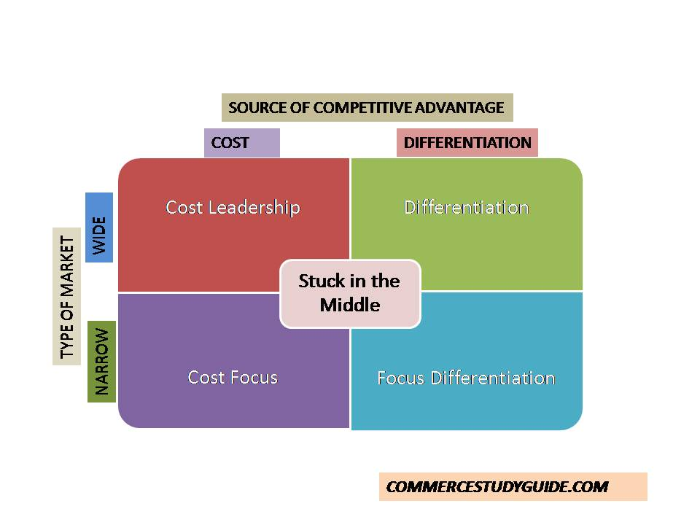
(September 2018)
There are two key dimensions of business strategies for a competitive advantage. Scope of the strategy and source of competitive advantage.

Cost leadership / overall cost
- Becoming the lowest price provider for a broad customer base

This is achieved by,

- Efficient production method
- Continually keeping a close relationship with suppliers
- Investment in newer technology

Overall Differentiation
- Doing something unique to ensure customers pay more for the product
This is achieved by,
- Higher quality
- Wide distribution
- Better brand value
Cost focus
- Cost leadership in a narrower focused market
Differentiation focus
- Differentiation in a narrower focused market
A lot of companies try and maintain a balance where if caution is not taken this can result in being stuck in the middle and neither being cost effective or different. Samsung is believed to sit slightly higher than the centre (as shown on table above) but with great caution (May2020).
Samsung do have many advantages over their competitors these include
- Appeal to Global market
- Make and sell products to all
- Is differentiated
- Uses an open system (Android)
- Products are diversified – ranging from phones and computers to household appliances and TV’s
- Quality is seen as excellent
- Competitive edge is mass production at low costs.

2.3 Strategy analysis of Samsung – Bowmans strategic clock

The Bowmans strategy clock was developed by two famous economists Cliff Bowman and David Faulkner to allow companies to be aware of their position in the current market compared to their competitors. The Bowmans clock allows organisations to identify their position in the market for their product or services based on two dimensions. Price and perceived value. Its very important for management of an organisation to understand the eight crucial fundamentals strategic positions of the model in order to place their organisation in a true, fair position that offers the most competitive advantage over their competitors (Bhasin 2019).

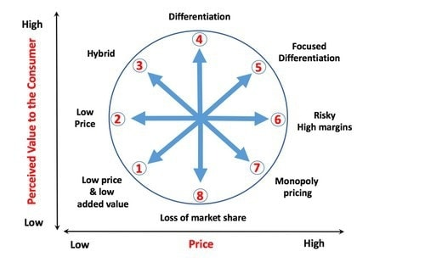 (Bhasin 2019)
On Bowmans clock I would personally position Samsung on 2 (marked X on the image above) From the information gathered throughout this report I believe that Samsung strive to maintain high quality products but at a low price. Samsung has proved to be the most compatible and produce high quality products affordable prices reaching out to a wider range of customers.

2.4 Evaluation of Porter and Bowman
Bowman’s clock can be seen as am alternative or extension to Porter’s generic strategy. Bowman’s clock is a strategy too to simply help an organisation see and understand, offering a range of starting points to discuss for the future improvements. Porter’s generic strategy works along side Bowman’s clock as another strategy tool to help see the position of the organisation to allow improvement to gain a competitive advantage. It is suggested that organisations should venture both tools as it gives them more of an understanding of where their organisation is placed on the market.

2.5 Strategy analysis of Samsung SWOT and PEST
SWOT and PEST analysis are two very valuable tools that gives an organisation the ability to see its position in the world. They are essential tools that an organisation should put into use as it gives them the opportunity to identify potential threats and help reduce the impacts that may occur. It also helps the impact of various decisions before implementing them. SWOT analysis tells the entity what it can and can’t do both internally and externally and how to accomplish goals. PEST on the other hand is a management method designed to show major external factors that may influence and organisations operations. (Woodruff 2019). Following this brief description is Samsung SWOT analysis including their strengths, weaknesses, opportunities and threats ranked from their importance.

Strengths
- Good brand image
- Strong dominance in smart phone manufacturing
- Global availability

Weaknesses
- Differentiation of product
- Dependence of the American market
- High price
Opportunities
- Entering other markets
- Innovation
- Business diversification

Threats
- High competition
- New technology
- Impact of pandemic

Samsung Objectives – Future electronics is inspiring the world and create the future
- To lead innovations in technology
- Dedicate to offering new values and standards in the industry
- Providing the worlds best quality of product.
Samsung’s Goals
- Quantitative goal is to reach a 400 billion figure of sales and become no.1 in the IT industry
- Quantitative goal is to be a creative leader and becoming a position in the top 10 worlds best workplaces to attract the worlds most talented people (Davis 2021).

Samsung PEST analysis is as followed
Political factors – Samsung being an electronics company need to abide by new and existing government regulations. Samsung have suffered but also benefited from exploitation of political instability. Samsung have been stopped from making electronic sales to parts of the world like Germany due to a previous court case.

Economic factors – Big brands like Apple and Google are direct competitors of Samsung. Samsung however remain the leading brand in the phone manufacturing sector. Remaining top gives some benefits but the downfall is Samsung solely relies on phone sales. Any type of Global crisis will lead to a crisis for Samsung but despite this they continue to produce new devices and remain on top.

Social factors – Samsung are still lacking in some aspects for example Google phones released the latest Android update immediately and it took Samsung six months to manage to release the same update. At this point the update is already six months closer to redundancy.

Technological factors – Technology is Samsung’s biggest strength. Samsung continuously upgrade existing products and creates new ones to have a stable lead (Frue 2019).

2.6 Evaluation of SWOT and PEST

SWOT PEST

Strengths Political

Weaknesses Economic

Opportunities Social

Threats Technological

2.7 Strategy analysis of Samsung – Stakeholder analysis
Following is a table showing Samsung’s stakeholders on a scale of importance.

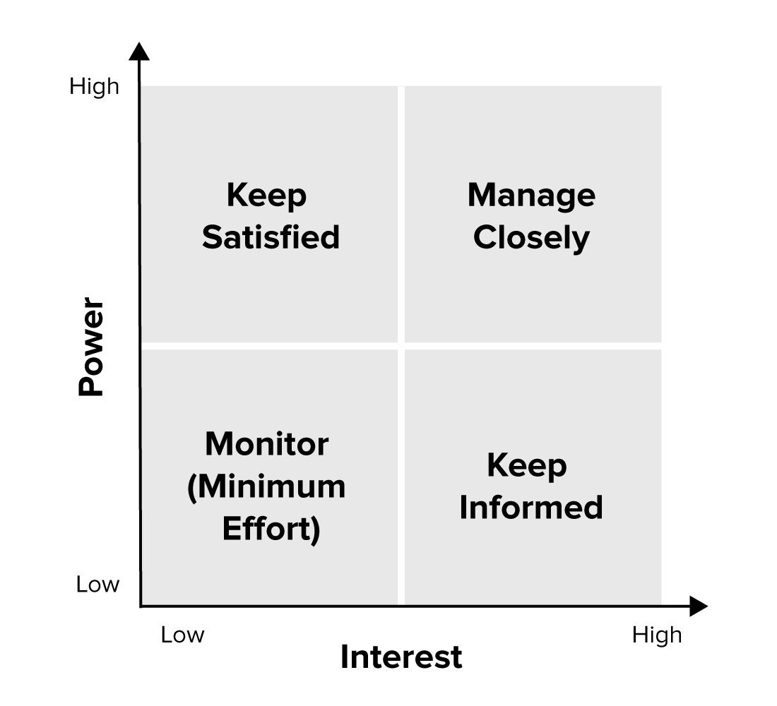
Communities
Owners
Government
Employees
Media
Suppliers
Customers

2.8 Evaluation of stakeholder analysis
Following the graph above this is a small evaluation of where I believe the stakeholders should be placed and why.
Owners – Owners of Samsung are of very high power and of interest. It is crucial that they are informed always about any aspects of the business. Samsung strongly advises that any issues are to be brought to the attention of highest member of team.
Customers – Customers are key in a technology firm such as Samsung. They strive for customer satisfaction. It is key to make sure customers are always satisfied and kept informed of the latest technology releases to maximise sales and keep customer loyalty.
Government – It is crucial to keep the government in the loop and satisfied. As Samsung are so big on the market its at great importance they keep up to date with rules and regulations set my the government.
Suppliers – Suppliers have an important roll with Samsung as they rely on their commitments. If deals are broke it could cause catastrophic problem for Samsung to be able to distribute their products.

Employees – One of Samsung’s goals is to be the best place in the world to work and this results in them keeping their employees satisfied, informed and closely monitored as they wish to resolve any issues that arise. Samsung also believes it wouldn’t be top without the hard work and dedication of all its employees.

Media – Media do play a part in Samsung when releasing new devices. The world as we know is revolved around media and Samsung relies on media to spread the word of what they are achieving and involved in. Its important that they are kept informed of new releases and only need to be lightly monitored.

Communities – Communities do need to be kept informed and Samsung’s plans but again only slightly monitored.

3.0 Conclusion
During the duration of this report we have covered who Samsung are and where they originated, A range of strategic tools used in businesses and applied to Samsung to utilise their goals and plans they have in place to make future changes such as Porters generic strategy, Bowman’s clock, SWOT and PEST analysis finishing with evaluations of the evidence found.

4.0 References

5 Ps of Strategy - Mintzberg. (2018, October 10). Youtube. Retrieved 25 October 2021, from https://www.youtube.com/watch?v=ZhM1JW2Bb8Q
Apple vs Samsung Strategy - What is Strategy - Strategy Made Simple - 0. (2020, May 6). Youtube. Retrieved 29 October 2021, from https://www.youtube.com/watch?v=NRTPDXaJspU
Bhasin, H. (2019, April 17). What is Bowman’s strategy clock. Marketing 91. Retrieved 29 October 2021, from https://www.marketing91.com/what-is-bowmans-strategy-clock/
Bhasin, H. (2019a, April 17). Bowman’s strategy clock [Photograph]. Bowman’s Clock. https://www.google.com/search?q=Bowmans+clock&source=lnms&tbm=isch&sa=X&ved=2ahUKEwjXqJOBgvDzAhUxh_0HHY3uB8QQ_AUoAXoECAEQAw&biw=1536&bih=882&dpr=1.25#imgrc=5Qf4pmHk1bqo_M
Bondarenko, P. (2021, October 1). Samsung. Samsung History and Facts. Retrieved 24 October 2021, from https://www.britannica.com/topic/Samsung-Electronics
Davis, A. N. (2021, July 10). Samsung SWOT analysis 2021 A Detailed report. Swothub. Retrieved 25 October 2021, from https://swothub.com/samsung-swot-analysis/
Frure, K. (2019, February 27). PEST analysis of Samsung. Pest Analysis. Retrieved 29 October 2021, from https://pestleanalysis.com/pest-analysis-of-samsung/
Hill, C., & Jones, G (2012). Essentials of strategic management. 3rd edition. Boston: Cengage learning. Retrieved 29 October 2021.
Marete, F. (2012). SWOT analysis of Samsung. Grin. Retrieved 25 October 2021, from https://www.grin.com/document/278578
Porter’s Generic (Competitive) Strategies. (2021, October 13). Business Balls. Retrieved 29 October 2021, from https://www.businessballs.com/strategy-innovation/porters-generic-competitive-strategies/
Porters generic strategies. (2018, September 10). [Graph]. In Commercestudyguide.
“Samsung business and corporate level strategies” (2017,May 11) Retrieved October 29,2021, from https://www.paperdue.com/essay/samsung-business-and-corporate-level-strategies-2165305
UKEssays. (November 2018). Business Strategy - Samsung. Retrieved from https://www.ukessays.com/essays/business/business-strategy-samsung.php?vref=1
Woodruff, J. (2019, January 28). Reasons to use SWOT & PEST analysis. Swot and Pest. Retrieved 29 October 2021, from https://smallbusiness.chron.com/reason-use-swot-pestle-analysis-40810.html

