18-11-2025
IWD : Database Design and Development
Design and Implementation of a Relational Database
Module Name: Introduction to Web and Database Concepts.
Module Code: ACCA 4023
Programme: CertHE Computing Skills for Workplace.

Student Name: Guido Garcia Llanos
Student ID: 2438787
Group: 3

Lecturer’s Name: Suneth Fernando

University of Wales Trinity Saint David
London CAMPS
Table of content
Introduction to the case study 2
Scenario Analysis 2
Rider 2
Bike 2
Rental 3
Staff 3
Tracking 3
Entity Relationship Diagram (ERD) 4
Type of Relationships 5
One – to – One 5
One – to – Many 6
Many – to – Many 7
Entities interact within the database 7
Logical Design 8
Relationships between tables 13
Testing and Validation 14
Normalization Process 15
MS- Access 17
Queries Creation 20
Report Creation 24
Calculations 26
Dashboard Creation 27

Introduction to the case study

The case study focuses on EcoRide, an electric bike rental scheme initiated by the local authority to promote sustainable and healthy commuting across public locations such as parks, train stations, and university campus in London. Riders can rent bikes by scanning their ID, use them for travel, and return them to any EcoRide station. However, the current manual system using paper forms and spreadsheets leads to inefficiencies, including poor tracking of bike availability, double-bookings, unreturned bikes, and limited analysis of usage patterns.

Scenario Analysis
EcoRide scenario, the tables are:

Rider: Rider renting bikes, Attributes:
Rider_ID(PK) (ShortText)
Rider_Name (ShortText)
Rider_Phone (ShortText)
Rider_Address (LongText)
E-mail (ShortText)

Bike: Bike can do many track, rent , Attributes:
Bike_ID(PK) (ShortText)
Bike_Type (ShortText)
Bike_Condition (ShortText)

Rental: Rent one bike , Attributes:
Rider_ID(FK) (ShortText)
Date (Date/Time)
Bike_ID(FK) (ShortText)
Rental_Data (Data/Time)
Return_Data (Date/Time)
Usage_Duration (Calculated
Hourly_Rate (ShortText)
Bike_Cost (Calculated)

Staff: Staff can do many track, Attributes:
Staff_ID(PK) (ShortText)
Staff_Name (ShortText)
Staff_Phone (ShortText)
E-mail (ShortText)
Staff_Task (ShortText)

Tracking: Many tracks can do one bike, staff, Attributes:
Staff_ID(FK) (ShortText)
Bike_ID(FK) (ShortText)
Location_ID (ShortText))
Bike_Track_No (ShortText)
Bike_Location (ShortText)

Entity Relationship Diagram (ERD):
Take a screenshot of your ER- Diagram and Paste it here
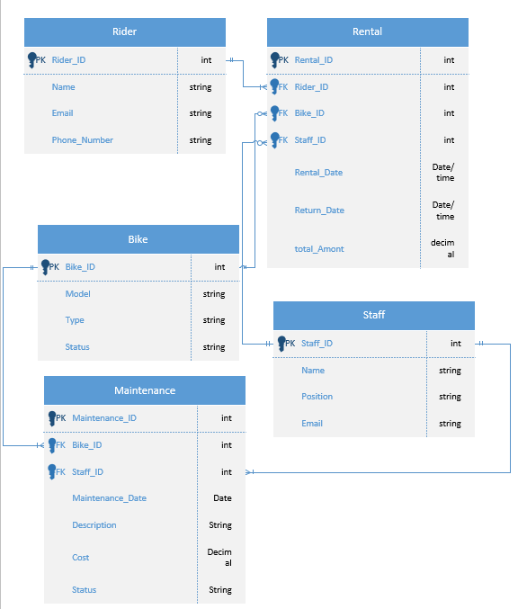

Type of Relationships
Type of Relationships between Entities (please explain each relationship with appropriate examples from the case study.)

One – to – One
It is a relationship where a single instance of entity A is associated with exactly one instance of entity B, and vice versa. It represents an exclusive and unique pairing.

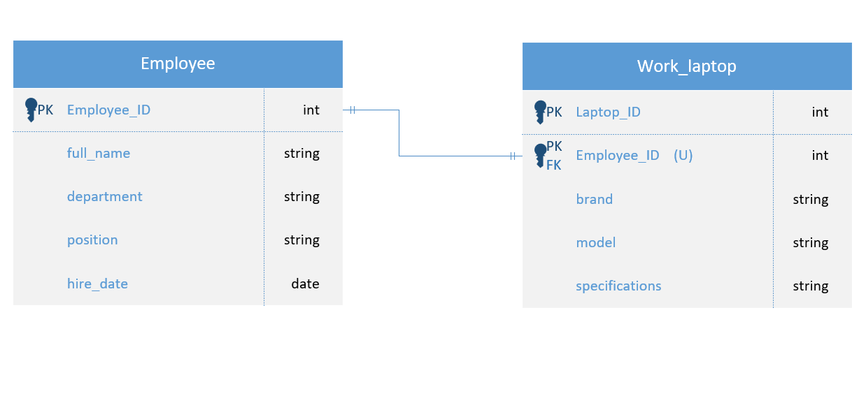

One – to – Many

One entity can be associated with multiple instances of another, But each instance of the second belongs to only one of the first.

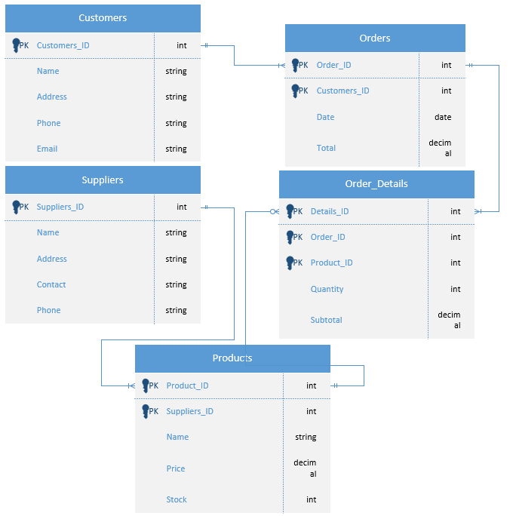

Many – to – Many

Multiple instances of one entity relate to multiple instances of another. Requires and intermediate (junction) table with foreign Keys from both.

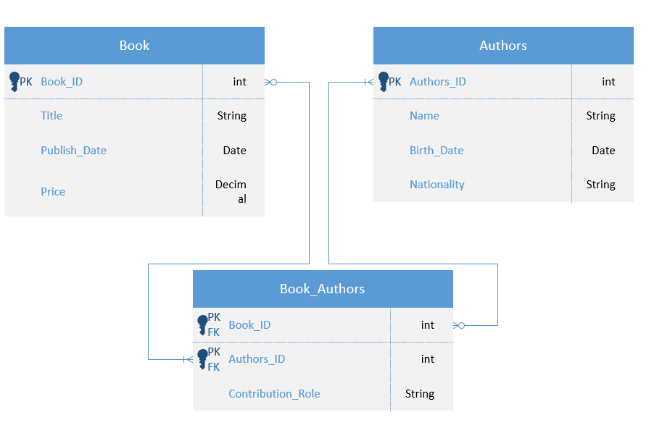

Entities interact within the database
Explain how ER modelling helps you when developing your database solution
EcoRide database development by providing a clear visual map of entities (Rider, Bike)
And their interactions, ensuring relationship like 1:M between Bike and Rental were properly defined to avoid data duplication. It facilitated identifying primary/foreign keys for integrity, guided normalization to prevent anomalies, and aligned the structure with requirements like tracking rentals and maintenance. This blueprint simplified implementation in MS Access, reducing errors and enabling efficient queries for availability.

Logical Design
Table Creation in MS – Access (take screenshots of each table (Datasheet view and design view) and paste it here and annotate each screenshot.
Customer Details table (Design view and datasheet view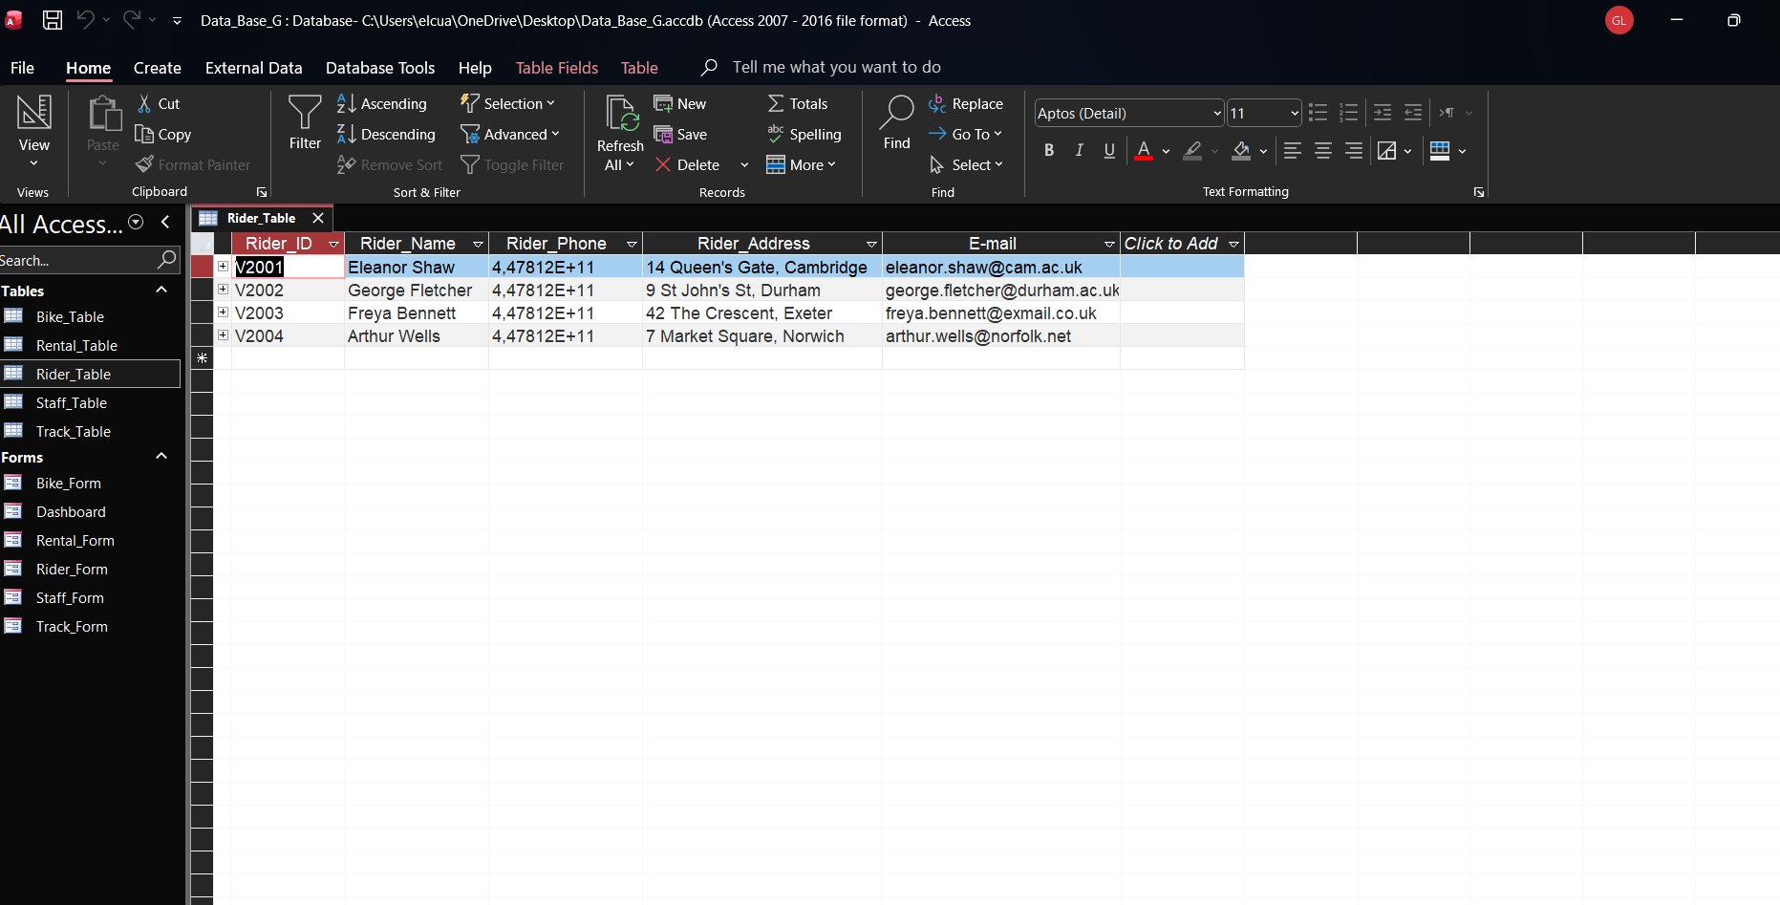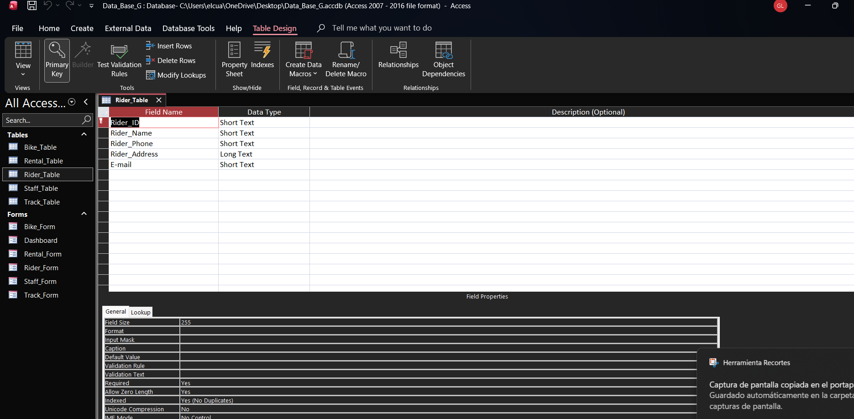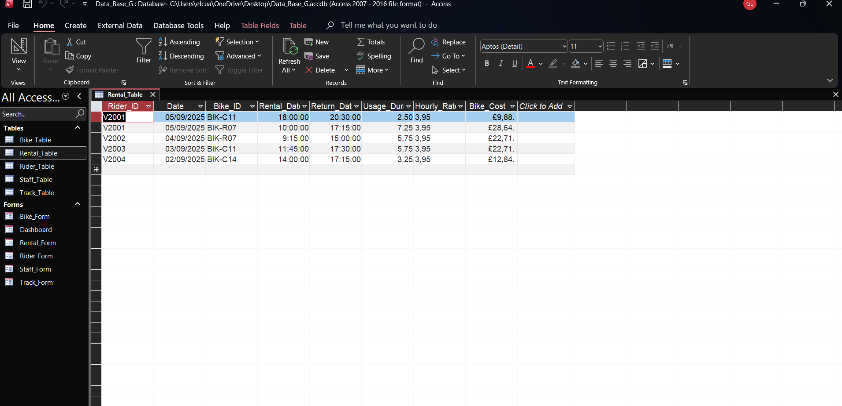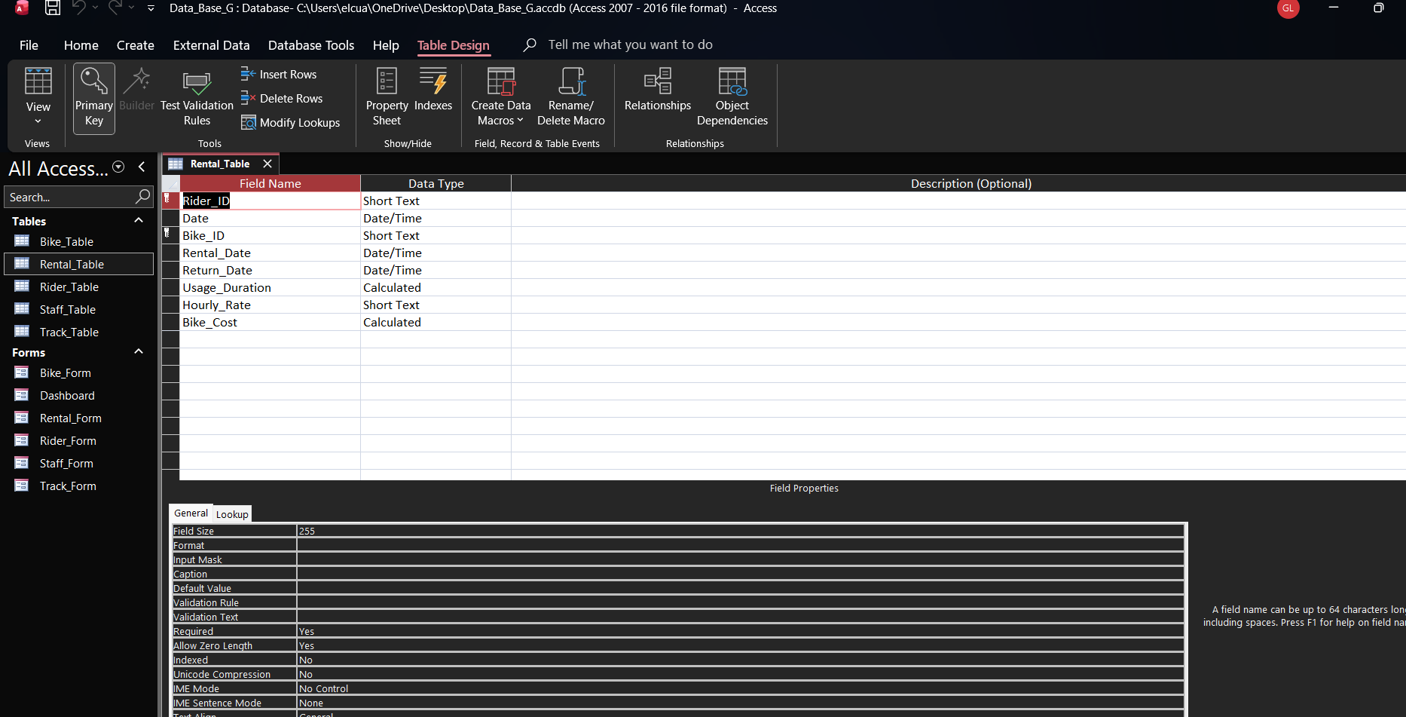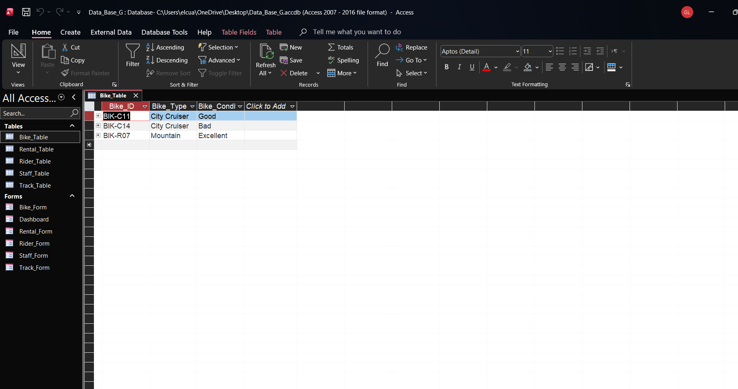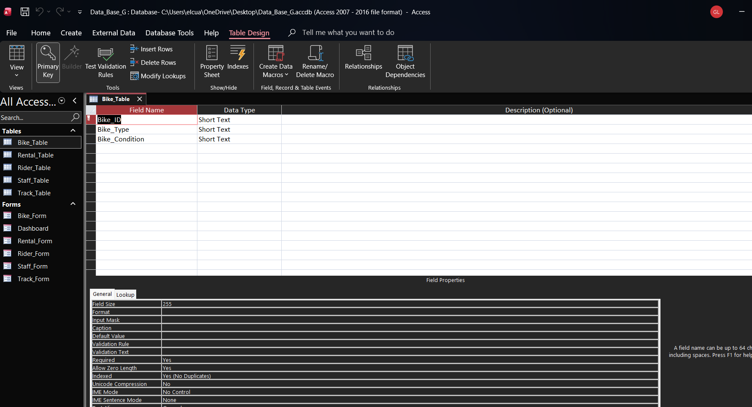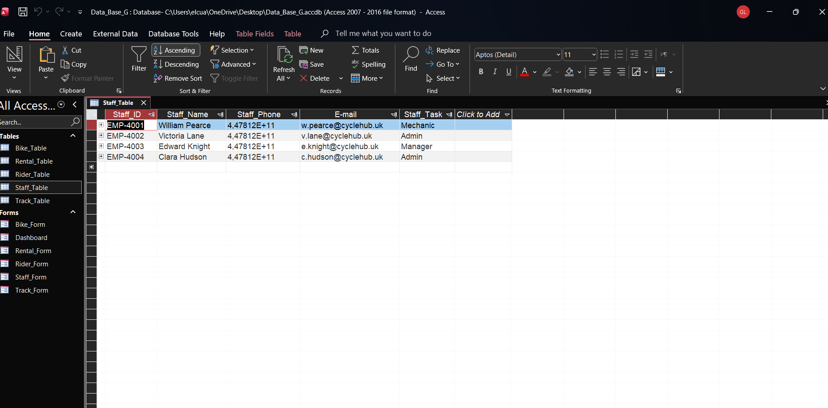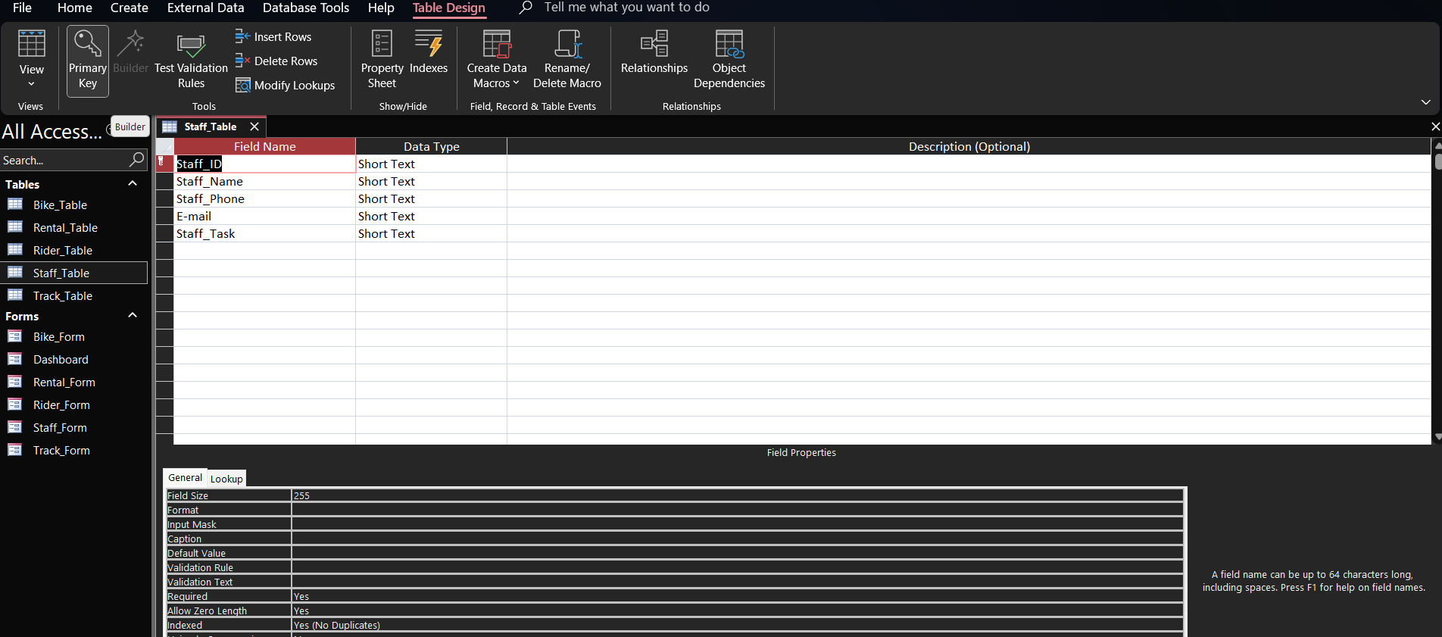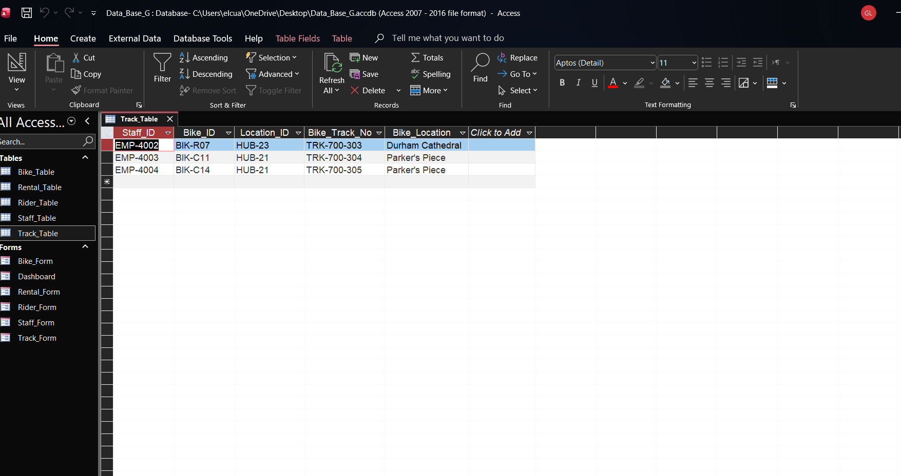

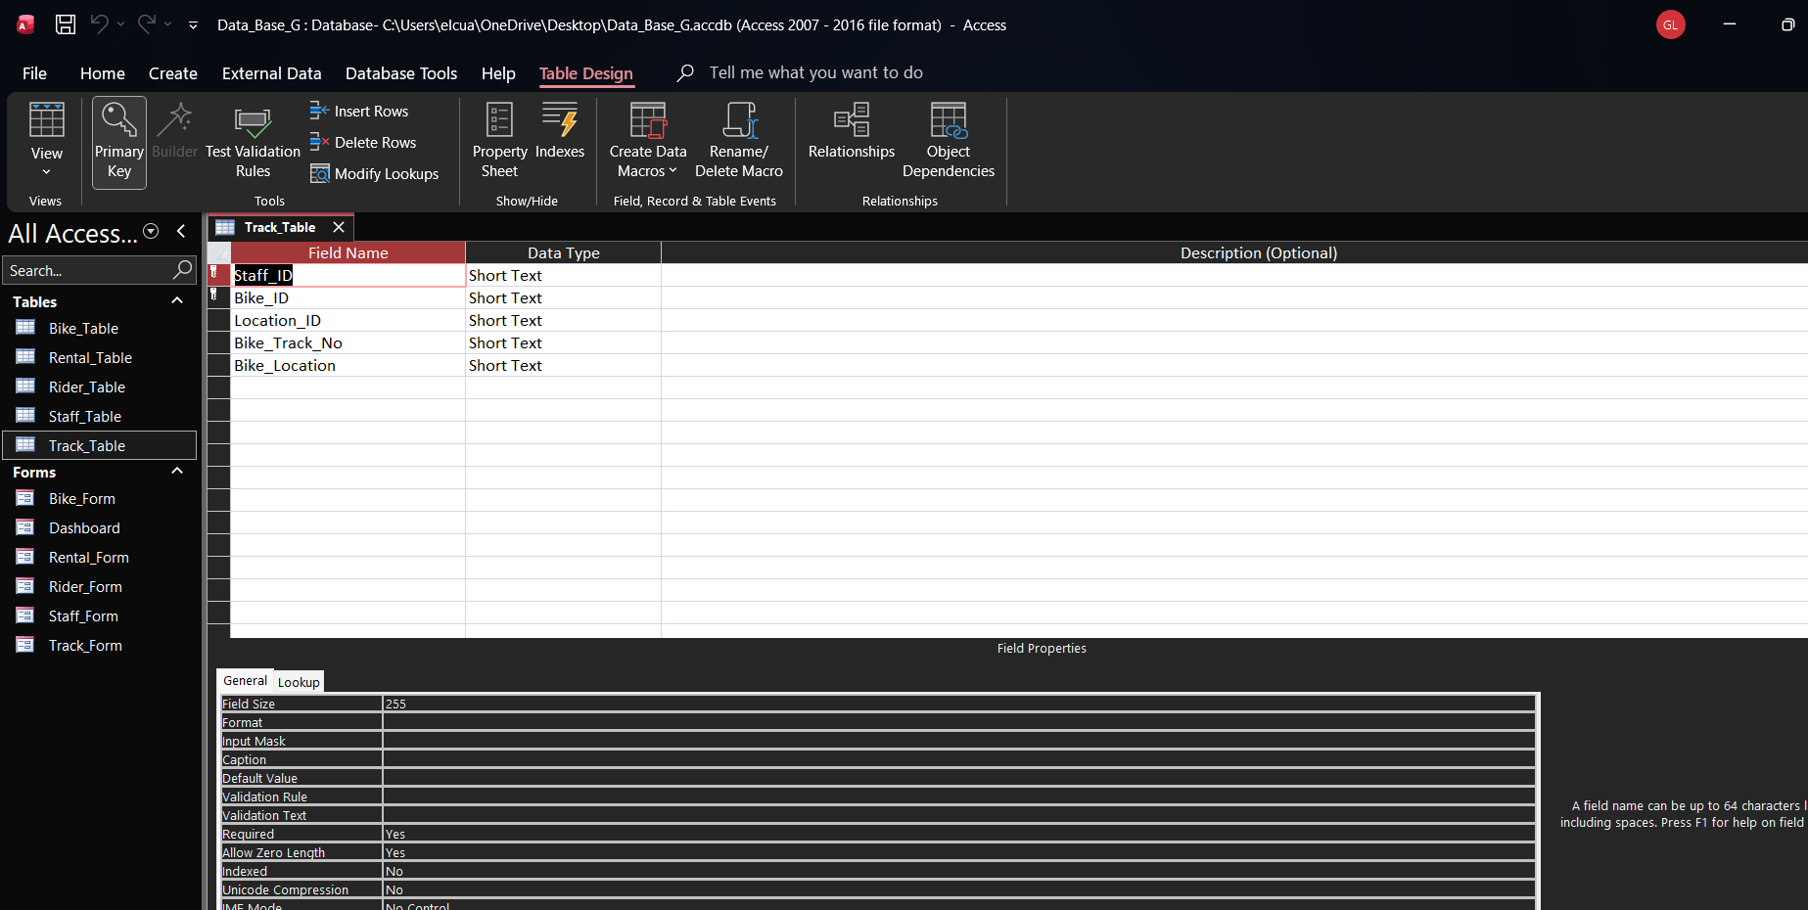

Relationships between tables
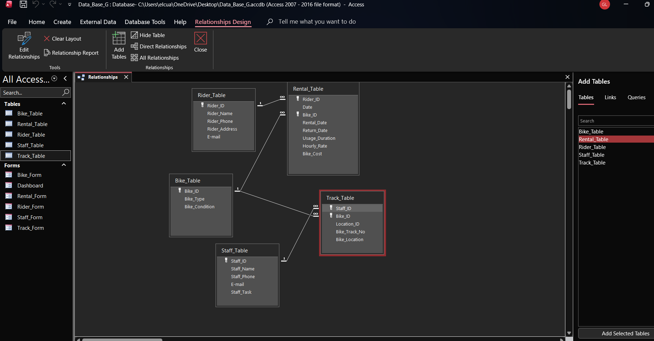
Explain what type of key attributes (each table) used to create relationships between tables.

1: Rider_Table → Rental_Table
One rider (Rider_ID = (PK)) can have many rents →*1:M* Each rental belongs to only one rider (Rider_ID =(FK)) in Rental_Table.
*One to many* relationship.
2: Bike_Table →Rental_Table
One Bike (Bike_ID = (PK)) can be ranted many times *1:M* Each rental corresponds to only one bike (Bike_ID = (FK)) in Rental_Table.
*One to many* relationship.
3: Bike_Table → Track_Table
One bike can have multiple tracking/location records → *1:M* Each record in Track_Table belongs to only one bike (Bike_ID(FK)).
*One to many* relationship.
4: Staff_Table →Track_Table
One staff member (Staff_ID(PK)) can records many tracking entries *1:M* Each tracking member (Staff_ID(FK))
*One to many* relationship.

Testing and Validation
Requirements of the case study
2. Customer Information: A table called "Customer” has been designed and developed……..
Test Cases | Expected Results | Actual Results | Any Discrepancies
Bike_Most_Rented | It is expected to filter data from Bike_Table and Rental_Table to find out how many bikes are the most rented | Separate queries have been created to filter required data from Rental_Table | No
Bikes_For_Services | It is expected to filter data from Bike_Table and Track_Table to find out how many bikes needs services | Separate queries have been created to filter required data from Track_Table | No
Daily_Revenue | It is expected to filter data from Rental_Table, It shows how much spend in one date | A single total query has been created to ground rentals by date and calculate the daily revenue from Rental_Table | No
Top_Spenders | It is expected to filter data from Rider_Table and Rental_Table to find out who is spent more money | One total query groups rentals by customer(Rider_Name), Sums Bike_Cost to calculate total amount spent per rider and displays results sorted from highest to lowest spending . | No

Normalization Process
Take screenshots of 3rd Normal form from MS-Excel and Paste here and annotate each table.
Rider_Details table
Rider_ID | Rider_Name | Rider_Phone | Rider_Address | E-Mail
V2001 | Eleanor Shaw | 4,47812E+11 | 14 Queen's Gate, Cambridge | eleanor.shaw@cam.ac.uk
V2002 | George Fletcher | 4,47812E+11 | 9 St John's St, Durham | george.fletcher@durham.ac.uk
V2003 | Freya Bennett | 4,47812E+11 | 42 The Crescent, Exeter | freya.bennett@exmail.co.uk
V2004 | Arthur Wells | 4,47812E+11 | 7 Market Square, Norwich | arthur.wells@norfolk.net

Rental_Details Table
Rider_ID | Date | Bike_ID | Rental Date | Return Date | Usage duration | Hourly rate | Bike_Cost
V2001 | 05/09/2025 | BIK-R07 | 10:00 | 17:15 | 7.25 | 3.95 | 28.64
V2001 | 05/09/2025 | BIK-C11 | 18:00 | 20:30 | 2.5 | 3.95 | 9.88
V2002 | 04/09/2025 | BIK-R07 | 9:15 | 15:00 | 5.75 | 3.95 | 22.71
V2003 | 03/09/2025 | BIK-C11 | 11:45 | 17:30 | 5.75 | 3.95 | 22.71
V2004 | 02/09/2025 | BIK-C14 | 14:00 | 17:15 | 3.25 | 3.95 | 12.84

Tracking table
Staff_ID | Bike_ID | Location_ID | Bike_Track_No | Bike_Location
EMP-4001 | BIK-R07 | HUB-21 | TRK-700-301 | Parker's Piece
EMP-4001 | BIK-C11 | HUB-22 | TRK-700-302 | Mill Road
EMP-4002 | BIK-R07 | HUB-23 | TRK-700-303 | Durham Cathedral
EMP-4003 | BIK-C11 | HUB-21 | TRK-700-304 | Parker's Piece
EMP-4004 | BIK-C14 | HUB-21 | TRK-700-305 | Parker's Piece

Bike_Details_Table
Bike_ID | Bike_Type | Bike_Condition
BIK-R07 | Mountain | Excellent
BIK-C11 | City Cruiser | Good
BIK-C14 | City Cruiser | Bad

Staff Table
Staff_ID | Staff_Name | Staff_Phone | E-mail | Staff_Task
EMP-4001 | William Pearce | 4,47812E+11 | w.pearce@cyclehub.uk | Mechanic
EMP-4002 | Victoria Lane | 4,47812E+11 | v.lane@cyclehub.uk | Admin
EMP-4003 | Edward Knight | 4,47812E+11 | e.knight@cyclehub.uk | Manager
EMP-4004 | Clara Hudson | 4,47812E+11 | c.hudson@cyclehub.uk | Admin

MS- Access
Forms Creation (take screenshots of all the forms and annotate them) 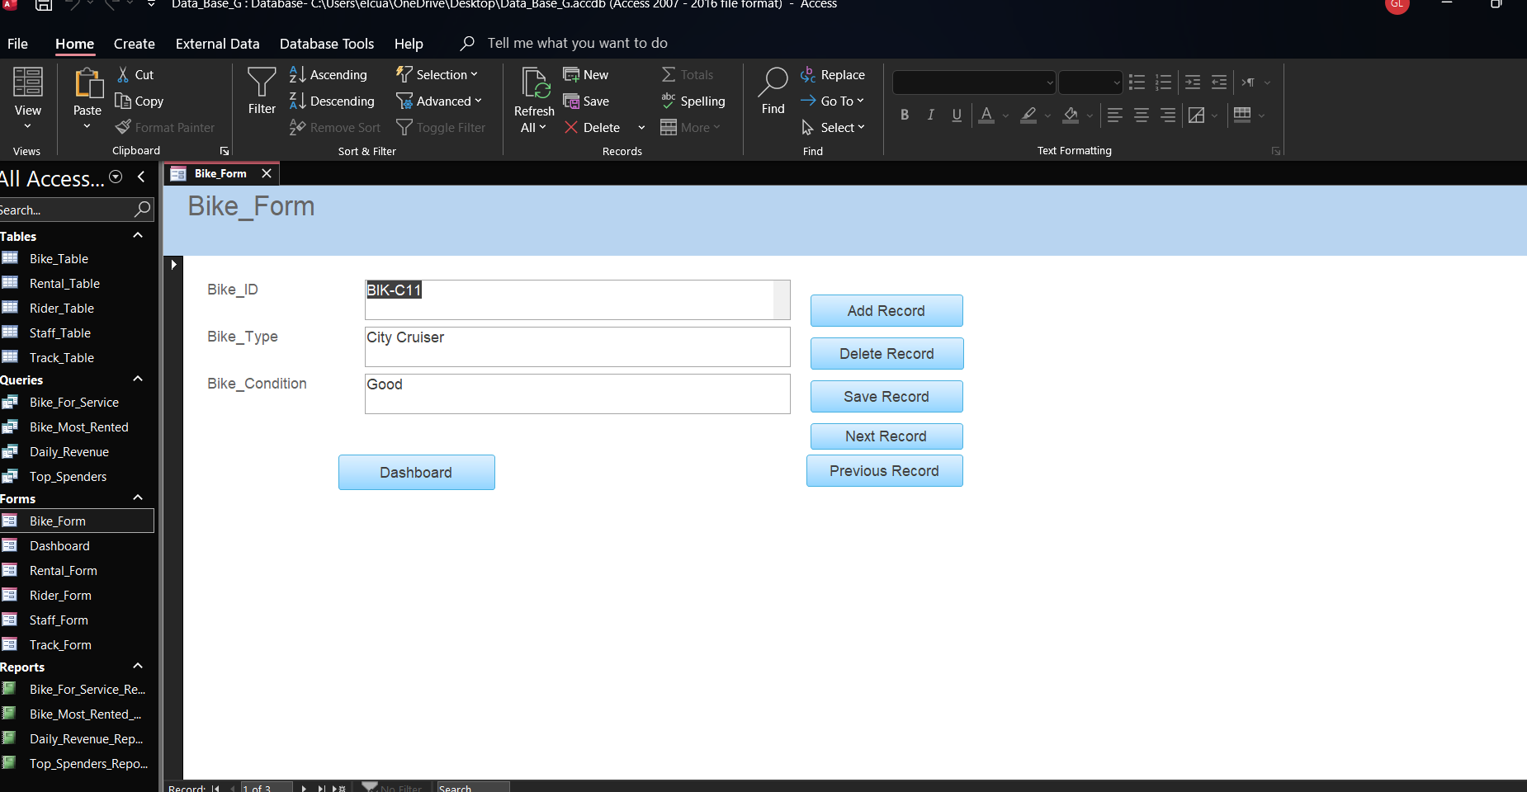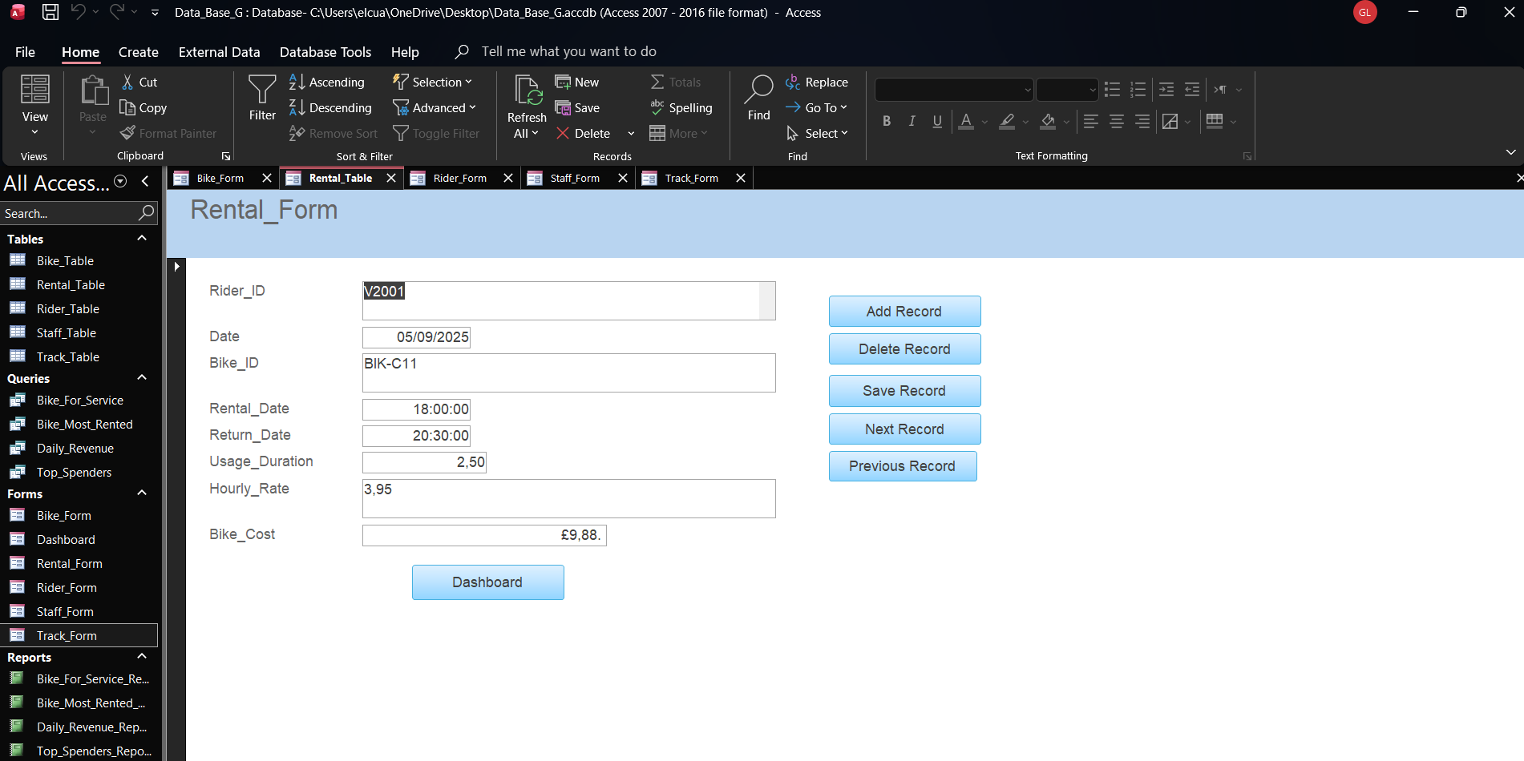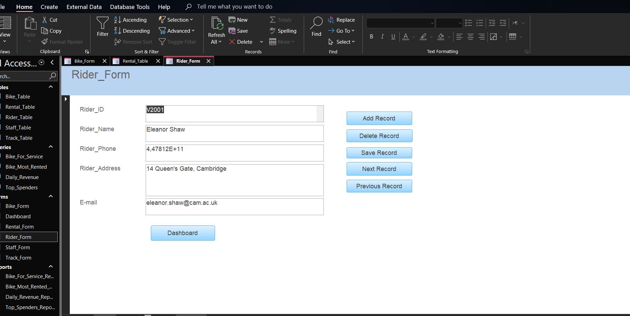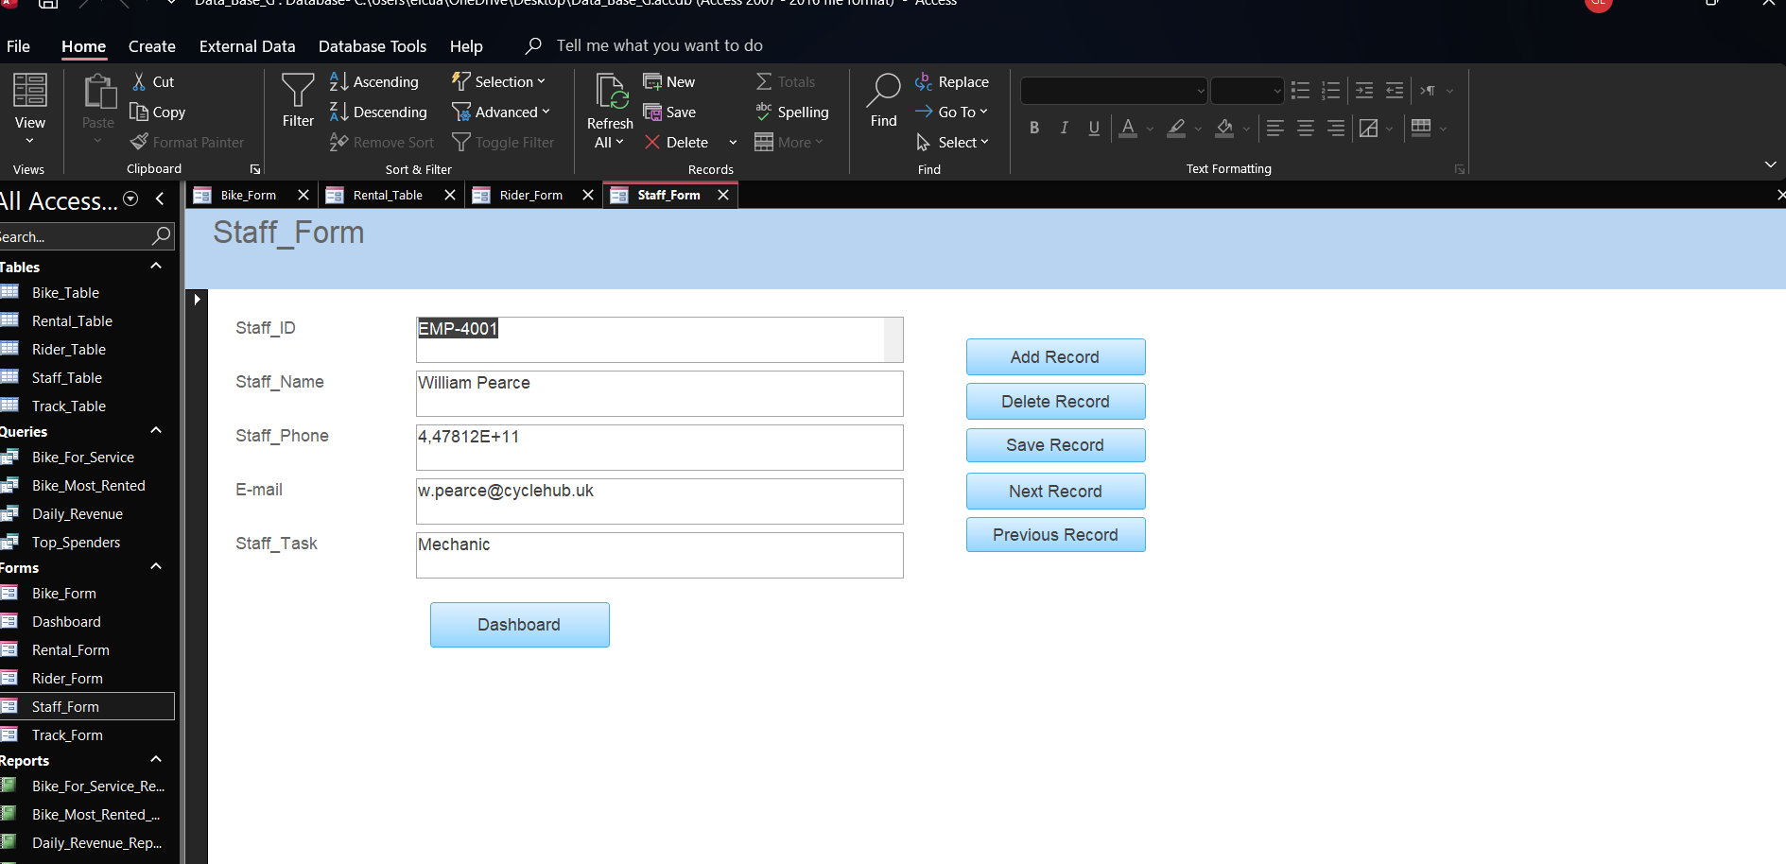

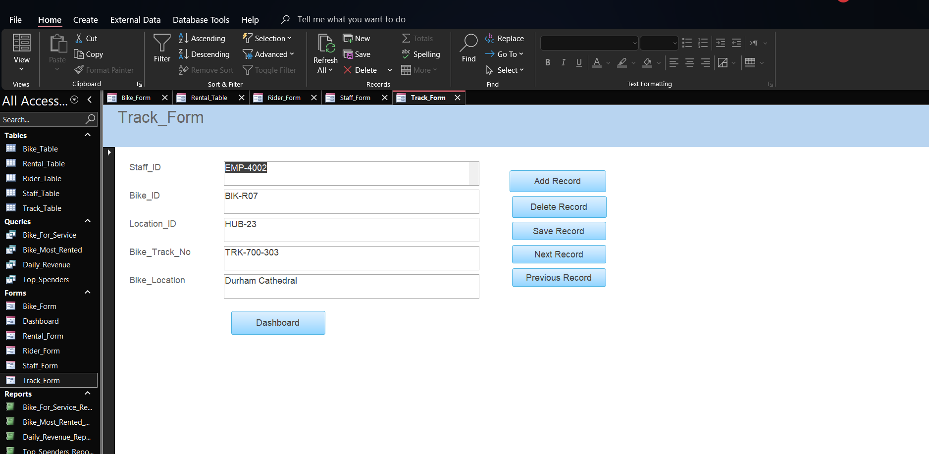

Queries Creation
(take screenshots of the design view, datasheet view and SQL view of each query and annotate them)
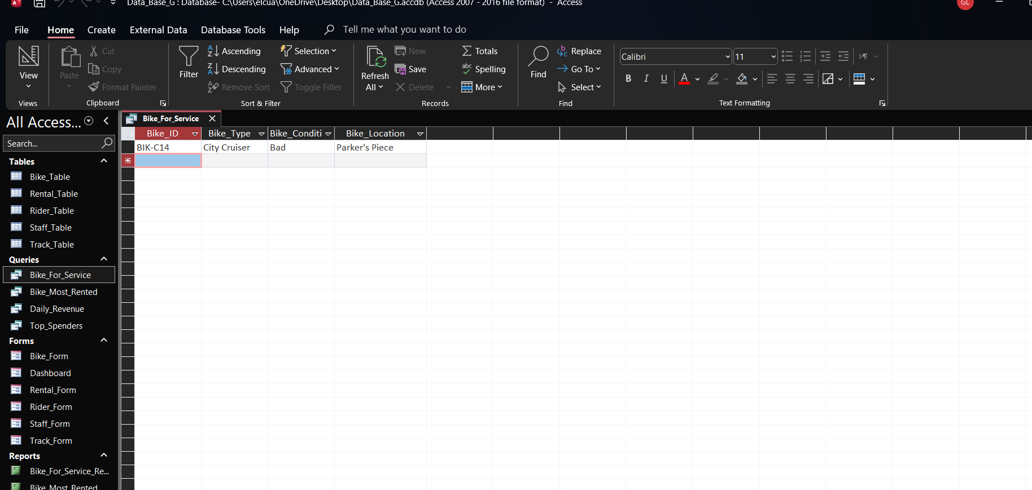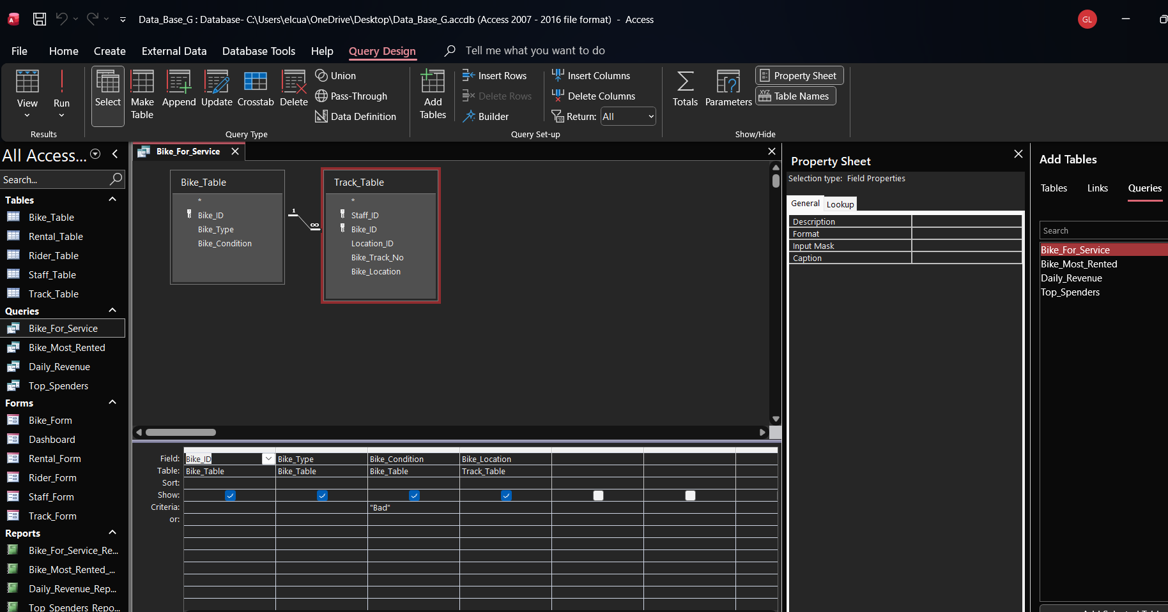

SELECT
Bike_Table.Bike_ID,
Bike_Table.Bike_Type,
Bike_Table.Bike_Condition,
Track_Table.Bike_Location
FROM
Bike_Table
INNER JOIN Track_Table ON Bike_Table.Bike_ID = Track_Table.Bike_ID
WHERE
(((Bike_Table.Bike_Condition) = "Bad"));
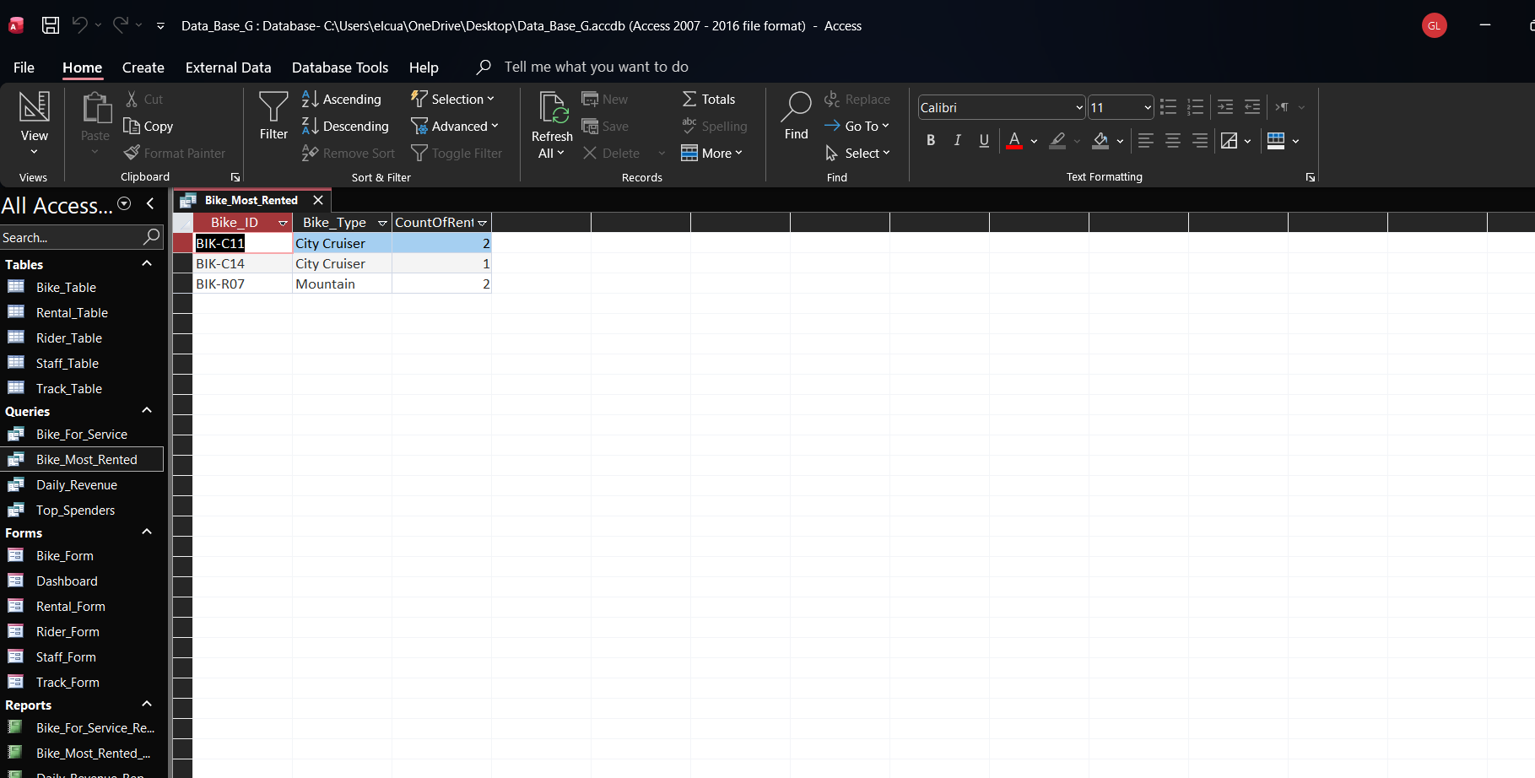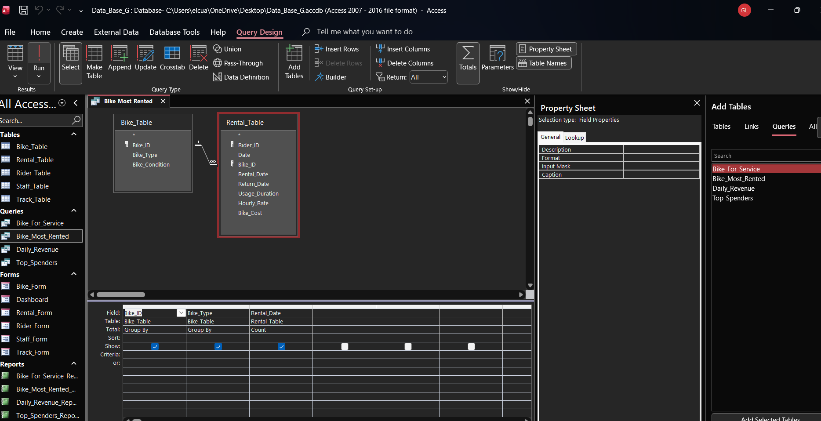

SELECT
Bike_Table.Bike_ID,
Bike_Table.Bike_Type,
Count(Rental_Table.Rental_Date) AS CountOfRental_Date
FROM
Bike_Table
INNER JOIN Rental_Table ON Bike_Table.Bike_ID = Rental_Table.Bike_ID
GROUP BY
Bike_Table.Bike_ID,
Bike_Table.Bike_Type;
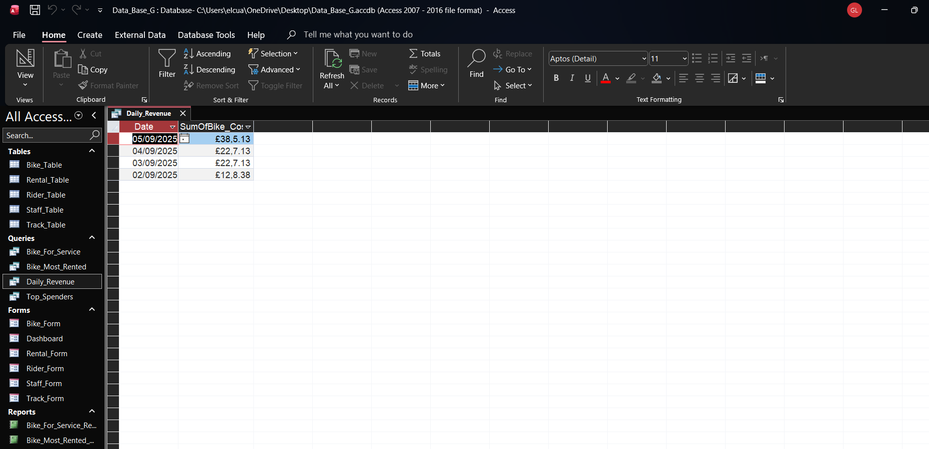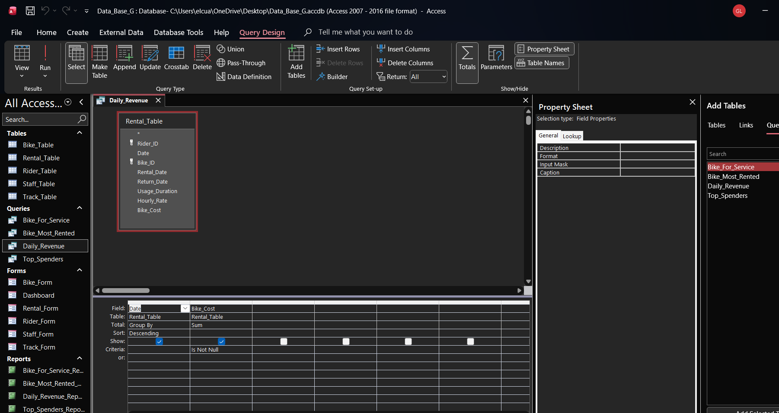
SELECT
Rental_Table.Date,
Sum(Rental_Table.Bike_Cost) AS SumOfBike_Cost
FROM
Rental_Table
GROUP BY
Rental_Table.Date
HAVING
(((Sum(Rental_Table.Bike_Cost)) IS NOT NULL))
ORDER BY
Rental_Table.Date DESC;
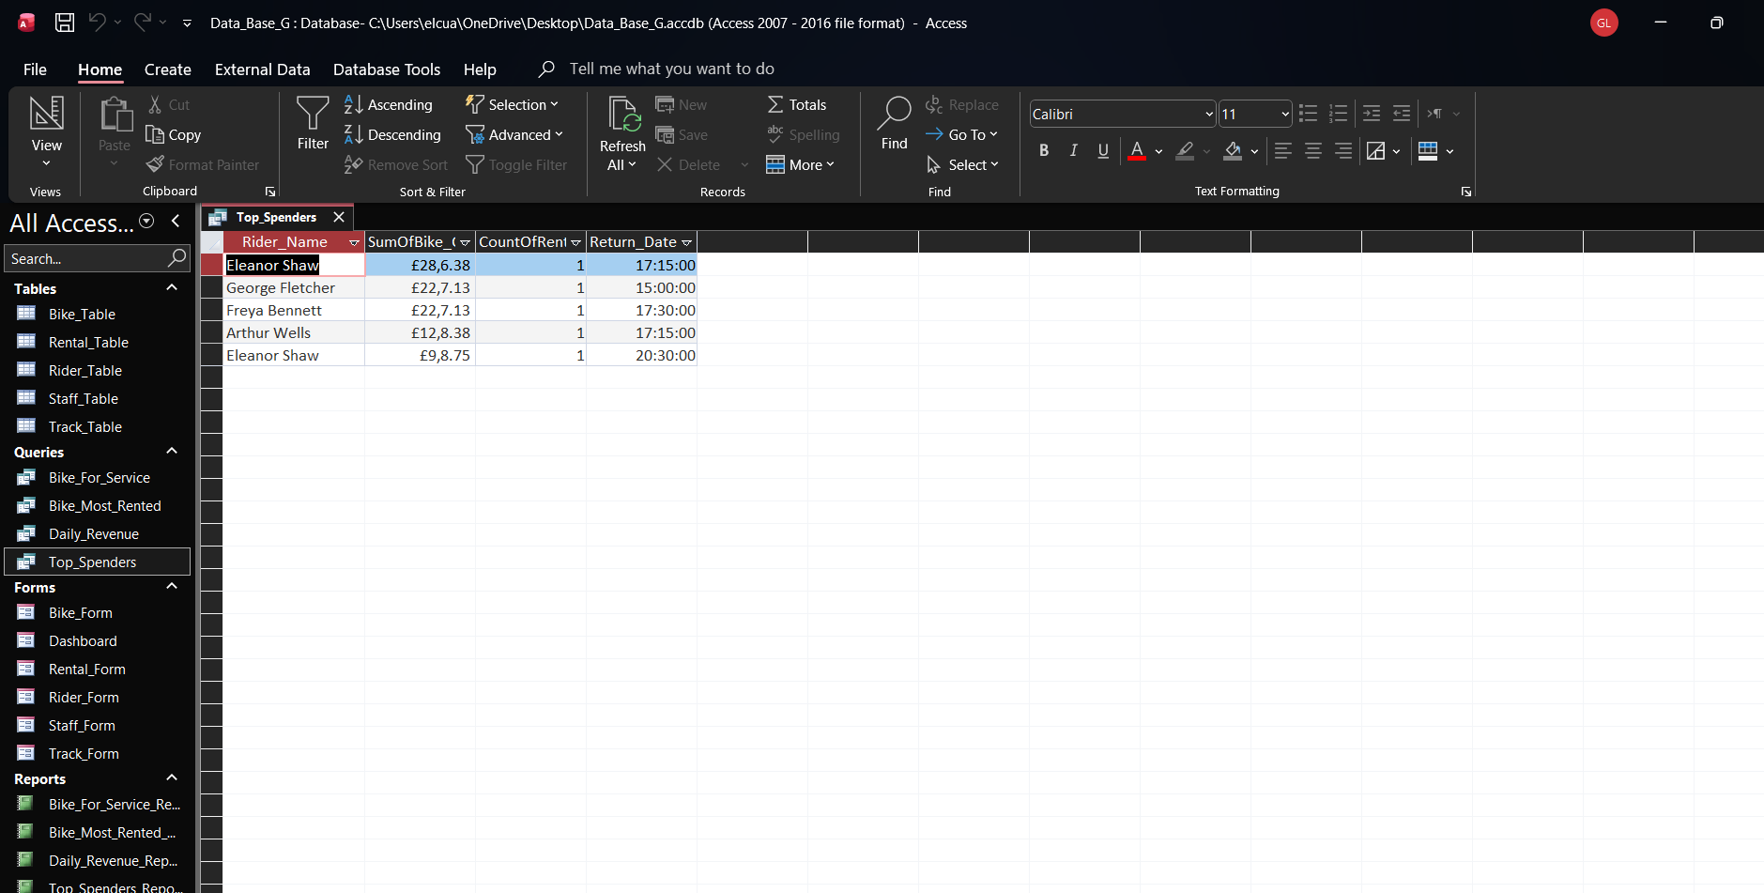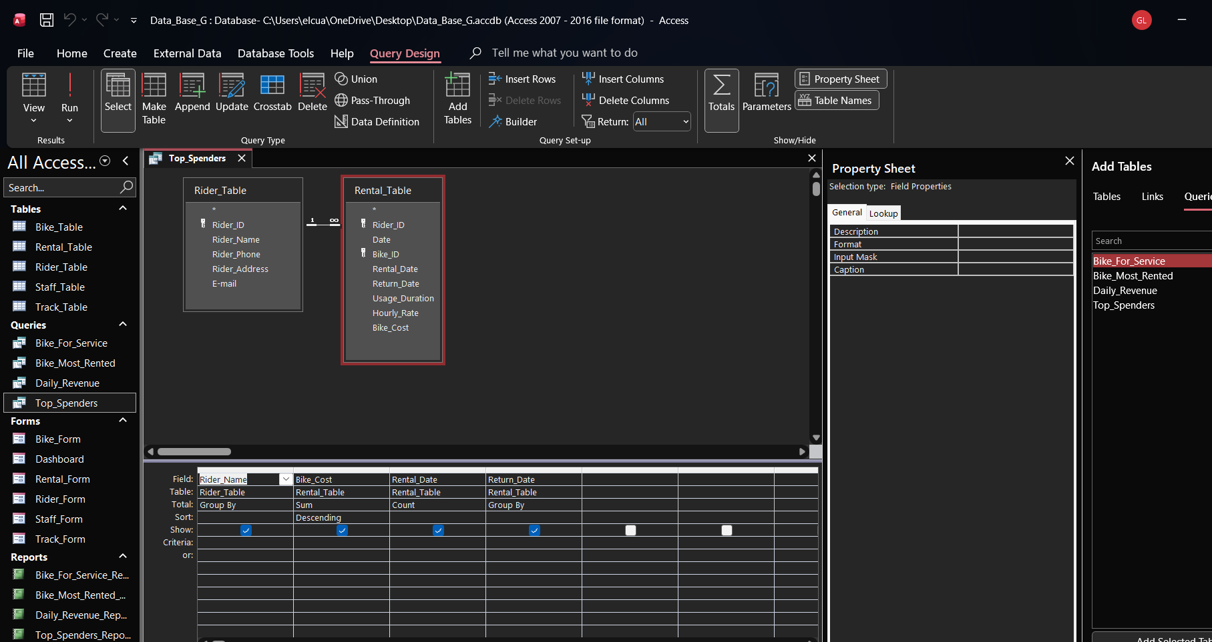
SELECT
Rider_Table.Rider_Name,
Sum(Rental_Table.Bike_Cost) AS SumOfBike_Cost,
Count(Rental_Table.Rental_Date) AS CountOfRental_Date,
Rental_Table.Return_Date
FROM
Rider_Table
INNER JOIN Rental_Table ON Rider_Table.Rider_ID = Rental_Table.Rider_ID
GROUP BY
Rider_Table.Rider_Name,
Rental_Table.Return_Date
ORDER BY
Sum(Rental_Table.Bike_Cost) DESC;
Report Creation
(create reports from each query and annotate them
Calculations (show how you implement calculation ( if any) and take screenshots) 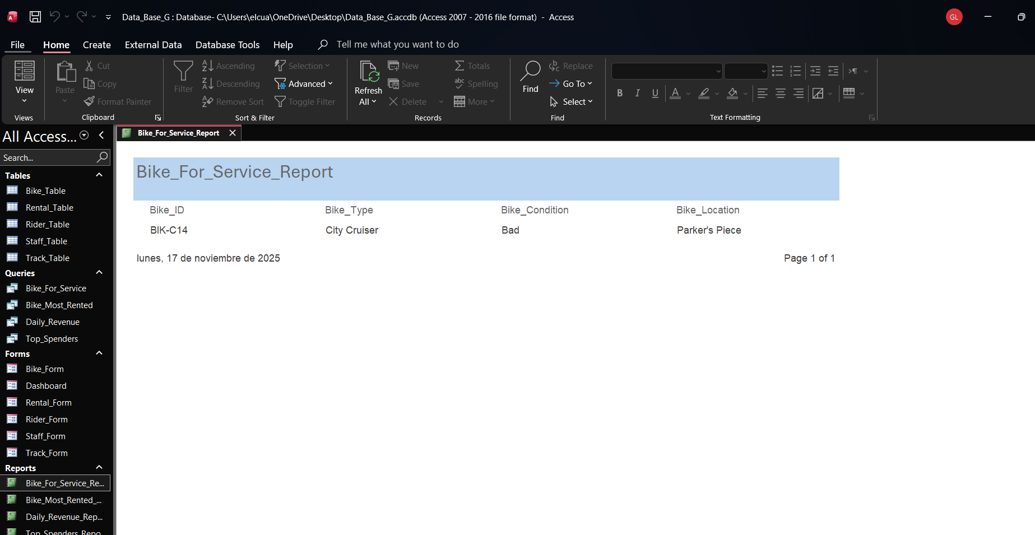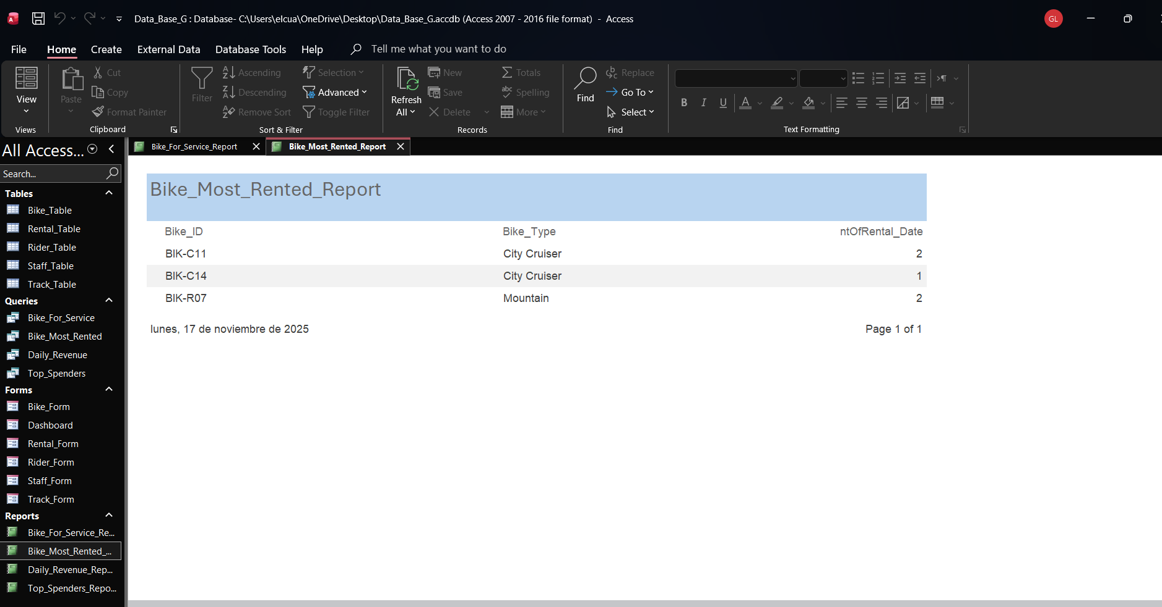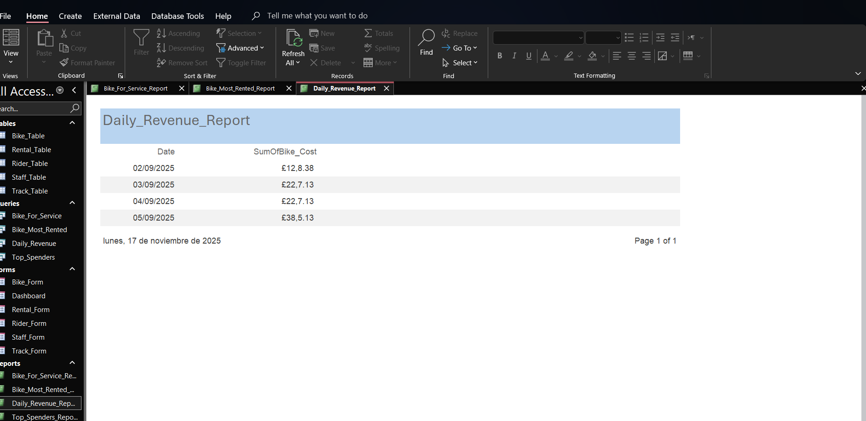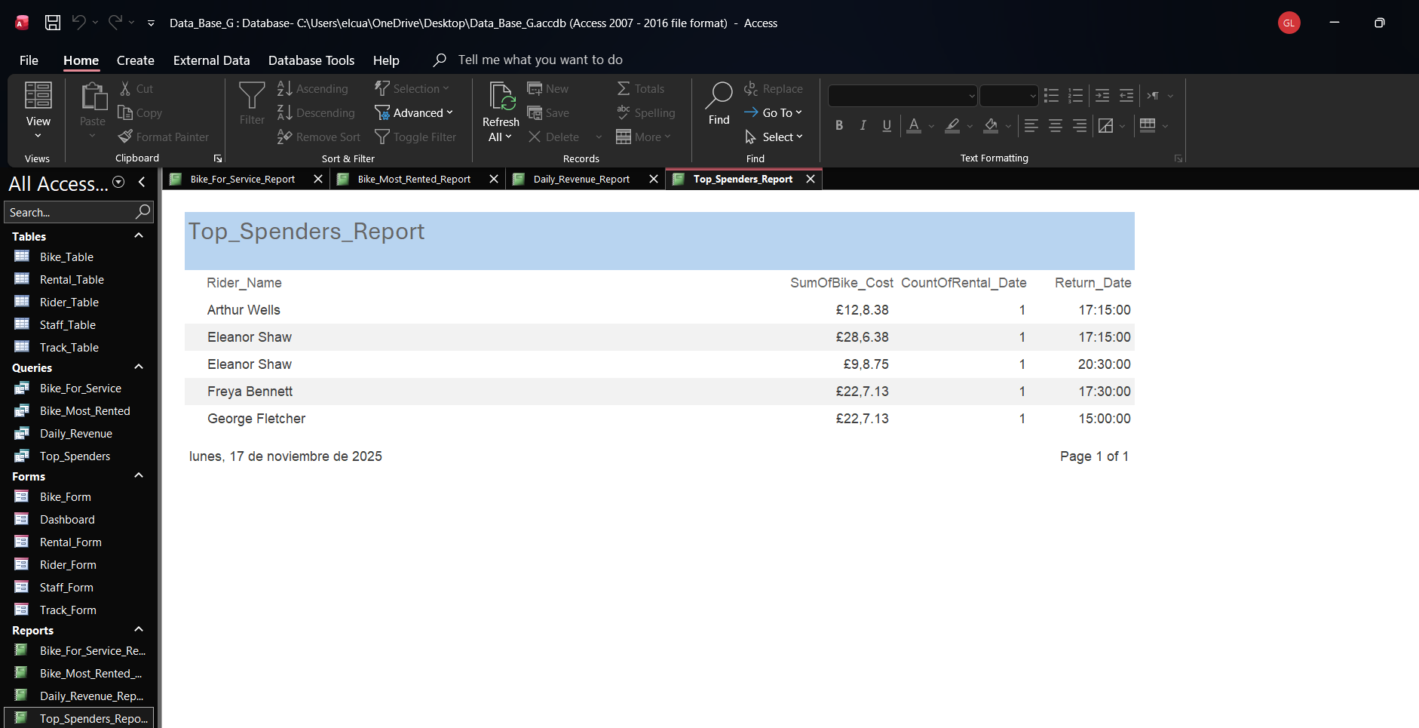
Calculations ( Show how you implement calculation (If any) and take screenshots)
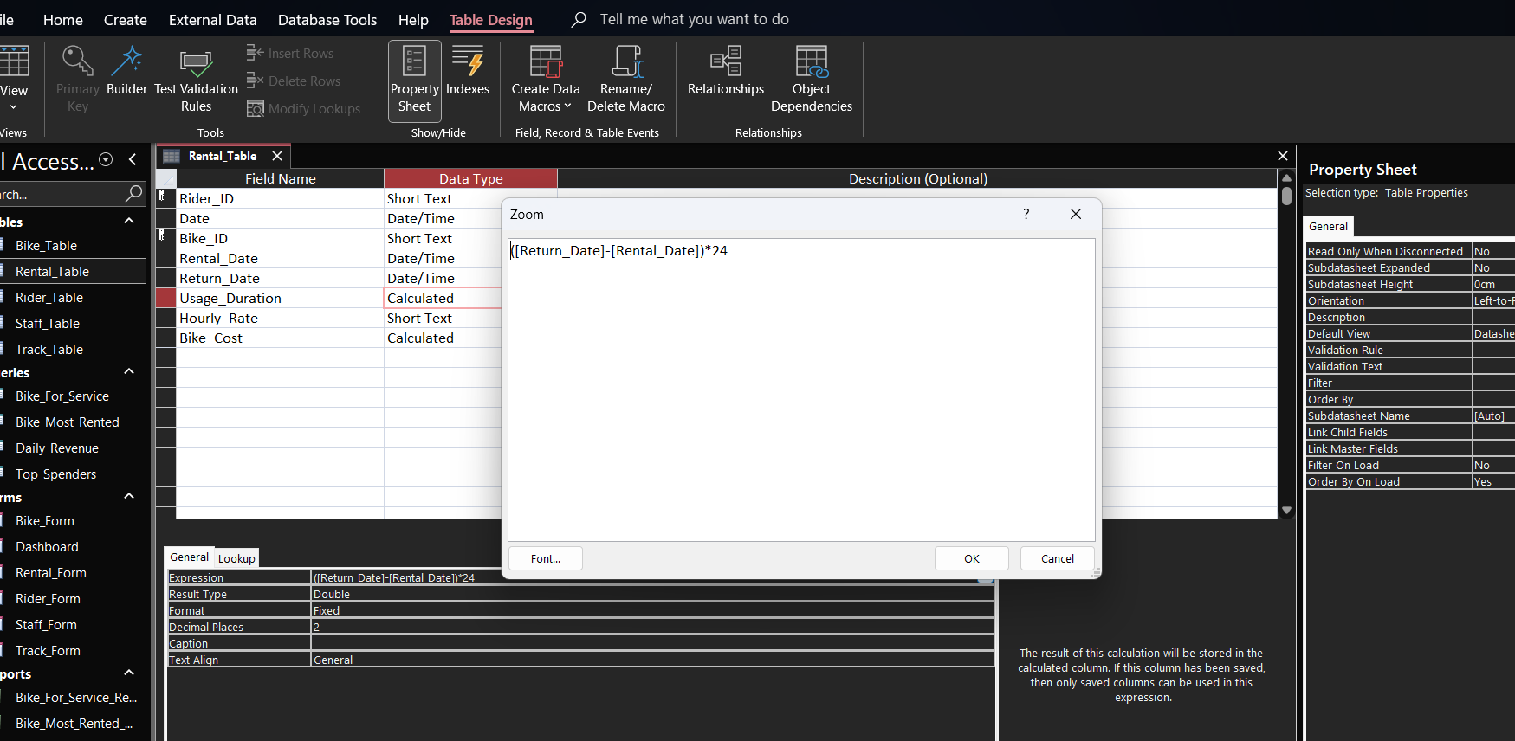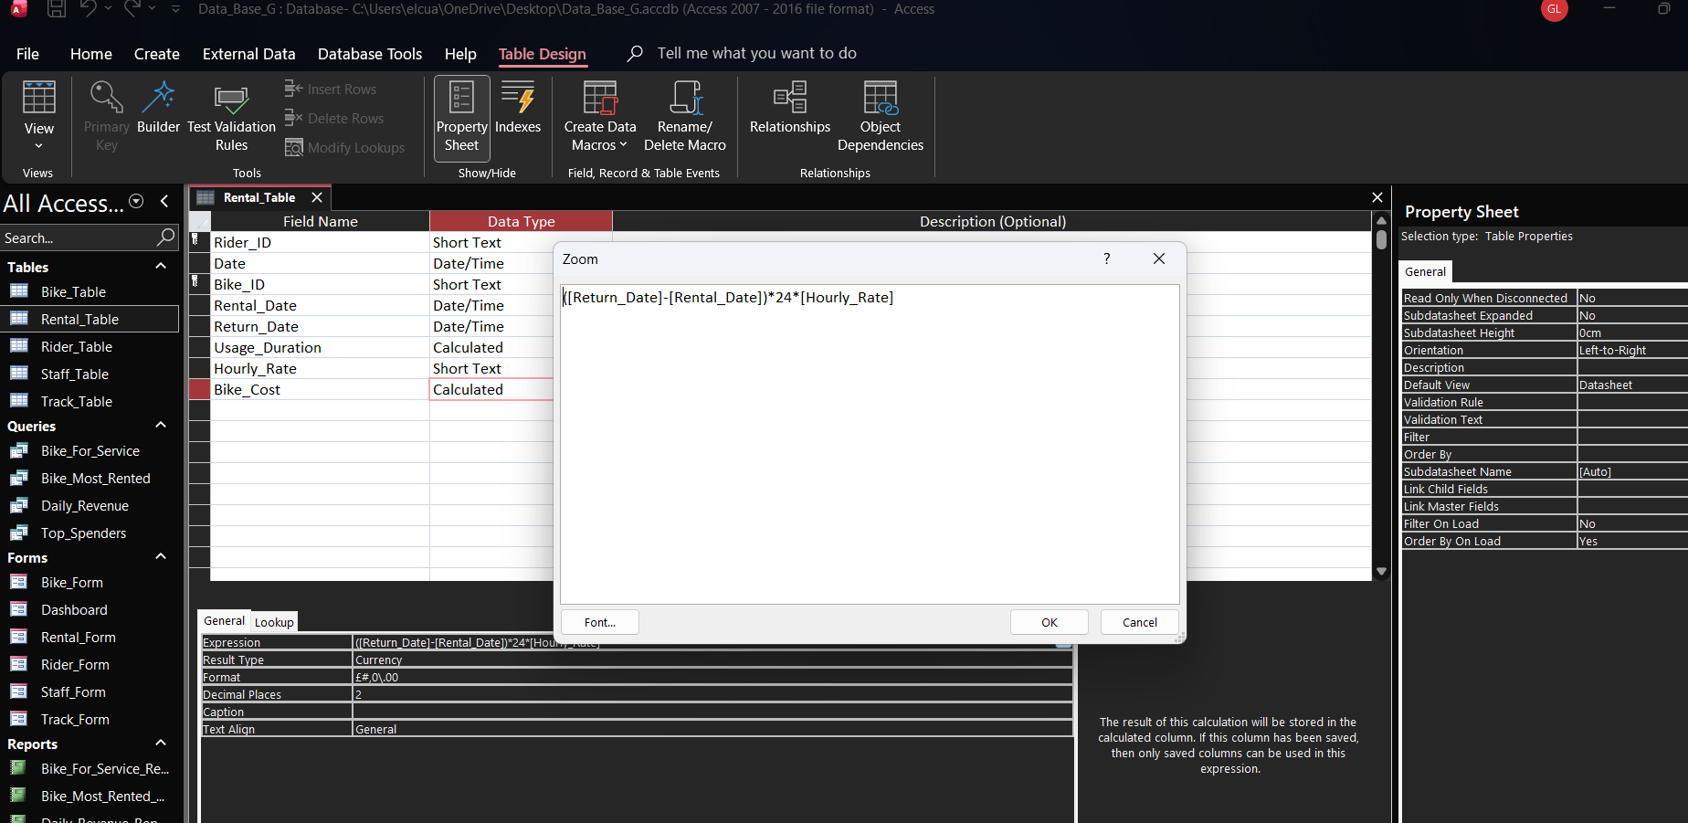

Dashboard Creation
(show how to navigate from dashboard to forms and forms to dashboard)


