Marketing Fundamentals

Assessment 1

Blogging to communicate

Student Name: Georgiana Ilie
Student Code:2024158
Module code: LCBB4004

Module Lecturer: Sadeque Shaikh

Table of Contents
Company Overview 3
Product Strategy 4
Pricing Strategy: 7
Place Strategy 8
Promotion Strategy 9
Reference 11

Company Overview
With headquarters in California, Apple is a worldwide corporation whose products are sold in more than fifty nations across the world. Apple inc. was founded on the 1st of April 1976. It was established by Steve Jobs and Steve Wozniak, as well as the corporation was officially created on the 3rd of January 1977 in California, United States of America (Van De Vliert, 2021). According to Steve Jobs' memoir, the title was established after he had just come out of an apple field and believed the word sounds "fun, lively, and therefore not scary.
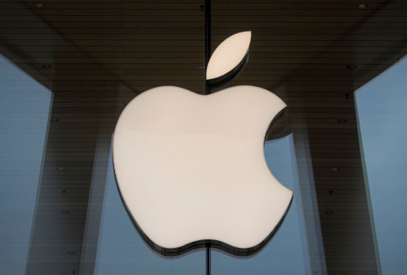
Product is sold via the firm's retail locations, e-shop, and sales agents, and also through third-party mobile network providers, distributors, and merchants across the globe. Apple also has its sights set on those with moderate to high incomes. Apple's most popular brand, the iPhone, is currently accessible in more than 50 nations, and then as a result of its widespread popularity and strong sales, the business has seen its sales growth grow steadily over time, allowing it to exit the marketplace quickly.
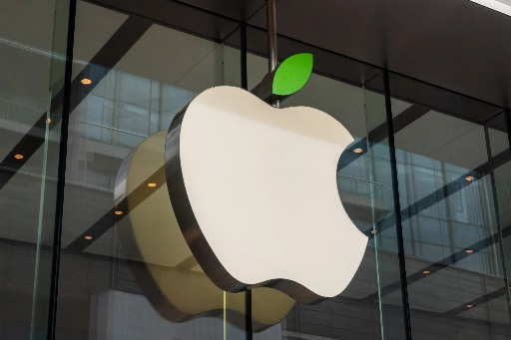
Apple is devoted to giving the finest portable computing experience to students, teachers, creative people, and customers across the globe via its revolutionary equipment, application, including Internet services. According to the company's mission statement. In contrast, the objective of Apple Inc. is "Apple develops Macs, the world's foremost home computers, complete with the operating system (OS X), applications (iLife, iWork, and commercial software.

Product Strategy
An item or service is considered a "product" when it is provided to a customer as a means of meeting their needs. The firm must consider the product's lifecycle whenever developing it, as well as the numerous challenges that may arise during the different stages of the project's creation. In an attempt to fully the marketplace and re-capture the attention of customers, a product must be redesigned towards the end of its life cycle.
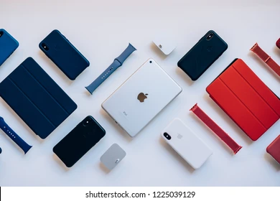
During the last several years, Apple has been credited with introducing a number of different and revolutionary items. Apple's product range has evolved throughout the period to satisfy the demands of people across the world. Apple's product portfolio comprises both physical things and digital services. The product aspect of the marketing mix demonstrates that Apple would be in the consumer electronics business (Li, 2021). Apple is a company that makes consumer gadgets. Apple's product mix is characterized by an emphasis on performance instead of volume. In contrast to extending out bending designs to other items within the same category, it concentrates on the selected products as well as strives to improve those. Apple's product approach demonstrates that the company has expanded its operations outside the computer tech industry to include ICT. A few of the company's goods are listed in the following section.

Macintosh - The Macintosh seems to be the basis because Apple operates. MacBook Air and MacBook Pro are the company's most popular laptops inside the United States, as well as they are putting the rest of the industry in a difficult position. MacBook Air, as well as MacBook Pro, are two of the most current versions that have become popular among users.
iPod - Following the introduction of the Mac computers, the iPod completely transformed the manner we stream music. When Apple released the iPod, it became an immediate smash and established itself as a global corporation in the same way that Sony did with its Walkman. The breakthroughs, on the other hand, were only getting begun.
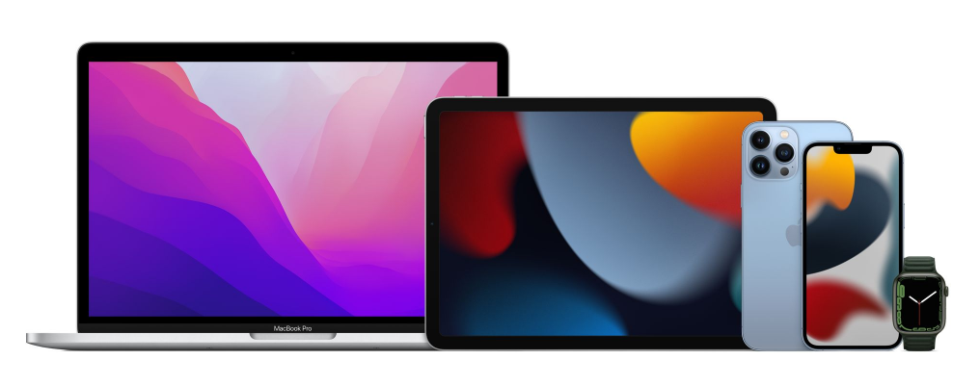
Apple became the very first company to launch multi-touch intelligent smartphones, which was the iPhone. In addition, they proceeded so far as to assert that their business seems to be using multi-touch technology. However, the technique has been around for a long time, and as a result, they also weren't granted a license. The iPhone, on the other hand, has been a huge success and continues to be so.
iPad — Following the success of the iPhone, the iPad was released, and it quickly proved popular with Apple enthusiasts. Users can now sync their pc, their smartphone, and the tablet all at the same time. Because this was an Apple product, the iPad was better in terms of appearance and usefulness.

iWatch and Apple TV - represent two of the other items made by Apple that have not been as successful as they may have been. When it comes to competitiveness, the iWatch confronts significant rivalry from Samsung. When it comes to streaming media, Apple TV is up against fierce rivalry from Amazon.
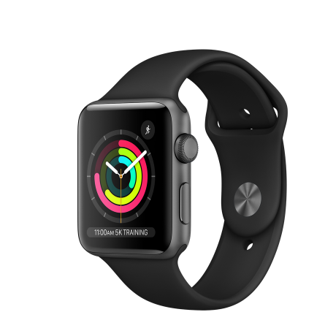
Software and services – One of Apple's market leaderships is its application and OS, which itself is known as the MacOS (Macintosh OS). Additionally, it released numerous applications like iTunes, Apple Music and other similar offerings. Every one of these is excellent, however, when they work collectively, they generate significant money for Apple (Pooja, 2020).
All of Apple's goods are the result of constant innovation. They are all unique, well-designed, and well-supported by the evidence. Apple became successful as a result of Steve Jobs' marketing skills and keen understanding of what consumers wanted. This was the driving force underlying the firm's long success.

Pricing Strategy:
The next step in the marketing strategy is to determine how much the customer is willing to pay for the product. This helps in evaluating how much money a firm can make. Price decisions must be made with extreme caution since they constitute a double-edged blade that must be properly balanced. Putting a price tag on an item that would be unnecessarily expensive might give the impression that this is of excellent quality. Additionally, this should make it possible to distribute products to both controlled and unrestricted locations at the same time (Mothersbaugh et al., 2020).
A distinct marketing approach built on distinction emphasises the product's worth, skills and strengths while allowing the corporation to offer the goods at much larger profits than any of its rivals. Unlike Apple, which swiftly became the industry champion in several product categories given its high prices, the corporation has rarely employed penetration pricing to achieve market dominance fast. Apple's true strategy would just be "market-skimming," or entering the marketplace using a new product valued more than the competitors in order to generate early-adopter profits (Tedja, 2020). However, there is a crucial distinction to be made herein. A price skimming approach tends to cut pricing throughout the time when clients lose excitement or new items are introduced. For the majority of the product life cycle, Apple sells its goods at premium rates, therefore the business has really only done this on a few rare instances and with little reductions.
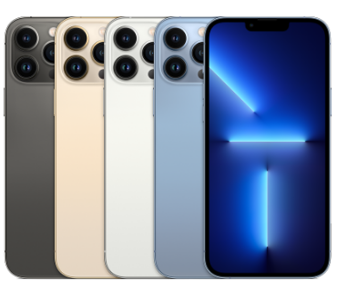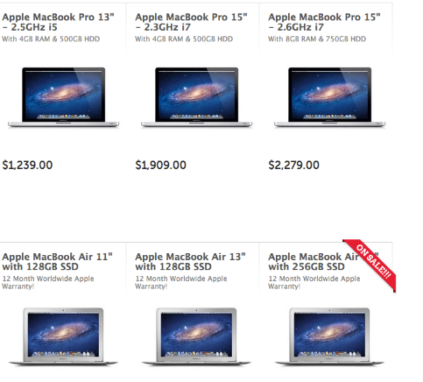

Aiming to break into a market formerly controlled by enterprises with little or no technology experience, Apple has raised the bar for distinctiveness with its 11.000 Apple (Statista. 2021) Watch Series. Thus, it becomes evident that the firm's pricing strategy relies on the utilization of distinction. Apple's buyers should thus be prepared to spend more than the usual price for a commodity that will put them in the exclusive group of individuals who will be seen and stared at by the public. Apple reportedly shifted to a more premium pricing strategy. Apple's iPhone 8 costs £699 inside the UK, whereas the iPhone 8 plus costs £799. When it comes to new goods, Apple is typically ahead of the pack when it comes to innovation (Van De Vliert, 2021).

Place Strategy
As per Kotler and Armstrong (2016), the space in which the items are accessible and may be distributed or bought is referred to as the "place." Consumers may acquire things from both real or virtual marketplaces, depending on their preferences. Market participants may physically meet as well as engage with one another in a traditional marketplace, while buyers or sellers may communicate and interact with one another over the web in a digital marketplace. The location of a firm's product selling is crucial because it must be in a location where the firm's target customers are likely to be found (Hanson and Kalyanam, 2020). Attempting to advertise to people who possess no interest in the products or services the company is offering would be a waste of effort. As a consequence, a company's products should always be located and distributed in a position that is easily accessible to those who may be interested in purchasing them.
As per Tien (2019), Apple has implemented a careful placement and distribution strategy. Its goods are offered at Apple shops, licensed luxury merchants, telecom carriers, and on a limited number of internet platforms, including Amazon. It was estimated that in 2015, there have been 463 Apple shops globally. Apple already has 510 retail locations across the globe. The overall quantity of shops in the United States exceeds 270, with 29 outlets in Canada (Tedja, 2020). These would be Apple's dedicated shops, through which the business offers its goods straight to consumers. They are located across the world.
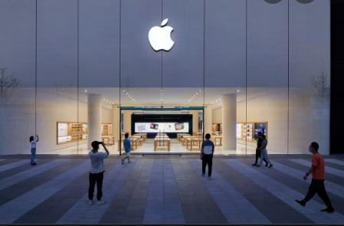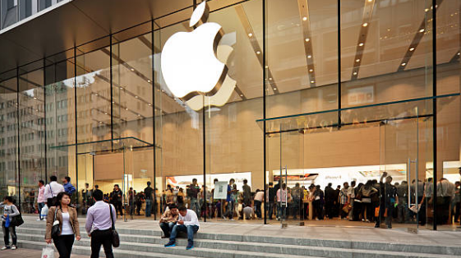

Consumers may buy Apple items through the Apple Store website (www.apple.com) and also have them shipped to their homes or offices directly. The iPhone is likewise available via a number of telecoms operators in the United Kingdom, including BT, 3, EE, Verizon as well as O2, who have stores and outlets around the country. Apple devices are therefore available via shops like Carphone, Curry's PC World, plus Amazon.

Promotion Strategy
As per Kotler and Armstrong (2016), Marketing uses many techniques and concepts to promote their products to end customers. Several approaches are used to advertise and popularize a product. Promotion could be utilized to boost a firm's image and acquire new prospects and consumers. This kind of promotion is called public relations. This strategy is often used to influence consumer purchase choices.
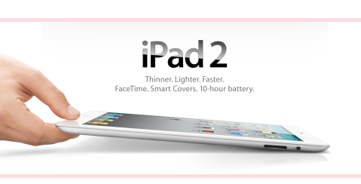
Apple's marketing approach centres on vigorous promotion through media, TV, billboards, and internet commercials. It promotes its goods using both traditional and unconventional methods. The items are additionally advertised online through the company's website. TV, specialist periodicals, banners, partnerships mobile ads in subways, carriages, and vehicles, etc. Apple is constantly looking for the best places to promote its products (Appel et al., 2020). Product placement is among the company's longstanding strengths. Today's famous Uk programs have characters utilizing a Mac, iPhone, even, more lately, an Apple Device (Li, 2021).
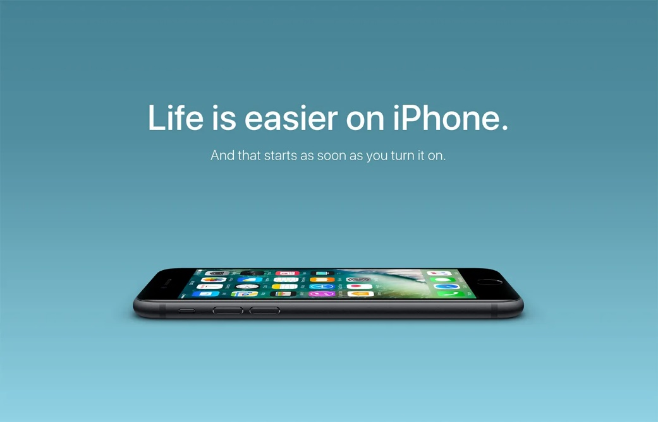
The commercials are short and sweet, without minimal unnecessary details. Print advertising continues during the lifecycle of goods and commercials air when it is initially released.
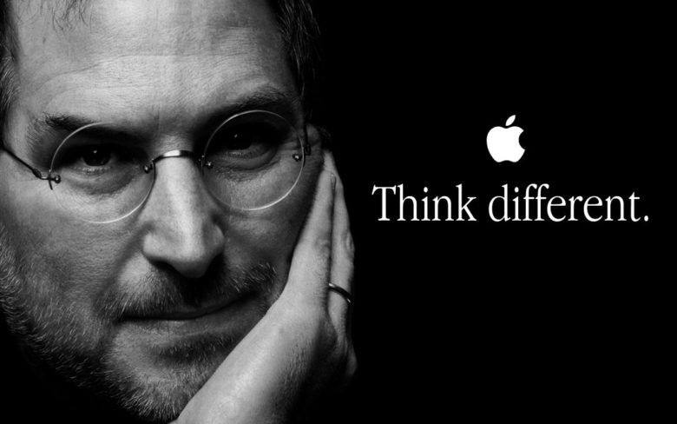
Steve Jobs started “Think Different” marketing in 1997. The significance of apples in a fast-paced environment. “Apple's key ideals are that individuals with enthusiasm can transform the society for the greater good,” he remarked. The ad encouraged individuals to be proud of their own skin, to “think different” as well to become proud of it. Apple targets a certain demographic; thus, its marketing efforts are centred on its goods, which are what set it apart from its rivals. Apple's marketing strategy includes public affairs to acquire new consumers.

Reference
Appel, G., Grewal, L., Hadi, R. and Stephen, A.T., 2020. The future of social media in marketing. Journal of the Academy of Marketing Science, 48(1), pp.79-95.
Hanson, W.A. and Kalyanam, K., 2020. Internet marketing and e-commerce. (Student ed.). Thomson/South-Western.
Kotler, P. and Armstrong, G., 2016. Principles of Marketing. Sixteenth edition, Global edition. ed. Harlow: Pearson Education.
Li, Y., 2021. Apple Inc. Analysis and Forecast Evaluation. Proceedings of Business and Economic Studies, 4(4), pp.71-78.
Mothersbaugh, D.L., Hawkins, D.I., Kleiser, S.B., Mothersbaugh, L.L. and Watson, C.F., 2020. Consumer behavior: Building marketing strategy. McGraw-Hill Education.
Pooja, B.C., 2020. An Organization Study Report of Apple Inc (Doctoral dissertation, CMR Institute of Technology. Bangalore).
Statista. 2021. Topic: Apple. [online] Available at: <https://www.statista.com/topics/847/apple/> [Accessed 2 December 2021].
Tedja, J.A., 2020. How product quality, brand image, customer satisfaction, and country of origin affect the purchase decision of apple devices in the Jakarta regional area (Doctoral dissertation, Universitas Pelita Harapan).
Tien, N.H., 2019. International distribution policy comparative analysis between Samsung and apple. International journal of research in marketing management and sales, 2020(1), p.2.
Van De Vliert, D., 2021. Apple. [online] Available at: <https://www.apple.com/> [Accessed 2 December 2021].

