I confirm that I have not used any AI tools in the research and creation of this assignment. I confirm that I have not presented any AI generated materials as my own work. I confirm I have copies of my drafts, notes, and other resources I used, which I may be asked to provide in evidence

Abstract
Social isolation and loneliness in older adults have been consistently associated with poorer cognitive functioning and an increased risk of cognitive decline (Cardona & Andrés, 2023). Autistic individuals may be particularly vulnerable to social exclusion due to differences in social communication and interaction, which can impact opportunities for social engagement across the lifespan. This study aimed to explore beliefs and opinions of university students regarding the potential cognitive, emotional, and social effects of social exclusion on older adults with Autism Spectrum Disorder (ASD), and how these effects might be remedied. A qualitative design was employed using semi-structured interviews. Data were collected from participants and analysed using Braun & Clarke’s (2006) thematic analysis. Several key themes were identified, including the cognitive impacts of exclusion, emotional consequences such as loneliness or low mood, and social disconnection, alongside the importance of structured and social support in mitigating these effects. Overall, the findings suggest that social exclusion is experienced as a multifaceted issue for older autistic adults, with implications for wellbeing, but that targeted support and increased social engagement may help to reduce its negative impact.

Autism Spectrum Disorder (ASD) is a neurodevelopmental condition characterised by differences in social communication and interaction, alongside restricted and repetitive patterns of behaviour and interests. These characteristics can influence how individuals form and maintain social relationships, potentially increasing vulnerability to social exclusion across the lifespan. Social exclusion refers to the process by which individuals are prevented from fully participating in social, economic, and community life, which can have significant implications for overall wellbeing. For autistic individuals, difficulties interpreting social cues and navigating social environments may increase the likelihood of exclusion, particularly within wider societal contexts. Research on social participation suggests that autistic adults often experience social isolation and limited close friendships, reducing opportunities for social engagement and connection (Chan et al., 2023). Similarly, Couture et al. (2020) found that autistic adults face a range of barriers to social participation, including environmental and structural factors, which may further contribute to exclusion.
Experiences of social exclusion have been consistently linked to negative emotional and cognitive outcomes, particularly in older adults. Loneliness, often a key consequence of exclusion, has been associated with increased anxiety, depression, and reduced overall wellbeing. Research suggests that autistic adults frequently report heightened loneliness and social disconnection compared to non-autistic individuals, which can significantly impact mental health (Grace et al., 2022). In addition to these emotional effects, social exclusion may contribute to cognitive difficulties, including reduced concentration and increased risk of cognitive decline over time. Roisenberg et al. (2026) highlight that social isolation in autistic adults can negatively affect cognitive functioning, particularly in relation to attention and the processing of social information. Together, these findings suggest that the impact of social exclusion extends beyond immediate emotional distress, influencing broader psychological functioning.
Beyond individual experiences, social exclusion is also shaped by broader societal attitudes and structural barriers. Autistic individuals often encounter stigma, misunderstanding, and negative stereotypes, which influence how they are perceived and treated in social and community contexts. For example, differences in social communication may be misinterpreted, leading to assumptions about competence and contributing to exclusion from social and occupational environments (Wilson & Gullon-Scott, 2024). In addition, environmental barriers, such as a lack of accessible or inclusive social spaces, may further restrict opportunities for meaningful participation. Research suggests that social exclusion is not solely the result of individual differences but is also shaped by societal expectations and limited understanding within wider communities (Kuzminskaite et al., 2020). This highlights the importance of considering both individual and structural factors when exploring exclusion.
Given the range of emotional, cognitive, and social consequences associated with social exclusion, there is increasing recognition of the importance of interventions aimed at promoting inclusion and wellbeing among autistic individuals. Research suggests that structured support, opportunities for meaningful engagement, and increased societal awareness can reduce the negative impact of exclusion (Couture et al., 2020). Supportive environments that provide predictability and clear expectations may enable autistic individuals to engage more comfortably, while social support networks can reduce feelings of isolation (Grace et al., 2022). However, much of the existing literature has focused on younger populations, with comparatively less attention given to older autistic adults (Chan et al., 2023). In addition, there is limited research exploring how these issues are perceived by others, particularly in relation to beliefs about the effects of social exclusion and how it may be addressed. Therefore, the present study aimed to explore beliefs and opinions of university students regarding the potential cognitive, emotional, and social effects of social exclusion on older adults with ASD, and how these effects might be ameliorated.

Method
Participants
2 participants took part in the study. Both participants were female with an age range of nineteen to thirty. Participants were recruited using opportunity sampling from University of Wales Trinity Saint David, meaning that they were selected based on their availability and willingness to take part. The wider year group from which participants were drawn was predominantly female, which may have influenced the gender composition on the samples.
Data Collection
Data were collected using a qualitative research design through a semi-structured interview approach. This methodology was considered appropriate as the aim of the study was to explore participants’ beliefs and opinions regarding the cognitive, emotional, and social effects of social exclusion on older adults with ASD. This approach allowed for in-depth exploration of subjective experiences and meanings, rather than attempting to measure variables quantitatively. The interview consisted of 12 open-ended questions and follow-up prompts designed to encourage participants to reflect on their understanding of social exclusion, its potential impacts on older autistic adults, and possible ways these effects could be reduced. The flexible nature of the interview schedule allowed the researcher to probe responses further where appropriate, enabling richer and more detailed data to be generated. The interviews were conducted in the university labs ensuring a quiet and confidential space and lasted approximately 15 minutes each. All interviews were audio-recorded through a private teams’ channel and later transcribed for analysis. Participants were informed that their participation was voluntary, that they could choose not to answer any question, and that they could withdraw from the study at any point prior to data analysis. Confidentiality was maintained throughout, and no identifying information was included in the transcripts.
Data Analysis
Data were collected using reflexive thematic analysis, following the six-phase framework outlined by Braun and Clarke (2006). This involved familiarisation with the data through repeated reading of the transcripts, followed by the generation of initial codes. Codes were then organised into potential themes, which were reviewed and refined to ensure the accurately represented patterns across the dataset. Themes were defined and named, with particular attention given to capturing shared meanings across both transcripts. This approach allowed for an interpretive analysis of participants’ accounts, moving beyond surface level description to identify underlying patterns.

Results

A reflexive thematic analysis following Braun and Clarke (2006) identified three overarching themes that captured shared patterns across participants: (1) psychological and cognitive impact of social exclusion, (2) barriers to social participation, and (3) inclusive support and adaptations. A summary of themes and sub-themes is presented in Appendix A.
Psychological and Cognitive Impact of Social Exclusion
This theme reflects the internal effects of social exclusion, particularly in relation to emotional wellbeing and cognitive functioning. Participants described how exclusion contributes to increased distress, negative self-perceptions, and difficulties with processing and decision-making.
Sub-theme 1: Anxiety and Overwhelm
Participants described how social exclusion can lead to escalating emotional distress, particularly when multiple stressors occur simultaneously. One participant explained how difficulties can “stack and stack… become overwhelming” (lines -), suggesting that small challenges can accumulate into significant emotional strain. Similarly, individuals may struggle with “lots of things… process and recognise” (lines -), particularly in demanding environments. Another participant highlighted that these experiences can become difficult to manage in the absence of support, contributing to heightened anxiety. These accounts suggest that social exclusion contributes to cumulative stress, where individuals must manage both environmental demands and internal emotional responses simultaneously.
Sub-theme 2: Low Self-Esteem and Self-Blame
Participants highlighted how individuals may internalise experiences of exclusion, leading to reduced self-worth and negative self-perceptions. For example, individuals may have “very low self-esteem… feeling very negatively” (lines -), particularly when they do not understand social interactions. This was reinforced by the suggestion that individuals may begin to “think that he… the problem” (lines -). Participants also described how repeated misunderstandings can contribute to feelings of inadequacy and self-doubt. These findings suggest that exclusion may become internalised over time, impacting identity and reinforcing negative self-perceptions rather than being attributed to external social factors.
Sub-theme 3: Overthinking and Decision Paralysis
Participants described how social exclusion can affect thinking patterns, leading to rumination and difficulty making decisions. One participant explained that individuals may become “stuck in decision paralysis… the right decisions” (lines -), reflecting increased uncertainty and lack of confidence. Participants also suggested that individuals may overthink interactions, particularly when unsure how they are perceived by others. These accounts indicate that exclusion increases cognitive load, with individuals becoming caught in cycles of overthinking that further reinforce difficulty in navigating social situations.
Barriers to Social Participation
This theme reflects how social exclusion impacts behaviour, routine, and engagement in everyday life. Participants described how exclusion can lead to withdrawal, disruption to daily structure, and reduced participation.
Sub-theme 1: Withdrawal from Social Interaction
Participants described how individuals may disengage from social environments as a response to exclusion. For example, individuals may “leave the room… without any explanation” (lines -), particularly in overwhelming situations. Participants also described avoidance of interaction following repeated negative experiences. Withdrawal appears to function as a coping strategy to manage distress; however, it may also reinforce ongoing social isolation and reduce opportunities for positive interaction.
Sub-theme 2: Disruption to Routine
Participants emphasised the importance of routine and how disruption can have wider consequences. One participant described how “once you have one thing… next thing will go wrong” (lines -), highlighting how disruption can escalate across the day. Participants suggested that these disruptions can accumulate, making it harder to manage everyday tasks. These findings suggest that social exclusion can destabilise routine, creating a cascading effect where initial disruption leads to broader difficulties in functioning.
Sub-theme 3: Reduced participation
Participants described how ongoing exclusion can lead to reduced engagement in both social and structured activities. For example, individuals may feel “like there’s no point” (lines -), particularly following repeated exclusion or lack of support. Participants also highlighted how individuals may struggle with “lots of things… process and recognise” (lines -), alongside difficulty “recognising emotions… or cues” (lines -) in demanding environments. These accounts suggest that exclusion may reduce motivation and capacity to engage, affecting both social participation and everyday responsibilities.
Inclusive Support and Environmental Adaptations.
This theme focuses on how the negative effects of social exclusion may be reduced. Participants emphasised the importance of awareness, support, and environmental adjustments.
Sub-theme 1: Greater Awareness and Understanding
Participants highlighted the importance of increasing awareness of autism. For example, there should be “much education… people with autism” (lines -), as a lack of understanding can lead to others becoming “offended… or confused” (lines -). These findings suggest that misunderstanding plays a key role in social exclusion, and that increasing awareness may reduce negative assumptions and improve inclusion.

Sub-theme 2: Supportive Relationships and Inclusion
Participants emphasised the importance of supportive relationships in reducing the impact of exclusion. For example, having “a buddy at work” (lines -) was suggested as a way to improve inclusion and provide guidance in social situations. These accounts indicate that supportive relationships may act as a protective factor, helping individuals navigate social environments more effectively and reducing the impact of exclusion.
Sub-theme 3: Environmental and Organisational Adaptations
Participants identified practical strategies that could reduce distress and improve participation. For example, providing “headphones… if they need them” (lines -) or allowing “5 minutes… if that helps them regulate” (lines -) were described as simple but effective adjustments. Participants also emphasised that workplaces should “look at the design… so that they’re inclusive” (lines -), and that “those little things… the world to somebody” (lines -). These findings suggest that inclusion requires systemic and environmental changes, rather than relying solely on individual coping strategies.

Discussion
The present study aimed to explore beliefs and opinions regarding the cognitive, emotional, and social effects of social exclusion on older autistic adults, and how these effects might be ameliorated. Overall, the findings suggest that social exclusion is a complex and multidimensional issue, with interconnected psychological, cognitive, and behavioural consequences. The three themes identified psychological and cognitive impact, disruption to daily functioning and social participation, and the importance of inclusive support and environmental adaptations indicate that exclusion affects not only emotional wellbeing, but also participation and everyday functioning.
The first theme, psychological and cognitive impact, is consistent with literature linking loneliness and social isolation to poorer mental health and reduced cognitive functioning. Cardona and Andrés (2023) found that loneliness is more closely related to emotional wellbeing and depression, while social isolation is associated with reduced cognitive stimulation and decline. This is reflected in the current findings, where participants described overwhelm, low self-esteem, and overthinking alongside difficulty processing social situations. Similarly, Grace et al. (2022) found that autistic adults commonly experience loneliness alongside anxiety and depression, suggesting that emotional and cognitive impacts are closely interconnected.
The findings relating to low self-esteem and self-blame also align with research on autism acceptance and stigma. Cooper et al. (2022) demonstrated that both external and personal acceptance predict depression and stress in autistic individuals, while Kuzminskaite et al. (2020) found that stigma is associated with lower self-esteem, reduced self-efficacy, and lower social satisfaction. Together, these findings suggest that exclusion may become internalised over time, contributing to longer-term psychological effects. The cognitive aspects of this theme are further supported by autism-specific research. Wilson & Gullon-Scott (2024) found that autistic adults experience social anxiety shaped by both individual and environmental factors, including sensory overload and inaccessible communication. Similarly, Kuzminskaite et al. (2020) found that social communication difficulties predict anxiety in autistic adults, suggesting that ongoing social challenges may contribute to both emotional distress and increased cognitive load. This supports the current findings, where participants described difficulty managing social demands and decision-making.
The second theme, disruption to daily functioning and social participation, also reflects previous research. Participants described withdrawal, reduced motivation, and disrupted routines, which is consistent with Quadt et al. (2024), who found that loneliness in autistic adults is closely linked to sensory differences and emotional distress. Similarly, Pellicano et al. (2021) found that social isolation is experienced as highly damaging to mental health, challenging assumptions that autistic individuals are unaffected by social disconnection. The findings relating to reduced participation also align with literature on social participation and communication. Chan et al. (2023) suggest that participation extends beyond friendships to include employment and community involvement, meaning exclusion can affect multiple areas of life. Likewise, Cummins et al. (2020) found that communication difficulties negatively impact daily functioning and access to support and are shaped by both individual and environmental factors. This supports the current finding that repeated misunderstandings can lead to avoidance and reduced engagement.
The third theme, the importance of inclusive support and environmental adaptations, is strongly supported by the literature. Participants emphasised awareness, understanding, and practical adjustments such as routine, clear expectations, and sensory support. This is consistent with Andoni et al. (2026), who found that autistic adults prefer support that is tailored to individual needs and focuses on coping with environments rather than changing the individual. Research on employment and inclusion further supports this, with Southey et al. (2024) and Fridchay and Reizer (2026) highlighting the importance of accessibility, workplace relationships, and understanding in shaping inclusion. Another important finding is that support appears to be both practical and relational. Cooper et al. (2022) found that positive autism identity and community belonging are associated with improved wellbeing, while Roisenberg et al. (2026) highlighted the importance of peer support and structured environments. These findings suggest that effective support involves not only reducing barriers, but also promoting acceptance and belonging. Taken together, the findings suggest that social exclusion may operate as a reinforcing cycle. Emotional distress may increase cognitive load, leading to withdrawal and reduced participation, which in turn increases loneliness and reduces access to support. Cardona and Andrés (2023) suggest that the relationship between loneliness, social isolation, and cognition may be bidirectional, supporting this interpretation. This highlights how emotional, cognitive, and behavioural impacts are interconnected rather than separate outcomes. The findings have several practical implications. Reducing social exclusion requires not only increasing social contact but improving the quality and accessibility of social environments. Awareness of autism, supportive communication, and sensory considerations may help reduce the negative effects identified. Giummarra et al. (2022) similarly emphasise the importance of inclusive and accessible communities, suggesting that meaningful participation requires both individual support and environmental change. There are several limitations to consider. The study involved a small sample, and participants discussed beliefs rather than lived experiences, limiting generalisability. As a qualitative study, the analysis is interpretative. However, the findings still provide useful insight into how social exclusion is understood and how it may be addressed. Future research should focus on the lived experiences of older autistic adults, using larger and more diverse samples. It would also be useful to explore differences between loneliness and social isolation, and to investigate which interventions are most effective in promoting inclusion.
In conclusion, the findings suggest that social exclusion has significant emotional, cognitive, and social impacts on older autistic adults. However, these effects may be reduced through inclusive environments, supportive relationships, and practical adaptations. Overall, this highlights the importance of recognising the role of wider social and environmental factors in shaping experiences of exclusion.
References
Braun, V., & Clarke, V. (2006). Using thematic analysis in psychology. Qualitative Research in Psychology, 3(2), 77–101. https://doi.org/10.1191/1478088706qp063oa
Chan, D. V., Doran, J. D., & Galobardi, O. D. (2023). Beyond friendship: The spectrum of social participation of autistic adults. Journal of Autism and Developmental Disorders, 53(1), 424–437. https://doi.org/10.1007/s10803-022-05441-1
Cheng, Y., & Grühn, D. (2015). Age differences in reactions to social rejection: The role of cognitive resources and appraisals. The Journals of Gerontology: Series B: Psychological Sciences and Social Sciences, 70(6), 830–839. https://doi.org/10.1093/geronb/gbu054
Cooper, K., Russell, A. J., Lei, J., & Smith, L. G. E. (2022). The impact of a positive autism identity and autistic community solidarity on social anxiety and mental health in autistic young people. Autism, 27(3), 848–857. https://doi.org/10.1177/13623613221118351
Couture, M., Normand, C., Jacques, C., Ruel, J., Beauregard, F., Fecteau, S., & Berbari, J. (2020). Perspectives on the social participation of adults with autism spectrum disorders (ASD): Descriptive data from a provincial survey. American Journal of Occupational Therapy, 74(Suppl. 1). https://doi.org/10.5014/ajot.2020.74S1-RP103D
Cummins, C., Pellicano, E., & Crane, L. (2020). Autistic adults’ views of their communication skills and needs. International Journal of Language & Communication Disorders, 55(5), 678–689.
Fridchay, J., & Reizer, A. (2026). Bridging worlds: The workplace experience of autistic adults. Journal of Autism and Developmental Disorders. https://doi.org/10.1007/s10803-026-07311-6
Giummarra, M. J., Randjelovic, I., & O’Brien, L. (2022). Interventions for social and community participation for adults with intellectual disability, psychosocial disability or on the autism spectrum: An umbrella systematic review. Frontiers in Rehabilitation Sciences, 3, 935473. https://doi.org/10.3389/fresc.2022.935473
Grace, K., Remington, A., Lloyd-Evans, B., Davies, J., & Crane, L. (2022). Loneliness in autistic adults: A systematic review. Autism, 26(8), 2117–2135. https://doi.org/10.1177/13623613221077721
Kuzminskaite, E., Begeer, S., Hoekstra, R. A., & Grove, R. (2020). Short report: Social communication difficulties and restricted repetitive behaviors as predictors of anxiety in adults with autism spectrum disorder. Autism, 24(7), 1917–1923. https://doi.org/10.1177/1362361320934218
Pellicano, E., Brett, S., den Houting, J., Heyworth, M., Magiati, I., Steward, R., Urbanowicz, A., & Stears, M. (2021). COVID-19, social isolation and the mental health of autistic people and their families: A qualitative study. Autism, 26(4), 914–927. https://doi.org/10.1177/13623613211035936
Quadt, L., Williams, G., Mulcahy, J., Larsson, D. E. O., Silva, M., Arnold, A. J., Critchley, H. D., & Garfinkel, S. N. (2024). “I’m trying to reach out, I’m trying to find my people”: A mixed-methods investigation of the link between sensory differences, loneliness, and mental health in autistic and nonautistic adults. Autism in Adulthood, 6(3). https://doi.org/10.1089/aut.2022.0062
Roisenberg, B. B., Boulton, K. A., Thomas, E. E., Perry, N., Yu, D., & Guastella, A. J. (2026). Autistic adults’ experiences of cognitive-behavioural group therapy for social anxiety: Relational experiences of participation. Autism. https://doi.org/10.1177/13623613251377930
Southey, G., Morris, R., Nicholas, D., & Pilatzke, M. (2024). Autistic perspectives on employment: A scoping review. Journal of Occupational Rehabilitation, 34, 756–769. https://doi.org/10.1007/s10926-023-10163-x
Wilson, A. C., & Gullon-Scott, F. (2024). “It’s not always textbook social anxiety”: A survey-based study investigating the nature of social anxiety and experiences of therapy in autistic people. Autism, 28(11), 2923–2936.

Appendices
Appendix A
Theme Table
Theme | Sub-theme | Quote
Psychological and Cognitive Impact of Social Exclusion | Anxiety and overwhelm | “Stack and stack… become overwhelming”
 |  | “Lots of things… process and recognise”
 | Low self-esteem and self-blame | “Very low self-esteem… feeling very negatively”
 |  | “Think that he… the problem”
 | Overthinking and decision paralysis | “Stuck in decision paralysis… the right decisions”
 |  | “Lots of things… process and recognise”
Barriers to Social Participation | Withdrawal from social interaction | “Leave the room… without any explanation”
 | Disruption to routine and ‘knock-on effects’ | “Once you have one thing… next thing will go wrong”
 | Reduced participation and functioning | “Like there’s no point”
 |  | “Lots of things… process and recognise”
 |  | “Recognising emotions… or cues”
Inclusive Support and Environmental Adaptations | Greater awareness and understanding | “Much education… people with autism”
 |  | “Offended… or confused”
 | Supportive relationships and inclusion | “a buddy at work”
 | Environmental and organisational adaptations | “Headphones… if they need them”

Appendix B
Interview Schedule
1.How familiar would you say you are with autism spectrum disorder?
2. Can you tell me about any experiences you’ve had, directly or indirectly, with autistic adults?
3. When you hear the term social exclusion, what does this mean to you?
4. In your view, what kinds of situations or environments might contribute to social exclusion for older autistic adults?
5. Some autistic adults may have lived very routine‑based or isolated lives, sometimes relying heavily on family. How might this shape their experiences of social connection later in life and in a working environment?
6. How do you think workplace changes or uncertainty might affect an older autistic adult who depends on structure and predictability?
7. How might an adult with ASD understand and interpret social cues in a work environment
8. Do you think misunderstandings in communication — from either side — could contribute to exclusion or social distance?
9. Do you think experiences of exclusion might influence cognitive processes such as attention, memory, or decision‑making in older autistic adults? In what ways?
10. How might exclusion affect emotions such as anxiety, loneliness, or self‑esteem?
11.What impact do you think exclusion could have on an older autistic adult’s motivation or ability to engage in community activities, hobbies, or social groups?
12. How might reduced social contact or routine disruption affect their day‑to‑day life?
13.What kinds of support do you think could reduce the negative effects of social exclusion for older autistic adults?
14. Are there particular services, environments, or community changes that you believe would help create a more inclusive experience?

Appendix C
Participant Information Sheet

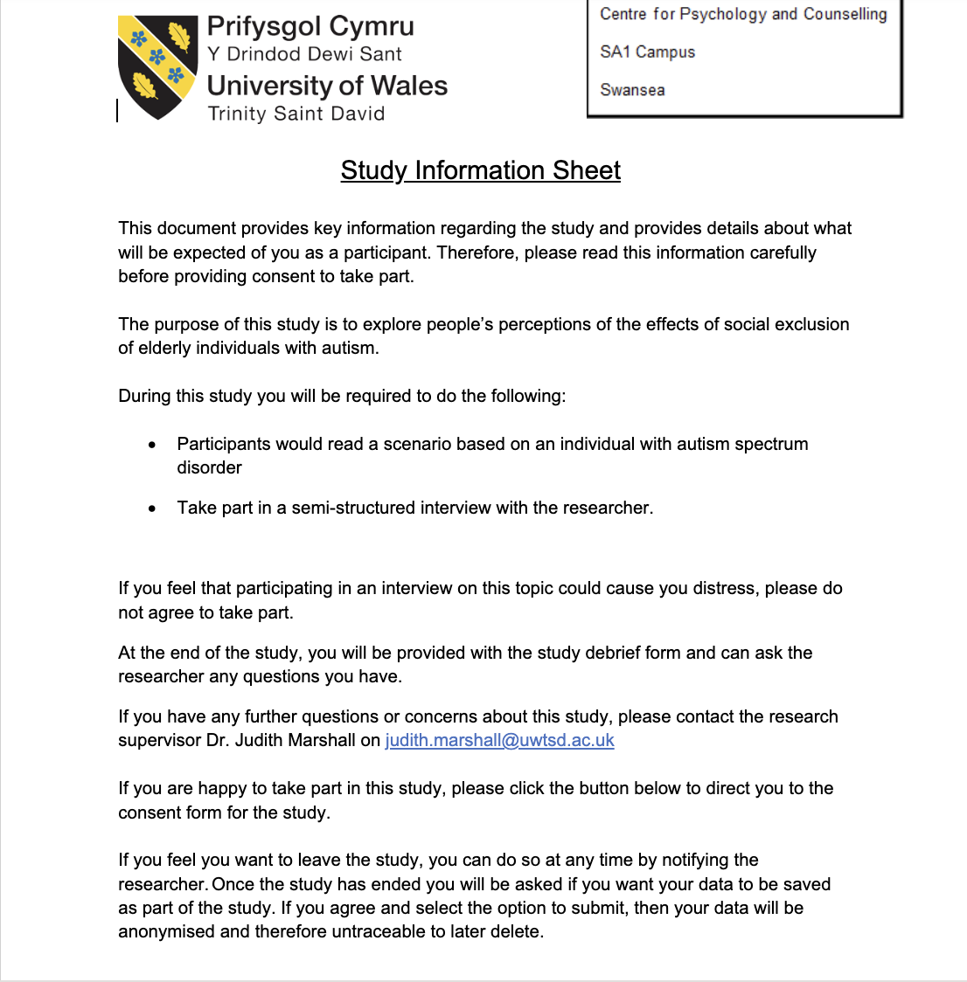

Appendix D
Consent Form

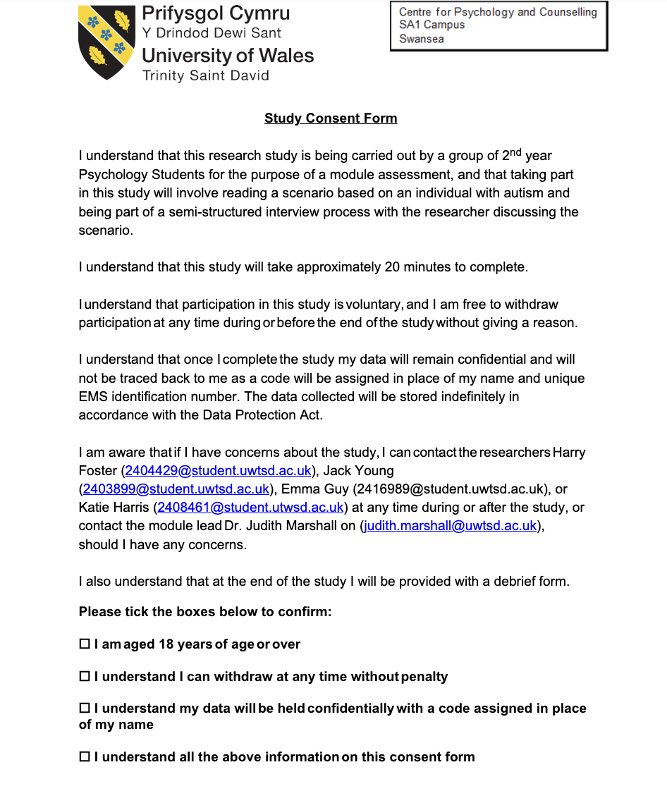

Appendix E
Debrief Sheet



