Introduction

During 2019 the Welsh Government launched a National strategy “Healthy Weight, Healthy Wales” to improve the nation’s health by aiming to reduce the level of obesity in its population. It is long proven that obese and overweight patients are at increased risk of other health conditions such as heart disease and diabetes. Obese patient also are at increased risk of suffering from mental health issues and generally have poorer health outcomes. The COVID-19 pandemic was further proof that this policy was required to improve population’s health with obese patients being a higher mortality risk from COVID-19 and having longer recovery periods. Obesity is effecting an increasing number of Welsh citizens yearly, with obesity costing the Welsh NHS more than £73m a year.

Obesity rates across Wales are expected to increase by an additional 160,000 people to 1.63 million by 2030, increasing from 59% in 2015 to 64.4% if no changes are made to the population’s current living habits and lifestyles. With projections like these in mind, the Welsh Government as part of the “Healthy Weight Healthy Wales” invested £5m through 2021-22 and are planning to invest a further £13m between 2022 and 2024 to fund programmes to facilitate change. The programme includes new legislation for a healthy food environment, funding services to provide equitable access to support across Wales and piloting interventions, behavioural change campaigns to support sustainable change.

The Child measurement data shows that 26.4% of children in Wales are overweight or obese. Wales figures for child obesity are higher than all other nations in the United Kingdom.

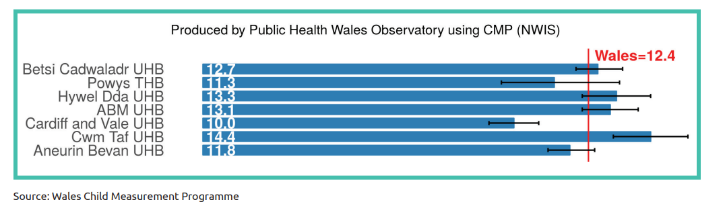
Chart 1. Percentage of children aged 4-5 years classified as obese by Welsh Health Board

Studies have been undertaken on the use of new technologies using smartphones, wearable devices and applications to help prevent or manage obesity. Wearable devices are pieces of technology that are worn on the body to record and monitor a number of health statistics about the wearer. The most common of these wearable devices is the smart watch, these vary in range and can be bought for as cheap as £6 through reputable online stores. By using a combination of these technologies it is possible to track and manage calorie consumption and physical activity as well as observing behaviour changes over a period of time.

The Welsh Government “Healthy Weight, Healthy Wales” strategy does not detail or contain any use of digital technology or use of wearable devices to help achieve the overall goals of the strategy. This paper aims to explore the introduction of using wearable devices in conjunction with and application on a smart phone or tablet to asses if this could assist to achieve the Welsh Government target of reducing childhood obesity.

Methods

To realise the benefits required in the Healthy Wales policy requirements for the system are set out into two categories. The first of the two requirements will be categorised as functional requirements these are elements of the how system will work, how it will interact with other systems and core features of the product.

The system to be produced will store information on patients dietary intake, daily exercise output, mental wellbeing and educational progress. Data from wearable technology such as smart watched will capture information on daily exercise linked to and app on the patients smart phone. The application will have a diet table for the patient to input daily calorie intake. A weekly mental health questionnaire will be completed to ensure that he patients is remaining engaged and to identify any underlying issues that could contribute to previous weight gain or hurdles for weight loss. There is strong evidential data that obese patients are more likely to suffer from mental health issues than patients that are not classed as obese, by incorporating mental health specialist into the system and working across specialities patients will hopefully receive better seamless care. This will also ensure that all services have access to data simultaneously; the system will also share data between primary and secondary. Educational services will also have an opportunity to raise queries or add important details e.g. child not participating in physical education classes that would assist in the policy goal of improving the health and weight of the Nation. The system would also be available for the parents or guardians of the child to have an overall view of progress.

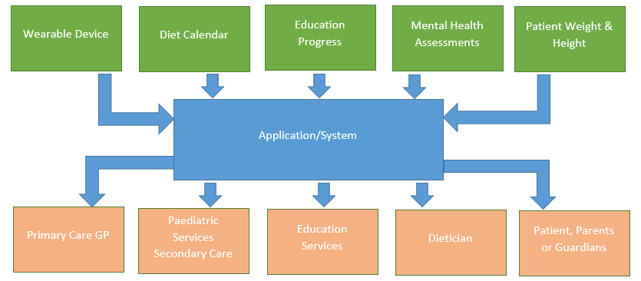

Figure 1 – System Data Flow Chart

An element of gamification within the application will aim to keep children engaged with the program. Games will be built into the application for patients, hitting daily exercise targets and following the weight loss regimen plotted at the start of the patients program will unlock achievements in the game and give the patient access to additional games or features. A best example of recent years of linking gaming to a form of physical exercise was the very popular game Pokemon Go. In Pokemon Go players move their character by walking around in the physical world finding Pokemon characters to capture. The game encourages players to explore other areas in the local area that they might not have been before to find new Pokemon characters. Pokemon Go is one of the most successful mobile games of all time grossed more than £4 billion in revenue and has nearly 600 million unique installs. Studies on the use of Pokemon Go showed that the game has a very positive effect on physical activity by increasing the number of steps walked and time spent on physical activity. Studies also demonstrated that as a result of participating in physical activity outdoors this way it had a positive impact on the individual wellbeing, emotions and mental health.

There are also Non-functional requirements that must be considered when measuring and appraising the system requirements. With the system using a combination potentially smart watches, smart phones and other personal devices sharing patient data, data security must been as a high priority for the project.
There is also risk that if patients require any home technology such as broadband or personal devices that the system may disadvantage and become unavailable to lower income households.

The system will need to work with a combination of Android and Apple devices as patients may want to use their own devices rather than carry two with them. There are also licensing issue to consider as well as already mentioned cyber security, there needs to be robust security in place to prevent children being exposed to possible harm through the use of the system.

There is also an additional danger that by providing daily data to patients on their physical activity and calorie intake that they could develop a Health anxiety that they are not keeping to the schedule or fulfilling daily tasks.

A feasibility aims analyse a projects chances of success by measuring the following factors, economic, technical, legal, and scheduling considerations. Before proceeding with this project a feasibility study was conducted to conducted to answer the following questions

- Does the system contribute to the overall objectives of the organization/Policy?

- Can the system be implemented within schedule and budget using current technology?

- Can the system be integrated with other systems that are used?

The feasibility study concluded that the proposed project would support the Health Weight, Healthy Wales policy. Increasing activity and monitoring calorie intake will help monitor and reduce rate of childhood obesity.
Current technology exists in the form of smart phones, tablets, smart watches and existing applications that can track and monitor exercise output, further to this devices and system are affordable within the budget available for this project.
Current National systems such as Welsh Patient Administration System (WPAS), Welsh Clinical Portal (WCP) and Welsh Community Care Information System (WCCIS) all have the potential to be integrated through an interface to a purpose bought or built application.

Following a positive feasibility study a decision was made to proceed with the project and to move to complete a GAP analysis to identify its direction.

A GAP analysis is undertaken to understand what is required to reach a certain goal. In this instance of producing a system to assist with child obesity the GAP analysis will measure what is in place currently and what additional resources that will be required to create a system that will help deliver the Health Weight, Healthy Wales policy. The current Welsh policy Healthy Weight, Healthy Wales makes no mention of utilising and using any digital solution although it does state the following targets

- A refreshed All Wales Weight Management Pathway which places a significant focus upon mental and physical health, with local health boards developing local plans and increasing capacity.

- Establishing system teams across Wales who will focus on prevention and working with communities to identify and find local solutions.

The second stage of the GAP analysis is set a SMART objective to transition from the current position to where we want the service to be. We have already discussed that the place we want the service to be is with a system that links the patients, parents, schools and clinicians. There needs to be Specific functional and non functional requirements set out to ensure that what is being developed is going to fulfil the task. The success of the system needs to be Measurable, the system needs be seen to make a difference to justify the investment. The proposed system needs to be Achievable, if the proposed system is not something that can be built or will not work due to poor participation then investment into the project will be wasteful. The objective must Relevant to the overall goal of the project, there is a danger when beginning a project that scope creep can move the original focus of the project in to other areas. The objective must be Time-Bound the system will need to implemented and functioning by 2024 to support the Welsh Government Policy

The initial gap between the policy goals and the current position is that there is no National or Local system that collects and shares data across multiple agencies to assist in the target of weight loss in children. Systems are available on the private market and systems have been developed in other countries such as Italy, Korea and Iran. These existing systems encourage and enable weight management through changing children’s perception of exercise by incorporating electronic devices and electronic games.

The second gap in the current process that has been identified is the lack of communication and data sharing across stakeholders that are involved in the patient’s welfare. To close the gap a system that can be accessed by all stakeholders that has the ability to share data quickly and easily will ultimately help achieve the policy goal. By increasing access to weight management support services early it is believed that early intervention will have better outcomes as it has been proved that Weight gain is recognised to increase more rapidly as children get older.

To consider the access potential of the system to all patients an Equality Impact Assessment will be conducted. The assessment aims to consider potential solutions for patients that might not be able to make use of the systems due to reasons such as visual impairment, learning difficulties or any other disability that may prevent use of the technology. A socioeconomic assessment will also need to be conducted to asses if all patients being targeted by the policy would have the access to broadband at home or at school for the devices to work, or if they had the skills and experience to be able to use the devices as required.

Results

The data collected from the questionnaire circulated at the children outpatients demonstrated that 27 of the 50 children that completed the questionnaire had their own smart phone device. Only 8 from the 50 children that completed the questionnaire had their own wearable activity tracker or smart watch. Parental or Gordian consent was gained before asking the children to complete the questionnaire.

Data was collected through researching papers and journals on other projects that had utilised technology to assist in weight loss programs. Interviews with stakeholders were conducted to ascertain the system requirements. Personal experiences were also used as a baseline for assessing the potential success of any chosen option. A questionnaire was circulated at the children outpatient department to ascertain the children that had smart phones and wearable activity trackers.

The results of the literature research were mixed as detailed below.

A Pilot study by Chad D Jensen, PhD of Brigham Young University looked to Evaluate Smartphone Assisted Behaviour Weight Control Intervention for Adolescents. The study concluded that smartphones have a potential to assist in weight loss initially but candidates struggled to maintain weight loss post study. It is hoped that the system being sourced for a Welsh perspective with its element of gamification would keep participants engaged whilst they are on the program, it is also hoped that development of the gamification aspect could work for children of differing age groups.

A similar study conducted by C. Mameli at the Department of Paediatrics, Children’s Hospital Vittore Buzzi, Milan, Italy, looked at a combined approach of a wristband and a smartphone in obese children to help with weight loss. The study examined
If a personalized programme based on the energy expenditure obtained from a smart watch and the calorie intake obtained from a smartphone application helped in promoting weight loss. The study concluded that a lifestyle programme based on a wearable device and calorie intake application was not superior to a standard lifestyle programme at promoting weight loss in obese children.

Hye Jung Yang of the Sungkyunkwan University School of Medicine, Seoul in Korea ran a study on preventing childhood obesity with the aide of smartphones and wearable devices. The study evaluated the effectiveness of obesity prevention in children using a mobile platform with smartphones and wearable devices. The study also developed a platform/system “HAPPY ME” that captured data and encouraged participants to increase physical activity with various games and daily challenges providing an encouraging environment for participating children. The HAPPY ME platform also feedback data to teachers on children weight, eating habits, physical activity, screen time and behavioural changes

Interviews with stakeholders were conducted to develop a better understanding of the system requirements. The interview results were then used for the basis of the GAP analysis as a list of key requirements for the system.

The author has worked in the National Health Service for over 20 years in a number of Health Informatics roles. Personal experiences of major national programs of building software systems have raised a number of issues. The Welsh Patient Administration System (WPAS) was born from an original in house build of a Patient Administration system at a small Mid Wales Hospital, a site the author previously worked l. As the system has developed and been made a National System that provides the service now for multiple Health Boards and hospitals it is evident that requesting changes to the system or applying upgrades takes longer than when the system was based at a single site.

The author has further experiences in National Health Service systems development and procurement. In 2017 the author was successful in being awarded funding from Welsh Government through a Small Business Research Initiative (SBRI) to develop a system of automated clinical coding. The project involved working with private companies to develop a solution to the challenge of developing automated coding set out in the project. The experience demonstrated the problems that can be encountered working with private companies developing systems. It became evident that although certain elements for the system had been promised at the planning stages of the project during development the company was unable to provide or develop the system to the technological specification required.

Following the completion of the GAP analysis and the requirements for the system were fully understood an optional appraisal was completed. The purpose of any options appraisal is to list the positive and negative elements of each option that could potentially be explored.

Pros of Building
- System can be built to unique requirement specification that may not be available on the open market
- System can be integrated with existing NHS Wales systems
- Control on maintenance, licencing and other annual fees.
- Opportunity to use grants such as SBRI (Small Business Research Initiative) to reduce costs
- Ability to recoup expenditure by selling the system to other health organisations globally.

Cons of Building
- Building a software system is costly
- Building a software system can take a long time, certainly more time than the option of purchasing an equivalent system already in existence.
- Ownership of building a system brings secondary cost of ongoing support for custom built software which is essential for proper maintenance.
- Any upgrades or changes to the system will be the responsibility of the organisation
- The organisation may not have the skill set required within its current or future staffing with the ability to build the required specification.

Pros of Buying
- Buying a system will cost less as an initial investment that the cost of building a similar system.
- Buying a system will be quicker than building and the organisation will be able to benefit from the systems additional functionality sooner
- Support, Maintenance, Performance, Security, Network Availability and SLA (Service Level Agreement) can be negotiated into the contract and will be the providers responsibility to meet these requirements.
- Private companies will want to develop the system and make improvements to increase their client base and maintain in-line with rival competitors.
.
Cons of Buying
- Buying a system will mean that there is potentially less functionality than the organisation requires. Any changes that you do require from the company will be scheduled on their time line rather than your own organisation.
- The initial cost outlay to buying a system will be more than building.
- There is a potential that annual maintenance and service fees could rise in the future and make the system unaffordable.

Pros of Do Nothing
- Doing nothing is a cheaper option to building or buying a system
- Reduced risk of reputational damage to the organisation if investment in buying or building a system is not successful

Cons Doing Nothing
- All Wales policy goal may not be achieved
- Negative effect on health board residents health
- Danger of population feeling disenfranchised a the organisation is not investing resources in this area of healthcare

Discussion

The decision was made that from the research that was conducted a platform resembling the “HAPPY ME” platform interfacing with range of smart devices would be the approach that would best support the delivery of the Welsh Weight loss policy.

Investment would be required for all participates in the program to have access to a smart phone device and a wearable activity checker or smart watch. Supplying these devices to all children that fall outside of the recognised healthy BMI of the Welsh Policy would have a significant cost implication.

The results of the options appraisal concluded that the option that would offer best value for money and that would fill the gaps identified in the gap analysis would be to purchase an existing system or customised off the shelf product from the private market.

To offer best value for money it was proposed that the procurement would be done on a National Level, There are many example of a “Once for Wales” procurement where there have been overall saving nationally making one individual purchase in comparison to eight individual Health Boards going through their own procurement. Other benefits to National procurement are being a larger customer that private companies will do more to keep rather than individual Health Boards.

Initiations for tender were advertised on Sell2Wales to UK and International companies to bid for the contract. Evaluation of bids were measured by Cost, Experience, Appreciation of the task, Past Performance, Management and Technical Skills, Management Systems.

References

Beynon, C. and Bailey, L. (2020), "Prevalence of severe childhood obesity in Wales UK", Journal of public health (Oxford, England); J Public Health (Oxf), Vol. 42, No. 4, pp. e435-e439.

Batsis, J.A ,et al. (2021), "A Weight Loss Intervention Augmented by a Wearable Device in Rural Older Adults With Obesity: A Feasibility Study", The journals of gerontology.Series A, Biological sciences and medical sciences; J Gerontol A Biol Sci Med Sci, Vol. 76, No. 1, pp. 95-100.
Jensen, C.D.et al (2016), "An Evaluation of a Smartphone-Assisted Behavioral Weight Control Intervention for Adolescents: Pilot Study", JMIR mHealth and uHealth; JMIR Mhealth Uhealth, Vol. 4, No. 3, pp. e102.
Jung, M.H. et al (2021), "Wrist-wearable bioelectrical impedance analyzer with miniature electrodes for daily obesity management", Scientific reports; Sci Rep, Vol. 11, No. 1, pp. 1238.
Kim, B., Hong, S. and Kim, S. (2021a), "Introducing an Integrated Model of Adults’ Wearable Activity Tracker Use and Obesity Information–Seeking Behaviors From a National Quota Sample Survey", JMIR formative research, Vol. 5, No. 9, pp. e23237.
Sommerville, I. (2016), Software engineering translated by Anonymous Pearson, Harlow, Essex, England.
Wang, A.I. (2021), "Systematic literature review on health effects of playing Pokémon Go", Entertainment computing, Vol. 38, pp. 100411.
Welsh Government (2022), “Healthy Weight, Healthy Wales”
Yang, H.J.et al (2017), "Interventions for Preventing Childhood Obesity with Smartphones and Wearable Device: A Protocol for a Non-Randomized Controlled Trial", International journal of environmental research and public health; Int J Environ Res Public Health, Vol. 14, No. 2, pp. 184.
.

