Title page BMHP5023
INTRODUCTION TO PHYSIOLOGY
Assignment title (component 1: - Case study
Report)
Name: - Erum Shehzadi
Student Number: - 23019030

Contents
Asthma in Adolescents.........................................................................................................3
Introduction.........................................................................................................................3
Section 2 Impact of Asthma..................................................................................................5
Section 3 Monitoring.............................................................................................................6
Monitoring of Respiratory Function and Peak Flow...................................................................6
Section 4 Evidence based Management and Lifestyle..............................................................7
Preventer Inhalers...............................................................................................................8
Evidence-Based Management and Lifestyle Recommendations..............................................8
Conclusion.........................................................................................................................10
References.........................................................................................................................10

Asthma in Adolescents:-
Introduction:-
- Asthma is a chronic inflammatory illness of the airways; asthma typically manifests in infancy and adolescence. About 262 million people worldwide suffer from it, making it one of the most common chronic respiratory diseases and a major cause of morbidity among youth (World Health Organization (WHO), 2023). Chronic airway inflammation, bronchoconstriction, and excessive mucus production are the hallmarks of asthma, which manifests as symptoms including coughing, wheezing, tightness in the chest, and shortness of breath (Global Initiative for Asthma (GINA), 2024). Depending on the person's exposure to environmental triggers and the efficacy of asthma treatment, these symptoms may be intermittent or continuous, and their intensity may vary. Several risk factors, such as exposure to allergens like pollen, home dust mites, and pet dander, respiratory illnesses, tobacco smoke, air pollution, and vaping, can exacerbate asthma symptoms in adolescents (NHS, 2023). A family history of allergies or asthma also raises the risk of getting the illness. Inadequate awareness of asthma self-management and poor adherence to recommended medication, especially preventer inhalers, can raise the risk of hospital admissions and asthma attacks (National Institute for Health and Care Excellence (NICE), 2021). This report's goal is to investigate teenage asthma by first examining the respiratory system's normal architecture and physiology before elucidating the pathophysiological alterations that take place during asthma. The relevance of employing peak flow measurements to monitor respiratory function, how lifestyle and environmental factors affect asthma control, and evidence-based lifestyle advice that enhance respiratory health will all be covered in this study. Lastly, the report will emphasise how medical professionals may help adolescents effectively manage their asthma and lower their risk of exacerbations (GINA, 2024; NICE, 2021). Effective asthma management requires a combination of appropriate medication, patient education and regular monitoring. Adolescents should be encouraged to understand their condition, recognise early signs of worsening asthma and use their inhalers correctly. Education provided by healthcare professionals can improve treatment adherence, reduce the frequency of asthma attacks and enhance the overall quality of life (GINA, 2024; NICE, 2021).

Pathophysiology and Impact of Asthma:-

Asthma is a long-term inflammatory condition that impairs the respiratory system's ability to function normally by producing more mucus, bronchoconstriction, and inflammation. Air freely travels to the alveoli, where gas exchange occurs, via the bronchi and bronchioles in healthy lungs. Asthma sufferers' immune systems are triggered by things like dust mites, pollen, pet dander, tobacco smoking, air pollution, cold air, or respiratory infections. The inflammation of the airway lining brought on by this immune response makes the airways dilated and more vulnerable to environmental stressors (Global Initiative for Asthma (GINA), 2024). Bronchoconstriction is the tightening of the smooth muscles around the bronchioles as inflammation progresses. Goblet cells that produce mucus simultaneously release an excessive amount of mucus, severely constricting the airways. Breathing becomes challenging because of these alterations, which raise airway resistance and decrease airflow to the lungs. Teenagers may thus suffer from wheezing, chronic coughing, chest tightness, and dyspnoea, especially when exercising, at night, or in the presence of allergens (National Institute for Health and Care Excellence (NICE), 2021). By raising airway inflammation and harming the cilia that aid in clearing the respiratory tract of mucus and dangerous particles, smoking and vaping can greatly exacerbate asthma symptoms. Asthma attacks can also be brought on by viral respiratory illnesses like the flu or the common cold, which increase mucus production and inflammation. According to NHS (2023), these factors can worsen asthma exacerbations and decrease lung function. Teenagers' physical, mental, and social well-being are all significantly impacted by asthma. Because activity can aggravate asthma symptoms, poorly managed asthma may restrict participation in sports and physical activities. Breathlessness and frequent coughing might interfere with sleep, resulting in fatigue during the day and diminished focus at school. All things considered, teens' physical, mental, and social wellbeing can be greatly impacted by asthma. It may generate worry about experiencing symptoms in public, limit physical activity, interfere with sleep, and lower school attendance. However, most people can achieve good symptom control and retain a normal quality of life with effective care, which includes trigger avoidance, preventer medication, and routine monitoring. Frequent asthma episodes can lead to missed school days, emergency hospital stays, and heightened fear of exhibiting symptoms in public. Uncontrolled asthma might cause respiratory collapse in extreme circumstances, necessitating immediate medical attention (GINA, 2024). To lessen the effects of asthma, effective management is crucial. Reducing airway inflammation, improving lung function, and lowering the frequency of asthma episodes can be achieved by adhering to a personalised asthma action plan, avoiding known triggers, attending routine asthma reviews, and taking preventer inhalers as directed. Adolescents can maintain regular daily activities, enhance their quality of life, and lower their risk of long-term issues with these interventions (NICE, 2021).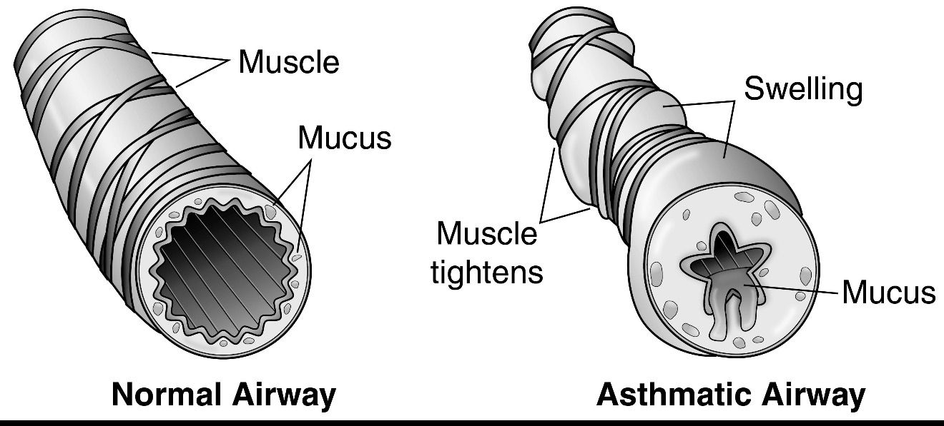

Global Initiative for Asthma (GINA) (2024) Global Strategy for Asthma Management and Prevention. Available at: https://ginasthma.org

Monitoring and data use: -
Because it enables patients and medical professionals to evaluate how well asthma is managed and spot early indicators of decline, effective monitoring is a crucial part of managing the condition. Frequent monitoring enhances symptom management, lowers the risk of severe asthma attacks, and promotes long-term respiratory health in teenagers (National Institute for Health and Care Excellence (NICE), 2021). Peak expiratory flow (PEF) monitoring is one of the most popular techniques for tracking asthma. Peak flow meters are portable instruments that gauge the fastest a person can exhale. Lower peak flow values could be a sign of airway constriction before symptoms worsen. In order to spot trends, track the efficacy of treatment, and discover early warning indicators of an asthma flare-up, adolescents are frequently urged to routinely record their peak flow values (Global Initiative for Asthma (GINA), 2024).

Monitoring of Respiratory Function and Peak Flow: -
Spirometry, a diagnostic technique that measures lung volumes and airflow, can also be used to evaluate respiratory function. Healthcare practitioners can assess the degree of airway obstruction and the efficacy of asthma treatment with the use of spirometry. Treatment strategies can be modified in accordance with the patient's needs by routine evaluations of lung function data (NHS, 2023).
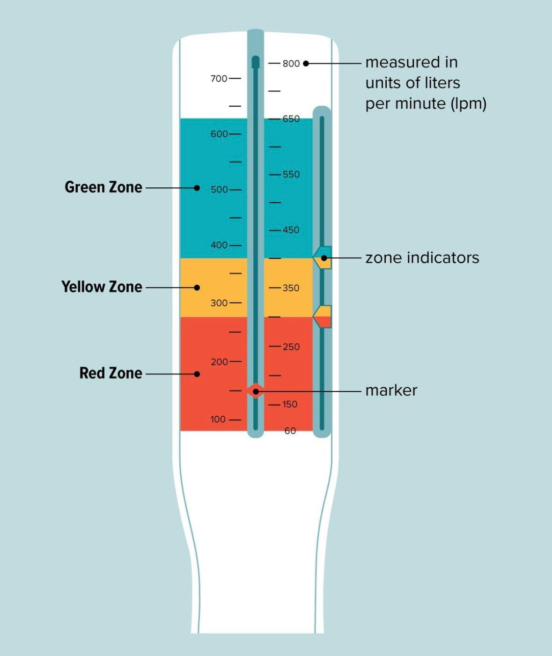

Evidence-Based Lifestyle Recommendations: -
Effective asthma care requires a combination of suitable medicine, good lifestyle choices and regular monitoring. Adolescents with asthma can have better asthma control, fewer exacerbations, and a higher quality of life thanks to evidence-based recommendations (Global Initiative for Asthma (GINA), 2024). Avoiding exposure to known triggers, such as dust mites, tobacco smoke, vaping, air pollution, pet dander, pollen, and respiratory diseases, is a crucial piece of advice. Inflammation of the airways and flare-ups of symptoms can be avoided by limiting contact with certain causes. Frequent exercise is also recommended since it enhances cardiovascular health, lung capacity, and general respiratory health. Exercise can occasionally exacerbate symptoms, but this can be controlled by warming up properly and taking prescription painkillers before engaging in physical activity as directed by a medical professional. Maintaining a healthy weight and food helps the immune system as a whole and eases respiratory system strain. A well-balanced diet high in fruits, vegetables, and substances that reduce inflammation may help improve general health.

Preventer Inhalers: -
The primary long-term treatment for asthma is preventer inhalers that contain inhaled corticosteroids. By lowering inflammation in the airways, these drugs lessen swelling and mucus production while also lessening the sensitivity of the airways to asthma triggers. Preventer inhalers should be used every day as directed, even in the absence of symptoms, in contrast to reliever inhalers, which offer quick symptom relief during an asthma attack. It has been demonstrated that regular use of preventer inhalers lowers the incidence of hospital admissions, improves lung function, and lessens asthma attacks (National Institute for Health and Care Excellence (NICE), 2021). Teenagers should learn proper inhaler technique from medical experts as well, since improper technique might lower medication efficacy (NHS, 2023).Using a spacer device when appropriate can further improve medicine delivery to the lungs and increase treatment effectiveness.
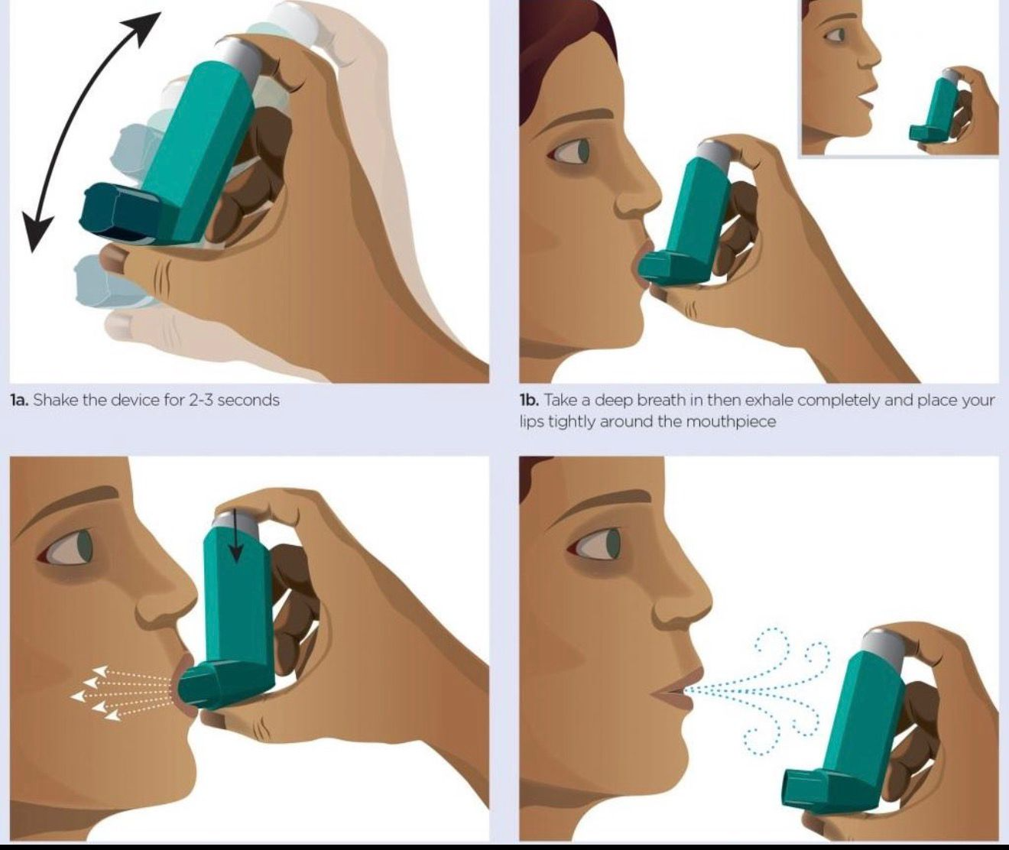
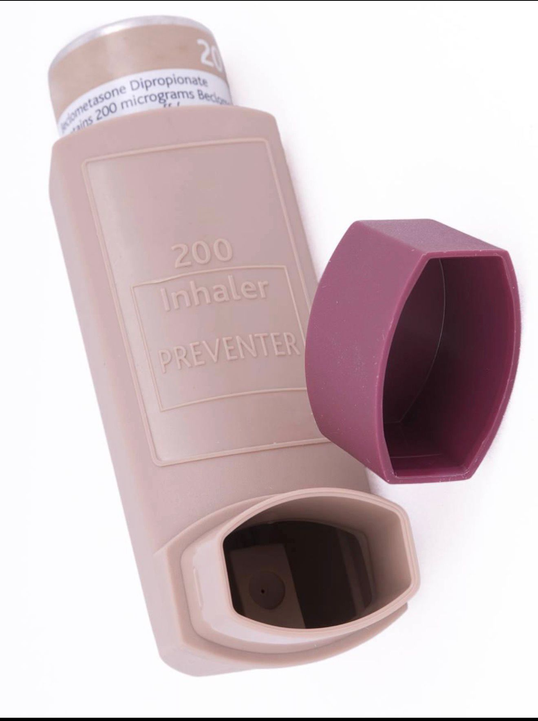
Evidence-Based Management and Lifestyle Recommendations: -
One of the most crucial aspects of managing asthma is avoiding recognised triggers. Adolescents should try to limit their exposure to dust mites, pollen, pet dander, air pollution, cigarette smoke, and vaping. Because they aggravate asthma symptoms, promote airway inflammation, and lessen the effectiveness of inhaled corticosteroids, smoking and vaping should be avoided (GINA, 2024). Frequent exercise is advised because it strengthens the respiratory muscles, increases cardiovascular fitness, and enhances general health. Teenagers should be encouraged to exercise while adhering to their asthma treatment regimen and, if recommended by their healthcare provider, taking medication prior to activity. Maintaining a healthy weight with a balanced diet may also help manage asthma symptoms and lessen their intensity. Asthma flare-ups are frequently caused by respiratory infections, which can be prevented with an annual influenza vaccination and proper hand cleanliness. Early detection of deteriorating symptoms and efficient self-management are made possible by routine asthma reviews, symptom monitoring, and the adoption of a customised asthma action plan. To increase medication adherence, identify early warning symptoms, and react effectively during asthma attacks, education is crucial for adolescents and their families (NICE, 2021). In general, reducing airway inflammation, improving respiratory function, and assisting teenagers in leading active and healthy lives while successfully managing their asthma are all made possible by combining effective medicine with good lifestyle choices and continuous education. maintaining good sleep hygiene, managing stress, and ensuring a balanced diet can support overall immune and respiratory health. With consistent adherence to medical advice and healthy lifestyle choices, most individuals with asthma can achieve good symptom control and maintain a high quality of life.

Conclusion: -
Asthma is a common chronic respiratory disease that significantly affects the health and wellbeing of many adolescents. This report has explored the normal anatomy and physiology of the respiratory system and explained how asthma disrupts normal airway function through chronic inflammation, bronchoconstriction and increased mucus production. These physiological changes reduce airflow, making breathing more difficult and causing symptoms such as wheezing, coughing, chest tightness and shortness of breath. The report has also demonstrated that environmental and lifestyle factors, including exposure to allergens, tobacco smoke, air pollution, respiratory infections and vaping, can worsen asthma symptoms and increase the risk of exacerbations. Regular monitoring using peak flow measurements and spirometry enables early detection of changes in lung function and supports effective treatment decisions. Evidence-based interventions, including the correct use of preventer inhalers, avoidance of asthma triggers, regular physical activity, maintaining a healthy lifestyle and following a personalised asthma action plan, can improve asthma control and reduce hospital admissions. Healthcare professionals play a vital role in supporting adolescents and their families by providing education, promoting medication adherence and encouraging self-management. Effective communication and regular asthma reviews enable patients to recognise worsening symptoms and respond appropriately, improving long-term health outcomes. good asthma management is essential in helping adolescents maintain normal daily routines, including school attendance, sleep quality and participation in sports and social activities. When asthma is well controlled, it can significantly reduce anxiety related to symptom flare-ups and improve confidence in managing the condition independently as they transition into adulthood. Therefore, early diagnosis, consistent treatment and ongoing education are key factors in preventing long-term complications and supporting a good quality of life.

References: -
Global Initiative for Asthma (GINA) (2024) Global Strategy for Asthma Management and Prevention. Available at: https://ginasthma.org (Accessed: insert date).
Marieb, E.N. and Hoehn, K. (2023) Human Anatomy & Physiology. 12th edn. Harlow: Pearson.
National Institute for Health and Care Excellence (NICE) (2021) Asthma: Diagnosis, Monitoring and Chronic Asthma Management (NG80). Available at: https://www.nice.org.uk (Accessed: insert date).
NHS (2023) Asthma. Available at: https://www.nhs.uk/conditions/asthma (Accessed: insert date).
Tortora, G.J. and Derrickson, B.H. (2021) Principles of Anatomy and Physiology. 16th edn. Hoboken, NJ: Wiley.
World Health Organization (WHO) (2023) Asthma. Available at: https://www.who.int/news-room/fact-sheets/detail/asthma (Accessed: insert date).
Reddel, H.K. et al. (2022) ‘Global Initiative for Asthma Strategy 2022’, European Respiratory Journal, 61(1).
British Thoracic Society (BTS) (2019) British Guideline on the Management of Asthma. Available at: https://www.brit-thoracic.org.uk (Accessed: insert date).
Kumar, P. and Clark, M. (2020) Kumar & Clark’s Clinical Medicine. 10th edn. London: Elsevier.
Rang, H.P., Ritter, J.M., Flower, R.J. and Henderson, G. (2020) Rang & Dale’s Pharmacology. 9th edn. London: Elsevier

