Strategic Management

Report for Tesla, Inc.

Course Title: LCMB7003



Student’s Name: Plamen Peev
Student’s number: 1815104
Lecturer: Dr Gladius D. Kulothungan

Table of Contents

Introduction 3
The Company's History 3
Mission and Strategic Objective 4
Success Factor 5
External Analyse 5
PESTEL Analyse 5
Industry Analysis and Life Cycle 7
Porter’s Five Forces Analysis 9
Competition for Tesla: 9
The Bargaining of Power of Suppliers 10
Bargaining Abilities of Buyers 10
The Threat Potential of New Entrants 10
Risk of Substitutes 10
The Extend of Complimentary Rivalry 11
Internal Analysis 11
Finance and Business Highlights 11
Value Chain Analysis 12
Primary activities: 13
Secondary activities: 13
SWOT Analysis 14
TESLA’s Strategic Resources and Capabilities 16
VRIO Framework for TESLA 17
Strategies to Sustain Competitive Advantage 18
Growth Strategy 19
Green Strategy and CSR 20
Recommendation 20
Conclusion 21
References 21
Appendix 27

Introduction

Strategic management may be defined as the identification of the organisation's goal as well as the strategies and activities to attain that mission. Thrilling and difficult strategic management basically determines decisions related to an organization's future directions, such as company purposes, resources and how well does it interact with the world in which it performs (Lynch, 2018). According to Jay B. Barney (2019), a good strategy is one that generates benefits.
The objective of the present report is to make a strategic analysis of key challenges Tesla faced while applying models, and theories and to demonstrate how they were used in emergent tactics while illustrating how the organisation gains a competitive edge through its strategic management option. In addition, at the end of the report, findings will be summarized, recommendations and a conclusion will be made.

The Company's History

The company Tesla, Inc. is a based at California automaker that develops, manufactures, selling electric vehicles, components, and energy storage and generating systems. Both Model S and 3 sedan, and Model X sport utility vehicle are among the company's electric car offerings (SUV). The company also sells energy systems such as rechargeable lithium-ion batteries and solar panels. The corporation sells and services its products and services through worldwide sales organisations, galleries, car facilities service, shops, and charge stations across the world. It caters to individuals, industrial and commercial clients, as well as utilities. The company operated in Europe, North America, and Asia. The headquarters of the company are in Palo Alto, California-United States. (Tesla Inc, 2021).

Marc Tarpenning and Martin Eberhard founded the firm Tesla Inc. on first of July 2003. Eberhard and Tarpenning held the positions of CEO and CFO, respectively (Reed, 2020). At the time M. Eberhard was Tesla's CEO, while Tarpenning was its CFO. When they founded the company with an idea to design and make a wholly electrical automobiles, in part because of the positive reception test markets had to General Motors' (GM) - Get General Motors Company (GM) Report prior electric car venture, the EV1. When GM only carried out this venture only for three years from 1996 to 1999, producing a limited number of automobiles that were never made available for public purchase, it was universally considered a technological success. Regardless of the fact that Elon Musk has become a symbol of Tesla for a long time, he joined the company in 2004 after Ian Wright and J. B. Straubel (Chief Technical Officer). Musk invested $30 million in the company and progressed to Chairman of the Board of Directors. A litigation settlement reached in September 2009 by Eberhard and Tesla permits all five – Eberhard, Tarpenning, Wright, Musk, and Straubel – to proclaim themselves co-founders ( LaMonica, 2009).

Mission and Strategic Objective

The company mission is to leverage the opportunity of eco-sustainable transportation by introducing mass-market electric vehicles to the marketplace (Furrier, 2020). The vision of the firm is to design compelling cars so that the world's transition can be brought to electric vehicles. The strategic objectives include recruiting highly expert employees to launch innovative vehicles in the automobile industry. The various product differentiations at Tesla Inc are basically grounded in advanced automation which is a prime niche differentiator along with battery technologies, and various eco-friendly products. This range of product differentiations includes customizable cars, periodical updates of software, solar panels, and so on (Furrier, 2020). The business strategy of the firm was to design high prices with low-volume vehicles like sports cars where people are not concerned about prices. This strategy would help the company to lower the costs of batteries to produce affordable and higher-volume cars (Furrier, 2020). The company’s competitive strategy is targeted at both the high-priced and the low-priced customers in the automobile industry. Tesla’s competitive advantages are capitalized by reducing the material costs for their differentiator products (Morris, 2020).

As a young company in the market, Tesla always has relied significantly on strategic alliances to expand its production capacity and processes, not only for economic reasons as well as for the sharing of experience and know-how. Since 2008, they have collaborated with Daimler, where Tesla designed a battery and powertrain solution for their electric fleet, which is also manufactured and supplied by Tesla. Since 2010, Toyota has been cooperating the same way and the company a collaboration deal has been signed together with Panasonic. Japanese’s partnership with the company is not only the main battery supplier, however, but it is furthermore a partner in the collaboratively planned Gigafactory project where Nevada-USA, is home to a massive battery research and production complex (Moritz, et al., 2015).

The company mission and driven by sustainability is a core of everything that motivates employees. It is also very important to consumers and stockholders. Tesla goods and services are focused on transportation, energy production, and storage. Historically these industries have been among the most polluting in the United States and across the world (Graph 1). To reach a zero-emissions future, the firm established a number of programs and initiatives at its production plants as well as in the communities where it works. Clean energy is provided to local schools, organisations, and everything in between through these initiatives (Tesla, 2020).

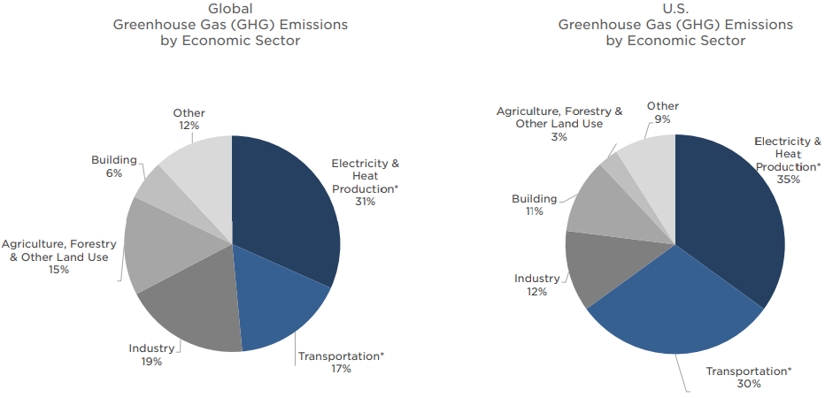
Graph 1: Greenhouse Gas (GHG) Emissions by Economic Sector

Source: (Tesla, 2020)

Success Factor

There are multiple success factors of Tesla. It is regarded as the most potential firm that entered the market early and achieved recognition in the electric vehicle market and gained popularity across the world (Tiwari, 2017). The brand of the firm influenced the majority of the consumers which represented a luxury image. The launch of Model 3 which was affordable to all economic groups of consumers increased its popularity and productivity. The leadership of Elon Musk is another major success factor as it is responsible for innovation and potential employees in the firm. The implementation of the NCA battery with Panasonic made better improvements in battery technology as well as crushing technology (Ingram, 2018).

External Analyse

PESTEL Analyse

PESTEL analysis focuses on six environmental factors in specific: political, economic, social, technical, ecological, and legal considerations. This listing emphasises that the environment comprises not just economics but also nonmarket variables. Businesses must examine both market and nonmarket components of strategy (Regner, et al., 2017). The analysis evaluates certain external factors of the company that could affect legal and environmental aspects of business operations (Lynch, 2018).
Political Factors
Tesla and its operations have spread across the world due to its supercharger abilities. The United States government has expressed an interest in renewable energy and electric automobiles and Tesla has become the first manufacturer to repay its debt under the Energy Department's Advanced Technology Vehicle Manufacturing program, less than four years after borrowing $465 million from the government (CNBC, 2013). Foreign government taxes, permits for the import of products designed by Tesla are other political factors (Kissinger, 2019).

Economic Factors
The impact of external factors may result in modifications in the economic conditions of any business. The automobile industry, specifically cars, is regarded as a symbol of luxury and fame which makes it difficult to impose prices considering market conditions across the world (Frue, 2018). The majority of the developing countries assume that purchasing cars from Tesla is quite expensive. However, governments in such countries are offering incentives so that people can afford them. Tesla can adjust expenses related to the engine which could impact the overall price of the car so that most consumers can purchase such luxurious cars (Dudovskiy, 2021).
Social Factors
Tesla is committed to producing low-carbon cars and also designing vehicles that are cheaper in terms of maintenance and fuel consumption. Americans continue to support efforts to build a sustainable economy, and as a result, the technology usage and design of cars were according to changing requirements of the consumers (Johnson, et al., 2017).
Technological Factors
Tesla is considered as a potential firm to design innovative products that are integrated with advanced technologies. For instance, smart summon is the technology that Tesla has launched that has self-driving ability embedded in cars. The technology was so advanced that it could drop the user or consumer at the destination without any manual operations of the user. Another significant innovation is that automobiles may now connect to platforms like as Netflix, Amazon Prime, Spotify, YouTube, and Hulu (includes live TV). Another new fun factor features are: "Caraoke," which allows you to sing with a big music library and lyrics songs supported plenty of languages on it, and Google trick: “I’m feeling lucky” (Welch, 2019).

Legal and Environmental Factors
The operations of Tesla have expanded to different countries in the world. It is necessary to have patents and copyrights and also need to maintain relations with suppliers and dealers of other countries as few countries do not permit them to sell vehicles (Kissinger, 2019). Labour laws need to be strictly followed and in case of any ignorance compliance expenses can be high. Tesla is famous for producing electric vehicles and solar cells which could reduce the burden on the environment. The production of electric vehicles in Tesla has reduced 4 metric tons of carbon emissions which indicates that the company is committed to protecting the environment (Dudovskiy, 2021).

Industry Analysis and Life Cycle

Tesla has created the sustainable transport industry and has been the leader in the same. The industry is still in growth phase as can also be seen through the launch of multiple products and services by Tesla. Martin Eberhard and Marc Tarpenning were responsible for incorporating Tesla in 2003. Later Elon Musk gained a share of $165 million from PayPal in 2002 (Klebnikov, 2017). Elon Musk was appointed as chairman of the board in April 2004 (Tesla, 2021). No one in the company’s leadership team has sufficient expertise in the automotive industry. Cost overruns were faced by Tesla in 2007 on its first electric vehicle Roadster. Appointed three CEOs have invested an amount of $55 million in tesla. Total nine members were included as board members of the company (Sorkin, et al., 2018). Major managers were retained from the company in 2018 that includes the vice president of engineering as well as other engineers that functioned in the automated production department (Luwei, 2021). The firm was made public in 2010 for $17 per share. In 2018 the share was trading $335 per share which made the company dominate market capitalization compared to General Motors. A profitable quarter of $11 million was recorded by the company in 2013 and again achieved profits in 2016 as well (Ahmed, 2018).

In 2008, the company took up agreements and corporate exchanges as well as regulatory approvals. The first flagship store was opened in Los Angeles which was regarded as the first retail store. Tesla made contracts with reputed companies like Panasonic associated with the construction of a large-scale battery plant in the United States of America (Tesla, 2014). Panasonic can produce cylindrical lithium cells and invest in equipment, machinery, and other manufacturing techniques. In 2009, acquisitions were made with Daimler that took a 10% stake in Tesla, and a contract was signed related to the supply of lithium-ion battery packs (Tesla, 2010). Another acquisition was with Capcom, a publisher of video games. In 2010 a merger was performed with Toyota with a 3% stake in Tesla (Harding, 2017). The firm also introduced a right-hand-drive version of its Roadster as well as TAG Heuer, the luxury Swiss watch manufacturer, was acquired to design a special edition of the Roadster. In 2011, the company started a store in Washington and its Santana Row store and signed an agreement with Toyota to design a power train for Toyota's electric Rav4. In 2012, the firm designed a new SUV so that production can be placed by 2014. The firm-initiated Linamar's plant in Tianjin, China as well as opened in Germany a new one. The firm also established new a European Distribution Center in Tilburg, Netherlands (Tesla, 2012). Tesla was also responsible for incorporating Titanium underbody shield and aluminium deflector plates into its Model S (Tesla, 2014). A new store was opened in a shopping center "The Westchester” in White Plains, located in the state of New York as well as Canada. In 2014, Tesla introduced the new online design studio of the Model S in China at a price of 734,000 CNY, which is about $ 121,000 (Hong, 2014). In 2016, major acquisitions were carried in Tesla with SolarCity Corp. in an all-stock with a value of $2.8 billion (Merced & Eavis, 2016). In 2021, Tesla introduced Full Self-Driving (FSD) with subscription charges of $199 per month for Basic Autopilot and $99 Enhanced Autopilot (Tesla, 2021).

It is important to emphasise that, in this report, there is no extra renewable energy capacity on the grid over the vehicle's life because the form of the renewable energy adoption curve in the United States is still being debated. However, a Tesla Model 3 charged in areas with "greener" grids, such as New York state, has significantly fewer lifespan emissions than the national average. In the future cities and nations alike will work to cut grid emissions. Graphic 2 emphasises how EVs on the road now will get cleaner as they age, as well as how important "greening" the grid will be in reaching lower transportation emissions (Tesla, 2019).

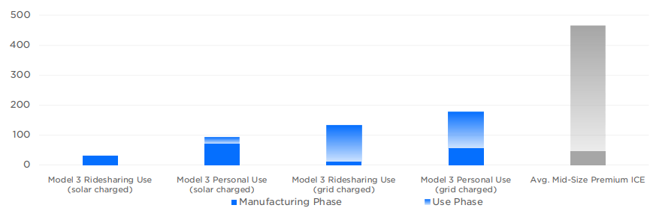
Graphic 2: Average Lifecycle Emissions in U.S. (gCO2e/mi)

Source: (Tesla, 2019)

Porter’s Five Forces Analysis

Michael Porter identified five forces that may be used to examine and comprehend an industry's dynamics. Buyers, suppliers, rivalry among existing enterprises, the threat of replacement products, and threats (barriers to entrance) are examples of these factors (Yetkin, 2013). According to M. Porter (2008), recognising which factor has a greater impact on the sector can assist a new entrant in developing the appropriate strategy. The five forces that shape Industry competition are depicted in Graph 3.

Graph 3: The Five Forces Shape Industry Competition
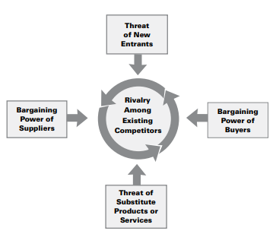

Source: (Porter, 2008)

Competition for Tesla:

In the existing automobile industry and electric car segment, there is less or low competition and competitors for the firm (Johnson, et al., 2017). There are not many firms that focus on manufacturing electric vehicles. Tesla is famous for offering high-end electric vehicles whereas other companies are providing few versions of the electric segment. Compared such as Chevrolet are not innovative enough to manufacture electric vehicles in terms of luxury and technology usage. In comparison to the entire automobile market, 14,240,036 registrations in 2020, a 15% decrease from 16,755,597 in 2019, the BEV market share climbed to 1.8 percent from 1.4 percent in 2019 (Kane, 2021).

The Bargaining of Power of Suppliers

The bargaining ability of suppliers is low as the design of electric vehicles is mainly based on technological and innovation incorporation in the products. The main elements of electric vehicles are batteries and engines that are produced by the company itself which results in lower dependency on the suppliers. This results in companies dominating the industry and suppliers and having a lower chance of bargaining ability for suppliers (Johnson, et al., 2017).

Bargaining Abilities of Buyers

The bargaining ability of suppliers is considered low due to less competition in the industry. The product offered by the company is usually designed with advanced technology along with promising value and this could make buyers bargain less. Another considerable factor of the product is there are limited versions of the product from which buyers can choose which results in the company dominating rather than the buyer (Johnson, et al., 2017).

The Threat Potential of New Entrants

Manufacturing electric vehicles involve multiple aspects such as higher investments, talented employees, innovation as well as technological usage. Technology keeps on updating and most of the companies may face difficulty in investing such huge amounts for technology to produce electric vehicles and this makes the risk of new entrants moderate (Johnson, et al., 2017). It is considered expensive for setting up manufacturing plants for designing electric vehicles and this factor could make firms rethink entering into the market. Identifying a talented workforce can be challenging to companies that are willing to produce innovative electric vehicles and all these factors lead to a moderate risk of new entrants into the industry.

Risk of Substitutes

The risk of substitutes in the automobile industry specifically in the manufacturing of electric vehicles is medium. The advancements of technology and innovation are increasing day-by-day, and the improvements can result in the emergence of similar companies in producing electric vehicles and self-driving vehicles. Constantly changing the high expectations of consumers in terms of luxury and technology also may motivate other competitor companies of Tesla to plan for designing electric vehicles. Electric vehicles are considered alternatives for fossil and gasoline-based cars. Biofuels are eco-friendly and do not cause any harm to the environment and these kinds of fuels are utilized in electric vehicles. This advantage of electric vehicles also encourages companies to manufacture electric vehicles. China is initiating to transform existing vehicles into biofuels by 2050 which could impose high risk to electric car segments. The mentioned factors can make the risk of substitution to the company moderate (Johnson, et al., 2017).

The Extend of Complimentary Rivalry

The industry has a high level of competitive rivalry. Tesla Inc. must compete with producers of both electric and non-electric vehicles. Although there aren't many significant participants, aggressive advertising and innovation by other businesses might have a negative impact on the company's capacity to compete. In 2021 Tesla stated that the production of the Cybertruck (an EV pickup) will begin in 2022. It also intends to begin manufacturing its electric semi-tractor truck next year (Tesla , 2021). Tesla will face in the future more rivalry in the electric pickup industry, as both Ford and GM are developing EV trucks. Both stated in 2021 (in the months of May and April, respectively) that their iconic trucks will be available in the entire EV form (Ford) (CHEVROLET ).

Internal Analysis

Assessing the business's strengths and weaknesses can help us to identify those actions carried out by the organisation that can produce a lasting competitive advantage for the business. To achieve this aim, it is necessary to identify the activities company succeeds in, not merely those in which it does relatively well as its competition (Gray, et al., 2004).

Finance and Business Highlights

The business operations of Tesla are classified into Automotive, and Energy Generation, and Storage. The automotive sector consists of developing, creating, manufacturing as well as lease and sale of electric vehicles. Other services of the automotive segment include sales of non-warranty vehicles, retail merchandise, vehicle insurance revenue services as well as vehicle services. Model 3, Model Y, Model S, and Model X. Under Model 3 are some of Tesla's products. The company is into manufacturing and designing mid-size sedan vehicles from Fremont Factory and Gigafactory (Tesla, 2021). Under Model Y. the firm produces compact sport utility vehicle (“SUV”) vehicles from Fremont Factory. Model S consists of a four-door full-size sedan vehicle, embedded Autopilot hardware as well as large touchscreen driver interfaces. Whereas model X consists of midsize SUVs designed with a unique falcon wing door system for superior access. Energy Generation and Storage segment contain installation, manufacture as well as sale of stationary energy storage products and solar energy systems to commercial individuals. Other business highlights of the company include creating and engineers engineering bodies, interiors, heating, and cooling as well as low voltage electrical systems. Producing lithium-ion battery packs, gearboxes, components both for its vehicles and for the firm’s machinery as well as electric motors. As per FY2020 see appendix 1 revenue generated by the automotive industry is recorded as US$31.54 million that indicates 93.8% of the total revenue generated by the firm. The revenue generated by the Energy Generation and Storage sector is recorded as US$1,994 million which represents 6.32% of the overall revenue produced by the firm (Tesla, 2021). The business operations are extended to different countries such as the US, others, China, the Netherlands, and Norway. Automotive revenue generated by the USA is indicated an increase of 28.31% compared to 2019 see Appendix 2, China - 48.5% increase in the third quarter of 2020 (CNBC, 2021). An investment of $1.5 million in Bitcoin was carried out by Tesla (Sky News , 2021). The company also invested $100 million In Panasonic associated with EV battery plant in the US. In 2021 Tesla did investment of US$6.5 million to deploy research and development of charging poles in Shanghai (2021). The company also planned to design electric vehicles worth $1 billion in Austin-Texas USA (Reuters, 2021). The firm also raised an amount of $2 billion through equity financing.

Value Chain Analysis

The value chain defines the types of operations inside an organisation that, when combined, result in the creation of a product or service. There are many organisations part of a wider value system, which is the collection of inter-organizational ties and interactions required to generate a product or service (Whittington, et al., 2020).
Primary activities shown in Graphic 4 are those that are directly related to the development or delivery of a product or service. For example, in the case of a manufacturing company like Tesla.
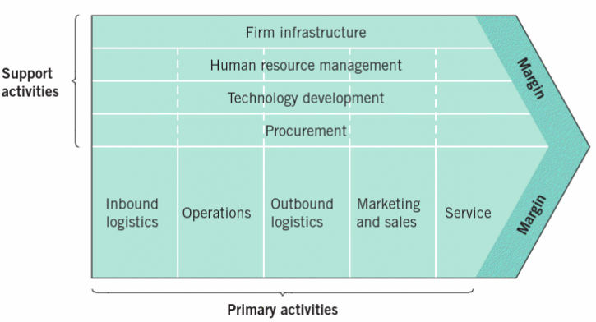
Graphic 4: The value chain within an organisation

Source: (Whittington, et al., 2020)
The value chain may be used to comprehend an organization's strategic position and analyse resources and capabilities.

Primary activities:
The activities consist of inbound logistics, outbound logistics, operations, sales and marketing, and other services (Lynch, 2018). Inbound logistics of Tesla contain transport and delivery. Major assembly of the firm occurs in different countries like The United States, California, and Fremont. The warehouses of the firm include Lathrop located in California, Taipei City in Taiwan as well as Sparks Nevada. Roadster is one of the potential products produced by the firm. Gigafactory 2 and Gigafactory 3 are the manufacturing plants that are implemented in New York and China. Outbound logistics is the area where final testing and assembly of products are carried out in the company. The operations of manufacturing and assembly are done in California. Marketing and sales are another primary activity and Tesla invested large amounts in marketing that includes digital sources and associated websites. The promotion of the company is also carried out through various social media platforms like Twitter (Lambert, 2021). The high rate of sales is recorded as there are limited versions of cars manufactured by the company which can be afforded by economically fit consumers. Other services of tesla include innovative products such as Cybertruck similar to sci-fi truck which is considered potential and eco-friendly truck.

Secondary activities:
Secondary activities play a significant role in collaborating activities associated with primary chain activities. Firm infrastructure is one of the secondary activities that include managing legal issues, planning, financial activities (Lynch, 2018). Tesla contains potential infrastructure that could balance the whole value chain and is capable of controlling overhead expenses within the firm to accomplish a competitive advantage. Human resource management is another area that examines HR actors such as shortlisting, recruiting, and training the candidates. HR management of Tesla is capable of identifying a talented workforce to improve the overall productivity of the firm and the firm is mostly dependent on the expertise of employees to carry out its operations which could enhance the activity. The majority of the operations of the value chain are based on technological abilities. Tesla has implemented technology innovation in multiple areas of the firm such as technology-enabled consumer services and data analytics to estimate sales and revenue. The research and development activities of the company fall under the technology area of secondary activities. Procurement is another major secondary activity that consists of buying inputs like raw materials, supplies, equipment, machinery as well as major relevant products required to design the end product (Johnson, et al., 2017).Tesla is associated with multiple external activities the firm is responsible to maintain the expenses of procurement after considering other secondary activities carefully.

SWOT Analysis

A SWOT analysis is a straightforward method for examining a company's present status by taking into consideration its strengths, weaknesses, opportunities, and threats. It allows an organization to account for internal and external elements, as well as positive and negative aspects, offering a balanced perspective on strategic concerns. The SWOT analysis may be used to determine a company's strategic fit between its internal environment (resources and capabilities) and its external environment (Fisher, et al., 2020).
Strengths
Strengths of Tesla can be classified as innovation abilities, rapid design, and vehicle engineering abilities as well as revenue. The innovative abilities of the firm made it possible to improve business performance. The research and development of the firm mainly concentrate on designing new and unique products. The firm is responsible for designing technology-enabled vehicles such as Model S, Model 3, Model X and Model S. Vehicle engineering abilities are also strengths as they provide onboard charging systems and recharging from any nearest electrical outlet. The limited versions are released from the company that could target consumers of higher economic groups. Highly vertical manufacturing capacity and in-house Engineering abilities are incorporated in electric vehicles. The enhanced revenue performance of Tesla is considerable strength as a maximum increase is observed in consecutive years compared to competitor companies. According to FY2020, the company observes a growth of 28.31% to US$31.54 million from US$24.58million (Tesla, 2021).

Opportunities
Opportunities of Tesla can be differentiated as leverage of electric vehicles as well as the global energy storage market. Tesla is regarded as a potential designer and manufacturer which led to commercializing motorcycles and cars on a global scale. The increase in electric vehicles has impacted Audi’s operations positively. A survey conducted (Graphic 5) by Edison Electric Institute and Institute for Electric Innovation indicated that sales of electric vehicles could reach 3.5 million by 2030 (Cooper & Schefter, 2018). The majority of the consumers are expecting unique features in vehicles such as electric vehicles. An increase is observed in the global energy storage market can enhance the operations of Tesla as well. The growth of renewable energy has impacted storage system devices in the power sector positively. The market could achieve 22.2 GW by 2023 worth US$13 billion. The majority of automobile companies are planning to design electric vehicles as per the requirements of consumers. According to Deloitte's forecast, yearly growth of 29% will be reached during the following 10 years: Total EV sales will increase from 2.5 million in 2020 to 11.2 million in 2025, and then to 31.1 million by 2030 (Walton, et al., 2020).

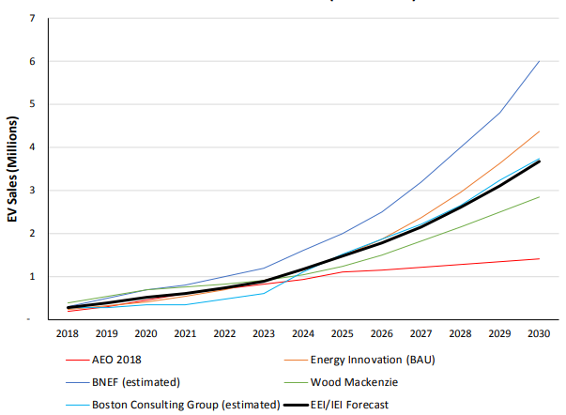
Graphic 5: Annual EV Sales Forecast Compared

Source: (Cooper & Schefter, 2018)
Comparing the forecasted EV sales is helping to understand reality for the moment and in the future. Some manufacturers have openly stated their EV sales objectives and plans for future models.
Threats

Threats associated with Tesla can be differentiated as increasing competition, seasonality, business operations, and Regulatory framework. The increase in demand towards alternative fuel vehicles has leveraged competition in the automotive industry which can be a threat to Tesla. Vehicle design and competition in the market are mainly based on propulsion technology as well as a traditional classification that is created between Model S and Sedan (Tesla, 2021).The sales of vehicles associated with the automobile industry are based on various seasons i.e., sales are usually higher during summer and spring seasons, and lower sales are recorded in winters. This seasonality sales can be an adverse threat to Tesla. The unexpected fluctuations in the sales of vehicles may result in a potential threat to the company. Regulatory bodies like the European Commission (EC) and the United Nations Economic Commission for Europe (UNECE) have restrictions regarding reduced carbon emissions as another potential threat (European Commission, 2021). A number of EU acts were reflected in the system of environmental law in Germany, which has caused delays in building the latest Gigafactory in Germany over concerns about water usage and pollution (Paul, 2021).
Tesla cars' energy efficiency will continue to improve over time (Graphic 6 & 7). Tesla Robotaxis will be built to be as energy efficient as possible by higher mileage. The carbon impact of each mile travelled will be reduced and customer' costs (Tesla, 2020).

Graphic 6:
Energy Efficiency - EPA range in miles/kWh Small SUVs (AWD)
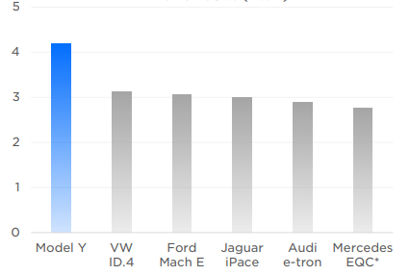
Source: (Tesla, 2020)
Graphic 7:
Energy Efficiency - EPA range in miles/kWh Mid-sized sedans (AWD)
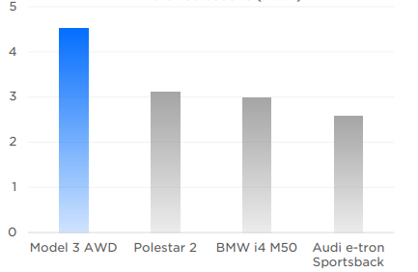
Source: (Tesla, 2020)

TESLA’s Strategic Resources and Capabilities

The major resources and capabilities of Tesla can be differentiated as a unique and technology-based production process, headquarters of Silicon Valley meant for innovation and technology is also considered as a major resource as well as the capability to raise capital according to the requirements of the company. The mentioned resources and abilities are tangible and intangible resources and abilities are expertise management team, consumer loyalty, retention as well as brand value, brand image, and innovation better consumer services, and extraordinary product development abilities. Tesla is regarded as a potential producer that offers unique products and services across the world such as electric sedan Model S, Model 3, Model Y, an SUV version of Model Y. Those models are capable of offering 250 miles to 396 miles (Model S) along with distinct battery performance, improvised storage, and seats (Tesla, 2021). The potential resources consist of megapack batteries, solar Panels powerpack, solar roof solutions, and some other related products. The differentiation strategy increases the capabilities of the company as the merging choices made by the firm are also unique and could enhance resources. For instance, SolarCity merged with Tesla, Inc. the merging resulted in the creation of a clean-energy ecosystem that enhanced the brand image of the firm. Strategies associated with the Research and Development department and abilities expressed in designing unique products and huge investments increased the production process. Increased renewable energy solutions in designing electric vehicles are also considered as potential resources and abilities of the firm (Tesla, 2016). The electric powertrain is another major resource of the company consisting of power electronics, battery packs as well as control software.

VRIO Framework for TESLA

The framework is utilised by managers in organizations to understand resources and capabilities (Johnson, 2017). VRIO can be classified as Valuable, Rare, Inimitable, and Organized (Table 5). The analysis can help to accomplish competitive advantage with proper usage of resources and abilities (Lynch, 2018).

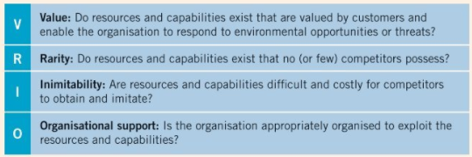
Table 5: VRIO

Source: (Regner, et al., 2017)
Multiple factors associated with the VRIO framework in Tesla can be differentiated as brand reputation, innovation, consumer experience, core competencies, market condition, HRM as well as product range. VRIO can be represented as positive for core competencies that accomplish competitive advantage. For Tesla, brand image is also positive and helps achieve competitive advantage. Innovation is also positive considering VRIO factors and so is consumer experience that helps in achieving competitive advantage (Sull & Reavis, 2019). In product range rare as a factor is negative and rest of the factors are positive. Market conditions are positive and achieve competitive advantage and in HRM, except rare and inimitable rest of the factors are positive that accomplishes competitive advantage.
The brand reputation of Tesla is a considerable ability that made the firm able to withstand competition in the automobile industry. The brand reputation of the company has leveraged not any marketing but uses innovation and consumer services. Technology ability is another positive factor of the framework that is utilized in manufacturing electric vehicles. Consumer experience is also positive (Valentin, 2014) as the design of vehicles in Tesla is carried out as per the expectations of the consumers in terms of technology and innovation incorporated in vehicles. The product range is considered as positive as the efficiency of vehicles produced by Tesla is higher compared to other competitor companies. The charges of products designed by Tesla are quite expensive but preferred by consumers. Tesla is the most potential company in the automotive industry that makes the firm superior in the market the automobile industry. Human resources management of the company is considered a powerful operation because of the talented workforce recruited by the firm (Valentin, 2014).

Strategies to Sustain Competitive Advantage

The operations carried out by Tesla can result in accomplishing a competitive advantage. The firm is strong in the market because of its rare and unique resources which can be one of the strategies to accomplish competitive advantage (Lynch, 2018). Other major strategies of the firm include assets, skills, intellectual capital as well as a distribution network. The value chain, product design, the technological innovation of a company also helps in sustaining competitive advantage (Valentin, 2014). Value chain analysis could help Tesla to achieve success in the automobile industry. Porter’s generic strategies along with value chain analysis can be utilized to determine competitive advantage. Tesla uses multiple factors such as marketing, operations as well as major value chain operations to acquire the cost and competitive advantage. The company could target consumers by its resources and technological abilities which is one of the strategies of marketing to acquire a competitive advantage. Costs and differentiation are two significant factors that firms consider accomplishing competitive advantage (Lynch, 2018). Costs are defined by the abilities and efficiency of the product designed by the company. Organizational policies, economies of scale, interrelationships, acquisitions as well as capacity utilization are some of the strategies to achieve competitive advantage (Valentin, 2014).

Growth Strategy

It is normal practice to estimate how much the market has grown over the preceding time – generally the prior year – when determining the size of the market. Growth is important in terms of strategy since it ties to the organization's goals. A fast-rising market may be more appealing to a company looking to expand quickly. Clearly, any such assessment must also take into consideration the above-mentioned point concerning market definition (Lynch, 2018). The growth matrix (Graphic 8) is a typical company strategy framework for identifying four fundamental organisational growth directions.
Graphic 8: The growth matrix
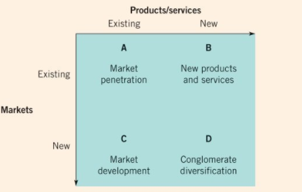
Source: (Johnson, 2017)
The growth strategies of Tesla are not limited to a single area but expanded into multiple areas like international or geographic expansion, mergers, and acquisitions as well as entry-stage strategies. The company planned to expand its territories across the world as demand for electric vehicles has been increasing rapidly. The main target of the firm was European and Asian markets that could enhance its revenue (Sull & Reavis, 2019). Tesla has operations in 438 stores across the world along with 100 service centres. The company even planned to construct manufacturing plants in China and Africa. However, it planned to launch in India but could not launch officially. The company entry strategy was based on designing unique and potential electric cars i.e., a Roadster that revolutionized the automobile industry (Baird, 2021). It also planned another strategy such as selling batteries for the car to improve its efficiency and protect the environment from carbon emissions. Financial strategies recently made by the firm include investing $1.5 billion in Bitcoin which could leverage organizational revenue. Strategies associated with acquisitions include Japanese organizations creating an energy storage facility with the help of rechargeable batteries in Hokkaido. The launch of a local vehicle design operation was planned in China by the company, which is one of the international strategies (Sull & Reavis, 2019).

Green Strategy and CSR
One of the earliest and most prominent definitions of Corporate Social Responsibility (CSR) is that given by Howard Bowen, who is referred to as the "Father of Corporate Social Responsibility" (Carroll, 1999) as "the responsibilities of businesses to pursue those policies, make those judgments, or follow those paths of action that are beneficial in terms of society's goals and values" (Bowen, 2013).
The complete competence of Tesla is based on improving the environment. With a focus on sustainable transport, Tesla has aligned itself with the key green strategies that need to be followed by the business. Further, it can also be seen that the launch of Electric Vehicles helps reduce pollution in the environment and also help in making sure that the overall cost for consumers is reduced from a long-term perspective. Thus, Tesla brings in green environment practices that are helpful for sustainable business growth (Sull & Reavis, 2019).

Recommendation
Tesla has been able to maintain its position in the industry with the launch of its vehicles that bring sustainability to the environment. The company has a brand image as its core strength and the use of technological prowess has been able to help Tesla in gaining the trust of the consumers. With the increasing focus on green energy and to reduce the overall emission rate, it is being observed that there are some companies that are also building vehicles that are environmentally friendly. Thus, there is a need for Tesla to up its game. The financials also indicate a positive picture for Tesla see Appendices 1&2. Thus, there is a need for Tesla to make use of its first-mover advantage and the technology that it uses to ensure that it is able to reach out to the end consumers faster. Strong marketing initiatives would hence be helpful for Tesla so that they are able to help them increase its market share. High debt is one concern for Tesla that will have to be taken care of by making sure that the company reduces the debt and uses internal sources of financing compared to using debt financing since debt financing has a negative impact on the overall profitability of the firm (Sull & Reavis, 2019). Another recommendation for the firm is that the firm must focus on its innovation which has been the core strength of Tesla to help them come up with better consumer services. Thus, not just the product but after sales also has to be made a seamless experience for consumers so that Tesla becomes the go-to brand for consumers.

Conclusion
Tesla has been one major player in the sustainable mobility business. Tesla created the created for Electric Vehicles and has been the first mover in the same. The strength of Tesla includes the quality of products, high focus on innovation, and strong brand. The increasing competition poses threat to Tesla. For the company, it is highly recommended that it should make use of innovation and use strong marketing to increase its mind share that would ultimately lead to an increase in the market share of the firm. Further, the company is also required to focus on reducing its debt since the debt directly has impacted the profitability of the firm. Thus, it is recommended that Tesla should use internal methods of financing since they would have a lower cost compared to debt, which is an external mode of financing. There is also a need to ensure that Tesla is able to develop a complete ecosystem that revolves around not just building the product but also the after-sales support or service that may be required by customers to give the customers a unique experience. This would thus be helpful in allowing Tesla to be the brand that consumers would trust.
The strategy of a company is its philosophy of how to acquire a competitive edge. Like others, this theory is founded on assumptions and guesses about how industry competitiveness is expected to evolve. When such assumptions and hypotheses match the actual growth of competition in an industry, a firm's strategy is more likely to provide a competitive advantage. The strategic management process is one method through which a company may select its strategies. This process consists of a series of studies and choices that raise the possibility that a corporation will be able to select a "good" strategy, that is, a strategy that will result in a competitive advantage (Barney & Hesterly, 2018).

References

Barney, . J. B., 2019. Strategic management and competitive advantage : concepts and cases. 6 ed. Harlow, England : Pearson.
LaMonica, M., 2009. https://www.cnet.com. [Online]
Available at: https://www.cnet.com/news/tesla-motors-founders-now-there-are-five/
[Accessed 7th November 2021].
Ahmed, S. I., 2018. Tesla short-sellers back in force as shares remain shaky. [Online]
Available at: https://www.reuters.com/article/us-tesla-musk-shorts-idUKKBN1KV1VE
[Accessed 27th November 2021].
Baird, I., 2021. HOW THE ROADSTER REVOLUTIONIZED THE AUTO INDUSTRY. [Online]
Available at: http://edgesd43.org/2021/10/12/how-the-roadster-revolutionized-the-auto-industry/
[Accessed 12th December 2021].
Barney , J. & Hesterly, W., 2018. Strategic Management and Competitive Advantage: Concepts and Cases. 6 ed. s.l.:Pearson .
Bowen, H. R., 2013. Social Responsibilities of the Businessman. Reprint edition ed. s.l.:University of Iowa Press.
Carroll, A. B., 1999. Corporate Social Responsibility: Evolution of a Definitional Construct. Business and Society, 38(3), pp. 268-295.
CHEVROLET , 2021. FIRST-EVER CHEVROLET SILVERADO ELECTRIC PICKUP TO BE BUILT AT GM'S FACTORY ZERO PLANT. [Online]
Available at: https://media.chevrolet.com/media/us/en/chevrolet/home.detail.html/content/Pages/news/us/en/2021/apr/0406-silverado-electric.html
[Accessed 5th December 2021].
CNBC, 2013. Tesla Repays $465 Million Loan from Federal Program. [Online]
Available at: https://www.cnbc.com/id/100759230
[Accessed 3th January 2022].
CNBC, 2021. Tesla’s China sales have grown to nearly half the size of the company’s U.S. sales. [Online]
Available at: https://www.cnbc.com/2021/10/26/teslas-china-sales-have-grown-to-nearly-half-the-sales-in-the-us.html
[Accessed 9th December 2021].
Cooper, A. & Schefter, K., 2018. Electric Vehicle Sales Forecast and, s.l.: Edison Electric Institute and Institute for Electric Innovation.
Dudovskiy, J., 2021. Tesla PESTEL Analysis. [Online]
Available at: https://research-methodology.net/tesla-pestel-analysis-2/
[Accessed 17 11 2021].
European Commission, 2021. Delivering the European Green Deal. [Online]
Available at: https://ec.europa.eu/info/strategy/priorities-2019-2024/european-green-deal/delivering-european-green-deal_en
[Accessed 9th December 2021].
Fisher, G., Wisneski, J. E. & Bakker, R. M., 2020. Strategy in 3D: Essential Tools to Diagnose, Decide, and Deliver. New York: Oxford University Press.
Ford, 2021. THE TRUCK OF THE FUTURE IS HERE: ALL-ELECTRIC FORD F-150 LIGHTNING. [Online]
Available at: https://media.ford.com/content/fordmedia/fna/us/en/news/2021/05/19/all-electric-ford-f-150-lightning.html
[Accessed 5th December 2021].
Frue, K., 2018. PESTLE Analysis of Tesla Inc.: The growth of the eco-friendly electric car. [Online]
Available at: https://pestleanalysis.com/pestle-analysis-of-tesla/
[Accessed 17 11 2021].
Furrier, A., 2020. Tesla: Business Model and Strategic Analysis. [Online]
Available at: https://alecfurrier.medium.com/tesla-business-model-strategic-analysis-c7d00bdc0339
[Accessed 17 11 2021].
Gray, A., Boehlje, M., Dobbins , C. & Ehmke, C., 2004. The Internal Analysis of Your Farm Business:. [Online]
Available at: https://ag.purdue.edu/commercialag/Documents/Resources/Mangagement-Strategy/Busniess-Planning/2004_05_01_Gray_Internal_Analysis_Farm.pdf
[Accessed 5th December 2021].
Harding, R., 2017. Toyota sells stake in Tesla as partnership dies. [Online]
Available at: https://www.ft.com/content/130a937a-48fd-11e7-919a-1e14ce4af89b
[Accessed 28th November 2021].
Hong, K., 2014. www.thenextweb.com. [Online]
Available at: https://thenextweb.com/news/tesla-reveals-china-pricing-for-model-s-with-minimal-markup-admits-it-could-charge-more
[Accessed 28th November 2021].
Ingram, N., 2018. Tesla Motors: A Potentially Disruptive Force in a Mature Industry. International Journal of Management and Applied Research, , 5(1), pp. 8-22.
Johnson, G., 2017. Exploring Strategy: Text and Cases. 11 ed. Harlow, England: Pearson.
Johnson, G. et al., 2017. Exploring Strategy Text and Cases. 11 ed. Harlow: Pearson.
Kane, M., 2021. 2020 U.S. Electric Car Sales: Tesla Captures 80% Of BEV Market. [Online]
Available at: https://insideevs.com/news/487969/2020-us-electric-car-sales-tesla-share/
[Accessed 27th November 2021].
Kissinger, D., 2019. Tesla, Inc. PESTEL/PESTLE Analysis & Recommendations. [Online]
Available at: http://panmore.com/tesla-motors-inc-pestel-pestle-analysis-recommendations
[Accessed 17 11 2021].
Klebnikov, S., 2017. 8 Innovative Ways Elon Musk Made Money Before He Was a Billionaire. [Online]
Available at: https://money.com/8-innovative-ways-elon-musk-made-money-before-he-was-a-billionaire/
[Accessed 27th November 2021].
Lambert, F., 2021. Tesla launches new social media platform to ‘engage’ its community and promote policies. [Online]
Available at: https://electrek.co/2021/03/05/tesla-launches-new-social-media-platform-engage-community-promote-policies/
[Accessed 9th December 2021].
Luwei, C., 2021. Brief Managerial Approach Analysis of Tesla in China. 2nd International Conference on Internet and E-Business, pp. 129-133.
Lynch, R. L., 2018. Strategic management. 8 ed. Harlow, England: Pearson.
Merced, M. J. d. l. & Eavis, P., 2016. Elon Musk Aims to Shore Up SolarCity by Having Tesla Buy It. [Online]
Available at: https://www.nytimes.com/2016/06/22/business/dealbook/tesla-solarcity-elon-musk.html
[Accessed 28th Novermber 2021].
Moritz, M. et al., 2015. Tesla Motors, Inc.: Pioneer towards a new strategic approach in the automobile industry along the open source movement?. [Online]
Available at: https://ieeexplore.ieee.org/abstract/document/7273032/citations?tabFilter=papers
[Accessed 17 11 2021].
Morris, C., 2020. ELON MUSK: TESLA’S LONG-TERM COMPETITIVE ADVANTAGE WILL BE MANUFACTURING. [Online]
Available at: https://evannex.com/blogs/news/elon-musk-manufacturing-is-tesla-s-competitive-advantage-over-other-automakers
[Accessed 17 11 2021].
Paul, J., 2021. Musk 'definitely considering' UK Tesla gigafactory as Brexit Britain's EV market 'strong'. [Online]
Available at: https://www.express.co.uk/news/science/1533875/elon-musk-gigafactory-tesla-uk-electric-car-nissan-germany-china
[Accessed 14th December 2021].
Porter, M. E., 2008. The Five Competitive Forces That Shape Strategy. Harvard Business Review, pp. 24-41.
Reed, E., 2020. www.thestreet.com. [Online]
Available at: https://www.thestreet.com/technology/history-of-tesla-15088992
[Accessed 7th November 2021].
Regner, P. et al., 2017. Exploring Strategy Text & Cases. 11 ed. s.l.:Pearson Higher Education & Professional Group.
Reuters, 2021. Tesla details $1 bln costs for new Texas factory, targets year-end completion. [Online]
Available at: https://www.reuters.com/business/autos-transportation/tesla-details-1-bln-costs-new-texas-factory-targets-year-end-completion-2021-11-22/
[Accessed 6th December 2021].
Shanghai.gov, 2021. V3 superchargers roll off Tesla's charging pole plant in Shanghai. [Online]
Available at: http://english.shanghai.gov.cn/nw48081/20210204/d666db0256214963ad5cedeb1594fd73.html
[Accessed 5th December 2021].
Sky News , 2021. Bitcoin hits new high as Tesla reveals $1.5bn investment. [Online]
Available at: https://news.sky.com/story/bitcoin-hits-new-high-as-tesla-reveals-1-5bn-investment-12212546
[Accessed 5th December 2021].
Sorkin, A. R., Silver-Greenberg, J., Kelly, K. & Boudette, N. E., 2018. nytimes.com. [Online]
Available at: https://www.nytimes.com/2018/08/14/business/dealbook/tesla-board-musk-tweets.html
[Accessed 27th November 2021].
Sull, D. & Reavis, C., 2019. Tesla's Entry into the U.S. Auto Industry. [Online]
Available at: https://mitsloan.mit.edu/teaching-resources-library/teslas-entry-u-s-auto-industry
[Accessed 12th December 2021].
Tesla , 2021. Cybertruck. [Online]
Available at: https://www.tesla.com/cybertruck
[Accessed 4th December 2021].
Tesla Inc, 2021. www.Marketline.com. [Online]
Available at: https://advantage-marketline-com.ezproxy.uwtsd.ac.uk/Analysis/ViewasPDF/united-states-hybrid-electric-cars-140339
[Accessed 6th November 2021].
Tesla, 2010. Strategic partnership: Daimler acquires stake in Tesla. [Online]
Available at: https://www.tesla.com/en_GB/blog/strategic-partnership-daimler-acquires-stake-tesla
[Accessed 28th November 2021].
Tesla, 2012. Tesla Motors Announces Major European Distribution Center in the Netherlands. [Online]
Available at: https://www.tesla.com/en_GB/blog/tesla-motors-announces-major-european-distribution-center-netherlands
[Accessed 28th November 2021].
Tesla, 2014. Panasonic and Tesla Sign Agreement for the Gigafactory. [Online]
Available at: https://www.tesla.com/blog/panasonic-and-tesla-sign-agreement-gigafactory
[Accessed 28th November 2021].
Tesla, 2014. Tesla Adds Titanium Underbody Shield and Aluminum Deflector Plates to Model S. [Online]
Available at: https://www.tesla.com/en_GB/blog/tesla-adds-titanium-underbody-shield-and-aluminum-deflector-plates-model-s
[Accessed 28th November 2021].
Tesla, 2016. Tesla and SolarCity to Combine. [Online]
Available at: https://www.tesla.com/en_GB/blog/tesla-and-solarcity-combine
[Accessed 9th December 2021].
Tesla, 2019. Tesla impact report, Austin: Tesla Inc.
Tesla, 2020. Financial Statements, Austin: Tesla Inc.
Tesla, 2020. Tesla 2020 Impact Report, Austin: Tesla Inc.
Tesla, 2021. Corporate Governance. [Online]
Available at: https://ir.tesla.com/corporate/elon-musk
[Accessed 27th November 2021].
Tesla, 2021. Full Self-Driving Capability Subscriptions. [Online]
Available at: https://www.tesla.com/support/full-self-driving-subscriptions
[Accessed 28th November 2021].
Tesla, 2021. Model S. [Online]
Available at: https://www.tesla.com
[Accessed 9th December 2021].
Tesla, 2021. Model S Premium Electric Sedan, Austin: Tesla Inc.
Tesla, 2021. Q4 and FY2020 Update, Austin: Tesla Inc.
Tesla, 2021. Tesla Factory. [Online]
Available at: https://www.tesla.com/en_GB/factory
[Accessed 5th December 2021].
Tiwari, J. D., 2017. Marketing Research on Tesla Inc. - Strategic analysis. ResearchGate.
Valentin, E. K., 2014. Business Planning and Market Strategy. s.l.:Sage.
Walton, B. et al., 2020. Electric vehicles Setting a course for 2030. [Online]
Available at: https://www2.deloitte.com/us/en/insights/focus/future-of-mobility/electric-vehicle-trends-2030.html
[Accessed 9th December 2021].
Welch, C., 2019. Tesla starts rolling out biggest software update ever with Spotify, Netflix, YouTube, and more. [Online]
Available at: https://www.theverge.com/2019/9/26/20885822/tesla-software-version-10-now-available-features-netflix-youtube-spotify
[Accessed 17 11 2021].
Whittington, R. et al., 2020. Exploring Strategy Text and Cases. 12 ed. London: Pearson.
Yetkin, U., 2013. Revealing the Change in the Maritime Security Environment through Porter’s Five Forces Analysis. Defence Studies, 13(4), pp. 458-484.

Appendix

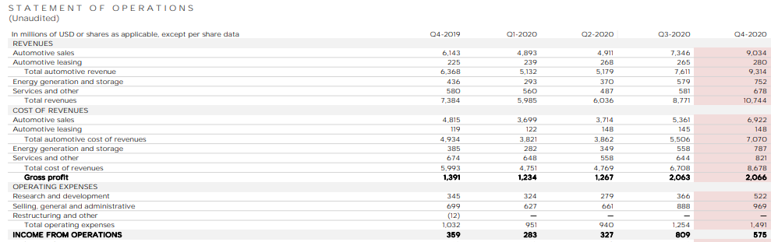
Appendix 1: Tesla Annual Financial Statement 2020

Source: (Tesla, 2021)

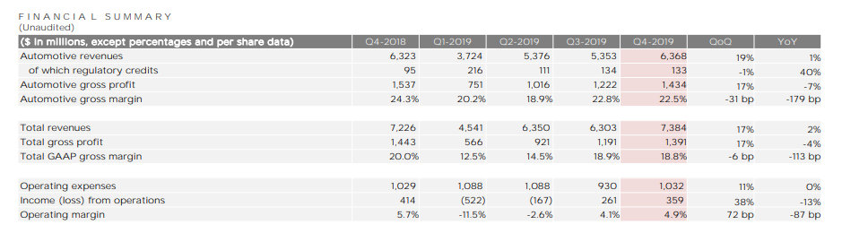
Appendix 2: Tesla Annual Financial Statement 2019

Source: (Tesla, 2020)

