ASSIGNMENT ON DATA HANDLING AND BUSINESS INTELLIGENCE

STUDENT NAME: NAVJOT KAUR
STUDENT ID: 2214338
CODE: LCBB5000
LECTURER NAME: ANUPAM MAZUMDAR
SUBMISSION DATE: 3 MAY 2024

Table of Contents

COMPONENT 1 EXCEL
INTRODUCTION………………………3
Pre -processing the data with example………………3
Answers of the excel questions………………4 - 9
Graphs to visualize the data and explanations …………………….4-9
Recommendations to gain profit in the business………………………9-10

COMPONENT 2 SPSS
Answers of SPSS questions ……………………………………..11-18
Graphs to visualize the data and their explanation………………11-18
Advantages and disadvantages of Excel and SPSS…………….19

INTRODUCTION: The purpose of this research is to examine the sales transaction data of an online retailer with headquarters in the UK that specialises in home goods and presents. From its London headquarters, the company was founded in 2007 and has catered to a wide spectrum of customers, from individual buyers to small companies that buy in bulk to resell in stores. The store has a global client base, and its data provides significant insights into customer buying patterns, product popularity, sales trends, and profitability by segment. This study makes use of Microsoft Excel to preprocess the given dataset, extract significant insights through thorough data analysis, and visually depict the results to provide practical solutions. Not only are the goals designed to evaluate past performance, but they also make use of this information to develop plans that improve profitability and market position. The report will specifically answer the following queries FOR EXAMPLES, monthly sales patterns , goods are bought most frequently, number things are typically bought in a transaction and consumer categories yield the highest profits. Also, strategic recommendations may be made to increase the profitability of the firm based on the analysis. This will help with strategic planning and decision-making.
PRE-PROCESSING DATA: For pre-processing the data ,the given dataset has been selected , where there was no total sales column, I have calculated it by multiply the price and quantity .Also months calculation by using formula=TEXT(B2,”mmm”) Evidence is given below because these columns are necessary for answering the sales trends over the months , most frequent purchased product and so on.

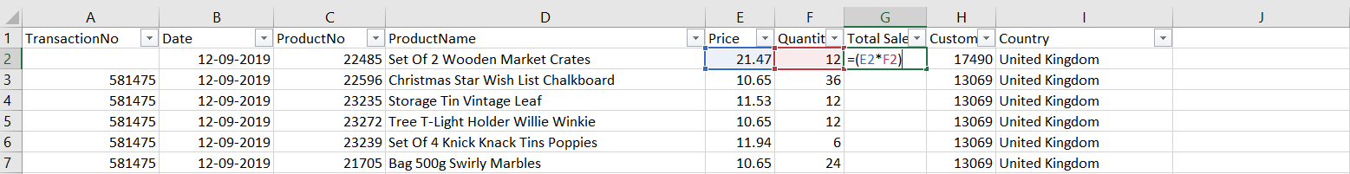
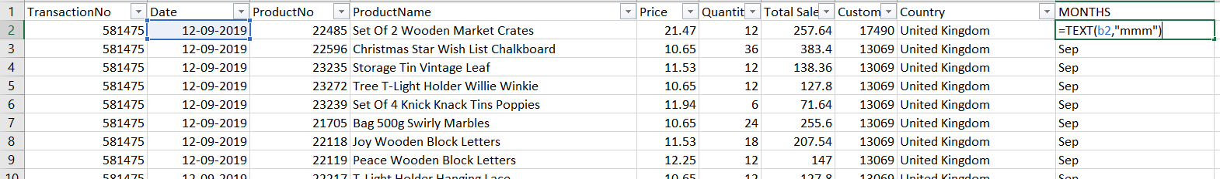

ANSWER1 : The sales trends over the months
As a data analyst to analyse the sales trends over the months , I have selected some data from the provided sales transaction dataset which is showing the sales trend in the month of September that clearly shown in (figure 1) with the help of line chart to visualise the data. To analyse the sales trends over the month I have used the pivot table by putting months under the column , product number under the rows and total sales in the values. As evidence is given below:

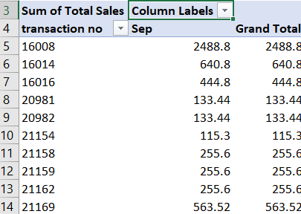
. FIGURE1 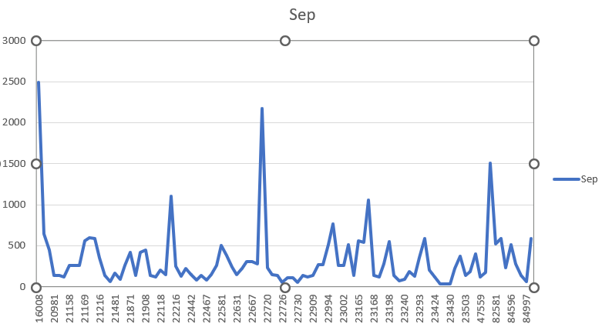
Figure 1 SALES TRENDS IN MONTH OF SEPTEMBER
EXPLANATION OF FIGURE 1: Outstanding Achievers: Determine the goods or product categories with the greatest overall sales figures. As an illustration, Product ID 22693 (total sales: 2177.28) fared noticeably better than other items. Secondly, the highest sale is noticeable that 1503.36 with the product id number is (72232) .Examining the reasons behind this product's success (such as price tactics, or promotions) may yield ideas for future pricing that would be helpful for for me to make decisions as a data analyst.
Poor Outcomes: Although, some products have highest sales but some items with low total sales as well; for example, Product IDs 23428, 23429, and 23430 each have sales of 37.2. It is clearly seen in the graph that some sales are greatest and some are lowest. So, sales are increasing and decreasing in the month of the September with the fluctuations. ( fg1)

ANSWER2: The most frequently purchased products:
According to the selected data from the transaction’s dataset so that as a data analyst I am able to ascertain the most popular goods from the comprehensive list , taking into account the total number of units sold. This data aids in understanding customer preferences. Below are the top goods along with a popularity breakdown with the help of the data visualization in the (figure 2 and 2.1).To, know about the most frequent purchased product I have use pivot table to analyse the data by putting products names in the row area, and SUM of quantity in the values and sort the data from largest to smallest. It is clearly seen in the above column chart that pointed-edge little folding scissors have sold out 240 pieces so, it is the most purchased according to selected data suggests a consistent demand, perhaps due to its usefulness for daily duties. Grow a Sunflower Or Flytrap in a Tin - 192 pieces Its popularity may be especially significant home gardening initiatives. After, Feng Shui pillar candles have sold 144 units as shown in the Column chart. Also, popcorn holder sold units are 100 and small ceramic top storage jar sold 96 units from the selected data from transaction sales. With the use of this information, As a data analyst in businesses I can make more informed decisions by knowing which goods are customer favourites.

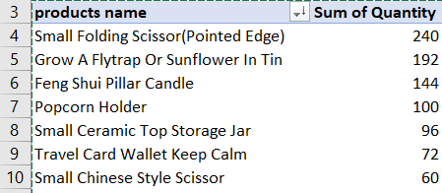fig1

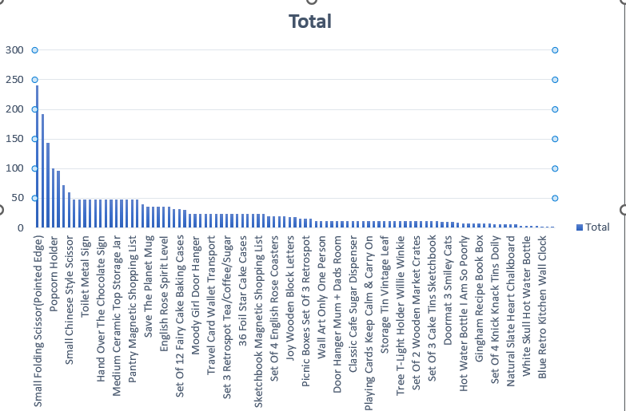 (FIGURE ,2.1)

ANSWER3: The number of products the customer purchase in each transaction.
For analysing, the number of products purchased by the customers ,I have selected some data from where, I have created a pivot table by transaction number in the rows area and count of products in the values area, Example is given below .Below in (figure 3 and 3.1) is a closer look at the purchase behaviours this data indicates and the consequences for business analysis. Transaction 581476: 64 goods, indicating a sizable and varied shopping basket that may be indicative of bulk purchases or purchases for commercial purposes. Purchases of 19 items were made in transaction 581475 Also, transactions 581477 to 581486 display a range of product counts, from as lower 1 to as high 64, demonstrating a diverse range of purchasing habits or goals. The transaction 581492, which is unusually large (296 goods), may be an indication of a corporation purchasing a significant amount of stock. The below evidence is clearly shown in the pivot graphs.

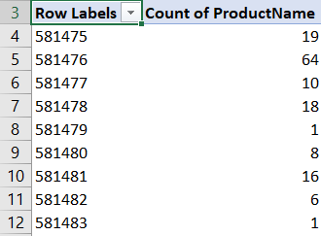(figure 3)

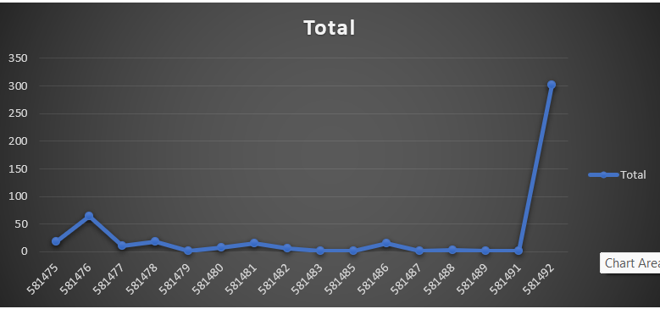
(Figure, 3.1)

Answer 4: The most profitable customers segmentation:
The selected data from the given dataset including both Norway and the United Kingdom, and provides more details about the sales contributions of various customers within these countries. This breakdown that are given below allows me to better analyze the most profitable customer segments as a data analyst.
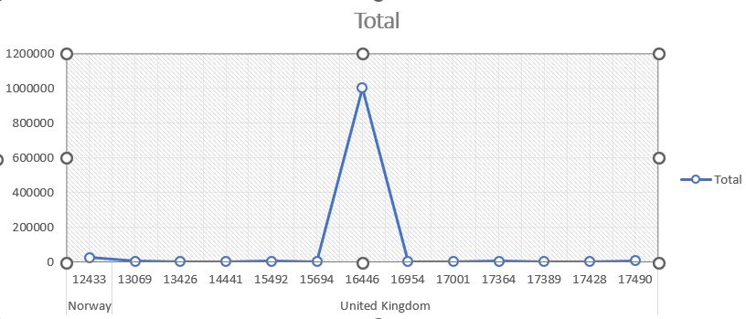

It is crystal clear in the above line chart that, Segments with the highest profitability: United Kingdom: Geographic Segmentation With revenues of over a million pounds, this segment is far more profitable than Norway. The revenue data indicate a clear dominance of the UK market, which warrants strategic attention. On the other hand, In Norway the one client from Norway (12433) has contributed significantly compared to their market size, despite the fact that their overall sales are substantially lower. This suggests a specialised market or a potentially lucrative client base that might be grown through focused tactics. Customer-Detail Analysis in the United Kingdom, Consumer 16446, With sales reaching £1,002,718.10—nearly 97% of all sales in the UK and 95% of all sales worldwide—this client sticks out significantly among the others in your data. This suggests that the wants and business of this very important customer should come first. Additional Notable British customers: Even while they don't make as much as customer 16446, other customers, such as 15492 (£5,210.25) and 17490 (£5,485.22), do make a significant contribution and are significant segments for growth and engagement.

Answer5: To drive greater profit for the firm based on the analysis of the sales transaction data, a multidimensional approach comprising customer segmentation, cost reduction, customer retention, market growth, price strategies, and investment in innovation should be explored. Below is a thorough approach suggestion:
1.Customer segmentation:
Using purchasing patterns analysis, segment customers according to product preferences, average transaction value, and frequency of purchases. This approach is known as behavioural and value-based segmentation. Customise advertisements and marketing initiatives for every category. Provide targeted retention tactics, such customised offers and first-rate service choices, to attract and keep valuable clients.

2. Cost reduction:
Enhance Supply Chain: Look for inefficiencies in the supply chain that could Improve the terms with suppliers, look into cheaper options from other providers, or combine purchases to save money on delivery. Also, ensure that there are enough items to fulfil demand by using a lean inventory management system that minimises waste and cuts down on surplus stock.

3.Investment in innovation: Product Innovation: Invest in R&D to create new items or enhance current ones, particularly if there is a significant demand from customers and big sales volumes. Also , with adoption of Technology, for example, Use data analytics and artificial intelligence (AI) to personalise content, do predictive analysis, and optimise processes.

4.Enhanced Promotional Activities , For example, boost online visibility to reach a wider audience by using social media interaction, content marketing,.
Data-Based Marketing: Utilise consumer purchase and interaction data to efficiently customise marketing offers and messaging.

5. Implement or improve customer retention loyalty programmes that use point or reward systems to incentivize repeat business. Ensure a high degree of customer satisfaction by investing in training for customer service. Also, personnel(Customer Service Excellence). This will directly influence repeat business and word-of-mouth referrals.
6. Strategic Alliances ; Partnerships: Establish strategic alliances with firms that complement each other in order to broaden your consumer base. One such alliance may be the bundling of together-frequently purchased items. Additionally, Collaborate with non-competing companies that target similar demographics to expand your brand's reach and visibility through cross-promotional initiatives.( Nguyen, et al.,2020)
In order to implement these tactics, it is necessary to weigh the short- and long-term advantages. To guarantee that the strategies successfully contribute to enhanced profitability, it is important to conduct regular reviews and adjustments based on input from the market and financial performance. Each component must be carefully put into practice, taking into account the unique circumstances and capacities of the company to guarantee that it complements overarching corporate goals and competitive market conditions.

COMPONENT TWO SPSS
Question: how many students are male and female?
ANSWER1: The data presented shows that there are 2133 valid entries, demonstrating a complete data gathering procedure with no information missing.
Male: Of the sample, 1056 students are male, making up 49.5% of the total.
Female: Of the whole sample, 1077 students are female, making up 50.5%.
The evidences of the above-mentioned statement are given below:

Statistics
GENDER
N | Valid | 2133
N | Missing | 0

GENDER
 |  | Frequency | Percent | Valid Percent | Cumulative Percent
Valid | MALE | 1056 | 49.5 | 49.5 | 49.5
Valid | FEMALE | 1077 | 50.5 | 50.5 | 100.0
Valid | Total | 2133 | 100.0 | 100.0

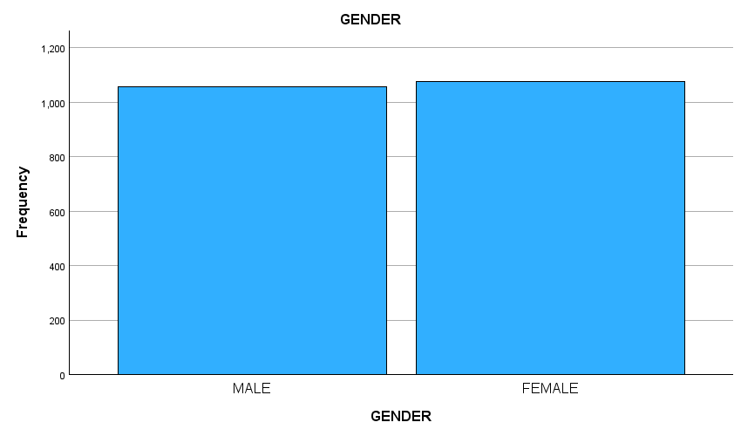

Question2: how many students qualifies and does not qualifies for reduced free lunch?
ANSWER2: According to the given dataset it has been noted that the lunch qualification distribution includes 2133 valid entries, all of which include complete data, just like the gender distribution does. Also, it has been noted that 918 students representing( 43.0% ) are eligible for free lunch, while 1215 students representing (57.0% ) do not qualify for free lunch . The evidences that has been produced from the given data are below.

Statistics
LUNCH
N | Valid | 2133
N | Missing | 0

LUNCH
 |  | Frequency | Percent | Valid Percent | Cumulative Percent
Valid | DOES NOT QUALIFY FOR FREE LUNCH | 1215 | 57.0 | 57.0 | 57.0
Valid | QUALIFY FOR FREE LUNCH | 918 | 43.0 | 43.0 | 100.0
Valid | Total | 2133 | 100.0 | 100.0
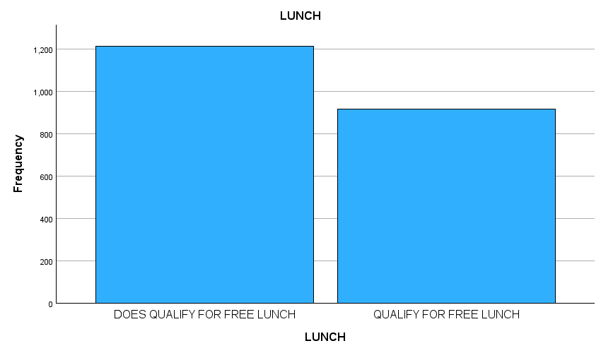
Question3: What are the mean and median of students who qualifies for reduced free lunch and does not for free lunch?

Answer3: According to their eligibility for reduced free lunch, the pupils' mean and median meal scores are revealed by the following data which are given below as well: There is a minor variation in mean lunch scores between students who are not eligible for reduced free lunch (1.51) and those who are qualify for free lunch (1.50). This suggests that the two groups' average meal ratings differ little from one another. There are more noticeable differences when the median lunch scores are taken into consideration. With a median lunch score of 2.00, it indicates that half of the kids who do not qualify for reduced free lunch . Conversely, half of the kids who are eligible for reduced free lunch have a lunch score of 1.00 or below, as indicated by the median lunch score of 1.00 for those students.

Case Processing Summary
 | Cases
 | Included |  | Excluded |  | Total
 | N | Percent | N | Percent | N | Percent
GENDER * LUNCH | 2133 | 100.0% | 0 | 0.0% | 2133 | 100.0%

Report
GENDER
LUNCH | Mean | Median
DOES NOT QUALIFY FOR FREE LUNCH | 1.51 | 2.00
QUALIFY FOR FREE LUNCH | 1.50 | 1.00
Total | 1.50 | 2.00

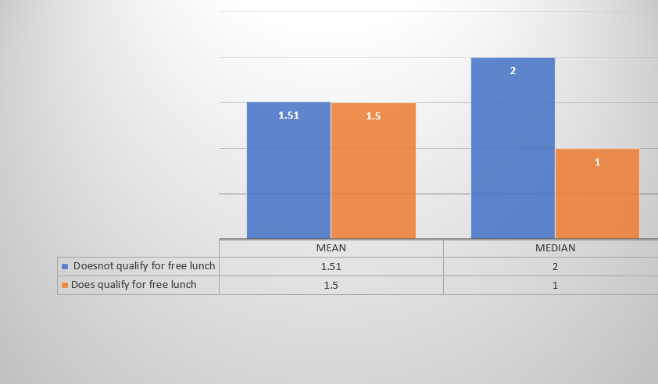

Question 4: Using the dataset provided in conjunction with spss, give a specific example ( k-mean clustering). Give an example of the results?
The initial centroids selected for every cluster are known as the original cluster centres. Frequently, they are chosen at random or according to presumptions.
Iteration History: This section demonstrates how the cluster centres vary across the k-means algorithm's iterations. Each centroid's movement from the previous iteration is shown in the "Change in Cluster Centres" column. The goal of the method is to minimise this change, and it reaches convergence when it gets extremely small—in this example, less than.000.
Number of Cases in Each Cluster: This section presents the number of data points that are part of each cluster following the last iteration.
The centroids' initial points for each cluster are displayed in this table. These starting points are picked at randomly
iteration 1: Notable shifts in each cluster centre as a result of a significant adjustment made to the original cluster assignment based on the set means, Cluster 1 advances by 5.632 points in the direction of its members' mean, and so on for every cluster and Iteration 2,As the clusters begin to stabilise, make modifications as before, but at smaller magnitudes: The movements of Cluster 1 are 2.086 points, and the movements of the remaining clusters are lesser. Following Returns (3 to 6) : Moving closer to the ideal locations that minimise intra-cluster variation, the centroids' motions continue to decrease:
The changes show how clusters stabilise around a mean that fairly represents the individuals inside that cluster as they continue to decrease. With clusters 5 and 6 being the biggest, this distribution shows how effectively the data points are categorised depending on how comparable their characteristics are. This suggests that many data points have similar properties relating to these centroids. The goal of the iterative centroid readjustment in k-means clustering is to maximise the degree of similarity between characteristics while clustering data points. As the method locates the best-fit centroid for each cluster, the rotation of the cluster centres gets less with each iteration until convergence, at which point no further gains are possible. In order to enable focused analysis, the extraction of insights, & the formulation of decisions based on these classifications, this procedure divides the collection of data into discrete groups that are both properly outwardly and internally diverse as shown above. The further information under the given tables.

Initial Cluster Centers
 | Cluster
 | 1 | 2 | 3 | 4 | 5 | 6
Pretest | 93 | 79 | 36 | 22 | 50 | 65

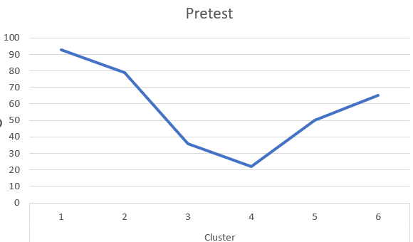

Iteration History
Iteration | Change in Cluster Centres
Iteration | 1 | 2 | 3 | 4 | 5 | 6
1 | 5.632 | 2.335 | 1.281 | 4.750 | .865 | 1.423
2 | 2.086 | 1.575 | 1.980 | 3.090 | .474 | .335
3 | 1.268 | 1.243 | 1.295 | 1.167 | .529 | .309
4 | 1.048 | .987 | .663 | .413 | .404 | .271
5 | .716 | 1.087 | .448 | .785 | .000 | .432
6 | .000 | .000 | .000 | .000 | .000 | .000
a. Convergence achieved due to no or small change in cluster centres. The maximum absolute coordinate change for any centre is .000. The current iteration is 6. The minimum distance between initial centres is 14.000.

Final Cluster Centres
 | Cluster
 | 1 | 2 | 3 | 4 | 5 | 6
Pretest | 82 | 72 | 42 | 32 | 52 | 62

In order to minimise the distance between each point in a cluster and its centroid, these values indicate the mean of the characteristics of the points assigned to each cluster.

Number of Cases in each Cluster
Cluster | 1 | 104.000
Cluster | 2 | 281.000
Cluster | 3 | 419.000
Cluster | 4 | 210.000
Cluster | 5 | 538.000
Cluster | 6 | 581.000
Valid |  | 2133.000
Missing |  | .000

ANSWER 5: The disadvantages and advantages of using Excel and SPSS with examples are given below.
Disadvantages of Excel with example | Disadvantages of SPSS with example
Excel's statistical tools have limitations, making it difficult for students to conduct thorough data analysis for complex studies like regression . This is particularly evident when evaluating data for project. | For SPSS , license purchase is required that can be very costly for some individuals who have very low budgets. For instance, buying a research lab's SPSS licences.
Challenges in Handling Large Datasets for Data Handling. For instance, As a student encounters Excel performance problems and data management difficulties while working on a research project with a sizable dataset. | The learning curve for undergraduate students in SPSS is a challenging one due to its sophisticated capabilities to perform the tasks without the learning .
Complexity of Managing Many Worksheets: Excel gets more difficult to navigate and time-consuming to consolidate information from when more worksheets and data sources are added. | Reliance on Syntax for More Complex Features .Example; need to be proficient in SPSS syntax in order to use advanced features like custom scripts and macros in SPSS.

Advantages of Excel | Advantages of SPSS
Commonly included in Microsoft office so it is the one of the advantages of excel. For instance, fundamental data analysis in undergraduate classes utilising Excel. So, it is easy for students to do their activities with very low cost as compare to spss. | It has very advanced visualization tools for complexify data. Also ,it offers various customizations options. For example, to make assignments there are lots of line charts , histograms , pie charts are available to visualize the data .
As like SPSS, Excel have visualization tools which helps the users to create charts ,graphs etc. Instance , so many graphs like histograms, bar graphs , charts to display the sales data etc. | Flexible Data Handling Example: The student can simply organise, filter, and analyse the data to provide insightful findings for their research assignment because to Excel's versatility in handling various data formats and kinds.
Usability and Accessibility: Example: A college student examines survey data in Excel as part of a research project. Excel is accessible and simple to use, enabling students to do simple data analysis tasks with efficiency thanks to its well-known interface and intuitive features. | SPSS is widely used in academic and research settings due to its extensive documentation, tutorials, and user assistance resources, including online courses, manuals, and forums.

ALL THE DATA AND GRAPHS RELATED TO EXCEL AND SPSS PRODUCED BY THE STUDENT.
REFERENCES
Nguyen, S.K., Vo, X.V. and Vo, T.M.T. (2020). Innovative strategies and corporate profitability: the positive resources dependence from political network. Heliyon, 6(4), p.e03788. https://doi.org/10.1016/j.heliyon.2020.e03788

.
‌

