Motivation Reflective Report
Academic and employment skills
Romeo Hanley ID number 1914399
Tutor Name Caroline
Module code BMSW 4001

Table Of Content

Introduction

The use of reflective Modules

Personal development plan

Notes on the assignment questions.

Issues

Easy and difficult things,

Ideas on anything else

Conclusions

Introduction
My Reflective report is going to try and explain, my understanding on what I have learnt about Motivation. I will try to match and organise my research activities, modules, and theories in a way that I can use them to enhance my Academic and employment skills. This would be done for further development or leading and motivating staff in the future. Along with my (PDP) the format of discussion is as follows: notes on the assignment questions. Issues, easy and difficult things, specific research recorded, ideas on anything else.

The use of reflective Modules
Wallace (1991) reflective model (below) was important for me to note. In stage one as a trainee or in my case a student at university. In stage two with my new learnt knowledge plus my life experimental knowledge and experiences. I had the chance to reflect and practice what I learnt. by fulfilling all the criteria, the Goal is to achieve professional competence in my assignments.
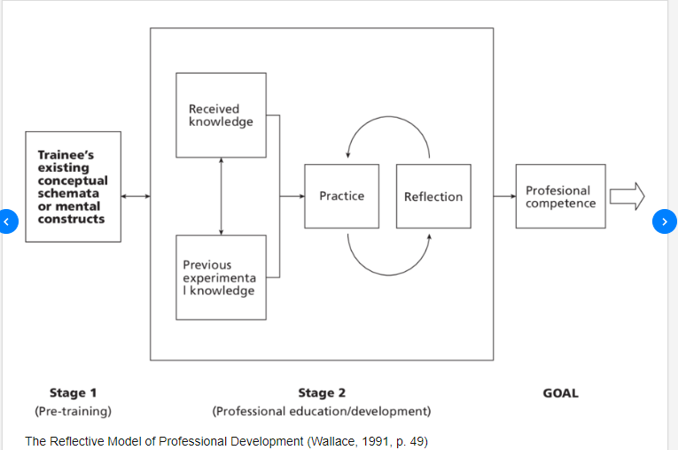
- (Basset 2020) describes three reflective models, that can be used for reflective purposes. The ERA module. Driscoll’s what module and Kolb’s experiential Learning Cycle. ERA models stand for my experience reflection action. I have learnt that I need to develop more experience before I take certain action. Driscoll (2007) help me to look at my own weakness and attempt to do something about it because it what? so what and now what.
- Kolb’s (1984) I find a good model. the concrete experience is what I know now, Reflective observations is what I see I can use, Abstract conceptualisation helps me to be creative using ideas not necessary for use with the project, Active experimentation for me can be me learning from the action that I am doing
- The Gibbs reflective cycle (1998) below cover six arears that I reflect on when I was

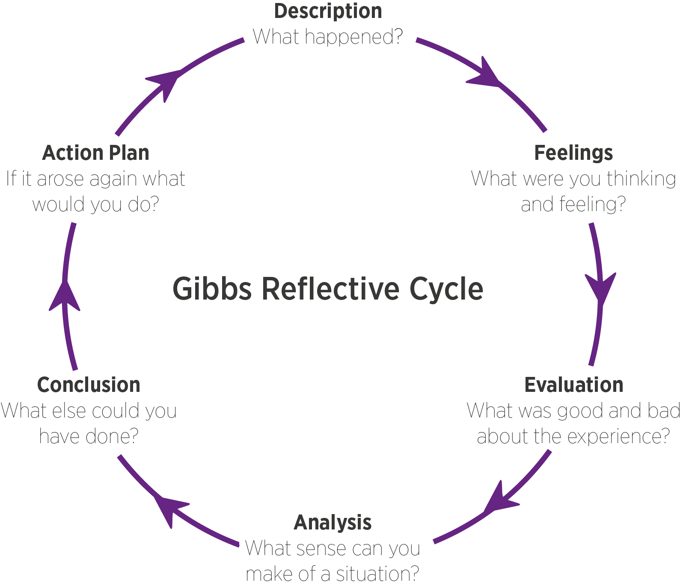
Reviewing my experiences, my actions, my emotions feeling, and my learning before, during, and after each action. Aiming to be a professional my ability to look back on my knowledges, skills and finding better ways to do things is growth and development
It was important that I do a (PDP) Personal Development plan (Below) in a (SMART) graph. SMART stands for specific, measurable, Achievable, realistic, and timed. These were skills that needed immediate attention.

Personal development Plan
Personal Target | How will I achieve this? | How will this improve my academic or employability prospects? | How will I know that I have achieved this? | When will I achieve this by
Do referencing professionally | Speak to the librarian – obtain book for Harvard referencing | Needed for my essay and report writing. | When I am confidence that the lecturer gives me the correct marks | July 2022 -December 2022
Improve my time management | Do things mathematically. a bit at a time daily. A good timetable | From being frustrated, rushing around. Late nights. Must give up certain things | The stress level reduces | July 2022 – December 2022

Notes on the assignment questions
Descriptions
Further use of Gibbs reflective cycle (GRC), I am glad that different people are motivated in different ways. Researching then describing the four arears that are motivators like pay, good working conditions, Awards, what recognition motivates best? Are all noted in the staff impact on the company.
- Feelings
The (GRC) discusses Emotions and feelings. I felt that in any workplace there is contentment, and stresses
- Evaluation
The (GRC) states a good or bad teams in paid employment works. The individual’s motivation is what keeps them going.
- Analysis
The (GRC) shows that it may be ironic that complete strangers who totally like or dislike each other. Then being brought together to fulfil a purpose.
- Conclusion
The (GRC) also can show that me as a manager who don’t be so quick to stake out a position, but I acquire all the facts before deciding what to do - get me results every time.
Action plan
The (GRC) expect me draft a plan for future up and coming provocations. For example, setting up a budget. I need to take note of this for the future.

Issues
There was an incident happened in the class that tried my patience, I worried about this for days and it have affected my decision whether I should study at this university. To explain. I needed a lecture to look at my work before I put it in to Turnitin. I asked the lecturer to look at my work. The lecturer looked at all the others assignment work, and then he looked at my work assignments ten minute after the time to turn it in. I questioned if this sort of thing happens to other students?

Easy and difficult things
Doing this assignment gave me a deep and meaningful insight into what motivated me. The difficult things like referencing, over coming the fear of getting things right. However the most difficult thing was trying my best to be friendly to my other students who did not care if they pass or fail the course.

Ideas on anything else
Grammatical Errors
On reflection, I have realised the grammatical errors made will impact greatly on my assignments. A lot of points that I have made in my essays, and I could have expanded on would have proved quite difficult because of this. How I wrote and expressed what I had written, I believed would be understood by others, but this was not always the case, as was pointed out to me by someone who was impartial. It was communicated to me had my completed work been proof-read, with attention to detail, these errors could have been avoided.
I find punctuations along with my spellings to be a couple of my weaknesses. I could be dyslexic, though this has not been proven. With the added support from the right channels and my willingness to learn further, this will improve over time.

Personal Tragedies
During my studies I have had some ongoing personal issues which needed to be resolved and at times, I neglected to do so. I also tend to procrastinate. This is one of my biggest faults because it becomes a delaying tactic which also impacts with other parts of my studies, especially where submission dates are concerned.
The situation with ‘personal tragedies’; this was something that I sensed was going to happen making it quite a difficult year for me. I was already aware that my mother was of poor health. But the channels in which this should have come from, was not the case and what happened during this, I had surmised. This left me feeling disgusted.
My daughter also had explained to me that her grandmother, too, was very ill and was hospitalized and to add to this, her mother wasn’t of good health either. I had no idea that this would affect me. However, a fortnight prior to the death of my daughter’s grandmother, her grandfather had also passed way. A week after her grandfather had been buried, the grandmother (his wife) followed suit.
News of my mother’s funeral was made known to me by my son. My siblings neglected to inform me due to an ongoing family feud. In essence, I had four funerals to emotionally deal with. The realisation of all four was huge, though I refused to acknowledge this at the time because I didn’t believe it would affect me so.
In ‘Hindsight’ I could have spoken to the appropriate department that would have been sympathetic to my circumstances and perhaps an extension would have been possible. But I did not wish to appear the ‘victim’, hence my decision not to disclose the above information. My pride played a great part in this too, as I wished to succeed with all my assignments, in the due times allocated, without using my situation to benefit from an extension to complete.
In future I will use all the resources at my disposal because this can make the difference between a ‘fail’, ‘pass’ or a ‘distinction’. Nobody should feel too proud to ask for help in any form. This is something which I need to seriously adopt for future reference.
Another area which I would like to highlight is regarding one of the lecturers; her name being Mrs Farhan. (A fantastic lecturer) There was an ‘outburst’ from her during one of her classes which surprised the entire group. As far as she was concerned, the attitude of the more mature students should have mirrored that of the age group.
Perhaps her thoughts of discipline did not meet with that of the students, this may have been due to a ‘cultural, age, misunderstanding’. She wasn’t at all happy with the attitudes and conduct of the class.
Whilst speaking to the class, one student proceeded to smile. He was asked the question, “What have you got to smile about?”. The response was met with, “What do you want me to do, cry?” Of cause the reply was met with chuckles from some of the class student to the dismay of Mrs Farhan. What followed next could only have been described as shocking. None of us expected any ‘outbursts’ from her. (Strange attitude from some of the students) It was as though she had past grievances, that she had allowed to fester, and the ‘Smart Alec’ response gave cause for her to strongly express her peevish attitude. (Or speak positive in support of the student who wish to learn)
From my perspective, what should have taken place from her was for her to utilise the ‘rule chart’ that was put in place by the engagement of the class. Another thing which could have been employed by her was ‘student representative approach’ who would have set out some common ground between both parties; this would have to be adhered to. By doing so the atmosphere within the class may not have changed as dramatically as it did.
I was voted in by the class as the resident representative. And at time it was challenging I just wanted to scream. Doing this retake assignment reminded why I am so motivated to succeed. Yes, it’s likely I will lose my home, yes, it’s likely my health will suffer, (Had COVID twice) studied on my holy day, plus if anyone know the troubles, I have gone true. The word stubbornness comes to mind.

Conclusions
This reflection was difficult to write because my mind was focus on anything but my assignments. I felt helpless and useless. But I know I tried.

