

Title: Can a Refined Referencing Tool Improve Workflow?

by
Ieuan Thomas
335780

Supervisor: Andrew Green
Second Marker: Gwyn Perry

Project submitted as part of the requirements for the award of BSc (Hons) Applied Computing

April 2025

Contents
Project Proposal Form 3
Statement of the Problem 3
Introduction 3
Literature Review 3
History of Academic Referencing 3
Why develop a Referencing Tool 4
Application Requirements 5
Currently Available Tools 6
Technology Platforms 7
Development Options 7
Project Architecture 8
Project Aim 8
Project Objectives 8
SDLC 9
Research Methodology 9
Project Resources 11
Equipment 11
Project Plan 12
Work Breakdown Structure 12
Time Planner 12
Bibliography 13
Appendix 17

Project Proposal Form

Statement of the Problem

Introduction
Citing academic references is a critical part of researching if the writer wishes to avoid accusations of plagiarism and bibliographies are heavily time-consuming. ^{[1]} Improper referencing will lead to researchers bearing the weight of academic plagiarism ^{[1]}. IT solutions providers have spotted a gap in the market for tools that make referencing less of a chore ^{[2]}. Citation managers such as Zotero, EndNote and Cite This For Me provide easy storage of academic sources in an online platform, making them accessible from most devices connected to the web ^{[3, 4]}.
Unfortunately, these tools are often riddled with problems ranging from poor performance to a lack of citing styles. ^{[5]} Some features are hidden behind paywalls. ^{[3, 4]} Oversights like these can make or break the user’s experience with an application. ^{[5]} This became more apparent after conducting preliminary research, which brought to light people’s opinions on available referencing tools. ^{[5]} Forum sites such as Reddit, Zotero Forums and The Student Room often have such discussions about users’ favourite tools and the issues within them. ^{[5]}
This project will delve into the process of creating a citation-managing solution that caters to the requirements of reference tools. It will seek to understand what makes these tools useful to students and researchers alike.

Literature Review

History of Academic Referencing
Documented examples using references date back to 4000 years ago in Sumer – now recognised as Iraq. ^{[6]} However, referencing was used primarily to record the sales and trade of goods in this time. ^{[6]} Referencing has since evolved into a complex system of academic acknowledgement of authors, literature and studies of theories and ideas which further humanity’s progression. ^{[6]} Following WWII, traditional indexing methods were deemed ineffective, and researchers opted to invent ways of recording and honouring literature that inspired them. ^{[6]} This birthed several new styles of citing and crediting the work of others, with Harvard being among the first to emerge. ^{[6]}
Edward Laurens Mark (1847-1946) is accredited as the first user of the “Harvard System” of referencing. ^{[7]} Mark, (Director of Harvard’s zoological laboratory) wrote a bulletin for Harvard College, documenting his observations of Limax campestris (slugs) and their natural lives. ^{[7]} Mark used an author-date citation accompanied by an explanatory footnote to acknowledge other researchers’ work [Appendix 2]. ^{[7]} This citation was later given great acclaim by 140 of Mark’s previous students, stating his paper as having “introduced into zoology a proper fullness and accuracy of citation and a convenient and uniform method of referring from text to bibliography” – his students grateful for being introduced to such a straightforward method of citing sources in their research. ^{[8]} Eli Chernin refers to this bulletin and the students’ appreciation of Mark’s work in a paper he published in 1988. ^{[8]} Chernin’s paper demystifies the otherwise obscure origins of the “Harvard system” of referencing, helping to understand the format for the Harvard system. ^{[8]} In 2024, the “Harvard system” is recognised as one of the most accessible referencing styles and widely used by several universities and research institutions. ^{[9]}
Where Harvard's style of referencing – and other styles derived from it (such as APA, MHRA and MLA) – use a parenthetical approach with their author-date-page, or author-page format, Vancouver uses citations ordered by numbers accompanied by a list of referenced sources (bibliography). ^{[10, 11]} This project follows Cardiff University’s style of Vancouver to cite work of interest to the project, for example [Appendix 3]. Instead of placing the reference in a footnote at the page’s end, a bibliography can be found below detailing each piece acknowledged in this work.

Why develop a Referencing Tool
Referencing tools exist to save time. ^{[12]} They create usable references from website links (URLs) or ISBNs by formatting data stored in a database and formatting them in a referencing style chosen by the user. ^{[12]} Current referencing tools, such as Zotero or MyBib allow user to store their references in an online bibliography. ^{[4]} Microsoft Word’s Citation Manager can also create references from citations written in documents, although users are forced to write their references by hand in this case. ^{[13]} Primary research has displayed that users are unsatisfied with some of the services currently available. An interview with a member of library staff who is experienced with using referencing tools listed several problems they had with websites such as ZoteroBib or MyBib. These free applications are convenient for performing lookups of ISBN or DOI numbers and storing them for later use. ^{[14]} However, they would frequently come back with the incorrect literature or be unable to find anything and even when successful would still create a bibliography in the incorrect format or miss out on key details.
Further reasoning for pursuing this project is how referencing tools can fail to match the style chosen by the user. Ensuring references are properly formatted and follow guidelines set by research and learning institutions reduces the risk of accusations of plagiarism. ^{[15]} Academic plagiarism is incredibly important to consider when undertaking any projects involving the works of other researchers. ^{[15]} Failure to acknowledge set guidelines will result in severe penalties, such as instantly failing one’s research or in cases outside of a learning institution, legal prosecution. ^{[15]} Students are made immediately aware of the setbacks of failing to follow these guidelines and can refer to their student handbook to identify specific styles required by different universities, with different modules/subjects having differing styles. ^{[15]}
These applications are produced to make referencing easier as it can be a very time-consuming process, but problems such as those listed above would suggest that the user would be wiser spending their time typing references by hand. ^{[12]} The inconsistent behaviour of these applications wastes more of the user’s time than it would reference using the traditional method. ^{[4]}

Application Requirements
Reference tools should allow users to input a unique identifier (i.e., URL, ISBN or DOI number) and the application searches a database to find a corresponding record, and then converts that into a reference in the style chosen by the user. ^{[12]} A referencing application at its core automates the process of creating references to save the user time, therefore it should be fast, responsive and accurate. ^{[12]} If the output is inaccurate then the user will have to edit the reference themselves, defeating the purpose of the application in the first place. ^{[15]}
The following requirements are transcribed from an interview discussing currently available referencing tools [Appendix 4].

Requirements List
- Be able to accurately identify ISBN, DOI or URLs.
- Ability to fetch data from an API.
- Use API data to create and load references into the application in a correct format.
- Create a reference list in the correct Vancouver system format.
- Option to choose a specific Vancouver style from an accessible list.
- Can reorder and edit references if necessary.
- User Interface with only the required features onscreen.
- Button to copy reference list to the clipboard.

Design Requirements
- Simple UI for ease of use, and reduced maintenance.
- Intuitive.
- Needs to apply to all levels of computer literacy.
- Drop-down list with a selection of Vancouver referencing styles.
- Drop-down list with font, colour and sizing options.
- List references in order of oldest to newest added.
- Keep menus to a minimum to avoid confusion.

Currently Available Tools
Having come up with requirements for designing the application it can be useful to analyse the market leaders to see what their programs do well.

Endnote
A referencing tool developed by Clarivate claiming to be “the world’s best referencing manager”. ^{[16]} Endnote is a desktop reference tool that prides itself on seamless integration with apps like Microsoft Word and several websites across the Internet. It also features tools for automatically creating citations and bibliographies. ^{[16]} It boasts more than 7000 referencing styles and tools to read, and access referenced PDFs all in the same app. ^{[16]}
Endnote requires a £260 one-time-purchase for regular users, or £140 for eligible students – a discount of 46.15%. ^{[17]}

Zotero
Zotero is a web-based reference management tool rather than a desktop application like Endnote. ^{[16, 18]} Extremely popular for being free, open-source, and easy to use, Zotero also boasts several thousands of referencing styles derived from several systems such as Vancouver and Harvard. ^{[18]} Availability via the web makes it arguably more accessible than Endnote, through mobile phones or computers. ^{[16, 18]}
Where Endnote has a single price for purchasing a license, Zotero is free to use until a storage limit is reached. ^{[4]} Zotero, by default, has 300MB for storing citations and reference lists, which can be increased through yearly plans. ^{[4]} The plans are as follows:
- 2GB for $20 a year
- 6GB for $60 a year
- Unlimited storage for $120 a year
[4]

MyBibliography
MyBibliography (commonly referred to as MyBib) ^{[19]} is another free web-based reference manager comparable to Zotero but uses a more streamlined user interface. ^{[19]} Unlike Endnote and Zotero, however, MyBib is 100% free even including its premium features. ^{[19]} It allows users unlimited storage and access to over 9000 reference styles, is ad-free and offers extension compatibility with browsers like Mozilla Firefox, Microsoft Edge, and Google Chrome. ^{[19]} MyBib will struggle with matching website data and finding books where the user will then have to fill in gaps from that lack of information.
MyBib is a completely free service that boasts paid features of other premium services at no additional cost. ^{[19]}

Technology Platforms
Web-based will be the most accessible format for most users. ^{[20]} Web has many other advantages, such as being accessible from multiple points (i.e., mobile phones to desktops), and allowing users to access the app wherever they have access to the web. ^{[20]} Having a web application also reduces multiplatform maintenance with only needing to cater aspects of the website to specific browsers. ^{[20]}
The desktop application format was deemed unfeasible for this project due to the college’s strict security with downloading software onto their computers. With the correct permission, it would be possible, however, this project is not on the same scale as a Microsoft Office application. Some additional complications were apparent where a web-based alternative would be preferable, such as communicating with APIs, databases and other cloud technologies. ^{[20]}
Saving to a usable text format such as .docx (MS Word) or .txt would be desirable as users would be able to easily carry their reference lists across documents. Microsoft Word is difficult with this, where text is often obscured by alternative formatting or conflicting styling and users must correct it to match their writing. ^{[21, 22]} Users of the program often complain of difficulties they have when copying and pasting online text or images into their documents is troublesome. ^{[21, 22]}
Human-Computer Interaction (HCI) is another important element to consider in the development effort. ^{[23]} HCI, in short, is the interaction people have with a program or website and the various things that can be done to improve that experience, from user interface improvements to loading times and resource usage. ^{[24]} A web application should load quickly and make everything clear for the user for the best experience, for example. ^{[24]}

Development Options

Development Environment
Visual Studio Code (VS Code) is a free development environment home to an extensive library of plugins, languages and development tools. ^{[25]} VS Code is best for this project as it is familiar, easy to use, and supports HTML, PHP, CSS and JavaScript development. ^{[25, 26]} VS Code is also widely available on several platforms, making maintenance simple from multiple devices. ^{[25]}

Programming/Styling Languages
HTML and PHP will be used for building the website to house the features outlined above. The website will be decorated using CSS (styling language) and utilise the CSS framework, Bootstrap to easily organise the webpage layout. ^{[27, 28]}

API
To access online literature databases and website information, the application will need an API to communicate with. ^{[29]} Research has identified two suitable APIs in ISBNDB and WorldCat which can access the necessary data and return it to the program quickly. ^{[30, 31]}

Project Architecture

Project Aim
- Construct an easy-to-use referencing tool that effectively creates a reference list in Vancouver style.

Project Objectives
- Analyse designs and features that make current referencing tools useful.
- Recognise drawbacks in current referencing tools.
- Research how referencing tools can improve workflow.
- Design and Build an application that aligns with user requirements and
- Evaluate effectiveness of the application against other software.
- Gather user feedback on the application.
- Report research findings.

SDLC
The optimal SDLC methodology for this project is the Agile model. Agile follows an iterative and incremental approach which focuses on fast development. ^{[32]} Agile’s iterative approach means each new application variant is treated like the previous, following a systematic approach as shown below. ^{[32]}
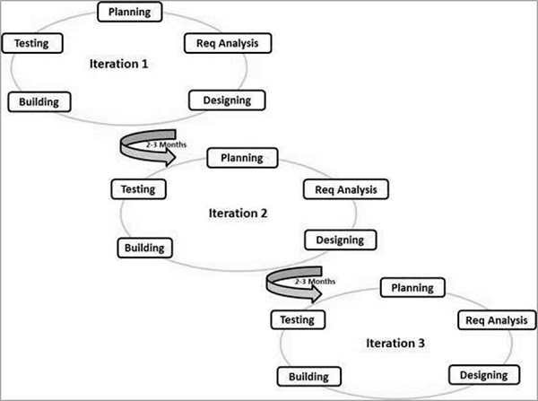
^{[32]}
This development style will match the research philosophy and strategy chosen for this project where the requirements analysis and testing are carried out without following a strict development schedule, while also demonstrating development over time. ^{[32]} Its repetitive nature also pairs well with research methods such as interviews and surveys. ^{[32]}

Research Methodology

Philosophy
Phenomenology is derived from the Interpretivism philosophy. ^{[33]} Researchers interpret their findings in a way that aligns with their personal beliefs and ideas, allowing them to make decisions on what they think is best for the parties involved in the project. ^{[33]} Thus, Phenomenology is best for this project because it aims to understand what makes a referencing tool that users would desire through an interpretation of design and development. ^{[33]} Being well-versed in the topics of discussion can allow the researcher to better communicate ideas and grasp feedback from testers. ^{[33]}

Approach
The inductive research approach will suit this project well as there are not many sources discussing the positives and negatives of current referencing tools in detail ^{[34]}. Preliminary research highlighted forums dedicated to debating this subject with much to be desired in the way of surefire ways to design a better referencing application. ^{[5]} Conducting primary research on experts and professionals using referencing tools will generate a greater solution ^{[34]}.

Strategy
The notion of analysing research findings and trying something new based on that data is where Action Research will be useful. ^{[34]} Implementing changes or features according to user feedback and testing allows the project to progress and improve with each stage. ^{[34]} It can be used to gauge the target audience’s needs which pairs perfectly with the interpretivist philosophy. ^{[34]}

Choice
This project will utilise the mixed method for gathering the necessary information and resources. ^{[34]} Increasing the number of quantitative and qualitative sources available to the project will yield reliable data with credibility to back it. ^{[34]} Interviewing subjects and handing out surveys while reading expert discussions on X (formerly Twitter) vastly expands this projects’ well of knowledge. ^{[34]}

Time Horizon
A longitudinal study will gather more insight as time progresses. ^{[34]} Having the ability to observe the application’s progress and compare it to the current market over an elapsed time means more changes and improvements can be made to compete with other applications. ^{[34]} Longitudinal complements the Action Research strategy by testing new iterations and observing users’ experiences, resulting in improved feedback over time. ^{[34]} However, this project is short-term and may not have the ideal amount of time to conduct continual additional research. ^{[34]}

Data Collection
Primary data collection methods include interviews and surveys. Interviews give better perspectives on people’s opinions while also allowing the interviewer to further question the interviewee for more detailed, specific information. ^{[37]}
Surveys are another great source for gathering opinions and experiences of others but through a wider sample size, giving more diverse data than 1-to-1 interviews. ^{[37]}

Project Resources

Equipment
Application development demands a desktop capable of handling hosting servers or running applications comfortably.
Home desktop specs:
- CPU: AMD Ryzen 5 5600X 4.6Ghz
- GPU: Gigabyte RTX 3050 8GB
- RAM: Corsair 16GB 3600Mhz
- 1x NVMe 256GB SSD
- 1x 2.5” 1TB SSD
Accessories:
- 144hz 27” monitor
- Keyboard + mouse

Project Plan

Work Breakdown Structure
Breaking down tasks to be completed during the project.
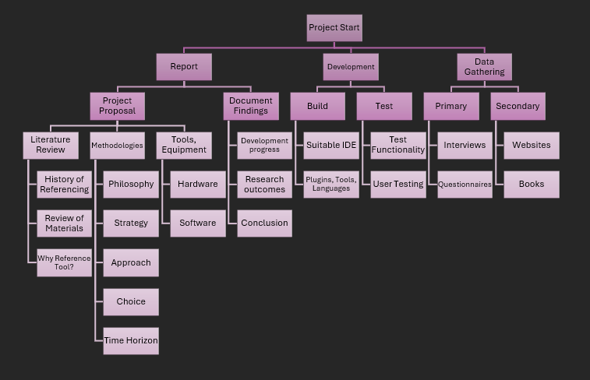

Time Planner
A Gantt Chart created in Tom’s Planner tracking task progress before and after milestones. ^{[38]}
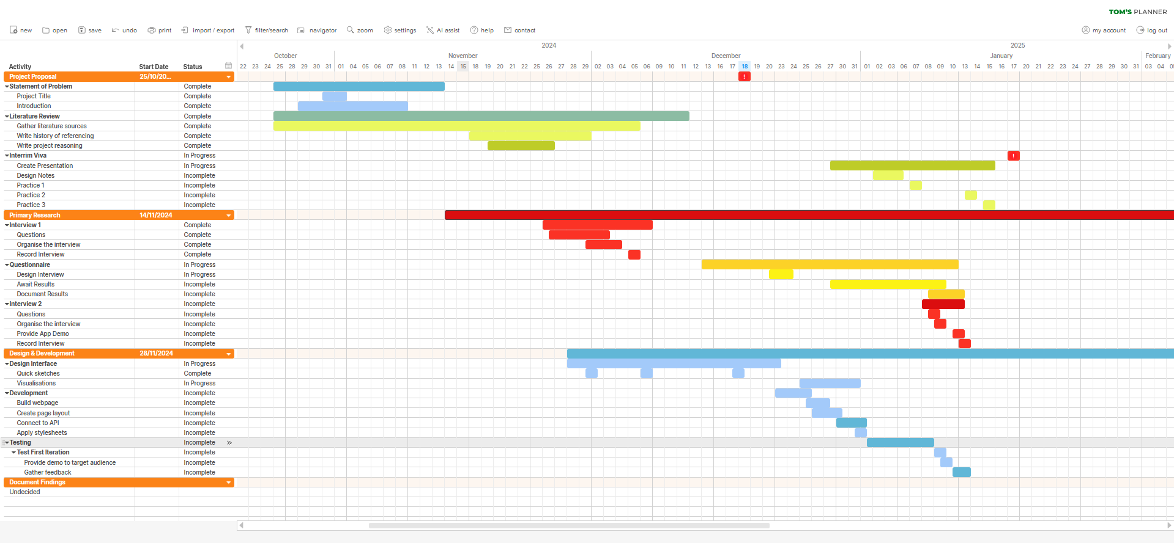

Bibliography
[1] Newcastle University. Referencing - Academic Skills Kit - Newcastle University [Internet]. www.ncl.ac.uk. Newcastle University. 2023 [Last accessed 20th November 2024]. Available from: https://www.ncl.ac.uk/academic-skills-kit/good-academic-practice/referencing/
[2] Oxford Students. Referencing | University of Oxford [Internet]. www.ox.ac.uk. University of Oxford. 2024 [Last accessed 20th November 2024]. Available from: https://www.ox.ac.uk/students/academic/guidance/skills/referencing
[3] Cite This For Me. Save Time and Improve your Marks with CiteThisForMe, The No. 1 Citation Tool [Internet]. Cite This For Me. Chegg Inc. 2010 [Last accessed 20th November 2024]. Available from: https://www.citethisforme.com/
[4] Zotero. Zotero | Storage [Internet]. Zotero.org. Zotero. 2024 [Last accessed 20th November 2024]. Available from: https://www.zotero.org/storage
[5] childrensparacetamol. Do you use referencing software? Why/why not? [Internet]. Reddit.com. 2024, May [Last accessed 20th November 2024]. Available from: https://www.reddit.com/r/AskAcademia/comments/1csapv9/do_you_use_referencing_software_whywhy_not/
[6] Henry. A Brief History of Academic Citation Styles | Petal [Internet]. Petal.org. 2022, 6th January [Last accessed 21st November 2024]. Available from: https://www.petal.org/blog/articles/a+brief+history+of+academic+citation+styles
[7] Mark E. L. Maturation, Fecundation, and Segmentation of Limax campestris, Binney. Cambridge, Massachusetts, USA. Harvard College. 1881 p. 194.
[8] Chernin E. The ‘Harvard system’: a mystery dispelled. British Medical Journal. 1988;297:1062–1063. Available from. https://doi.org/10.1136/bmj.297.6655.1062.
[9] McElligott M. LibGuides: Reference & Citation: History of Harvard Style [Internet]. ncad.libguides.com. [Last accessed 23rd November 2024]. Available from: https://ncad.libguides.com/c.php?g=688721&p=4928704
[10] Kennedy D. MLA, APA, Harvard or MHRA? [Internet]. rlf.org.uk. The Royal Literary Fund. 2014. [Last Accessed 24th November 2024]. Available from: https://www.rlf.org.uk/resources/mla-apa-harvard-or-mhra/
[11] Young A. LibGuides: References, citations and avoiding plagiarism: Vancouver referencing. library-guides.ucl.ac.uk. University College London. 2024, 13th November [Last accessed 1st December 2024]. Available from: https://library-guides.ucl.ac.uk/referencing-plagiarism/vancouver
[12] University Library. Subject Guides: Reference Management: a Practical Guide: Introduction [Internet]. York.ac.uk. University of York; 2016 [Last accessed 13th December 2024]. Available from: https://subjectguides.york.ac.uk/reference-management/intro
[13] Microsoft. Create a bibliography, citations, and references - Microsoft Support [Internet]. support.microsoft.com. Microsoft; 2024 [Last accessed 13th December 2024]. Available from: https://support.microsoft.com/en-gb/office/create-a-bibliography-citations-and-references-17686589-4824-4940-9c69-342c289fa2a5
[14] University of Sussex Library. LibGuides: Zoterobib: ZoteroBib [Internet]. Sussex.ac.uk. University of Sussex; 2024 [Last accessed 13th December 2024]. Available from: https://guides.lib.sussex.ac.uk/zbib
[15] The Open University. Referencing and plagiarism [Internet]. www5.open.ac.uk. The Open University; 2011 [Last accessed 14th December 2024]. Available from: https://www5.open.ac.uk/library/help-and-support/referencing-and-plagiarism
[16] Clarivate. Product Details [Internet]. EndNote.com. Clarivate; 2024 [Last accessed 15th December 2024]. Available from: https://endnote.com/product-details/
[17] Clarivate. Buy | EndNote [Internet]. EndNote.com. Clarivate; 2018 [Last accessed 15th December 2024]. Available from: https://endnote.com/buy/
[18] Zotero. Zotero | Your personal research assistant [Internet]. Zotero.org. Zotero; 2019 [Last accessed 17th December 2024]. Available from: https://www.zotero.org/
[19] MyBib Contributors. Terms [Internet]. MyBib. 2018 [Last accessed 16th December 2024]. Available from: https://www.mybib.com/terms
[20] Ramotion. Web Application vs. Desktop Application: A Comparative Guide | Ramotion Agency [Internet]. Ramotion.com. Ramotion; 2024 [Last accessed 17th December 2024]. Available from: https://www.ramotion.com/blog/web-application-vs-desktop-application/#section-web-application-advantages
[21] jgnordby. When pasting text from Web into MS Word it will not keep the color formatting shown on the web [Internet]. Microsoft.com. Microsoft; 2022 [Last accessed 17th December 2024]. Available from: https://answers.microsoft.com/en-us/msoffice/forum/all/when-pasting-text-from-web-into-ms-word-it-will/3844d928-58d1-43c6-89f9-cd147288ab75
[22] R1596. When I copy text from another source and paste it into Word, it always formats with one space after a period [Internet]. Microsoft.com. Microsoft; 2024 [Last accessed 17th December 2024]. Available from: https://answers.microsoft.com/en-us/msoffice/forum/all/when-i-copy-text-from-another-source-and-paste-it/4376a20f-8d22-416d-a16b-3b1e58968f6b
[23] Tidwell J. Designing interfaces. 2nd ed. Sebastopol, California, USA: O’reilly; 2011 p 77-80.
[24] Dix A, Finlay J, Abowd GD, Beale R. Human-computer interaction. 3rd ed. Harlow, England, UK: Pearson Prentice Hall, Cop; 2003 p 225-241.
[25] Microsoft. Visual Studio Code. Visual Studio Code [Internet]. Microsoft; 2016 [Last accessed 18th December 2024]. Available from: https://code.visualstudio.com/docs/editor/whyvscode
[26] Microsoft. Language Support in Visual Studio Code [Internet]. Visual Studio Code. Microsoft; 2016 [Last accessed 18th December 2024]. Available from: https://code.visualstudio.com/docs/languages/overview
[27] Jennifer Niederst Robbins. Learning Web design : a beginner’s guide to (X)HTML, style sheets, and web graphics [Internet]. 3rd ed. Sebastopol, California, USA: O’reilly; 2007.
[28] Bootstrap. CSS · Bootstrap [Internet]. getbootstrap.com. Bootstrap; [Last accessed 18th December 2024] Available from: https://getbootstrap.com/docs/3.4/css/
[29] w3schools. Web APIs [Internet]. www.w3schools.com. W3Schools; 2024 [Last accessed 18th December 2024]. Available from: https://www.w3schools.com/js/js_api_intro.asp
[30] ISBNDB. ISBNdb API Documentation v2 | ISBNdb [Internet]. isbndb.com. ISBNDB; 2024 [Last accessed 18th December 2024]. Available from: https://isbndb.com/apidocs/v2
[31] OCLC. WorldCat Search API | OCLC Developer Network [Internet]. oclc.org. OCLC; 2024 [Last accessed 18th December 2024]. Available from: https://www.oclc.org/developer/api/oclc-apis/worldcat-search-api.en.html
[32] TutorialsPoint. SDLC Agile Model [Internet]. www.tutorialspoint.com. Tutorials Point; 2019 [Last accessed 18th December 2024]. Available from: https://www.tutorialspoint.com/sdlc/sdlc_agile_model.htm
[33] Smith DW. Phenomenology [Internet]. Stanford Encyclopedia of Philosophy. 2013 [accessed 18th December 2024]. Available from: https://plato.stanford.edu/entries/phenomenology/
[34] Jansen D. Saunders’ Research Onion Explained (+ Examples) [Internet]. Grad Coach. 2021 [Last accessed 18th December 2024]. Available from: https://gradcoach.com/saunders-research-onion.
[35] Grounded Theory Review. The Logic and Language of Classic Grounded Theory: Induction, Abduction, and Deduction | Grounded Theory Review [Internet]. Groundedtheoryreview.com. 2023 [Last accessed 18th December 2024]. Available from: https://groundedtheoryreview.com/2023/06/22/the-logic-and-language-of-classic-grounded-theory-induction-abduction-and-deduction/
[36] Harvard Catalyst. Mixed Methods Research [Internet]. Harvard Catalyst. 2022 [Last accessed 18th December 2024]. Available from: https://catalyst.harvard.edu/community-engagement/mmr/
[37] Hunt N. Primary research. library.soton.ac.uk. University of Southampton; 2021 [Last accessed 18th December 2024]. Available from: https://library.soton.ac.uk/sash/primary-research
[38] Tom's Planner. Tom’s Planner - Gantt charts for the rest of us [Internet]. TomsPlanner. 2024 [Last accessed 18th December 2024]. Available from: https://www.tomsplanner.com/

Appendix
[Appendix 1] Ethics Approval Form
Ethics Approval Form

Before you complete this form, please take time to carefully consider the following questions:

Have you considered yet whether there are any problematic ethical issues in your proposed research project? If you have not you should talk to your Course Tutor or Supervisor.

Have you already completed an Ethics Approval Form? Yes – then you do not need to complete this form

No – please complete this form in as much detail as you can

Name: | Ieuan Thomas
Project/Research Title: | Can a Refined Referencing Tool Improve Workflow?
Name of Supervisor: | Andrew Green
School/Dept. | NPTC Group (Neath)
Faculty: | School of Computing and IT
Proposed Start Date: | November 5th, 2024. | End Date: | 03/04/2025

1. Summary of planned research (please indicate below the purpose of your planned project/research, together with your aims, main research questions and research design – you should continue onto a separate sheet if necessary)
To understand currently available referencing tools and their weaknesses to build a better application aimed towards students at the college (NPTC Group).

2. Methodology (You need to be clear about the methodology you intend to use in your study; this could include any number of methods, so either tick those shown below (where appropriate) or put the details in the box marked *)

✓ | Interviews | ✓ | Participant Observation |  | Use of personal data
 | Focus groups | ✓ | Questionnaire | ✓ | Literature Review
 | Performance |  | Presentation |  | Other (state below) *

3. Participants - Does your proposed project/research involve human participants?

✓ | 1. Yes, as a primary source* |  | 2. Yes, as a secondary source* |  | No- go to section 4

*If you have ticked yes, it is likely you will need an Advanced CRB check before undertaking your study

If yes, indicate who your participants are:

 | Early years/Pre-School children | ✓ | Adults - give details below
 | School age children |  | Vulnerable people - give details below
 | Young People aged 17-18 | As this application is being developed due to personal reasons, I will be using my siblings as people to test my application
✓ | Unknown at this stage

4. Ethical issues - you should tick all that apply

 | Administration of drugs incl. alcohol |  | Deprivation
 | Unpleasant stimuli in any manner or form |  | Active deception or withholding information
 | Collection of highly personal information |  | Payment

5. Are there any ethical concerns other than those listed above? (Continue onto a separate sheet if necessary)

N/A

6. If there are any ethical concerns, please state how you intend to minimise any risk of harm or distress that could be caused (continue onto a separate sheet if necessary)

N/A

You should enclose any materials (e.g. questionnaire, interview schedule), plus the Consent Form, and the Debriefing Sheet when submitting the Ethics Approval Form to your supervisor.

Student Signature Ieuan Thomas _________________________________
Date: 18/12/2024

*************************************************************************
 | Advanced CRB check required |  | CRB confirmation received –  Date:_______________
 | Recommendation of approval given at Faculty Level
 | Approval not given at Faculty level – forwarded for discussion at the next meeting of the University Ethics Committee
Comments:

Signature: (Assistant Dean/Head of School) _______________ ____________ Date: ________________

Faculty recommendation endorsed by the Ethics Committee | Chair’s Initials |  | Date

[Appendix 2] Mark’s use of Harvard style referencing in his cytological monograph: Maturation, Fecundation, and Segmentation of Limax campestris, Binney. By E. L. Mark (Est 1881). Page 194
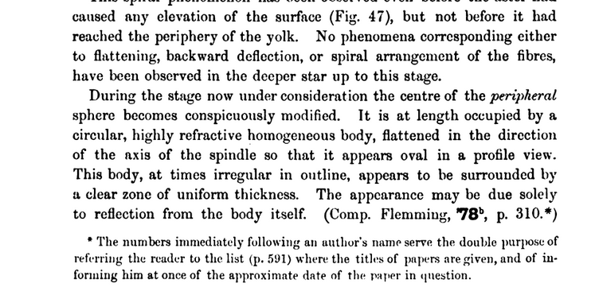

[Appendix 3] Cardiff University’s referencing style varies per source, so referencing a book might look as such:
[Ref Num] Author Surname and initial. Book Title. Edition. Place of publication. Publisher. Year of publication
Example:
[1] Doe. J. Learning to Reference Using the Vancouver System. 1st ed. NPTC Group (Neath). Neath Publications Inc. 2024.

[Appendix 4] Interview Transcription from personal project journal



