

Alternative Manufacturing Methods for a helicopter cockpit floor

By:
Elizabeth Roberts

Advanced processes and materials assignment for
BEng Mechanical and Manufacturing Engineering

University of Wales Trinity Saint David
Faculty of Engineering

Abstract

This report presents an examination of three manufacturing CNC Milling, Abrasive Water Jet cutting and Direct Metal Laser sintering for the use in the manufacturing of an Aluminium helicopter cockpit floor. The intent of this paper is to; 1) depict one superior process compared to the original process, CNC Milling 2) discover a process with improved dimensional accuracy and surface roughness compared to CNC milling, 3) and highlight advantages /limitations of each process in comparison to CNC Milling. This paper also provides a generalised summary of each process and its current and potential applications.

After extensive research, it was apparent that CNC milling was still a valued traditional method, with the capabilities to produce a range of dimensionally accurate components. However, was long outdated and not as versatile as the other processes.
Although abrasive water jet cutting had many advantages in terms of accuracy, tolerances and versatility. Its manufacturing rate was decreased to achieve the preferred dimensional tolerance.
Therefore, it is fair to say that direct metal laser sintering is a revolutionary process which greatly surpasses both CNC milling and Abrasive Water Jet cutting, by providing high quality components, with excellent telebanking and surface finish in lower production time. This process has the ability to improve company growth with its multi-application options ranging as far as the medical community

Introduction

As previously mentioned the traditional manufacturing method is to CNC mill the required profile from a sheet of aluminium metal and then to finish by heat treating the component. This method is long outdated, sometimes inaccurate and not very cost effective. Therefore, the aim of this report was to look for alternative methods which can manufacture the component with improved surface finish, keep all tolerances to +/- 0.0127cm and prove more cost effective.
The cockpit floor of an aircraft is placed inside the front fuselage and attached to the fuselage frame. The cockpit floor supports any pressure such as the pilots and control stick loads. Therefore, the component must have a high yield and thermal strength, which is why keeping aluminium as the preferred material was essential.
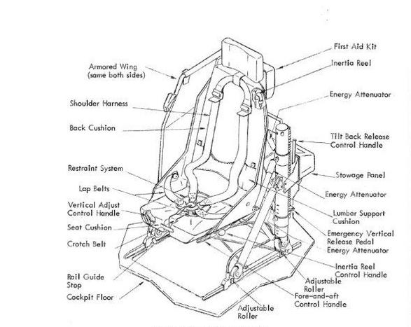Schematic of Pilots seat and cockpit floor [1]
Considerations to be acknowledge; Components from ALL processes will require heat treatment after production, both CNC milling and abrasive water jet must have additional components welded at a later date.
I will be referring to Direct Metal Laser sintering as DMLS and Abrasive Water Jet Cutting as AWJC throughout the report.

Materials
The material used for the manufacture of the cockpit floor is aluminium, this is a favourable material for the use on aircrafts due to its light weight, corrosion resistant and creep resistant properties. To ensure dislocations and defects in the crystal lattice do not occur in the aluminium, it is therefore, heat treated to minimise the risks and increase yield stress of the material. Meaning both processes must not affect the molecular structure of the material.
The cockpit floor is usually heat treated to a ‘T6 standard after fabrication” [3], cooled at room temperature, heat treated with a much higher temperature and quickly quenched to retain its molecular structure. This process “offers an increase in hardness” [3]

Methods
CNC Milling; -
CNC milling is a machining process which relies on computerized controls, with several rotating cutting tools to remove material from the workpiece and produce a custom product. The component is secured to the bed of the milling machine, a facing tool will machine the component to its desired orientation and dimension, it will them locate drill and bore the holes into the component. The process works by using several types of tooling; facing tools, boring tools, drills, tip cutter etc. These tools can be quite expensive as many of the tools are usually made from tungsten carbide or high-speed steel to ensure a long life for each tool. During the entire process the component is flooded with a special coolant to try and stop the material from heating up and effectively case hardening it.

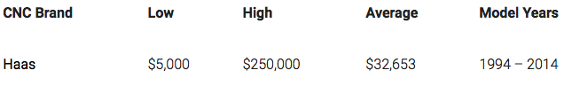
Shown above are images with the average prices for a CNC milling machine in 2018. [4]
Some would say CNC milling is a revolutionary process within the engineering industry. Manufacturers will argue that one advantage of CNC milling is its ability to “eliminate the probability for human error” [5] and therefore, requiring less trades people. The Machine only “requires one skilled programmer “[5] and that individual can over see more than one machine at a time. “CNC machines can and will produce uniformed components” [6] and can achieve dimensional accuracy within 1/1000th of a mm. The CNC machine will produce components “24 hours of the day without the need of much monitoring. “[6] meaning no down time, proving the process to be more cost effective on all levels compared to traditional methods.
However, CNC milling isn’t without its disadvantages, their start-up costs are high, due to the cost of the machine [4], the parts to maintain and repair it and all operators need basic training on the machine which is also expensive. It also does not totally eliminate errors, operators can make mistakes by loading wrong programs or pushing wrong buttons. During machining “A skilled operator is required to choose between different tools, speeds, cutting paths and any repositioning of the material the part is being created from.” [7]. Whilst machining “thermal distortion” [8] can occur from the friction caused between the cutter and the part. This can produce “micro cracks on the surface” [8], which will affect the yield strength and toughness of the part. The entire Process Produces a considerable amount of material wastage and for optimum surface finish (0.58um) [9] a finishing cut is required. This is not cost effective when you compare it to alternative processes.

Abrasive Water Jet Cutting (AWJC)
Abrasive water jet cutting is generally classed as a mechanical manufacturing method. The material is secured to the bed of the machine, just like the CNC miller. “high pressure” [2] [10] water flows through an aperture in a carbide jewel orifice. Abrasive is added to the water [2] via an inlet to “increase cutting efficiency” [11] and the mixture is forced out of the pressurised abrasive nozzle onto the workpiece causing micro erosion to occur. The processes use a single point to accurately cut away the material at high speeds. As this technique is a cold cutting method, no heat is dissipated onto the workpiece, the water acts as a coolant, providing a high surface finish. Below is an example of a Water jet cutting Head. [12]
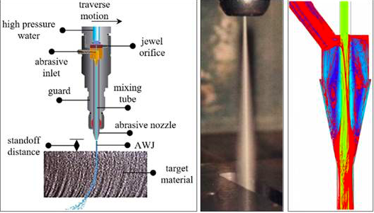
The entire process is controlled by several interfaces; CNC, which is run on real-time platform. Microsoft windows, for its graphical interface for the operator and typically supports both CAD and CAM so completed drawings can be uploaded onto the system and the machine is then all ready to run. There is also motion controller technology built in so the machine is more sensitive and aware to the functions of the waterjet nozzle. The process can be fully operated or left to independently run by itself. A schematic of the entire process can be seen below. [13]
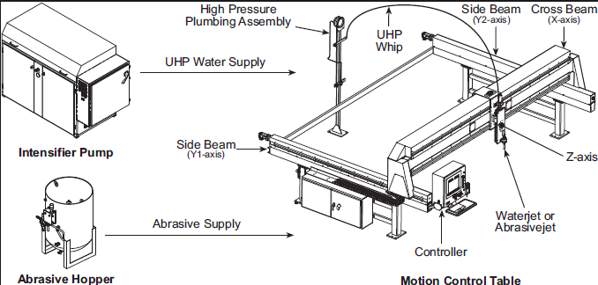
Direct Metal Laser Sintering (DMLS)
DMLS is a rapid prototyping technology, which produces “finished quality” [14] components directly from CAD. It does this via a “fibre laser” [2] [14] which sinters a variety of powdered materials, creating solid layered parts. This technology provides the option to create complex geometries, which would otherwise be impossible to manufacture. A 2D CAD drawing is uploaded into the operating system, this informs the machine what profile to construct onto the enclosed bed of preheated levelled powder. Once the first layer of “sintered powder bonds” [15] to the required shape, the “platform is lowered by one layer thickness” [24] and the distribution roller creates another layer of powder. This process continues until the “3D CAD” [2] component is completed, all residual power in and around the component acts as a support whilst being manufactured, the residual powder can simply be brushed off and reused again. A cooling down period is required, in order to allow the bonds and structure to strengthen more efficiently. However, due to the components lattice structure, impurities and deformations can occur internally and externally. Therefore, the parts are heat treated to make “the microstructures more homogeneous” [16]
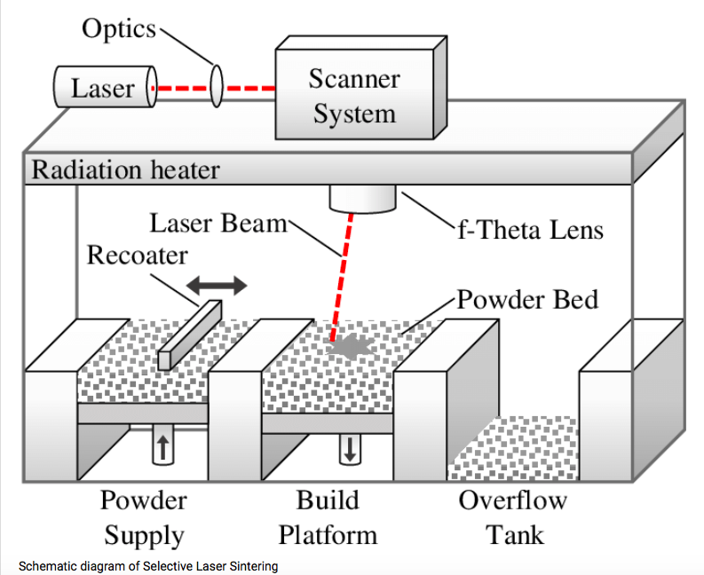Schematic of SLS Machine. [17]
DMLS uses an advanced CNC / CAD system to operate its process. However, it also has a “closed loop control” [17] system integrated into it to achieve uniformed conditions, along with an array of sensors; thermographic cameras, pyrometer, laser beam cameras and emission sensors. This process would need extensive training, not only on the physical aspect, but the operating system is exceptionally advanced. The operator must know how and when to alter settings, this can be as simple as adjusting the laser during manufacturing to allow uniformed sintering to occur.
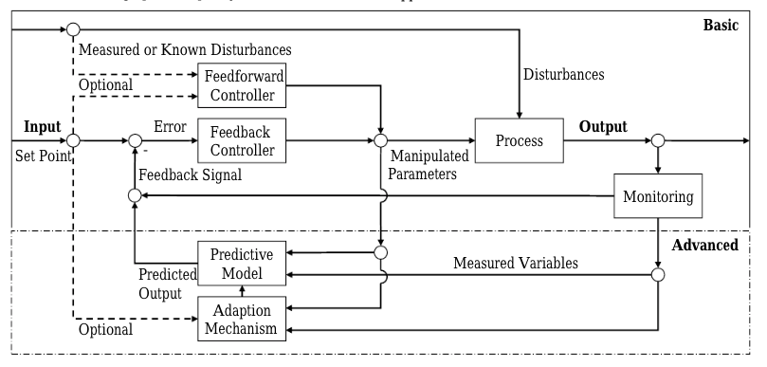Schematic of Basic SLS operating system [17]

Discussion:
Through my own knowledge and research, I have compiled a referenced table of several variables to consider in the comparison between; CNC Milling, AWJC and DMLS.
Fig 1: Table of variables

One of the aims of this report was to source a process which had improved surface roughness and tolerances, compared to CNC milling. DMLS surface roughness and tolerance excels that of AWJC and CNC milling. It’s surface finish is far more accurate, when you consider 0.58um [21] and 0.1um [19[ to that of 0.025um [26], and tolerances are far more advanced. SLS tolerances can be monitored and altered throughout the process ranging from 0.03mm to as little as 0.05mm [24] [25], whereas CNC milling does not have this luxury and its max tolerance could be as large as 1mm.

The effects from the process show us that heat migration from CNC milling can cause “micro cracks” [8] to occur, causing potential component failure. AWJC strain hardens the material, causing subsurface deformation [27]. This could negatively affect surface finish and the integrity of the material. This is still and improvement to that of CNC milling.
The DMLS lattice structure can incur deformations or impurities [17] during manufacturing, this can affect the strength and fatigue life of the component. Effects from both DMLS and AWJC can be improved via heat treatment.

When comparing machine cost, DMLS and AWJC are of relatively similar prices ranges. But when compared to CNC milling they are almost double the price, meaning a high initial cost for both processes.

In order to gain a better understanding of DMLS and AWJC, I have complied two tables, which outline some advantages and disadvantages for each process (Fig 2 and Fig 3).
Fig 2 Advantages Table.
When we review AWJC and DMLS, the are many advantages which sufficiently outweigh CNC Milling. Firstly, the waste concern, there is nearly no waste with AWJC and DMLS, only abrasive and unusable powder waste. CNC Milling produces material and unusable cutting tool waste. DMLS and AWJC do not require “specific tooling” [32] and therefore do not require a “tool change” [27], CNC Milling requires both variables. Both SLS and AWJC have Less production set up time, DMLS prints the object straight from CAD or a Scanned copy and AWJC can start cutting the component at any point in time, meaning pre-machining preparation is not required, reducing manufacturing time. CNC milling may need several operations performed before actual manufacturing, e.g. Cutting material to required dimension, start holes, deburring etc. therefore, it requires longer production time.
No cutting stress is incurred during the manufacturing of AWJC and DMLS components. AWJC is a “cold cutting” [28] method, meaning “hardened “[29] materials can be machined, and no thermal degradation or mechanical heat is transferred onto the component. DMLS completely manufactures “full density” [23] components, meaning no stress is incurred and complex “finished quality” [22] parts are made, creating stronger longer lasting components. CNC Milling however, causes heat degradation and micro cracks to appear on the component, this weakens the internal and external structure.
The operating system for all 3 processes are relatively similar, using CNC as their platform. AWJC system would need little training, and could be adapted for 3D printing. However, DMLS system is far more advanced, allowing new and complex applications. Not only is DMLS used in the engineering industry, but is widely used in the “medical community” [34] as DMLS and SLS. Extensive training would be required, but the future opportunities for company growth outweighs this.

Alongside the Advantages of SLS and AWJC. There are many important disadvantages to consider, in the comparison between CNC milling, DMLS and AWJC.
Fig 2 Disadvantages Table.
DMLS and AWJC Produce high quality components. However, the processes are not without their limitations. DMLS parts can be manufactured “porous” [36], which can cause “ductile fatigue striations” [37], which could jeopardise its structural integrity and fatigue life. When Direct Metal Laser Sintering aluminium, “cracking” [32] may occur and “surface roughness” [32] maybe reduced. AWJC “dimensional accuracy” [27} can be compromised when tapers occur when cutting harder and thicker materials. AWJC surface roughness can also be compromised, appearing dull or “matte” [29]. To remedy this, the “speed of the head” [27] must be reduced significantly, meaning longer manufacturing time. If we compare this to manufacturing via CNC milling, “micro cracks” [8] can occur, this too can be remedied through reduction in cutting speed, but also via sharper cutting tools and an increase in the flow of coolant.
When we look more in depth at the alternative applications for DMLS and AWJC, we see many limitations. The use of 3D printing for AWJC is a complex, time consuming process, which can emit “100db” [29] of noise pollution. Dimensional accuracy is compromised and hard to monitor due to “spent abrasives” [31]. When introducing DMLS as a “medical application” [32], we must take into consideration the cost implications and the component “shrinkage and warpage” [36] possibilities, causing inaccurate parts. CNC milling however, has been around for many years, all applications have been fully established and recognised.
Both CNC Milling and AWJC need the additional welding of 4 additional components meaning longer production time, whereas DMLS will not require this addition meaning less production time.

Conclusion
From the report, it is observed that CNC milling is a highly accurate process, which can produce a range of products to desired specification. CNC Milling heavily relies on personnel to control and run it, creating potential for human error. The process is time consuming, requiring additional finishing cuts, to achieve the preferred surface roughness. Meaning an increased turnover of tooling from working at high speeds, thus producing poor dimensional accuracy. Although its initial costs are low, its upkeep costs are significant and its applications are limited also. It is certainly clear that CNC milling is far outdated and must allow room for the more advanced techniques such as DMLS and AWJC to come to the forefront of industry.
The benefits of AWJC are an improvement to CNC Milling, with tighter tolerances and surface roughness. The need for tooling is made redundant and the possibility for complete automation, fast cutting speeds and component turn around. This process ensures continued material integrity alongside an economical process. However, AWJC is not without its limitations. At higher cutting speeds, the water nozzle produces tapers in the workpiece, meaning dimensional accuracy is compromised. The surface of the material can be come damaged during production, and initial set up costs are high. AWJC and CNC milling applications are very similar, meaning alternative applications for future company development are unlikely.
Based on the Advantages of DMLS presented earlier, it is fair to say that this process is by far, the most multifunctional, economical processes, producing superior accuracy in terms of tolerances and surface roughness, when compared to CNC Milling and AWJC. DMLS is not without its drawbacks, component lattice structure can be porous, but is remedied via heat treatment. Surface cracks can appear, but can be prevented by regulation the laser beam correctly. The advantages of DMLS sufficiently outweigh these draws back; all geometries can be created; 24/7 automation is readily available. Although initial investment is high, low tooling and low maintenance costs outweigh this. The potential for medical application could offer new exciting investment and growth for the company in the near future.

