

An Analysis of a sample Unarmed Techniques (Straight Arm Bar Takedown, Rear Take Down, and Ground Pin) Taught in Officer Safety Training used by UK Police Officers and the exploration into more effective alternative techniques. (Supporting Document)

School: UWTSD Swansea
Degree: PCDA
Due Date: 29th Nov 2021
Word count:4264

Declaration
This work has not previously been accepted in substance for any degree and is not being concurrently submitted in candidature for any degree.
Signed Date: 28th Nov 2021

STATEMENT 1
This dissertation is being submitted in partial fulfilment of the requirements for the degree of BA.
Signed: Date: 28th Nov 2021
STATEMENT 2
This dissertation is the result of my own independent work/investigation, except where otherwise stated.
Other sources are acknowledged in the Reference Section.
Signed: Date: 28th Nov 2021
STATEMENT 3
I hereby give consent for my dissertation, if accepted, to be available for photocopying and for interlibrary loan, and for the title and summary to be made available to outside organisations.
Signed: Date: 28th Nov 2021

STATEMENT 4
I hereby give consent for my dissertation, if accepted, to be available on the university’s IT system to those who have consent to use the system.
Signed Date: 28th Nov 2021

ABSTRACT

Many recent events in the UK and globally have brought Police integrity into question when using unarmed techniques which have caused injury and sometimes death to subjects to which force has been used upon. Limited research has been conducted has been conducted into the individual unarmed techniques taught to officers to modify them despite the public scrutiny. This study aims to reflect the confidence of three techniques (Straight Arm Bar Takedown, Rear Take Down, and Ground Pin) amongst active officers and how open they would be to learning alternative techniques. This study also aims to explore the biomechanics of each of these techniques to find their strengths and weakness and aims to find alternative techniques that provide the same function with more control and high levels of safety.
This study is based around a closed survey conducted by 53 active Police Officers within South Wales Police of roles of either Sargent or Constable which queried their confidence in using the three techniques that have been studied whether they use these techniques whilst performing their role or alternatives, and whether they are open to learning new techniques. The three techniques being studied were then drilled by the author and a coach skilled in Brazilian Jujitsu to find strengths and weaknesses. Alternatives to these techniques were then created with the combined knowledge of competition style grappling and Police utility to provide the same function with better control and a higher level of safety for the officer and the subject.
The results showed that confidence in the three techniques being explored amongst active officers were mixed, many of them used techniques not taught in Officer Safety Training and an overwhelming majority were open to leaning alternative techniques. Whilst drilling techniques many weakness were found in the three techniques being explored. Therefore, the alternatives avoided these same weaknesses when being created.
In conclusion Police Forces in the UK should seek reform in teaching Officer Safety Techniques to make them safer and easier to use by active officers to avoid further injuries to subjects and increase confidence in active officers when using these techniques.

Contents
Section 1: INTRODUCTION 6
Section 2: LITERATURE REVIEW 7
Section 3: RESEARCH METHODOLOGY 11
Section 4: ANALYSIS OF RESULTS 13
Section 5: FINDINGS AND CONCLUSION 21
RECOMMENDATIONS 23
REFERENCE LIST 25
APPENDICES- COPY OF QUESTIONAIRE 26

Section 1: INTRODUCTION

Historically, and increasingly, over recent years there has been much scrutiny, by the general public, regarding how police officers have used force whilst detaining or defending themselves against aggressive or violent individuals. Although the “the public expects the police to protect them and are clear about the role policing plays in society” (Key 2020), recent events such as the death of George Floyd in the United States in 2020 and, closer to home, the death of Mohamud Mohammed Hassan in 2021, have caused negative public perceptions of the police and this has been evidenced by the mass protests in the UK and worldwide.
Although protest groups such as the Black Lives Matter Movement began as a result of the disproportionate use of deadly force (firearms) against African American individuals in the US, more recent incidents were due to police officers using unarmed techniques. Whether these techniques were as taught by their police organisations or not helped form the basis for this proposal, which suggests that It is appropriate to analyse and review some of the selected unarmed techniques taught in officer safety training in England and Wales. The techniques that have been chosen for this research are: 1. Straight Arm Bar Takedown. 2. Distraction Strike to Rear Take Down. 3. Ground Pin as taught in Officer Safety Training in South Wales Police and most forces in England and Wales.
It is fair to examine and critique them based on their effectiveness, how readily they are learned, their ease of use and their possible effect on public perceptions.
To this end, this research will consider the following areas:
The biomechanics behind the unarmed techniques taught in officer safety training.
Why these techniques taught their aims and uses.
The effectiveness of each technique.
Do officers feel confident in the techniques.
Whether these techniques need adaptation.
Whether there are alternative methods that could be used and their biomechanics and injury potential.

Section 2: LITERATURE REVIEW

The topic around unarmed techniques taught in officer safety training is one the author has a particular interest in, being a serving South Wales Police Officer (for two years) and having lengthy experience of and in self-defence and Martial Arts (Brazilian jujitsu) that offers another approach to the physical control of aggressive and violent people. As such it is fair to say that he is ideally qualified to offer a different perspective on this subject and able to analyse and critique the chosen techniques that are taught as part of officer safety training, with the aim of comparing their effectiveness etc. to some other techniques that may be more effective and consequently of real value to policing.
Although there is sufficient research into the history of officer safety techniques taught to UK officers (Banton et al 2020), no existing research was found critiquing the specific techniques covered here. Ideally the data required for this research will come from primary sources i.e. from serving operational police officers.
A quantitative approach, using survey questions should deliver sufficient data, providing percentages and other findings that will form the basis of reasoned conclusions. In this way it is hoped that a greater understanding of Officer Safety Techniques and the possible alternative ones. The data provided by using these methods will also provide the basis of a 15 minute presentation that will add to the understanding of the use of these techniques.

The aim of this section is to review literature based on this topic and to find gaps in research found to be able to fill them with my own with to create more comprehension and understanding on the subject.
The literature on unarmed techniques used by UK Police forces can be summed up in two categories. The first is literature regarding the content of information given to officers on how to apply techniques that are taught across UK police forces along with statistic-based reports and the second is literature based on the public perception of how use of force is received by the public. Consequently, both types of literature are relevant to this review.so I will explore both types of literature and explain why they are relevant to my research.
The first type of literature I will review looks at the operational information given to officers and trainers, so they are able to convey training to active police officers. When reviewing use of force, the commissioner of Dyfed Powys Police created a deep dive report into their own practice in September 2018. This document contains a reflection on the use of force involving public feedback, alcohol, drugs, mental health factors and unarmed skills, including ground restraints and handcuffing which were the major tactics that gave rise to complaints of excessive force. (Police and Crime Commissioner for Dyfed-Powys-2018). Due to the outcomes of this deep dive report, one of the recommendations was for there to be a review, with officers, of the current use of force training package to ensure this reflected real practice as far as possible and that it included sufficient coverage of reporting requirements. One of the motivations for creating this report was an increase in complaints of negative outcomes recorded by the Public Service Bureau that accused officers of using unnecessary force or where suspects/defendants experienced harm upon arrest and contact with Police. This showed that there may be need for changes to the techniques taught to police officers. (Police and Crime Commissioner for Dyfed-Powys-2018)
This piece of literature mentions within it “Ten Key Principles Governing the Use of Force by the Police Service” from the college of Policing. It states that Police officers should attempt non-violent outcomes before resorting to force and that where force is necessary use the minimum force possible and that this should be exercised with restraint. Police officers shall therefore, as far as possible, apply non-violent methods before resorting to any use of force to provide a lawful objective. This principle was taken into account whilst conducting this research. Statistics gathered for Dyfed Powys force area for this report show that unarmed techniques as the third highest use amongst use of force reports after handcuffing (compliant and uncompliant) and tactical communications. (Police and Crime Commissioner for Dyfed-Powys-2018)
This report found that officers in anonymous focus groups said that “use of force training should be more often, more intensive and more realistic” (Police and Crime Commissioner for Dyfed-Powys-2018). The report goes onto say that officers found there was a “disconnect between training and reality, with the restraints demonstrated in training being ineffective in practice.” One example was given where one incident required four officers to restrain an individual due using the techniques taught. Officers suggested that they would feel more comfortable working towards a basic self-defence qualification to learn more effective techniques and that there should be more time dedicated to learning officer safety to improve their confidence.
At a result of this report, there are many actions that Dyfed Powys Police state they will change including, better recording of information and analysis of data, however they do not suggest any changes to techniques taught in Officer Safety training even though Officers said that change would be effective in building their confidence.
Another piece of literature covering unarmed use of force is the Police “use of force statistics, England and Wales April 2018 to March 2019”. This document shows that the most used unarmed use of force tactics was for restraint with firearms being the least used tactic, showing that officers use unarmed tactics more regularly. This report also shows that the main reason officers chose to use force was to protect themselves and other people around them including members of the public and other officers. This should be taken into account when reviewing unarmed techniques.
This report also acknowledges that impact factors were also taken into account when officers decided to use force including size/height/weight when dealing with subjects. (Home Office-2019) meaning these factors also need to be taken into account when evaluating unarmed techniques taught to operational officers. Subject injury statistics are also covered showing that 6% of subjects received injuries after having forced used against them by officers, with 2 % of them being listed as severe. (Home Office-2019)
As previously mentioned, there is also literature on how the public perceives the use of force used by officers. A journal entry in the “Journal of Global Faultline’s” tackles the subject of use of force by Police and military in the UK amidst social and cultural events of 2021. This piece of literature explains how Policing in the UK is based around the “Peelian Principles” and the European Convention of Human Rights; however, this has come into scrutiny due to recent events such as the death of George Floyd in the United States. This article goes on to explain the use of a “Prone Position” restraint, which due to the explanation given, is recognised as the conventional ground pin or modified ground pin technique. It goes onto discuss the potential risks of positional asphyxia when subjects are in this position and states that officers are still careless when placing a knee on a subject. (Hamourtziadou, Headech & Jackson-2021) This article concludes the subject of use of unarmed force by stating that the College of Policing teaches that all force must be proportional but that placing a knee on the back of someone on the floor in questionable in terms of being proportionate.
In terms of reform of unarmed techniques taught to officers, information is again scarce except from a programme being conducted by Gracie University run by the founding family of Brazilian Ju Jujitsu. The Gracie University has been shown to work with Marietta Police Department in Georgia, USA to develop a programme to which techniques and training are taught to new recruits which have shown substantial drops in injuries to officers, injuries to suspect and the need of taser deployments. (Gracie University-2021) This shows that their can be positive outcomes for reforming unarmed techniques used by Police Forces.
Although critiquing specific techniques is scarce amongst publicly shared documents, the recurring theme when reviewing techniques used by officers is that there seems to be a heavy lean on pointing out what the problems are with certain techniques or focussing on officers' negative responses to training. There seems to be a lack of information or discussion in an attempt to improve techniques used to make them more efficient for officers and better received by the public. Because of this I believe there is a gap in the existing literature on discussion of this subject and aim to add more comprehension in order to further explore this subject.

Section 3: RESEARCH METHODOLOGY

As the previous chapter has shown, there is little research into police officer’s opinions of ground pins and takedown techniques as taught in Officer Safety Training so have a broader understanding of this subject further research should take place to compile statistical evidence that quantify officers’ opinion on this subject.
Quantitative research is the practice of studying available statistical data to help form an opinion of a specific research topic. Using quantitative research relies on critically analysing data within context instead of simply dealing with raw numbers. Data patterns are able to provide context to the study and help to show trends and relationships within the research topic. The goal is that valid conclusions can then be derived from the data instead of simply sorting data into various categories.
The three major goals in quantitative analysis are: determining what questions to ask during all phases of a data analysis, recognizing how to judge the relevance of potential questions, and deciding how to understand the deep-level relationships within the data. (Albers-2017)
The philosophy of this research is based on Positivism. The prime method of Positivism is to create conclusions from quantifiable research and observations that lead to better analysing of statistics. Inn positivism research an independent researcher forms the study and ensures there is no biased within the study. Usually, positivism relates to the viewpoint of the researcher, focussing on the facts as opposed to phenomenology, which is focused on the human interest. A deductive approach is usually adopted when using positivist studies.
“The five main principles of positivism research philosophy can be summarized as the following:
- There are no differences in the logic of inquiry across sciences.
- The research should aim to explain and predict.
- Research should be empirically observable via human senses. Inductive reasoning should be used to develop statements (hypotheses) to be tested during the research process.
- Science is not the same as the common sense. The common sense should not be allowed to bias the research findings.
- Science must be value-free and it should be judged only by logic.” (Dudovskiy-2016)

To collect data, I will create an online survey where I will be sending an anonymous questionnaire via an online link shared internally within South Wales Police. These questions will focus on police officers' confidence in the techniques taught in officer safety training and whether they use the techniques taught as a primary reaction to incidents of conflict.
The sampling method will be participants of South Wales Police officers chosen as the selected population. I will prepare the survey as a set of multiple closed questions to create quantitative data that can be used for statistical analysis in the context of the research topic.
Close-ended questions will be in a multiple-choice format, giving the participant options to choose the answer that they desire. As said, the survey will require online participation in order to maintain the anonymity of the participant and this ,will also be the most cost and time effective option when compared to alternatives such as to meeting in person or talking over the telephone. (C.Troy-2021)
The data collected through this survey will then be processed to create percentages that can used to create conclusions by analysing them using statistical tools.
Due to the nature of the subject matter, it is paramount the research remains ethical at all times. This is achieved by making sure the research abides by the following principles:
. Validity- The conclusion of the study is based on the results of the data.
. Voluntary Participation and Consent- All participants engaged willingly and without force or persuasion.
. Sampling- The sample group is valid for the research taking place.
. Confidentiality- All participant’s information will remain confidential
. Risk of Harm- All participants should not be put into danger when generating results
. Research Methods- The methods should fit the aim of the research and the restrictions will be addressed during the thesis. (Enago Academy-2020).
These ensure that the research method used for this study will be relevant, ethical, and informative to the research topic. This will help create a greater understanding of active officers attitude towards takedowns and ground pins taught in Officer Safety Training.

Section 4: ANALYSIS OF RESULTS

To create an insight into the opinions of unarmed techniques taught during Officer Safety Training amongst serving Police Officers in the United Kingdom, I have created a survey based around their opinions on this subject. This survey has then been proliferated on various internal platforms which can be accessed by South Wales Police officers. The survey was advertised on various platforms only accessible to South Wales Police Officers and Staff to be completed by serving Police Constables and Police Sergeants. Although 59 participants started this survey only 52 participants answered all questions. It is not known if this is due to technical issues or if the 7 participants who did not fully complete the survey became fatigued part way through
This survey was anonymous to allow the participants to answer without the fear of being scrutinised by their answers therefore having no biased in the answers given.


I felt it was important to ask the length of service of the participating respondents to give an idea of how long the individuals completing the survey had been serving officers to show the scope of the answers being given. This information was important to see what service demographics were represented within the survey. The results showed that the majority of officers were either 10+ year veterans or had only been in the role for 3 years and under.

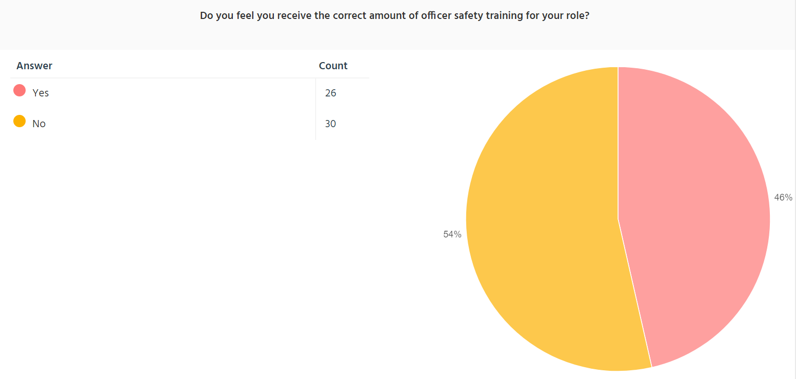

I have decided to ask these respondents if they felt they had undertaken the required amount of Officer Safety Training as I know there are many different demands on the officer’s time, without including training for of other aspects of the role. Therefore, I wanted to know what the general opinion was of the amount of input to be put into this subject. The results of this were fairly split with 54% stating it was not at the required level whereby 46% stated it was.

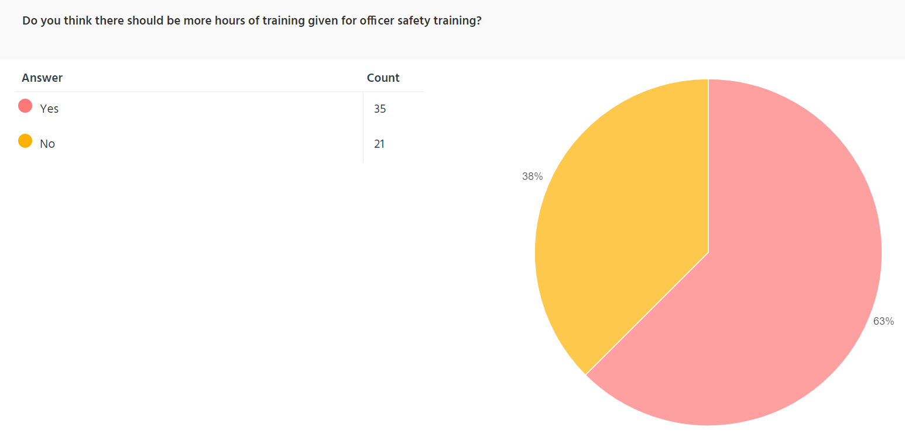
I then asked whether more hours of training should be given to Officer Safety Training to see if respondents needed more time on this subject to perfect techniques. The results showed that the majority of respondents think that there should be more officer safety training with 63% thinking there should be more hours of training given to this.
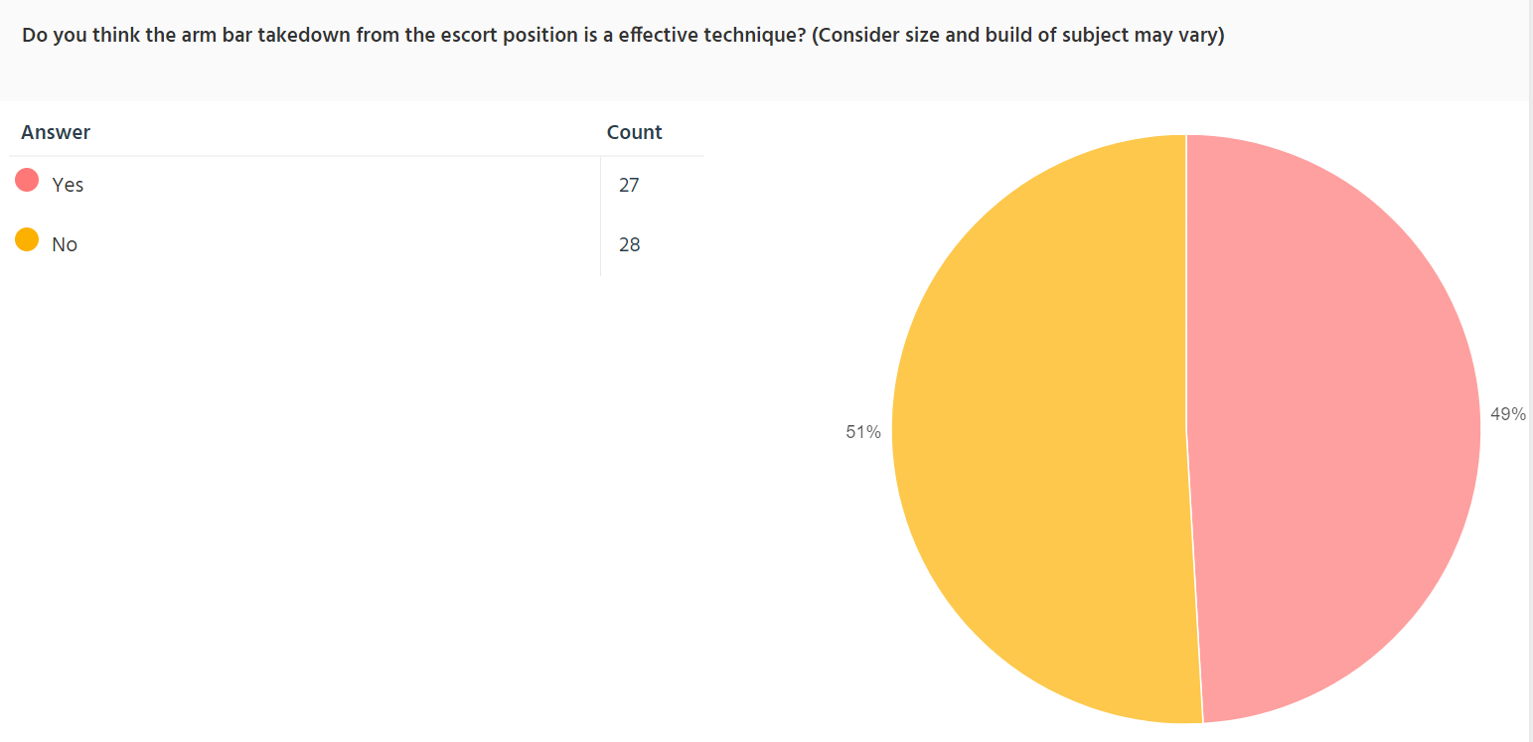
I have then asked officers about the effectiveness of specific techniques taught in Officer Safety training. Respondents were mostly split as to whether the armbar takedown technique from the escort position was effective with 51% showing to have answered no and 49% answered yes.

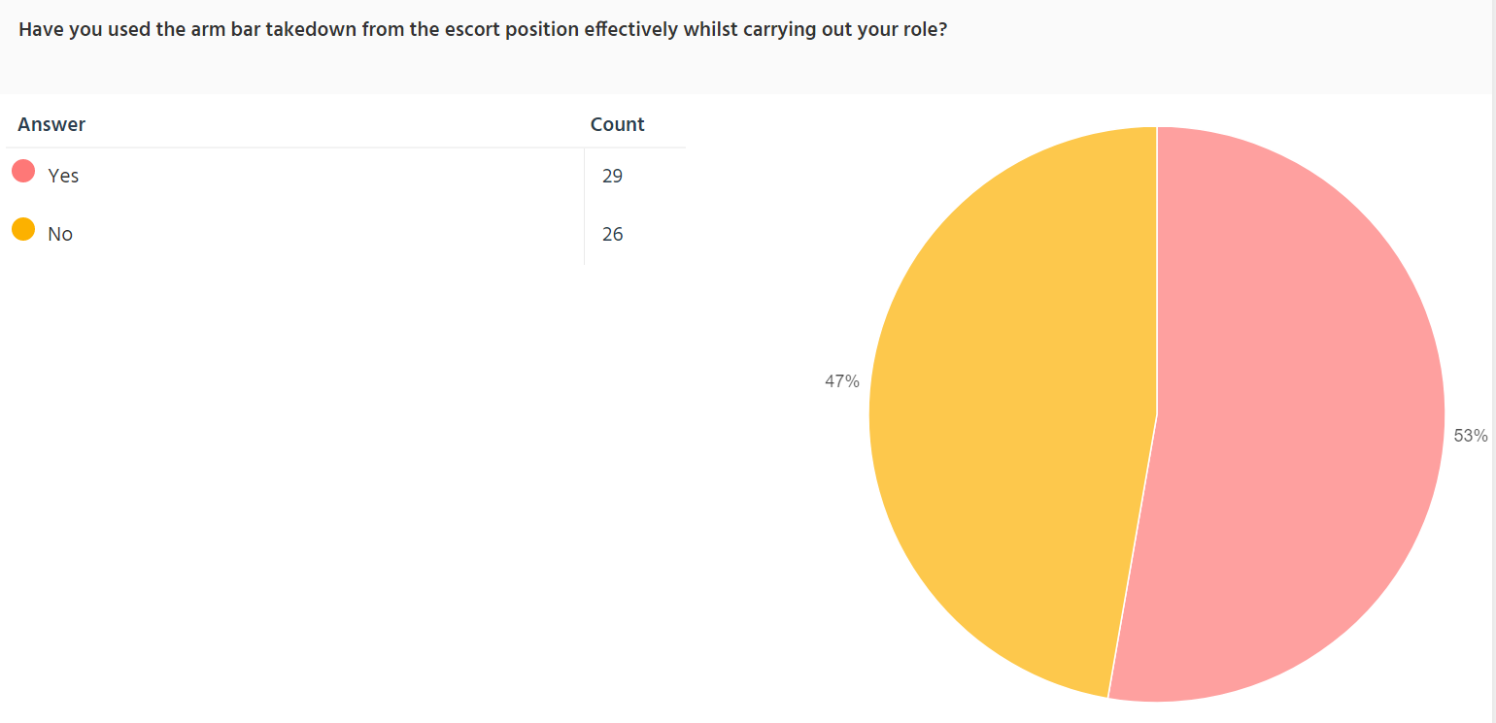
I then asked that if respondents have effectively used this technique whilst carrying out their role. The results showed that a small majority (53%) said had used this technique effectively whereas 47% have said they had not.

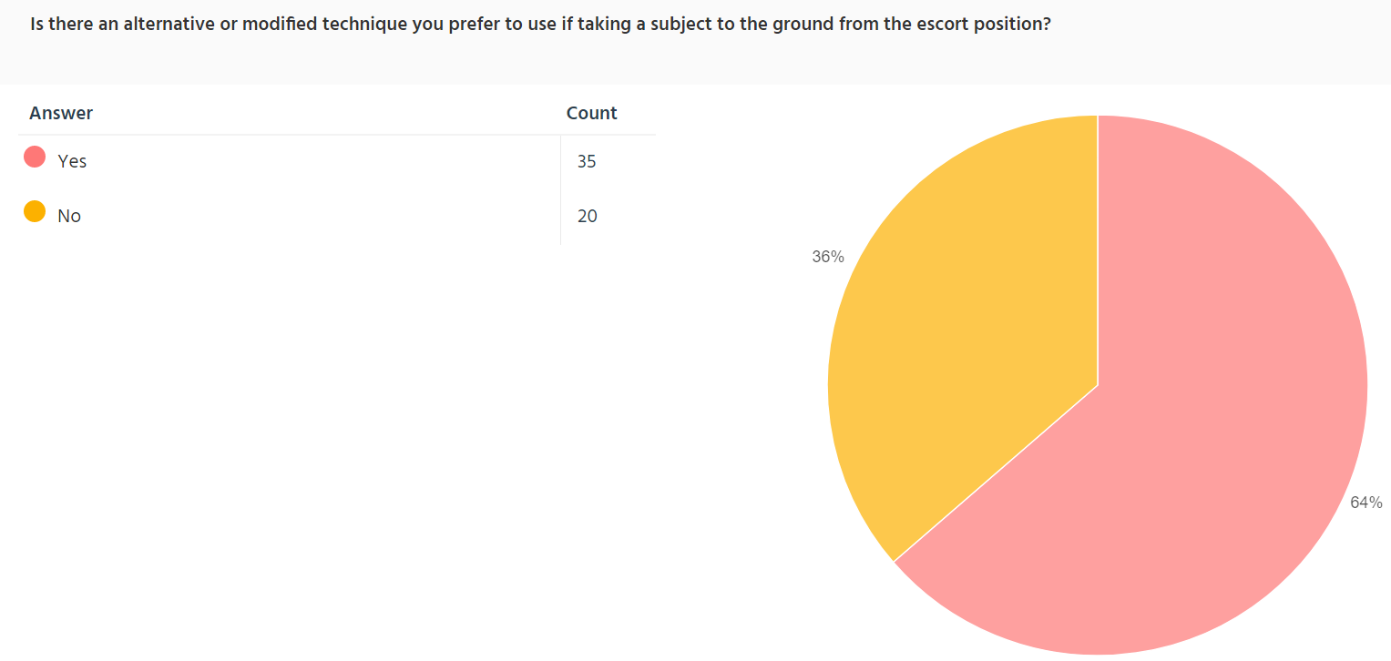
I have then gone on to ask if respondents preferred an alternative technique to take a subject to the ground from the escort position. I have this question to enquire whether respondents are using alternative techniques instead of the ones taught in training. The majority of the respondents (64%) said they did have an alternative technique that they used whereas 36% said they did not.

The same method of questioning was used for the remaining techniques discussed in this survey and the results are as follows.
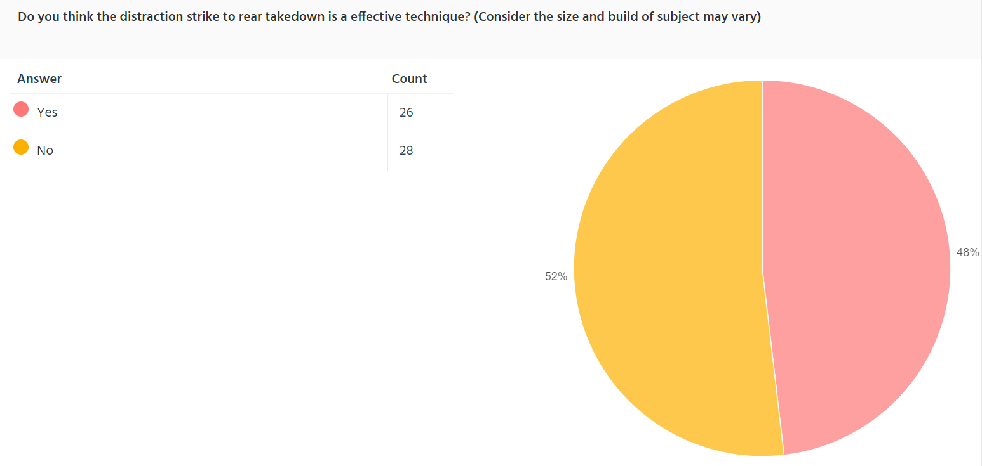
52% of respondents stated that they do not think the distraction strike to rear takedown is an effective technique whereas 48% said that it was.

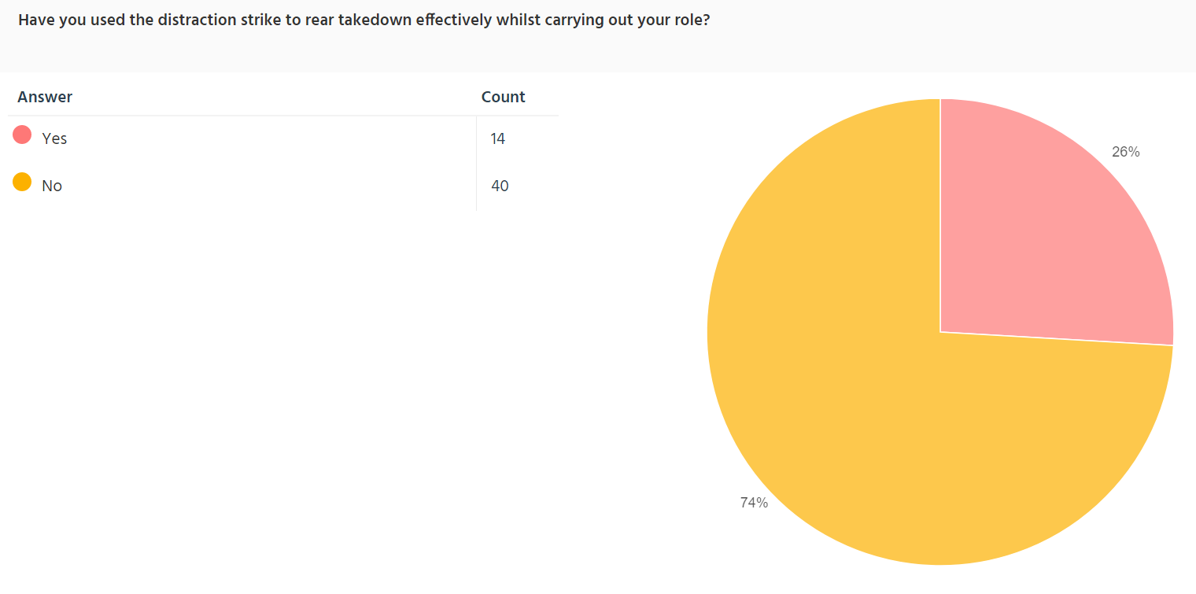

74% of respondents said they have not used this technique during their role whereas 26% said they have not.

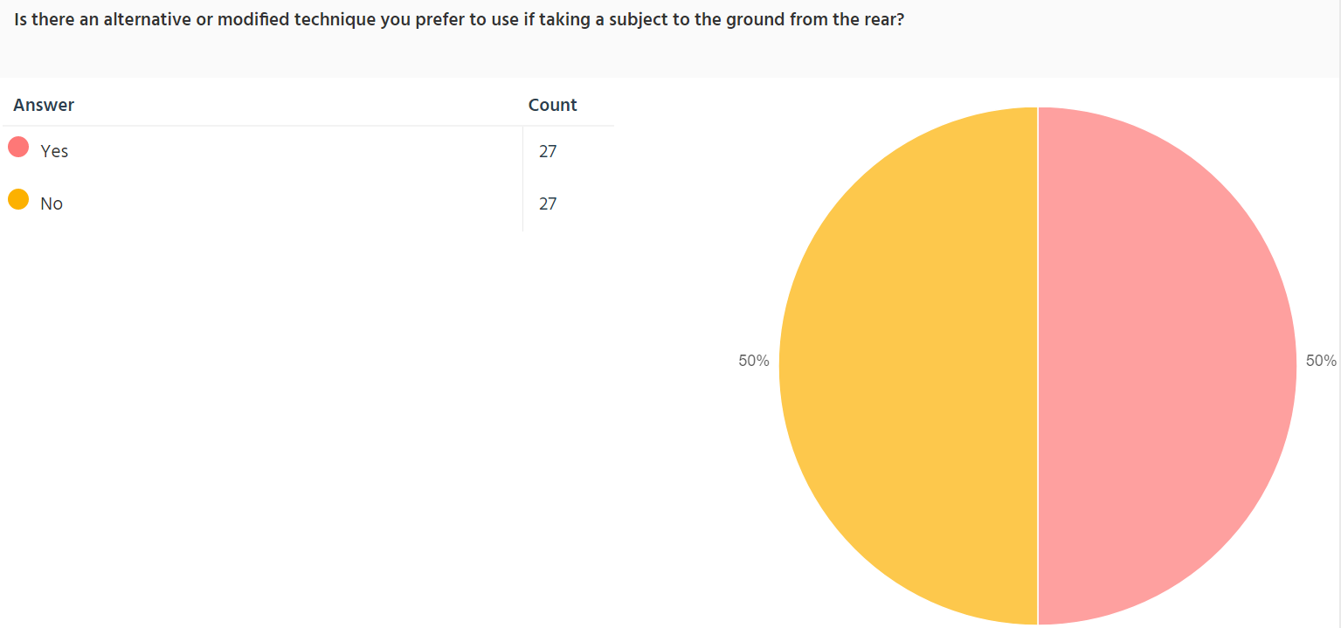

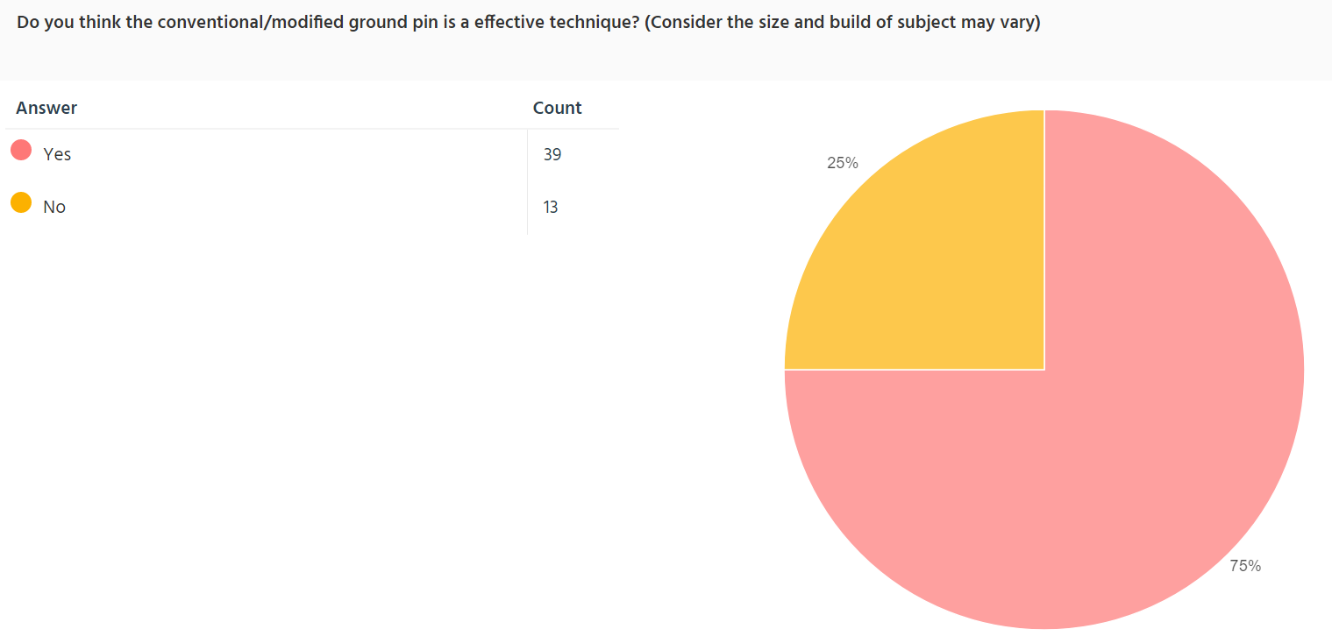

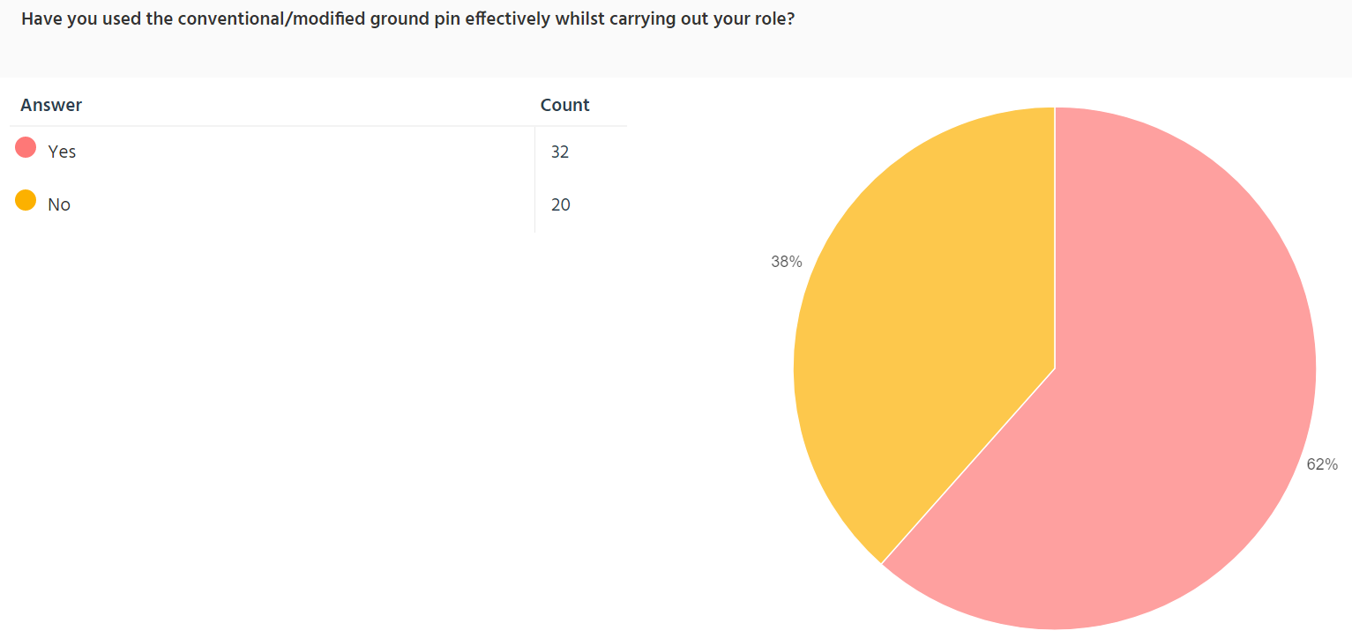

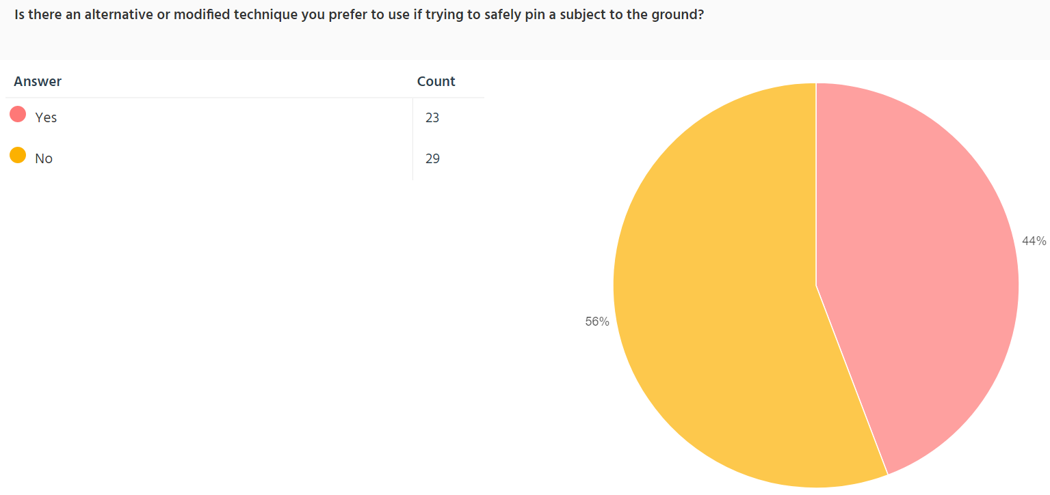

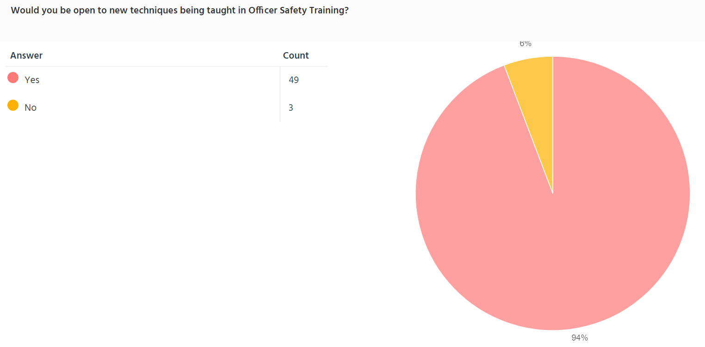

These results show the majority of Serving South Wales Police Officers say that there should be more time dedicated to Officer Safety Training. They also show that officers’ opinions on whether certain techniques taught are effective are either split or negative with the exception of the conventional/modified ground pin technique. The majority of officers seem have indicated that they use alternative techniques to the ones taught in officer safety training. This may be due to them finding other techniques more effective in being able to control a subject safely. Using techniques that are not taught in Officer Safety training may leave officers at a greater risk of litigation if a person was hurt by them whilst they were using techniques not supported by the police as it may them make them personally liable Lastly, this research found that an overwhelming majority of serving officers are open to learning new techniques. I therefore recommend that there should be options for new techniques to be taught which maybe more effective and not leading to officers using alternative techniques not taught in training.

Section 5: FINDINGS AND CONCLUSION

In conclusion to this supporting document there are many factors which show there is need for the techniques of Straight Arm Bar Takedown, Distraction Strike to Rear Takedown, and Ground Pin that are taught in Officer Safety Training, to be reviewed and modernised to be made more effective and safer for both the officer and the subject being acted upon by the officer. This can be shown by the lack of confidence serving Officers have in the techniques.
The review of available literature (at least that available in the public domain) shows that there is a gap in the knowledge and research, especially as regards to any reviews of their effectiveness. Most of the information based on individual techniques is categorised as official (and therefore outside the scope of this work) and there does not seem to be any focus on improving or critiquing these techniques to make them safer, simpler and more effective. The available literature seems to focus on the negative impacts of when techniques have been used wrongly, whereby a suspect or member of the public has been injured, which has resulted in negative public perceptions. This apparent lack reform of unarmed techniques in the UK suggests that improving the safety and wellbeing of officers and subjects might not be as high a priority as it should be. Therefore, more focus should be put into this research area as the negative events are not matched with the reforms to make the techniques more effective.
This research has drawn upon the experience of currently serving, front line Police Constables and Police Sergeants allowing reasoned conclusions based on their opinions regarding Officer Safety Training, specifically the Straight Arm Bar Takedown, Distraction Strike to Rear Takedown and Ground Pin techniques. This demographic showed that the majority (63%) thought that there should be more time put into Officer Safety Training (Fig.3) therefore showing that the confidence of officers using these techniques to be low and therefore either needing more time to learn and drill the current techniques or have alternative techniques that could be more readily learned, providing a higher level of competence in less time. Amongst this demographic, just under half of the of the participants thought that the techniques of the Straight Armbar Takedown (49%) and the Distraction Strike to Rear Takedown (48%) were an effective technique (Fig.4, Fig.7) and a majority of them for the Straight Armbar Takedown (Fig.6) and half of them for the Distraction Strike to Rear Takedown (Fig.9) used a different technique to the ones taught in Officer Safety Training. This correlation is to be expected as if an officer is not confident in the technique or feels it does not work, they will use one that they feel that does. It is understood that an officer can use any techniques as long as it is justified, proportionate and ethical (J.P.L.A.N.E) in the current Officer Safety Training, however if officers are using techniques the majority of the time that have not been tested and sanctioned as the official techniques there is more room for error which is more likely to lead to an injury to the subject or officer and which can lead to further negative effects on the police as a whole. The presentation linked to this document will detail the biomechanics of the above techniques showing their strengths, weaknesses and where they fall short systematically when it comes to safety, control, and ease of use.
The outlier of the techniques asked to this demographic was the Ground pin as it showed most officers (75%) thought this was an effective technique and had used it effectively during their role (Fig.10, Fig 11.) and just under half preferred to use an alternative technique. (Fig.12) Although the ground pin taught in Officer Safety Training has its positive aspects, there are many shortcomings which will be highlighted during the presentation which this document supports. A possible reason why more officers feel the ground pin to be more effective than the other techniques discussed is the lack of public knowledge of what makes a ground pin effective as opposed to a takedown. For example, popular sports in the modern zeitgeist such as rugby, show people taking other people down effectively, which can be seen visually whereas effectively pinning someone to the ground is less common in mainstream sports and media and is, more importantly, something more kinaesthetic which is hard to convey without practicing the technique yourself. As with the other techniques discussed, the presentation will demonstrate their strengths and weaknesses show how an alternative can be more effective and safer.
The overwhelming majority (94%) of the respondents stated that they would be open to learning techniques. (Fig.13) These alternative techniques can allow more control by officers and are safer for subjects and officers are needed in modern policing as failure to reform can lead to more injuries to officers and members of the public or the level of force to increase and prepared for such as arming all officers with firearms. I propose that this is to be avoided and alternative techniques should be implemented which are based around a body lock control system which will be explained in the presentation to which this document supports.
Police across the UK should consider the reforming of techniques taught in Officer Safety Training to safer techniques with more control and that are more natural to an untrained person by using more gross muscle movements. This therefore overall will lead to more modern, positive, and safe Police service in the context of Officer Safety Training.

RECOMMENDATIONS

IT IS ADVISED THAT THE READER OF THIS SUPPORTING DOCUMENT WATCHES THE ACCOMPANIED PRESENTATION BEFORE READING THIS SECTION
Several areas where information is lacking were highlighted in the literature review. Whilst some of these were addressed by the research in this thesis, others remain. Limits to this research as covered in previous chapters are that a majority of the information on specific unarmed techniques used by Police is not available in the public domain. Other limitations are mainly based upon time and resources available to the author. In relation to the findings in this research based on the three techniques discussed (Armbar Takedown, Distraction Strike to Rear Takedown, and Ground Pin) as well as exploring alternatives to the techniques to them, the following recommendations are suggested:
- Police services and Officer Safety Training departments across the UK are recommended acknowledge the weaknesses in the techniques that have been shown in the presentation and taught in Officer Safety Training. Active Officers may be at a safety risk if these weaknesses are not acknowledged. This can be done by drilling the techniques currently taught with subjects of different strengths and sizes with safety equipment (e.g Boxing gloves, Head Guards) so maximum resistance can be tested.
- Police services and Officer Safety Training departments across the UK are recommended to find alternative techniques to the Armbar Takedown, Distraction Strike to Rear Takedown, and Ground Pin that are safer for the subject and the officer performing the technique. Confidence amongst active officers will remain low if alternatives are not found and may lead to unsanctioned techniques to be used which may lead to further injuries. Research in partnership with trained coaches from grappling style disciplines (Wrestling, Jujitsu) could be considered to develop alternative techniques not shown in the presentation.
- Police services and Officer Safety Training departments across the UK are recommended to use the alternative techniques shown in the presentation in replacement of the Armbar Takedown, Distraction Strike to Rear Takedown, and Ground Pin due to the positive elements described. These techniques have been shown to be more effectively utilised by officers in the presentation for the following reasons:
. Better leverage when the height and weight discrepancy is high between themselves and the subject
. Provided more control by the officer allowing them to calm down to gather their thoughts and implement their tactical communications
. Avoid the subject to be taken down headfirst, avoid the subject to be pined to the floor by a small point of contact (which may be painful)
. Avoid pain compliance techniques (which may merely anger the subject and not assist the officer)
. Avoid strikes to the rear of a subject (which may cause negative public perception)
. Uses concepts familiar to officers (e.g health and safety pick up position and first aid recovery position)
. Uses mass muscle movement as opposed to fine muscle movements which are harder to perform when adrenaline is high or under stress.
. Puts the subject in safe positions and allows them to break their fall when taken down.
. Concepts are “built to fail” whereby an officer still has control if the full technique isn’t implemented using the “body/leg lock system”.
. Techniques are similar to each other allowing for more repetition during training allowing officers to perfect the technique.
This can simply be achieved by simply changing the original techniques out for these purposed alternative techniques.
- Police services and Officer Safety Training departments across the UK are recommended to implement full reform on all unarmed techniques. This is so the UK can modernise the Officer Safety Training to make it more effective and avoid high uses of force to be considered in the near future (e.g all officers carrying firearms.) This can be implemented by seeking out tactical programs such as the Gracie University method mentioned in the literature review (Refence No.5).
- Police services and Officer Safety Training departments across the UK are recommended to give Active officers an outlet to which they can give opinions on unarmed techniques whereby a range of confidence can be determined of the officer implementing the technique if new techniques are taught in Officer Safety Training. This can be done by drilling new techniques and have interactive feedback sessions to see if changes need to be made.
- Police services and Officer Safety Training departments across the UK are recommended to give more hours dedicated to Officer Safety Training to new officers to allow them more time to become competent with these techniques. This can be done by using training days which are implemented every 2 months to officers.

REFERENCE LIST

- Albers. (2017). In the Graduate Curriculum. Quantitative Data Analysis. 47 (2), p215-233.
- Banton, M. Parker , Brodeur, . Jean-Paul , Kelling, . George L. , Walsh, . William Francis and Whetstone, . Thomas. (2020). Police. Encyclopedia Britannica.. Available: https://www.britannica.com/topic/police/Equipment-and-tactics. Last accessed 14/05/2021.
- Dudovskiy (2016). The Ultimate Guide to Writing a Dissertation in Business Studies: A Step-by-Step Assistance. research-methodology.net
- Enago Academy. (2020). What are the Ethical Considerations in Research Design?. Available: https://www.enago.com/academy/what-are-the-ethical-considerations-in-research-design/. Last accessed 23rd Aug 2021.
- Gracie University. (2021). Police Training Reimagined. Available: https://www.gracieuniversity.com/Pages/Public/Information?enc=kP%2fKbrj0TEbCXXaMIVHTUw%3d%3d. Last accessed 25 Nov 2021.
- Hamourtziadou, Headech and Jackson. (2021). Security Legitimacy and Crisis in the Aftermath of Colonialism and in the Midst of a Pandemic: The Role of State Organs. Journal of Global Faultlines. 8 (1), p9-p22
- Home Office. (2019). Police use of force statistics, England and Wales April 2018 to March 2019. Available: https://assets.publishing.service.gov.uk/government/uploads/system/uploads/attachment_data/file/853204/police-use-of-force-apr2018-mar2019-hosb3319.pdf. Last accessed 14 Jun 2021.
- Key, A. (2020). Policing new boundaries. Available: https://www.pwc.co.uk/industries/government-public-sector/policing-new-boundaries.html. Last accessed 14/05/2021.
- Police and Crime Commissioner for Dyfed-Powys. (2018). Deep Dive Scrutiny Report into Dyfed-Powys Police’s Use of Force. Available: https://www.dyfedpowys-pcc.org.uk/media/6719/use-of-force-report.pdf. Last accessed 24th Jun 2021.
- Troy. (2021). Methods of Data Collection. Available: https://www.researchprospect.com/methods-of-data-collection/. Last accessed 23rd Aug 2021.

APPENDICES- COPY OF QUESTIONAIRE



