BA (Hons) Leadership and Management Skills in the Workplace

Managing Projects in the Organisation

BMSW5104

Managing Projects in the Organisation

Task 2- Evaluation of Project Management Plan

Name: Mihaiela Petreanu

Student No.: 2030622

Lecturer’s Name: Olusegun Awolaran

Executive Summary

The project was to introduce an on-site catering service at the manufacturing site of Unilever in Lonon for their employees to have access to a wide variety of foods in their breakfast, lunch, and evening snacks. The report has introduced multiple project management tools and techniques to undertake the concerned project. The interest of the stakeholders, relevant communication plan, scheduling of the project tasks through Gantt chart, risk analysis, costing and breaking down of the complicated activities through Work Breakdown structure has been undertaken. Moreover, the application of Project Lifecycle to achieve desired outcomes has been focused in the report.

Table of Contents
Executive Summary 2
Evaluation of proposed Project Management Plan 4
Introduction 4
Project Initiation 4
Project Outline 4
Description of the Project 5
Aim of the project 5
Scope of the Project 6
Communication Strategy 6
Stakeholder Analysis 6
Project Planning 10
Work-Breakdown Structure (WBS) 10
Drafting of the resources 11
Project Monitoring 12
Risk Management 12
Project Schedule 13
Project closure 14
Conclusion 14
References 15

Evaluation of proposed Project Management Plan

Introduction
Project Management is an integrated process to lead the project team for achieving the project goals within the cost and timeline (Chin, 2017). Moreover, the purpose of Project Management is to identify the possible barriers and accordingly develop a plan to meet the desired project outcomes. The application of ‘Project Lifecycle’ to ensure effective delivery of the project will be focused (Jones, 2016). In the project lifecycle, the sequence of phases that the project progresses can be spotted.
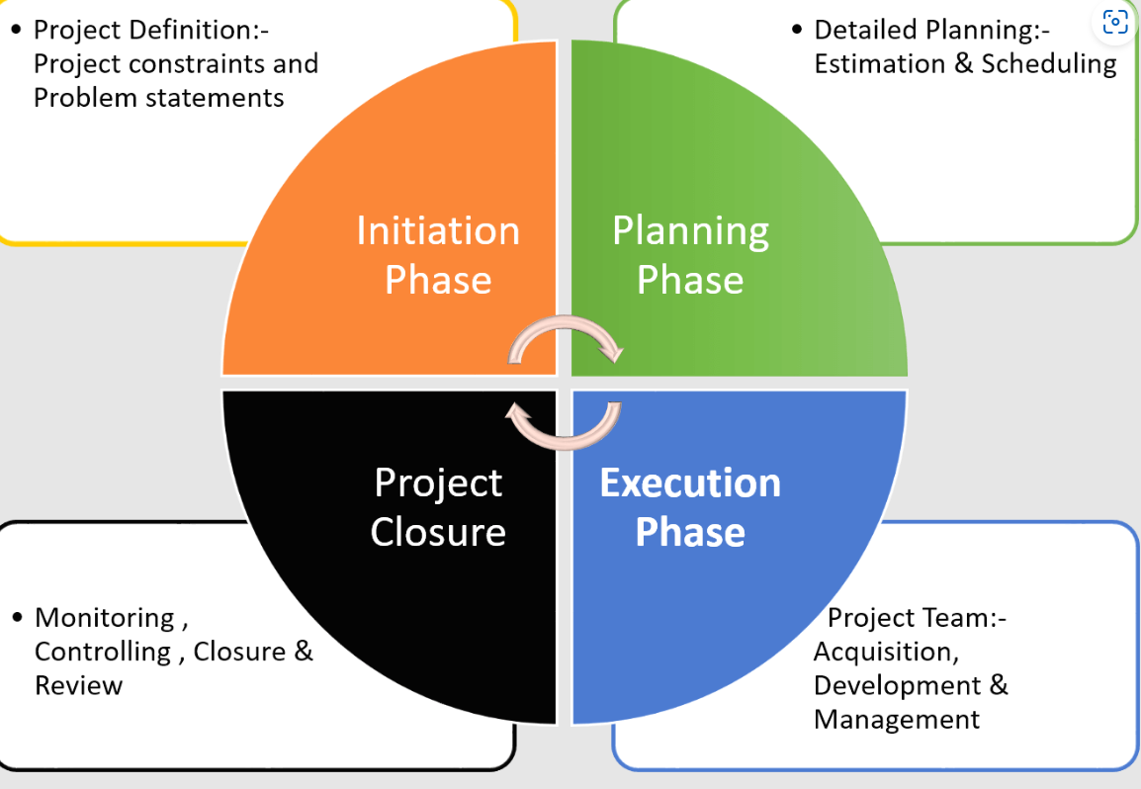
Project Lifecycle
Source: https://venngage.com/

Project Initiation
The Project Initiation is the preliminary phase of the project life cycle that outline the objectives, scope, and background to ensure a clear direction (Crawford, 2017). Moreover, clarifying the value delivered by the project can be demonstrated in the project initiation phase.

Project Outline
The project is of the ‘Hungry Moment,’ an on-site catering service that will be located at Unilever’s manufacturing site in the UK. The staff working at Unilever will get access to the on-site catering service of Hungry Moment. The canteen will be placed centrally to support 100 seating arrangements of the employees at a time. Moreover, a wide variety of foods like hot breakfast, lunch, soups, desserts, fruits, etc. will be served to the employees. Previously, there were no catering services for the employees at Unilever’s manufacturing site in the UK. However, the on-site catering service of Hungry Moment can support the employees to get access to a wide variety of foods in their offices at different times. The ‘change management program’ at Unilever will be effective in stimulating the motivation level of the staff. The new program considers the health and safety needs of the employees by providing on-site catering services. Positive work culture is the primary aim of the project that prioritizes the employee’s well-being, offers support to all levels of the organisation, and implementation of policies that enhance empathy, trust, and support. The facilities provided to the staff related to their daily meals can help them to concrete on their duties and responsibilities more efficiently.

Description of the Project
Unilever has planned to set up an on-site catering service at their manufacturing site in Lonon for their employees. The staff working at Unilever will only get access to such proposed on-site catering service of Hungry Moment. The canteen will be placed centrally to support 100 employees' seating arrangement at a time. Moreover, a wide variety of foods like hot breakfast, lunch, soups, desserts, fruits, etc. will be served to the employees at a specific time. The main purpose of the project is to enhance positive work culture. The project has considered employee motivation as the outcome. A positive work culture supports employees’ well-being, offers support to all levels of the organisation, and implementation of policies that enhances empathy, trust, and support among the employees. The commitment of the employees to their duties and responsibilities will be increased due to the addition of the facilities in the workplace by the organisation.
Firstly, the on-site catering service will be a ‘time-saver’ for the employees due to the real-time accessibility of the meals by the staff in their office. The employees do not have to go outside for lunch. The catered lunch and meals will support the employees to manage their time as per their work schedules. Hence, the employees can concentrate on their responsibilities efficiently with the introduction of on-site catering services in the office.
Secondly, the organisation can maintain the health and safety needs of the employees by providing nutritious diets and meals. The health awareness objective of the organisation for the employees can be executed with the on-site catering service. Thirdly, the employees can have a space for relaxation during their breaks. The socialisation among the employees and improvement of the networking can be enhanced with the canteen being placed under the on-site catering service of Hungry Moment. Hence, the improvement of the office environment through the on-site catering service is effective.

Aim of the project
The project aims to introduce an on-site catering service at the manufacturing site of Unilever in Lonon for their employees to have access to a wide variety of foods in their breakfast, lunch, and evening snacks.

Scope of the Project
The project is to introduce an on-site catering service at Unilever’s manufacturing site in the UK for giving accessibility to the staff to have their meals. Moreover, the project is part of a change management programme undertaken by Unilever to enhance positive work culture in their manufacturing site. A positive work culture supports employees’ well-being, offers support to all levels of the organisation, and implementation of policies that enhances empathy, trust, and support among the employees.
The commitment of the employees to their duties and responsibilities will be increased due to the additional facilities in the workplace. Hence, on-site catering service at Unilever’s manufacturing site can be a time-saver for the employees and also help to ensure their health and safety needs.
Therefore, the included scope of the project is as follows:
- To implement a positive work culture in the manufacturing site of Unilever
- To ensure the meeting of the health and safety needs of the employees with the on-site catering service at the office premise
- To drive the organisational productivity of the organisation by reducing the time that the employees used to invest for their meals at outside the premise
- To create a place for relaxation of the employees during their breaks for strengthening the socialisation and networking
- To increase the motivation level of the employees by taking care of their requirements

Communication Strategy
Project Communication management is a designated process that ensures the message are sent, received, and decoded by the stakeholders in the project (Helleno, 2020). In the current project, an integrated communication process followed by two-way communication will be followed to manage the conflicts and miscommunication issues. Moreover, the tracking of real-time information and the progress of the project can be achieved with the application of an integrated communication process.

Stakeholder Analysis
Stakeholder analysis is one of the project management tools that help to discover the expectations and needs of the stakeholders from the specific project undertaken by the organisation (Ibbs, 2016). Moreover, stakeholder analysis specifies the process of identifying the individuals or groups during the project initiation phase and accordingly grouping them based on interest and influence. The current project is to introduce an on-site catering service at Unilever’s manufacturing site in the UK for giving accessibility to the staff to have their meals.
Moreover, the concerned project is part of a change management programme undertaken by Unilever to drive organisational productivity in their manufacturing site. Therefore, the following stakeholders are identified based on the dimensions like interest and power.
Stakeholders | Description | Category | Strategy
Employees | The employees are strategic resources of Unilever that help to attain a competitive advantage in the market. Currently, more than 6,000 employees are working in the manufacturing sites of Unilever in the UK. Unilever is committed to delivering an inclusive workplace that respect and values all employees irrespective of their backgrounds. Moreover, Unilever has focused on an employee engagement strategy to make sure that the employees share their valuable opinions and views to create superior value propositions for the customers. | High Interest and Low Power | In the proposed project, employees need to be informed about the plan for setting up an on-site catering service in the office premise. The views and opinions of the employees will be collected to execute the project management plan.
Suppliers | On-Site catering service ‘Hungry Moment’ will Provide a wide variety of foods like hot breakfast, lunch, soups, desserts, fruits, etc. to the employees at a specific time. The suppliers have to maintain quality benchmarks by focusing on health and safety standards. | High Interest and Low Power | Unilever has to work closely with suppliers to achieve quality assurance. Therefore, providing important information regarding the planning of on-site catering services can be focused.
Investors | Investors play a strategic role in the organisation raising fund for the project. The raising of investments and contributing towards financial resources are the responsibilities of investors. | High Interest and High Power | The project team has to manage the investors with priority to raise the required funding for the project. Moreover, involving the investors in the decision-making process of the project can be emphasised.
Customers | Unilever is a leading consumer goods brand that has reached 2.5 billion consumers in a day in over 190 countries. In the UK, Unilever has contributed directly up to £643 million to the GDP. Moreover, the customers of Unilever directly impact the company’s profitability. In the year 2022, the underlying operating profit was €9.6 billion. |  | Unilever has to deliver a superior value proposition to the customers by enhancing organisational productivity. Therefore, keeping satisfied can be an effective stakeholder management strategy in consideration of customers.
Project Team | The project team comprises the members that are working on a concerned project having shared goals and targets. | High Interest and Low Power | Coordination among the team members can help to attain the target. Moreover, real-time information accessibility can track the actions efficiently in a group project.
Project manager | The project manager supports the planning and monitoring of the project by forming a reporting structure. Moreover, assigning duties among the project team members and having clear knowledge about possible risks are the key duties and responsibilities of the project manager. |  | A project manager has to work closely with the project team by providing guidance and support. The clarity in the communication process between the project team members and the project manager can help to reduce the chances of conflicts and miscommunication that create delays.

Project Planning
The project Planning phase consist of the actiossssn plan and schedules that help to complete the project with the stipulated deadline and budget (Jones, 2016). Hence, planning of the resources, identifying deliverables, and setting measurable objectives are the key areas of project planning aspect.

Work-Breakdown Structure (WBS)
Work-Breakdown Structure (WBS) is a tool of project management that considers step-by-step approach in completing a large project into multiple manageable parts (Jovanovic, 2018). The purpose of WBS is to organise the project deliverables based on dependencies.
Work Breakdown Structure (WBS)
Project Aim: The project aims to introduce an on-site catering service at the manufacturing site of Unilever in Lonon for their employees to have access to a wide variety of foods in their breakfast, lunch, and evening snacks.
WBS ID | Level | Project Management phases | Work Description | Resources | Deliverables
A1 | 1 | Project Initiation | The Project Initiation is the preliminary phase of project life cycle that outline the objectives, scope and background to ensure a clear direction. | Background study and market analysis | Project Charter
A2 | 2 | Project Planning | Project Planning phase consist of the action plan and schedules that help to complete the project with the stipulated deadline and budget | Identification of project variables | Drafting of the resources, Risk Analysis and setting the Project Budget
A3 | 3 | Project Monitoring and Controlling | Project monitoring and controlling reflects the reviewing of project status and evaluating key obstacles for implementing necessary changes | Reviewing the project activities based on the standard benchmark | Project Scheduling
A4 | 4 | Project Closure | Project Closure phase ensure the work is completed within the stipulated deadline and budget | Documentation and presentation of the project | Project is approved and signed off

Drafting of the resources
Project resources are the essential elements that are necessary to complete a project (Kerzner, 2019). In the current project, certain resources are crucial for successful project implementation.
Resources | Description | Budget (£)
Human resources | Hiring of the specialists that are having adequate knowledge in civil engineering and office space management  Incentives to the project team members | 2,500
Technical resources | New software for project designing and communication process | 1000
Financial resources | Allocating the fund for the new project in the office | 5,000
Other resources | Conducting the survey, travelling cost, printing and other miscellaneous expenditure | 1,500
Total |  | (£) 10,000

Project Monitoring
Project monitoring and controlling process ensure the project is reviewed, and controlled to achieve the desired outcomes (Meredith, 2018). Moreover, reviewing of project status and evaluating key obstacles for implementing necessary changes can be spotted under project monitoring phase.

Risk Management
Risk Management underlines the process of finding, assessing, and controlling the obstacles that can influence desired project outcomes (Munns, 2017). The purpose of risk management is to address the potential problem and related strategies to overcome such barriers in the execution process of a project.
The below risk management table for the concerned project has been prepared based on the ratings (1=Insignificant, 2=Minor, 3=Significant, 4=Major, 5=Severe).
Risks | Ratings | Risk Management strategy
Exceeding the proposed budget | 5 | Project manager has to lead the team and ensure that the activities are completed within the budget. Hence, proper guidance and direction from project manager is needed to maintain the budget.
Quality assurance from the suppliers | 4 | Suppliers can fail to meet the quality standard. Hence, close working relationship with the suppliers is needed from the project team. The separate policies for the food quality and hyenine standards need to be formulated while selecting the suppliers.
Lack of coordination and communication issues | 3 | The communication issues within the project team fan affect the project outcomes. The introduction of an integrated communication process by involving the project team members and manager is required. Moreover, tracking of the progress through monitoring is also needed. Therefore, proper coordination among the project team members can help to reduce the communication issues.

Project Schedule
Project Scheduling is mainly a timetable that organises the tasks, resources, and due dates in a logical sequence (Wells, 2019). The purpose of project scheduling is to act as a guide for executing the tasks within the deadline. Moreover, the estimation of duration and outlining the sequence of the project activities can be spotted under Project Scheduling. In consideration to project scheduling, Gantt chart can be an effective project management tool that help to illustrate the tasks that need to be completed within the due dates (Wood, 2018). The time allocated for each activity in the project can be visualised with the Gantt chart.
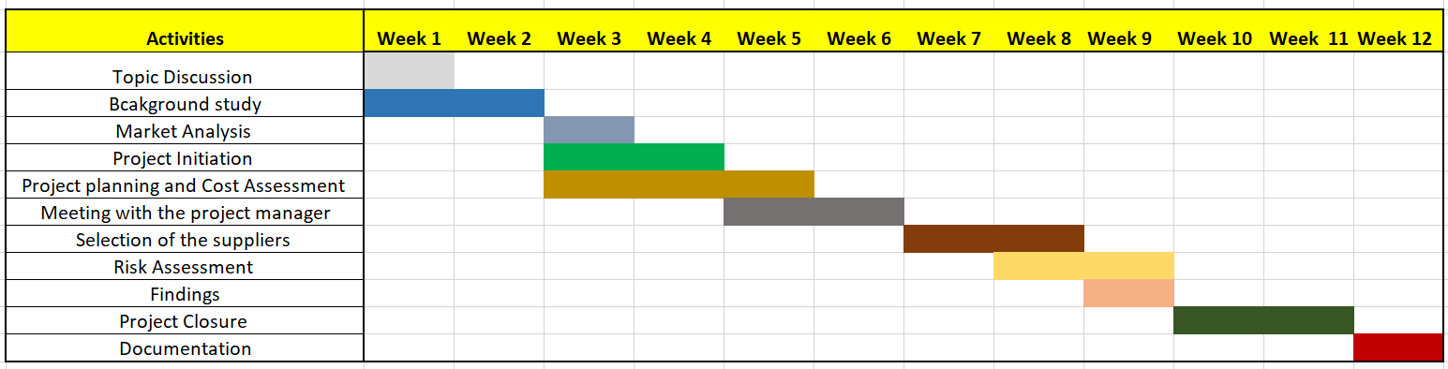
Gantt Chart
Source: Author

Project closure
Project Closure is the last phase of project lifecycle that ensure that the project is completed within the deadline and allocated budget (Meredith, 2018). The approval of the project based on the outcomes and project deliverables can be spotted under Project closure phase. In the current project, selecting the on-site catering supplier, documenting of the ways of redemption to access the meals, and convenience to the employees are the outcomes are the outcomes of the project. The project manager has to approve the project based on the accomplishment of the outcomes.

Conclusion
The project was to introduce an on-site catering service at the manufacturing site of Unilever in Lonon for their employees to have access to a wide variety of foods in their breakfast, lunch, and evening snacks. To conclude, the report has introduced multiple project management tools and techniques to undertake the concerned project. The interest of the stakeholders, relevant communication plan, scheduling of the project tasks and breaking down the complicated activities through Work Breakdown structure has been undertaken. Moreover, the application of Project Lifecycle to achieve desired outcomes has been focused in the report.

References
Chin, C. S. A. a. Y. E., 2017. Project management methodologies: a comparative analysis.. Journal for the advancement of performance information and value, 12(7), pp. 106-106.
Crawford, L., 2017. Senior management perceptions of project management competence. International journal of project management, 33(6), pp. 7-16.
Helleno, A. P. C. F., 2020. Integrating value stream mapping and discrete events simulation as decision making tools in operation management. The International Journal of Advanced Manufacturing Technology, 80(7), pp. 1059-1066.
Ibbs, C. a. K. Y., 2016. Assessing project management maturity. Project management journal, 34(5), pp. 32-43.
Jones, G. a. G. J., 2016. The experience and evolution of trust: Implications for cooperation and teamwork. Academy of management review, 23(4), pp. 531-546.
Jovanovic, P. a. B. I., 2018. Analysis of the available project management methodologies. Journal of Sustainable Business and Management Solutions in Emerging Economies, 15(8), pp. 1-13.
Kerzner, H., 2019. Project management: a systems approach to planning, scheduling, and controlling. London: John Wiley & Sons.
Meredith, J. S. S. a. M. J. S., 2018. Project Management: A Strategic Managerial Approach. London: John Wiley & Sons.
Munns, A., 2017. The role of project management in achieving project success. International journal of project management, 14(5), pp. 81-87.
Wells, H., 2019. How effective are project management methodologies? An explorative evaluation of their benefits in practice. Project management journal, 11(3), pp. 43-58.
Wood, S., 2018. The integration of human resource and operation management practices and its link with performance: A longitudinal latent class study. Journal of operations Management, 28(7), pp. 455-471.

Annex PowerPoint Presentation


