Introducing the Modern Workplace
  - A project report on the leadership and management practices at Adidas



Module Title | Introducing the Modern Workplace-Assessment 2
Assignment Title | Introducing the Modern Workplace
Module Lecturer’s Name | Dr. Rexon Nting
 | Team Leader | Team Member 1 | Team Member 2 | Team Member 3 | Team Member 4
Name | Claudia Babadac | Cornelia Carpen | Ligia Neacsu | Cristinel Gherfi | Radu Neata
Student Number | 1905902 | 1905632 | 1905215 | 1909492 | 1905633
Task done by the member | Part 1 and Presentation | Part 2 | Part 3 | Part 4 | Part 5

Table of Contents
TABLE OF FIGURES 3
PART 1 4
PART 2 7
PART 3 10
PART 4 13
PART 5 16
REFERENCES 19
APPENDICES 21

TABLE OF FIGURES
Figure 1: Logo history of Adidas 5
Figure 2: Leadership Traits 10
Figure 3: Transformational leadership 11
Figure 4: Belbin team roles 13
Figure 5: Tuckman team development theory 15
Figure 3: Motivational techniques 17

PART 1 – CLAUDIA BABADAC
BACKGROUND OF THE PROJECT AND ADIDAS
Adidas is a shoe, clothes, and accessories manufacturing company based out of Germany and operate worldwide. It has been founded by Adolf Dassler in the year 1924 and named after his name. It employs more than 59,000 people all over the globe and Kasper Rorsted as a CEO. Adidas believes in power of sports to change the lives of the people in the world, thus, it is dedicated to promoting and serving the sport persons of the world. In 2019, the annual sales of Adidas have been € 23.640 billion by selling 1.1 billion sports products. With such figures of growth and achievement, Adidas aims to become the best sports company of the world (Adidas, 2020).
This project aims at analyzing leadership and management practices at Adidas to understand its organisational behaviour and culture which has contributed to its growth in the international market. After its foundation in the year 1924, it has established in 1949 as a Sportswear manufacturing group. Since then, it has been a part of several sports events and historical moments like Football World Cup of 1974, Boston and Vancouver Marathons etc. in continuity of its growth as a Sportswear brand; it has also acquired Reebok in the year 2005 (Adidas, 2020). Leaders in Adidas promote performance based culture and follow a compensation programme to motivate the employee base for achieving higher goals which makes Adidas competent to many other large companies like Nike. The leaders and managers have been an integral part of the individual growth of the employees and support them in improving themselves to have a progressive career ahead (Yuliansyah et al., 2017).
Organisation culture of Adidas is the by-product of the strong leadership and management approaches used at Adidas over the years. The Tradition along with Progressive approaches has been a strong driver of growth and development of Adidas. The company promotes and manages diversity very effectively at the workplace which shows in its performances over the years. The organisational structure of the company is unique and has three main division; original division, equipment division, and forever sports division. Due to producing different products in these divisions, the company has different kind of competitors. To handle them there is a internal network between all the divisions. This network makes the employees, leader, and managers to stay connected and make different project feasible (Mansouri et al., 2018).
This project studies the process through which the leader and managers motivates their employees to be a part of the challenges and opportunities which the company undertakes to grow and succeed in the market. The wages, compensation, lifestyle and workplace standards (policy and code of conduct), working hours, freedom of expression, and disciplines of employees are explained to demonstrated their effectiveness in the workplace management at Adidas (Vaagaasar et al., 2019).
Adidas has a huge multi-layered supply chain structure in 65 countries which manufactures its products like in the US, Canada, China, Japan, UK and Germany are some of its top suppliers. The different sites of Adidas around the world have been called as Green Company as named by the company to pursue its zero emission vision. The effective management at Adidas has incorporated best practices to support the passion for waste management and making a greener planet in the people associate with the company. The Global management system implemented by the company has been certified by the ISO in the years 2010-2013 in 12 major locations of Adidas. Having recognized by many awards and acknowledgements for its global sustainability initiatives, Adidas have made itself a part of DJSI which is the first sustainability index of world (Adidas, 2020).
The belief and values of the company are based on Passion towards what they do, Excellence in performance and plan execution, integrity in being open, honest and ethical to people, and encouragement to diverse minds, interests, and backgrounds. Adidas believes in sustainable business to access a lasting economic success. It can be done by extensive preparation, setting right goals, keep trying, and overcoming challenges. The company focuses on designing environment friendly products to reduce the negative impact on the environment from its operation and supply. Adidas has incorporated standard policies for its production units to follow so that they can achieve the safe, secure and healthy conditions at the workplaces (Adidas, 2020).
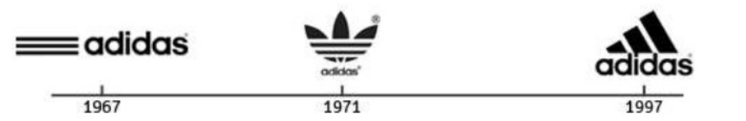
Figure 1: Logo history of Adidas
(Source - Adidas, 2020)
The logo of the company has a intriguing story behind its evolution since 1967 when Adolf Dasseler has designed it. The three stripes present in the logo of Adidas has gained massive amount of popularity to the company that the leader and managers have always stick to keep it in the logo as the identity of the brand. Then he redesigned it in 1972 into a Trefoil to demonstrate the diverse excellence of the company in industry which becomes instantly popular like the previous one. In 1997, the creative designer of Adidas redesigned the trefoil into a triangle to make it more effective which has later become the corporate symbol of the company (Adidas, 2020).
Adidas has a huge scope in the Consumer lifestyle market, where it can merge and acquire the business in different countries for the expansion of the business. The effective leadership and management at Adidas have helped in managing the financial position for the company in the global market, which is beneficial for its business expansion. The company must continue to innovate and create new products and ways to serve customers through its sustainable strategic way. The evaluation of leadership and management practices is also a part of this learning and development strategy of Adidas, where it wants to identify the areas where the improvements can be done. It will help in devising more effective programs for the managers and employees to be better at their skills and competence. Adidas has created its workplace a healthy and competent work environment which facilitates its employees, organizational performance, sales, and sustainable lifestyle to its consumers (Adidas, 2020).

PART 2 -CORNELIA CARPEN
GOALS AND OBJECTIVES
The Goal of this project is to analyze the effectiveness of leadership and management practices at Adidas which has contributed to its sustainable growth over the years. To conducts this project at Adidas the project team needs to understand the goals and objectives of the company over the years and determine the effectiveness of management and leadership practices on the basis of that (Tang, 2018).
The mission of the company is to become the leading sportswear company of the world by providing the best sportswear. Adidas believes in power of sports to change the lives of the people in the world, thus, it is dedicated to promoting and serving the sport persons of the world. The objective behind this goal is to create and sell the best quality and styled products that can be used by the people who love and pursue sports and fitness in their regular life. The object is to provide the best possible services and service experiences to the customers by pursuing the sustainable methods of doing business (Adidas 2020).
The company wants to be an innovative yet consumer focused brand in the world, which is supported by its usage of technologies in the operations and adding feel to all the processes. Adidas practice to be honest and authentic to the world by dedicating all its efforts to better the consumer’s life better and by continuously providing the right quality products it has been successful so far. Passion to make Adidas from its first shoe pair to this large organisation has been the driving force of the employees, managers, and leader at Adidas. The commitment to forever producing and supplying the high quality standards, uncompromised, unwavering and comfort in their products and services has been the strongest part of the business management at Adidas. Being responsible towards society and environment by encouraging diversity, creativity, and innovation at workplace, Adidas has made strong relationship with the stakeholders and employees globally. The simplicity and persistency in achieving its goals has resulted in its consistent financial growth (Adidas 2020).
IMPORTANCE OF GOALS AND OBJECTIVES
The Goals and Objectives of Adidas are important to direct it in the right direction that means the direction which includes financial success and social reputation. Without having a goal and objectives, the company can ruin its existing value and may not grow further since the performance of the company without any direction can never reach a common point. The management of Adidas will not be able to understand the main drivers of success for the company like its unique selling point, success point, growth rate and financial performance. In addition to direction, the planning of business for achieving goal and objectives must be effective too. It needs to be the strategy which helps in making the process feasible. So SMART goals needs to be planned and executed by the company to succeed further in market. Like the Green Company strategy of the company has worked so far to maintain the social image as well as financial performance. It also helped in the achievement of the set goals and objectives of Adidas to be the best sportswear company of the world (Stacey, 2016).
The motivation to sustainable and steady growth in the future can only come from the determination of managers and leaders towards the success and belief in the goal and objectives. The passion in employees and stakeholders of Adidas towards the Environment and Society has been the motivation to go through all these years of business. The social image of a brand is very necessary for its growth and success in the market and once the image is build it is even more necessary to maintain that to serve the expectation of the customers. The company needs to have a balance between financial outcomes and social outcomes in all its strategy, product, services, and commitments. It helps in creating the right environment of work for the employees since the company is incorporating ways to obey the government policies and social responsibilities. Thus, having a goal and smart objectives is very necessary to achieve growth, better workplaces, talented employees, trustable stakeholders, reliable customers, right strategy, strong motivation and ways to evaluate the success (Tang, 2018).
WAYS TO DETERMINE GOALS AND OBJECTIVES
The mission of Adidas is the basis of setting Goals and objectives for the company. To determine the right goals and objectives for the company, it needs to be specified. Goals are the long term intentions that are difficult to measure, while Objectives are short term precise actions towards the achievement of goals which are set to be measurable. Adidas can deconstruct the goals into SMART objectives that will help it in achieving the set Goal of the company (Rieckmann, 2017).
For example, If Adidas set a goal as the implementation of organisational-level training program for Leaders and managers of Adidas for the management effectiveness. The SMART objectives for the achievement of this goal can be-
- To develop a strong and feasible training programme in a month for all the managers with the help of experts and leader of the company.
- To develop and present materials and workshops to all the participants of the Training Programme by the end of the month.
- To establish a team to organize and oversee the weekly progress of the Training Programme in all divisions of the company.
- To measure and evaluate the performance at the end of Training Programme for each member for determining effectiveness of the programme (Stacey, 2016).
To understand and prepare feasible and effective objectives, the company can use SMART criteria in which the letters are the initials of five parameters which need to be applied. A SMART objectives need to be Specific, Measurable, Achievable, Relevant, and Time bound. If the company wants to set a goal to achieve its ultimate vision, it must assure that the goals are not just statements and does not have a defined direction for the company to follow. The company must have a defined statement which can be achievable and measured in a set amount of time. The Vision of the company might look broad and huge to achieve but with defined goals towards achievement of the vision can help the company to make its way. The goals need to be long term- and broad on-scale but must have a statement to follow a direction to lead the company Rieckmann, M. (2017).

PART 3 -LIGIA NEACSU
LEADERSHIP AND MANAGEMENT BEHAVIOUR
The behaviour of people in position of leader and manage at any business organisation defines and directs the behaviour of employees and overall organisation. Thus it is crucial to understand and improve the leadership and management bahaviour of Adidas to understand their practices in leading and managing the company. Leadership Behaviour refers to the initiatives and practices of leaders to influence, motivate, and cultivate the employees and managers towards a specific goal. Management Behaviour is the administration and measurement of regular activities according to the set protocols and policies (Schmitt et al., 2016). The Trait Theories of Leadership explains that the Leaders and managers must possess certain qualities to lead and manage effectively. Emotional intelligence, honesty, integrity, self confidence, drive to achieve goals, and cognitive ability are some of the major traits of an effective leader (Zaccaro et al., 2018)
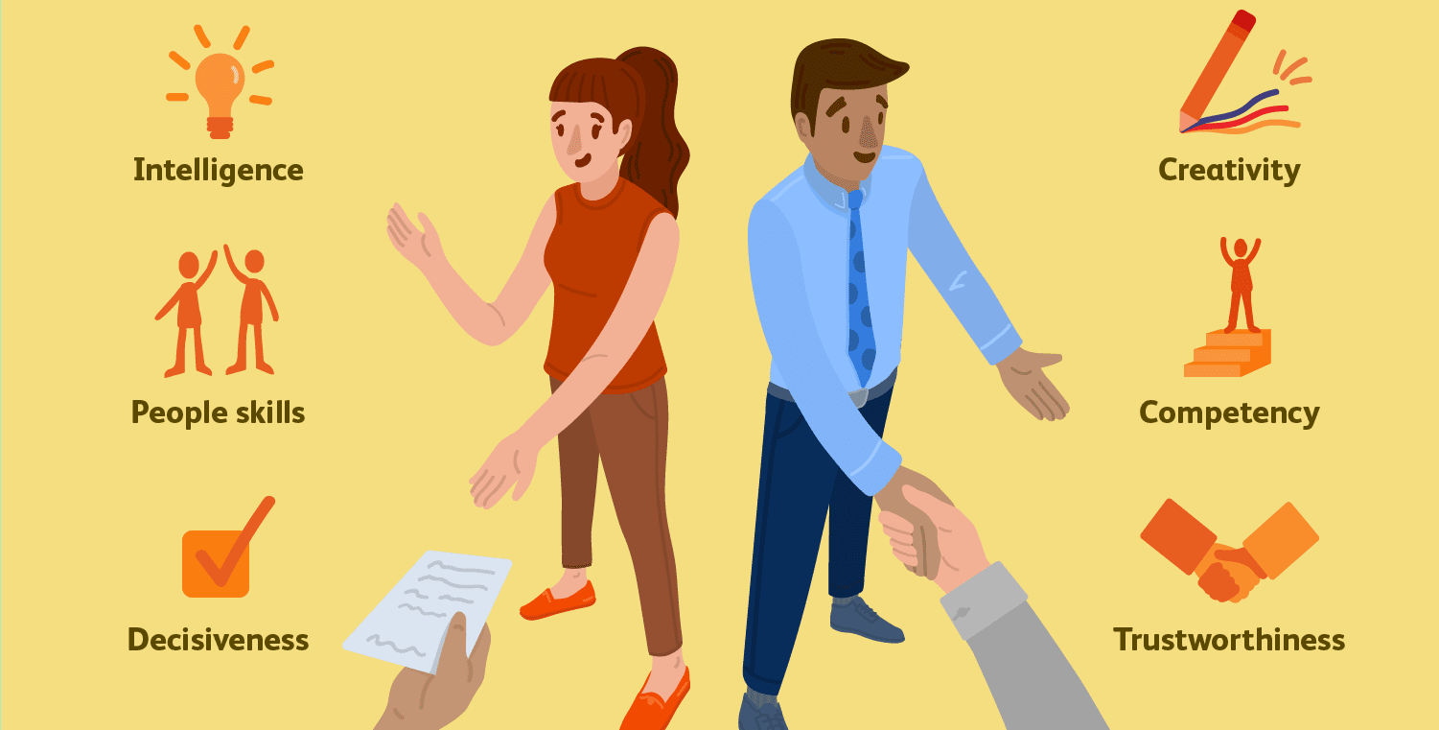
Figure 2: Leadership Traits
(Source – Zaccaro et al., 2018)
At Adidas, the leaders and managers urge to keep the processes simple, steady and sustainable so that they can learn and grow through it rather rushing up and failing. This can only be possible to have when the people believe the same way. An effective leadership plays a major part in this, hence the Leader of Adidas has to believe and act on the same belief in order to influence people associated with Adidas. The leader has to implement that belief at all levels of the organisation, and make sure that other employees are being trained the right way so that they can contribute in the achievement of company’s goal. To manage the production from all its production units around the world, Adidas has a effective multilayered chain management system. By providing quality products and services to the customers, this relationships with the suppliers and distributors needs to be in place. It helps in being the preference of stakeholders and investors among the competitors like Nike (Adidas, 2020).
The managers at various levels and department of the organisation are very essential part of the team as they ensure the planning, budgeting, implementation, progress and measurement of the set goals. They coordinate with other departments to make sure that the overall process is leading into right direction. They manage skills, performance, and issues of the Staff at Adidas to make sure that the employees are contributing in the right direction. They plan and control the budget of the company. All these tasks directly affect the achievement of goals and objectives of the company hence the Managers of Adidas need to follow a set administrative protocol. The Blake Mouton Managerial Grid is a very effective tool to evaluate all managerial decision from recruiting employees to manage them at all stages of HR life cycle. It helps in choosing the right leadership style in a particular situation to lead the employees in the achievement of desired level of performance (Amankwaa et al., 2019).
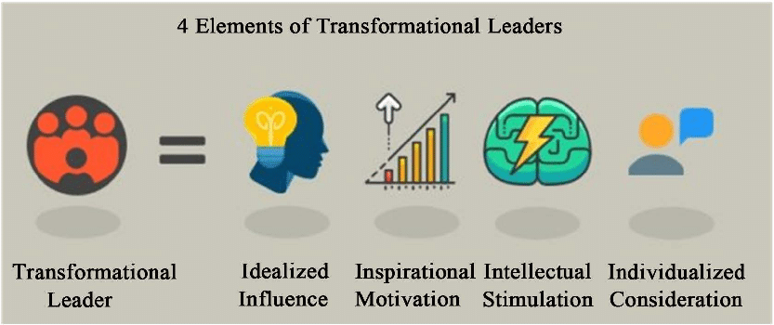
Figure 3: Transformational leadership
(Source – Amankwaa et al., 2019)
The leadership and management practices followed at Adidas are in coordination with the Mission of the company. They follow the sportsman spirit to encourage the employees to achieve their goals, improve performances, and be consistent towards delivering it. to implement it various leadership styles are developed over the years; Autocratic, democratic, participative, transactional, transformative, etc. The CEO of Adidas has a simplistic approach in leading and managing the whole business where he believes to uses the passion of people towards the society and environment to drive the workforce in the direction of achieving sustainable goals by following sustainable strategy. This can be done effectively through Transformational leadership style of leading people (Schmitt et al., 2016).
The three division of the company follows the same strategy to fulfill their respective goals in their ways. The employees at all the division gets the same benefits to ensure the equality at workplaces; Wages, Insurances, Retirement Plans, Compensation, Flexibility In Working Hours, Vacations, Trainings. These benefits help in shaping the whole employee base in a team which leads to a sustainable growth of the company (Adidas, 2020).
The management also provides opportunities to the employees to have a balanced work-life and pursue the right path to grow personally and professionally. For this, Adidas provides learning and development programs and FlexiTime Programs. In FlexiTime Programs, the employees are allowed to work comfortably and balance their life at home and work to have a healthier and sustainable life. The Learning and development plan ensures that the talent base of the company is competent and strong enough to work today and tomorrow effectively. For this, Adidas has named the programmes as Fit for Today and Fit for Tomorrow. These programs ensure the necessary skills and competency to continuously changing landscape of the company and plan to make the employees fit for upcoming challenges so that they can become a global leader in future. The training programs are implemented on executives and managers separately and it has various levels accordingly. The executive training programs for today and tomorrow, Executive development programme for future, advance management training for managers for present scenario, management development programme for future. The talent management approach of Adidas helps it in retaining the employees in which the company has invested all this years and expertise (Adidas, 2020).
Due to effective and efficient management of individuals and organisation behaviour, Adidas have grown so far in the business from pair of Shoe to a multinational globally recognized leading brand of sports shoes, apparels and accessories. It has become the first choice of sportsmen, sports organisations, and authorities of many countries due to its sustainable approach towards society and environment. The social recognition achieved by the company is the result of consistent financial growth over the years, effective leadership and management, fulfilling corporate social responsibilities, and maintaining the momentum of doing all these practices simultaneously. The competitive advantages of being one of the most sustainable businesses in fashion and textile industry are achieved due to effective leadership and management practices (Mansouri et al., 2018).

PART 4 -CRISTINEL GHERFI
GROUP AND TEAM BEHAVIORS
Teamwork and collaboration are important for any organisation. To make their working effective Adidas promotes teamwork in their working culture. Teamwork in Adidas so important for the firm, that it is painted on the walls of Portland headquarters. The global sports brand Adidas promotes collaborative working and teamwork in their team and make them play together. To unleash the creativity of its employees, the firm is promoting teamwork so that all the members can creatively and effectively work together. Collaborative working promotes winning culture at the workplace, as for winning any game only physical power is not enough, the staff also needs mental support for the effective working. Therefore, to provide a fresh approach to their consumers, several teams have been combined at Adidas. These teams ensure that all the aspects of the messages should touch all the key points of the work (Mahembe and Engelbrecht, 2014).
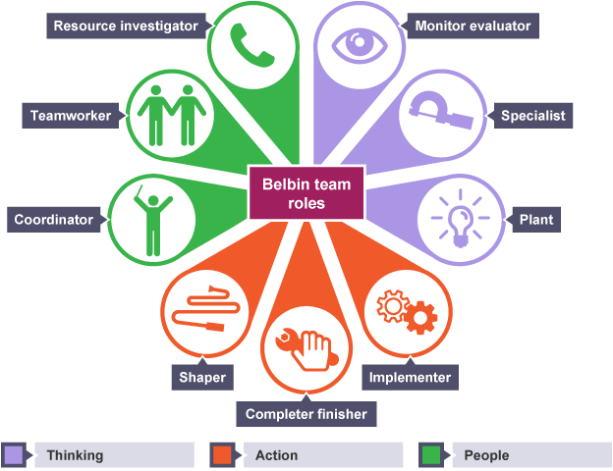
Figure 4: Belbin team roles
(Source - Belbin, 2012)
To improve their consumer reach, the marketers of the Adidas are using marketers share consumer insight, budgets so that they can make a real business impact on their consumers. Therefore, the staff of the Adidas works together in the team. To improve the performance of the team, Belbin team role behavioursare followed in Adidas, so that they can become a high performing team. There are nine clusters of behaviour, which are defined by Belbin in their Belbin team roles theory. Although some of the nine roles defined by the Belbin need to need nine different people to foster these roles. Maximum two or three people can accomplish the nine different roles of the Belbin most comfortably. However, all the roles have their significance, which is essential for managing and improving the performance of the people in the workplace. Nine different roles, which are defined by the Belbin, are Implementer, Co-ordinator, Shaper, Plant, Resource investigator, Monitor Evaluator, Team worker, Completer-finisher. In Adidas, this teamwork theory helps in creating awareness among the team members of the different teams and lead to the improvement of the performance. Besides this, it improves the relation between the employees and the subordinates. Teamwork enables the staff to accomplish the tasks more efficiently and quickly, along with this, it helps the individuals in tackling the different projects. Since, the Adidas follows collaborative working, which reduces the workloads of the employees and enables them to share the ideas and responsibilities at the workplace (Belbin, 2012).
Other than this, the division of work in Adidas reduces the pressure of work on the employees, which helps them in accomplishing the tasks and roles on time. Apart from this sharing of ideas at the workplace promotes creativity and enhances the productivity of the workplace. Apart from this, teamwork in Adidas provides an opportunity for the employees to establish their bond with the other people at the workplace. It helps in improving the relationships among these people. It also enhances the respect for each other at the workplace. Since the Belbin nine team roles are followed in Adidas therefore, it increases the accountability of all the members in the team. Accountability for work increases the productivity of the workforce of Adidas. Besides this, team members ensure that the teamwork must be conducted successfully along with this, they do not want to let each other down, which later leads to the success of the team. While in solo working, the situation is opposite and the pressure on the individuals is also high. With the support of their team, Adidas has become one among the largest country in the world.
Despite this, team working at the Adidas helps in accomplishing the tasks ahead of the deadline. For the new staff of Adidas, co-operative working is also helpful as they can learn new things and working patterns from the existing employees of the firm. In addition to this, various programs, which are organised by the Adidas for the community and their employees, all the working and responsibilities, are successfully performed by the diverse teams of Adidas. Moreover, Adidas promotes team working by engaging their employees in different sports activities such as tennis, football, volleyball etc. These games increase team spirit and teach them team working which helps in their professional career and the attainment of redesigned goals of the Adidas. Other than this, the teamwork at the workplace is successful only when appropriate leadership styles are adopted in the firm. However, in Adidas effective leadership styles are followed which helps in the effective completion of the work. Wisdoms of the team is represented by the team leader, which helps them in making realistic and competitive decisions for the firm (Mahembe and Engelbrecht, 2014).
Different teams in the organisation work on the pieces of a larger mission of the organisation. These larger goals are accomplished under the leader and the effectiveness of these goals are measured by the success of these goals, which is mainly the financial performance of the business. Therefore it is clear team works best when they have an effective skilled leader to direct or guide them. Teamwork also brings innovation at the Adidas, as for any work or program, several ideas come forwards while working in a team due to which the creativity and innovations at the workplace of Adidas are increased.
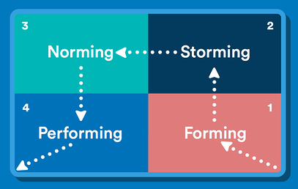
Figure 5: Tuckman team development theory
(Source - Natvig and Stark, 2016)
Apart from the Belbin team roles, the leaders of Adidas also follows Tuckman’s team development theory, which helps in the development of the team, prepares the members for facing the different challenges, supports them in tackling with the different problems, and also facilitates them with the effective solutions. Belbin team roles theory defines the roles of the different members of the teams similarly, on the other hand, the Tuckman team development theory determines the different stages which prepares the team for handling the multiple situations of a world-class organisation Adidas (Natvig and Stark, 2016).

PART 5-RADU NEATA
MOTIVATION AND PERCEPTION
The motivating environment offers growth possibilities for the firm. Motivation at the workplace helps in maintaining the healthy work-life balance and increases the productivity of the firm. Adidas encourages and promotes motivating working culture at the workplace so that the performance of the employees can be enhanced. Out of the numerous sports industries across the world, Adidas is one of the most successful and biggest organisations. Nowadays, most of the successful business firms are adopting motivational techniques to encourage their staff. The management of Adidas used to motivate their workforce through staff volunteering. Employee volunteering and involvement of the people in the various activities play an essential role in developing the working environment at the workplace. Engagement of people in the different activities of the Adidas will not only enhances the engagement but also the achievement of the objectives of Adidas. Volunteering promotes the spirit of teamwork, leadership and communication among the employees. Apart from this, it also helps in improving the decision-making of the staff of Adidas. Improvement in the communication amid the leaders, subordinates and higher authorities, which helps in gaining more commitment to the firm (Vallian, 2013).
Although the company Adidas is operating its business operations in approx. more than 100 countries of the world. Therefore, the overall number of people who acts as the volunteers for this motivation programme of Adidas is approx. 26,000 volunteer hours, which are donated by the workers of Adidas for the community work, which was started by the Adidas in approx. 22 countries. It was a sport-based program which was initiated by the Adidas known as “Ginga Social”. In this program, the volunteers (who are mainly the staff of Adidas) have to teach the values and life skills to the youth. The participants of this program are mainly the youth aged between the 7-17. This program of the Adidas was continued for the coming two years in the five cities that hosted the FIFA world cup 2014. These five countries are Sâo Paulo, Rio de Janeiro, Belo Horizonte, Porto Alegre and Salvador (Vallian, 2013).
Apart from volunteering, the Adidas is also adopting another motivational technique. According to another motivational technique adopted by the Adidas, the company has organised and initiated a childcare facility at the workplace. According to this program, the children of the staff will be taken care of. Simply, in other words, it is like a babysit for the children of the workers. This childcare facility has been developed at one location of Adidas, which is in Canton, USA, however, at the end of the year 2013, Adidas will develop another babysitting location which will be developed at headquarters of Adidas which is in Germany (Adidas Group, 2020). Besides this, the Adidas also facilitates its staff with safety needs. According to the safety needs programme of the Adidas, the staff of the industry were asked to attend the training course for the first aider. After attending this motivational programmer of the Adidas, the company get 165 first aiders at the workplace. Apart from this, Adidas also facilitates their employees with the online courses to meet the emergency needs such as the measures for fire safety, so that the ergonomics of the workplace can be improved.
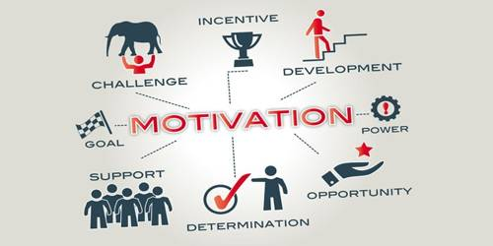
Figure 3: Motivational techniques
To develop the skills and talents of their employees the Adidas Company facilitates their workers with a variety of 120 classes and events, which is enough to motivate the staff. Other than this, the Adidas also offers its employees a wide range of sports activities, which the workforce can join to relax. The different sports activities offered by the company are Volleyball court, tennis court, football stadium along with the running track. Along with the flexible working hours and schedule, the staff also makes optimum use of the different facilities, which are offered by the Adidas. Moreover, Adidas also offers its workforce the restaurant service, which is known as stripes. These facilities are also the major motivating factor for the workforce of the Adidas. Flexible working, food, and sports activities reduce the burden of the staff and relax them.
According to the management of the Adidas group, managing the performance of the staff can also lead to the improvisation in the level of their motivation. Just like the other big organisations of the world, Adidas also believes that the workforce must be provided with the feedbacks, as making them realise their mistakes and appreciating them for their good deeds will boost their morale. Besides this, the interaction with the higher authorities during the feedback process will also help motivate the workers. Feedbacks helps the staff in improving their performance. In the year 212, the goals of the Adidas were redesigned, so that the goals of the company can support the ‘New Ways of Working’ principles. The main motive behind redesigning the goals is to provide better alignment and to bring simplicity in the working so that it can be easy for the teams and the workers to attain the goals of the Adidas. Despite simplifying the working, the Adidas group also provides rewards to their workers. There are different programmes under the reward system of the Adidas group such as Global Salary Management System. According to this system, the firm provides their staff salaries based on their performance and the market demand, other than this, the Adidas group also have a global bonus program which is known as "Aim 2 score", the profit-sharing program of the company is known as “Champion Bonus” etc. Apart from this the Adidas group also provides their employees with different insurance facilities such as health insurance, supplemental insurance etc. (Adidas Group, 2020).

REFERENCES
- Adidas 2020. Profile (Online) Available at https://www.adidas-group.com/en/group/profile/ last Accessed on 25th April 2020.
- Adidas Group, 2020. About Adidas. (Online) Available at: https://www.adidas-group.com/en/ last Accessed on 25th April 2020.
- Amankwaa, A., Gyensare, M. A., & Susomrith, P. (2019). Transformational leadership with innovative behaviour. Leadership & Organization Development Journal.
- Belbin, R.M., 2012. Team roles at work. Routledge.
- Mahembe, B. and Engelbrecht, A.S., 2014. The relationship between servant leadership, organisational citizenship behaviour and team effectiveness. SA Journal of Industrial Psychology, 40(1), pp.01-10.
- Mansouri, A. A. A., Singh, S. K., & Khan, M. (2018). Role of organisational culture, leadership and organisational citizenship behaviour on knowledge management. International Journal of Knowledge Management Studies, 9(2), 129-143.
- Natvig, D. and Stark, N.L., 2016. A project team analysis using Tuckman's model of small-group development. Journal of Nursing Education, 55(12), pp.675-681.
- Rieckmann, M. (2017). Education for sustainable development goals: Learning objectives. UNESCO Publishing.
- Schmitt, A., Den Hartog, D. N., & Belschak, F. D. (2016). Transformational leadership and proactive work behaviour: A moderated mediation model including work engagement and job strain. Journal of occupational and organizational psychology, 89(3), 588-610.
- Stacey, R. D. (2016). The chaos frontier: creative strategic control for business. Butterworth-Heinemann.
- Tang, V. (2018). Sloppy goals and objectives: Lethal to Strategy Implementation.
- Vaagaasar, A. L., Müller, R., & De Paoli, D. (2019). Project managers adjust their leadership: to workspace and project type. International Journal of Managing Projects in Business.
- Vallian, 2013. Motivation is All In ADIDAS. (Online) Available at: https://mcd1020adidas.wordpress.com/category/motivation/Last Accessed on 25th April 2020.
- Yuliansyah, Y., Gurd, B., & Mohamed, N. (2017). The significant of business strategy in improving organizational performance. Humanomics.
- Zaccaro, S. J., Dubrow, S., & Kolze, M. (2018). Leader traits and attributes.

APPENDICES
PRESENTATION SLIDES-
Slide 1

Slide 2
Slide 3

Slide 4

Slide 5

Slide 6

Slide 7

Slide 8

Slide 9

Slide 10

Slide 11

Slide 12

Slide 13

Slide 14

Slide 15
Slide 16

Slide 17

Slide 18

Slide 19

Slide 20

Slide 21

