My Creative Event Concept
  - Creative Events Design and Planning (BMBM4000)
The Creative Bubble Organisation gives students and other the opportunity to plan an event in an empty space. This offers them the chance to show off their work and skills for more recognition and achievement in a reasonable scenario. This report will explain a new event plan that is perfect for this scenario.

Contents Page

Executive Summary = Page 2
- Introduction = Page 2

- Main Findings = Page 2-4
  - Event Concept
  - Market Research
    - Secondary Research
    - Demographic Research
  - Operational Requirements
  - Resource Requirements

- Conclusion = Page 4-5
- References = Page 5
- Appendices = Page 6

Executive Summary
This report has underlined whether this event concept will work and how it can. It has examined the potential market it will be targeting and why it is thought that these targeted attendees would wish to come. Competition against the chosen event concept has been thought about but, adding a new material to an event will give this one a different view and experience compared to what is already out there. All income and budgets have been considered to ensure that the event can take place without falling into any debt issues.

Introduction
This will guide you through an idea of how a new aspiring event may work effectively in the free space of the Creative Bubble in Swansea. The Creative Bubble is an organisation which helps individuals/groups to plan and run an event in a free space to design however they like. This report will discuss a new idea for future use and after a lot of research, confirm whether it is the perfect place to hold and run this event to its full expectation. The main findings will cover how this event brings a new and diverse concept to this organisation; it will also be original as it will target the gap in the defined marketplace. And lastly, other approaches such as geographical location, financial costs and its attendees will be covered.

Main Headings
The Creative Bubble is an effective way for students to do what they want with their interests whether its to do with their degree/level, work experience or to generally grow their workflow and CV. There have been 300 students which have been directly involved in planning and running shop-based activities (Creative Bubble, 2020). Its history has been successful, which is the reason for examining this organisation for the event concept.
  - Event Concept
The event concept was thought about before any information on location or outlook of the building was known. What was thought to be done was a silent disco. This is where the public could come in and start their night out before going to popular hangouts such as Wind Street. Inside the venue will be dark but have multiple coloured lights around the room. Tickets would be bought for the event as the number of headphones would have to be known to be ordered in. Students will be permitted to bring their own alcohol but, there will be refreshments and snacks available inside.
Having a theme can be easily added into the venue also. Ideas such as different decades can be designed to compliment and connect with a disco feel. This can also be rather straightforward to do as the music choice can easily go with a decade’s theme as we would use that genre. The 60’s-90’s are now coming back into trend with the younger generation. Majority of the time other clubs will have songs from a while back playing which everyone knows the words to. The older students/guests will also connect with the genre as it was the songs that they grew up to and already know. ‘With a theme that is appreciated and understood, an event planner is more easily able to convey a message that will reach its audience and reason with the latter’ (OPC Evenements, 2018).
  - Market Research
The decision for a silent disco was made strategically for the known fact that Swansea has a busy nightlife for most of the nights in the whole week. Although there is already a lot of competition for nightclubs in the area, the idea is an innovative event design as it has added another element in nightlife by having headphones.

Barker (2016) states that you must connect with your audience before the event even happens. This means that using a social media can help get attendees excited for your event and keep their interests strong. Pek (2016) also suggests that being on social media can also help organisers identify the strengths and weaknesses of its competitors. Discovering what they lack can give you the answer of what gap you need to fill in that is missing in the industry.
Thinking strategically, the best place to promote the event is in Universities. Creating promotional materials with the information on the event and placing them around buildings where students will be most of the week will make it known what is going on and when. The event must be promoted in a way that shows off effectively how this concept is different; the charity we are raising money for will need to be shown and also add their purpose so that the students understand their work and the materials will have to show off that refreshments will be available inside the venue. Lastly, the most important element is stating the use of headphones throughout the night.
2.2.1 Secondary Research
The reason why the use of the building would be a good match with the event concept is because it can be designed however it is desired. Not much has to be added into the room to create a silent disco venue as it will be mainly dancefloor. O’Toole, W (2011) informs that the marketing mix is an important tool for the development of the event. It can help discover uncertainties or any strengths in the process. By focusing on the product, price, promotion, place and people the whole thing will mold together and answer all the questions. The reason for this is because this tool can manage risk due to working out any uncertainties with financial or physical priorities and a control mechanism as it will help fit every element of the design into desired results throughout.
2.2.2 Demographic Research
The design and facilities that are best for a silent disco vibe would best suit a rather younger to middle-aged audience. The best nights for this event to take place is a Wednesday, Friday or Saturday night as they are the busiest of nights out with students. Between Swansea University and University of Wales Trinity St David, there are 24,000 students studying in the local area (Swansea Council, 2018). The event will appeal to this demographic as students look for a relatively cheap and new event where they can go out and enjoy themselves in. Examining the demographics is key in this situation as we need to find the audience that need what we can give them (Leonard, 2019). And in this case, it’s a venue which has a new and fresh vibe for student’s social life.
Regarding its location, the Creative Bubble is walking distance away from the University of Wales Trinity Saint David’s in Swansea (Appendix 1) and its accommodations around it. Another plus about its location is the fact that it is still close to other nightlife. The reason why this is a good thing is because students like to jump from club to club therefore, when the event is finished, they won’t have hassle finding a way to their next destination.
2.3 Operational Requirements
An event cannot be planned without discovering the requirements of the operation. A great example of a plan which covers all these requirements has been depicted in Figure 7.1 by Getz, D and Page, S (2016). It states that the three foundations of the event to have a ‘unique, satisfying, memorable’ experience. Beginning with the setting. This classifies the location of the event and what the event design will look like, in this case it will be in the Creative Bubble and will have a colourful, exciting theme depending on which decade chosen. The people will be anyone that has any involvement with the event such as staff or extra help that are required to stand at the door for tickets and at the refreshments counter. And it also means the type of guests that will be joining the event which has been thought to be students. And lastly, management also is considered for the systems and services we inquire. Combining these three together will also show the “why?” to this event meaning, what is the point of this event, which is to bring a different vibe to the public that current nightclubs in Swansea are missing. A matching copy of the diagram can be seen in appendix 2.
To summarise, what needs to be done is purchasing props and furniture that gives the chosen decades feel. A counter for where the refreshments are getting sold must all be purchased and decorated with the theme. Depending on what can save us money but what keeps up the value, the refreshments will either be purchased from a warehouse in boxes or made by a chosen caterer which could also be another sponsor. A team also needs to be arranged to cover every aspect. This includes staff to create promotional materials, organisers to ensure that all physical materials are correct and delivered on time and any extra work we want done for the room such as a painter, electrician etc.
Placing certain members of the team into certain tasks will make a strong group performance. Having the correct people in the correct jobs will ensure that all tasks have been done most effectively. Strategic techniques will be used in the process to keep it professional and successful. The Management Centre (2020) has given an in-depth idea of roles and its specialties into perceptive and therefore, the Belbin technique will be used to figure out the events team.
2.4 Resource Requirements
The cost of the space may be free but there will be other costs that need to be covered. Considering having an area of income with this event, the way money is spent must be carefully analysed to maintain a high income. When buying props, technology and lighting, refreshments and furniture it must come to a rather reasonable cost. The actual entry costs to the event will want to be kept to a minimum for preventing any disagreements from the guests. But it must be high enough to regain the money spent on the event and to make a profit. Martin Lewis OBE (2020) suggests using the Piggybank Technique when it comes to budgeting. It states that all areas need to be selected and the amount that is willing to be spent on in them. Splitting the money in different sections can cover everything that is needed to be purchase with the highest amount that can be used.
A major cost structure will have to be thought about in the planning process of the event. The way this will work is by pointing out the elements that are the most crucial yet beneficial. It is best to look into the most expensive elements first but then, it must be thought about whether you are going to be cost-driven or whether you are going to look more into the value (upcounsel, 2020).
A way that was thought about to increase income in a more personal way is by working with a charity, changing the event into a fundraiser. What is meant by personal is the fact that the customers may be already supporting the charity and has a passion for what the charity does. Also, sponsors are worth it when it comes to fundraisers as they add value to your image and is beneficial to your market and promotions (Paquet, n.d). It will be the perfect way to get promoted as the sponsors this event has chosen will have to promote them which will then reach to their audience.

Conclusion
To therefore conclude on this event concept, the event will be more successful if it takes place on one of Swansea’s busiest nights. It is thought that geographically, the building is in a good place which is surrounded by different student accommodations and is walking distance away from Wind Street. The Creative Bubble is a very effective way for a student to use their full capabilities to put their strengths to the test when planning. It gives them that starter point that can tend to be rather difficult achieving as a beginner therefore, planning an event there can begin a young entrepreneur’s ideas.
Therefore, having a silent disco can be successful in the creative bubble as many would want to see what the event is about as it would be unique in Swansea. The area has a huge nightlife and students are always up for trying new places and activities. This event could be a success due to the facts that students want to try something new, the fundraiser could be an easy way for the attendees to help out and they will enjoy when doing it.

References
Barker, H. (2016). ‘How to Beat Your Event Competition in 5 Easy Steps’. [blog]. May 4. Available at: https://www.eventmanagerblog.com/beat-your-event-competition (Accessed: 13/03/20).
Creative Bubble, (2020). Creative Bubble. “A year of Creative Bubble Data”. Issue 4. p. 3.
Getz, D and Page, S. (2016) Event Studies. Theory, research and policy for planned events. 3rd edn. Abingdon: Milton Park. Routledge.
Leonard, K (2019). The Importance of Demographics to Marketing. Available at: https://smallbusiness.chron.com/importance-demographics-marketing-25365.html (Accessed: 12/03/20).
Lewis, M. (2020). The Budget Planner. Available at: https://www.moneysavingexpert.com/banking/Budget-planning/#piggybanking (Accessed: 11/03/20).
OPC Evenements, (2018). The Importance of the Theme in Event Planning. Available at: https://opcevenements.com/en/event/ (Accessed: 11/03/20).
O’Toole, W. (2011). Events feasibility and development from strategy to operations. 3rd edn. Amsterdam: Butterworth-Heinemann.
Paquet, M. (n.d). ‘Nonprofit Fundraising, Part 3: How to Get Sponsors for Your Event’. Constant Contact. [blog]. n.d. Available at: https://blogs.constantcontact.com/successful-nonprofit-fundraising-event-getting-sponsors/ (Accessed: 13/03/20).
Pek, C. (2016). ‘The Latest Event Industry Insights’. How to Stay Ahead of the Competition in the Events Industry. [blog]. May 31. Available at: https://www.gevme.com/blog/how-to-stay-ahead-of-the-competition-in-the-events-industry/ (Accessed: 12/03/20).
Swansea Council, (2018). Key facts and Figures about Swansea. Available at: https://www.swansea.gov.uk/businessfactsandfigures (Accessed: 04/03/20).
The Management Centre, (2020). High performing teams: Belbin’s team roles. Available at: https://www.managementcentre.co.uk/high-performing-teams-belbins-team-roles/ (Accessed:13/03/20).
Upcounsel, (2020). Cost Structure Example Startup: Everything You Need to Know. Available at: https://www.upcounsel.com/cost-structure-example-startup (Accessed: 13/03/20).

Appendices
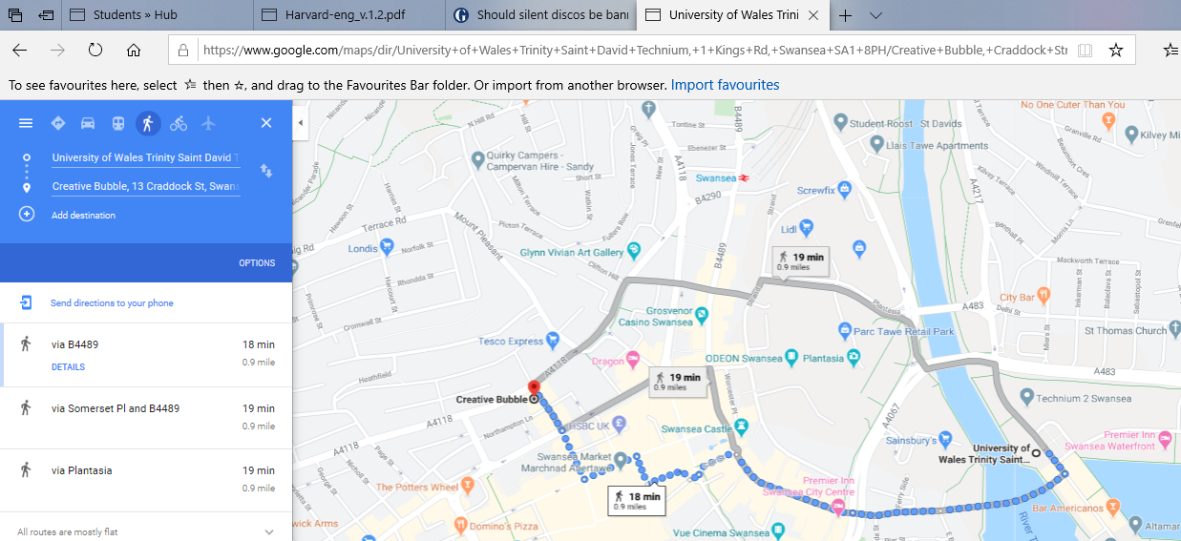
Appendix 1

Directions from University of Wales Trinity Saint David to the Creative Bubble (Google Maps).
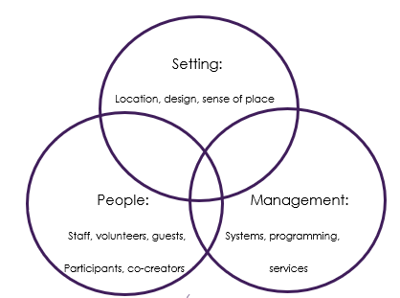
Appendix 2

Figure 7.1 Foundations of event design (Getz, D and Page, S, 2016).

