William Taylor Durban - 2218327
Materials and Introduction to Processes Assignment

Summary

A few different experiments have been carried out to collect data to be used to identify the Young's modulus and ultimate tensile strength of an elastomer material, in this instance an elastic band. The findings of this experiment have been represented by a stress/strain graph.
Other material characteristics were also tested, such creep, hysteresis and fatigue to see how the material properties behave under different loads and in different environments.

The data that was collected and the values that were calculated have been compared to scientifically recognised theories and align with the patterns that would be expected for an elastomer material (an elastic band in this instance).
The experiment has been evaluated and critiqued so that recommendations can be made for when the experiment is repeated, suggestions have also been made for upgrading equipment to minimise errors and increase the reliability of future results.

Introduction

Through the means of simple experiments, the effects of stretching an elastic band will be recorded and used to identify key properties such as the Young’s modulus, the ultimate tensile strength, creep, hysteresis and fatigue.
Displaying all the data in stress/strain graphs will help to show some of the material properties and the research of elastomer structures of elastomers will help to explain some of these material properties.

The Young’s modulus, or modulus, refers to the materials resistance to changing length under longitudinal tension or compression and is equal to the longitudinal stress divided by the strain (Britannica, 2022).
This value is hugely important in material selection situations where the important characteristic is how a material acts under tension/compression and whether stretching is a desired property; for example, selecting a material for a climbing rope compared to for a support for a bridge.

Another property that will be identified will be the ultimate tensile strength (UTS), this is the maximum tensile force that the material can withstand before failure. Often confused with the UTS is the yield point, this similarly is a measure of how much force a material can withstand in tension, but to the point of plastic deformation, instead of failure. Plastic deformation is where the material is stretched outside of the elastic zone – where it can return to its original length once the stress has been removed – instead, in the plastic region the material cannot return to its original length (thegundcompany, 2022).

Hysteresis is another material trait that will be investigated in one of the experiments. This characteristic explains the variation in how a material stretches (in the elastic region) compared to how it retracts. (pennyroyalresearch, 2017).

There are two other properties that will be tested, these are creep and fatigue. Creep is when a material, such as a rubber band continually lengthens when under tension for a long period of time (metalsupermarkets, 2019). Fatigue explains the number of times a material can be cycled - in this experiment loaded and unloaded with the same mass - until it breaks (comsol, 2017).
All the above material characteristics are some of the most important when discussing rubber. Compared to many other solid materials, rubbers have unique properties of elasticity that are different to other materials. These characteristics are due to the structure of elastomers, elastomers are built up in long chains of monomers (polymers), that without tension are arranged in an unorganized coil like states. When tension is applied these coils have the ability to unravel and extend, allowing for the material to stretch. Once the force is removed the polymer chains can return to their original state, this elastic trait of the polymers is where the term elastomer derives from (Britannica, 2019).

Experimental Method
The set up for the experiment involves a bike stand holding a carabiner that hangs the elastic band. From this elastic band another carabiner is hung and is attached to a container. This container is where the mass can be added to stretch the elastic band.
A vernier callipers will be used to measure the cross-sectional area and the original length of the elastic band before the experiment begins, throughout the experiment the length of the elastic band will be measured using a tape measure. It is important to remember that as an elastic band is being used the cross-sectional area must be doubled (for each side of the band).
Figure 1 shows the set up of the bike stand. Figure 2 shows the carabiner.

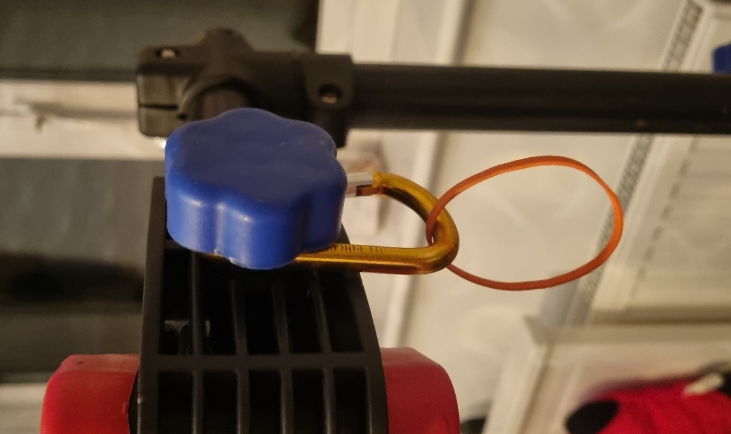


Figure 1 Figure 2
Below is an image showing the experiment in the set-up position, with the container hanging on the elastic band and the weighed out 100g masses ready to be loaded into the container. Figure 3 and 4.

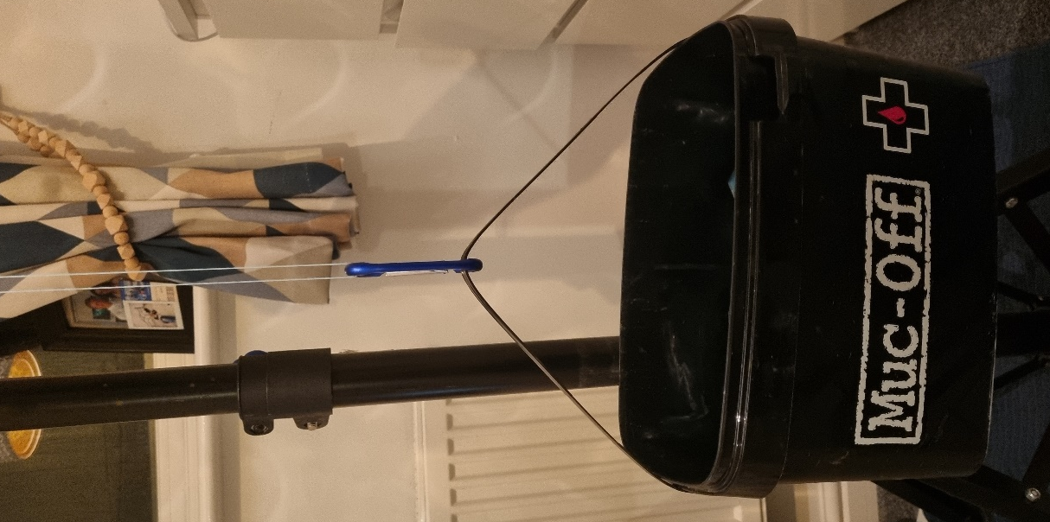
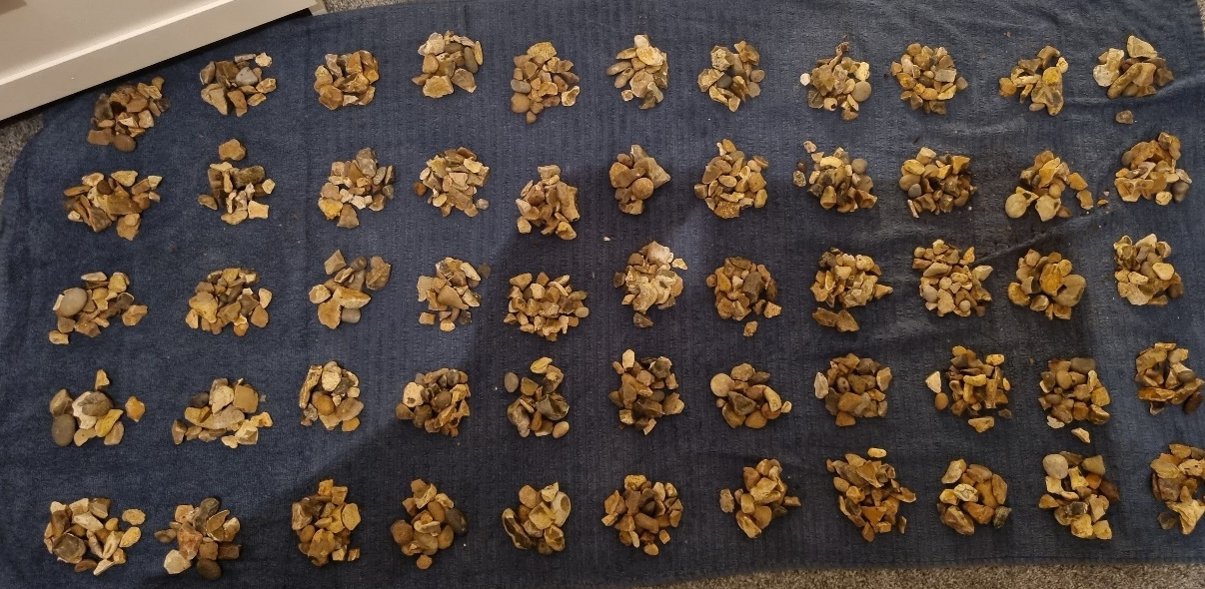

Figure 3 Figure 4

Young’s Modulus Test
For this experiment the length of the elastic band will be measured approximately 15 seconds after the weight has been added to allow for the elastic band and mass’ movement to stabilise, the mass will be added in 100g increments, every 30 seconds, until the band snaps.
This experiment was completed a few times before the recorded experiment to try and identify and reduce the number of mistakes and errors in the final test, hopefully this will increase the chances of obtaining reputable data. The increment in mass to be added each time as well as the time to wait before measuring the band was also determined from these pre-run practice experiments.

Hysteresis Test
This experiment will follow the same structure but with 500g masses, however, this time it will only be added up to 2.5 kg. Once the mass gets to 2.5kg the masses will be removed with the same timings. This experiment should produce results that will help to clearly demonstrate the principle of hysteresis of a material.

Creep
This test will be done by only adding 500g to the elastic band and measuring the length of the band over 24 hours, measurements will be taken as frequently as they can be to try and collect enough data to support the pattern of creep.

Fatigue
The elastic band set up will be the same as in previous tests but now the container will be loaded with a set mass and the weight lowered and raised every 20 seconds. The number of times this can be done before the band breaks will be counted and the experiment repeated a few times with different masses.
Experimental Findings
Young’s Modulus Test
The data from the experiment can be seen in the table below (figure 5). The data has been converted back into its standard SI units so all future calculations can be clearer.
Figure 5
From this data the values for engineering stress and strain can be calculated using the formula shown below:
Stress = Force / Cross sectional area
Strain = Change in length / original length
Engineering ToolBox, (2005).
The values for both stress and strain are shown in the table on the right (figure 6).

The calculations to find these are as follows:

Strain
- Stretched length – original length to find the change in length.
- Divide this by the original length to find the strain.

Stress
- Multiple the mass by gravity (9.81) to obtain the force.
- Divide by the cross-sectional area.
- Divide the answer by 1,000,000 to set into MN instead of N.

Figure 6
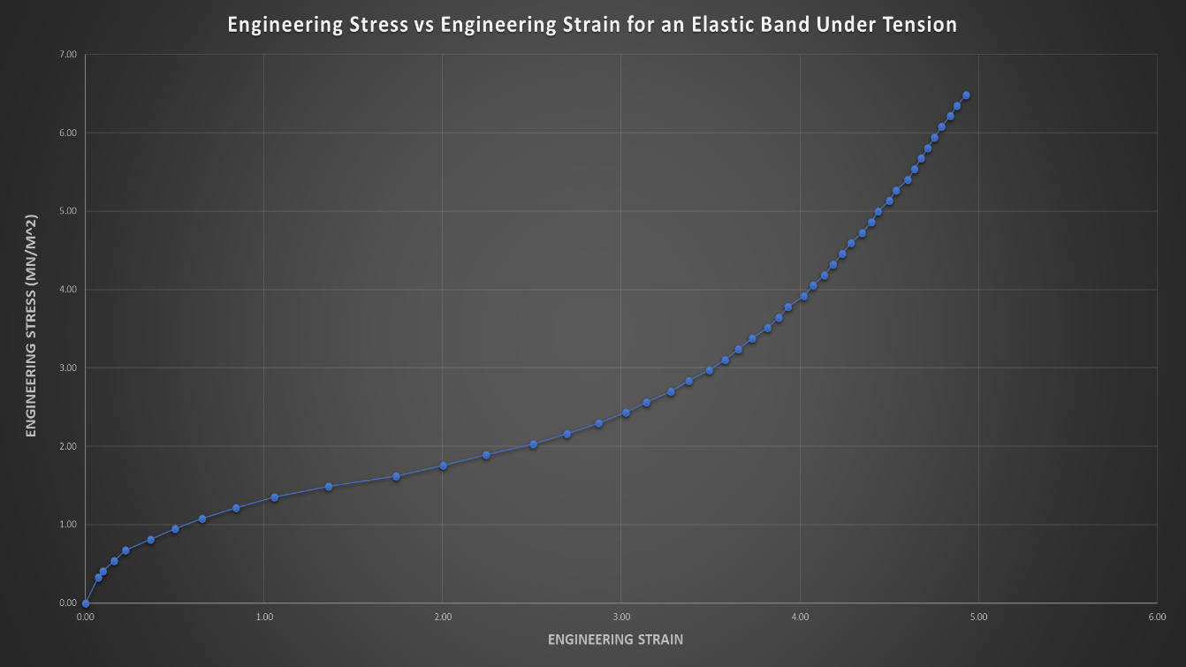
The calculated values for the engineering stress and strain where then used to produce the graph shown below (figure 7).
Figure 7

As can be seen in the graph (figure 7) there is a clear outline of how much the rate of extension changes throughout the tension. Initially it can be seen that the first few 100g weights cause a very linear stretch, the band then reaches its yield point and begins to stretch more easily, requiring less force. Gradually the band stiffens and stretches less and less before snapping, this is where the line stops, this is the UTS of the band.

Before continuing to use the data in other calculations the engineering stress and strain must be converted into true stress and strain, this is done using the equations shown in figure 8.
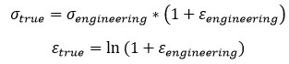

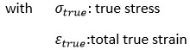
Figure 8 (Simoleon, 2017)
The reason that true stress / strain is used is to account for the change in cross sectional area of a sample during deformation. As stated by msestudent, 2022;

“When deforming a sample, engineering stress simplifies by neglecting cross-sectional change. True stress correctly accounts for the changing cross-sectional area.”

With the values converted into their true stress and strain equivalents (as seen in figure 9) a new graph can be produced (see figure 10). From this graph the materials UTS and the Young’s modulus can be found.

Figure 9
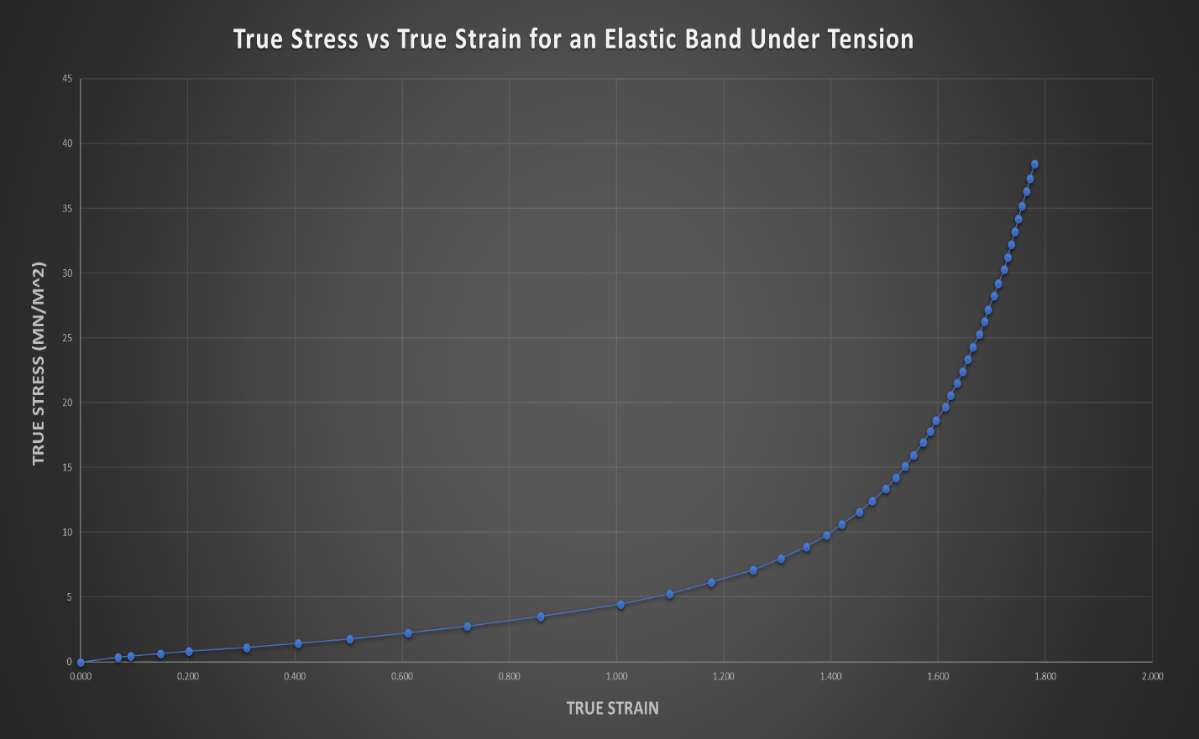
Figure 10
Using the true stress and strain values the Young’s modulus can be calculated from the initial stretch of the elastic band under load.
In this case, using figure 9; strain = 0.070 and stress = 0.356
Using the Young’s modulus equation; Young’s modulus = stress / strain
Britannica, 2022
Therefore, Young’s modulus = 0.356 / 0.070 = 5.086 MN/m^2 (3dp)
Reading from the table/graph the UTS of the elastic band is 38.447 MN/m^2 (3dp)

In many engineering situations the engineering stress and strain values would be used for calculating both the Young’s modulus and the UTS. Based upon this experiment these would be:
Young’s modulus = stress / strain = 0.332 / 0.072 = 4.611 MN/m^2 (3dp)
UTS = 6.485 MN/m^2 (3dp)
This comparison shows the difference it makes when using the true stress and true strain values when wanting to consider the change in cross sectional area.

Hysteresis Test
The results from this experiment can be seen in Figure 11 and 12.
Figure 11 Figure 12

This data has then been used to create the graph shown in figure 13.
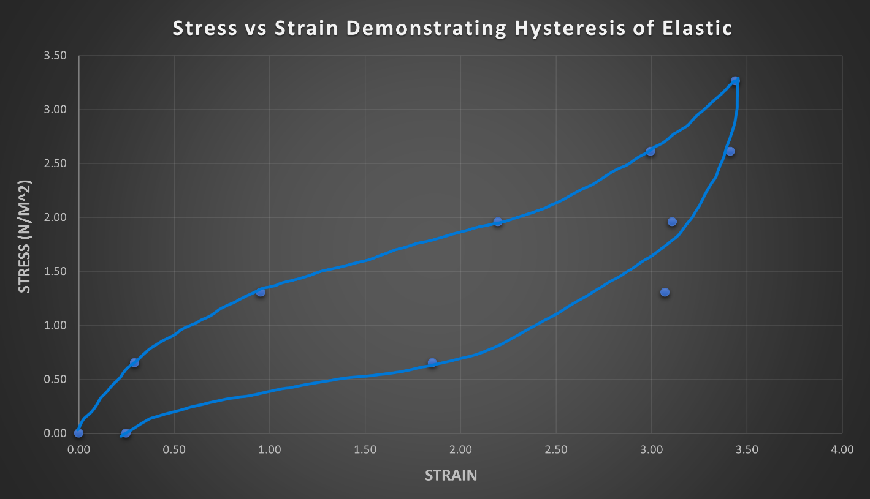
Figure 13
As can be seen in the graph, the force loading curve (the top curve) acts the same as in the other experiments, however, on the unloading curve (the bottom curve) it can be seen that the elastic band is ‘slow’ to contract back to its original displaced length when under the same force. This variation explains the energy that is used to overcome the resistance in the band and get the polymer chains to begin moving; something that is not a factor when the elastic band is returning to its original length when the tension is lowered.
Fatigue
The results from the fatigue test can be seen in Figure 14.
Figure 14

This data was then used to produce the graph below (figure 15).

Figure 15.

As can be seen in the graph (figure 15) the number of cycles/times that the band has been loaded and unloaded with the mass is hugely dependent on the mass itself. It can be noticed that small difference in the mass can make a huge difference to when the elastic band will fatigue and fail. For example, reducing the mass from approximately 2.35kg to 2.1kg is enough to increase the number of cycles before fatigue failure by 10. This ratio increases drastically, with the drop from 2kg to 1.5kg increasing the potential number of cycles before fatigue failure from 26 to 53. As the line would progress (if more experiments were to be done with less mass) there would likely be a point known as the fatigue limit, this is the point where the material can be loaded and unloaded with a mass below the fatigue limit for a theoretical infinite number of times without fatigue failure.

Creep
An elastic band set up with a small mass, 500g, produced the following results. (see Figure 16).

Figure 16

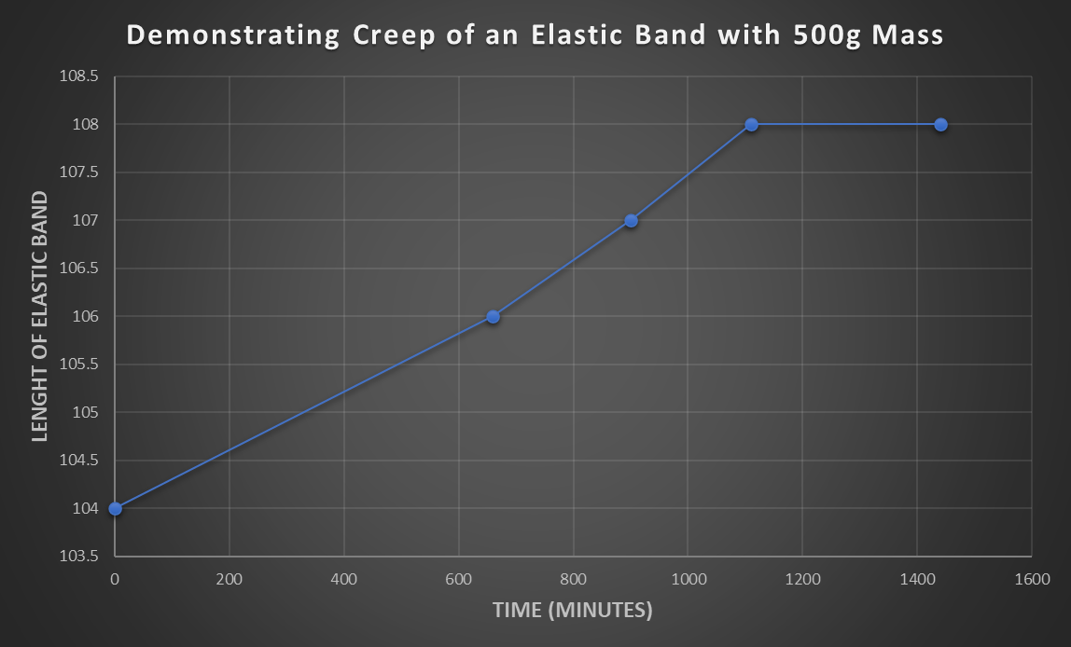
Figure 17
The line in the graph (figure 17) shows how over time the material slowly deforms and stretches despite no extra mass being added. Creep, such as in this instance is a very common failure cause for materials and so material creep can greatly influence what material is chosen for a situation.

Critical Analysis of the Experimental Method
Although the experiment obtained results that reflect the theories for elastomers under tension there were a lot of errors and inaccuracies in the method that will have affected the reliability and scientific credit that the experiment holds.
Some of the key issues that have been identified include:
- Compound error in weighing the masses, as the scales measured to 1g resolution there is a large chance of compound error as the weight was added 100g at a time.
- There was a large variation in the dimensions of each elastic band, this meant that the different experiments could not be compared accurately and repeat experiments could not be used to get average results.
- The space that the experiment took place was the same throughout and was dry, out of direct sunlight and in stable temperature conditions, however, there is no guarantee that small changes in the environment would have affected the elastic bands behaviour.
- Although the mass was added gently, and the container controlled each time there was still some bounce in the elastic band that may have caused weaknesses/fatigue.
- Despite best efforts the stretch of the elastic band could not always be read at the exact same time after the mass was added, this leaves room for creep in the elastic band to occur distorting the true reading.
- When reading the tape measure to see the stretch there was a large risk of parallax error, the 1mm resolution of the tape measure also makes it very easy to be 1+mm out when reading the stretch.
If the experiment were to be repeated the key factors to improve upon would be accurately weighing the masses, and a better means of reading the stretch each time. It would also be beneficial to find elastic bands that have much higher quality control and so are all of a similar starting size to limit variation.
If the budget for the experiment were to be increased, then the quality of the data would be improved as well as the opportunity for extra experiments to be completed. For example, soaking the elastic band in a hydrogen peroxide to see how the oxidation of the rubber effects the results, exposing some of the bands to varying amounts of concentrated UV light to see how UV degradation of rubber would influence the data. Even simply changing and controlling the temperature would show a change in how much the elastic band stretches as well as the modulus and UTS of the band.

Conclusion
Despite the small budget and small time scale for this experiment the results show that they were successful in demonstrating the patterns/finding results for multiple different material properties, such as the Young’s modulus, UTS, hysteresis curve, creep, and fatigue. The results seem to have minimal anomalies, which suggest that the data is reliable. However, if the results were going to be used it would be recommended for considerably more time and money to be spend setting up a more reputable experiment with high quality and more accurate instruments in order to obtain more reliable and repeatable results.

References
Britannica, 2022. Young’s modulus. [online] Available at: https://www.britannica.com/science/Youngs-modulus [Accessed 09.11.22].
thegundcompany, 2022. Understanding Tensile Strength. [online] Available at: https://thegundcompany.com/understanding-tensile-strength#:~:text=Ultimate%20tensile%20strength%20(UTS)%2C,yield%20point%20have%20been%20reached. [Accessed 09.11.22].
pennyroyalresearch, 2017. Hysteresis of Rubber Bands. [online] Available at: https://pennyroyalresearch.wordpress.com/2017/01/05/hysteresis-of-rubber-bands/ [Accessed on 10.11.22].
metalsupermarkets, 2019. What is Creep? [online] Available at: https://www.metalsupermarkets.co.uk/what-is-creep/ [Accessed on 10.11.22].
comsol, 2017. What Is Material Fatigue? [online] Available at: https://www.comsol.com/multiphysics/material-fatigue [Accessed on 10.11.22].
Britannica, 2019. Elastomer. [online] Available at: https://www.britannica.com/science/elastomer [Accessed on 12.11.22]
Engineering ToolBox, 2005. Stress, Strain and Young's Modulus. [online] Available at:
https://www.engineeringtoolbox.com/stress-strain-d_950.html [Accessed 09.11.22].
Simoleon, 2017. Converting Engineering Stress-Strain to True Stress-Strain in Abaqus. [online] Available at: https://info.simuleon.com/blog/converting-engineering-stress-strain-to-true-stress-strain-in-abaqus [Accessed on 11.11.22].
msestudent, 2022. True Stress-Strain vs Engineering Stress-Strain. [online] Available at: https://msestudent.com/true-stress-strain-vs-engineering-stress-strain/ [Accessed on 11.11.22].

Images
Figure 1 – Image showing the experiment set up of the bike stand.
Figure 2 – Image showing the carabiner hooked onto the bike stand.
Figure 3 – Image showing the container hanging on the elastic band set up.
Figure 4 – Image showing the pre-weighed 100g weights ready for the experiment.
Figure 5 – The data collected from the young’s modulus experiment.
Figure 6 – Table of the engineering stress and strain from the young’s modulus experiment.
Figure 7 – Engineering stress and strain graph from young’s modulus experiment.
Figure 8 – True stress and strain calculations
Figure 9 – True stress and strain values from the young’s modulus experiment.
Figure 10 – True stress and strain graph from the young’s modulus experiment.
Figure 11 – Data taken from the results of the hysteresis experiment.
Figure 12 – Information processed from the data collected in the hysteresis experiment.
Figure 13 – Graph created from the data collected from the hysteresis experiment.
Figure 14 – Table showing the data count from the Fatigue experiment.
Figure 15 – Graph of the fatigue curve of the elastic band.
Figure 16 – Table showing the data collected from the creep experiment.
Figure 17 – Graph generated from the data in figure 16 for the creep experiment.

