Report for Data Handling & Business Intelligence Assignment 2 2019 – Data Analytics

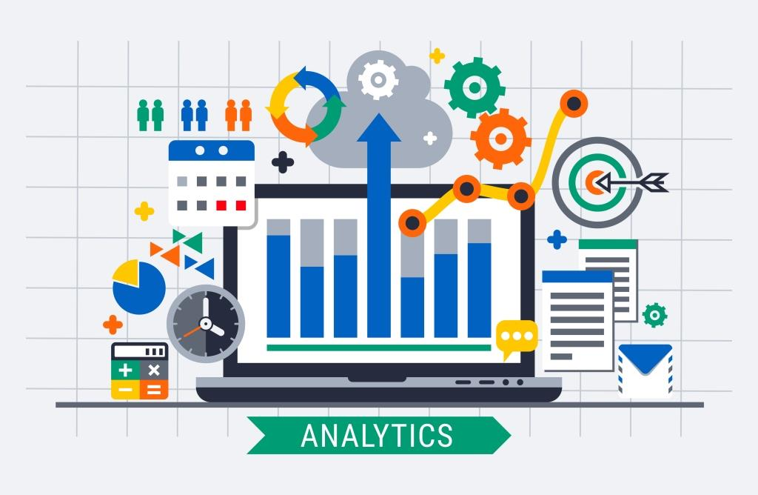
May 2019
MODULE NAME: Data handling & business intelligence
Name: Ryan price
Student Number: p152137/1651240
Table of Contents
1. eXECUTIVE sUMMARY 3
2. Introduction 4
2.1 Report Remit 4
2.2 Strengths and weaknesses of using excel to pre-process, analyse and visualise data 4
2.3 why sarn helen stationery should use excel for decision making 5
2.4 Main data mining approaches 8
2.5 evaluation of how data mining approaches would be relevant for sarn helen stationery 12
2.6 Weka 14
2.7 Conclusion 14
3. References 16

eXECUTIVE sUMMARY
The purpose of this report is to conduct a critical analyses of spreadsheet software MS Excel identifying strengths and weaknesses and why organisations such as Sarn Helen Stationery should use spreadsheet software for decision making purposes. It was found that using Excel to pre-process, analysing and visualising data held many benefits and these were; use of formulas to undertake difficult calculations, pre-set functions, ability to edit pre-existing data, graphical displays
Some disadvantages of using excel were also identified and these were; Time consuming, only good for one-time analysis, scope for human error.
The report then discusses how Excel can improve decision making at Sarn Helen Supplies. It identifies that using Excel’s power techniques such as IF function, VLOOKUP, Pivot tables and charts and graphs that Sarn Helen Supplies could enhance their decision-making process based on actionable data.
Part two of the report discusses data mining approaches such as Prediction, Clustering and Association. It drives on to discuss the strengths and weaknesses of data mining which were; gaining competitive advantage, ability to predict future trends, improved customer optimization etc. The report also identifies weaknesses of data mining these were; privacy issues, online security threats and difficulty to use.
After this, there is an introduction to Weka which is an open source data mining application that contains tools for data preparation, classification, regression clustering, association rules mining and visualisation. (CS Waikato, 2019)

Introduction

Report Remit
The purpose of this report is to evaluate the strengths and weaknesses of using spreadsheet software such as Excel to pre-process, analyse and visualise data and how a company named Sarn Helen Stationery could benefit from using Excel. The report will then discuss the various data mining approaches particularly prediction, association and clustering. The report will finish by evaluating how data mining is relevant to company’s such as Sarn Helen Stationery.

Strengths and weaknesses of using excel to pre-process, analyse and visualise data
Data Handling is a common frustration amongst business owners. Using spreadsheet software such as Microsoft excel a business owner can begin to understand the data that has been captured. Microsoft Excel used correctly can be a useful application and has benefits.
Formulas are usually hailed as the best part of Excel and they allow the user to process calculations to manipulate the data in ways that would not be able to be done without the use of formulas. Common Excel functions include; VLOOKUP, IF statement, arithmetic calculations, counting and transforming data items. Excel also provides pre-set functions, instead of having to remember or to save time Excel offers a range of pre-set functions such as sums and percentages. (Cook, 2016)
A major advantage of using Excel is the ability to edit pre-existing spreadsheets. For example, there could be a cell in a spreadsheet that performs a calculation using the values from other cells. If you then update the values in these other cells, the result is the formula cell updates as well. For this reason, spreadsheets offer a way to carry out continual analyses and calculations on your data sets automatically. (Fish, 2016)
Excel can transform data into various types of graphical displays. Using the charts section provides the ability to present a data set within a chart or graph. This allows users to visualize and communicate their data sets within presentations. Visualizing data in this way can help to understand the data and inform future planning decisions. (Fish, 2016)
Although Excel has its benefits when using it to pre-process, analysing and visualising data, just like everything, it has its weaknesses.
Microsoft Excel can be time consuming when entering the data manually it can be time consuming. ‘Research from Ventana indicates that spreadsheet users spend on average 12 hours per month updating, revising, consolidating, modifying, and correcting spreadsheets.’ (ContractLogix, 2019)
Some people find using a spreadsheet difficult to analyse. It becomes problematic as the data grows and emerge over time. As new rows and columns get added or new ones created, the data and the formulas are not consistently updated. These mistakes lead to poor results and wrong decisions. (Soffar, 2015)
MS Excel has a huge scope for human error. ‘During the 2012 London Olympics a data entry error into a spreadsheet of 20,000 instead of 10,000 for the number of available event tickets caused major mayhem. With ticket prices ranging from £20 to £75, this is a mistake cost between £20,000 to £75,000.’ (ContractLogix, 2019) Small businesses such as Sarn Helen Stationery wouldn’t be able to recover from such mistakes.

why sarn helen stationery should use excel for decision making
The main decision-making benefit from using MS Excel comes when businesses identify what is actionable and meaningful data. Sarn Helen Stationery could use the data collected on MS Excel to identify the most profitable regions or product, both of which are meaningful and actionable data.
Sarn Helen Stationery could use IF statements, VLOOKUP, pivot tables and charts and graphs to improve their decision-making process.
(Kaul, 2018) suggests that using the IF statement on Excel, Sarn Helen Stationery can check for any condition on their raw data. For example, they could check the condition of profit per product. If the product makes a profit it could be viewed as ‘TRUE’ or, ‘FALSE’ if the product is making a loss.
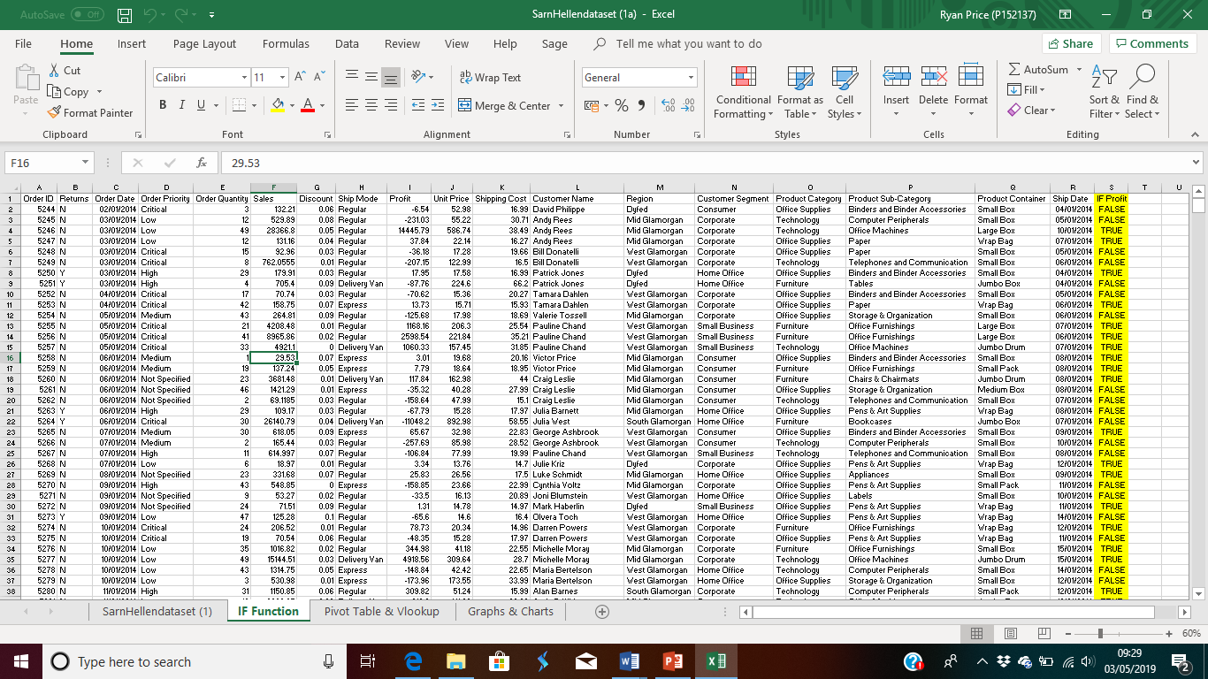
This is an example of using the IF function using the Sarn Helen data set. Highlighted in yellow is the IF function that is identifying whether given products have made a profit or not.
Excel also hosts a function named ‘VLOOKUP’ which retrieves information from a database/list based on a supplied instance of the unique identifier. (Heddings, 2016) implies that this can be helpful for Sarn Helen Stationery when deciphering data as it makes syphoning through thousands of rows and columns an instant process.
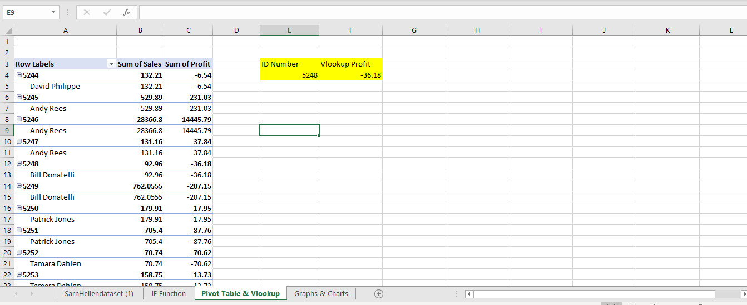
Here is an example using Sarn Helen Data to conduct a VLOOKUP via profit per ID number. In this example it shows that order number 5248 is making a loss.
Pivot tables are a common use of MS Excel to improve decision making. It ‘uses data organized on two dimensions to create a three-dimensional table. It represents a very proper means to concentrate a lot of information in a small space. The unique characteristic of pivot tables is their capacity to move fields by drag and drop. Excel instantaneously replaces the data in a new arrangement. New formulae or the re-filtering of data are not necessary, as the pivot table is automatically recalculated when the fields are recalculated’ (Mihãlcescu, 2013). 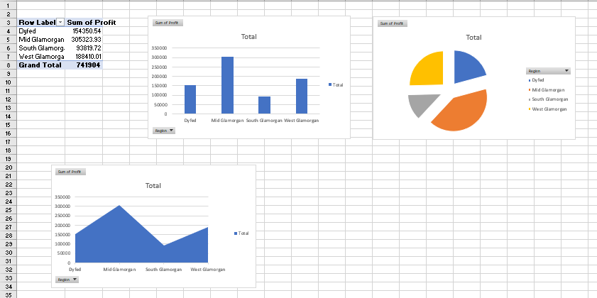
The graphs are used to visually represent the ‘profit by region’. The region and sum of profit table was created using the pivot table option on excel and using the data from this pivot table graphs were created. From the finding of ‘profit per region’ graphs it is evident to see that South Glamorgan region is performing the worst. Using this information Sarn Helen Stationery could increase their marketing budget in that region to promote sales thus increasing profits.

Main data mining approaches
Data mining is a process that involves decoding mass amounts of information to generate new information. Data mining is about extrapolating patterns and new knowledge from the data that has already been collected. (Alton, 2017)
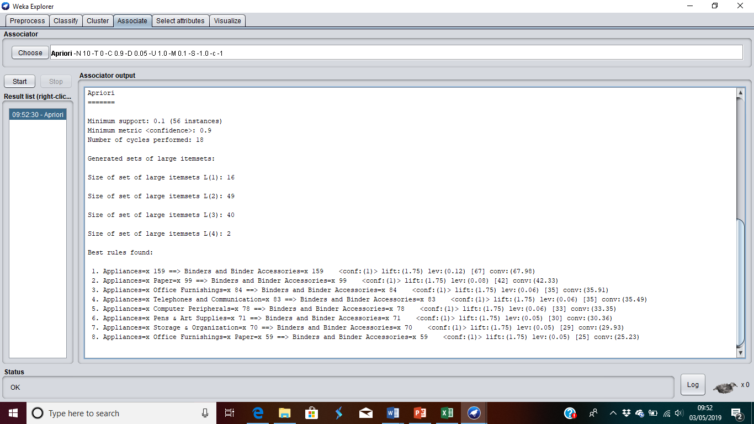
Association is usually what’s used to populate “people also bought” sections of online stores. This is done by tracking patterns, but it is more specific to linked variables. This approach will look for specific events or attributes that are correlated with another. In the “people also bought” example, the data results might notice that when customers buy a specific item, they also often buy a second, related item. (EDUCBA, 2018)
Using the association function ‘Apriori’ it was evident to see which products were regularly bought together. In this example, when purchasing appliances customers are likely to buy binders and binder accessories.
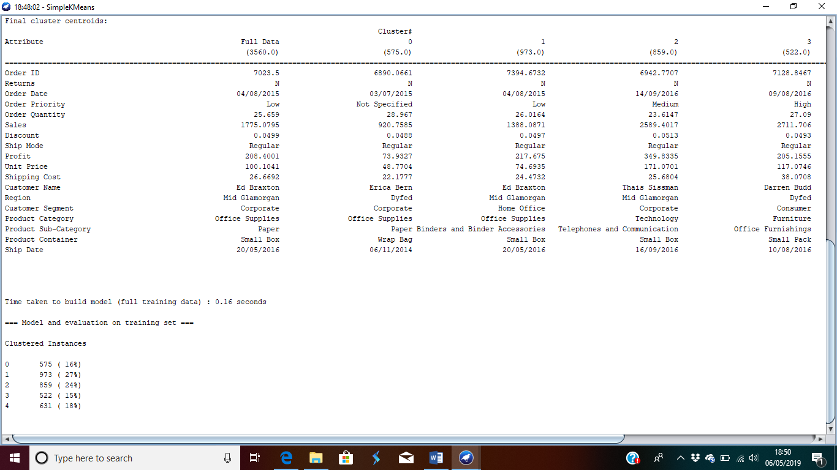
Clustering is the approach that groups together chunks of data based on similarities within the data. Some of the most popular application of clustering are; recommendation engines, market segmentation, social network analysis. Below is a ‘SimpleKMeans’ cluster function with the Sarn Helen data set;

‘Prediction is one of the most valuable data mining techniques, since it’s used to project the types of data you’ll see in the future. In many cases, just recognizing and understanding historical trends is enough to chart a somewhat accurate prediction of what will happen in the future. For example, reviewing consumers’ credit histories and past purchases to predict whether they’ll be a credit risk in the future.’ (Alton, 2017)
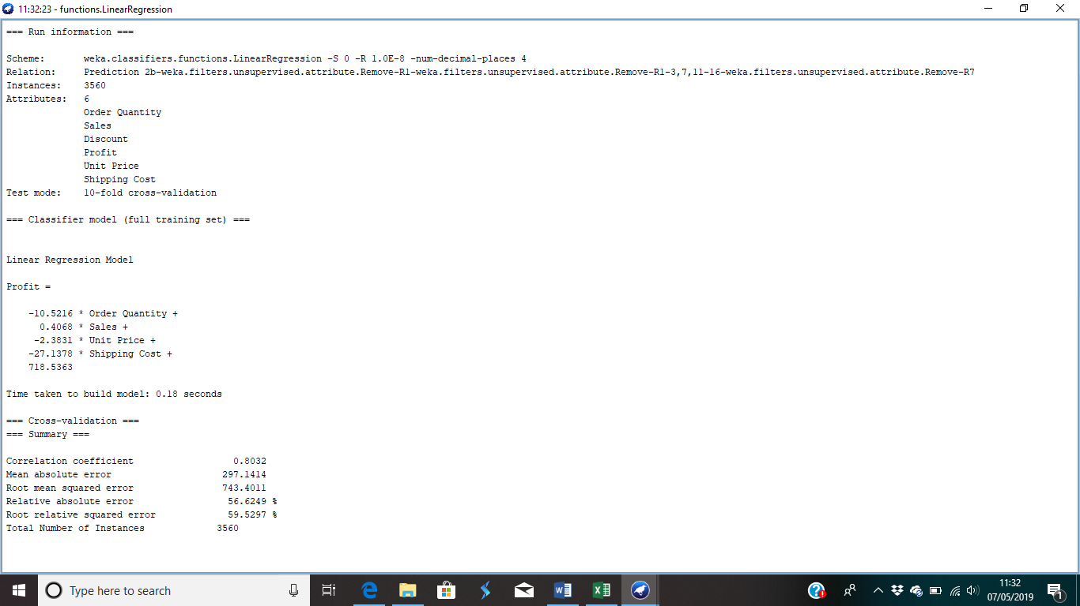
The classification tab on Weka is used for prediction functions. Using the LinearRegression function this was mined;
The results of this data are not clear and therefore not the best for Sarn Helen Stationery to use in the future.

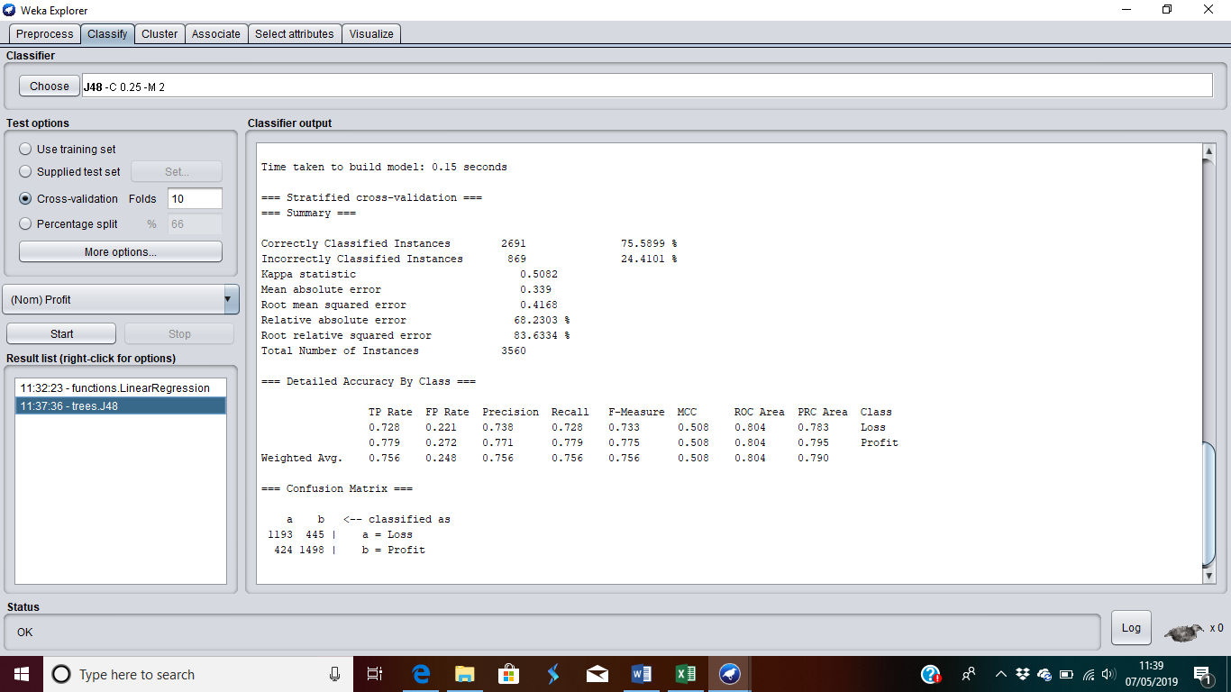
Another classification function on Weka is J48. This creates a decision tree based on the data. The results from the J48 function are only 75% accurate in this example and therefore should be used with caution by Sarn Helen Stationery.
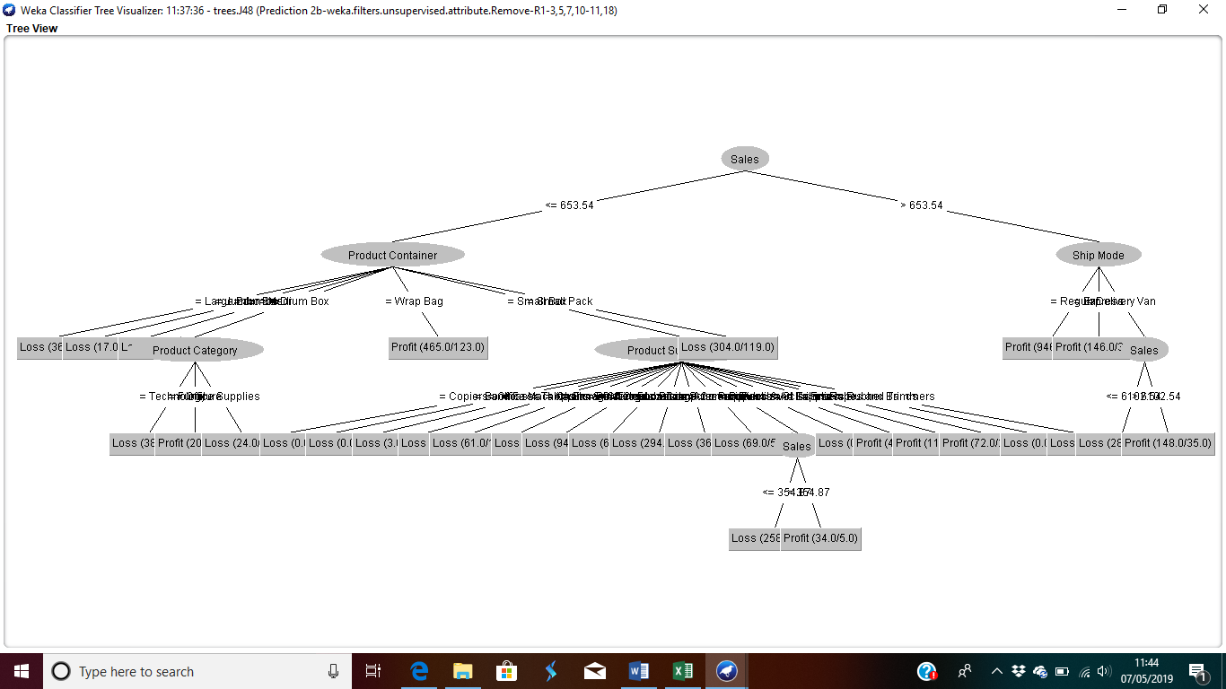

The decision tree looks whether sales above or below £653.54 make a profit or loss. If the sale is over £653.54 it looks at the product container whether it made profit. If the sale was less than £653.54 the next stage identifies the shipping mode and if profit was made.

evaluation of how data mining approaches would be relevant for sarn helen stationery
Data mining has become a business intelligence trend in recent years. It allows businesses to process enormous sets of data to obtain meaningful and actionable knowledge. This is advantageous to the business/organization but there are disadvantages.
Data mining when used correctly can optimise business workflow efficiency to give an organization a competitive advantage. (Lombardo, 2016) suggests that companies can gain a competitive advantage by analysing whether an industries sales trends have increased or decreased and shows emerging gaps in the market through prediction analysis. These data mining approaches will allow Sarn Helen Stationery to identify these trends in customer behaviour and peaks in sales, this will improve the relationship the company has with its customers.
Data mining allows businesses to build models based on historical data to predict future behaviour. Using models businesses can determine which decision to make will be most successful based on historical data. This method is used regularly in financial organizations to determine whether a customer should be granted a loan or not based on the historical data they have collected on a given person. (Zentut, 2019)
Data mining techniques allow greater target customer optimization. ‘A 2014 Infosys survey reported that 78% of consumers said they’d be more likely to purchase from a retailer again if they provided more offers targeted to their interests, wants, or needs. Most customers (86%) said they’d be willing to pay up to 25% more for a better experience. Through data mining, retail stores can use their customer shopping habits to optimize their store layout. This improves the customer experience and subsequently increase profits.’ (Infosys, 2013).
Data mining has many other advantages for businesses such as improving security risk procedure, improved planning and forecasting, cost reduction, customer acquisition, new customer acquisition/retention and development of new products. However, there are three major disadvantages to data mining; Privacy issues, misuse of information and security issues.
The biggest argument opposing data mining is the privacy issues it possesses. Since the process creates patterns such as purchasing behaviour of consumers and demographic factors, it is not unlikely that sensitive information can be disclosed and in effect violating consumers privacy (White, 2012). Although this is an unlikely event for small business Sarn Helen Stationery it is nonetheless a real barrier to the acceptance of data mining.
Nowadays, security of online information is becoming a major talking point. There is a big concern with big data being stolen or acquired by unethical and dishonest organisations with the intent to take advantage of the vulnerable consumers and use the information for their personal interests. Businesses own information about their employees and customers including social security number, birthday and payroll. However how properly this information is taken care is still in question. There have been a lot of cases that hackers accessed and stole big data of customers from big corporations such as Ford Motor Credit Company and Sony, with so much personal and financial information available, loss of credit card information and identity theft is becoming an ever-increasing threat. (Zentut, 2019)
The major barrier for data mining in small businesses like Sarn Helen Stationery is the difficulty to use. Before obtaining any data, many steps must be undertaken such as pre-processing the data in Excel then understanding how to use each approach to obtain actionable data. Even after correctly pre-processing and entering the data into Weka the results are not clear to the untrained eye.

Weka
‘Weka is an open source data mining application it contains tools for data preparation, classification, regression clustering, association rules mining and visualisation.’ (CS Waikato, 2019)
Weka is a free application under the GNU General Public License which means that any entity can use the platform for free. Secondly, being a software that is written in Java programming language it runs on almost every platform whether being a Mac or PC. Thirdly, it hosts an array of data pre-processing and modelling techniques. Lastly, it’s a very easy data mining application to use due to its graphical features.
Weka does have its own limitations, firstly the sequence modelling is not covered by the algorithms included in the Weka distribution. Secondly, Weka is not capable of multi-relational data mining and lastly, Weka is heavily memory bound meaning that it is common for the application to crash when attempting to formulate large groups of data (Ian H, 2011). Another problem found when attempting to use Weka was that it can take a lot of pre-processing on Excel before the data is ready to be mined.
Before entering the data set into Weka Data mining there were few pre-processing steps that had to be undertaken, for example there was an error in the data with ‘1.2’ being on the end of the data so that had to be removed. Then all apostrophes were removed using the ‘find and replace’ feature on excel

Conclusion
Sarn Helen Stationery would benefit from using MS Excel to analyse, pre-process and visualise their data because it simplifies the process of understanding the data that has been collected. MS Excel would benefit Sarn Helen Stationery to make clear and concise decisions resulting in a more streamline organisation. Once Sarn Helen have a lot of data collected on their Excel spreadsheets they can transport that data into a data mining application such as Weka, using the data mining techniques mentioned earlier Sarn Helen Stationery could gain a competitive advantage.

References

Alton, L., 2017. The 7 Most Important Data Mining Techniques, s.l.: Data Science Central.
ContractLogix, 2019. Top 3 Disadvantages of Using Spreadsheets for Contract Management. [Online]
Available at: https://www.contractlogix.com/2015/07/top-3-disadvantages-of-using-spreadsheets-for-contract-management/
[Accessed 02 05 2019].
Cook, S., 2016. Advantages of Microsoft Excel. [Online]
Available at: https://turbofuture.com/computers/Advantages-of-Microsoft-Excel
[Accessed 30 04 2019].
CS Waikato, 2019. Weka 3: Machine Learning Software in Java. [Online]
Available at: https://www.cs.waikato.ac.nz/~ml/weka/
EDUCBA, 2018. Introduction to Data Mining Methods. [Online]
Available at: https://www.educba.com/data-mining-methods/
[Accessed 02 05 2019].
Fish, L., 2016. 5 Benefits of Microsoft Excel. [Online]
Available at: https://turbofuture.com/computers/Advantages-of-Microsoft-Excel
[Accessed 30 04 2019].
Foster, D., 2018. Disadvantages of Using Microsoft Excel. [Online]
Available at: https://www.techwalla.com/articles/disadvantages-of-using-microsoft-excel
[Accessed 30 04 2019].
Heddings, L., 2016. How to Use VLOOKUP in Excel. [Online]
Available at: https://www.howtogeek.com/howto/13780/using-vlookup-in-excel/
[Accessed 29 7 2019].
Ian H, W., 2011. Introduction to Predictive Analytics Tools: Weka. s.l.:Morgan Kaufmann.
Infosys, 2013. Consumers Worldwide Will Allow Access To Personal Data For Clear Benefits, Says Infosys Study. [Online]
Available at: https://www.infosys.com/newsroom/press-releases/Pages/digital-consumer-study.aspx
Kaul, A., 2018. Excel IF Statement – How to Use. [Online]
Available at: https://www.exceltrick.com/formulas_macros/excel-if-statement/
[Accessed 02 05 2019].
Lombardo, C., 2016. Pros and Cons of Data Mining, s.l.: Vision Launch.
Mihãlcescu, C., 2013. PIVOT TABLES, A DECISION-MAKING INSTRUMENT FOR TOURISM AGENCIES, s.l.: JOURNAL OF INFORMATION SYSTEMS & OPERATIONS MANAGEMENT.
Soffar, H., 2015. Microsoft Excel advantages and disadvantages. [Online]
Available at: https://www.online-sciences.com/computer/microsoft-excel-and-its-advantages-and-disadvantages/
[Accessed 30 04 2019].
White, M. C., 2012. Big Data Knows What You’re Doing Right Now. TIME.
Zentut, 2019. Advantages and Disadvantages of Data Mining. [Online]
Available at: http://www.zentut.com/data-mining/advantages-and-disadvantages-of-data-mining/
[Accessed 02 05 2019].

