


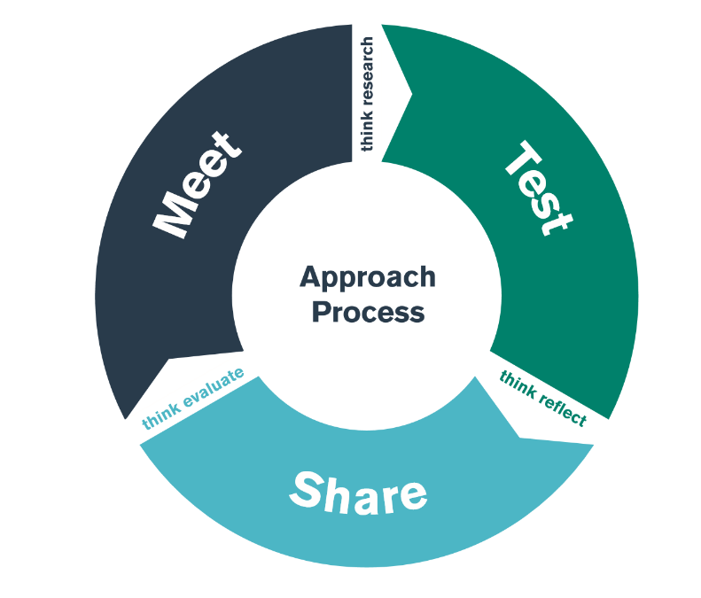

Cognitive Development
TEST Day

Student-Teacher Enquiry Evidence Record

18th November 2019

What is the purpose of the ‘COGNITIVE FOCUS’ bridging activity?

By the end of the ‘Cognitive focus’ TEST day, you should have an understanding of some of the strategies, policies and approaches that the school use to ensure the cognitive development of their learners, especially within the Foundation Phase.

What are some of the key principles the school adhearse to when addressing teaching and learning?

Which policies include children’s cognitive developmet as a focus? (Teaching and learning policy?)

What does/ do the policy/cies state?

Are there any links between the school’s behaviour policy and a Behaviourist approach? If so, discuss these below:

How is the importance of children’s Learning evident throughout the school/ class? (eg displays, assemblies)

How are children rewarded for their Learning/ cognitive development?

What do the staff do to create a classroom climate that promotes their children’s desire to learn?

How does the physical environment of the classroom promote children’s learning and cognitive development? Are there specific resources that aid this?

What strategies do staff utilise to support children who are finding a task challenging?

How do staff enable children to understand how well they are doing in their learning?

From classroom observation, can you describe a learning experience where an ADULT performed the role of ‘More Knowledgeable Other’ (MKO) and a learner was able to do then something that they couldn’t previously do?

From classroom observation, can you describe a learning experience where a CHILD performed the role of ‘More Knowledgeable Other’ (MKO) and another learner was able to do then something that they couldn’t previously do?

Did you observe any of the following approaches in the school environment?

Activity/ Strategy | Description | Your personal reflection
Independent work

A learner working on their own to complete a task

Collaborative ‘Paired’ work

Two learners working together to complete a task

Collaborative ‘Group’ work

Three or more learners working together to complete a task

Repetition

Learners engaging in ‘repetition’ to aid memeory

Peer teaching

One child teaches another

Active Learning

Children taking an active role within the learning experience, including thinking.

Pupil Choice

Children selecting what they want to learn/ how they want to learn etc

Have you observed any further examples of constructivist, behaviourist or humanist approaches to teaching?

Did you notice any children displaying of the main characteristics of the ‘Preoperational stage’ of cognitive development?

Symbolic play  (Using object to represent something else ) | Egocentrism  (Unable to see another’s view) | Using Symbols  (Using words and pictures to represent objects) | Role Play  (Pretending to be somebody else – Mum/ Dad/ Policeman etc) | Conservation  (Understnding when obects associated with capacity, weight, length, number etc remain constant)
Concrete Thinking  (Only thinking about what is physically in their environment and taking things literally) | Not using Logic  (Driving an activity with emotion not with clear sense or reasoning) | Reflections

During observation, did you see a learner develop their understanding of something by ‘adding new’ information (assimilation) to their existing of ‘categories of knowledge’ (schemas)?

During observation, did you see a learner change their understanding or alter their ideas (accomodation) in light on new information?

