BA Business Management

Management Economics:LCBB5003

Assessment component 2:Covid 19 Pandemic

Lecturer: Vasilios Tavlaridis

Table of Contents
Introduction 3
Discussion 3
Overview of COVID 19 pandemic 3
Impact of the pandemic on the world economy 4
Changes in the managerial decision making process in the organisation during and after the pandemic 5
Impact of the changes in decision making in the lives of the employees 6
Effect of employment and standard of living in the UK because of managerial decision making 7
Conclusion 8
Reference list 9

Introduction
The pandemic has created a huge impact in the business process management of the companies. In this aspect, it can be stated that the organisations have determined different policies that can help the improvement of their business. The lives of the employees have been affected in different ways because of the implementation of these changes in the organisation's operation. The study sheds light on the understanding of the pandemic and its impact on the world economy. It will also provide a vast knowledge on the impact of the same in compelling changes in the managerial decision making process full stop these changes have usually impacted the lives and employment of the people that are working in these organisations.
Discussion
Overview of COVID 19 pandemic
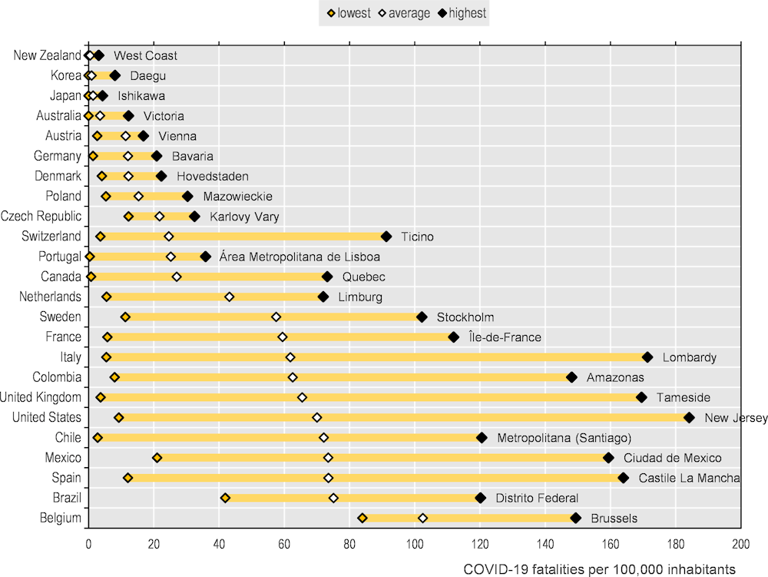
It can be stated that the COVID 19 has been affecting the lives of people since 2020. Because of this, the people of the world observed the situation of lockdown for many days. The financially advanced countries have been able to stop the spread of this pandemic with proper provision of health checkups and maintaining the requirements for the lockdown process full stop however the countries which have been financially downgraded has not been able to revise from the effect of the virus till date. countries like the UK have observed the downfall of the economy as well because of the Breakout of the pandemic. As opined by Lone and Ahmad (2020), the organisations that are operating in the business markets had to reduce their operating workforce at a significant rate so that the government enforced laws can be properly adhered to. It can be stated that the world economy has not been able to revive from the state even at this time as there are some significant changes in the employee behaviours of the organisations as well (Sharifi and Khavarian-Garmsir, 2020). The pandemic has caused numerous deaths worldwide that have compared the government take drastic actions to stop the spread of the virus. In this regard, the organisations have to come up with strategies of working from home so that they are capable to continue their operation. The organisations that have not been working in the sector that can provide working from home to the employees had to stop their business such as the hospitality sector.
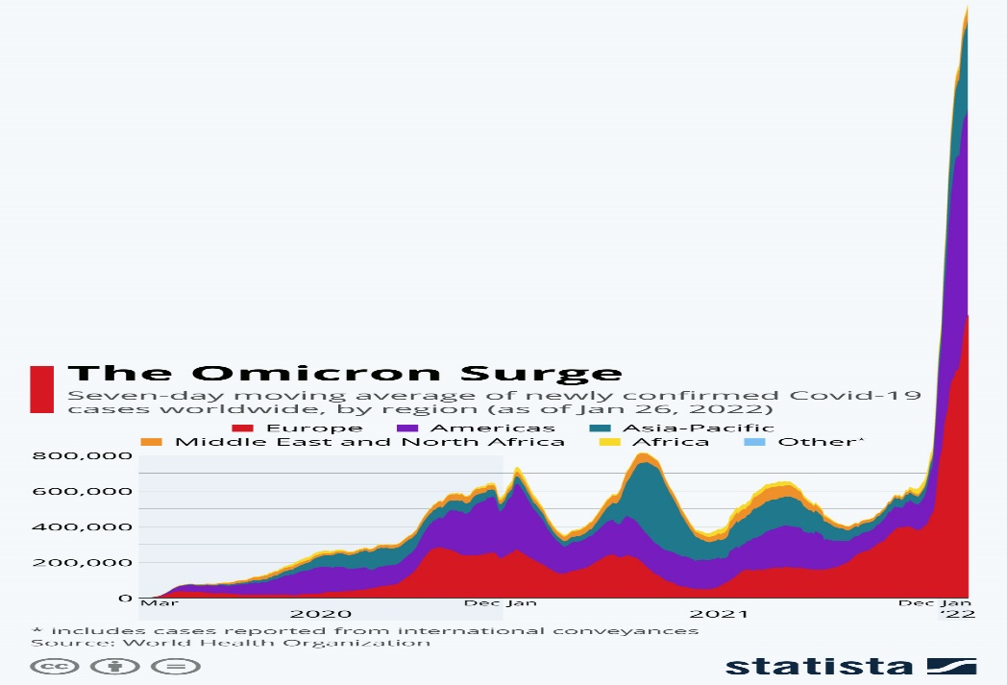
The organisations that have not been working in the sector that can provide working from home to the employees had to stop their business such as the hospitality sector.
Impact of the pandemic on the world economy
As mentioned in a study by Susilawati et al., (2020), the world economy has faced the adversities of the pandemic in a huge way. It is to be mentioned that the companies operating in the market needed to develop their strategies of operation based on the laws that have been enforced by the concerning government. It is to be asserted that the world economy has faced an overall downfall during the years of the lockdown despite the fact that many of the countries have been capable to stop the spread of the virus in a relatively short amount of time. As Feyisa (2020) have added, the business operations of the companies have been fallen down because they have to work with less number of employees to maintain the social distancing. At some points, the employee productivity has been in a down search because of the long working from home facility. Moreover, there has not been much scope for the skill development of the employees which have compelled the employees to be dissatisfied with the operations making them search for new jobs. As the employees do not have many options for a job change or switching their companies it has been an aspect of this satisfaction as well (Sułkowski, 2020). The aspect of leadership in the organisations has not been proper as the process of working from home is new to everyone.
Therefore it is obvious that the world economy will face the effect of a lack of employment management knowledge during a worldwide pandemic by the organisation management. As per the reports of Qiu et al. (2017), it has been observed that the impact on the world economy of the pandemic has been huge and took a great amount of time to recover as well. To revive the economy from the alleged downfall the governments of the concerned countries have deployed different strategies that can improve the same with no time. It can be said that the implementation of these strategies needed a proper improvement of leadership aspects as well as it can help the organisations keep the employees properly motivated and willing to provide as much as fart as possible in the operation of the process of the organisation (Bailey et al., 2020). It has been observed that many of the organisations have lost a significant amount of employees because of the fact that provision of work from home for these organisations would not have been fruitful.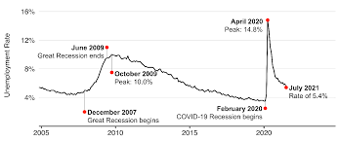
Changes in the managerial decision making process in the organisation during and after the pandemic
It has been observed that the companies that are operating in the market of UK the implementation of proper changes while adhering to the situation of a pandemic (Açikgöz and Günay, 2020). In this regard, the leadership aspect of the companies needed to be strong and full feeling so that the employees can attend proper satisfaction while there working in the company during the pandemic. The break out of the pending has been a traumatized in the situation for the people as it has provided thread to the lives of the near and near once as well (Obrenovic et al., 2020). Not only the job cards that have been observed in different organisations but that's it to lose the people who are closed to the employees at the expectations that have compared them to reduce the efforts while working in an organisation. The companies need to understand the same and develop proper strategies to ensure that the employees are being capable to work better in the organization while providing them with a comfortable working atmosphere. The changes in the decision making process of these organisations need to make sure that the employees are being able to work according to the implemented changes as this will determine the success of business operations of these organisations.
Sharma et al. (2020) Argue that at some point the companies that are providing work from home facilities to the employees are tending to exploit their efforts more as they are getting flexibility and home comfort during their working hours. At some point, the working hours for the employees are extended for no reason which can lead to a lack of employee satisfaction. In this respect, the organisations will need to understand the requirement of the employees which should be clarified out by the leaders of the organisations (Fletcher and Griffiths, 2020). On the other hand, it is also to be mentioned that to retain the employees the organisation needs to develop proper strategies and provide better comfort to the employees. In the process of managing the business, it has been observed that the technology implementation has played a vital role in the business level process of the organisation. In this regard, the companies will need to improve the technical skills of the employees as well to make them accustomed to the new operational process.

Impact of the changes in decision making in the lives of the employees
With the changes in the decision making process of the leaders in different organisations, the lives of the employees have been changed as it affected their lifestyles as well (Irawanto, 2015). It can be stated that the employees that are working in an organisation need to develop their lifestyles based on the salary they are being paid in the organisations. In this regard, their efforts and operational improvement will be determined with the satisfaction of the gate from the paid salary of the company (Koch et al., 2015). It can be mentioned that at some point the employees may feel dissatisfied with their work process because the companies will need time to change the leadership aspect as the changes in the operational process have been new to them too. It is to be mentioned that the determination of the changes and working accordingly to implement the same in the workforce will need proper understanding on the requirement of the employees as well. In this regard, the organisation's management needs to implement proper leadership strategies that can provide proper solutions to the needs of the employees as well. It has been observed that the unemployment rate in the country has been enhanced because of the break out of the pending (Makridakis, 2017). The employees that have been working loyally in the companies because of the fact that the operation in the organisations will need to be channelised through the provision of work from home.
It is to be mentioned that the provision of work from home needs to develop the skill of the employees with respect to the enhancement of understanding of technology (Li and Chapman, 2020). The employees need to get through the knowledge development process of technology upliftment of the operation of the process. in many cases it can be observed that the aged employees who have not been able to develop their understanding regarding technology need to improve their skills in order to work hand in hand with the others as well it is to be mention that these employees have faced different challenges during their operations in the organisation because they had to improve their understanding without the support of the organisation they are working for. With the provision of work from home, it has been observed that the organisations are incapable of providing proper training for the implementation of SIM in the workplace. Therefore resulted in the increase of unemployment in the country making the economy day by day. It is necessary for the organisations to understand the requirement of the employees to make sure that they are able to improve their workforce during a time such as the pandemic as it has caused the organisations to reduce their working hours as well as skilled workforce.
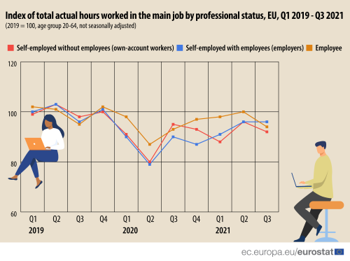
Effect of employment and standard of living in the UK because of managerial decision making
The process of managerial decision making has been capable to enhance the operation process of the organisations during the pandemic (Newell and Marabelli, 2015). However, it has been observed that many of the employees have been cut short because of the reduction of the workforce enforced by the government. The process of skill development of the employees has not been an easier aspect for the organisations because the pandemic has compelled the management to provide work from home to most of the employees. In this regard, the organisation's management needs to develop different strategies that can improve the performance of the employees. These strategies can improve the ideation of the employees on the benefits of adopting technology to their working provisions. The operations of the employees will be enhanced with the development of the skills from the technological aspect. It can be asserted that the organisations will be able to enhance they are performance if they can implement the recent technology is in their workforce and train the employees based on the same. However, the break out of the pandemic has compelled the organisation to take these drastic measures to enhance the operation of the process of the companies (Bauer and Sousa-Poza, 2015). In this respect, the life of the employees has been some how changed as they have been working from home. For some of the organisations, it has been pressurizing for the employees as the companies provided work regardless of the time limit mentioned by the government.
The process of exploitation has been in trade because of the work from a home provision in the organisations. In this record, the company needs to understand the requirement of the employees to make sure that they are being able to work better in their operations and process (Gupta et al., 2020). It has been observed that many of the companies have compelled the employees to work at half salary because of the reduced business profit their collecting from the market during the pandemic. It can be stated that this can enhance the employee this satisfaction and make them want to work somewhere else. It has been observed that the companies need to implement proper leadership in this aspect to make sure that the employees are getting a comfortable working atmosphere. It is to be mentioned that the organisation's management needs to implement proper strategies so that they are capable to return the skilled employees. The standard of living of these people has been lowered because of the reduction of salaries for some people.
No matter how low the business profit of the organisation was, it is to be made sure that the employees are being comfortable while working in the organisation. It is to be mentioned that at some point, the employee management process of the organisations has been evident while some companies choose to fire their employees to maintain the business profit in the organisations. This has caused many people to go homeless or reduce their standard of living moreover working in companies that are not valuing their skills at all. In this aspect, the organisations that are being capable to retain their skills employees have not been getting more profits however there being able to create faithful employees that will do whatever they can within their power to improve the work force of the organisation that can further improve the business profit of the organisation after the pandemic.
Conclusion
It can be concluded that the organisations will be able to enhance their operations with the implementation of better strategies to make sure of the attainment of the required business profit. The management of the employees will be better with the enhancement of the change implementation. It can be stated that the pandemic has created a vast impact on the economy of the organisations. It has been observed that the organisations need to enhance the business process with the understanding of the current needs of the time. It is to be mentioned that the changes in the decision making process of the organisations will be able to enhance the business opportunities in the organisations. It can be stated that the understanding of the business in the market will need more technological implementation in the operational process. It is to be developed based on the technical support team. The organisations can enhance their operations based on the needs of the market and the skills of the employees will need to be developed to improve the performance of the organisations.

Reference list
Açikgöz, Ö. and Günay, A., 2020. The early impact of the Covid-19 pandemic on the global and Turkish economy. Turkish journal of medical sciences, 50(SI-1), pp.520-526.
Bailey, D., Clark, J., Colombelli, A., Corradini, C., De Propris, L., Derudder, B., Fratesi, U., Fritsch, M., Harrison, J., Hatfield, M. and Kemeny, T., 2020. Regions in a time of pandemic. Regional Studies, 54(9), pp.1163-1174.
Bauer, J.M. and Sousa-Poza, A., 2015. Impacts of informal caregiving on caregiver employment, health, and family. Journal of population Ageing, 8(3), pp.113-145.
Dwivedi, Y.K., Hughes, D.L., Coombs, C., Constantiou, I., Duan, Y., Edwards, J.S., Gupta, B., Lal, B., Misra, S., Prashant, P. and Raman, R., 2020. Impact of COVID-19 pandemic on information management research and practice: Transforming education, work and life. International journal of information management, 55, p.102211.
Feyisa, H.L., 2020. The World Economy at COVID-19 quarantine: contemporary review. International Journal of Economics, Finance and Management Sciences, 8(2), pp.63-74.
Fletcher, G. and Griffiths, M., 2020. Digital transformation during a lockdown. International Journal of Information Management, 55, p.102185.
Irawanto, D.W., 2015. Employee participation in decision-making: Evidence from a state-owned enterprise in Indonesia. Management-Journal of Contemporary Management Issues, 20(1), pp.159-172.
Koch, A.J., D'Mello, S.D. and Sackett, P.R., 2015. A meta-analysis of gender stereotypes and bias in experimental simulations of employment decision making. Journal of Applied Psychology, 100(1), p.128.
Li, M. and Chapman, G.B., 2020. Medical decision making. The Wiley Encyclopedia of Health Psychology, pp.347-353.
Lone, S.A. and Ahmad, A., 2020. COVID-19 pandemic–an African perspective. Emerging microbes & infections, 9(1), pp.1300-1308.
Makridakis, S., 2017. The forthcoming Artificial Intelligence (AI) revolution: Its impact on society and firms. Futures, 90, pp.46-60.
Newell, S. and Marabelli, M., 2015. Strategic opportunities (and challenges) of algorithmic decision-making: A call for action on the long-term societal effects of ‘datification’. The Journal of Strategic Information Systems, 24(1), pp.3-14.
Obrenovic, B., Du, J., Godinic, D., Tsoy, D., Khan, M.A.S. and Jakhongirov, I., 2020. Sustaining enterprise operations and productivity during the COVID-19 pandemic:“Enterprise Effectiveness and Sustainability Model”. Sustainability, 12(15), p.5981.
Qiu, W., Rutherford, S., Mao, A. and Chu, C., 2017. The pandemic and its impacts. Health, culture and society, 9, pp.1-11.
Sharifi, A. and Khavarian-Garmsir, A.R., 2020. The COVID-19 pandemic: Impacts on cities and major lessons for urban planning, design, and management. Science of the Total Environment, 749, p.142391.
Sharma, M., Luthra, S., Joshi, S. and Kumar, A., 2020. Developing a framework for enhancing survivability of sustainable supply chains during and post-COVID-19 pandemic. International Journal of Logistics Research and Applications, pp.1-21.
Sułkowski, Ł., 2020. Covid-19 pandemic; recession, virtual revolution leading to de-globalization?. Journal of Intercultural Management, 12(1), pp.1-11.
Susilawati, S., Falefi, R. and Purwoko, A., 2020. Impact of COVID-19’s Pandemic on the Economy of Indonesia. Budapest International Research and Critics Institute (BIRCI-Journal): Humanities and Social Sciences, 3(2), pp.1147-1156.

