BASIC CONCEPT OF HOW A BIPOLAR TRANSISTOR WORKS
This description aims to explain the basic operation of a transistor in terms of an analogy using a water based system.
Water pressure at B acts upwards on the valve seat. A slight pressure downwards at B will cause the valve seat to rise. As it rises water will flow from C to E. The flow of water from C to E is quite large compared with the flow from B to E. In this way we can see that a small amount of flow from B to E can control a much greater flow from C to E.
We might say that a small flow control signal at B is being used to control a much bigger flow from C. This may be considered as some form of amplification.
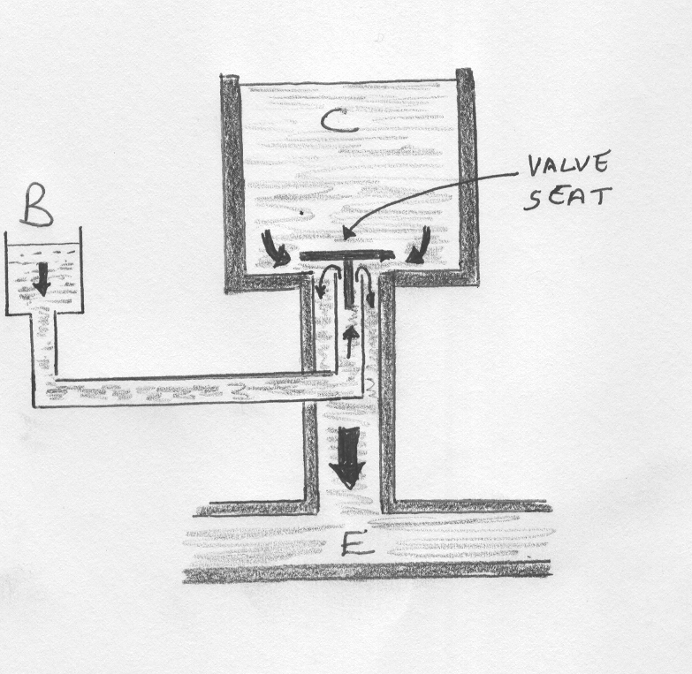
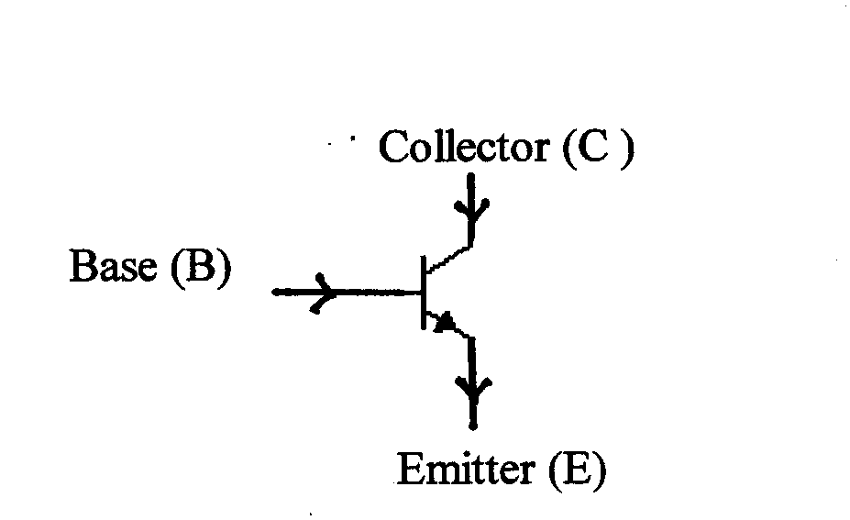

We use a transistor to control the flow of current in a circuit or to a load. By applying a base to emitter drive current we can control the collector to base current. Because it is possible for a small base current to control a much larger collector current then we may consider that the transistor has an amplifying effect.

The base current is amplified within the transistor so that the collector current is h_{FE} times the size of the base current. h_{FE} is known as the d.c. current gain, the term "gain" means amplification. If h_{FE} for a given transistor is 10 then this means that if we put in a given base current, the resulting collector current will be 10 times that of the base.
We may write the following relationships: I_{C} = h_{FE} .I_{B} and I_{E} = I_{B} + I_{C}
This type of transistor comes in two basic forms: the npn transistor and the pnp transistor.

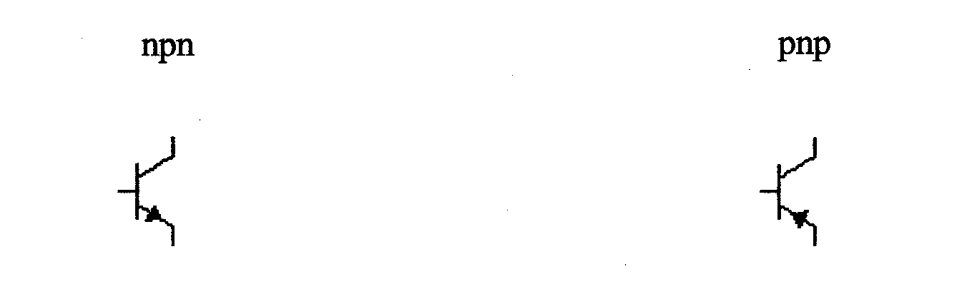
In the water based system above we could consider the possibility of either applying no pressure or full pressure at B. If we did this we would either get no flow or maximum flow at E.
We can apply the same idea to the transistor. We can either apply no base current or a high base current and nothing in between. This will either give us no collector current or a maximum collector current. This makes the transistor look like a switch which is either on or off.
This means that depending on the way we drive current into the base we can either use
the transistor as a switch or as an amplifier. In digital electronics we use the transistor as a switch and in analogue we use the transistor as an amplifying device.
To cover both cases we need simply think of the transistor as a current controlled resistance. As we drive current into the base we can control the effective resistance between the collector and emitter terminals and therefore control the flow of current from through the collector.
For high base current, the transistor behaves like a closed switch ( O ohms ). For low base current the transistor behaves like an open switch (∞ ohms ). For medium base current the transistor behaves like a resistor.
Ic

C

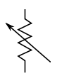
E Ie = Ib + Ic
Ib B

