University of Wales Trinity Saint David

Component two Research Methods

Student Name: Jamilla Robinson
Student No: 2030082
Module: Digital Skills and Research Methods
Module Code: BMSW4003
Lecturer: Paul Ranson

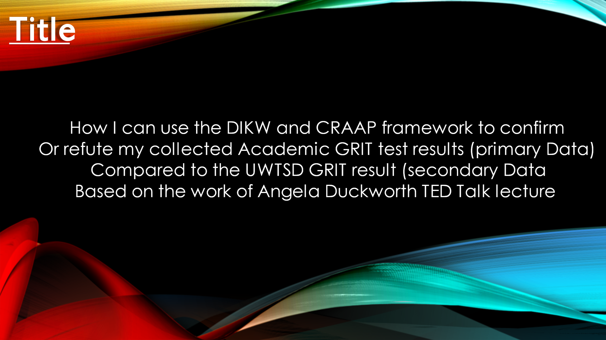



For this assignment I need to demonstrate how Angela Duckworth passes the CRAAP test, to do this I have watched her TED Talk lecture (ted, 2009) and have asked myself the five questions in the CRAAP test (Developed by Sarah Blakeslee (2004). Is the information current, is it relevant, what authority is she speaking with, how accurate her work is and finally what is her purpose? From watching the TED talk lecture, I can see that she has millions of views from people watching her video, Angela Duckworth has been published many times, this tells me that she is credible. Her work is up to date, so she has currency. I feel that her work has relevance as it can apply to everyone, the authority that she speaks with is from the research her and her team did at Westpoint military Academy and at The National Spelling B, she said that in doing this research that one thing stood out and that was GRIT. The accuracy of her work, I cannot say that I am sure, as I need to research and look at the data collected. But I am sure that as I continue with my assignment, I will find out how accurate her work is. I feel that Angela Duckworth has purpose, as she has nothing to gain from sharing her research.

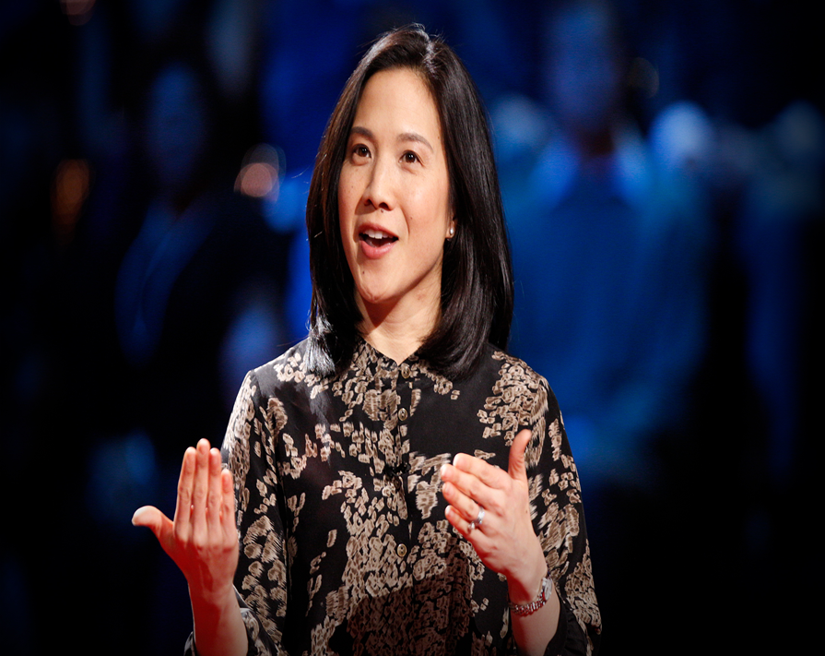

Who is Angela Duckworth?
What is GRIT?
Angela Duckworth was born in 1970, she has a Neurobiology B.A from Harvard College which she got in 1992. Her first book, Grit: The Power of Passion and Perseverance, was released in May 2016, and it stayed on The New York Times bestsellers list for twenty-one weeks. When Angela was twenty-seven years old, she left a demanding job in managing consulting, to start another demanding job (teaching). She taught seventh grade students’ mathematics, making quizzes and tests, and calculating their grades. But she said that the IQ levels were not the only difference between her best and worst students. After several more years of teaching, she concluded, that what was needed in education was a better understanding of students and learning from a motivational perspective. She asks the question what if doing well in school and life depended on much more than your ability to learn quickly and easily?
Angela went to Graduate school to become a psychologist, studying children and adults in challenging setting. The questions she asked were who is successful and why? Along with a research team she went to Westpoint Military Academy to try to predict which cadets would stay, and which would drop out. She went to The National Spelling B and tried to predict which children would advance furthest in the competition, and then she went onto studying new teachers in rough neighbourhoods, asking which teacher would still be there at the end of the school year? And who would be most effective in improving the learning outcome for their students.
So, what is GRIT? Angela Duckworth says that GRIT is the Passion of Persistence, she says that GRIT is having the stamina to stick with something day in and day out, working hard to make whatever you set your mind to a reality. (Duckworth, Peterson, Matthews, and Kelly 2007) states that “The constructs of GRIT defined as passion and perseverance for long term goals, was introduced to help explain why some individuals are driven to maximise their potential.”

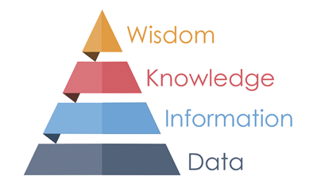(Ackoff, 1999)

The DIKW Framework for research was created by Russell Ackoff (1999). This DIKW pyramid represents the relationship between data, information, knowledge, and wisdom. Each step will answer different questions about an initial piece of data and add to its value.
Historically, the strands leading to DIKW comes from the mention by the poet T.S. Eliot [2] and, separately, from research from Harland Cleveland and the systems theorists Adler, Ackoff and Zeleny (Rowley 2007; Sharma 2008; Cleveland 1982; Lambe 2011; Williams 2014). The main views are perhaps best expressed in the traditional sources of Alder (1986), Ackoff (1989) and Zeleny (1987). “Where is the life, we have we have lost in living, Where
Is the wisdom we have lost in knowledge? Where is the knowledge we have lost in information? (T.S. Eliot) “The Rock” Faber & Faber 1934. T.S Eliot could not have anticipated the discussion that has continued from his poetic lines.

DATA



Data is raw, it simply exists and has no significance beyond its existence (in and of itself) Ackoff [7]
Here is the survey that was created on Microsoft forms in class where we used quantitative data to get information from Angela Duckworth’s online test and to find out our highest academic results. When I have the results, I will make a graph displaying the results.
Ackoff states in “From Data to Wisdom” (1989), An ounce of information is worth a pound of data. An ounce of knowledge is worth a pound of information, An ounce of understanding is worth a pound of knowledge.

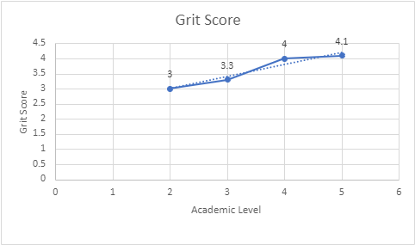

Information
Information is data that has been given meaning by way of relational connection. This “Meaning” can be useful but does not have to be (Ackoff [7]).

This scatter chart is from the survey that is shown above, the information is inside the data that we collected. From our results it shows that Angela Duckworth does not match up with our class results, however we are all humans, and these results may be because of the amount of people that took the survey, also it could be that not everyone understood the questions that were asked. The trend line however appears to be going up and does match Angela Duckworth’s results. The data that we collected could be classed as weak evidence due to the number of people who took the survey, as when people normally do survey’s the number of people taking it is much higher.
Ackoff (1989) states Ackoff posited a hierarchy at the top which lay wisdom, and below that understanding, knowledge, information, and data, in that order. Ackoff estimated that “on average about 40% of the human mind consist of data, 30% information, 20% knowledge, 10% understanding, and virtually no wisdom”

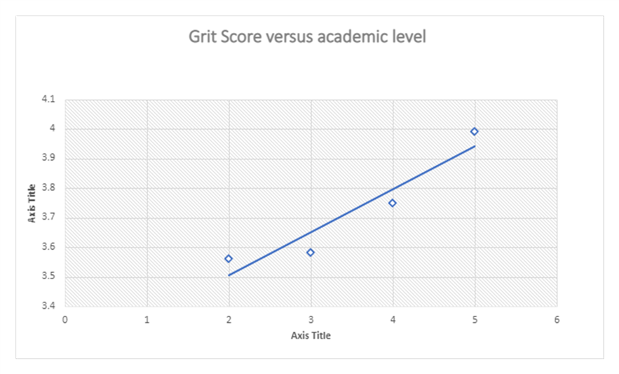
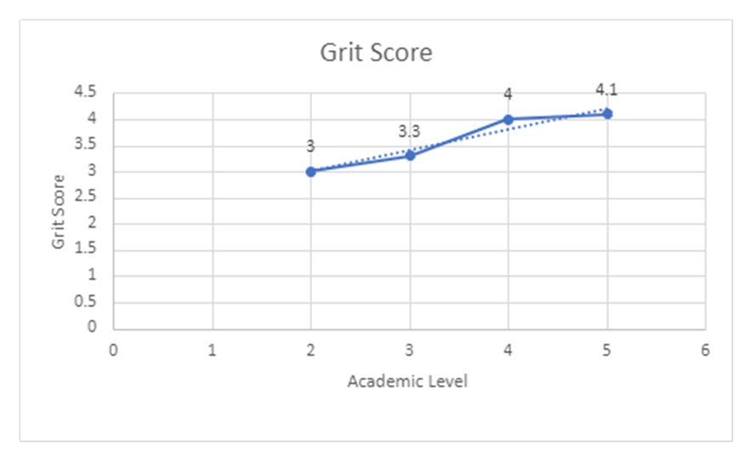

Knowledge
The appropriate collection of information, such that its intent is to be useful Ackoff [7].
Using the DIKW framework which was created by Russell Ackoff (1990). I was able to turn data into information, and by comparing the two sources of data, my primary data, which was the survey taken online by the class, and then the secondary data that was given to us in week seven, I was able to turn my information into knowledge. The most obvious difference was the amount of people who had took the survey, the primary data was only taken by a small amount, so there was not enough data to see if Angela Duckworth’s theory actually works, however even though the secondary data had more people taking part in the survey, and I could see the difference in my scatter charts, it was still not on the scale of the research done by Angela Duckworth.
Angela Duckworth says in her TED lecture that she does not know how to build GRIT, but she does think that Carol Dweck has a good perspective, that the brain is not a fixed size and can grow, this is Growth Mindset. Angela states that Growth Mindset is a good tool for building GRIT. She also states that “we have to be gritty about making our kids grittier”.



The DIKW Hierarchy “wisdom is not a product of schooling, but of lifelong attempts to acquire it” Albert Einstein.
Carol Dweck (2016) states that, individuals who believe their talents can be developed (through hard work, good strategies, and input from others) have a growth mindset. They tend to achieve more than those with a more fixed mindset (those who believe their talents are innate gifts). Carol states that this is because those with a growth mindset worry less about looking smart and that they put more energy into learning.

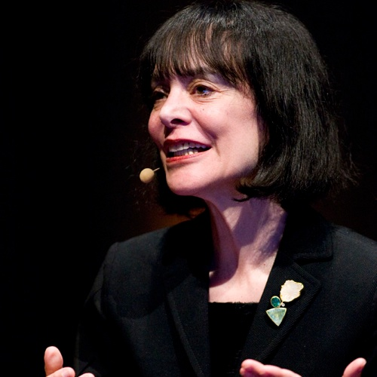

Carol Dweck
Carol Dweck is the Lewis and Virginia Eaton Professor of Psychology at Sandford University, and one of the worlds leading researchers on motivation and mindset. Dr Dweck has sought out to understand why some students give up in the face of failure, while others thrive.
In the book “Changing the way you think to fulfil your potential” (2021) Dweck talks about going into a school and bringing children into a class one by one, and giving them series of puzzles to do, first easy and then harder ones. She talks about seeing something she had never expected, one ten-year-old boy rubbed his hand together and cried out “I love a challenge”, another looked up with a pleased expression saying with authority “You know, I was hoping this would be informative”. Carol states that she always thought you coped with failure, or you didn’t cope with failure. She asks the question “Were these children alien or were they onto something?”. (Dweck, C.S. 2021).
So now I have all my data - information- knowledge and wisdom, I am left to decide whether I believe that Angela Duckworth’s theory about GRIT is true or false, and whether Carol Dweck’s belief that individuals who believe their talent can be developed through hard work, good strategies, and input from others (growth mindset) has some truth to it.



On my journey as a new student, the knowledge I have gained from this assignment is huge, from learning how to make a PowerPoint and turning that PowerPoint into a word document. I have learnt how to demonstrate if someone passes the CRAAP test, and to demonstrate each part of the DIKW framework. Learning that Quantitative Data is information about quantities, while Qualitative Data is information about qualities. I used primary data as well as secondary data and learnt what each of these mean. Researching both Angela Duckworth and Carol Dweck has been very interesting, I feel that both women have similar ideas about how the mind works and about what people can achieve, because of this I believe that Angela Duckworth is correct when she talks about developing GRIT to improve students’ academic levels, and Carol Dweck talking about there being two mental constructs: fixed mindset and growth mindset. I will admit that at first, I was not totally on board with Angela and her talk of GRIT, as although she has said that it makes no difference where you come from, or the environment in which you are raised, or the income of your family, that you can still have GRIT. I feel that sometimes these things can hold you back and make it more difficult to have GRIT. However, we still don’t know a lot about how to build GRIT, and how to build GRIT in children, about how to teach children a solid work ethic and keep them motivated, like Angela Duckworth said, “I don’t know”. But what I do agree with is what Carol Dweck says about people who believe their talents can be developed and having a growth mindset. I believe that if you put your mind to something and are fully focused on achieving your goals that you can do anything, so that is why I believe from using the DIKW and CRAAP framework that I can confirm from my primary data and secondary data that we can indeed develop GRIT to improve students’ academic levels.

References
Carol Dweck, What Having A “Growth Mindset” Actually Means, Harvard Business Review, January 13,2016.
Dweck, C.S. 2021. Mindset: Changing the way you think to fulfil your potential. Deewang aggorwal.
Dweck C.S. 2015. A Growth Mindset: The Joy and Power of Reading, p.10
Duckworth, A.L., Peterson, C, Mathews, M.D and Kelly, D.R. (2007), GRIT Perseverance and Passion for Long-term Goals. Journal of personality and Social Psychology, 92 (6), 1087-1101.
Jay H, Bernstein, The Data-Information-Knowledge-Wisdom Hierarchy and its Antitheist, City University of New York, (CUNY). Publications and Research, Kingsborough Community College, 2009.
Martin Fricke, Knowledge Organization Journal, Knowledge Pyramid, The DIKW Hierarchy.
R.L. Ackoff “From Data to Wisdom” Journal of applied system analysis, 1989_Softwarezen.Me.
Syed Ahsan and Abad Shah, Data, Information, Knowledge, Wisdom: A Doubly Linked Chain? Research and Development Centre of Computer Science, University of Engineering and Technology, Lahore.

