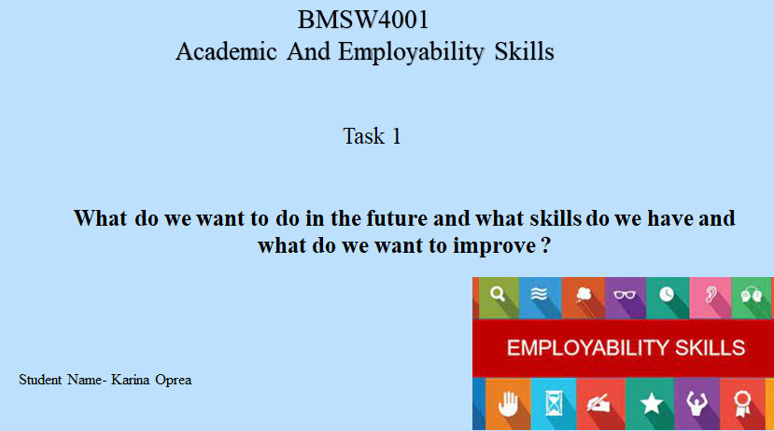
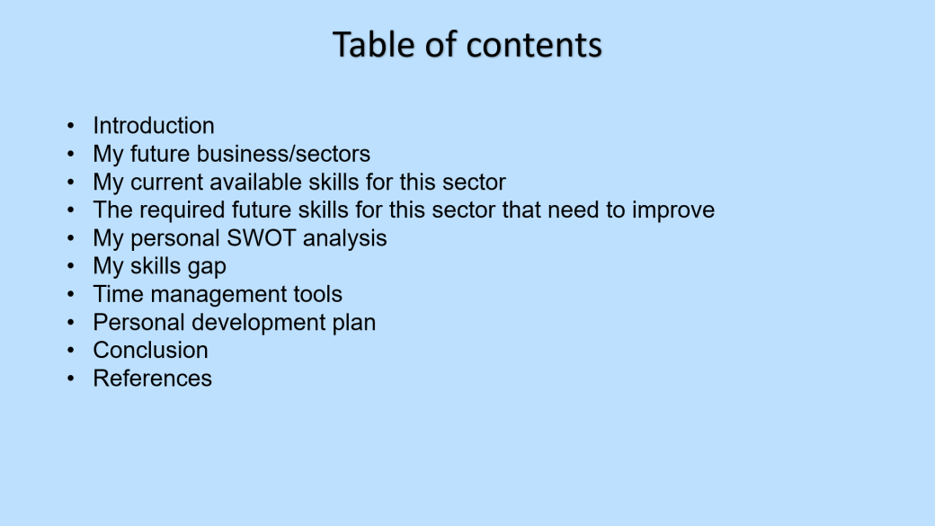

Introduction
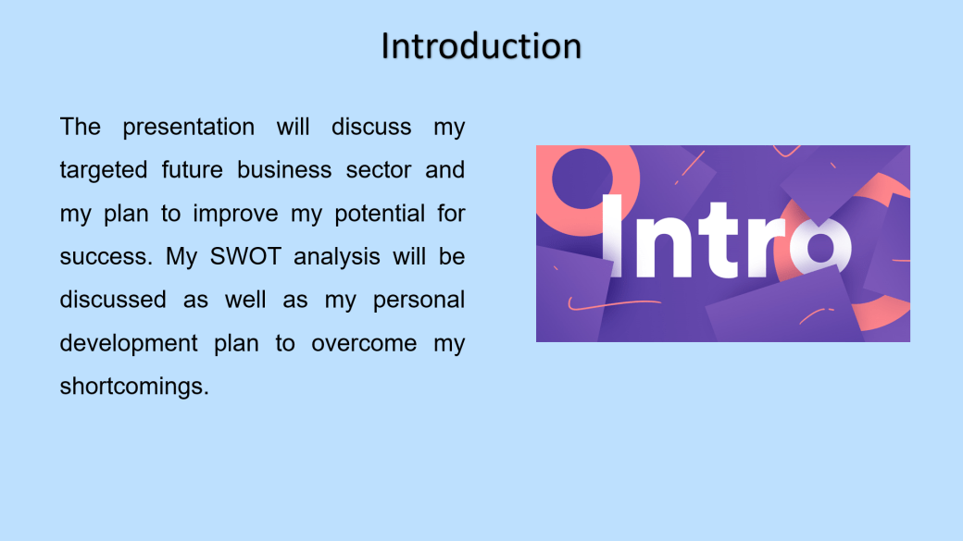
The presentation will discuss my targeted future business sector and my plan to improve my potential for success. My SWOT analysis will be discussed as well as my development plan to overcome my shortcomings. Everyone needs to have a strong plan for future businesses from the student life if they want to get success in business. I have my eyes on a particular business sector for the future and in this presentation, I'll elaborate on that. I have a set of skills that are relevant to the business and I need to acquire some more skills & improve some of the existing skills to find success in my business. So, I'll conduct a SWOT analysis in this presentation where my skill gaps will be highlighted. Lastly, I'll create a personal development plan to fill the gaps, overcome the shortcomings, & turn weaknesses into my strengths (Bala et al, 2018).

My future business/sectors
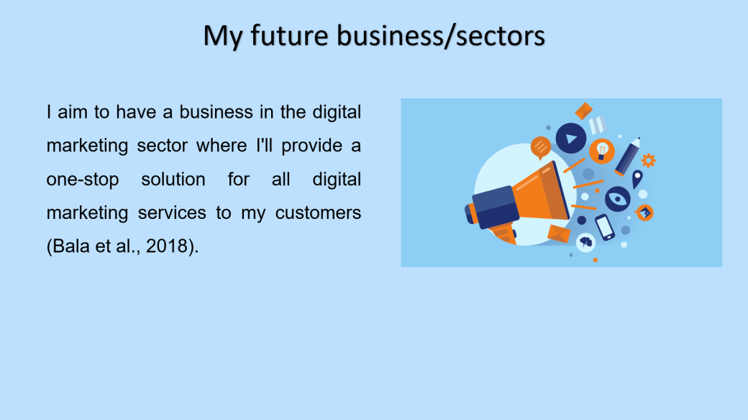
I aim to have a business in the digital marketing sector where I'll provide a one-stop solution for all digital marketing services to my customers (Bala et al, 2018). My future business will offer versatile services to my target customers and the customers will not have to go anywhere else to avail of any related additional service. I have a strong grasp of the market, particularly the digital marketing business and its requirements. I understand how search engines work and how to use keywords to push my website to the top of the results page. My clients will get to enjoy services like advanced search engine optimization, pay-per-click services, social media marketing services, content marketing services, email marketing services, mobile marketing services, marketing analytics, affiliate marketing services, etc. In addition, since I want my company to be a one-stop shop, I need to be well-versed in user interface and user experience. In order to provide the greatest outcomes for my consumers, I'll have to analyse their accessible data and make digital marketing choices based on it. (Saura, 2021).

My current available skills for this sector
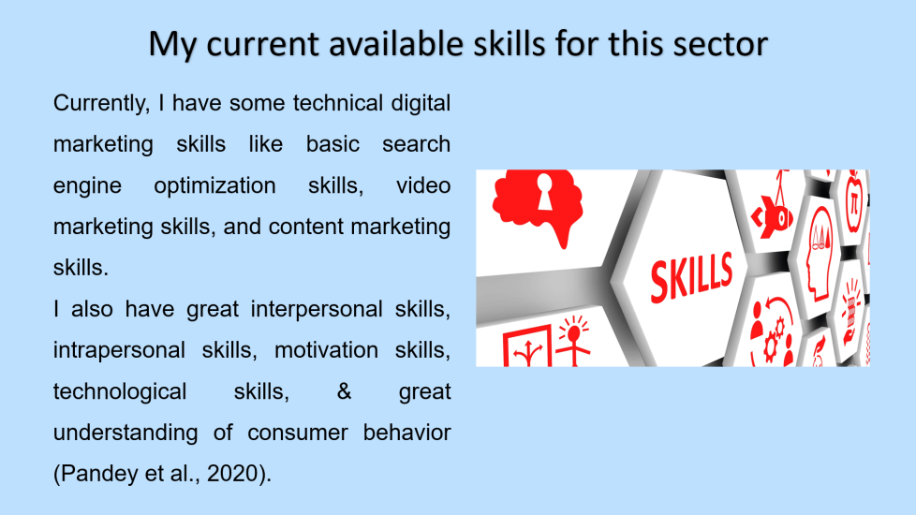
Currently, I have some technical digital marketing skills like basic search engine optimization skills, video marketing skills, and content marketing skills. I also have great interpersonal skills, intrapersonal skills, motivation skills, technological skills, & great understanding of consumer behaviour (Pandey et al, 2020). I understand search engines and I know the tricks of using keywords to get my website to the top of the search list. This will be very useful not only for building my brand but also for serving my customers better. I also know the tricks of video marketing, video production, and the way the videos need to be edited to get the desired results and that will help me to build a business that serves the specific needs of my target customers (Hanlon, 2021).
To build my business some of my existing soft skills will add great value too. For example, I have great interpersonal skills which will help me to run my teams. I also have excellent intrapersonal skills that are required by every entrepreneur like me. With my motivation skill, I'll be able to keep my team motivated & March towards success for my organisation. I am also very tech-savvy and that will keep me ahead of my competitors. Lastly, I understand consumer behaviour well and that will help my business to grow and also that will help to create great digital marketing strategies (Key et al, 2019).

The required future skills for this sector that need to improve
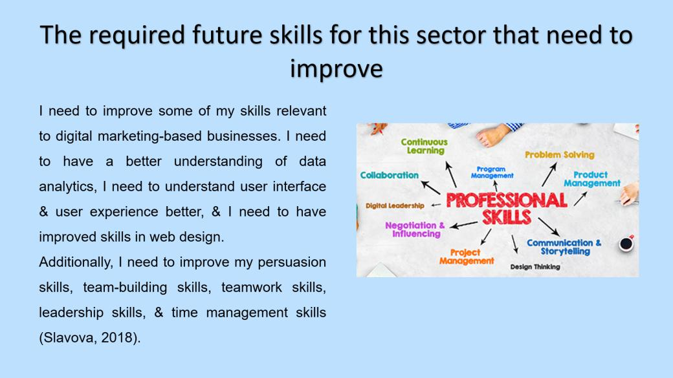
I need to improve some of my skills relevant to digital marketing-based businesses. I need to have a better understanding of data analytics, I need to understand user interface & user experience better, & I need to have improved skills in web design. Additionally, I need to improve my persuasion skills, team-building skills, teamwork skills, leadership skills, & time management skills (Slavova, 2018).Although I have great skills at this stage, building a business around it is very difficult and it requires some additional skills.
Digital marketing is being more and more dependent on data analytics and there I have no expertise. While serving my customers I'll have to analyse their available data and make digital marketing decisions based on them to bring the best results for them. Additionally, as I want my business to be a one-stop solution, I need to have a great understanding of user interface and user experience. Digital marketers will need to have improved knowledge about web design & web development in the future and so I need to improve my skills there as well (Chaffey et al, 2019).

Furthermore, to be an entrepreneur I need to improve some general soft skills. My persuasion skills aren't top-notch and it needs to improve for customer acquisition and strategic partnerships. Additionally, my team-building skills need to improve too because I can't do it all on my own and I will need to build a strong team around me with a specific skill set. Furthermore, I haven't always been a great leader, but to build a successful business, I'll have to improve my leadership skills. Lastly, I tend to procrastinate at times and I can't always meet deadlines. I need to improve my time management skills so that my teams can follow the standard (Di et al, 2019).

My SWOT analysis
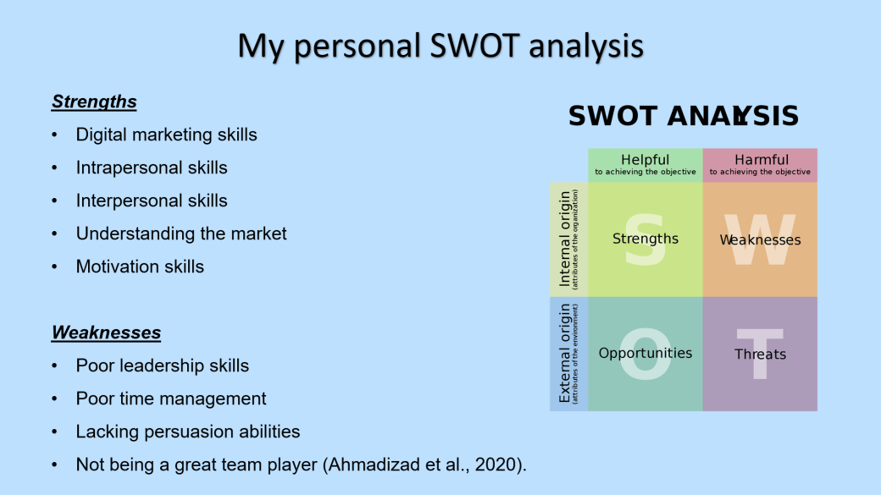
Strengths
Digital marketing skills
Intrapersonal skills
Interpersonal skills
Understanding the market
Motivation skills
I have excellent digital marketing skills in almost all aspects of digital marketing and it provides me with technical advantages. I also have excellent intrapersonal & interpersonal skills. I have a great understanding of the market and specifically the digital marketing industry and its needs. Lastly, I have great motivation ability and I know how people can get motivated to work towards my goals (Suleman et al, 2018).

Weaknesses
Poor leadership skills
Poor time management
Lacking persuasion abilities
Not being a great team player (Ahmadizad et al, 2020).
However, I haven't shown great leadership skills throughout my life and I don't believe that I'm a great leader. I'm also not good with time management as I frequently can't meet deadlines. Furthermore, I'm not very good at persuading people although it's necessary for business. Lastly, I am not a great team player and I tend to do everything on my own (Nisha et al, 2018).
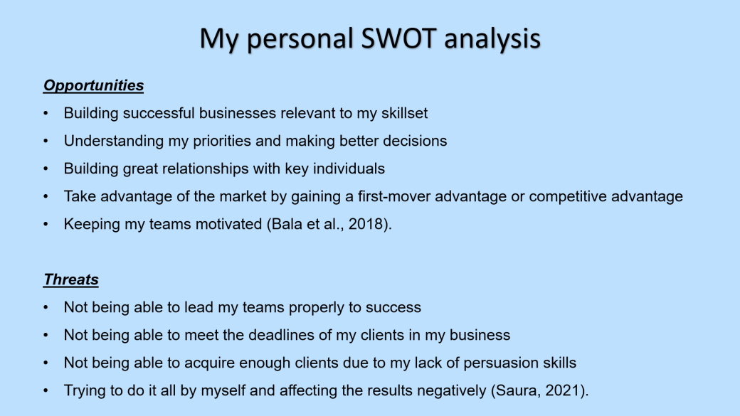

Opportunities
Building successful businesses relevant to my skillset
Understanding my priorities and making better decisions
Building great relationships with key individuals
Take advantage of the market by gaining a first-mover advantage or competitive advantage
Keeping my teams motivated (Bala et al, 2018).
Threats
Not being able to lead my teams properly to success
Not being able to meet the deadlines of my clients in my business
Not being able to acquire enough clients due to my lack of persuasion skills
Trying to do it all by myself and affecting the results negatively (Saura, 2021).
As I have great technical skills in the digital marketing sector, I may have the opportunity to build a great business around it. Additionally, due to having great intrapersonal skills I have the opportunity of understanding my priorities and making better decisions. As I have excellent interpersonal skills too, I have the opportunity to build great relationships with relevant stakeholders and grow my business. Due to having a great understanding of the market I have the opportunity to take advantage of the market and gain competitive advantages. Lastly, with my motivation skill, I have the opportunity to keep my teams motivated during tough times (Pandey et al, 2020).

Due to not having the required leadership skills, I may not be able to lead my team properly towards success. Additionally, as I have never shown great time management skills, I may not be able to manage my time and meet the deadlines of my clients in my business. Furthermore, business leaders need to be persuasive to get more clients & partner with the right entities. So, my lack of persuasion skills may lead to business failure. Lastly, as I am not a great team player I may want to do everything on my own and spoil the projects in my business (Hanlon, 2021).

My skills gap
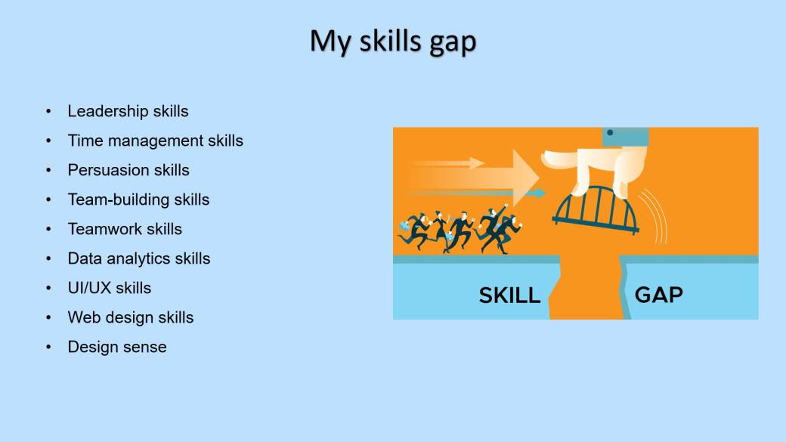
Leadership skills
Time management skills
Persuasion skills
Team-building skills
Teamwork skills
Data analytics skills
UI/UX skills
Web design skills
Design sense

I have certain skills gaps that have already been mentioned throughout the presentation and such gaps may hinder my success as a digital marketing-based business owner. If somebody wants to be successful in business, they must have a clear strategy for future enterprises from the time they are a student. My SWOT analysis, as well as my growth strategy to address my weaknesses, will be addressed. For the future, I'm interested in a certain company area, which I'll discuss in this presentation. This will be very beneficial not just in terms of expanding my brand, but also in terms of better servicing my clients. My future company will provide a wide range of services to my target clients, and they will not need to travel elsewhere for any relevant extra services. Currently, I have shortcomings in leadership skills, time management skills, persuasion skills, team building skills Teamwork skills, data analytics skills, UI/UX skills, web design skills, & design sense (Key et al, 2019).

Time management tools
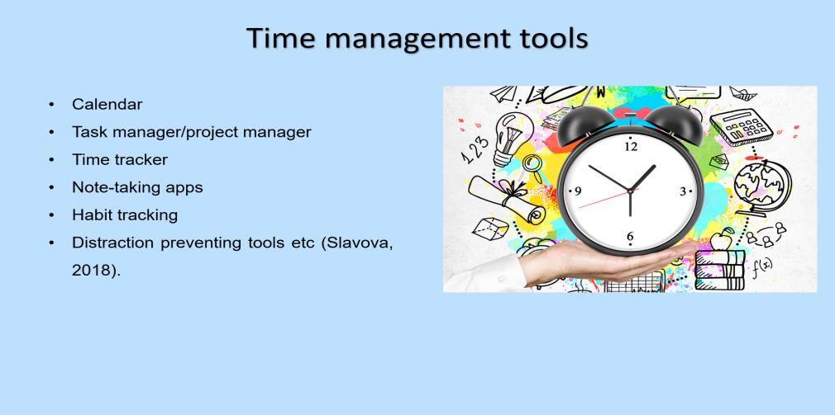
Calendar
Task manager/project manager
Time tracker
Note-taking apps
Habit tracking
Distraction preventing tools etc (Slavova, 2018).
As I have already mentioned that I have poor time management skills and which can be improved if the right time management tools can be applied. I can maintain a calendar like Google calendar so that I can always keep track of my obligations. I can use different project management tools to complete projects on time too. I can also use a time tracker so that I can minimize the time I waste on regular intervals. I can also use note-taking apps so that keeping track of my to-do list becomes easier. I can also track my habits so that I can build better habits and improve my time management skills. Lastly, I can use different distraction prevention tools that will help me to maintain my attention to the work at hand (Chaffey et al, 2019).

Personal development plan
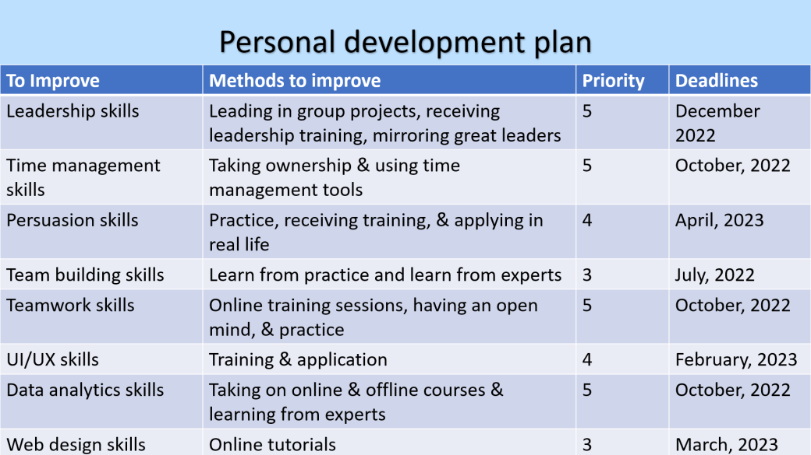
I have lackings of different skills and I need to create and follow a proper personal development plan. To improve my leadership skills, I can start leading different group projects and learn from my mistakes there. I can also receive leadership training from different online and offline sources and I can mirror great leaders and follow in their footsteps (Di et al, 2019).
To improve my time management skills, I need to take ownership of my actions first and be firm on the idea that I'll meet my deadlines no matter what. Additionally, I can use different time management tools to maintain consistency and deadlines. To improve my persuasion skills I can practice being persuasive in different social situations, receive training, & apply my learnings in real-life situations (Ahmadizad et al, 2020).
To build my team-building skills, I can learn from practice and by observing the experts about how they build their teams. To improve my teamwork skills, I need to have an open mind and attend online sessions to practice. I can improve my UI/UX design too by getting trained and applying the learnings. I can improve my data analytics skills by enrolling in different online and offline courses and learning from industry experts. Lastly, I can improve my web design skills by following online tutorials as they are available on many digital platforms (Suleman et al, 2018).

Conclusion
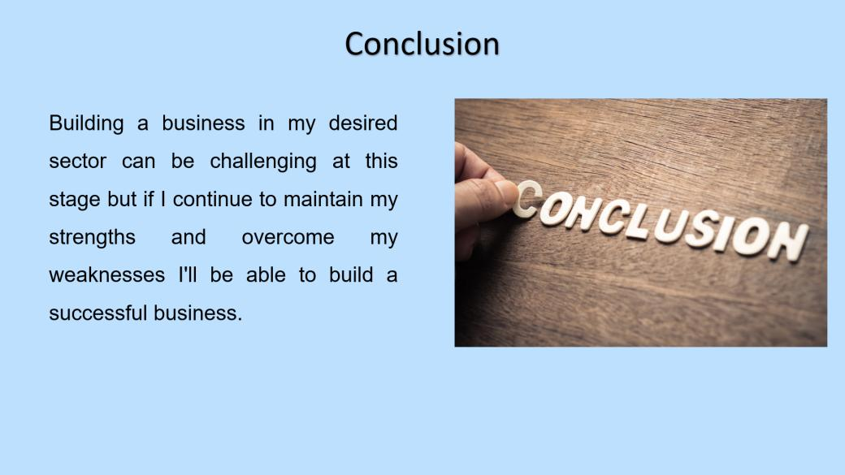
Building a business in my desired sector can be challenging at this stage but if I continue to maintain my strengths and overcome my weaknesses I'll be able to build a successful business. I have a set of talents that are relevant to my company, but I need to learn more and develop some of my present skills in order to be successful. I have excellent skills to build a business in the digital marketing sector but I need to overcome my shortcomings first to find success here. My development plan and its proper execution can bring the desired results (Suleman et al, 2018).

References
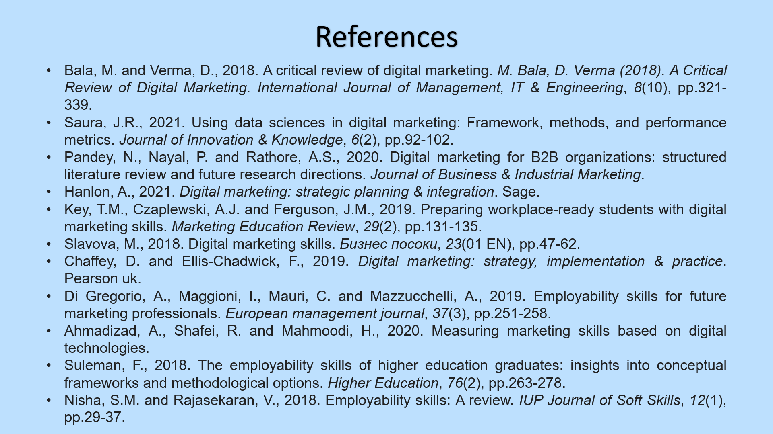
Bala, M. and Verma, D., 2018. A critical review of digital marketing. M. Bala, D. Verma (2018). A Critical Review of Digital Marketing. International Journal of Management, IT & Engineering, 8(10), pp.321-339.
Saura, J.R., 2021. Using data sciences in digital marketing: Framework, methods, and performance metrics. Journal of Innovation & Knowledge, 6(2), pp.92-102.
Pandey, N., Nayal, P. and Rathore, A.S., 2020. Digital marketing for B2B organizations: structured literature review and future research directions. Journal of Business & Industrial Marketing.
Hanlon, A., 2021. Digital marketing: strategic planning & integration. Sage.
Key, T.M., Czaplewski, A.J. and Ferguson, J.M., 2019. Preparing workplace-ready students with digital marketing skills. Marketing Education Review, 29(2), pp.131-135.
Slavova, M., 2018. Digital marketing skills. Бизнес посоки, 23(01 EN), pp.47-62.
Chaffey, D. and Ellis-Chadwick, F., 2019. Digital marketing: strategy, implementation & practice. Pearson uk.
Di Gregorio, A., Maggioni, I., Mauri, C. and Mazzucchelli, A., 2019. Employability skills for future marketing professionals. European management journal, 37(3), pp.251-258.
Ahmadizad, A., Shafei, R. and Mahmoodi, H., 2020. Measuring marketing skills based on digital technologies.
Suleman, F., 2018. The employability skills of higher education graduates: insights into conceptual frameworks and methodological options. Higher Education, 76(2), pp.263-278.
Nisha, S.M. and Rajasekaran, V., 2018. Employability skills: A review. IUP Journal of Soft Skills, 12(1), pp.29-37.

