

Matthew Howells 1702520
Academic Writing M4X01498
Computing and Information Systems
Technical report on Analytics for Websites and Social Media

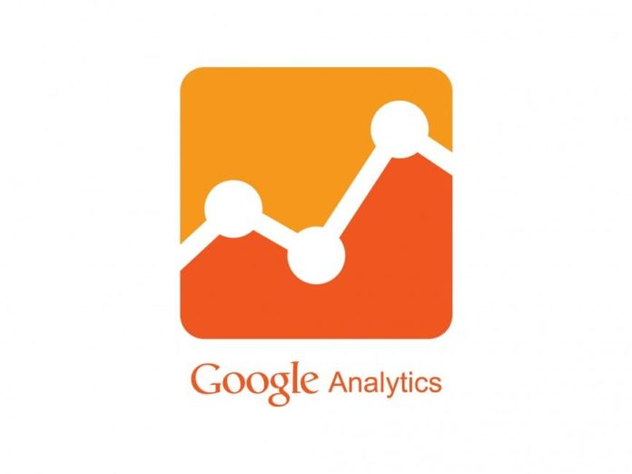

Table of Contents
Introduction 3
What is google Analytics? 3
Why have you chosen to ANALYSE GOOGLE ANALYTICS in this REPORT? 3
How popular is Google ANALYTICS? 4
Positive Impacts 4
Negative Impacts of Google ANALYTICS 5
Improvements 5
Conclusion 5
References 5

Introduction
The purpose of this report is to discuss the topic, Web Analytics for websites. While writing this report I will ensure that I can break the topic into small sections allowing me to be able to cover each point positively. This will include any conducted research that I have done. Throughout this report, I shall be focusing on Google which is one of the largest well-known search engines over the internet. Google offers its own personal analytics service which can be used to analyze important website data for clients. I will aim to evaluate Google Analysis using as much detail as I can.

What is google Analytics?
Google Analytics is a free Web analytics service launched in 2005, that provides statistics tools for marketing purposes. Since Google launched this service more than 48 million websites have chosen to use this service [1]. The service is available to anyone who owns a Google account. Google Analytics is usually directed toward clients who require the need to learn more about their website. This is recommended as businesses can track how well their website works and what changes can be made to make improvements.

Why have you chosen to ANALYSE GOOGLE ANALYTICS in this REPORT?
The reason why I have chosen to use Google is that its well-known across the internet and strongly recommended by people. I must ensure that I show how Google has had an exceptional influence on the way people work. As guessed the Analytics tool can be used to explain lots of useful information. Most companies rely on access to this website allowing them to be able to manage and view the number of people accessing their website. Google Analytics is geared toward Internet marketers and small businesses who wish to learn more about their website [2].Google offers this service helping industries ensuring that everyone gets the most out of their information and use it to improve their website’s content.

Main Body
It has been found that the amount of analysis for websites continues to increase from time to time. Google Analytics provides detailed reports on the number of people who visit your website, the pages they access, their time zone and location. This can show companies exactly what tactics and actions should be taken to gain better results from the internet’s marketing strategy. This can contain both positive and negative features which shall be compared throughout this report. Google provides a Powerful marketing analytics solution catering for companies of all shapes and sizes.
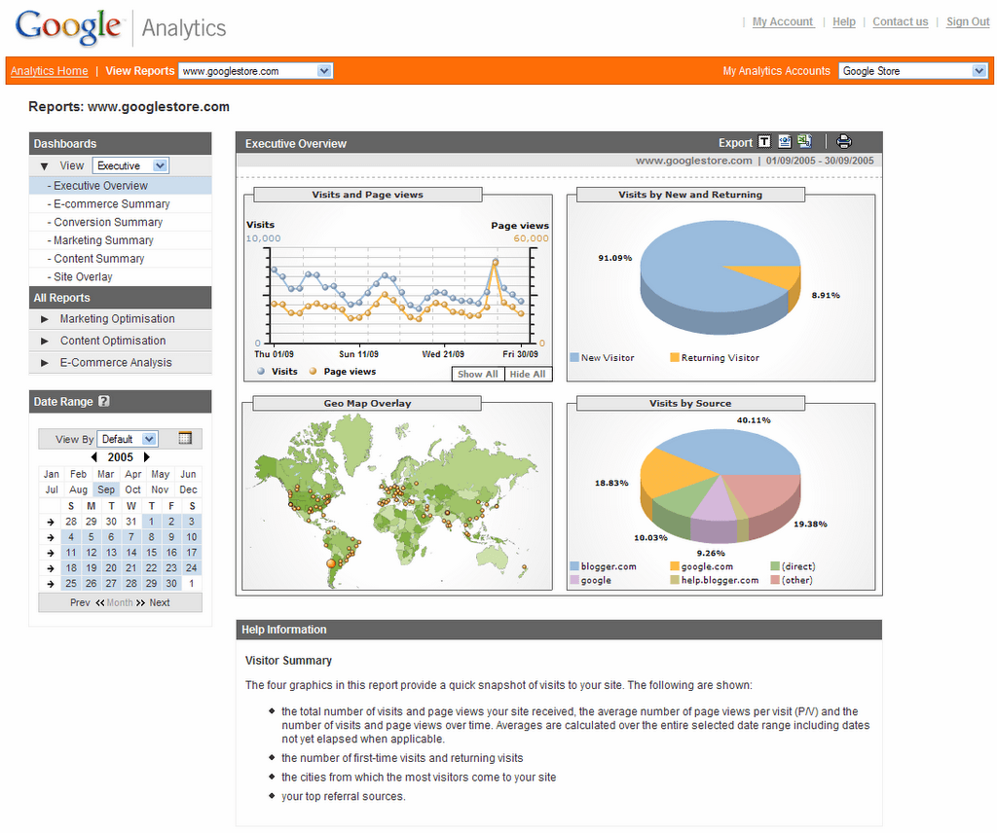
Image - https://www.websiteplanet.com/wp-content/uploads/2014/08/google_analytics_large.png
The image above displays an example of what Google Analytics can be used for. Clients can use the Google service to find out exactly how much traffic and page views their website receives each day. This information is broken down into pie charts and graphs making the information much easier to understand. This is an advantage for users as this allows them to see exactly how many visits their website has had a certain amount of days. This also includes the cities which most people can visit your site across the world.

How popular is Google ANALYTICS?
By using official information gathered from Google I have managed to find out there are other sources that provide estimated information of how many people use this service. By researching, I found out that over are 29.3 million websites using Google Analytics. This information has been gathered by BuiltWith, a website that tracks what software is being used on websites across the internet. Google is one of the most popular online company’s available out there on the internet.

Positive Impacts
- Google offers an Analytics service help to industries ensuring that everyone gets the most out of their information and use it to improve their website’s content.
- Analytics Users can view the exact Location demographics of their website visitors.
- Google uses data visualization tools including a dashboard, scorecards and motion charts, which display changes in data over time.

- Google Analysis is a free service to use, unlike some other providers who may charge to use their services. [3]

Negative Impacts of Google ANALYTICS
- Security experts have raised concerns about the Number of privacy issues in Google Analytics.

- All data must be viewed with caution. [4]

- Website links can break [5]

Improvements
Taking all negative point into consideration Google could introduce extra policies to prove to users that all issues are addressed, and any stored data can’t always be accurate. This must be followed using the Data Protection Act [6]and General Data Protection Regulations [7]which come into effect from May 2018.

Conclusion
Overall by summarising the amount of research, I have gathered throughout this report I have concluded that I can clearly and visually say that Google is a never-ending success which shall carry on for many years. I believe Google shall continue to expand their business ideas orientated as most businesses around the world choose to use this facility. Two Major examples for this is electrical company Panasonic and Travel website Airbnb. These are two famous company’s using Googles services to improve their websites further. This report has clearly discussed the chosen topic positively.

References

[1] | M. McGee, “s Google Analytics Turns 10, We Ask: How Many Websites Use It?,” Marketing Land, 12 November 2015. [Online]. Available: https://marketingland.com/as-google-analytics-turns-10-we-ask-how-many-websites-use-it-151892. [Accessed 10 April 2018].
[2] | C. Sparks, “10 Great Social and Web Analytics Tools,” 29 June 2007. [Online]. Available: https://www.searchenginejournal.com/10-great-social-web-analytics-tools/90629/. [Accessed 10 March 2018].
[3] | nexusadmin, “8 benefits of using Google Analytics.,” Nexus, 2010. [Online]. Available: http://www.nexuswebsites.co.uk/8-benefits-of-using-google-analytics/#blog-tabs. [Accessed March 2018].
[4] | R. Gill, “The Good and Bad of Google Analytics Real-Time Data,” 25 June 2013. [Online]. Available: https://www.web-savvy-marketing.com/2013/06/the-good-and-bad-of-google-analytics-real-time-data/. [Accessed 24th March 2018].
[5] | S. Barnes, “The upside down:Negative in Google Analytics,” lunametrics, 13 February 2018. [Online]. Available: https://www.lunametrics.com/blog/2018/02/13/negative-google-analytics-goals/. [Accessed 14 March 2018].
[6] | Gov, “Data-Protection,” Gov, [Online]. Available: https://www.gov.uk/data-protection.
[7] | G. Report, “GBDR,” 1 Feb 2018. [Online]. Available: https://gdpr.report/news/2018/02/01/gdpr-google-analytics-2/. [Accessed 08 April 2018].
[8] | L. Hay, “Google Analytics: The Basics Explained, and Pitfalls to Avoid,” sitepoint.com, 14 December 2017. [Online]. Available: https://www.sitepoint.com/google-analytics-basics-and-pitfalls/. [Accessed 2018 March 14].
[9] | K. Hines, “9 Awesome Things You Can Do With Google Analytics,” Kissmetrics, 2010. [Online]. Available: https://blog.kissmetrics.com/awesome-google-analytics/. [Accessed 21 March 2018].
[10] | M. Rouse, “Tech target,” [Online]. Available: http://searchbusinessanalytics.techtarget.com/definition/Google-Analytics. [Accessed 24 March 2018].

