Module Title: BMSW4002
Assignment Title: Effective Teamwork and Communication

Name: Costel-Ionut Porumba
Student Number:1920946
Module Lecturer’s Name: Akinseye Aluko

Contents
Introduction 3
Models of Communication 3
Shannon and Weaver model of communication 3
Schramm’s model of communication 5
Berol’s Model of Communication 6
Communication Skills 8
Verbal Communication Skills 8
Non-verbal Communication Skills 8
Written communication Skills 9
Listening Skills 9
Example of Poor Communication at the Workplace and how it could be improved 10
Conclusion 11
References 12

Introduction
Communication is the core of everything and creates the bridge between people, removes misunderstanding by exchanging information through a different medium (Oetzel, 20017). But all communication is not effective that means the conveyed message may not reach accurately to the desired person. The communication process is sometimes complex and Effective communication depends on the communication skills of both communicators (Blanchard and Johnson, 2020). To have a clear understanding of effective communication, this paper includes communication models, communication skills, examples of poor communication at workplace and those could be improved.

Models of Communication

Shannon and Weaver model of communication
In 1948, American mathematician, electronic engineer Shannon and scientist Weaver developed a model to improve technical communication among sender and receiver, and in their famous article titled “A Mathematical Theory of Communication”, they explained the theory and the model in details (Narula, 2006). Later, the model was used in various field of communication and widely known as the Shannon–Weaver communication model. Shannon and Weaver's model includes 7 key concepts of human communication namely-
- Sender or information source
- Encoder or transmitter
- Channel
- Decoder
- Receiver or destination
- Noise and
- Feedback
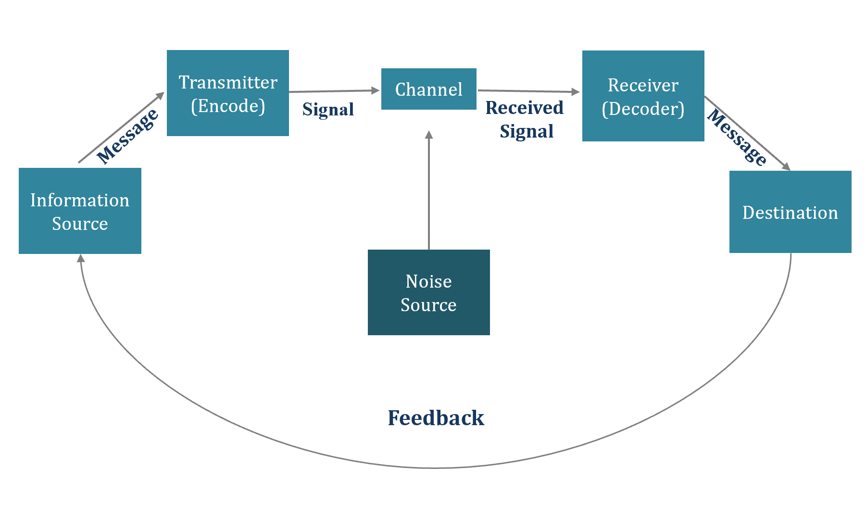
Shannon and Weaver Model of Communication (Narula, 2006)
The sender is the person who has the original message and chooses what to send, whom to send and how to send (Collins and Jim, 2001). The information source or the sender decides a suitable channel to send the message to the desired person or place. The encoder or the transmitter can be a machine or person that converts messages into signals so that it can be sent through the channels to reach the destination (Morgan, 2016). An example can be a radio station that can computers that encodes the words using different codes like binary digits. Channel is the medium that connects sender and transmitter with decoder and receiver. For example, when people talk on the telephone, the cables and electric wires are the channels. The Shannon –Weaver explained the concept of noise which means anything that can interrupt the understanding of the message during sending and receiving process and it can be any mistakes during encoding and decoding, poor internet connection, physical noise-like sounds of traffic etc. (Maund and Tinkler, 2017). The decoder is the opposite of encoder which decodes messages from the signals and brings back into a format that the receiver can understand. The destination or the receiver is the end-point of the process where the message is finally received by the desired person. Later, the concept of feedback was added where the receiver responds to the sender whether they got the message clearly or not (Magin, 2004). The model works best for a person to person communication rather than mass communication.
An example of this model can be watching the news on television. The sender is the news presenter. The encoder will be the microphone the new presenter is using that turns the voice into signals so that it can be sent through the television transmitter. The channel will be waves and cables. The decoder will be the television the person watching the news which will turn the signals into voice and picture.

Schramm’s model of communication
The famous scholar and communication theorist Wilbur Schramm in his book ‘The Process and Effects of Mass Communication’ explained a simple communication model. He introduced Schramm’s model of communication in 1954 and suggested that communication is a two-way circular process (Narula, 2006). This cyclical communication model explains how message flow in two directions and how communication between two people happens when they exchange information (Maund and Tinkler, 2017). The model also emphasis on encoding, decoding and interpretation of messages.

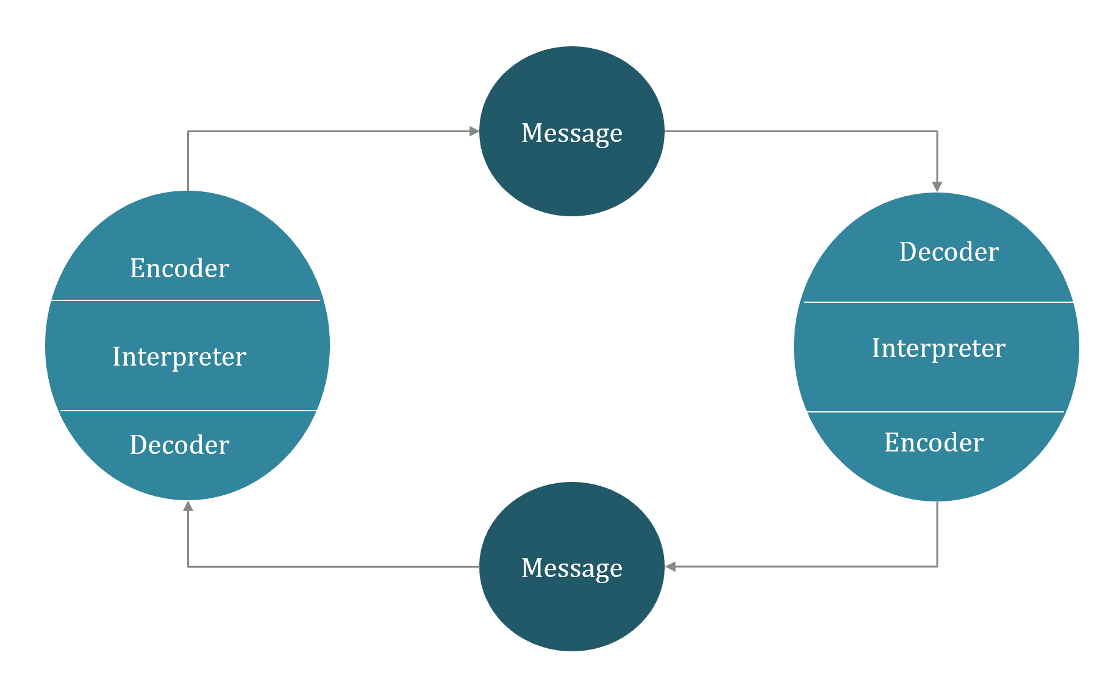
Schramm model of communication (Maund and Tinkler, 2017)
The model shows that two people in the communication act as both sender and receiver and use interpretation to convey the message (McQuail and Windahl, 2015). The sender or the encoder converts the thoughts into a message and initiates the process of communication. The decoder converts the encoded message into understandable language so that it makes sense to the message receiver (Oetzel, 20017). The message receiver and the interpreter are the same person and analyse the message so that they understand the meaning. Messages can be interpreted or misinterpreted because people can understand the message differently (Magin, 2004). According to this model, encoding and decoding are the important processes of communication and encoding, interpret, decoding takes place at the same time (Morgan, 2016). This model also talked about semantic noise which takes place during encoding and decoding. As Schramm’s is a two-way communication model, it gives both sender and receiver an opportunity to contribute equally, interact, share and receive feedback and all these ensure that the message is conveyed effectively (Maund and Tinkler, 2017).

Berol’s Model of Communication
Using Shannon-Weaver’s communication model, David Berlo developed Sender-Message-Channel-Receiver (SMCR) model in 1960 to make the communication more efficient and effective (McQuail and Windahl, 2015). Just like the previous two models, this model also includes encoding before sending the message and decoding before the receiver gets the message but, this linear model does not have the concept of feedback and noise.
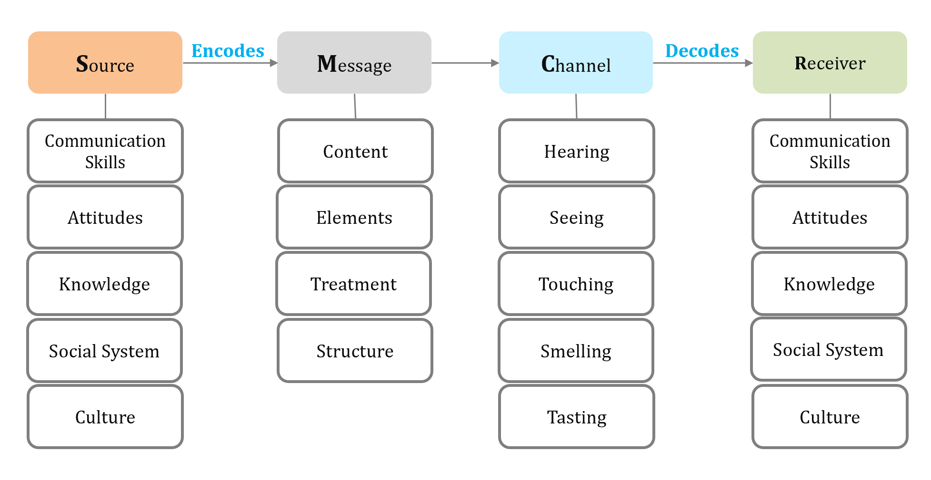
Berlo’s Model of Communication (McQuail and Windahl, 2015)
S-Source
The first element among the four elements of the communication process of this model is Source or sender. The source is the place where the message is created by the sender to send to the desired person or receiver (Morgan, 2016). Some factors that affect the source is given here-
- Communication skills of the sender to convey the message effectively that includes the skills to speak, listen, write, read etc.
- The positive or negative attitude of the sender which can change the meaning of the message.
- Sender’s clear knowledge about the subject matter of the message.
- Sender’s communication approach is affected by different social factors like values, beliefs, religion etc. (Magin, 2004).
- Cultural differences between sender and receiver can affect the communication.
M- Message
The message is the main content that senders want to send to the receiver which can be in different forms like voice, audio, text etc. (Magin, 2004). The factors that affect message are-
- Its elements which mean nonverbal contents like gesture and signs.
- Treatment means how the message is carried.
- How its structure is arranged
C-Channel
Channel or the medium of sending a message can vary according to the type of communication (Maund and Tinkler, 2017). For example, in mass communication technical machines, cables, internet telephone etc. can be channel but in a face to face communication human senses like- hearing, touching, seeing, smelling, tasting can be the channels of communication (McQuail and Windahl, 2015).
R-Receiver
The receiver is the final destination of the message and according to the model the receiver also has to have good communication skills, attitudes, knowledge etc. to get the message effectively (Magin, 2004). The factors that affect this element are the same as the source or sender.

Communication Skills
Understanding of different communication skills for successful and effective communication are outlined here-

Verbal Communication Skills
In every aspect of life, verbal communication skills are required to convey the message effectively and it is more than just talking and exchanging information by using words (Maund and Tinkler, 2017). Verbal communication includes how the speaker is delivering the message, the speaker’s appropriate tone of talking, language, words etc. (Blanchard and Johnson, 2020). As writing uses words just like verbal communication to convey a message, writing also considered a form of verbal communication. Verbal communication skills include the ability to listen actively, ability to speak, maintaining eye contact, body language etc. (Cenere and Lewis, 2015). Encouraging other people to participate in the conversation and asking questions is essential in verbal communication to clear any misunderstanding and to test understanding. For effective verbal communication, it is also necessary to receive feedback and check for clarification that the message is conveyed perfectly (Maund and Tinkler, 2017). An example can be the case study ‘MAX the MULTITASKER’ where Max did not listen to his client properly and missed the event date, a phone call before the event to confirm everything could clarify that the message has been received properly or not.

Non-verbal Communication Skills
Message can be received and sent without using words and it is known as non-verbal communication (Oetzel, 20017). When people communicate with each other, their non-verbal communication skills are as important as verbal communication skills, because non-verbal communication that means facial expression, gesture, tone of voice, posture, touch, space etc. make an impression on the listener which affects the way messages are received (Dalley and Burton, 2010). Some example of non-verbal communication can be smiling when conveying happy messages, maintaining eye contact, maintaining positive body language, handshakes etc. According to Maund and Tinkler (2017), non-verbal communication skills can be developed by learning how to manage stress while taking and by developing emotional awareness that includes understanding and reading other people, creating trust and responding in a way that shows the message is understood clearly.

Written communication Skills
Written communication is required in every stage of professional life, from applying to the job until sending mail to the managers (Cenere and Lewis, 2015). In the workplace written communication is essential to send a cover letter to managers, memo to co-workers reports to the client etc. Ensuring clarity by using simple language, maintaining conciseness by avoiding unnecessary details, keeping formal and friendly tone in writing, using active voice, paying attention to accurate grammar etc., are essential for effective written communication (Morgan, 2016). Written communication skills can be improved by having a clear mind-set before writing, gathering all resources, sorting the key points first and checking thoroughly before sending the message (Cenere and Lewis, 2015).

Listening Skills
In effective communication, listening is as important as speaking because developing listening skills can solve problems by understanding the information provided, reduce misunderstandings, resolve conflicts and improve the overall communication process (Collins and Jim, 2001). There are different forms of listening, among them active listening and empathetic listening to well-known ineffective communication. Active listening is the ability to pay complete attention to a speaker, showing attention, engagement, understanding the message and responding thoroughly (Covey, 1989). Active listening helps to connect with the speaker and improve understanding of the message (Forbes, 2020). Empathetic listening involves showing mutual concern, attention, compassion, and trust when listening to the speaker (Magin, 2004). Some qualities of empathetic listening are being focused closely on the conversation, patience, responsiveness etc. (Blanchard and Johnson, 2020). An example of poor empathic listening can be the same case study named ‘MAX the MULTITASKER. Max was busy talking with someone else when his client Tamara called over the phone and he tried to continue both conversations and missed the important message provided by Tamara. This poor effective and empathetic listening made a huge problem later. Listening skills can be improved by giving attention to the speaker, keeping an open mind to listen without judging, providing verbal affirmation etc. (Forbes, 2020).

Example of Poor Communication at the Workplace and how it could be improved
Poor communication can lead to misunderstandings that can make employees stressed and eventually reduced performance (Business Insider, 2020). I have observed some communication problems at the organisation I previously worked for. Very often senior managers provided the unclear and brief direction of the tasks which was hard to follow. Besides, sometimes they communicate through short and ambiguous emails instead of face to face conversation. Different rumours related to change of new manager, company policy, remuneration, co-worker’s personal life etc. spread around the office which distracted employees from their actual responsibilities. This gossip and rumours not only hampered jobs but also led to cultural conflict and bad feelings which are not appropriate for the workplace environment.
To optimise the performance of employees, implementing effective communication is essential (Husain, 2013). The above problems could be improved by implementing effective communication strategies. Some suggestions are given here-
- Providing Notes and Specific Set of Expectation
After finishing the meeting, the managers can provide notes and specific set of expectation to the employees so that everyone gets a clear understanding of what to do and what the managers are expecting from them (Kyllonen, 2013). Clear instructions will help employees to stay focused and complete the task within the deadline (Business Insider, 2020).
- Promoting Feedback and Two-way Communication
Instead of sending simple handouts, emails or text messages, managers need to communicate face to face with their employees so that they get a chance to ask more questions to clear confusions (Husain, 2013). Besides, two-way communication enables getting feedback, giving others to share their ideas and all of this improves employee engagement (Oetzel, 20017).

- Taking Measures to Prevent miscommunication
The best way of implementing effective communication is to preventing miscommunication between managers, employees and co-workers (Collins and Jim, 2001). The need to be transparent about their rules, policy and decisions. Besides, the organisation can establish communication standards with expected communication practices so that everyone can follow those (Kyllonen, 2013). All of this will reduce unnecessary rumours and gossip within the organisation. Moreover, arranging a workshop on effective communication, team engagement, adaptability and cultural diversity can also improve workplace communication (Dalley and Burton, 2010).

Conclusion
Developing effective communication skills is a must for maintaining both the workplace and personal communication. Effective communication at workplace ensures better team working, better working relationship with workers and improved productivity. Understanding different communication models and communication skills can help to foster effective communication. The organisations need to implement different strategies to improve employees’ communication skills and that will increase productivity at the workplace. Besides, good communication skills help to express ideas and thoughts which can improve personal relationships.

References
Blanchard, K.H., Hersey, P. and Johnson, D.E. (2000) Management of organizational behavior: Leading human resources. 8th edn. United Kingdom: Prentice Hall
Business Insider. (2020). An Executive Coach Reveals 4 Secrets Of Effective Communication At Work. [online] Available at: <https://www.businessinsider.com/secrets-of-effective-communication-at-work-2016-7> [Accessed 24 August 2020].
Cenere, P., Gill, R., Lawson, C. and Lewis, M. (2015). Communication Skills for Business Professionals 7. Cambridge University Press.
Covey, Stephen R. (1989) The 7 Habits of Highly Effective People: Powerful Lessons in Personal Change. 5th edn. New York: Simon and Schuster.
Collins, J.C. and Jim, C. (2001) Good to great [why some companies make the leap ... And others don’t]. 4th edn. New York, NY: HarperCollins Children’s Book Group
Dalley, D., and Burton, L. (2010) Developing your Influencing Skills: How to influence people by increasing your credibility, trustworthiness and communication skills (2010) Universe of Learning Ltd
Forbes. (2020). Council Post: Improve Your Active Listening Skills With These 13 Strategies. [online] Forbes. Available at: <https://www.forbes.com/sites/forbescoachescouncil/2018/11/14/improve-your-active-listening-skills-with-these-13-strategies/#4e55d9735827> [Accessed 24 August 2020].
Husain, Z. (2013). Effective communication brings successful organizational change. The Business & Management Review, 3(2), p.43.
Kyllonen, P.C. (2013). Soft skills for the workplace. Change: The Magazine of Higher Learning, 45(6), pp.16-23.
McQuail, D. and Windahl, S. (2015). Communication models for the study of mass communications. Routledge.
Morgan, P. (2016). The Business Student’s Guide to Study and Employability. Sage Publications.
Maund, A. Schriek, M. and Tinkler, P. (2017). Certificate in Higher Education: Skills for the Workplace Student Yearbook. Sage Publications.
Magin, M. (2004) Making teams Work: 24 Lessons for working together successfully. McGraw-Hill Pub.
Narula, U. (2006). Communication models. Atlantic Publishers & Dist.
Oetzel, J.G. (2017). Effective intercultural workgroup communication theory. The International Encyclopedia of Intercultural Communication, pp.1-5.

