Name: Rhiannon Blythe
Student number: 1404928
Module number: M4X01559
Lecturer: Gwenllian Beynon
Overall word count: 1353

The Theme of Protesting within Punk Art

My imagined exhibition is going to explore the idea of protesting within Punk art and how this type of art is used to make a statement against the establishment and authority. The Punk subculture of the late 1970’s was focused on rebellion and would often rebel against certain political issues, and the artwork that was made during this time often showed imagery that may have shocked or disturbed a viewer, in order to make them feel certain emotions.
For example, Sid Vicious, the bassist for the Sex Pistols, would often wear a shirt daubed with a swastika, and although this was horrendously controversial and incredibly offensive, he did not practice Nazi ideologies and simply wore the shirt as a way to cause controversy and draw attention to the band for being very offensive and get reactions from critics and people who disagreed with the Punk movement. Melody Weckel, writing for the Odyssey, explained that, “The intent wasn’t to alienate those who were Jewish or to spread an anti-Semitic message.”
Connecting this back to the idea that Punks wanted to rebel and protest against those in authority and those who were holding them back, this ideology of shocking and disturbing an audience in order to gain a reaction carries through to the art of the time, and continues to be prevalent in Punk art from later years. Although not all of the artworks I chose are outwardly protesting against anything, the historical context of the image is what makes them important and connects them to my theme.
I decided to look at artworks by Jamie Reid, Ben Brown, Banksy, Shirley Baker, and John Holmstrom, as they are all notable within art and focus on the theme of protest either within their work or the context behind it. I have a strong interest in Punk music and the Punk subculture and how it evolved, and how people treat it nowadays. It is a fascinating look at how teenagers became the leaders of a subculture that was full of strength and passion for what they believed in, and although Punk is no longer prevalent in our society today, its influence lives on in those who were teenagers in the 70’s and young people who discover it in today’s day and age.

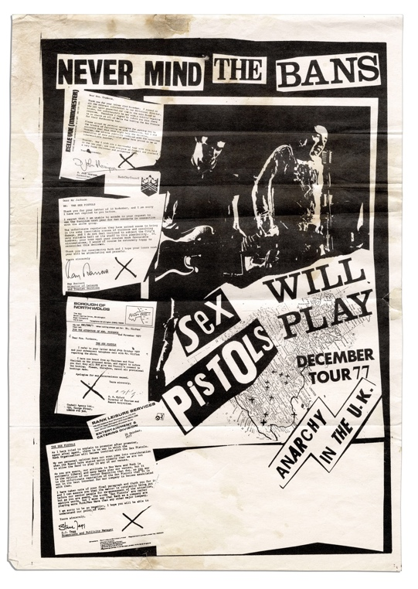
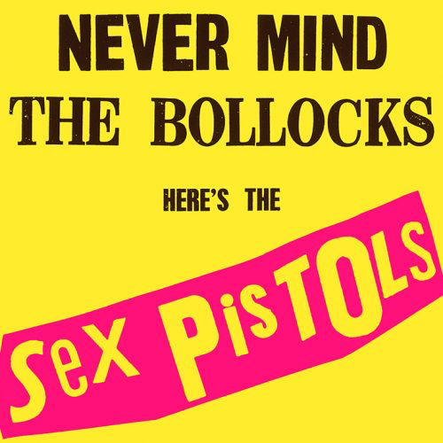
Jamie Reid, Never Mind the Bans,
Sex Pistols will play, 1977
Jamie Reid, Never Mind the Bollocks, Here’s the Sex Pistols, 1977

Jamie Reid is an artist best known for his work with the Sex Pistols, an influential (and controversial) punk band from the 1970’s Punk era. This era was a step forward for punk music and the album cover and touring poster made by Reid are at the forefront of the major Punk subculture and movement.
The album Never Mind the Bollocks, Here’s the Sex Pistols was highly controversial and sparked a lot of backlash when it was first released to the public in 1977. A quote from the book The Art of Punk by Russ Bestley and Alex Ogg, explains this.

“The album cover used deliberately loud fluorescent colours and a provocative title
which led to further media attention and a court appearance on obscenity charges
for a record shop owner in Nottingham, UK, and Virgin Records boss Richard
Branson. The case did little to calm the controversy surrounding the group.” (41)

I have chosen these two artworks for this reason. Both pieces are a commentary on rebellion (it especially appealed to teenagers who wanted to rebel against their parents). The language used on the cover, that some may find obscene or offensive, on the front of the Sex Pistols cover caused a lot of problems, and many shops had to censor the offending word as it was deemed unsuitable. Top of the Pops refused to play the Sex Pistols’s song, God Save the Queen, even though it had hit number one in the charts, as it was deemed disrespectful to play during the time of the Silver Jubilee, which was ongoing at the time.
The Sex Pistols also had trouble with their concerts, as explained in the book The Art of Punk, “Never Mind the Bans tour refers directly to a series of cancelled gigs during one year” which reinforces the idea that the Sex Pistols were protesting against the bans and censors as a way of rebelling against authority and in an attempt to get their messages heard by the Punk youth of that era.

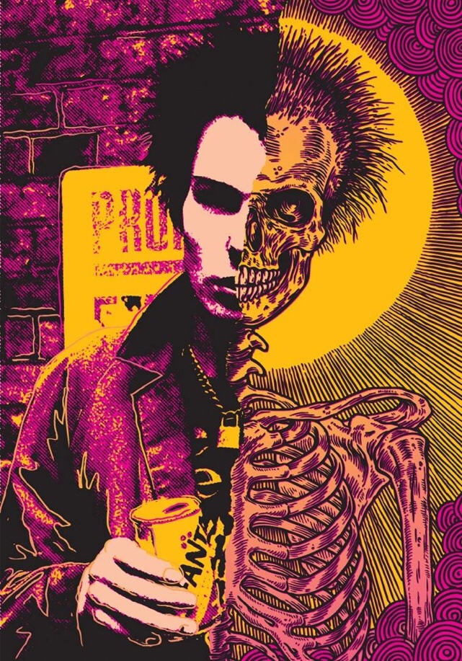
Ben Brown, Die Young/Sid Vicious, 2011

This artwork by Ben Brown is a more modern example of how Punk art has evolved with time. His illustration of Sid Vicious is particularly impactful, due to the fact that many believe the Punk lifestyle was Vicious’s downfall. Sid Vicious is the epitome of the Punk image, and although he couldn’t play bass or sing very well either, his image fit the Sex Pistols and the Punk subculture so well that he’s known by many as a Punk icon. I decided to include this image in my exhibition as it connects with the previous pieces (Jamie Reid’s album cover and poster) and it is also very visually interesting and has a lot of original Punk vibes to it. It’s a much more modern take on Punk art and the production value is clearly a lot higher. Punk art in the 1970’s was made cheaply, and posters were often copied in grayscale, pasted together with newspaper clippings and mass produced for very little money, meaning the wok always looked low maintenance. This fit well with the Punk subculture as part of the appeal was rebelling against capitalism and unfair distribution of money, meaning that making their posters and album covers as cheap as possible, went against the idea that music record and posters always had to have high production value. Brown’s work fits well into this, as, although the illustration itself has a high production value, the overall appearance of it fits well into the Punk image (the thick black lines and bright colours especially). Similarly to the Sex Pistols album cover, this piece uses fluorescent colours and thick blocks of these bright colours to draw attention to the piece itself. This illustration is also very visually similar to Pop Art, which was a big influence for a lot of Punk artists. John Holmstrom, in an interview for the book The Art of Punk stated that “the biggest influences on punk from the art scene were minimalism and Pop Art” (22) and that “cartoonists are most subversive and use visuals as a weapon” (23) which I think is very true to Brown’s work, wether he intended it to be that way or not.
I decided to place this image in the same area of my exhibition as Jamie Reid’s work as they relate well visually and the content and context of the images themselves are very visually similar.
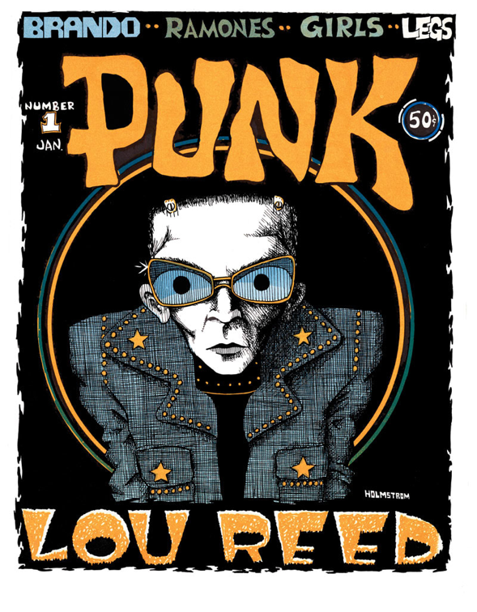
John Holmstrom, Punk #1 Lou Reed, 1976
John Holmstrom’s work is very similar to Brown’s work, and in the book The Art of Punk, Holmstrom explains, “we couldn’t afford typesetting… we established a radical look that… marked our own territory.” (22) This focuses on the idea that the Punk subculture were protesting against the idea that art needed to look high quality, or expensive. Punk art was the exact opposite of this and Punk fashion was similar, as seen in Shirley Baker’s photographs of young Punks, which will be displayed in the same room as Holmstrom’s work.
Shirley Baker, Punk, 1986 -91
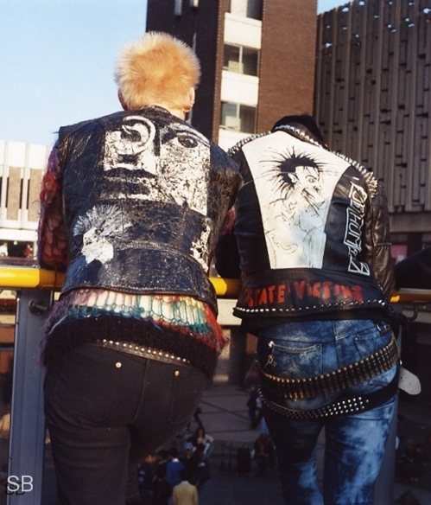
The final artwork I chose to display is Banksy’s graffiti mural called Punk Mum. This mural shows a different side to the Punk movement, implying that the protesters go home to their mothers and live safely and happily, and are somewhat ‘mummy’s boys’ at home. This connects to the idea that a lot of Punk was based around money, which is different to the subculture the Punk music bred. The Sex Pistols are often considered to be a band that advertised clothing for Vivien Westwood, and that the members of the band were not as invested in the Punk lifestyle as they were thought to be.
However, Banksy’s work is also a work of protest in itself, as graffiti is an illegal act, the artwork is essentially illegal. Although some do consider Banksy’s work to be art, some think it’s a pest and disagree with him making this artwork illegally.
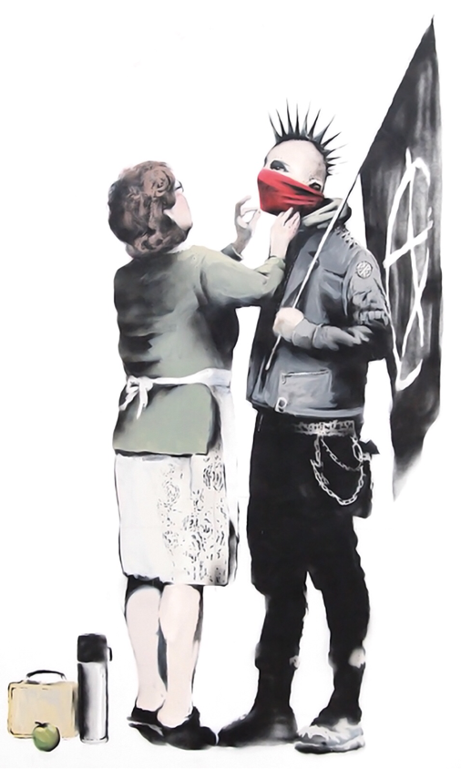
Banksy, Punk Mum (date unknown)

My proposed layout in the Mission Gallery
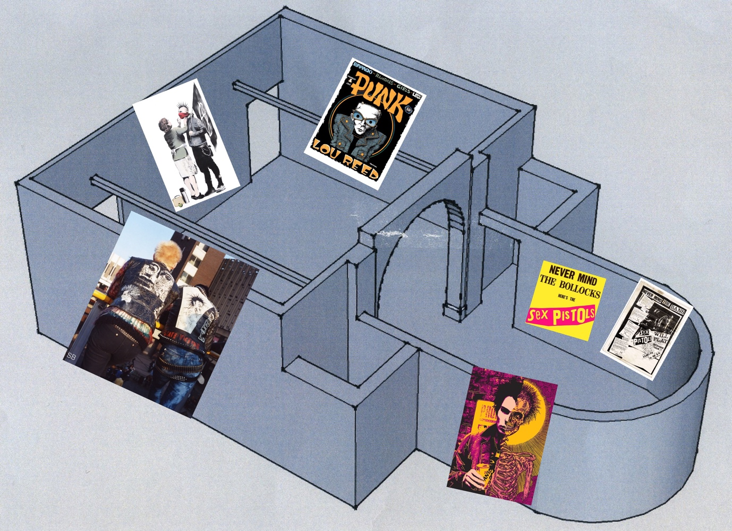

Reference list
Baker, S. (1986 – 91), Punk, [photograph], [date viewed: April 30th 2018], Available at: http://shirleybakerphotography.com/punk/

Banksy, (date unknown), Punk Mum, [graffiti mural], [date viewed: April 30th 2018], Available at: http://www.banksy.co.uk/#

Besttley, R. Ogg, A. (2012), The Art of Punk, Omnibus Press, Elephant Book Company Ltd (Pages: 22, 23, 39, 41)

Brown, B. (2011), Die Young/Sid Vicious, [etching], [date viewed: April 30th 2018], Available at: http://obsessedwithskulls.com/blog/?p=3155#.Wu8I-hbTXYU

Goldman, V. The Guardian, (2014), Never Mind the swastikas: the secret history of the UK’s ‘punky Jews’, [online], The Guardian, [date viewed: April 30th 2018], Available at: https://www.theguardian.com/music/2014/feb/27/never-mind-swastikas-secret-history-punky-jews

Holmstrom, J. (1976), Punk #1 Lou Reed, [magazine cover], [date viewed: April 30th 2018], Available at: http://www.45worlds.com/magazine/issue/punk-1-1

Reid, J. (1977), Never Mind the Bollocks, Here’s the Sex Pistols, [album cover], [date viewed: April 30th 2018], Available at: https://en.m.wikipedia.org/wiki/Never_Mind_the_Bollocks,_Here%27s_the_Sex_Pistols

Reid, J. (1977), Never Mind the Bans, Sex Pistols will play, [poster], [date viewed: April 30th 2018], Available at: https://www.justcollecting.com/music-memorabilia/uk-scarce-sex-pistols-tour-poster

Weckel, M. Odyssey, (2016), Why 80s UK Punks wore swastikas, [online], Odyssey, [date viewed: April 30th 2018], Available at: https://www.theodysseyonline.com/why-80s-uk-punks-wore-swastikas

