

Research on Collaborative Adaptive Cruise Control Strategies Considering Communication Delays
by
Mingyang Zhu

Supervisor: Michael Dacey

September 2023

Abstract:
This research delves into the Collaborative Adaptive Cruise Control (CACC) system and proposes a robust car-following control algorithm grounded in the principles of fuzzy Proportional-Integral-Derivative (PID) control. Initially, we establish a nonlinear vehicle dynamics model that takes into account driver delay and acceleration constraints. Subsequently, we devise a hierarchical control structure, featuring both upper and lower controllers. The upper controller takes inputs in the form of the velocity differential between the leading and trailing vehicles and the spacing error, generating the target acceleration for the following vehicle as output. Meanwhile, the lower controller, utilizing the target acceleration as its input, manages the throttle aperture and brake master cylinder pressure for the following vehicle. Moreover, in the quest for optimized performance, we further refine the determination of the target spacing by considering the relative velocity between the leading and trailing vehicles, as well as the acceleration of the leading vehicle. This approach, as evidenced by experimental trials, outperforms the conventional variable safe distance model, notably enhancing both vehicle acceleration and deceleration, consequently elevating road utilization and driving safety. In addressing the influence of communication latency on CACC system stability, this study introduces the Convolutional Neural Network-Long Short-Term Memory (CNN-LSTM) approach, which effectively mitigates communication delay by predicting future car-following states. We conduct comprehensive simulation experiments within the Simulink/Carsim co-simulation environment. Our findings reveal that under variable-speed following conditions characterized by a communication delay of 0.5 seconds, the CACC system employing the CNN-LSTM algorithm exhibits superior car-following stability. This is exemplified by a maximum spacing error not exceeding 0.3 meters, signifying a substantial enhancement in platoon driving safety.

1 Research Background
Adaptive Cruise Control (ACC) is a prevalent feature in modern automobiles, especially on highways, enhancing driver comfort and convenience. Nevertheless, ACC technology possesses inherent limitations. It operates solely based on the behavior of the preceding single vehicle, lacking awareness of the broader context involving the entire vehicle fleet. Consequently, this can result in frequent acceleration and deceleration when navigating congested roadways, adversely impacting ride comfort and driving fluidity. Cooperative Adaptive Cruise Control (CACC) represents an evolutionary step beyond ACC, augmenting it with communication and collaborative capabilities among fleet vehicles.

In the CACC framework, the leading vehicle within the fleet employs sensors to gather road and traffic data, which is then communicated to trailing vehicles. Subsequent vehicles autonomously adapt their speed and following distances in response to this transmitted information, facilitating synchronized fleet movement. This reduction in abrupt acceleration and deceleration within the fleet context yields enhanced safety, traffic efficiency, and fuel utilization.

Extensive global experimental research has been dedicated to CACC systems. Nevertheless, real-world vehicle tests often yield results that deviate significantly from simulation outcomes, at times demonstrating disparities several or even tens of times larger. Notably, the field of vehicle-to-vehicle communication technology introduces varying degrees of latency among different communication systems. Traditional Dedicated Short-Range Communication (DSRC) systems and Long-Term Evolution (LTE) systems exhibit notable communication delays, typically ranging from approximately 250-600ms and 180-300ms, respectively. In hybrid DSRC-LTE networks, an average latency of about 110-150ms prevails[1].

Elevating the challenge, as communication latency escalates from 0.02s to 0.1s, the minimum following distance must double to maintain string stability. To address this concern, Sinan Öncü[2] has proposed a CACC controller that explicitly accounts for communication delay, diligently exploring its implications on string stability. This research elucidates that if communication delay surpasses 50ms, string stability stands compromised. Furthermore, Haitao Xing[3] has derived the connection between the minimum string-stable inter-vehicle spacing within CACC platoons and communication delay. The findings underscore that as communication delay increases from 0.02s to 0.1s, the minimum following distance must be doubled to uphold string stability.

Additionally, Ploeg has conducted simulations to determine the minimum safe distance for platoon driving, considering scenarios with and without communication delay. This evaluation assumes vehicles traveling at a speed of 90km/h in the absence of communication delay. In this scenario, the minimum following distance satisfying stability criteria stands at 2.5m, disregarding vehicle length. However, when the actual communication delay stands at 0.02s, vehicles necessitate maintaining a following distance of 3.75m.

Huang Lu failed to account for communication delays when implementing the sliding mode control for designing the CACC controller. In experiments involving variable-speed tracking, the speed errors recorded from the actual vehicle ranged from -2 to 2 m/s², while the position errors ranged from -10 to -5 meters, resulting in subpar performance. Cheng Long, in the application of the H-infinity CACC controller, demonstrated that in simulation results, the maximum longitudinal error was approximately 5 meters (at a speed of 50 km/h), and the maximum speed error was around 5 km/h. However, during real vehicle tests, the longitudinal distance error exceeded 15 meters (at a speed of 50 km/h), with the maximum speed error reaching about 10 km/h. Additionally, lane-keeping functions exhibited more pronounced oscillations compared to the simulation results.

Luo Ruoyu applied the MPC algorithm to the design of the CACC controller. In simulation results at a leading vehicle speed of 100 km/h, the spacing error ranged from -1 to 2 meters for various communication topologies[4]. However, in real vehicle tests, when the leading vehicle speed was only 35 km/h, the spacing error ranged from -2 to 4 meters, and the performance fell significantly short of the simulation.

It is evident that communication delays, actuator errors, and low algorithm real-time performance lead to significantly poorer performance in real vehicle tests compared to simulation results. In severe cases, these factors can even impact the string stability of the platoon, presenting challenges to the practical application of CACC controller algorithms. Consequently, in recent years, an increasing number of researchers have shifted their focus towards technologies and methods aimed at mitigating the impact of communication delays on platoon driving stability.

Shi Yuan Han, utilizing the traditional LQR algorithm, initially formulated a platoon model that accounts for delays. Subsequently, he established a system model and an evaluation function without delays and incorporated the no-delay model into the delay model. By deriving solutions from the equivalent control problem and performance metrics of the CACC system without delay reconstruction, he introduced a delayed centralized longitudinal controller.

Yi Liu[5] conducted Fourier transforms on signals collected both with and without communication delays and deduced the transformed relationships. Through simulation tests, it was determined that when employing DSRC systems, LTE, hybrid DSRC-LTE networks, and 5G communication in conjunction with integrated communication delay models, the risk of rear-end collisions could be reduced by 60%, 74%, 85%, and 96%, respectively. In an ACC queue, only one following vehicle can respond to the acceleration oscillations of the preceding vehicle. However, in a CACC queue employing 5G+ communication delay models, at least three following vehicles can respond to the acceleration oscillations of the preceding vehicle.

Addressing the challenge of continuously fluctuating delays in vehicle queues during heterogeneous network transmission, Liao Xiaoxin devised a CACC controller utilizing linear matrix inequalities. By resolving the issue of converting nonlinear matrices into linear ones, he demonstrated through simulations that the string stability of the vehicle queue cruise control system remained intact even when considering actuator delays and heterogeneous wireless network transmission delays.

In a similar vein, Lian Cui[6] developed a robust model predictive cruise controller grounded in linear matrix inequalities (LMI) optimization. He established a fresh state-space model for a CACC heterogeneous vehicle system, accounting for uncertainty, input constraints, and time-varying delays. The Lyapunov-Krasovskii method was employed to scrutinize the stability of the closed-loop system, and simulation results illustrated the commendable performance of the proposed controller.

Lipu Wu[7] implemented the linear matrix inequalities optimization-based robust model predictive control approach in CACC heterogeneous vehicle systems. This methodology integrated factors like inter-vehicle communication range, input constraints, and time-varying delays into the control model. An optimization problem based on linear programming was formulated and resolved through the computation of the state feedback control law, addressing optimization challenges rooted in linear matrix inequalities (LMI)[8].

Saito[9] introduced a rear measurement technique, employing a Smith predictor for delay compensation. This approach amalgamated the control signal with the delay estimation signal, incorporating rear vehicle spacing for feedback control while comprehensively integrating it with front vehicle spacing. Research findings demonstrated the attainment of a stable CACC system with reduced communication traffic.

Similarly, Wang Jiawei harnessed a Smith predictor to contend with communication delays. Upon analysis, it was discerned that using following vehicles to detect information from the preceding vehicle and employing a Smith predictor only eliminated actuator delays, not communication delays. Consequently, Wang Jiawei employed the front vehicle's millimeter-wave radar to collect data on the rear vehicle's distance and velocity difference. Combining this information with its own acceleration data, the desired acceleration of the following vehicle was determined, with the Smith predictor facilitating compensation for transmitted communication delays.

Numerous prevailing delay compensation techniques entail predicting the future states of preceding or target vehicles, encompassing parameters like their positions, velocities, and accelerations. Such methods necessitate precise estimation of vehicle dynamics and accurate forecasting of future driving actions. Nevertheless, when confronted with uncertainties, existing delay compensation prediction techniques may fall short of achieving optimal results. In response, Yu Zhang[10] adapted the widely utilized Cooperative Adaptive Cruise Control (CTG) strategy to formulate the Semi-Constant Time Gap (Semi-CTG) strategy. This strategy employs a linear feedback control law to regulate spacing errors and leverages historical data rather than instantaneous information. Consequently, communication delays are fully mitigated, yielding enhanced stability performance.

Jihong Liu[11] introduced a CACC system that takes into account dynamic network topology and communication delay jitter. This system encompasses the design of a multi-vehicle forward-looking network topology control. Control parameters are derived by solving algebraic Riccati equations, and the relationship between the minimum following distance and communication delay is examined under varying network topologies. Simulation results establish that, with a communication time delay of 0.26 seconds, the spacing error remains below 0.5 meters.

This study employs deep learning techniques, specifically Long Short-Term Memory (LSTM) neural networks. These networks take historical data such as vehicle speed, distance, and acceleration, inputted as a sequence, to learn intricate nonlinear relationships between vehicles and predict future car-following states. These predictions prove valuable in scenarios with communication delays, enabling car-following control based on LSTM forecasts without reliance on real-time communication data. This capability serves to mitigate the adverse effects of communication delays on car-following control.

2 Vehicle Model Development and Validation

2.1 Vehicle Dynamics Modeling and Sub-Controller Design
Carsim software, developed by the Mechanical Simulation Corporation (MSC), holds a prominent position in the realm of automotive engineering. It possesses the capability to simulate vehicle responses, road conditions, and aerodynamic inputs. This potent tool primarily serves the purpose of designing and analyzing vehicle control systems, playing a pivotal role in the research and optimization of vehicle performance. Vehicle dynamics modeling, a complex yet indispensable field, empowers engineers to simulate vehicle behavior under diverse conditions, thus enabling assessments of performance, safety, and stability. By establishing mathematical models to encapsulate a vehicle's dynamic characteristics, researchers attain a comprehensive comprehension of vehicle behavior and can conduct a multitude of simulation experiments, negating the necessity for costly real-world road testing. This approach substantially economizes both time and resources. In this paper, the Carsim software will be employed for vehicle dynamics modeling, with a focus on a C-class car chosen as the simulated vehicle, and the requisite parameter settings will be specified[12].
set as follows.
Table 1. Vehicle dynamics models and environmental parameters
Parameters name | Symbol | Unit | Numerical value
Vehicle mass | $$M$$ | kg | 1412
Main reduction ratio | $$R_{m}$$ | - | 4.1
Direct gear | $$N$$ | - | 4
Distance from the vehicle CG to the front axle | $$a$$ | $$mm$$ | 1015
Distance from the vehicle CG to the rear axle | $$b$$ | $$mm$$ | 1885
Wheel rolling radius | r | $$mm$$ | 325
Air density | $$ρ$$ | $$kg/m^{3}$$ | 1.206
Wheel track | $$d$$ | $$mm$$ | 1916
height of the center of mass | $$H$$ | $$mm$$ | 540
Gear ratio | $$R_{g}$$ | - | -
coefficient of air resistance | $$C_{D}$$ | - | 0.3
rolling resistance coefficient | $$f$$ | - | 0.02
transmission efficiency | $$η$$ | - | 0.9
attachment coefficient | $$φ$$ | - | 0.9
Engine’s power | $$P$$ | kW | 125

All vehicles are equipped with standard 215/55 R17 tires and a 6-speed manual transmission. Notably, the direct gear corresponds to the 4th gear, featuring a speed ratio of 1. Additionally, these vehicles are fitted with independent suspension systems. Furthermore, to accommodate the simulation requirements for a diverse range of vehicle models, each vehicle is outfitted with a 125 kW engine[13].

2.1.1 Vehicle Inverse Longitudinal Dynamics Modeling
In this section, we will establish both the entire vehicle inverse engine model and the inverse braking system model. These models serve the essential function of translating computed acceleration values from the upper-level controller into corresponding throttle openings and master cylinder pressures. This step assumes paramount importance in the realms of vehicle dynamics research and control system design.

To begin, let us delve into the creation of the inverse engine model. Within the domain of vehicle dynamics, the inverse engine model constitutes a mathematical framework elucidating the response characteristics of the vehicle's engine, including how to regulate throttle openings based on desired acceleration. This endeavor necessitates the consideration of various factors, such as engine power curves, torque curves, and air flow rates[14]. The establishment of this inverse engine model enhances our comprehension of the engine's behavior, thereby enabling precise acceleration control.
Subsequently, the formulation of the inverse braking system model is of equal significance. This model serves the purpose of delineating the correlation between master cylinder pressure and the desired deceleration. It encompasses the characteristics of the braking system, encompassing factors like the friction coefficient of the brake discs and the mechanical attributes of the brakes[15]. Through the establishment of the inverse braking system model, we gain improved control over the vehicle's braking behavior, thereby ensuring safety and enhancing passenger comfort.

During the model creation process, it is imperative to consider the vehicle's characteristics, with a particular focus on passenger comfort. To mitigate the occurrence of frequent transitions between acceleration and braking, the introduction of a buffer zone is a viable strategy. This buffer zone functions as a control mechanism, affording the vehicle a defined transitional region between acceleration and braking, thereby mitigating unnecessary shocks and jolts, ultimately enhancing passenger comfort[6].
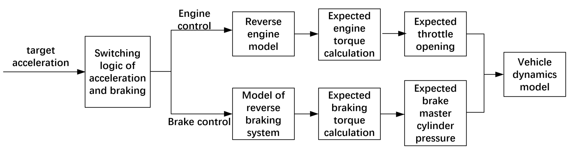
Figure 1. The control process of the vehicle inverse dynamics model

2.1.1.1 Inverse Engine Modeling for Automobiles
When an automobile travels on a road with an anticipated acceleration, denoted as $a_{des}$, its motion equation can be expressed as follows:

$Ma_{des}=F_{t}-\sum{f}$ (1)
For this study, we selected a flat road with a length of 3 kilometers and set the coefficient of adhesion to 0.9. This choice was made to provide a simplified road condition, facilitating a more in-depth exploration of the vehicle's motion characteristics. In this context, we can break down the total resistance into two components: tire air resistance and rolling resistance, with no consideration of slope resistance:
$\sum{f}=\frac{1}{2}C_{d}Aρv^{2}+Mgf$ (2)
Assuming no deformation in the transmission system and disregarding mechanical clearances, the driving force of the vehicle can be defined as follows:

$F_{t}=\frac{ηT_{e}τ(\frac{w_{t}}{w_{e}})i_{g}i_{0}}{r}$ (3)
$K_{t}=\frac{ητ(\frac{w_{t}}{w_{e}})i_{g}i_{0}}{r}=\frac{ητ(\frac{vi_{g}i_{0}}{rw_{e}})i_{g}i_{0}}{r}$ (4)
$F_{t}=K_{t}T_{e}$ (5)
Here, $K_{t}$ represents a real-time variable, the calculation of which relies on the torque characteristics of the torque converter [13]. This torque converter plays a critical role in the automobile transmission system, responsible for transmitting the engine's output torque to the wheels, thus propelling the vehicle. The torque converter's performance is intricately linked to the vehicle's power transmission and fuel efficiency, underscoring the importance of precise modeling and control.

The term $\frac{w_{t}}{w_{e}}$ signifies the speed ratio of the torque converter, reflecting the ratio between the turbine wheel and the pump wheel in the torque converter. This speed ratio exerts a substantial influence on the operational state and efficiency of the torque converter. Meanwhile, $τ(\frac{w_{t}}{w_{e}})$ captures the relationship between the torque ratio and the speed ratio, delineating the torque output of the torque converter under varying speed ratios.

To compute the $K_{t}$ module, we employ the structure depicted in Figure 2, which illustrates how to estimate $K_{t}$ based on the torque characteristics of the torque converter and the interplay between speed ratio and torque ratio. This calculation module stands as a pivotal component of the automobile power transmission system, empowering real-time monitoring and control of the torque converter's performance, ultimately optimizing the vehicle's power transmission and fuel efficiency.
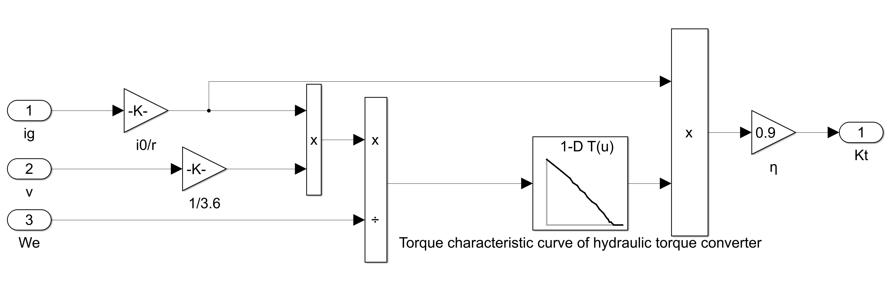
Figure 2. The computing module of $K_{t}$
The expression for the desired engine torque can be formulated as follows:
$T_{des}=\frac{Ma_{des}+\sum{f}}{K_{t}}$ (6)
Combining equations 2 and 6 yields:
$T_{des}=\frac{Ma_{des}+\frac{1}{2}C_{d}Aρv^{2}+Mgf}{K_{t}}$ (7)
In the realm of vehicle dynamics modeling, many research papers also incorporate the consideration of inertial torque generated during the acceleration process due to rotational mass. Typically, this consideration is quantified by introducing a parameter known as the rotational mass conversion coefficient (δ), aimed at quantifying this inertial torque:
$T_{des}=\frac{δMa_{des}+\frac{1}{2}C_{d}Aρv^{2}+Mgf}{K_{t}}$ (8)
Figure 3. The conversion coefficient of the rotational mass[20]
We set the initial speed of the vehicle to be 10 km/h, the target acceleration to be 0.2g, and the duration to be 8 seconds. Simulations were conducted for two different models. By simulating and verifying these different models, we can compare their performance and applicability to determine which model better matches real-world conditions. This comparison is crucial for vehicle engineering and control system design, as it helps us optimize vehicle performance and ensure it performs well in various situations. The simulation results are shown in Figure 4.
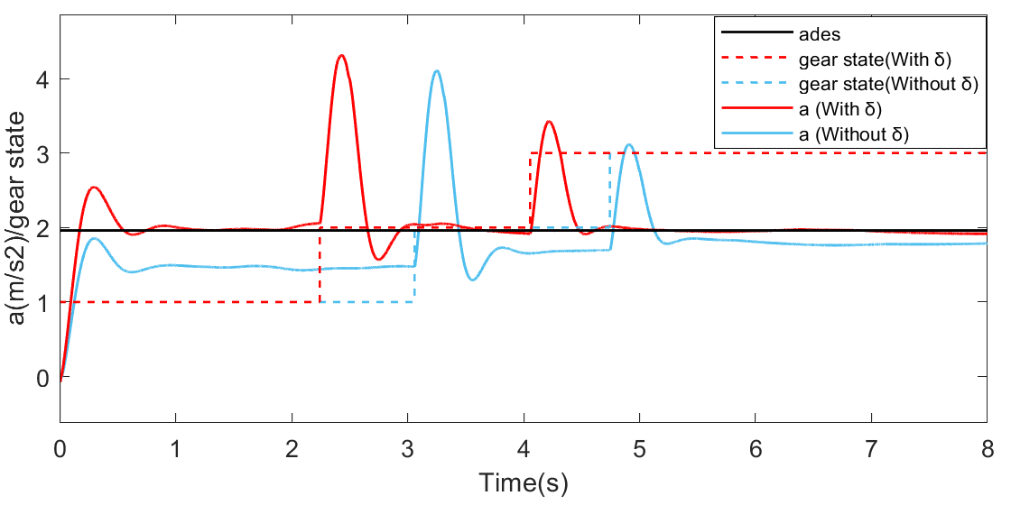
Figure 4. Acceleration curves and gear state of two dynamic models
Figure 4 presents evident findings from the simulation results pertaining to the application of the CACC (Cooperative Adaptive Cruise Control) system. Notably, the dynamic model that neglects the inertial torque attributable to rotational mass fails to sustain the predetermined target acceleration throughout the entire simulation duration. Furthermore, this leads to delayed shift times due to the lower actual acceleration. Conversely, when considering the dynamic model that accounts for the inertial torque resulting from rotational mass, the model manages to maintain proximity to the target acceleration of 0.2g, except during the initial start and shift phases. These observations firmly establish the superior accuracy and suitability of the dynamic model incorporating the inertial torque stemming from rotational mass for simulating CACC systems. In the context of the CACC system, precision in modeling holds paramount importance for meticulous vehicle control and the enhancement of system performance. Consequently, this paper opts for the adoption of the dynamic model that incorporates the inertial torque due to rotational mass to better fulfill the demands of practical applications.

The engine's MAP (Manifold Absolute Pressure) graph delineates the interrelationships among throttle opening, engine speed, and the engine's target torque:
$θ_{des}=f(T_{des},w_{e})$ (9)
To this end, we introduce the engine's MAP (Manifold Absolute Pressure) data into Simulink and utilize the Look-Up Table method to acquire the throttle opening values. Through this procedural step, we have successfully constructed the inverse engine model, with its structure and schematic diagram featured in Figure 5.
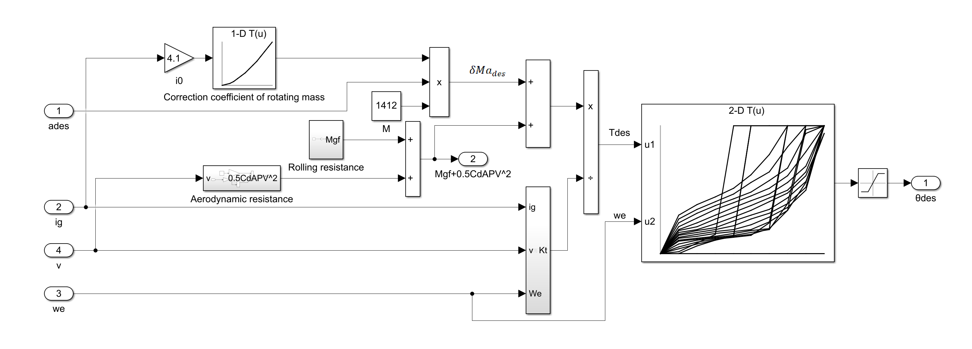
Figure 5. Inverse engine model

2.1.1.2 Modeling the Vehicle Anti-Braking System
When a vehicle undergoes braking, its driving force becomes zero. Consequently, the longitudinal dynamic equation governing the vehicle's behavior can be succinctly expressed as:
$Ma_{des}=-F_{bdes}-\sum{f}$ (10)
To facilitate our analysis, we introduce the concept of the braking force coefficient, denoted as the ratio of braking force to brake master cylinder pressure, to characterize the braking force:
$F_{bdes}=K_{b}P_{des}$ (11)
Consequently, we can represent $P_{des}$ as follows:
$P_{des}=\frac{|-Ma_{des}-\frac{1}{2}C_{d}Aρv^{2}-Mgf|}{K_{b}}$ (12)
the relation between $F_{bdes}$ and the braking torque of the front ($T_{bf}$) and rear wheels ($T_{br}$) can be expressed as:
As$K_{b}P_{b}=\frac{T_{bf+}T_{br}}{r}$ (13)
suming a constant value for $K_{b}$ (braking force coefficient), we consider an initial velocity of 60 kilometers per hour and a braking pressure of 0.3 megapascals (Mpa). Following simulation, we measured $T_{bf}$ as 74.5 Newton·meters and $T_{br}$as 44.5 Newton·meters. Substituting these values into equation 13, we derived the numerical value of $K_{b}$​ as 1220. The construction of the anti-braking system model within Simulink is detailed as follows.
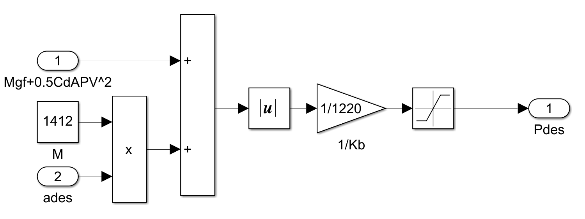
Figure 6. Inverse braking system model

2.1.1.3 Switching Logic for Acceleration and Braking
In the pursuit of reducing the frequency of transitions between the accelerator pedal and the brake pedal during vehicle operation, a commonly employed strategy involves the introduction of a buffer zone[16]. Within this buffer zone, neither accelerator nor brake pedal operations are executed. To ascertain the appropriate dimensions of this buffer zone, the following experimental approach is conventionally applied: Once the vehicle attains a speed of 120 kilometers per hour, a coasting phase is initiated. Subsequently, subject to the influence of various resistances, the vehicle gradually decelerates to a speed of 0 kilometers per hour. Over the course of this deceleration process, acceleration data at discrete speed intervals are meticulously recorded, subsequently yielding relevant curves, as exemplified below.
Figure 7. The car’s acceleration curve at idle speed
The information presented in Figure 7 reveals that while the vehicle undergoes coasting at various speeds, the deceleration displays irregularities and, at times, substantial abrupt fluctuations. In a bid to mitigate unwarranted operational disruptions, we conducted a polynomial fitting analysis employing Matlab to determine an appropriate buffer zone[17]. The methodology involved the selection of Δh (vertical distance change) both above and below the polynomial fitting curve to define the buffer zone. In practical engineering applications, Δh is frequently designated as 0.01g. Subsequently, relying on the outcomes of the fitting process, we formulated the corresponding control logic, as illustrated in Figure 8.
Figure 8. Switching logic of acceleration and braking
The creation of the inverse longitudinal dynamics model for the vehicle is depicted in Figure 9. The target acceleration is first subjected to filtering through the switching logic, following which it is fed into both the inverse engine module and inverse braking system module. These modules subsequently yield throttle opening and master cylinder pressure values, which are subsequently incorporated into the Carsim model.
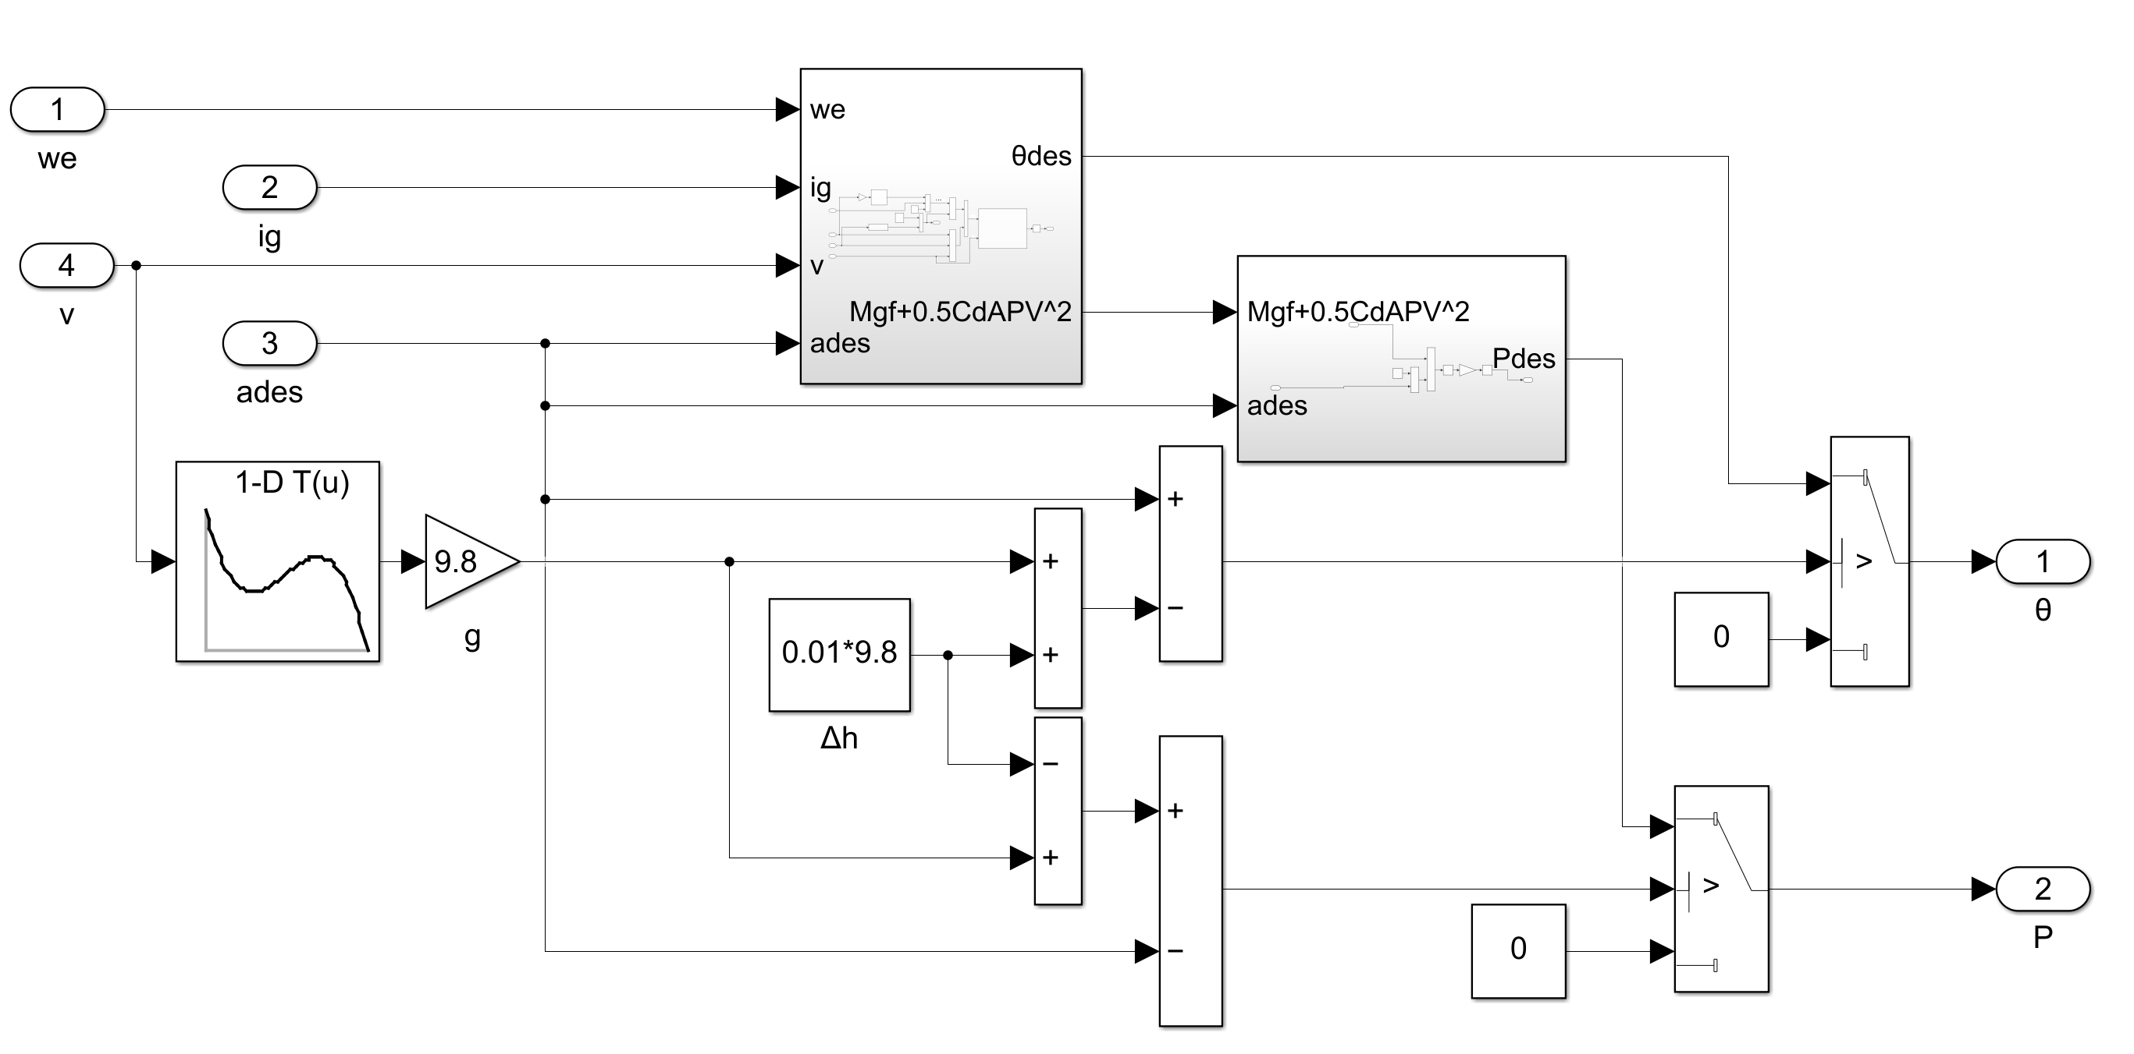
Figure 9. Inverse longitudinal dynamics modeling of a vehicle

2.1.2 Lower-Level Controller Design
The lower-level controller, serving as the vehicle's actuator, plays a pivotal role in converting the acceleration input received from the upper-level controller into precise throttle opening and master cylinder pressure adjustments. This enables the controller to effectively regulate the vehicle's motion in accordance with the desired acceleration. Despite the establishment of the switching logic in Section 1.2 (Vehicle Longitudinal Inverse Dynamics Model), it is crucial to acknowledge that the aforementioned formulas are derived under ideal conditions and may not accurately capture the intricate nonlinear dynamics of the vehicle. Consequently, the integration of a fuzzy PID algorithm into the lower-level controller becomes imperative. This algorithm facilitates agile and accurate attainment of the target acceleration.

2.1.2.1 Fuzzy PID Algorithm Design
The schematic diagram outlining the operation of the fuzzy PID algorithm is presented in the following figure. The core principle of this control strategy hinges on the fuzzification of error and the rate of change of error. This process involves mapping these critical parameters into a fuzzy rule base, subsequently enabling the derivation of fuzzy decisions based on predefined rules. Afterward, through defuzzification, the numerical values for the PID controller's gain parameters—namely the proportional gain (KP), integral gain (KI), and derivative gain (KD)—are determined. These parameters are then supplied to the PID controller, thereby facilitating precise control over the system under consideration.

For the lower-level controller, we define the error (E) as the disparity between the desired acceleration of the vehicle (a_des) and its actual acceleration (a_real). Initially, we input this error (E) into the standard PID control module. Through a collaborative simulation involving Simulink and Carsim, coupled with multiple rounds of debugging and optimization iterations, we ascertain the optimal PID parameters: KP=10, KI=0.5, and KD=0.005[3]. These parameter values serve as the initial settings for the fuzzy PID controller. Notably, the parameter optimization was conducted under the stipulation of the vehicle operating on a road surface characterized by an adhesion coefficient of 0.9. In pursuit of ensuring driving safety, we set the maximum vehicle deceleration as close to its upper limit as possible, selecting -0.8g as the maximum deceleration. Additionally, to prioritize passenger comfort, we imposed an upper limit of 0.3g on the vehicle's maximum acceleration. Consequently, the vehicle's acceleration range was constrained within the interval [-0.8g, 0.3g]. Within this range, an array of repeated tests was conducted, yielding a spectrum of error (E) values spanning from -3 to 2.5, while the rate of change of error (E_C) exhibited variations within the range of [-25, 45].

This system is characterized by a complex two-input three-output fuzzy PID controller, necessitating the definition of seven linguistic variables: "Very Big" (VB), "Big" (B), "Small" (S), "Zero" (Z0), "Negative Small" (NS), "Negative Big" (NB), and "Negative Medium" (NM). These linguistic variables serve as descriptors for the system's inputs and outputs within the framework of fuzzy logic reasoning. The fundamental domain for KP is established as [0, 20], while for KI and KD, the foundational domains are defined as [0, 1] and [0, 0.01], respectively. Furthermore, E, E_C, KP, KI, and KD are equipped with quantification factors set to 1.
Table 2. Language variable parameter list
fuzzy linguistic variables | $$E$$ | $$E_{C}$$ | $$KP$$ | $$KI$$ | $$KD$$
Basic Domain | [-3, 2.5] | [-25, 45] | [0,20] | [0,1] | [0,0.01]
fuzzy universe | [-3, 2.5] | [-25, 45] | [0,20] | [0,1] | [0,0.01]
quantization factor | 1 | 1 | 1 | 1 | 1

Drawing upon our parameter simulation experiments involving KP, KI, and KD across different values of E and E_C, we have constructed the subsequent fuzzy rule table. This table facilitates the rapid attainment of the target acceleration by the lower-level controller, with minimal overshoot and steady-state error.
Table 3. Fuzzy rule table for the lower controller
PID |  | $$E_{C}$$
 |  | NB | NM | NS | Z0 | PS | PM | PB
$$E$$ | NB | NB, PS, PS | NB, Z0, PM | NM, NS, PB | NM, NS, PB | NM, NS, PB | NM, NS, PB | NM, NS, PB
$$E$$ | NM | NB, PB,PS | NB, PS, PM | NB, PS, PM | NB, Z0, PM | NB, Z0, PB | NB, Z0, PB | NM, Z0, PB
$$E$$ | NS | NB, PM, NM | NB, PS, NS | NB, Z0, NS | NB, Z0, NS | NB, Z0, Z0 | NB, NS, Z0 | NS, NS, PS
$$E$$ | Z0 | NB, PS, NM | NB, Z0, NS | NB, Z0, NS | NB, Z0, NS | NB, Z0, Z0 | NB, NS, Z0 | NM, NM, PS
$$E$$ | PS | NM, PS, NB | NM, PS, NB | NM, PS, NB | NS, PS, NB | NS, PM, NM | Z0, PM, NM | Z0, PB, NS
$$E$$ | PM | PB, PS, PB | PB, PS, PB | PB, PS, PB | PB, Z0, PB | PB, Z0, PB | PB, NS, PB | PB, NM, PB
$$E$$ | PB | PB, NS, PB | PB, NS, PB | PB, NS, PB | PB, NS, PB | PB, NM, PB | PB, NM, PB | PB, NB, PB

2.1.2.2 Verification of Lower-Level Controller through Simulation
To illustrate the contrasting effectiveness of two distinct control strategies, we have conducted simulation experiments. In these simulations, we initiated the vehicle at an initial speed of 10 kilometers per hour, maintained a target acceleration of 0.2g, and sustained this acceleration for a duration of 8 seconds.
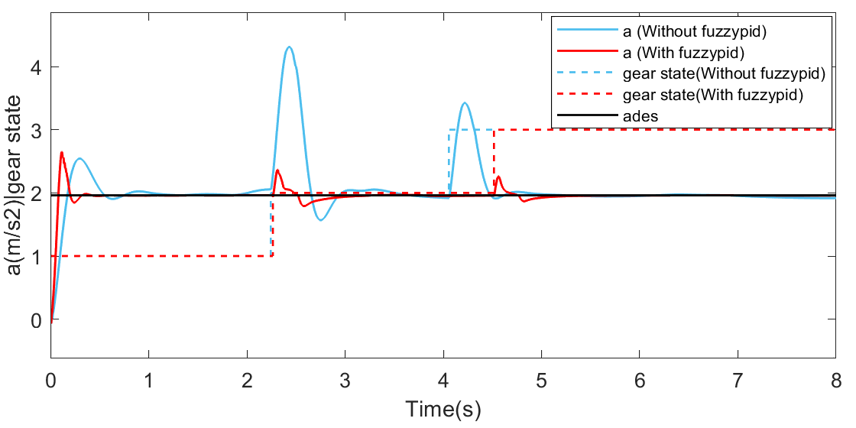
Figure 10. Acceleration curves and gear state of two controllers
Within the initial 1.5 seconds of observations, it becomes evident that the lower-level controller lacking integrated fuzzy PID exhibits suboptimal response and settling times. Although the overshoots between the two controllers are comparable when contrasted with the fused fuzzy PID controller, the non-fused fuzzy PID's lower-level controller accumulates more substantial errors. This indicates that over a specific timeframe, the system's actual performance diverges significantly from the desired benchmarks. At approximately 2.2 seconds, both models executed a gear shift operation. However, the non-fused fuzzy PID model displayed a more considerable fluctuation amplitude and longer fluctuation duration in its acceleration curve. These discrepancies also led to an earlier subsequent gear shift time (4 seconds for non-fused fuzzy PID and 4.5 seconds for fused fuzzy PID). Beyond the 5-second mark, neither model initiated a gear shift operation. The model enriched with fuzzy PID effectively sustains an acceleration of 0.2g, whereas the alternative model, incorporating a dynamic framework that considers rotational mass inertia coupling, still exhibits residual errors.

2.2 Establishment of the Safe Following Distance Model and Upper-Level Controller Design

2.2.1 Establishment of the Safe Following Distance Model
In the context of the Cooperative Adaptive Cruise Control (CACC) system for vehicles, the safe following distance model holds pivotal significance. It assumes a critical role in preserving the separation between the trailing vehicle and the leading vehicle, constituting a fundamental element in ensuring safety across diverse driving scenarios. The safe following distance must maintain sufficient magnitude to avert rear-end collisions during emergency braking situations. However, an excessively large safe following distance can potentially impede the operational efficiency of vehicles and give rise to lane merging from adjacent lanes. Consequently, the safe following distance model stands as an indispensable component governing system performance .

Presently, safe following distance models are chiefly categorized into two types: fixed safe distance models and variable safe distance models. The fixed safe distance model, among the earliest approaches, employs a relatively straightforward algorithm, but it is inherently inflexible and incapable of adapting to dynamic vehicle driving conditions. Notably, during high-speed travel, this model carries an inherent risk of causing safety incidents in scenarios requiring emergency braking, rendering the fixed safe distance models progressively obsolete .

In recent years, variable safe following distance models have witnessed rapid development. A pivotal focus in this arena is the safe following distance model based on time headway, defined as:
$d_{des}=t_{h}v_{f}+d_{0}$ (14)
Here, $v_{f}$denotes the leading vehicle's velocity, and $t_{h}$ represents a fixed value within the range of 0.5 to 2.5. The introduction of $t_{h}$allows for the adaptation of safe following distances based on the preceding vehicle's speed, representing a safer alternative to fixed safe distances. However, this approach bears certain limitations since variations in the safe distance are contingent upon the relative velocity between vehicles, rather than solely their speeds[18].

To enhance control over the inter-vehicle distances, Yanakiev and fellow researchers proposed a variable time headway safe following distance model based on the relative velocities of the leading and trailing vehicles. The model assumes the following form[19]:

$t_{h}=t_{0}-c_{0}v_{rela}$ (15)
$v_{rela}=v_{f}-v_{r}$ (16)
This vehicle spacing model introduces several critical parameters and variables. Notably, $t_{0}$ and $c_{0}$ represent constants greater than zero, $v_{rela}$ signifies relative velocity, and $t_{h}$ denotes the variable time headway. These parameters and variables assume pivotal roles in the model, particularly concerning the safety distance between vehicles and traffic efficiency. The variable time headway dynamically adjusts when the current vehicle's speed differs from that of the trailing vehicle. Specifically, if the current vehicle's speed surpasses that of the following vehicle, the variable time headway contracts. Conversely, if the current vehicle's speed lags, the variable time headway expands. This model harmoniously accommodates safety and traffic efficiency prerequisites, ensuring that inter-vehicle distances remain appropriate across varying driving conditions, thereby contributing to enhanced traffic flow.

This paper augments the model by incorporating a variable time headway model predicated on the preceding vehicle's acceleration:

$d_{des}=t_{h}v_{f}+d_{0}$ (17)
$t_{h}=t_{0}-c_{v}v_{rela}-c_{a}a_{f}$ (18)
Here, $a_{f}$ denotes the preceding vehicle's acceleration, and $t_{0}$, $c_{v}$, and $c_{a}$ are constants greater than zero. Notably, the time interval should not be overly protracted or truncated; therefore, upper and lower thresholds govern this time interval. Specifically, t_hmax is established at 2.2 seconds, t_hmin at 0.2 seconds, $c_{v}$ at 0.1, $c_{a}$ at 0.05, and $d_{0}$ at 8 meters (comprising 3.5 meters plus a vehicle length of 4.5 meters).

This comprehensive model, accounting for both relative velocities between the preceding and trailing vehicles and the preceding vehicle's acceleration, offers a more nuanced depiction of vehicle dynamics. During vehicle acceleration, a reduced safe distance can be implemented, maximizing road space utilization and enhancing convoy traffic efficiency. Conversely, when the current vehicle decelerates, adopting a larger safe distance ensures sufficient braking distance and, consequently, traffic safety.

In Simulink, three safe following distance models based on time headway have been established, with the target speed of the lead vehicle set as illustrated in Figure 13. Subsequently, the target distance of the following vehicle 2 was recorded, yielding the following results after simulation.
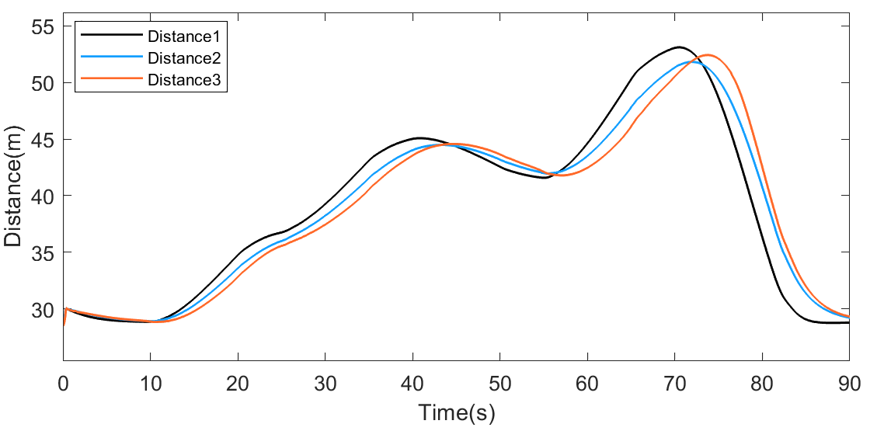
Figure 11. Results of three safety distances
The data in Figure 11 reveals discernible patterns and trends. Yanakiev's proposed distance2 model, when contrasted with the traditional distance1 model, adapts a more condensed safe distance when the preceding vehicle attains higher speeds, effectively accommodating high-speed driving conditions. Conversely, for scenarios where the current vehicle's speed is lower, the model opts for a more generous safe distance, thereby enhancing inter-vehicle safety. Furthermore, noteworthy is the smoother safe distance variation exhibited by the distance2 model, characterized by the absence of abrupt fluctuations. This design minimizes unwarranted interference and discomfort experienced by drivers and vehicles alike.

In contrast to Yanakiev's distance2 model, the distance3 model, introduced in this paper, further diminishes the safe distance when the preceding vehicle accelerates. This strategic choice targets convoy efficiency by enabling vehicles to maintain closer proximity. However, when the preceding vehicle undergoes deceleration, the distance3 model leans towards a more expansive safe distance, effectively mitigating the potential hazard of multiple-vehicle rear-end collisions.

For a more comprehensive assessment of these modifications, we conducted thorough calculations and comparisons. We amalgamated distance alteration curves for two scenarios: car acceleration and car deceleration, subsequently computing the mean values. This analytical approach furnishes an enhanced understanding of the performance distinctions among distinct safe distance models. According to our calculations, during car acceleration, the distance3 model reduces the distance by 1.9 meters and 0.67 meters compared to the traditional distance1 model and Yanakiev's distance2 model, respectively. Employing the distance3 model conveys that vehicle spacing is more compact, significantly amplifying traffic efficiency by minimizing inter-vehicle gaps and potentially alleviating traffic congestion. Specifically, these reductions equate to roughly 5.43% and 1.98%, respectively.

Conversely, during car deceleration, the distance3 model extends the distance by 1.15 meters and 0.3 meters compared to the distance1 model and distance2 model, respectively. This signifies that the distance3 model inclines towards a more conservative safe distance configuration during deceleration, efficaciously curtailing the conceivable risk of multiple-vehicle rear-end collisions. These distance extensions approximate 2.74% and 0.7%, respectively.

2.2.2 Design of the Upper-Level Controller

2.2.2.1 Principle of Fuzzy PID Self-tuning
The fuzzy PID controller represents an advanced control methodology that leverages fuzzy inference techniques to dynamically fine-tune the controller's essential parameters, namely proportional gain (KP), integral time (KI), and derivative time (KD). The settings of these parameters bear significant implications for the control system's performance, directly influencing its dynamic responsiveness and steady-state error. Initially, the proportional gain (KP) plays a pivotal role in enabling swift convergence of the actual distance towards the desired distance. A higher KP value signifies a more rapid response rate, enabling the system to attain a steady state promptly, thus enhancing control precision. However, an elevated KP value may precipitate overshooting, wherein the actual distance oscillates in proximity to the target value, potentially impacting both dynamic and steady-state characteristics of the system. Subsequently, the integral time (KI) assumes responsibility for mitigating the system's steady-state error, ensuring that the disparity between the actual and desired distances asymptotically approaches zero. A greater KI value holds the capacity to diminish steady-state error, albeit at the cost of heightened overshooting tendencies. Consequently, the selection of KI necessitates a delicate balance between steady-state performance and overall system stability. Finally, the derivative time (KD) serves to enhance the system's dynamic attributes by tempering fluctuations stemming from rapid shifts in error. Nonetheless, an excessively large KD value can induce an overly hasty controller response, potentially causing premature braking in the following vehicle and extending the tuning duration of the entire control system[20].

2.2.2.2 Design of the Fuzzy PID Algorithm
The input parameters for the fuzzy control system encompass the relative velocity disparity between the leading and trailing vehicles, alongside the differential between the actual and ideal distances. The output of this system comprises three parameters (KP1, KI1, KD1) that govern the PID controller. The PID controller itself receives the distance error as input and generates the target acceleration as output.

Within the Simulink and Carsim environment, PID controllers were employed for exhaustive testing and debugging across diverse scenarios. The range of variation for the difference E1 between the actual and ideal distances spanned [-1, 6], while the range of relative velocity E2 oscillated within [-3, 2]. The domains for KP1, KI1, and KD1, representing optimal values under distinct conditions, were [8, 15], [0.1], and [0, 0.1], respectively.
Table 4. Language variable parameter list
fuzzy linguistic variables | $$E1$$ | $$E2$$ | $$KP1$$ | $$KI1$$ | $$KD1$$
Basic Domain | [-1, 6] | [-3, 2] | [8,15] | [0.1] | [0.1]
fuzzy universe | [-1, 6] | [-3, 2] | [8,15] | [0.1] | [0.1]
quantization factor | 1 | 1 | 1 | 1 | 1

Suppose the input-output variables are KP1, KI1, KD1, E1, and E2, all of which are described by seven fuzzy sets: (PB - Positive Big), PM (Positive Medium), PS (Positive Small), Z0 (Zero), NS (Negative Small), NM (Negative Medium), NB (Negative Big). Gaussian membership functions are selected to describe these fuzzy sets.

In a control system, we need to dynamically adjust the controller's parameters to achieve smooth vehicle operation and safety for different error situations.

First, when the absolute value of the error E1 is large, it indicates a significant difference between the actual distance and the safe distance, which may lead to potential collision risks. To quickly reduce this deviation, we should increase the proportional gain KP1 and integral time KI1 to accelerate the controller's response. However, it's important not to make the derivative time KD1 too large to avoid premature tuning that could cause system instability.

Second, when the absolute value of the error E1 is moderate, we need to not only reduce the deviation but also consider the vehicle's smoothness. Therefore, it is necessary to moderately increase KP1 and KI1, but KD1 should be reduced cautiously to maintain system stability.

Third, when the absolute value of the error E1 is small, our main concern is the stability and ride comfort of the vehicle. To suppress potential overshooting, we should moderately reduce KP1 based on the magnitude of the relative velocity E2 while increasing KI1 and KD1. This can enhance the control system's disturbance resistance and ensure smooth vehicle operation.

Finally, when the deviation approaches zero, it indicates that the distance between vehicles has approached the safe distance. In this situation, we should appropriately increase KD1 to maintain a stable distance while reducing KP1 and KI1 to ensure system stability and safety.

Based on the rules mentioned above, the fuzzy rules obtained are shown in the following table.
Table 5. Fuzzy rule table for the upper controller
PID |  | E2
 |  | NB | NM | NS | Z0 | PS | PM | PB
$E$1 | NB | PB, NS,PS | PB, NS,PS | PM, Z0,Z0 | PM, PS,Z0 | PS, PS, NS | PS, PM, NS | Z0, PM, NM
$E$1 | NM | PM, NM,NS | PM, NM,NS | PS, NS, Z0 | PS, NS,Z0 | Z0, Z0,PS | NS, Z0,PS | NM, PS, PM
$E$1 | NS | PS, NS, Z0 | PS, NS, Z0 | Z0, Z0, PS | Z0, PS, PS | NS, PS, PM | NM,PM,PM | NB,PM,PB
$E$1 | Z0 | Z0, NS, NM | Z0, NS, NM | NS, NM, NS | NS, NM, Z0 | NM, NM, Z0 | NM, NM, PS | NB, NB, PM
$E$1 | PS | PS, NS,Z0 | PS, NS,Z0 | Z0,Z0, PS | Z0,PS, PS | NS, PS, PM | NM, PM, PM | NB, PM, PB
$E$1 | PM | PM, NM,NS | PM, NM,NS | PS, NS, Z0 | PS, NS,Z0 | Z0, Z0,PS | NS, Z0,PS | NM, PS, PM
$E$1 | PB | PB, NS,PS | PB, NS,PS | PM, Z0,Z0 | PM, PS,Z0 | PS, PS, NS | PS, PM, NS | Z0, PM, NM

3 Vehicle Speed Prediction Using Hybrid Deep Learning Techniques

The domain of vehicle speed prediction has witnessed a diverse array of methodologies and algorithms. Researchers have ventured into the realm of artificial intelligence, employing neural networks and chain neural network models [87, 88], alongside traditional statistical techniques like exponential smoothing and random prediction. Concurrently, studies have demonstrated the potential for enhancing predictive accuracy by amalgamating multiple algorithms into composite models. Notably, in reference, a K-nearest neighbor-based non-parametric regression model was proposed, leveraging historical data to fulfill the stringent demands of intelligent traffic applications. Conversely, reference established a short-term vehicle speed prediction model using a hybrid deep learning algorithm, considering variables intimately linked with the present vehicle's speed, such as the speeds of the target vehicle and its two predecessors. This model found application in developing energy management strategies for hybrid electric vehicles, resulting in substantial improvements in fuel economy. Reference introduced a short-term vehicle speed prediction model founded on backpropagation neural networks, leading to a 41.8% reduction in prediction errors and a marked enhancement in accuracy. Furthermore, reference presented a data-driven approach to short-term vehicle speed prediction, demonstrating remarkable precision by analyzing data's impact on predictive accuracy and harnessing deep learning algorithms.

These diverse research endeavors underscore the efficacy of employing a blend of artificial intelligence algorithms when grappling with the intricacies of multidimensional time series speed prediction problems. Consequently, in this chapter, grounded in the historical vehicle data acquired in Chapter 3, data-driven hybrid artificial intelligence methodologies were chosen as the underpinning framework for vehicle speed prediction. This novel approach amalgamates the weight-sharing and feature extraction functionalities of Convolutional Neural Networks (CNN) with the temporal modeling prowess of Long Short-Term Memory (LSTM) networks to navigate the intricate web of time series correlations. The concurrent application of Convolutional Neural Networks (CNN) excels in discerning salient features within time series data, bolstering the model's ability to comprehend and represent input data effectively. Meanwhile, Long Short-Term Memory (LSTM) networks specialize in modeling time series data and handling inter-temporal correlations, further augmenting the predictive performance of the model.

The central objective of this study revolves around tackling the intricate task of speed prediction, a formidable challenge entailing non-stationary multivariate time series data. Within these data, intricate interrelations among variables persist, underscored by a profound connection between information from the preceding moment and that from the subsequent one, thereby amplifying the intricacy of the prediction endeavor. In response to such complexities, deep learning algorithms have emerged as a popular recourse. These data-driven intelligent algorithms exhibit exceptional prowess in processing and dissecting vast datasets, demonstrating outstanding performance across a spectrum of tasks, including speed prediction. Nevertheless, given the non-stationary and multivariate nature of the data, this investigation harnesses Recurrent Neural Networks (RNNs) to grapple with these inherent challenges. While RNNs boast an aptitude for managing sequential data, they also contend with a prevalent obstacle: the vanishing gradient problem, potentially leading to information oversight. In a bid to surmount this challenge, this study embraces an enhanced variant of Long Short-Term Memory (LSTM) as the foundational network structure. LSTM introduces the concept of gate units, which serve to facilitate a more robust capture of long-term dependencies intrinsic to speed data, thereby elevating prediction accuracy. In an effort to curtail model complexity and expedite training, this research embeds Convolutional Neural Networks (CNNs) at the lower stratum of the model. CNNs, celebrated for their attributes of local connectivity and weight sharing, effectually reduce the model's parameter count, thereby bolstering robustness and hastening convergence during training. Consequently, this study propounds a hybrid neural network model, amalgamating CNNs and LSTM to grapple with the distinctive intricacies of time series data within speed prediction tasks. This hybrid model strategically combines CNNs for data feature extraction and LSTM for modeling prolonged dependencies, promising to deliver exceptional performance within speed prediction domains[21].

3.1 Construction of the CNN-LSTM Deep Learning Model

3.1.1 One-Dimensional CNN Layer
Convolutional Neural Networks (CNNs) originally drew inspiration from the perceptual capabilities of feline vision. This inspiration stemmed from the discovery that in visual contexts, akin data and images frequently exhibit pronounced correlations. This insight catalyzed the development of CNNs, rendering them potent tools for feature extraction. Within the CNN framework, the pivotal concept of a convolutional kernel, often termed the "receptive field," emerges. The convolutional kernel traverses the input features with a defined stride, with each feature or element sharing weights and biases with the convolutional kernel. This shared characteristic amplifies CNN's efficacy in extracting features from data and images. Remarkably, in the realm of time series analysis, one-dimensional Convolutional Neural Networks have showcased remarkable aptitude for feature extraction. Their capability to manage multidimensional time series data significantly enhances feature extraction across various data dimensions.

In practice, input sequences are conventionally represented as follows: x = {x1, x2, ···, xT}, where T denotes the length of input sequences received by the model on each occasion, i.e., the quantity of historical data points. Simultaneously, the input at each time step is delineated as xt = {xt1, xt2, ···, xtn}, where n represents the number of features. Consequently, the input sequence x can be conceptualized as a T×n matrix. Within CNNs, convolution unfurls through the introduction of K 1×n dimensional convolutional kernels, thereby yielding a T×K matrix. This implies that each convolutional kernel boasts distinct weights and assumes responsibility for extracting unique features from the input sequence. This parallelism and diversity amplify CNN's proficiency in extracting features from time series data, enabling the model to detect and harness patterns and correlations inherent in the data.

Convolutional Neural Networks (CNNs) commonly use pooling functions such as max-pooling and mean-pooling. Among these pooling functions, max-pooling is widely adopted because it effectively preserves important feature information in the data. Therefore, this study chooses the max-pooling method for feature selection and downsampling of the results of convolutional operations . This step helps further extract significant features from the data for subsequent analysis and processing.
（19）

3.1.2 LSTM Layer
Recurrent Neural Networks (RNNs) stand as a specialized neural network model tailored to handle sequential data. In contrast to traditional fully connected neural networks, RNNs introduce memory cells designed to store and transmit information from the previous time step's hidden layer. This intrinsic memory mechanism empowers RNNs to process data characterized by sequences, such as time series and logical progressions, with heightened efficiency. The hidden layer features at the present time step within RNNs result from the multiplication of the current input features by the corresponding weight matrix and the incorporation of the prior time step's hidden layer features. This intricate mechanism enables RNNs to incorporate historical information during the processing of sequence data, rendering them exceptionally suitable for data imbued with temporal correlations. The hidden state at each time step extends to the subsequent time step, thus culminating in a sequence of hidden states that aptly model relationships within sequential data. RNNs command broad application across diverse domains, spanning speech recognition, machine translation, and word sense disambiguation. These contexts frequently involve the manipulation of sequence data, underpinning RNNs as indispensable tools for capturing temporal information and dependencies within the data.

In the preceding section, the output emanating from the Convolutional Neural Networks (CNNs) is delineated as c = {c1, c2, ···, cT}, with each time step's output represented as ct = {ct1, ct2, ···, ctK}, where K signifies the number of features extracted by the convolutional kernels. These outputs stemming from the convolutional layers serve as inputs for the RNN layer. The RNN, in turn, generates fresh hidden states grounded in these convolutional layer outputs and the antecedent hidden states. Subsequent to traversing neural network units across N hidden layers, the RNN layer furnishes a sequence of hidden states expressed as h = {h1, h2, ···, hT}, where each time step's hidden state assumes the form ct = {ht1, ht2, ···, htN}, collectively forming a T×N matrix. This matrix encapsulates the feature representation of sequence data across varying time steps, thereby facilitating further analysis and modeling. This hierarchical organization of hidden states augments the network's capacity for representation and its capacity to discern intricate relationships.
$\left\{h_{t}^{2}，∙∙∙ ,h_{t}^{N} \right\}$ represents a T×N matrix, the formula is expressed as:
（20）
is the weight parameter matrices that the RNN network can learn: is the bias vectors

Recurrent Neural Networks (RNNs), while competent in handling temporal sequence dependencies, encounter a significant challenge when processing extended input sequences. This challenge pertains to their inclination to forget information from distant historical time steps, thereby causing gradual information erosion and deleterious repercussions on prediction precision. To surmount this challenge, Long Short-Term Memory (LSTM) networks emerged as a specialized iteration of RNNs explicitly tailored to address the constraints of traditional RNNs when confronted with prolonged temporal dependencies. A pivotal innovation within LSTM is the incorporation of gate mechanisms within memory cells, encompassing input gates, forget gates, and output gates. These gate mechanisms play a pivotal role in endowing LSTM networks with the ability to judiciously retain or discard information from the previous time step's hidden state. Precisely, the input gate facilitates the influx of fresh information into the memory cell, the forget gate ascertains the necessity of discarding specific information from the memory cell, and the output gate determines the content to convey to the network's output. The integration of these gate mechanisms empowers LSTM to adeptly capture both long-term and short-term dependencies in the data, circumventing superfluous information loss. Moreover, LSTM's structural design effectively mitigates the challenges of gradient vanishing and exploding gradients, recurrent issues in traditional RNNs. These predicaments are prevalent in deep neural networks, and LSTM's meticulous gate mechanism architecture renders it amenable to tasks encompassing protracted sequences.

The state update process of LSTM at time is as follows:

First, the forget gate chooses to discard some information, and the input gate determines what kind of information is stored in the "memory cell". The equation can be expressed as follows:
（21）
（22）
（23）
In the equations, where represents the forget gate, represents the Sigmoid activation function, represents the hyperbolic tangent activation function, represents the weight matrices of the corresponding gates, is the hidden layer vector at time t-1, represents the input of the LSTM layer at time t, which is the output of CNN, b is the bias vector for the three gates, and is the input gate, must be the neuron state that needs to be updated at time t.

The hidden layer state at time t, denoted as , is determined by the input and , so the neuron state at time t needs to be updated. That is, the neuron decides to forget a part of the neuron state information from time t-1 and input the neuron state to be updated at time t. Finally, the output state of the "memory cell" neurons at the current time t is determined by the output gate .
（24）
（25）
（26）
The attention mechanism layer has already integrated all the spatiotemporal features of the input sequence, so the input to the output layer is the weighted output result ; of the attention mechanism layer. Now, introduce an output node, denoted as d, in the fully connected layer, which outputs the predicted speed of the target vehicle for the next d seconds, representing the vehicle's future speed within d seconds. Simultaneously, introduce the non-linear ReLU function as the activation function. Therefore, the formula for the output layer is expressed as
（27）

3.2 Model Training

3.2.1 Experimental Data and Preprocessing
Leveraging the Simulink-Carsim joint simulation model established in Chapter 2, the target vehicle speed of the leading vehicle can be flexibly configured, and its real-time driving speed can be precisely determined by executing speed tracking. The figure below illustrates the setup for defining the target vehicle speed of the leading vehicle.
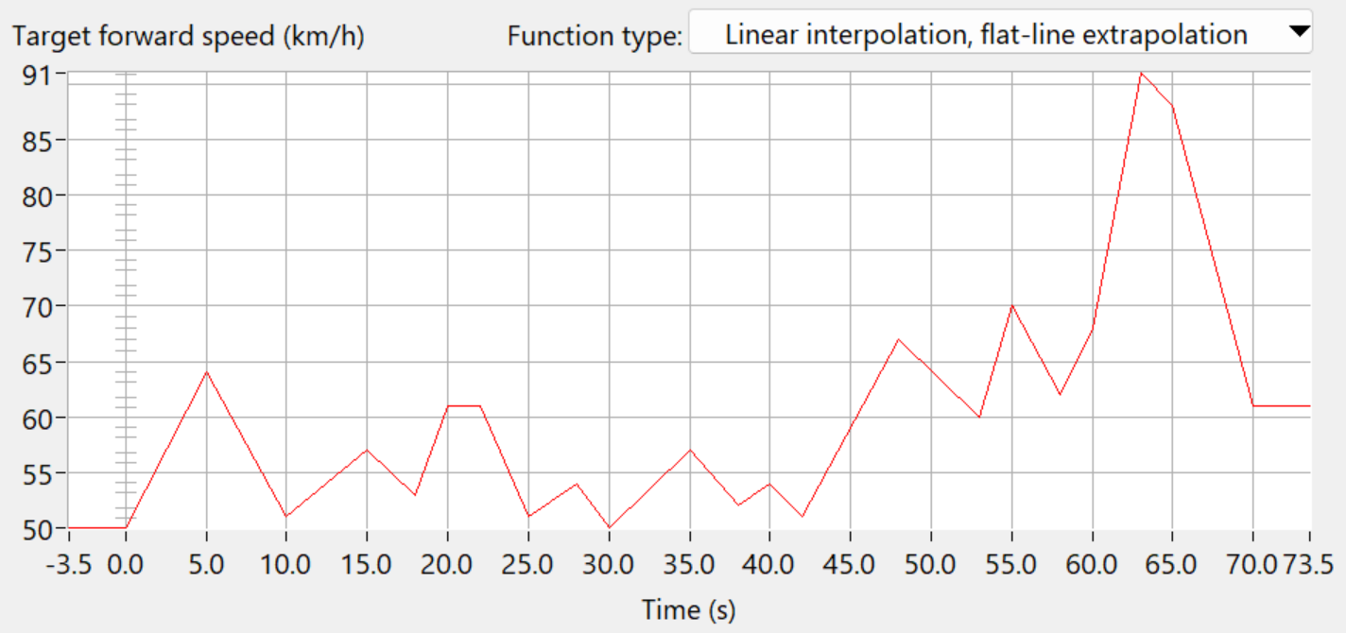
Figure 11. Target speed of the leading vehicle
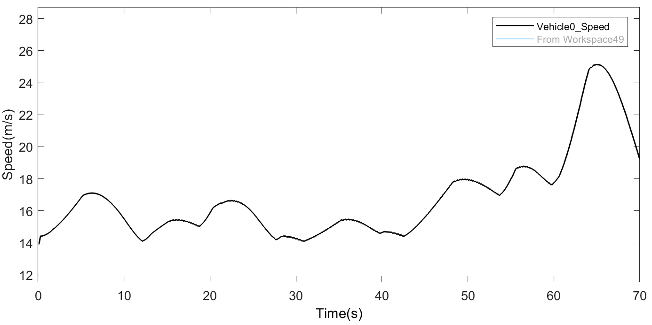
Figure 11. The actual speed of the leading vehicle
The speed data is exported in CSV format, resulting in a dataset comprising 140,000 speed samples, each temporally spaced by 0.0005 seconds. Given the substantial data density, training demands a considerable amount of time. To address this, the original dataset is subjected to preprocessing, wherein every 100 consecutive speed values are subsampled, yielding 1,400 distinct speed sample points with an interval of 0.05 seconds. Subsequently, 30% of this refined dataset is allocated for training purposes, with the remaining 70% reserved for testing.

3.2.2 Speed Prediction Experiment
The training phase of deep learning networks represents a pivotal and intricate stage, wherein fundamental procedures such as forward propagation and error backpropagation assume significant roles. The primary objective during this phase is the iterative optimization of neural network weight matrices, enhancing their capacity to effectively model training data and exhibit robust generalization capabilities when exposed to new data.

Drawing upon comprehensive literature reviews and empirical insights, the initial configurations encompass 64 convolutional kernels, each with a kernel size of 3, 50 LSTM hidden units, a neuron count aligned with the anticipated time steps (set at 10), a batch size of 64, 100 epochs, 4 historical data points, and a pooling layer window of length 2.

The outcomes subsequent to the training process are delineated as follows:
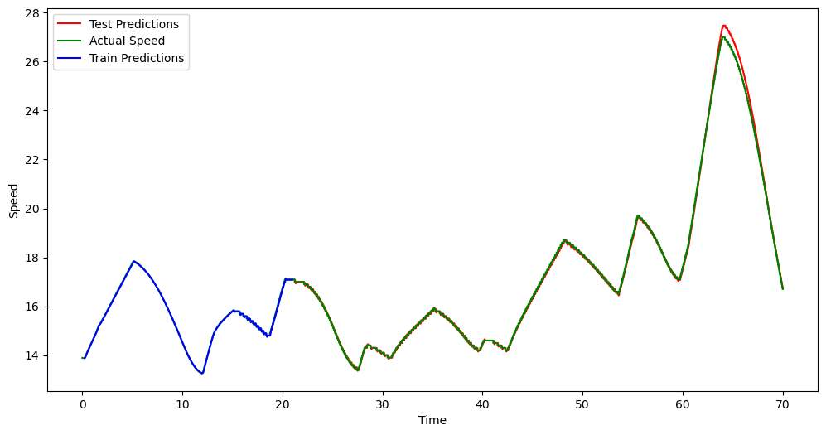
Figure 12. Training results
This paper employs Mean Absolute Error (MAE) as the loss function for assessing model performance. MAE is a commonly used loss function that effectively measures the absolute magnitude of the deviation between the model's predicted values and the actual observed values. Its calculation formula is as follows:
（28）
By calculating MAE, we can quantitatively assess the average magnitude of errors made by the model, further evaluating the model's performance. A smaller MAE value indicates a better fit of the model to the observed data, while a larger MAE value indicates a significant discrepancy between the model's predictions and the actual observations.

Root Mean Square Error (RMSE) is a commonly used metric for assessing model performance, especially for measuring the goodness of fit of the model to the data. RMSE is sensitive to outliers as it calculates the root mean square of the errors. Its formula is as follows:
（29）
（30）
The final results indicate that the MAE on the test set is 0.0817, the RMSE is 0.1934, and the R-squared value is 0.9966. All of these metrics demonstrate excellent performance.

4 Algorithm Validation in CACC Systems under Communication Delay Conditions
To recapitulate, this study introduces a bi-directional controller algorithm for CACC systems, incorporating a variable headway safety distance model that factors in the acceleration of the preceding vehicle. Furthermore, an adept speed prediction algorithm tailored to accommodate communication delays is formulated. To affirm the efficacy of both the system and the algorithm, this chapter constructs a collaborative simulation model within the Simulink and Carsim environments, subjecting it to comprehensive performance evaluations across diverse operational scenarios[9].
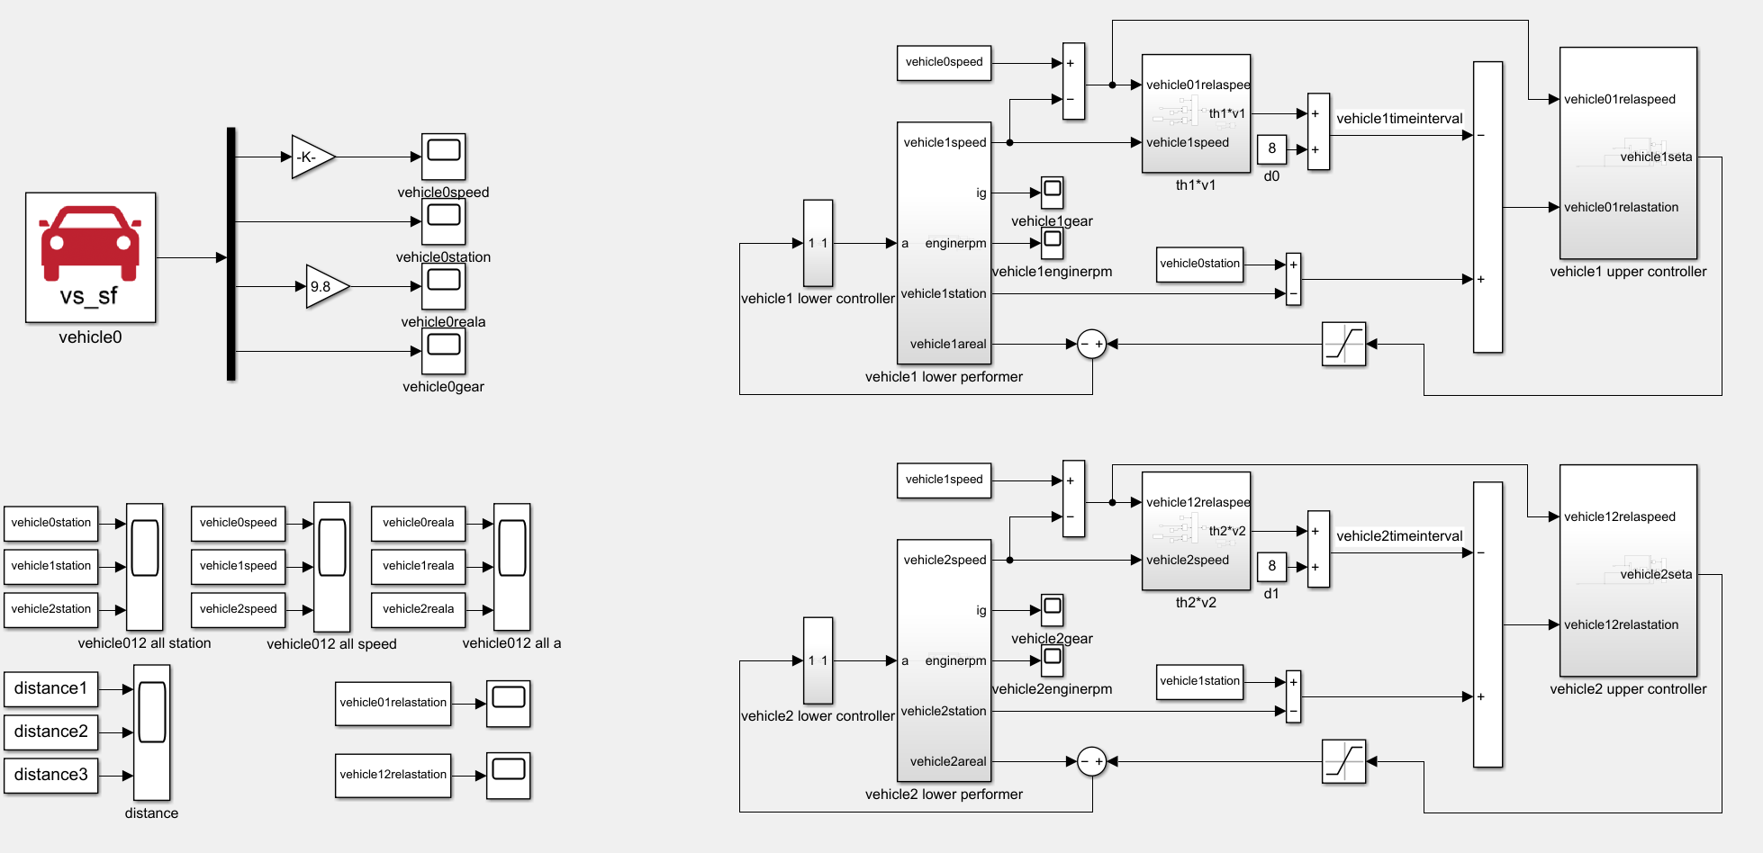
Figure 12. The simulation model
In the framework of the established model, a comprehensive car-following test is meticulously orchestrated to evaluate the performance of the system under specific conditions characterized by a 0.5-second communication delay. The primary objective of this assessment is to investigate and compare the car-following performance with and without the integration of a speed prediction mechanism.

In the context of varied speed-following scenarios, it is imperative that the following vehicle adeptly and precisely trails the preceding vehicle. This entails a meticulous endeavor to maintain the error margin between actual and target distances at an absolute minimum, all while prioritizing passenger comfort within the confines of safety parameters. The lead vehicle serves as the initial reference point, commencing from a position 60 meters ahead at a steady speed of 50 km/h. Correspondingly, the following vehicle (Vehicle 1) initiates its motion from a point 30 meters behind the lead vehicle, also maintaining a constant speed of 50 km/h. The simulation, capturing this orchestrated car-following scenario, unfolds over a duration of 70 seconds.

Following the simulation, an extensive dataset is curated, encompassing crucial information regarding the speeds and positions of both vehicles throughout the simulation duration. Additionally, meticulous attention is directed towards quantifying and analyzing the disparities between the actual and target distances for both the lead vehicle (Vehicle 0) and the following vehicle (Vehicle 1). This analytical approach offers a profound understanding of how the integration of a speed prediction mechanism affects the car-following precision and the overall performance of the system under the influence of communication delays.
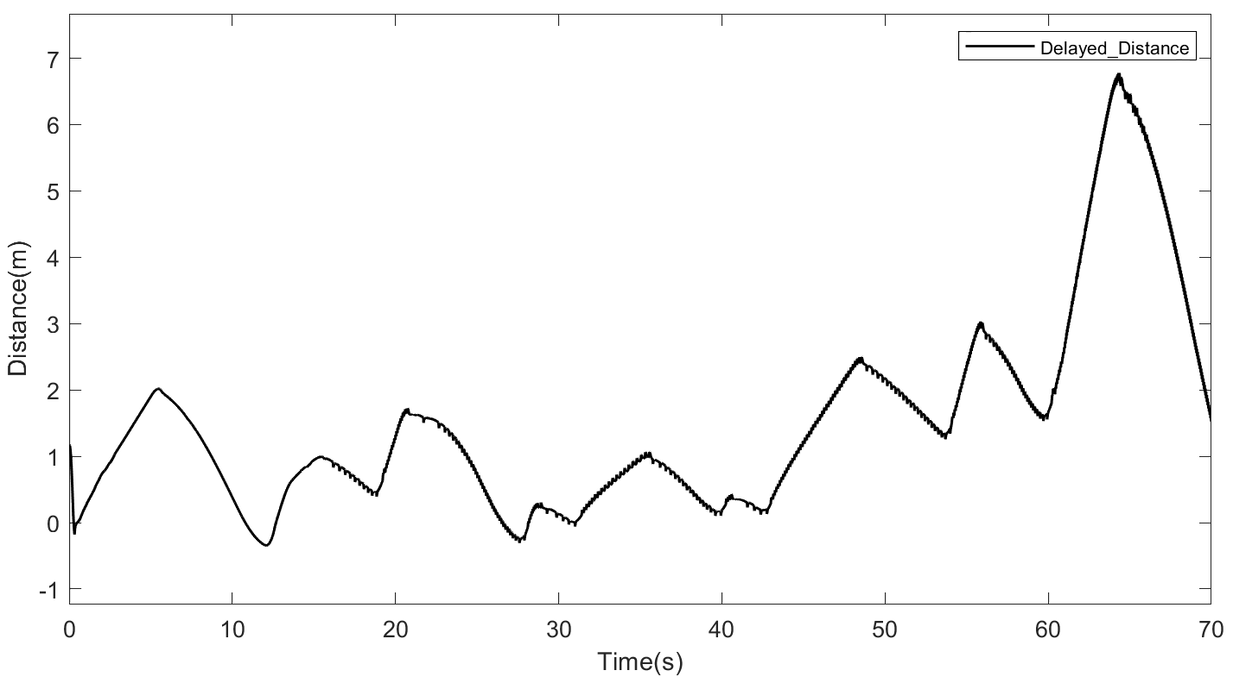
Figure 12. Vehicle distance error under delayed conditions
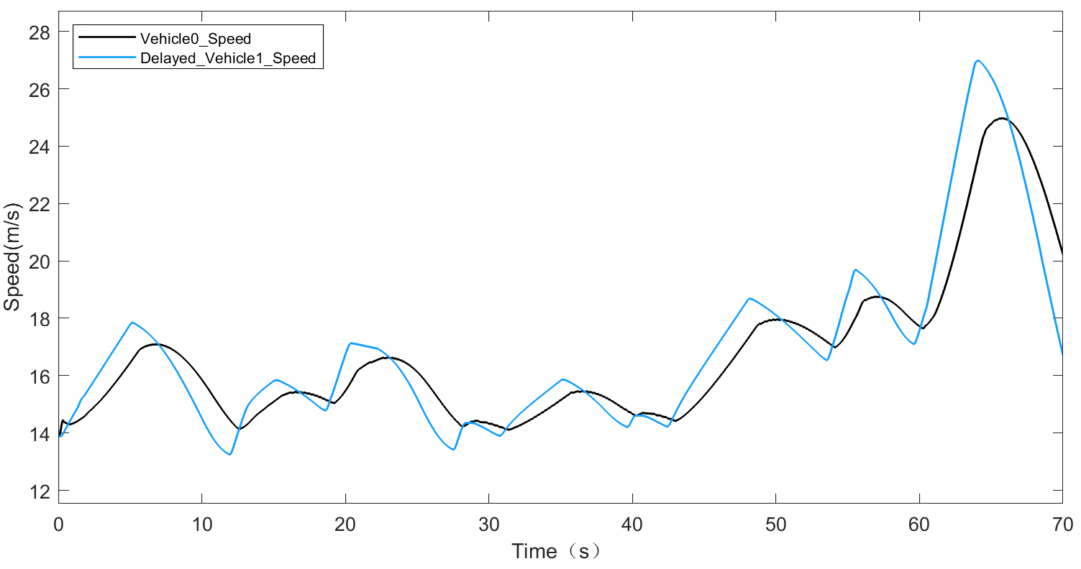
Figure 13. The speed of the following car and the speed of the leading car under delay conditions
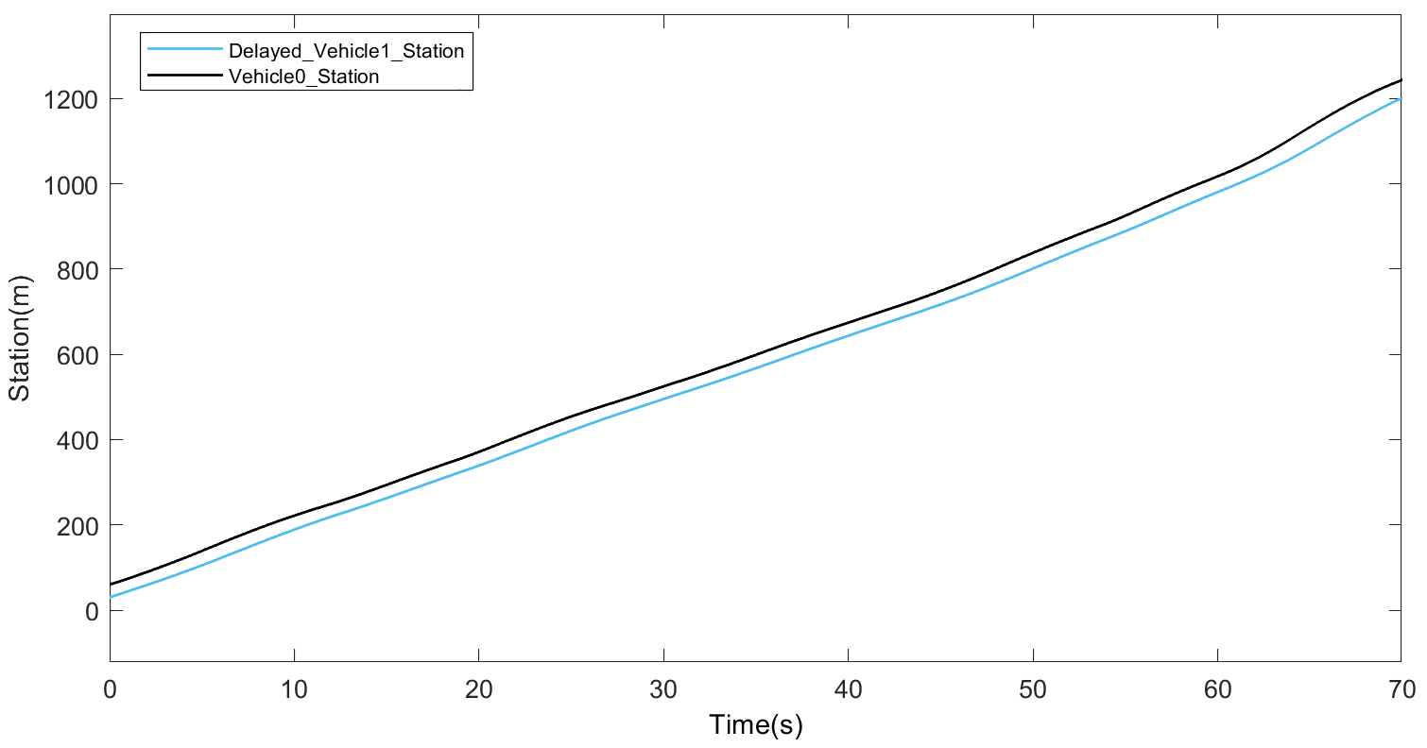
Figure 14. The station of the following car and the speed of the leading car under delay conditions
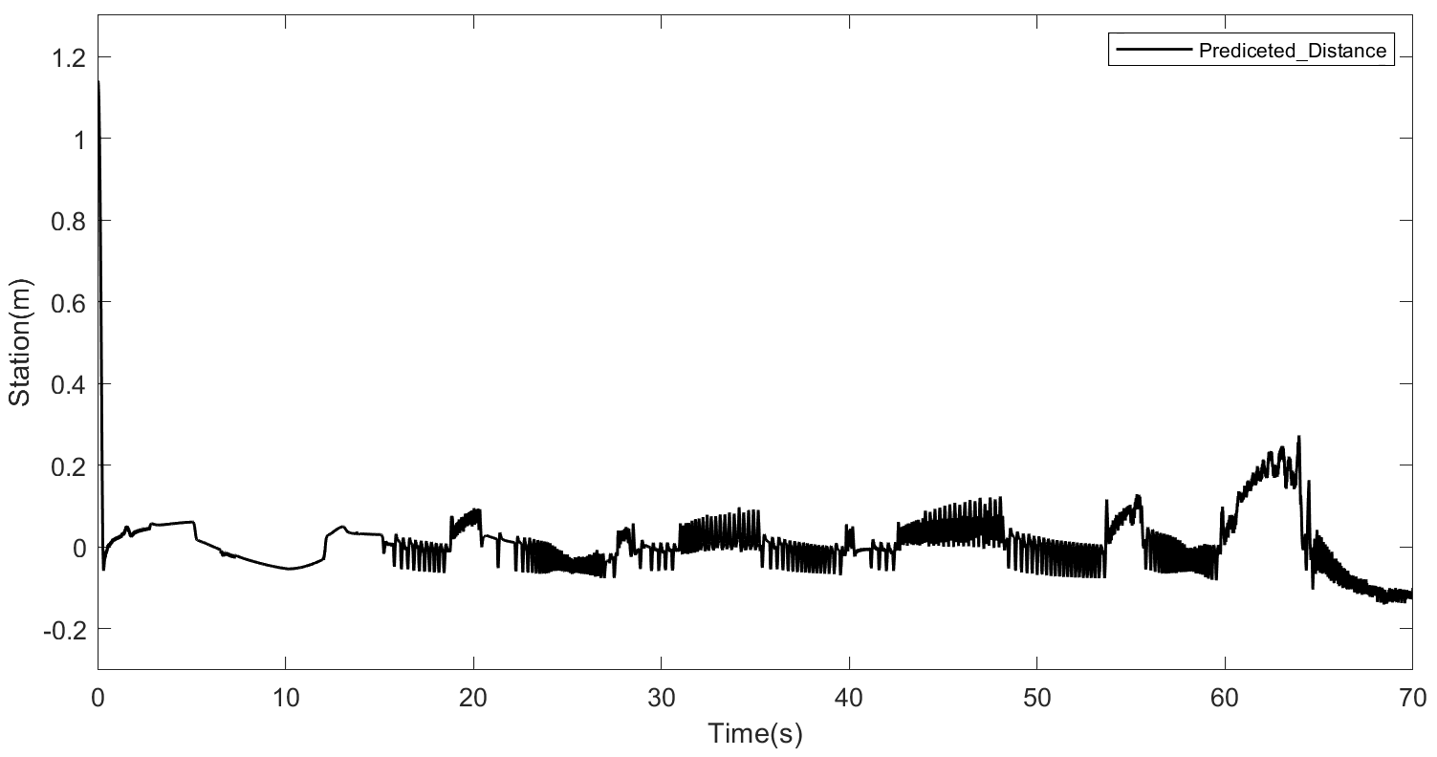
Figure 15. Vehicle spacing error under delayed conditions with speed prediction
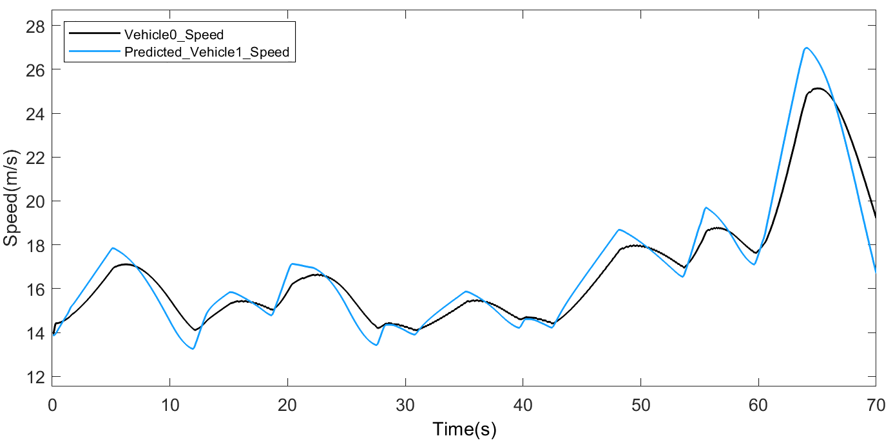
Figure 16. Follower vehicle speed under delay conditions and lead vehicle speed with speed prediction
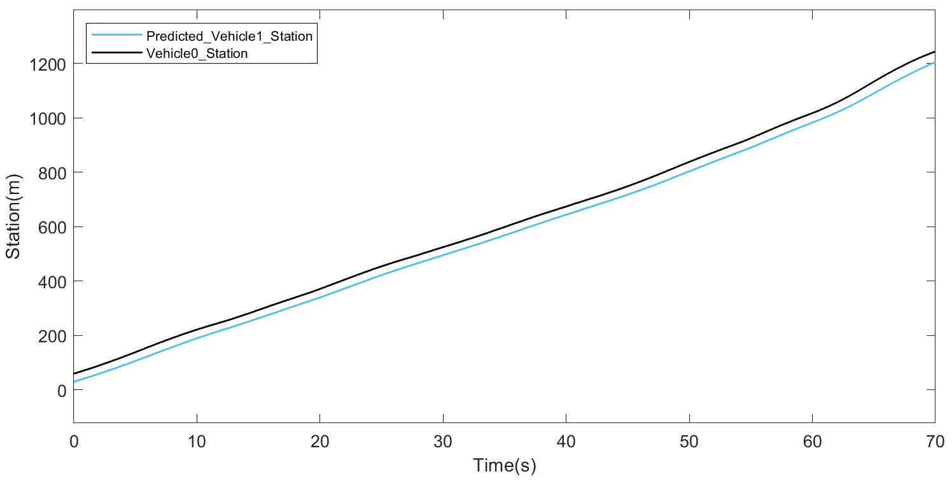
Figure 17. Follower vehicle position under delay conditions and lead vehicle position with speed prediction
The in-depth analysis of the graphical representations in Figure 13 and Figure 16 provides profound insights into the speed dynamics of the following vehicle within the car-following framework. Remarkably, the observed trend in speed changes remains consistent, regardless of the integration of the speed prediction algorithm. This consistent trend closely mirrors the speed change pattern of the leading vehicle, demonstrating the robustness and reliability of the speed tracking algorithm. Such findings affirm the algorithm's ability to effectively track the lead vehicle's speed, even in the presence of communication delays, a critical aspect for the system's functionality and safety[22].

Central to the evaluation is Figure 12, which significantly highlights the consequences of not employing a speed prediction algorithm. In the absence of this predictive mechanism, the system manifests a spacing error of up to 7 meters. This sizable error in the inter-vehicle distance underscores a notably unsafe condition, posing potential risks to both the occupants and other road users. Contrastingly, the pivotal insights derived from Figure 15 illuminate the positive impact of integrating the speed prediction algorithm. The graph showcases a remarkable reduction in spacing error, merely measuring 0.3 meters when the speed prediction algorithm is effectively utilized. This substantial reduction underscores a significant enhancement in safety performance within the car-following system.

5 Conclusion
In this study, we have delved into the realm of Cooperative Adaptive Cruise Control (CACC) systems, a pivotal innovation in the domain of intelligent transportation systems. CACC, leveraging vehicle-to-vehicle communication and advanced control algorithms, holds the promise of substantially enhancing traffic efficiency, safety, and overall road network performance. This research embarked on a multifaceted exploration, focusing on the development and validation of a bi-directional controller algorithm for CACC systems, integrated with a speed prediction mechanism to mitigate communication delays.

The foundation of our investigation rested on an in-depth review of the existing literature pertaining to CACC systems, predictive modeling, and safety-distance algorithms. Extensive research efforts have been dedicated to comprehending vehicle dynamics, communication protocols, and the intricate interplay between vehicles in a connected environment. Subsequently, we formulated a novel bi-directional controller algorithm that adeptly considers both lead and following vehicles, incorporating a variable time headway model influenced by the preceding vehicle's acceleration. This algorithm, pivotal to the enhancement of inter-vehicle spacing and traffic efficiency, was seamlessly integrated with a speed prediction mechanism.

In the realm of speed prediction, a hybrid deep learning model, amalgamating Convolutional Neural Networks (CNN) and Long Short-Term Memory (LSTM) networks, was proposed to accurately forecast the speed of the target vehicle. This model, capable of handling non-stationary multivariate time series data, effectively addresses the challenges posed by temporal dependencies and communication delays, critical aspects of CACC systems. The experimental validation of this model, conducted through meticulous simulations, demonstrated exceptional predictive accuracy and robustness, emphasizing its viability for real-world applications with the result of test dataset(the MAE is 0.0817, the RMSE is 0.1934, and the R-squared value is 0.9966).

The collaborative simulation model, implemented in Simulink and Carsim, provided a platform for comprehensive performance evaluations under diverse operational scenarios. The simulations meticulously assessed the car-following precision and overall system performance under the influence of communication delays. The integration of the speed prediction mechanism showcased a substantial reduction in spacing errors, enhancing safety within the car-following system(0.3m spacing error with speed prediction mechanism while 7m without speed prediction mechanism) Moreover, the speed dynamics of the following vehicle closely mirrored those of the leading vehicle, validating the efficiency and reliability of the speed tracking algorithm, even in the presence of communication delays.

In conclusion, this research contributes a comprehensive and integrated framework for CACC systems, encompassing a novel bi-directional controller algorithm and an efficient speed prediction mechanism. The findings underscore the pivotal role of predictive modeling and real-time control algorithms in optimizing inter-vehicle spacing, enhancing traffic efficiency, and promoting road safety. Future endeavors in this domain should strive for real-world implementation and validation, considering diverse driving conditions and scaling up to accommodate larger traffic networks. The continuous refinement and integration of intelligent algorithms within CACC systems hold the promise of revolutionizing modern transportation, ensuring safer roads and streamlined traffic flow for the benefit of society as a whole.
References:
[1]. A., V., 3GPP LTE Versus IEEE 802.11p/WAVE: Which Technology is Able to Support Cooperative Vehicular Safety Applications? IEEE Wireless Communications Letters, 2012. 1(2): p. 125-128.
[2]. S., Ö., et al., Cooperative Adaptive Cruise Control: Network-Aware Analysis of String Stability. IEEE Transactions on Intelligent Transportation Systems, 2014. 15(4): p. 1527-1537.
[3]. H., X., P. J. and N. H., Padé Approximation of Delays in Cooperative ACC Based on String Stability Requirements. IEEE Transactions on Intelligent Vehicles, 2016. 1(3): p. 277-286.
[4]. S., Y.H., et al. Output-Based Centralized Longitudinal CACC Systems with Wireless Communication Delay and Actuator Delay. in 2019 IEEE International Conference on Systems, Man and Cybernetics (SMC). 2019.
[5]. Liu, Y., et al., Safety Analysis of a Modified Cooperative Adaptive Cruise Control Algorithm Accounting for Communication Delay. SUSTAINABILITY, 2020. 12(18).
[6]. Cui, L., et al., Development of a simulation platform for safety impact analysis considering vehicle dynamics, sensor errors, and communication latencies: Assessing cooperative adaptive cruise control under cyber attack. TRANSPORTATION RESEARCH PART C-EMERGING TECHNOLOGIES, 2018. 97: p. 1-22.
[7]. Wu, L., et al. Model Predictive Cruise Control of Heterogeneous Vehicle Systems. 2019. Nanchang, China: Institute of Electrical and Electronics Engineers Inc.
[8]. Tian, B., et al., Communication delay compensation for string stability of CACC system using LSTM prediction. VEHICULAR COMMUNICATIONS, 2021. 29.
[9]. H., S., et al. Time-Delay Compensation for CACC Systems Considering Inter-Vehicle Distance Measurement. in 2022 IEEE International Conference on Consumer Electronics - Taiwan. 2022.
[10]. Zhang, Y., et al., Control Design, Stability Analysis, and Traffic Flow Implications for Cooperative Adaptive Cruise Control Systems with Compensation of Communication Delay. TRANSPORTATION RESEARCH RECORD, 2020. 2674(8): p. 638-652.
[11]. Liu, J.H., et al., Communication Delay-Aware Network Topology Adaptation for Cooperative Control of Vehicular Platoons, in 2021 IEEE GLOBAL COMMUNICATIONS CONFERENCE (GLOBECOM). 2021: IEEE Global Communications Conference (GLOBECOM).
[12]. J., P., et al., Controller Synthesis for String Stability of Vehicle Platoons. IEEE Transactions on Intelligent Transportation Systems, 2014. 15(2): p. 854-865.
[13]. Y., Z., et al., Cooperative Adaptive Cruise Control With Robustness Against Communication Delay: An Approach in the Space Domain. IEEE Transactions on Intelligent Transportation Systems, 2021. 22(9): p. 5496-5507.
[14]. Bai, Y., et al., Cooperative weaving for connected and automated vehicles to reduce traffic oscillation. Transportmetrica A: Transport Science, 2022. 18(1): p. 125-143.
[15]. Sun, Y., P. Wang and F. Liu. Design and Implementation of Cooperative Adaptive Cruise Control based on V2X. 2020. Virtual, Shanghai, China: Institute of Electrical and Electronics Engineers Inc.
[16]. Liu, F. and Y. Chen. Improved model predictive control for cooperative adaptive cruise control subject to actuator delay. 2017. Jinan, China: Institute of Electrical and Electronics Engineers Inc.
[17]. F., E.S., et al. MPC based collaborative adaptive cruise control with rear end collision avoidance. in 2014 IEEE Intelligent Vehicles Symposium Proceedings. 2014.
[18]. Ayres, T.J., et al. Preferred time-headway of highway drivers. 2001. Oakland, CA, United states: Institute of Electrical and Electronics Engineers Inc.
[19]. D., Y. and K. I., Nonlinear spacing policies for automated heavy-duty vehicles. IEEE Transactions on Vehicular Technology, 1998. 47(4): p. 1365-1377.
[20]. Zhu, M. and G. Tan, Research on Cooperative Adaptive Cruise Control (CACC) Based on Fuzzy PID Algorithm. 2023, SAE Technical Paper.
[21]. Mahama, H., Design of Aflagging Protocol for a Cooperative Adaptive Cruise Control LANE Change. 2014, 北京工业大学.
[22]. Zhang, S. and X.T. Zhuan, Study on Adaptive Cruise Control Strategy for Battery Electric Vehicle. MATHEMATICAL PROBLEMS IN ENGINEERING, 2019. 2019.

