

Assessment 1 – Reading Task Template
PART 1: Upload your photo of your A3 in-class notes here:
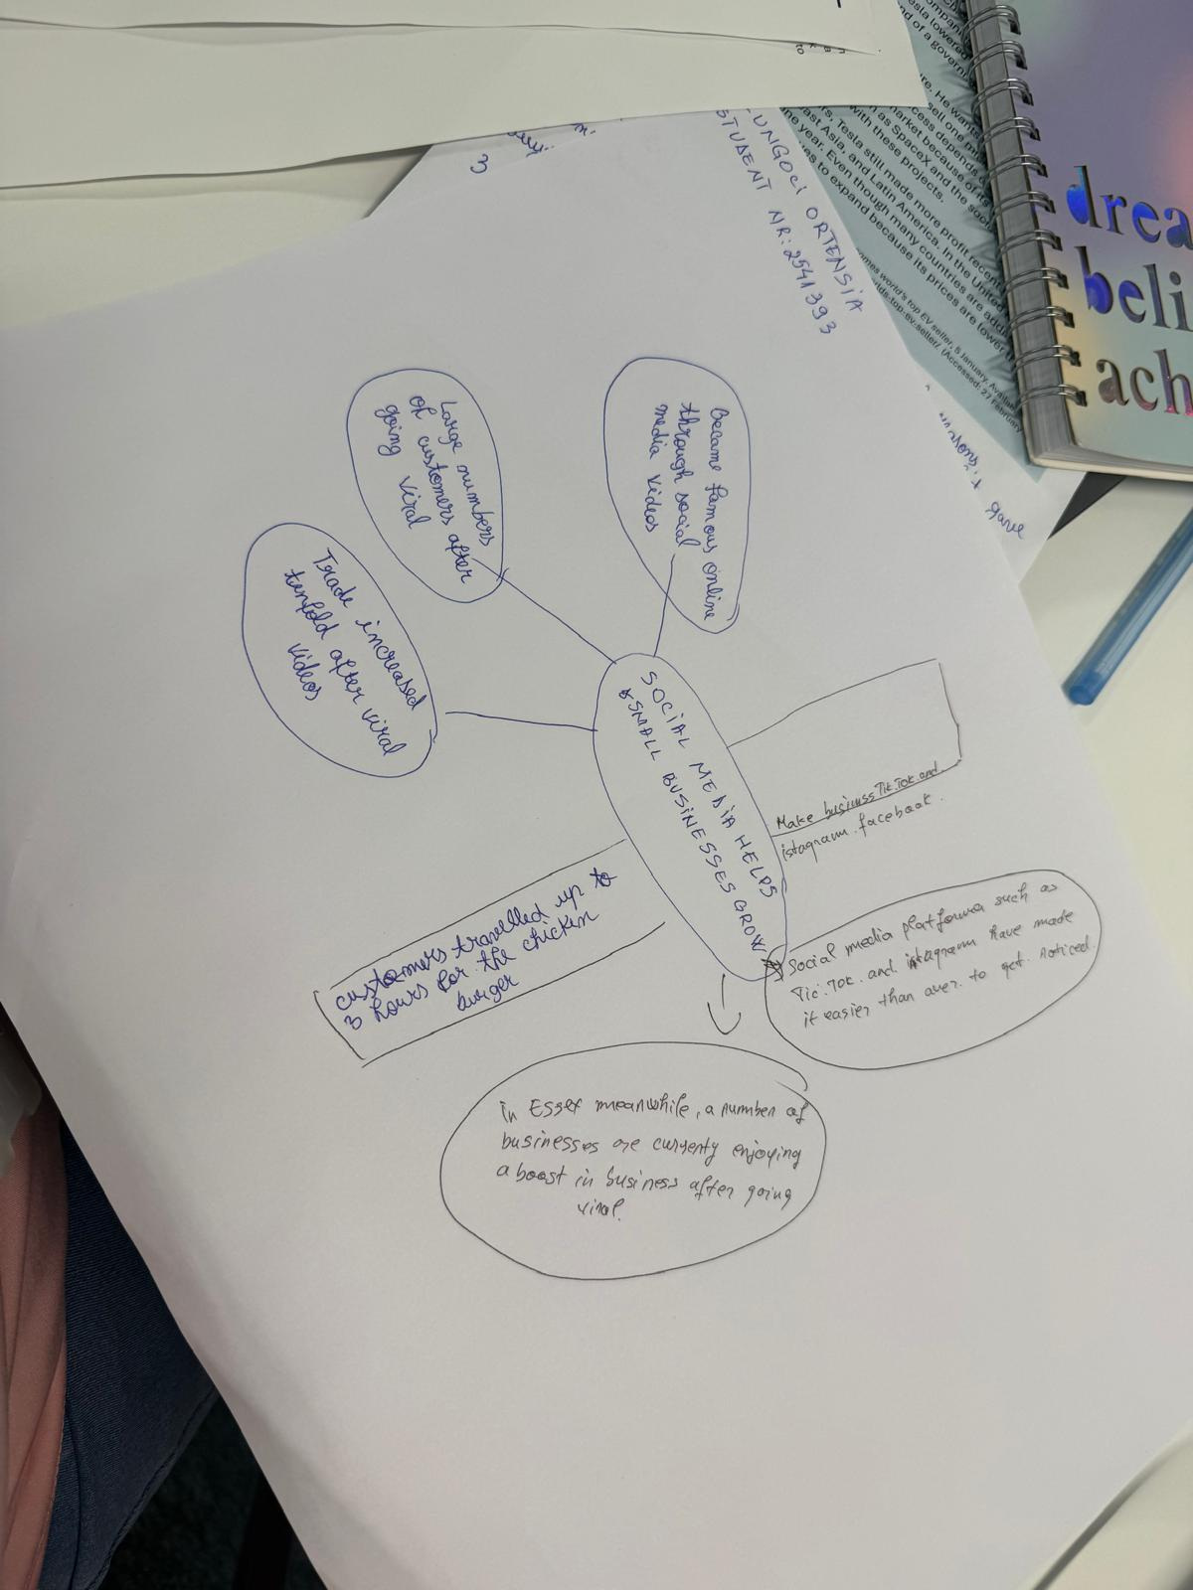

PART 2:
- Answer every question below in 1-3 full sentences.
- Use your own words. Do not use generative AI to answer these questions.
- Include a specific detail from the text when asked.
REMINDER
- The main idea is the overall message of the whole text.
- A key point helps to explain the main idea.
- A specific detail or example from the text shows that the key point is true.

- What is the main idea of the whole text?

The main idea is that social media can help small businesses become popular and attract customers from far away.
For some owners , online attention has been turned a small business into a full-time livelihood.

- What is one key point that supports the main idea, and which specific example from the text shows this?

One key point is that viral posts can bring customers from outside a business local area.
For example, customers travelled for hours to try the chicken burger at Murat Mutlu’s shop in Basildon.
- What is a different key point that supports the main idea, and which specific example from the text shows this?
Another key point is that social media can help business owners grow their work into something much bigger. Chloe Huggins and Ross Bliss’s party business receive about 45 million views in a year, and they now help young people celebrate nearly every day.

- Which part of the text do you think is most important, and why?
I think the most important part is the example of the chicken shop, because it shows how online videos can have a real effect on a small business. Customers travelling for hours to buy a burger shows how far a viral post can reach.

Reflection:
- What did you find difficult in this task (including in-cl ass components), and why was it difficult?
I found it difficult to identify the most important details in the text and explain them in my own words.
There was a lot of information, and I wasn’t sure which examples to include.

- What helped you with this difficulty, and how did it help you?
Rereading the text and looking at the examples helped me. They made it easier to understand the main ideas and choose the details that supported my answers.

