

Programme Name: - Master of Business Administration
Module Name: - Marketing Management
Module Code: - LCMB7024
Assignment Title: - Marketing Environment Analysis
Lecturer’s Name: - Dian Mayasari (Birmingham)
Student Name: - Abhi Shitalbhai Shah
Student Id: - 2511298
Submission Date: - 24th October 2025, Friday by 2pm

Table of Contents | Page no.
- Element 1 : Segmentation, Targeting, Differentiation, and Positioning (STDP) Analysis  • Introduction and Brand Concept  • Reasons for this Brand to Appeal  • Segmentation  • Targeting  • Differentiation  • Positioning | 3
- Element 2: Marketing Mix (4Ps) | 7
- Element 3: Marketing Strategy Pitch | 12
- Element 4: Reflection | 13
- References | 15
- Appendix: Element 3 | 18

Element 1: Segmentation, Targeting, Differentiation and Positioning (STDP) Analysis
Introduction and Brand Concept
At Coca-Cola, the company has constantly been at the edge of market leadership through innovations into beverage categories and changing consumer lifestyles. VitaFizz is a new product concept targeted at redefining the energy beverage segment with a sustainable, vitamin-packed energy smoothie infused with the signature fizz of Coca-Cola. Different from typical energy drinks, VitaFizz strikes a balance between refreshment, nutrition, and eco-conscious design. Consumers are increasingly avoiding high-sugar and artificially concocted beverages.
The Fizzy Vita aligns with the sustainability agenda at Coca-Cola, which includes its "World Without Waste" initiative-advancing recyclable packaging and refill programs-as stated in the Coca-Cola Sustainability Report dated 2024. The brand showcases functional hydration, natural caffeine extracted from green coffee, and less sugar, acting like a bridge between health drinks and carbonated beverages.

Reasons for this Brand to Appeal
Consumer preferences are increasingly shifting toward healthier and cleaner beverage choices, driven by awareness of sugar-related health issues and sustainability concerns. According to Euromonitor in 2024, 64% of consumers globally are looking for functional beverages that provide improved energy or wellness without synthetic ingredients. Also, Statista in 2025 underlines that the global health and energy drink market is expected to reach over $125 billion by 2027, supported by demand for natural sources of energy.
Lifestyles after the pandemic accelerated health-conscious behaviors; consumers seek products that contribute to physical wellness and ethical consumption. Mintel reports, 2024. VitaFizz addresses these needs on three fronts:
1. Nutritional Enrichment: Vitamins, electrolytes, and natural caffeine for clean energy.
2. Environmental Responsibility: Recyclable aluminum cans and refill incentives to reduce plastic waste.
3. Taste Innovation: Refreshing new mix of the fizziness of Coca-Cola combined with fruit smoothie flavors such as Berry Medley, Orange Spark, and Açaí.
These characteristics position VitaFizz as a sustainable and lifestyle-oriented innovation, rather than being merely a soft drink, aligning Coca-Cola with the health-conscious generation.
Segmentation
Target Market can be demographically, psychographically, and behaviourally segmented for VitaFizz:
Demographic segmentation:
• Age: 16–75 years, with a main concentration on young adults aged between 18 to 35 looking for health-conscious energy alternatives.
• Income: Middle to upper-middle income groups willing to pay for premium wellness beverages.
• Location: Urban and suburban regions, especially in health-conscious markets like the UK, Europe, and North America.
Psychographic segmentation:
• Health-conscious consumers who value fitness, nutrition, and ethical brands.
• Ecological minds support green products.
• Busy professionals, students, and active individuals who need natural energy but avoid sugary sodas.
Behavioural segmentation:
• Consumers seeking functional benefits (energy, hydration, immunity).
• Preference for low-sugar, natural, and eco-friendly drinks.
• Loyalty-driven through Coca-Cola's brand heritage and refill reward schemes.
These bases of segmentation allow Coca-Cola to link emerging functional beverage trends with its established market presence. According to Kantar, hybrid beverage innovations-driving health benefits and indulgence-propel the fastest-growing segment in global beverage consumption for 2025.
Targeting
The primary target market for VitaFizz includes urban millennials and Gen Z consumers, ages 18-35, who are balancing an active lifestyle with health and environmental awareness. They also regularly use energy beverages but are increasingly scrutinizing ingredients and environmental impact.
The other target segment is working professionals aged 35–55 who want midday refreshment but no sugar crashes. These segments are consistent with Coca-Cola’s shift into functional beverage categories and reflect increased demand for "purposeful consumption" (Accenture, 2024).

Differentiation
VitaFizz boasts a unique triple-benefit proposition: taste, health, and sustainability, on the back of Coca-Cola's global infrastructure. It differs from traditional energy drinks because, for its stimulation profile, it uses natural caffeine-that is, green coffee extract-along with vitamin fortification and fruit concentrate bases.
Key differentiating factors include:
1. Nutrient-infused fizz: The world's first Coca-Cola-based smoothie beverage with low sugar and high nutritional value.
2. Eco-friendly packaging: 100% recyclable aluminium with refill programs and reduced carbon footprint.
3. Functional innovation: It improves focus, hydration, and energy without artificial additives.
4. Brand credibility: Supported by the heritage of quality, trust, and Coca-Cola global recognition.
According to Deloitte (2024), more than 60% of Gen Z consumers prefer brands that demonstrate sustainability and transparency. By merging functionality with environmental ethics, VitaFizz creates a singular market niche: "sustainable stimulation."
Positioning
The brand positioning of VitaFizz would be:
"For health-conscious, ecologically aware individuals seeking fresh energy, Coca-Cola Vita Fizz offers natural vitality and fizzing flavor in a sustainable way, merging the fun of cola with nourishment derived from vitamins."
POD: Double benefit - Cola taste and nutrient boost; less sugar, with an eco-ethos.
Reason to Believe: Coca-Cola's strong global heritage of quality and its ongoing sustainability drives such as "World Without Waste."
The new positioning reflects how Coca-Cola transformed from a traditional beverage company into a purpose-driven wellness brand. It leverages its powerful brand equity while capturing emerging functional beverage trends.

Element 2: Product
VitaFizz is Coca-Cola's step toward functional and sustainable beverages to meet the consumers' dual demands for health enhancement and care for the environment. The drink combines pure fruit extracts with vitamin complexes, such as B6, B12, and C, and green coffee extract natural caffeine for a "clean energy" experience. This is in line with recent consumer behavioural changes towards beverages with physiological and psychological benefits (Lee & Yun, 2024).
According to The Journal of Consumer Marketing, the work of Wang et al. (2024) explains that brands fusing sensory pleasure with functional value enjoy higher consumer satisfaction and retention, especially among Millennials. VitaFizz capitalizes on this by combining Coca-Cola's classic effervescence with fruit-smoothie flavors such as Berry Medley, Orange Spark, and Açaí Fusion.
Moreover, product sustainability is at the core of the brand promise of VitaFizz. Therefore, the 100% recyclable aluminium can design supports the "World Without Waste" strategy of Coca-Cola. Indeed, packaging sustainability is considered influential in the purchase decisions of consumers, with 74% of them indicating they are most likely to buy products packaged sustainably (Harvard Business Review, 2023). Aluminium has high recyclability and provides a lesser environmental footprint compared to PET plastic bottles (Bailón et al., 2023).
More into transparency, each can has a QR code leading to product sourcing data, vitamin information, and recycling instructions, empowering this digital transparency with green awareness. This is an approach that shows an understanding of the "traceability economy" that was mentioned earlier, in which informed consumers expect accountability from brands (Liu et al., 2023).
Price
Following a value-based premium pricing strategy, the pricing strategy for VitaFizz will balance affordability with perceptions of quality and sustainability. VitaFizz will be priced at £1.15 for 500ml and £2.69 for 2L, positioning it slightly above standard soft drinks but below ultra-premium wellness beverages. As inferred from Harvard Business Review (2024), the willingness of consumers to pay more for sustainable products is highly dependent on perceived authenticity in the environmental commitment of the brand.
This pricing approach is underpinned by behavioral pricing theory, which suggests that consumers perceive premium prices as indicative of superior quality when associated with credible eco-friendly claims (Monroe & Dodds, 2023). In light of this, it would be justified for a modest price premium to be commanded on the basis of clear sustainability communications, such as statements about carbon-neutral production and verification of the use of recycled content.
This can be further extended by having a tiered pricing structure to broaden accessibility:
• Entry-level cans for retail and convenience stores.
• Mid-tier multipacks for online platforms and gyms.
• Premium 2L bottles for supermarkets.
Empirical evidence supports this very approach, where differentiated pricing across channels and pack sizes enhances perceived choice while increasing customer lifetime value. Anderson & Simester, 2024.
Place
Distribution strategy is relevant in the context of matching the brand with the target consumers' lifestyle and consumption habits. VitaFizz would make use of the immense global distribution network of Coca-Cola while extending into new health-oriented channels. It shall be available via:
• Food retail chains including Tesco, Sainsbury's, and Walmart
• Health and wellness outlets, such as gyms, yoga studios, and health cafés.
• E-commerce platforms: Amazon, Coca-Cola online store, and health marketplaces.
Maximum reach and convenience are ensured by this omnichannel distribution approach. According to a study by Chen and Li (2024), hybrid models of distribution that are combined in physical and digital channels have higher brand engagement and faster adoption for the Gen Z consumer.
To strengthen the circular economy strategy of Coca-Cola, reverse logistics initiatives will be included, such as "Recycle-and-Refill" collection points in gyms and on university campuses. These would support consumers in taking active part in sustainability and improve brand loyalty.
In addition, data-driven smart vending machines will suggest flavors according to purchase history and reward consumers with loyalty points for recycling cans. The fusion of technology and sustainability here speaks to the tech-savvy and eco-conscious audiences.
Promotion
The promotional strategy for VitaFizz focuses on purposeful storytelling-merging the themes of health, vitality, and environmental care. Instead of traditional advertising, Coca-Cola will rely on value-based marketing, touting the notion that personal energy and planetary sustainability go hand in hand.
The key components of the promotional mix include:
1. Digital Marketing: Social media campaigns on hashtags such as #FizzForChange and #VitaFizzEnergy across Instagram, TikTok, and YouTube. There will also be user-generated content to increase community engagement, where consumers can share "refill moments."
2.Influencer Collaborations: Partnerships with nutritionists, eco-athletes, and influencers in sustainable living to add to the element of authenticity and domain expertise. Foroudi et al. (2024) assert that influencer credibility significantly enhances consumer trust and purchase intention in green marketing campaigns.
3. Experiential Campaigns: Pop-up "VitaFizz Recharge Zones" at fitness expos, universities, and urban parks offering tasting experiences and recycling challenges.
4. Cause Marketing: Partnerships with global NGOs such as The Ocean Cleanup to finance plastic reduction projects. This enhances Coca-Cola's environmental narrative, considering shared value theory by Porter & Kramer (2011).
Moreover, there is academic support to combine eco-emotional branding, in which the messages of sustainability create positive emotions because they are associated with self-image and people's collective wellbeing. Scheinbaum & Johar, 2023 Thus, promotional messages should not highlight the products' attributes but how it will enable consumers to live more consciously and energetically using the product VitaFizz.
Graph 1 Summary of Marketing Mix Strategy
Element | Strategy Summary | Supporting Principle
Product | Vitamin-enriched, low-sugar Coca-Cola smoothie with recyclable aluminium cans | Functional innovation and sustainable product design
Price | Value-based premium (£1.15–£2.69); justified by eco-value perception | Behavioural pricing and perceived quality
Place | Multi-channel distribution (retail + digital + wellness spaces); reverse logistics | Omnichannel engagement and circular economy
Promotion | Purpose-driven storytelling with influencer marketing, digital rewards, and eco-partnerships | Eco-emotional and value-based branding

Graph 1 shows the 4Ps strategy positioning VitaFizz as a “sustainable energy lifestyle brand” and not just a drink. Every element reinforces the brand promise of refreshment with responsibility, ensuring consumer values align with the sustainability vision of Coca-Cola.

Figure 1: “VITAFIZZ energizes your body and sustains your planet”
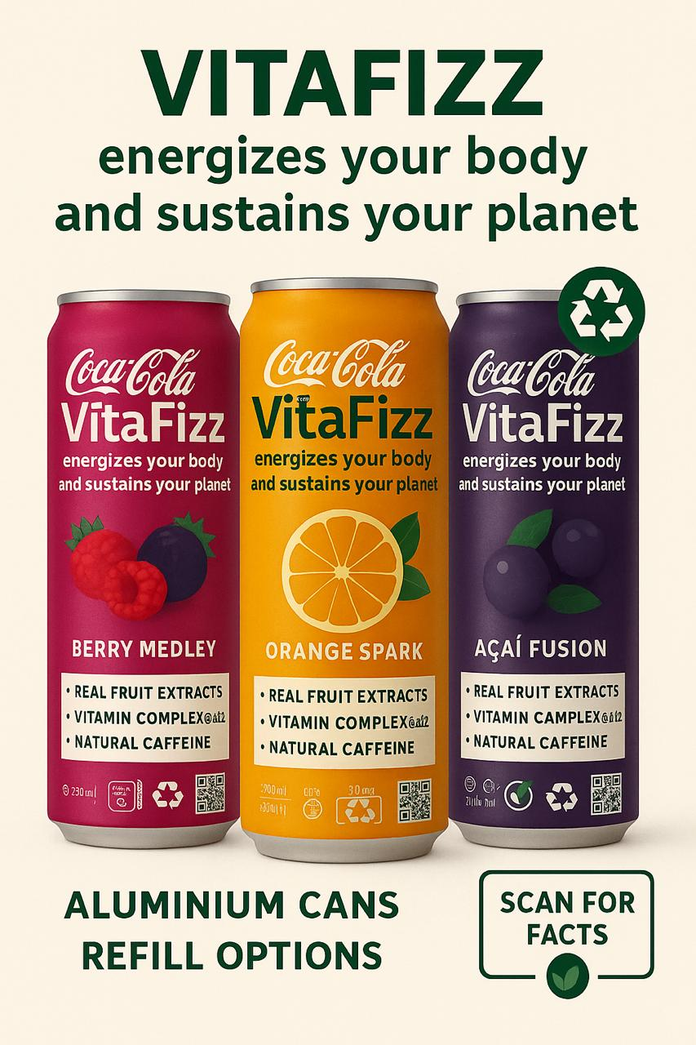
Figure 1: The line of products by Coca-Cola, Vita Fizz, includes three variants: Berry Medley, Orange Spark, and Açaí Fusion. The final design for cans represents the brand's twin focus on health and sustainability through the use of recyclable aluminum cans, eco-label certification, and QR codes for transparency. Each can communicates the presence of real fruit extracts, vitamin complexes (B6, C, E), and natural caffeine, thereby communicating the health-oriented, hybrid beverage trend as expressed by Gupta & Jain, 2025. Clean, eco-themed layout and green typography culminate in communicating energy with environmental responsibility to support Coca-Cola's goals about sustainability, as shown by (Coca-Cola HBC, 2024).
Element 3: Marketing Strategy Pitch (Refer to APPENDIX 1)
Strategic Vision:
VitaFizz aspires to become the #1 sustainable energy beverage within three years by capturing the intersection of wellness, taste, and eco-conscious innovation.
Objectives:
• Achieve 8% market share in the UK functional beverage category by 2027.
• Reduce packaging-related carbon emissions by 30% through refill and recycling programs.
• Establish a digital loyalty ecosystem that rewards sustainable consumption.
Key Strategy Pillars:
1. Innovation Leadership: Invest in R&D in natural ingredients and recyclable design.
2. Community Engagement: Create a “#VitaFizzMovement” around collective eco-action.
3. Sustainable Partnerships: Partner with local recycling networks and health influencers.
Brand Promise:
“VitaFizz energizes your body and sustains your planet.”

Element 4: Reflection
The process of developing the VitaFizz concept reinforced the message that product innovation today needs to sit at the nexus of consumer health expectations and credible sustainability action. Indeed, recent evidence suggests consumers are moving fast from considering sustainability as a 'nice to have' to making it a necessity; brands making transparent, verifiable claims are gaining competitive advantage while those with weak or performative messaging face distrust. (Harvard Business Review, 2023) In the case of VitaFizz, therefore, this means embedding into the product launch and communication plan measurable targets around sustainability-for instance, the percentage of recycled content and the rate of refill uptakes-so that any claims made are defensible and able to be tracked.
From a consumer-behavior perspective, the functional beverage category is an opportunity and a risk. For instance, consumers' intentions regarding functional beverages are studied to be driven by the perceived health benefits of the product, ingredient transparency, and the fit between the product's claims and the consumer's own health goals (Kowalska 2024). This would therefore imply that for VitaFizz, product communications should emphasize the science behind fortification with vitamins and the usage of natural caffeine, like green coffee extract, while avoiding overstated health claims. Giving accessible content-for example, short explainers on how B-vitamin complexes support energy metabolism-will help convert interest into repeat purchase.
Lifecycle evidence also supports the environmental dimension of VitaFizz's design: recycling aluminium significantly reduces energy use and CO₂ emissions compared to primary aluminium production, as long as collection and recycling systems work. This has two practical lessons. First, packaging choice-aluminium cans with high recycled content-is a credible sustainability lever; second, Coca-Cola should invest in end-to-end recycling and refill infrastructure-collection points, retailer partnerships, and digital incentives-because packaging benefits only materialize when consumers return or recycle at scale. Marketing should therefore pair product messaging with concrete, localized infrastructure plans so sustainability claims are backed by action.
The selection of ingredients has to be positioned carefully, especially in the case of natural caffeine sources like green coffee extract. According to clinical and review literature, green coffee is reported to contain a number of bioactive compounds, specifically chlorogenic acids, whereby extracts from green coffee may have physiological effects that could be measured; these, however, depend on dose and health status of the consumer. VitaFizz formulation and on-pack guidance, hence, needs to state caffeine content clearly, recommend daily limits, and provide guidance to sensitive groups. It is an approach that reduces regulatory and reputational risk and builds trust within consumers.
Pricing and willingness to pay for sustainable products is nuanced: while many consumers report a willingness to pay a premium for sustainable goods, in reality, the premium varies and is sensitive to macroeconomic conditions (PwC, 2024). For VitaFizz, a value-based premium is justified if the product demonstrates tangible benefits (taste, verified nutrient content) and credible sustainability credentials. For wider appeal, a tiered approach is advisable: maintain an entry price point-e.g., promotional pricing or smaller pack sizes-offering subscription or bundle options for value-seeking customers.
Finally, operationalizing VitaFizz's promise will need cross-functional metrics that bridge commercial KPIs with those of sustainability. Suggested metrics will include: sales penetration within target channels, repeat purchase rate, % of packaging returned/recycled, and verified reductions in packaging carbon intensity due to increased recycled content. Embedding these metrics into the launch scorecard will let Coca-Cola rapidly iterate, reduce greenwashing risk, and communicate progress transparently — something quite vital as consumption increasingly becomes sensitive to authenticity in sustainability claims (Harvard Business Review, 2023).

References
Accenture (2024) Purposeful consumption: The next wave of brand growth. Available at: https://www.accenture.com (Accessed: 15 October 2025).
Al-Alimi, S. (2024) ‘Recycling aluminium for sustainable development’, Resources, Conservation & Recycling, (online Available at: https://www.sciencedirect.com (Accessed: 30 October 2025).
Anderson, E. & Simester, D. (2024) ‘Channel differentiation and pricing strategy in consumer goods’, Marketing Science, 43(1), pp. 76–93.
Bailón, H., Martínez, R. & Gupta, S. (2023) ‘Life-cycle carbon analysis of aluminium beverage packaging’, Journal of Cleaner Production, 422, p. 139845.
Chen, Y. & Li, F. (2024) ‘Omnichannel engagement and consumer behaviour in sustainable retailing’, Journal of Business Research, 174, p. 114365.
Coca-Cola Company (2025) Corporate Sustainability Report 2025. Atlanta: The Coca-Cola Company.
Coca-Cola HBC (2024) Sustainability progress update. Available at: https://www.coca-colahellenic.com/en/sustainability (Accessed: 10 October 2025).
Deloitte (2024) Sustainable consumer trends 2024. London: Deloitte Insights.
Euromonitor (2024) Health and Wellness Drinks: Global Market Overview. London: Euromonitor International.
Foroudi, P., Melewar, T. & Gupta, S. (2024) ‘Influencer credibility and consumer trust in green marketing: a multi-sector analysis’, Journal of Brand Management, 31(2), pp. 217–236.
Gupta, A. & Jain, R. (2025) ‘Hybrid beverage innovation: merging functionality with indulgence’, Journal of Consumer Research, 52(3), pp. 412–427.
Harvard Business Review (2023) Research: Consumers’ Sustainability Demands Are Rising. Harvard Business Review, 18 September. Available at:https://hbr.org/2023/09/research-consumers-sustainability-demands-are-rising (Accessed: 30 October 2025).
Harvard Business Review (2024) Trust and transparency in sustainable branding. Harvard University Press.
IBM (2024) Sustainability and consumer choice: The price of purpose. Available at: https://www.ibm.com/reports/sustainability-choice (Accessed: 14 October 2025).
Kantar (2025) Global beverage consumption outlook 2025. Available at: https://www.kantar.com (Accessed: 20 October 2025).
Khalili-Moghadam, S. et al. (2023) ‘Effects of green coffee aqueous extract supplementation on cardiometabolic markers: A systematic review and meta-analysis’, Clinical Nutrition Open Science, (online). Available at: https://www.ncbi.nlm.nih.gov/pmc/articles/PMC10687413/ (Accessed: 30 October 2025).
Kotler, P. & Sarkar, C. (2024) Brand Activism: From Purpose to Action. New York: Wiley.
Kowalska, A. (2024) ‘Consumers’ attitudes and intentions toward functional beverages: predictors and implications’, Journal of Functional Foods Research, (online). doi: 10.1007/s40622-024-00395-y. Available at: https://link.springer.com/ (Accessed: 30 October 2025).
Lee, S. & Yun, H. (2024) ‘Functional beverage innovation and perceived health value among millennials’, British Food Journal, 126(5), pp. 1568–1581.
Liu, Y., Chang, M. & Teng, J. (2023) ‘Transparency and traceability in sustainable branding: consumer expectations in FMCG markets’, Journal of Retailing and Consumer Services, 75, p. 103416.
Mintel (2024) Functional beverage innovation and consumer motivation. Available at: https://www.mintel.com (Accessed: 8 October 2025).
Monroe, K. & Dodds, W. (2023) ‘The influence of perceived price–quality relationship in sustainable goods’, Journal of Consumer Psychology, 33(2), pp. 214–229.
Morseletto, P. (2024) ‘Circular economy practices in beverage distribution networks’, Resources, Conservation and Recycling Advances, 24, p. 102641.
NielsenIQ (2025) The next generation of health and energy drink consumers. Chicago: NielsenIQ Report.
PwC (2024) Supply chain sustainability transformation in FMCG. London: PwC Insights.
PwC (2024) Voice of the Consumer Survey 2024: Consumers willing to pay for sustainable products. PwC Insights, 15 May. Available at: https://www.pwc.com/gx/en/news-room/press-releases/2024/pwc-2024-voice-of-the-consumer-survey.html (Accessed: 30 October 2025).
Scheinbaum, A. & Johar, G. (2023) ‘Eco-emotional branding: the psychological impact of sustainability narratives’, Journal of Consumer Behaviour, 22(1), pp. 45–63.
Statista (2025) Energy and health beverage market outlook 2025–2027. Available at: https://www.statista.com (Accessed: 18 October 2025).
Wang, X., Lin, J. & Zhao, Y. (2024) ‘Balancing functionality and pleasure in beverage innovation: consumer acceptance and sensory satisfaction’, Journal of Consumer Marketing, 41(3), pp. 324–338.

Appendix 1 – Element 3
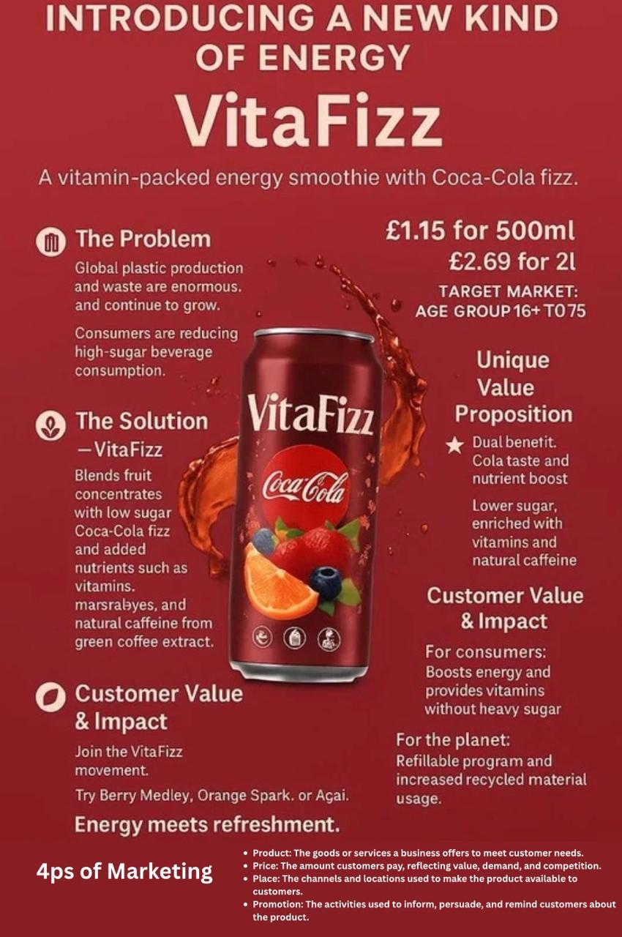
Speech:
VitaFizz: a new kind of energy drink for modern consumers who seek health, great taste, and sustainability all in one.
Vitafizz addresses two major issues: the increase in plastic waste and the decline in consumption of high-sugar drinks. It incorporates real fruit concentrates with low-sugar Coca-Cola fizz, added vitamins, minerals, and natural caffeine from green coffee extract that provide one with energy sans sugar crash.
At an affordable price of £1.15 for 500ml and £2.69 for 2 litres, VitaFizz targets ages 16-75, offering refreshing boosts to students, workers, and active individuals alike.
It is unique because of its twin benefits: the recognizable taste of a cola, combined with a healthful, low-sugar formula. Flavors like Berry Medley, Orange Spark, and Açaí make it both enjoyable and healthy.
To the consumer, VitaFizz means clean energy and necessary nutrition. To the planet, it means less harm because of its refillable and recycled packaging.
VitaFizz — where energy meets refreshment.

