
Skills for the Workplace
Module Assignment Submission

Student Name: | GAIL PHILLIPS
Student Number: | 1918511
Module No: | BMSK4007
Module Title: | Digital Skills and Personal Branding

Statement of Confirmation of Authenticity
By the act of making this submission, the student declares that this is the work of the student named above. The work has not, in whole or in part, been knowingly presented elsewhere for assessment, or where assessment has been built on a previous assessment, this has been identified. Where materials have been used from other sources it has been properly acknowledged. If this statement is untrue, the student acknowledges that an assessment offence has been committed.
Attention is drawn to the plagiarism and unfair practice policies of both the University and of ILM.
Permission for ILM to use this script
ILM uses learners’ submissions – on an anonymous basis – for assessment standardisation. By submitting, both the centre and the learner agree that ILM may use this script on condition that identifying information is removed. However, if you are unwilling to allow ILM use this script, please refuse by ticking the box: □

Table of Contents
What has been the impact of 21st Century Technologies on the modern workplace? 3
Evaluate the appropriate use of modern technologies and social media in the workplace generally 4
Explore the use of modern technologies and social media in own workplace 4
How can Personal branding help YOU? 5
and currant Your LinkedIn Profile to promote your Personal Brand 5
Evaluate the value of other social media platforms to enhance networking and career prospects 5
Examine the impact of Personal Branding on your own employability 6
Discuss personal and professional security and safety online. 7
References Error! Bookmark not defined.
Appendix 1 Error! Bookmark not defined.
Appendix 2 10

What has been the impact of 21st Century Technologies on the modern workplace?
In the 18th century, modern technology began and improved in the 19th 20th and 21st century. Technology and the way we work has changed considerably. The impact of 21st-century technology in the workplace is more productive than ever before in history for people in the workplace. Technology today can have advantages and disadvantages in any business. Businesses need to keep updated with today's technology because a company will more than likely not succeed without it in some style (Heinrich, 2014).
Technology has become part of everyday life; it has improved performance in the workplace immensely. Technology in earlier days was much slower than today. Today it is much faster and has many more devices. There are a few advantages of modern technology in the workplace. Communication is a lot quicker and more efficient. A quick way to communicate can be done by email; this is a fast way for any business to communicate, scarcely do people send letters. Long gone are the pen and paper. People can send emails using many devices by, e.g. smartphones, laptops, computers, iPad (Maund, Schrick & Tinkler, 2017).
Smartphones in the industry have become very popular. Most people carry a mobile phone; it will help individuals communicate with their customers faster. A phone can send messages, send emails and make calls. Social media apps can also respond the same way these can be sent at any time of the day and respond quickly. Communication with a larger audience in group chats whattup, the messenger can also set up virtual meetings. You can join theses meeting where ever you are, providing you have internet access (Morgan, 2017).
As Heinrich (2014) states, Modern technology can also increase your sales and widen your market; if your business is retail, you can quickly use Amazon and eBay to sell your products. It can significantly reduce your overhead costs. With modern technology, you can build your business more efficient with stocktaking and ordering system. When going on holiday, you can book it all online using a smartphone or computer you can even download your boarding pass to your mobile instead of having to use a check-in desk. Paying for petrol is also easier you can now pay at the pump with your bank card you don't even have to go into the shop. Technology today has changed how more people do their shopping.
We can now order shopping via an app arrange the delivery or click and collect where you go to the store and its ready to be picked up. We don't even need to go to the cashier to pay; you can walk around the store scan your items with the latest smart shop app on your mobile phone or with an in-store scanner you can grab a scanner and scan whilst you shop rather than having to queue and use a checkout. Different medical field technologies can help when booking a doctor's appointment online; you can walk into the doctors and use the computer to check-in rather than queue to speak to the receptionist. You can order your repeat prescriptions online. Pharmacy uses robotics to track medication prescriptions. You can even have a one to one with your doctor by virtual visits, and you can also download apps that track your diet (Doraszelski & Jaumandreu, 2018).
Baiju (2018) suggests modern technology can also have a disadvantage in the workplace. It can increase the risks of jobs; for example, amazon use drone carrier. They are becoming more popular and a part of our lives because many jobs are now becoming automated. But many new jobs in the technology side are being created.
Security risks are another disadvantage. With the online market becoming widespread theft and scammers can access your information when they hack into your business, they can also get information about our private lives and your home. They can also find out your bank card details if you are not careful.
When using the internet in work a disadvantage of having this is if you have a power cut, everything will shut down and you could lose important information and you would no longer be able to work until its back on.

Evaluate the appropriate use of modern technologies and social media in the workplace

The appropriate use of modern technologies in the workplace can improve your business and help it to grow. It has allowed companies to market themselves to their customers better. Technology has changed so much that it can help us communicate with our team members outside the workplace. We can also interact with one or more persons at any time. We can have teams meetings online with members being in different places at the same time. You can send one email to many individuals with one click of a button. Technology plays a vital part, and many workplaces have a high-security level for safe running, and only authorised members of the team can have access.
iCloud can back up and sync all of your contacts, your appointments in calendar, all of your notes and attachments in apple notes. It can also store photos, and when you upload them they will be backed up by iCloud, you do have to keep an eye on you on your storage space though, if you run out of storage space you can always buy more. Any music you download and save on a device you can listen to if you sign in to your account on a different device. You can see everything that iCloud can back up for you by opening your setting on your phone or iPad.
When you have iCloud, it benefits you if you lose one of your devices, you can sign in to your Apple account on a different device and all your data can be restored. iCloud is also very useful in the workplace; it is an apple name for storing all your photos, music, library, it also backs up your devices. You can sign in to see all of your data in one place, and it is backed up to a secure location and synchronised to all your devices.
Social media in the workplace is compelling; it can help your business communicate, solve problems and build personal relationships with co-workers. It is also a right way for employees to spread information about your company. It can positively impact your business; it can show people that their staff work in a happy environment; companies can also grow and learn and find information to succeed. Modern technology can also save your business in operating costs by letting some of their employees work from home

Explore the use of modern technologies and social media in own workplace

Today’s technology in my workplace allows us to be more efficient. We have work phones that only authorised for work purposes; it records all the tasks we have to do. If we have not done a job it will red flag telling us its needs to be done as a priority .these cannot be used for our personal use. The phones also help us communicate better for example, if you’re not sure if a person did a task or not or what time they did it you would only have to look it up on the phones to check.
We use social media such as Facebook to interact with family members to see all the residents' activities throughout the day. They can see a picture of them joining in and having fun, singing and dancing.
WhatsApp is also used with iPad so the residents can see and speak to their families. It helps immensely at these challenging times with families not being able to visit with the pandemic that is going on. We are also provided with a company laptop to take home and do work from home; it is set up for strong security reasons. We can use theses for messaging all staff members for example if we are short staff and if anyone wants to pick up shifts, it is for updating care plans and anything that is needed to do via the internet.

How can Personal branding help YOU?
The process of personal branding involves finding your uniqueness and things you want to be known for and allowing yourself to be known for them. When you use personal branding, it is vital to make a first good impression. It tells people what they would like to know about you. Developing a personal brand helps to identify your values and what you stand for. Personal branding can help in many ways to grow your business. It allows you to stand out. It is vital to have a well-crafted personal brand as well as a business brand, and it gives you the ability to share your knowledge, personal branding involves communicating your values, beliefs and goals

Your LinkedIn Profile to promote your Personal Brand
People will make a first impression of you within minutes of them meeting you, so making a good first impression is really important.
You must have a profession photo this is one of the first things people will look at when they look at your profile , so one with you partying and being drunk will not be a good first impression! You can make your profile professional so that people will trust your content more. Optimise your profile with targeted keywords so more people can find you. LinkedIn is a media platform and is the best place for growing your brand. LinkedIn is booming and is a professional version of yourself. Companies are using LinkedIn to find employees; its helps them to gain a wider audience, so your profile must be professional. Your personal brand must thrive your career, and with a good professional profile LinkedIn will connect you many people in the same industrial as yourself, but you must have the right search terms for your profile to stand out. If people search for you on google they will more than likely end up on your LinkedIn profile, so it’s essential to have a professional one. A LinkedIn profile helps to tell people who you are and everything you have to offer and how your work is valuable to employees ,they can find out what strengths you have and if you can bring any positives to the company. With a LinkedIn profile you can learn and grow, connect with groups and stay involved with relevant issues you can also build up relationships with individuals and find help within your career. When you show all your achievements, it can open many door for you that would otherwise be closed for you and you can also decided which ones you would like to keep open.

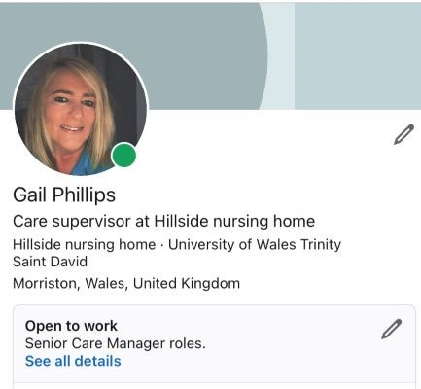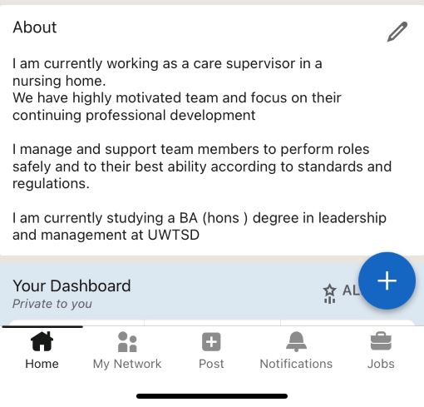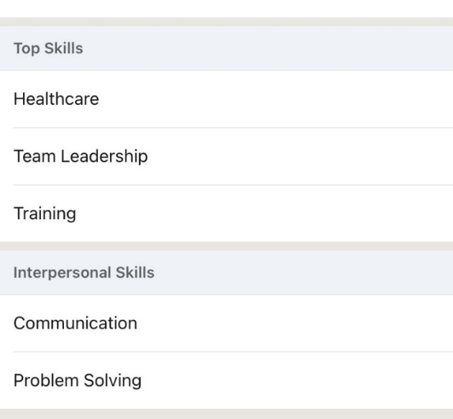

Evaluate the value of other social media platforms to enhance networking and career prospects

Social media sites are an excellent way for employers to understand their potential employees and backgrounds.
- Facebook
- Twitter
- Instagram
- LinkedIn
FACEBOOK: is a network where you can change your privacy settings so only the people you want to see can see your posts, for example, your friends and work colleagues, you can use the settings so no one you wish to can see your profile. It has 2.6 million monthly active users, and It is beneficial for small business; it is an excellent place to start your social strategy. Setting up a business page can connect potential customers to a webpage to view all products.
TWITTER: When looking for employment, Twitter can be beneficial as part of a job search.
Twitter can be helpful for a wide range of industries, from entertainment to e-commerce. It benefits the music industry immensely because it can connect to your audience and new fans.
When looking for a job role on Twitter the best way of using Twitter is to look for a company and the parts they want to fill; larger companies will have a separate Twitter account for job vacancies.
INSTAGRAM
Instagram can help people looking to move into more niche careers such as modelling, music, dance and beauty and can be very useful to connect with top people in these industries.
Instagram is a perfect marketing tool it allows to market yourself to 700 million active monthly users.
LinkedIn was launched on May 5th, 2003. Over 500million members in 200 countries use the network; it is a more professional social network designed to help you contact professional people and their experiences. Many Businesses are now with LinkedIn.
LINKEDIN
When you set up your LinkedIn profile always use a professional photo because it is your first impression, add your industry and location when you set up a LinkedIn profile account and have an internet address called URL. This will help people find you.

Examine the impact of Personal Branding on your own employability

The care sector is a growing market, especially for dementia care and the fact that people live longer. Discovering why personal brand identity in care homes is so essential the identity is not just about aesthetics it’s the whole package for the residents and staff influencing how they live.
For all residents, it's about the location and their life experience and to make the home a homelife environment a happy, comfortable and fulfilling part of their life journey; for example, we consider how residents experience eating socialising resting and activities. We have to look at history and industries to see what the residents would be familiar with because this could be reflected in the design, taking a look at the target market and current care provision in the area
- is it well-led
- is it responsive to people’s needs?
- is it caring
- is it effective
- it must be safe
For staff, it's providing an environment in which they can give excellent care safely and to streamline routine tasks.

Discuss personal and professional security and safety online.

GDPR came in to place in April 2018, and it helps organisation comply with regulations it applies to everyone who has day to day responsibility for data protection. Its is updated every month by the Information Commissioner Office. GDPR The General Data Protection Regulation is a replacement of European data protection legislation. It could be the most effective regulatory framework to hit businesses. Any businesses that hold data on the EU regardless of residence in the EU must manage and protect personally identifiable information (information commissioner’s office, 2018)
BYOD security is essential because when employees bring their personal devices into the workplace, it can have serious security problems on your business’ BYOD security will ensure a balance between business security and employees personal privacy. It can have a positive and negative affect on your business. Employees may not keep up with security or lose their devices, and when team members fail to update it could leave cloud software open to scammers to open.
When securing your business online, it is vital to turn on the firewall, but this is not enough. While this would provide the first line of defence, you would need other methods of security. It identifies you in another way: fingertip face id or even send a code via a text message to your mobile phone. Passcodes are also very important; this is optional added security and protects your accounts when your device is unlocked. Two-Factor Authentication can also make your accounts safer it gives you another layer of security it verifies who you are. Not all websites have it available, but when they do come available you should turn it on,
VPN is also important to have because if you decided to connect to the internet that you’re not sure about it gives you security over the data and websites on which the user uses. When setting up accounts online, it is essential to use different passwords for different accounts. By doing this if a scammer gets hold of one of your online accounts using the same password could give them access to all your accounts, having a unique and strong password is so important. Personal and professional security and safety is paramount. Online security is essential these days with more and more scams going on. Potential employers do not need to know about your background, or your home address it is very important to keep your privacy settings on.
.

References
Baiju, N. T. (2018). 5 advantages and disadvantages of using Cloud Storage. Available at: https://bigdata-madesimple.com/5-advantages-and-disadvantages-of-cloud-storage/
Barclays. (2020). Badges. Available at: https://digital.wings.uk.barclays/badges/
Doraszelski, U. & Jaumandreu, J. (2018). Measuring the Bias of Technology Change. Journal of Political Economy. 126(3).
H. Arif, H. Hajjdiab, F. A. Harbi and M. Ghazal, "A Comparison between Google Cloud Service and iCloud," 2019 IEEE 4th International Conference on Computer and Communication Systems (ICCCS), Singapore, 2019, pp. 337-340, doi: 10.1109/CCOMS.2019.8821744
Heinrich, T. (2014). Technological Change And Network Effects In Growth Regimes. Hoboken: Taylor and Francis.
Information Commissioner’s Office. (2018).Guide to the UK General Data Protection Regulation (UK GDPR). Available at : https://ico.org.uk/for-organisations/guide-to-data-protection/guide-to-the-general-data-protection-regulation-gdpr/
Maund, A., Schriek, M., & Tinkler, P. K. (2017). Certificate in Higher Education: Skills for the Workplace Student Yearbook. London: SAGE.
Morgan, P. (2017). The Business Student’s Guide to Study and Employability. London: SAGE. `
Olalere, M. et al. (2015) ‘A Review of Bring Your Own Device on Security Issues’, SAGE Open. doi: 10.1177/2158244015580372.
Vodnik ,s (2018) how to include your pubications in your linkedin profile https://blog.taaonline.net/2018/03/how-to-include-your-publications-in-your-linkedin-profile/

Appendix 1

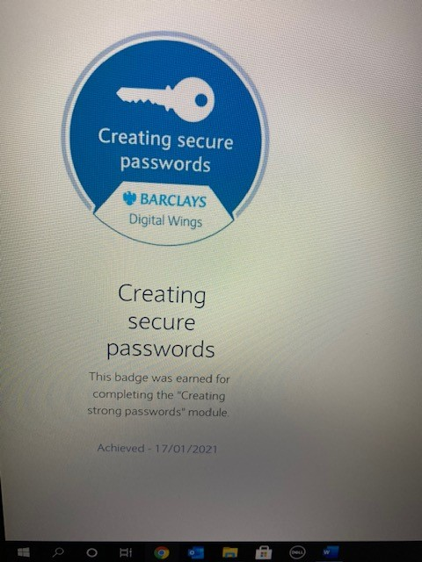
Barclays (2020)

