THE GLOBAL BUSINESS ENVIRONMENT
LCBB4005
Rexon Nting

Elena Blagoeva 1913400
BA Business Management
Group 1 Term 2
Assessment 1

Contents
PART-A 2
External and Internal Forces 2
Change in the Automobile Industry 3
Part-B 3
PESTEL Analysis of Automobile Industry 3
Political Consequences 4
Economic Consequences 4
Social Consequences 5
Technological Consequences 5
Environmental Consequences 5
Legal Consequences 5
Porter’s five forces model 6
The threat of New Entrants 6
Bargaining Power of Suppliers 6
Bargaining Power of Buyers 7
The threat of a Substitute 7
Competitive Rivalry 7
Reference List 8

PART-A
The automotive sector of the world has been experiencing fluctuations for the past few years. This has caused the stakeholders to take action so that they can improve the conditions. One thing that is of great importance is that this business is the most profitable of all across the globe. The automotive sector has been able to increase job opportunities for the ones who were not able to find jobs earlier. Apart from this, they have been involved in philanthropy as well. This means they are also supportive of the community and its wellbeing (Braithwaite and Drahos, 2000)
Businesses the sector also focuses upon increasing the profitability by providing the state of the art services to their customers keeping in mind their preferences. The inception of this industry date backs to more than a century.it expanded operations from the European Union towards the USA. The earlier days of their operations got them great profits (Peng, 2016). SUVs were ones are luxury but in the current situation, they have become necessity therefore customers never get bored of by them. Statistical reports show that the European Union is the region where the automotive sector is the most profitable and efficient as compared to the world (Hill and Hernandez, 2008).
This Business already exists in many parts of the world and it is looking forward to expanding in the coming years. Already there have been many expansions done in different countries of the world. The current situation shows that customers have become very selective and expect customization which the businesses provide to them. There are very few places found on the map where this industry does not exist because of many reasons like the political situations the law and order etc. But as time is passing the sector is planning to expand. COVID-19 has affected many settings and plans of the business sector especially of the automobile industry therefore The Giants have to re-strategize once the situation has become under control (Vogel, 2008).

External and Internal Forces
Many factors affect the business of Car manufacturing companies. These may be from the inside or the outside. Internal means the situation inside of the company the staff, management, etc. By the outside factors here it means that the policies that have been devised by the higher administration like the change in taxation policy and trade (Dunning and Dunning, 2006).
As technology has taken over each and everything in the life of a common person the vehicles that this person uses are also equipped with the most advanced technical features be it related to safety or mechanical (Kose et al., 2012). Technology has overtaken many operations that were earlier done by humans, therefore, decreasing the chances of errors. No machinery is used to manufacture a car and the staff is trained on how to use the machinery properly it requires great skills and expertise to operate that particular machine that is involved in the manufacturing of cars (Trompenaars and Hampden, 2011). By using technology but it has become easier to work as it saves time and money both. Best weekend said that fire has become efficient and the employees are working more productively than ever before. To overcome the issue related to the emptying fuel reserves, by using technology the companies have introduced new fuel-efficient cars and vehicles that are solely run on electricity and do not use fuel at all (Croucher and Cotton, 2011).
The world now faces challenges related to the scarcity of fuel and this has made experts look at other alternatives, the automobile sector has switched their technologies to the world's producing hybrid vehicles are the ones that are solely run on electricity. Both have gained a great amount of attention from buyers worldwide (Thomas, 2008). This innovation will lead towards an eagle friendly initiative that would be a great boost for the business. All the companies are competing to have an edge over all other vehicle manufacturers. Another more important part of technology is to use software and other gadgets so that the consumer experience becomes one of a kind and this is how the companies retain loyal customers (Govindarajan and Gupta, 2001).

Change in the Automobile Industry
The automobile sector keeps on changing and make sure that they don't remain behind in applying any new technology, therefore, they keep their NPD Department vigilant enough to incorporate new changes in their vehicles that will attract a great population. In addition to this, as it has been stated earlier as well that this sector has provided many jobs to the unemployed and made the region developed strengthening the economy. It is now important for all these companies that are manufactured in vehicles to incorporate modern technology through the passage all signs show that their products do not get obsolete. Therefore all the people are working tirelessly and putting in the effort so that the company gains profit. There are two important departments of any company that are the research and development and the new product development for which they hire the most competent individuals (Govindarajan and Gupta, 2001).
People are now largely dependent on technology therefore the companies catering to them should be taking care of all the requisites and demands because this is the thing that makes greater revenue for the company. Technology has become an important part of our daily lives there for each and everything that is used by an individual must carry technology in it. Moreover, safety becomes more advanced therefore people can rely greatly on them. Technology has taken a great place in our lives and is very important because of the advantages that it provides to all its users. It is getting advanced with every passing day one such example is AI and ML (Govindarajan and Gupta, 2001).

Part-B

PESTEL Analysis of Automobile Industry
Every business requires a certain number of analytical tools through which it can evaluate the environment in which it is operating. One such tool is the PESTLE analysis that informs the company about many external forces that can affect the business badly therefore through this analysis the company gets an idea about what it is going to face in the future and plan about the strategies that it will be going to use to come over these problems. Various external factors are going to be discussed through the PESTLE analysis over here that allows the company to take an overview and device strategies accordingly.
Another tool that lets the company know about their strengths, weaknesses, opportunities, and threats in the SWOT analysis tool, This one is for the company to identify their stones and opportunities to overcome their weaknesses and threats hello and let them think about ways through which they can use these to overcome all the issues that they are facing in the corporate market (Schmidheiny and Timberlake, 1992).
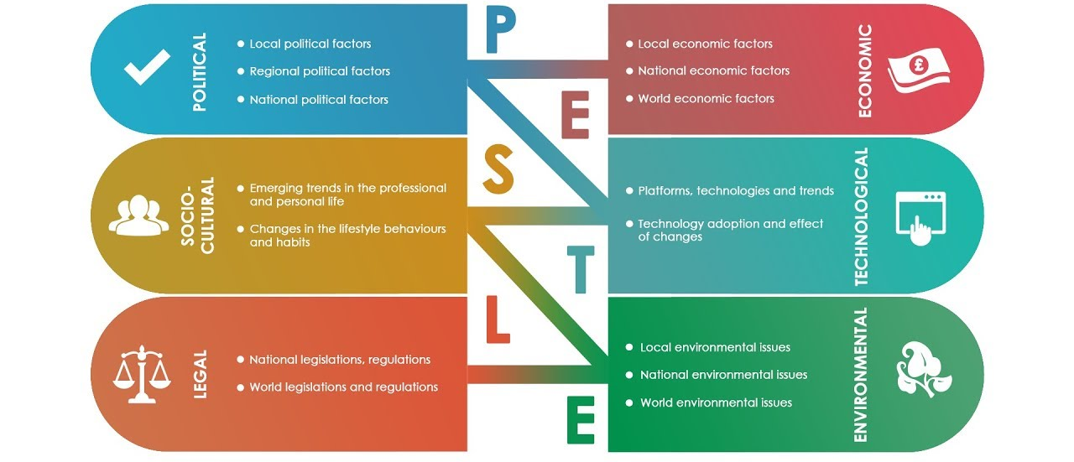
Many different points have to be considered while performing the analysis is the company. The geographical location. The cultural aspects all are required to be all right-aligned. Because my analysis is taking place all these issues are discussed in detail for the company's knowledge (Neeley, 2012).

Political Consequences
The higher administration of any country is responsible for making plans regarding the trade rules and regulations. The automobile sector is spread across vast geography and these regions are divided based on a different ruling administration. Therefore, all these rules and regulations vary according to the region and it is a great issue for the automobile sector to abide by all of these in different regions of the world. There are companies due to their large name and existence in the market for a great time now can overcome all these issues but the smaller companies still have to go through a lot of hassle to reach their required goals. To operate smoothly all of the functioning companies have to abide by all the principles made by the government so that they don't land their selves into any legal trouble (Neeley, 2012).

Economic Consequences
A company operating in a region where there is economic stability will gain profits and greater revenues and the buying power of the customers will also be good therefore it is an ideal condition for a business to grow. But some regions do not have good economic strength; thus it is quite an issue for some of the companies that are not so developed and have to struggle to operate in such underdeveloped regions. Apart from this the exchange rate also plays a great role in business if it keeps fluctuating then things may get a bit problematic. In addition to this if the region is unstable then obviously the people there cannot buy the products offered by the companies, therefore, it is a great loss to the automobile sector in a particular region (Neeley, 2012).

Social Consequences
If a new product launched by a company in a region is very well appreciated by the customers then it means that the company will generate great revenue as per the expectations but if the case is opposite then the company might suffer. All of this is dependent on the reaction and behaviour of the customers therefore it is required by the company to keep an eye over the attitudes of the buyers (Neeley, 2012).

Technological Consequences
As reiterated technology has taken over the world by storm and millions and billions of people are using technology every day, every second and they cannot live without it. Therefore the corporate sector has thought to apply these technologies oil changes to their operations so that they can facilitate the customers according to their needs and demands and as further modern trends that are the use of technology. Technology nowadays is playing a vital role in day-to-day activities and the lives of all individuals that have access to it (Neeley, 2012).

Environmental Consequences
Currently, the ecosystem is facing a great hammer due to the emission of chlorofluorocarbons carbon monoxide smoke dirt and many other harmful chemicals that are exposed to our environment. But people have become bored knowledgeable regarding this issue and in now want to prevent the ham being implied over the ecosystem, therefore, they are preferring eco-friendly products and hello want companies to switch to eco-friendly operations so that they can Avoid great harm being inflicted over the environment, therefore, a great number of companies are practicing and she started to use eco-friendly operations so that the environment is saved and the customers are also attracted (Neeley, 2012).

Legal Consequences
For businesses there are certain legal regular trip principles is made by the government and the legislation so that the business can abide by them and operate securely and provide such services to the customers that their safety is also maintained. Apart from this, certain legalities have to be followed for their product packaging and its integrity these are also made by the bodies responsible. If any company he is to abide by them then it may land itself into legal troubles. For the automobile sector, the legal characteristics are to provide all the safety measures that should be present in a car for the safety of all passengers and drivers including. One thing that is to be remembered is that all regions have different safety and legal measures, therefore, the company operating worldwide has to take all these measures in their respective regions of operation (Neeley, 2012).

Porter’s five forces model
Let’s have a detailed insight below.
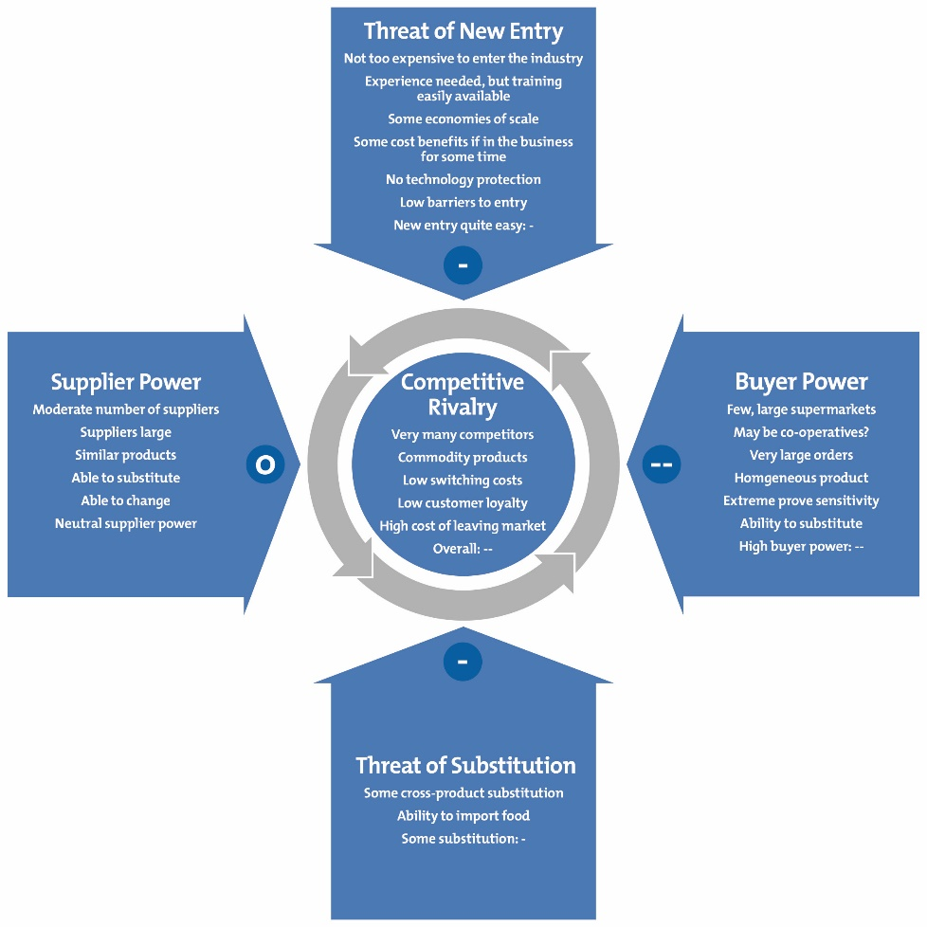

The threat of New Entrants
In the present situation, there is no thread for all the companies that are existing in the market because the market is completely saturated and a new entrant would require a great number of finances and many other things that are nearly impossible (Logsdon and Wood, 2002).

Bargaining Power of Suppliers
The automobile sectors have some Giants operating for many years now and they have good public relations and have great relations with the suppliers as well, therefore, they have a great supplying family with them so there is no chance that bargaining power supplies may hinder the operations (Logsdon and Wood, 2002).

Bargaining Power of Buyers
As the market is highly saturated and there are many companies providing thousands of vehicles that the people can choose from there for the chance of targeting is there and the market has to deal with it (Logsdon and Wood, 2002).

The threat of a Substitute
Although there is no substitute for a car for transportation still as the market is highly saturated and there are great competitors present. Customers won't substitute for cars but they can substitute for the model of car from any other company that offers at a lesser rate and with more specifications (Logsdon and Wood, 2002).

Competitive Rivalry
This sector generates the highest revenues as compared to any other business in the world. The automobile sector is highly competitive because of many Giants operating for quite a great time now and offering such great luxurious cars for the people to choose from (Logsdon and Wood, 2002).

Reference List
Braithwaite, J., and Drahos, P. (2000) Global business regulation. Cambridge university press.
Croucher, R., and Cotton, E. (2011) Global unions, global business: global union federations and international business. Libri Publishing.
Dunning, J.H., and Dunning, J.H. (2006) Alliance capitalism and global business. Routledge.
Govindarajan, V. and Gupta, A.K. (2001) “Building an effective global business team” MIT Sloan Management Review, 42(4), p.63.
Hill, C.W., and Hernández-Requejo, W. (2008) Global business today. New York: McGraw-Hill Irwin.
Kose, M.A., Otrok, C., and Prasad, E. (2012) “Global business cycles: convergence or decoupling” International Economic Review, 53(2), pp.511-538.
Logsdon, J.M., and Wood, D.J. (2002) “Business citizenship: From domestic to global level of analysis” Business ethics quarterly, pp.155-187.
Neeley, T. (2012) “Global business speaks English” Harvard business review, 90(5), pp.116-124.
Peng, M.W. (2016) Global business. Cengage learning.
Schmidheiny, S., and Timberlake, L. (1992) Changing course: A global business perspective on development and the environment (Vol. 1). MIT press.
Thomas, D.C. (2008) Cultural intelligence: People skills for global business. ReadHowYouWant. com.
Trompenaars, F., and Hampden-Turner, C. (2011) Riding the waves of culture: Understanding diversity in global business. Nicholas Brealey International.
Vogel, D. (2008) “Private global business regulation” Annu. Rev. Polit. Sci., 11, pp.261-282.

