Student Name: Zara Zafar
Student Number: 1605787
Module: Knowledge and Information Management Skills for the Workplace
Lecturer: Tanja Nathan
Introduction
Knowledge is something we all gain as we go on in life from a young age to an old age we are always learning something and that which we have learned is called knowledge. The more accomplished a person is in their field the more likely people will call him a knowledgeable person but nowadays knowledge can have many different meanings for example some people might say that knowledge is information and some might say its wisdom and concepts such as understanding, skills and experience begin to come up (Defining Knowledge, Information, Data, 2010). Knowledge can be described as the collection of skills, information and facts one has acquired through education and experience (Knowledge). It is very important for a person to gain knowledge as the more knowledge a person has the more their chances of getting a good job and getting promotions which also helps organisations grow and become bigger and when an organisation gets big it needs to have knowledge management. Knowledge management is the management of information and learning which is shared within an organisation for all to access (Knowledge management). Knowledge management came about as the internet had started as organisations realised the usefulness of the tools and how those tools can be very beneficial to the organisations as information could be shared to everyone in the organisation whether in the same building or another (Koenig, 2018).
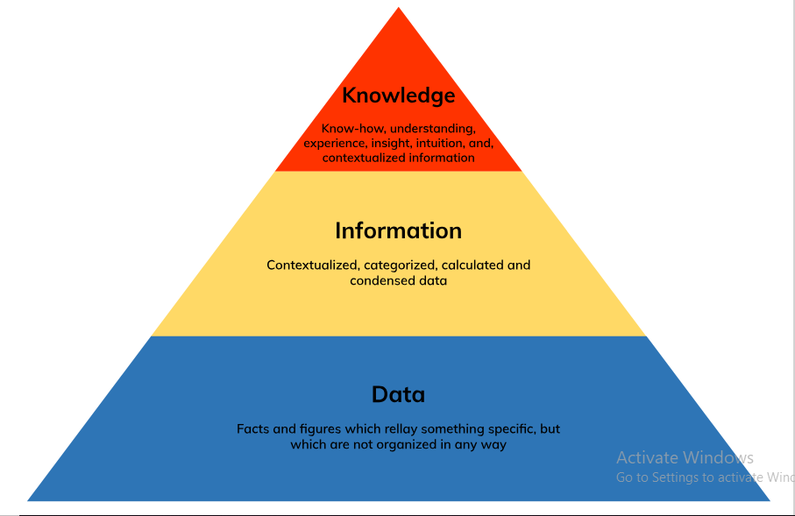
The relationship between data, information and knowledge

Knowledge can be hard to define because of other concepts such as information and data and this because in this day and age the words information, data and knowledge are used to convey the same meaning and because of this people can get confused when talking about certain specific things. There is a significant different between these three words for example Theirauf (1999) describes the three words this way: data is the lowest point, an unstructured collection of facts and figures; information is the next level, and it is regarded as structured data; finally knowledge is defined as "information about information" (Defining Knowledge, Information, Data, 2010). Knowledge, Information and data have been defined and are continuously being defined differently over the century, every journal that comes out is theorising something a bit different, for example now there are models which are used to explain these three concepts such as information which has models like the value-chain model, the materialisation model etc.
Data: If we are talking about computing then data can be many different forms of digital information such as numbers and texts (Data). Data is usually known to be facts and figures which are not structured properly or something that is unprocessed, for example weight, price, product names, costs, employee names etc.
The ages of all employees: 26, 34, 41, 29, and 32
Names of employees: Ben, Anne, Clark, Nate and Luke
Information: Information is data which has been presented and processed so that it can be understood by anyone who is reading it (What do you mean by Data and Information ?). According to Buckland (1991) there are three uses for the term information, information-as-process, information-as-knowledge and information-as-thing (Mingers & Standing, 2018).
Information-as-process: In the first way information is used by being informed that something is different to what they might actually believe thus changing their view (Mingers & Standing, 2018).
Information-as-knowledge: In the second way information is used by being informed about something such as facts or event, which is the subject of the information (Mingers & Standing, 2018).
Information-as-thing: Lastly the third way information is used by conveying information in a certain format for example, text, signs, pictures etc. (Mingers & Standing, 2018).
Information is data which has been structured so that it starts making sense (Basiao, 2016).
Age of employees: Ben is 26 years old; Anne is 34 years old; Clark is 41 years old; Nate is 29 years old and Luke is 32 years old.
Knowledge: According to Cambridge dictionary knowledge is the “understanding of or information about a subject that you get by experience or study, either known by one person or by people generally” (Knowledge). In business knowledge is a strategic asset which is the collective amount of skills, capabilities, abilities and experiences which one creates and uses in a business (NI Business Info). Knowledge can take on many forms and different explanations but in general knowledge can be put under three categories:
- Tacit Knowledge: Knowledge one gains from experience, jobs that they have done in the past what they learnt from it, values, beliefs etc. People have a huge amount of unconscious tacit knowledge in their minds which is why it is difficult to describe or record (Tacit and Explicit Knowledge).
- Explicit Knowledge: Knowledge that is detailed and formal which can be stored easily on documents, reports, memos, manuals etc. This type of knowledge is easy to share and can be understood and taught easily (Tacit and Explicit Knowledge).
- Embedded Knowledge: Skills and understanding specific to the organisations for example a routine only performed in the organisation you work in (NI Business Info).
Knowledge is the conscious awareness and understanding of a concept where one can interpret and analyse the data and information they have been given, which can also be called wisdom.
For example:
The age of all employees and what does it mean:
- Nate and Ben are young and they are inexperienced but are growing at a steady rate.
- We should give them more lessons so that they may able to cope better with the fast paced environment of this organisation.
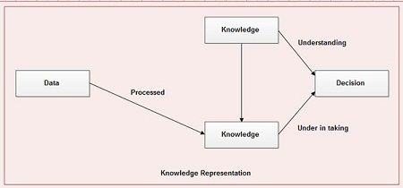

The relationship between individual knowledge and organisational knowledge
Individual Knowledge: Information that an individual believes to be true which can be justified, this is stored in the brain through the process of learning through observation or first-hand experience, this knowledge can be recalled (What is Individual’s Knowledge).
Organisational Knowledge: Collective knowledge of all individuals in the organisation (Organisational Knowledge).
To properly look at the relationship between individual and organisational knowledge we look at something called issue selling. Issue selling is something individuals in an organisation do in order to direct the attention of the top management in the organisation to the issues within the organisation (Individual and Organisational Knowledge). Issue selling is a good practice as it allows for individuals in the organisation to use their knowledge to fix issues within the organisation and this allows the organisation to take action and fix those issues while making employees happier and collectively increase organisation knowledge as everyone would learn from the issue and make it so it does not happen again. For an organisation to grow and get a competitive edge against other companies it will need to rely on knowledge from individuals to grow which will then be conveyed to all other workers and when each individual is proving new knowledge to the organisation in turn everyone is learning from them making the organisation get a competitive edge on other organisations but the problem is that at times organisation can ignore such issues as they may deem it not beneficial enough to be sorted out. Issues brought up by employees can improve an organisations knowledge and can also show others that they can do the same as an article points out that “It is this knowledge that is offered by issue sellers that has the potential to increase organisational performance as well as society’s perception of the organisation” (Individual and Organisational Knowledge).
Model presented below shows that individual knowledge is the starting point for organisational knowledge creation (Nonaka and Takeuchi, 1995) (Miura, 2007).

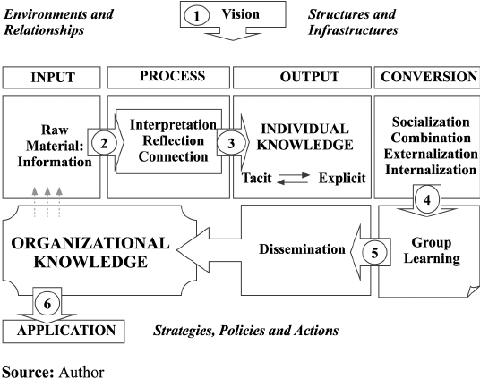

Analysis and modelling techniques to identify knowledge assets
Knowledge assets are all the intellectual resources an organisation and its workforce possess and these resources are in the form of skills, ideas, data, information, memory etc. (Knowledge Assets, 2003).
One of the ways of identifying knowledge assets is by using a simple method called semi structured meetings used by Doctusoft (Doctusoft, 2015). Semi structured meetings are like an interview with questions already written beforehand, it is like a questionnaire where employees, colleagues answer the questions and depending on the answers the needs of the workforce are determined. Focus groups are made and then those groups have a semi structured meeting separately where they focus on different issues along with identifying knowledge assets, this is done in three steps.
- Evaluate the previous years: Looking at the targets set last year and comparing them to what was achieved this year.
- Setting goals for next year: what needs to be achieved in the next year and then knowledge is evaluated by breaking down different areas and technology while also keeping an eye on competitors.
- Comparing results of the two focus groups: the next step is to have KM come up with an event for issues that were raised for everyone to expand their knowledge. For example if the overall customer communication skills were bad then basic knowledge on customer communication should be gained where KM will organise events for employees to gain such knowledge.
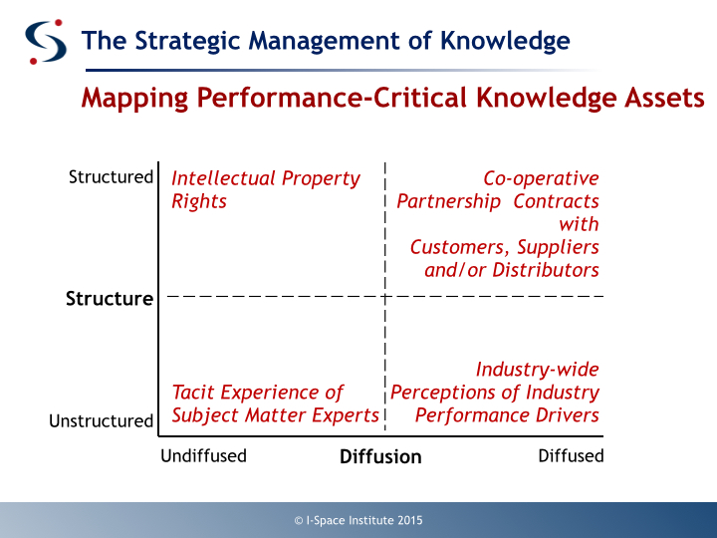
Another method to identify knowledge assets is called a Knowledge Map (MacMillan, 2015). In knowledge maps the key knowledge resources are identified which support an organization’s competitive advantage over others and those are mapped along two dimensions. One dimension being the structure of knowledge, unstructured to structured, tacit to explicit and the second dimension being the level of diffusion.

Another model used to identify knowledge assets is called the ashen model which was designed by Snowden (2003) this model focuses on something called the knowledge disclosure points which are any activity or event which reveals knowledge through the use of (Information Management, 2016):
- Learning points
- Judgement
- Solution creation
- Decisions
- Problem resolution
An example of a knowledge disclosure point would be when a manager decides to price the cost of tickets on a low-cost airline company. The Ashen Model then breaks that point down into five different categories:
- Artefacts: Anything that is made by people
- Skills: Abilities that can be trained
- Heuristics: The outcome of experience
- Experience: Everything a person has been through successes and failures
- Natural Talent: Naturally gifted in some sort of way whether they be through genetics or other ways
Evaluate actual and potential knowledge assets
A dry cleaner is required to have a lot knowledge regarding many different things such clothing, material clothing is made out of, chemicals needed to be used for cleaning, how to operate machinery etc. because of this reason a dry cleaner needs to be focused and always gaining knowledge. When it comes to working in a dry cleaners most of the time it is expected of a person to have at least some form of knowledge about dry cleaning whether that is knowledge about machinery or just plainly knowing how to iron everyone starts of somewhere. The actual knowledge assets Select Dry Cleaners have are mostly tacit knowledge meaning that most of the work is taught verbally or by instructions printed and put on the machines so that anyone using knows what to do step by step and apart from that there is little to no other knowledge assets as the owners are old schooled and do not care about what degree a person has had as long as they have the knowledge to do the bare minimum as the rest can be taught to them. A dry cleaning business has a lot of potential knowledge assets for example technology as all the information can be stored on a device about all the different types of clothes, the fabric, the material needed to clean the stains etc. it can do wonders for the business. Another potential knowledge asset is the teaching aspect as most new employees tend to get hired as long as the know the basics which is ironing and putting clothes in a washing machine where instead if they are hired they are first taught for a week using paper and paper about the usage of different machinery and what to do in situations where there is a potential problem.
What is required to create, store, apply and integrate knowledge
"Knowledge management is a discipline that promotes an integrated approach to identifying, capturing, evaluating, retrieving, and sharing all of an enterprise's information assets. These assets may include databases, documents, policies, procedures, and previously un-captured expertise and experience in individual workers." (Koenig, 2018).
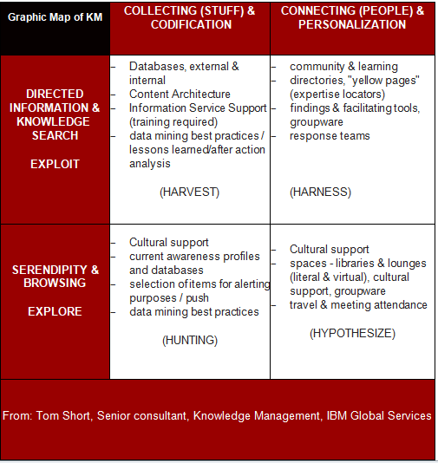

Knowledge management cycle has six steps in total; it is a process where information is transformed into knowledge (Models of Km Cycle).
Those six steps are (Rahul, 2012)
- Sharing and learning: Sharing is caring even more so when it comes to knowledge that can benefit an entire organisation for instance an issue arises on the computers and an employee has a solution to the problem if that employee shares the knowledge that he has on the solution of the computer problem it will be great help to the organisation as they will not have to call in a computer specialist to come in and fix the problem. Sharing of knowledge is basically sharing your views, ideas, beliefs, etc. with everyone else from which everyone else can learn from.
- Creating: A creation is made from an idea and any creation that is in this world was once an idea so sharing ideas is the key to coming up with even better ideas.
- Capturing and acquiring: Knowledge obtained by various means of learning is very important, an organisation needs knowledge to be able to grow and knowledge can only be gained by getting more of it from individuals in the workforce or somewhere else which is then stored for anyone to use in the organisation.
- Organising: The next step of the knowledge management cycle is the organising of the knowledge obtained via models and frameworks. These models and frameworks are used specifically to match a certain aspect of the organisation such as the culture.
- Accessing, Searching and Disseminating: The knowledge that has been gained, created and acquired is organised and it made available to everyone where anyone can access is if they search for it, it will pop up and it can be then learnt by any individual wanting to learn it.
- Using and discovering: The new knowledge that has been learnt can now be put to use by solving problems and issues in the organisation.
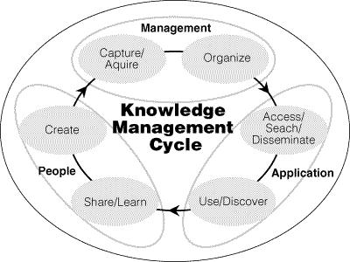

Figure from Knowledge Management Cycle, Source: McIntyre, Gauvin and Waruszynski, 2003
The importance of Intellectual Property rights
Intellectual property rights are right that are given to people for what they have created. These right give the creator exclusive rights for their creation for a certain amount of time.
Intellectual property rights are very important as any creation that is made by you for yourself or your business can be stolen if not protected by IPR. The copyrights can be divided into two categories (What are intellectual property rights?):
- Copyright and rights related to copyright
  - Right for authors and artists and their work such as comic books, novels, paintings, movies etc.
  - Rights for musicians, actors, singers etc.
- Industrial property.
  - Trademark signs for example something originating in china and the goods is attributable to the location.
  - Other types of industrial property
The main reason copyright and related right are given is so that it encourages people to create something original and reward creative works (What are intellectual property rights?).
Intellectual Property rights are important because they can (Protecting intellectual property):
- Set and individual business apart from its competition
- The IP can be sold or licensed which then provides the business with an important revenue stream
- Original work which means different it will pique a lot customers interest
- Can become essential for marketing or branding
There are many reasons why it is necessary to have IP rights as some are automatically protected but some need to be applied for here is why it is important to apply for rights (Protecting intellectual property):
- To protect it against infringement by others
- Defends in the courts as it is your sole right to use, make, sell or import it
- To stop others from using, making, selling or importing it without your permission
- You can make money by selling intellectual property
The contribution knowledge assets have on an organisation
“Knowledge assets represent the fount of an organization’s competences and capabilities that are deemed essential for its growth, competitive advantage and human development.” (Yucelen & Kamasak, 2010) Knowledge assets are crucial for the growth of an organisation as the more knowledge an organisation gains the more they will grow as mentioned above in the knowledge management life cycle as knowledge is gained it is made available to the entire organisation from where anyone in the organisation can learn it increasing the organisational knowledge.
Benefits of knowledge assets are:
- Improvement in organisational agility: With a high percentage of people with the knowledge to work efficiently and quickly it makes for a smooth workflow.
- Faster and Better decision making: Knowledge assets make it easier for information to be found and used which helps in making quick decisions.
- Quicker problem-solving: Problems are solved quicker due to more people having access to the knowledge required to fix the problem.
- Increased rate of innovation: Employees will come up with new ideas and plans quicker and more frequently.
- Supported employee growth and development: All the employees will grow quicker and they will develop quicker.
- Specialist expertise: If one person is an expert in something and that knowledge is available to the whole organisation then an organisation is bound to grow at a fast pace.
- Better communication: Having more knowledge means better and efficient communication as tasks will conveyed easily and solved easily too.
A wide pool of Knowledge assets can help:
- Create better products and services: As more knowledge is available people will get more ideas and more ideas means inventions and these inventions whether product or service can catch the interest of top managers which will then be turned into a product or service which will be sold to customers.
- Develop better strategies: Employees will come up with better strategies for tasks and events for example less work but same quality.
- Improve profitability: Profits will increase as organisational knowledge goes up.
- Reuse existing skills and expertise: Individual knowledge is turned into organisational knowledge making expert knowledge available to everyone.
- Increase operational efficiency and staff productivity: Tasks will be done with more efficiency and there will be less hick ups from employees and because of all the growth staff morale will increase which will improve productivity.
- Recognise market trends early and gain an advantage over your rivals: More employees to share knowledge meaning that at least a few will be able to notify the top managers of the latest trends which will help gain an edge in the competition.
Evaluate the knowledge requirements for the organisation
In the Dry Cleaning business there are many things that a person needs to pay attention to as in this business you are working on clothing that can be very pricey and one mistake could cost you hundreds of pounds but surprisingly it seems that dry cleaning is always thought of as a job that does not require much knowledge but mostly experience. According to UCAS to become a dry cleaner one does not require any specific qualification (Dry-Cleaner) and I feel like this is quite wrong as the amount of work and details that a dry cleaner has to think about is quite a lot and on top of that the pressure of not damaging the clothes it can be detrimental. For example if one piece of clothing is not checked properly and by chance that one item had a pen inside it, it will stain all the other clothing and it can even tear the clothing because of a pens sharp tip causing a huge loss. I believe a dry cleaner should not just start from practical work but start by acquiring a degree such as a BTEC Specialist qualification in Laundry and Dry Cleaning Technology or get an apprenticeship to learn more about the dry cleaning industry. At the moment any person can start a dry cleaning shop they just need a license and that is not good enough as it can cost them and the business countless amount of money because of their negligence. A dry cleaner should not only have a good qualification but also the necessary skills to be a good dry cleaner for example a dry cleaner needs to give attention to detail, good customer service and interpersonal skills these are a must as only washing clothes properly does not equal growth and improvement.
The organisation’s framework for enabling knowledge sharing
In a dry cleaning business there is not much knowledge being passed around except for the general knowledge of do’s and do not’s and this is not enough as there are many things that need to be talked about for example there are many different types of fabrics and each needs to be washed differently just posting a note in the front of the shop saying “at your own risk” will only deter people away from the shop which is why it is important to gain more knowledge and the seniors should have an easier way of conveying that knowledge to the entire workforce. At the moment only instructions are printed and posted onto the machinery for the workers to follow and this is not enough as it just makes it so that employees can get lazy and not work as hard as they can just look at the note and carry along, this kind of work stops a person from being creative and stops them from improving their work life. This dry cleaning shop is very old schooled as the knowledge is mostly tacit knowledge and anytime someone is having problems a senior will come in and explain it to them and this can cause delays in the working schedule which can leave customers unsatisfied and workers under even more pressure. All employees need to be able to have the knowledge to use any machinery and know that what clothes can be dry cleaned and which cannot be dry cleaned and this cannot happen if not all employees have the knowledge necessary which is why there needs to be another way in which knowledge is shared so that the business can grow and improve by also increasing its organisational knowledge.
Recommend improvements to the current framework
In this new day and age of technological advancement a dry cleaners can get left behind if they only stick to old school methods which is why new technology should be introduced to make life easier for the dry cleaners and any new information should be made available to every single employee. When this happens Information should be monitored as it can get out of hand if information is coming it a rapid rate, but if information is coming in at such a rate it can get difficult to handle it and it can cause problems which is why it is better to create transfer and access channels. To create such channels case studies have highlighted a few practices for designing an effective system (F., Zairi, & Schiuma, 2010):
- Lessen the amount of transmissions of knowledge between individuals to cause less distortion
- 24 hour access to all employees in any location.
- Allow and encourage employees to contribute and make the system easier to use
- A flexible system which automatically updates as answers are given
- Design multiple channels for knowledge transfer, ranging from intranet to face-to-face. Each has its benefits and techniques and times to be used.
Another improvement can be the implementation of new practices for example changing the chemicals being, new technology, better equipment to clean with; new type of hangers, new covers etc. and these new practices can be shared using knowledge management software’s. “Knowledge management software allows an organization to have one unified pool of information that is always updated, accessible and makes it easy to discover insights for employees at anytime, anywhere from any device” (20 Best Knowledge Management Software for 2019).

Bibliography
20 Best Knowledge Management Software for 2019. (n.d.). Retrieved January 9th, 2019, from Finances Online: https://financesonline.com/knowledge-management/
Basiao, R. R. (2016, September 5th). Can someone give a simple example for data, information, knowledge and wisdom? Retrieved January 9th, 2019, from Quora: https://www.quora.com/Can-someone-give-a-simple-example-for-data-information-knowledge-and-wisdom
Data. (n.d.). Retrieved January 9th, 2019, from Technopedia: https://www.techopedia.com/definition/807/data
Defining Knowledge, Information, Data. (2010). Retrieved January 9th, 2019, from Knowledge Management Tools: http://www.knowledge-management-tools.net/knowledge-information-data.html
Doctusoft. (2015, Febuary 24th). How to identify knowledge assets. Retrieved January 9th, 2019, from Medium : https://medium.com/@doctusoft/how-to-identify-knowledge-assets-a80847dad8f8
Dry-Cleaner. (n.d.). Retrieved January 9th, 2019, from UCAS: https://www.ucas.com/ucas/after-gcses/find-career-ideas/explore-jobs/job-profile/dry-cleaner
F., D. Y., Zairi, P. M., & Schiuma, D. G. (2010). Defining Organisational Knowledge. Retrieved January 9th, 2019, from European Centre for Best Practice Management: https://pdfs.semanticscholar.org/2bbb/a497cdc4b35a886a402d88a9847dce4347b3.pdf
Individual and Organisational Knowledge. (n.d.). Retrieved January 9th, 2019, from Sims Monash EDU: http://www.sims.monash.edu.au/subjects/ims2603/resources/week4/2603paper4.3.pdf
Information Management. (2016). Retrieved January 9th, 2019, from Slide Player: https://slideplayer.com/slide/5692126/
Knowledge. (n.d.). Retrieved January 9th, 2019, from English Oxford Living Dictionaries : https://en.oxforddictionaries.com/definition/knowledge
Knowledge. (n.d.). Retrieved January 9th, 2019, from Cambridge Dictionary: https://dictionary.cambridge.org/dictionary/english/knowledge
Knowledge Assets. (2003). Retrieved January 9th, 2019, from Baldrige : http://www.baldrige21.com/BALDRIGE_GLOSSARY/BN/Knowledge_Assets.html
Knowledge management. (n.d.). Retrieved January 9th, 2019, from APM: https://www.apm.org.uk/body-of-knowledge/context/governance/knowledge-management/
Koenig, M. E. (2018, January 15th). What is KM? Knowledge Management Explained. Retrieved January 9th, 2019, from KM World: http://www.kmworld.com/Articles/Editorial/What-Is/What-is-KM-Knowledge-Management-Explained-122649.aspx
MacMillan, I. (2015, April 23rd). Do you understand your company’s knowledge assets? Retrieved January 9th, 2019, from We Forum : https://www.weforum.org/agenda/2015/04/do-you-understand-your-companys-knowledge-assets/
Mingers, J., & Standing, C. (2018, June). What is information? Toward a theory of information as objective and veridical. Retrieved January 9th, 2019, from Springer Link: https://link.springer.com/article/10.1057/s41265-017-0038-6
Miura, I. K. (2007, March). Knowledge management model: Practical application for competency development. Retrieved January 9th, 2019, from Research Gate: https://www.researchgate.net/figure/From-individual-knowledge-to-organisational-knowledge_fig1_235323325
Models of Km Cycle. (n.d.). Retrieved January 9th, 2019, from Tutorials Point : https://www.tutorialspoint.com/knowledge_management/models_of_km_cycle.htm
NI Business Info. (n.d.). Retrieved January 9th, 2019, from Knowledge management and business growth: https://www.nibusinessinfo.co.uk/content/what-knowledge-business
Organisational Knowledge. (n.d.). Retrieved January 9th, 2019, from Business Dictionary: http://www.businessdictionary.com/definition/organizational-knowledge.html
Protecting intellectual property. (n.d.). Retrieved January 9th, 2019, from NI Business Info: https://www.nibusinessinfo.co.uk/content/importance-protecting-intellectual-property
Rahul, R. (2012, October 1st). Knowledge management cycle. Retrieved January 9th, 2019, from Project Guru: https://www.projectguru.in/publications/knowledge-management-cycle/
Tacit and Explicit Knowledge. (n.d.). Retrieved January 9th, 2019, from TLU: https://www.tlu.ee/~sirvir/Information%20and%20Knowledge%20Management/Key_Concepts_of_IKM/tacit_and_explicit_knowledge.html
What are intellectual property rights? (n.d.). Retrieved January 9th, 2019, from World Trade Organisation: https://www.wto.org/english/tratop_e/trips_e/intel1_e.htm
What do you mean by Data and Information ? (n.d.). Retrieved January 9th, 2019, from E-Computer Notes: http://ecomputernotes.com/fundamental/information-technology/what-do-you-mean-by-data-and-information
What is Individual’s Knowledge. (n.d.). Retrieved January 9th, 2019, from IGI Global : https://www.igi-global.com/dictionary/quality-attribution-data-information-knowledge/34693
Yucelen, M., & Kamasak, R. (2010, October). The Relationship Between Knowledge Assets and Organizational Strategy Development. Retrieved January 9th, 2019, from Research Gate: https://www.researchgate.net/publication/290152559_The_Relationship_Between_Knowledge_Assets_and_Organizational_Strategy_Development

