a

university of wales trinity saint david(uwtsd) LONDON CAMPUS
Student Name: RUHUL ISLAM RUBEL

STUDENT ID: 2533221

MOODLE: INTRODUCTION TO THE WEB AND DATABASE CONCEPTS

MOODLE CODE: ACCA023-LON

TERM:2

LECTURER NAME: ANUM PRACHA
Table of Contents

No. | Contents |  | Page No.
1 | Introduction
2 | Scenario Analysis
(a) | Determined Organizations (Entities)
(b) | Entity Tables
(c) | ParkingSite Table
(d) | ParkingSlot Table
(e) | Customer Table
(f) | Vehicle Table
(g) | Booking Table
(h) | Payment Table
2. | Analysis of Relationships
3 | Entity Relationship Diagram (ERD)
4 | Development of Data Structures
5 | Database Constraints and Integrity Rules
(a) | Primary Key Constraints
(b) | Foreign Key Constraints
(c) | Referential Integrity
(d) | Validation Rules
6 | Normalization (Third Normal Form – 3NF)
(a) | First Normal Form (1NF)
(b) | Second Normal Form (2NF)
(c) | Third Normal Form (3NF)
(d) | 3NF Compliance Table
7 | Sample Data Population (screenshot of tables from access work)
8. | SQL Query Development
(a) | Available Parking Slots
(b) | Active Parking Bookings
(c) | Total Revenue
(d) | Customer Parking History
(e) | Frequently Used Parking Slots
9 | Database Forms (screenshot of the forms )
10 | Testing and Validation
(a) | Functional Testing
(b) | Relationship Testing
(c) | Validation Testing
(d) | Performance Evaluation
11 | Design Reflection and Evaluation
12 | Conclusion
13 | References

Database Implementation for AutoPark Management System Using Microsoft Access

Introduction
Rising car ownership, parking capacity constraints, and the need for effective mobility have made parking management more difficult. In order to record client information, car details, slot availability, reservations, and payments, many organizations still rely on manual processes. This leads to duplicate records, inconsistent data, sluggish reporting, and ineffective resource utilization. Currently, AutoPark uses manual processes to run several parking facilities, which makes it challenging to maintain accurate records and trustworthy operational information
By centralizing data, establishing relationships, and facilitating automated queries, forms, and reports, a relational database in Microsoft Access provides an organized solution. To minimize redundancy and enhance data consistency, Access offers tools for table construction, primary and foreign key enforcement, validation rules, and SQL writing [1],[2],[3]. Additionally, relational systems facilitate improved analysis and decision-making [4], [5]. For better allocation and less traffic, research on smart parking emphasizes the use of structured databases and real-time processing [7]–[13].

I. Scenario Analysis
The AutoPark Management System's main goal is to replace manual record keeping with a centralized relational database that can handle regular parking operations. Parking locations, parking spaces, patrons, cars, reservations, and payments are all stored in the database. By dividing data into distinct entities while preserving connections between related records, a relational method increases accuracy. This facilitates effective information retrieval through queries, decreases duplication, and enhances maintainability [4], [5].

Determined Organizations (Entities)
The AutoPark database contains six core entities:
- ParkingSite,
- ParkingSlot,
- Customer,
- Vehicle,
- Booking,
- and Payment.
Each entity represents a distinct operational function within the parking environment.

Entity Tables

ParkingSite Table

Field | Data Type | Description
SiteID | AutoNumber (PK) | Unique site identifier
SiteName | Short Text | Parking facility name
Location | Short Text | Site location
TotalSlots | Number | Total parking capacity

The ParkingSite table stores information about each parking facility. Each site can contain multiple parking spaces, enabling management to compare capacity and usage across locations.

ParkingSlot Table

Field | Data Type | Description
SlotID | AutoNumber (PK) | Unique slot identifier
SiteID | Number (FK) | Related parking site
SlotNumber | Short Text | Space reference
SlotType | Short Text | Standard/Disabled/EV
Status | Short Text | Available/Occupied

Individual parking spaces are represented by the ParkingSlot entity. The Status property shows whether a slot is available or occupied. The relationship between ParkingSite and ParkingSlot supports efficient monitoring and future integration with smart parking technologies [9], [11].

Customer Table

Field | Type of Data
CustomerID | AutoNumber (PK) | Primary key generated automatically for each customer record
FullName | Short Text | Full name of the customer
PhoneNumber | Short Text | Contact details
Email | Short Text | Electronic mail address
Address | Short Text | Residential or correspondence address

Customer information is stored separately from vehicle and booking data to prevent repeated storage of personal details. This follows database normalization principles and reduces redundancy [4],[5],[6].

Vehicle Table
Field | Data Type | Description
VehicleID | AutoNumber (PK) | Primary key generated automatically for each vehicle record
CustomerID | Number (FK) | Owner
RegistrationNumber | Short Text | Unique registration plate
VehicleType | Short Text | Car/Van/Motorcycle
Model | Short Text | Vehicle model

Each vehicle belongs to one customer, while one customer may own multiple vehicles. RegistrationNumber is configured as a unique field to prevent duplicate vehicle records.

Booking Table
Field | Data Type | Description
BookingID | AutoNumber (PK) | Primary key generated automatically for each booking record
VehicleID | Number (FK) | Transport reference
SlotID | Number (FK) | Parking slot reference
StartTime | Date/Time | Entry time
EndTime | Date/Time | Exit time
Status | Short Text | Active/Completed
Booking is the main transaction entity because it connects vehicles with parking spaces. Historical booking records allow AutoPark to analyse demand patterns, occupancy trends, and customer usage behaviour.

Payment Table
Field | Data Type | Description
PaymentID | AutoNumber (PK) | Primary key generated automatically for each payment record
BookingID | Number (FK) | Related booking
Amount | Currency | Payment value
PaymentMethod | Short Text | Cash/Card/Online
PaymentDate | Date/Time | Transaction date

Separating payment data from booking records improves financial reporting and allows future support for different payment systems such as online and digital transactions [8]-[13].

Analysis of Relationships
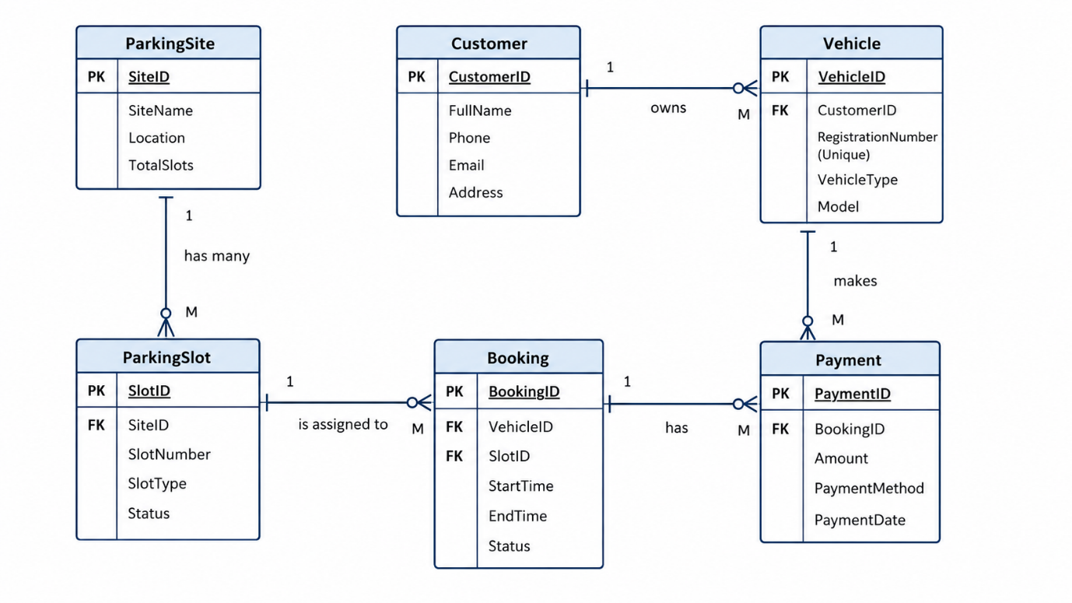
ParkingSite → ParkingSlot is one to many (1:M), which supports your claim that every site has several slots.
client → Vehicle is one to many (1:M), which is consistent with your reasoning that a client may own several automobiles.
Vehicle → Booking has a one-to-many (1:M) relationship, which supports your claim that vehicles can produce several bookings.
ParkingSlot → Booking is one to many (1:M), in line with your observation that slots may be used in several bookings throughout time.
Booking → Payment is one to one (1:1), which is consistent with your argument that every booking generates a single payment record.
[1]– [5].

II. Relationship between entities diagram (ERD)
The AutoPark management system's logical structure is represented by the ERD. It ensures that the database efficiently supports AutoPark's operational workflow by graphically illustrating how each entity interacts. The Relationships tool in Microsoft Access is used to construct relationships, and referential integrity is turned on to ensure consistency. While cascade deletion should be avoided to safeguard previous booking and payment data, cascade updates could be permitted for significant changes.
Future enhancements such as IoT sensors, mobile applications, automated reservations, and vehicle identification systems can be supported by the scalable database structure [9], [11],[12],[13].

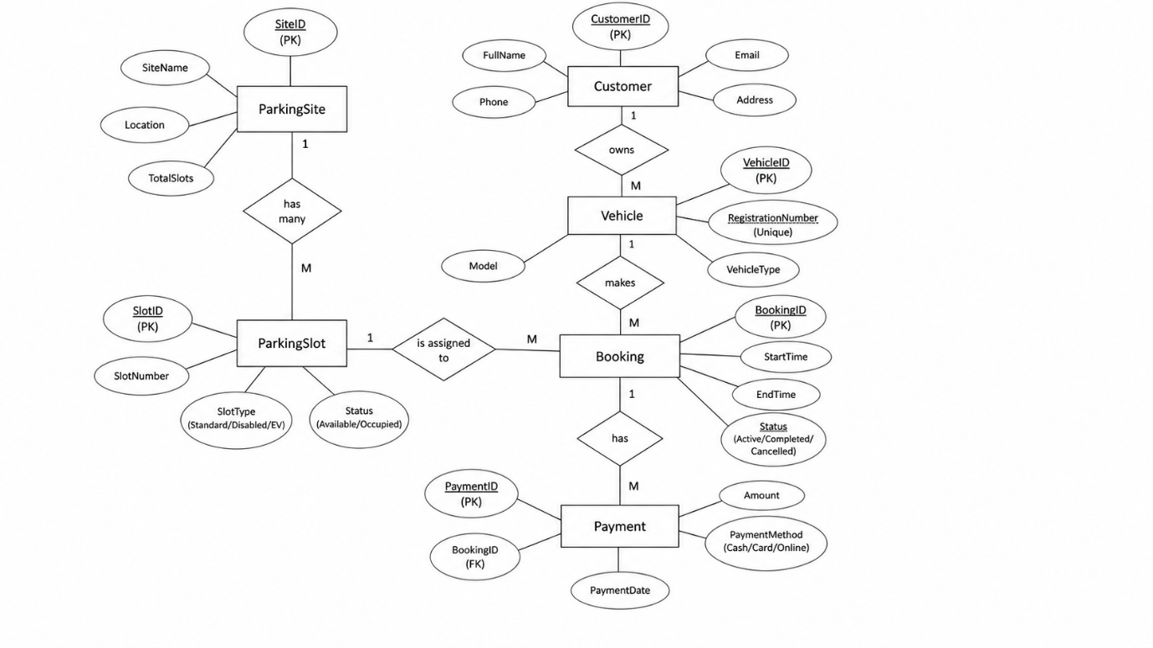

III. Development of Data Structures
Microsoft Access was used to transform the conceptual ERD into a real database. Tables, attributes, primary keys, foreign keys, and validation rules are all part of the implementation. The database's fundamental structure is represented by the entity tables that were previously included.
IV. Database Restrictions and Integrity Guidelines
Principal Limitations
Each record is uniquely identified by its primary key. They enhance query performance, support table relationships, and avoid duplication. SiteID, CustomerID, and BookingID are a few examples. Maintaining correct associations between database tables requires primary keys [4], [5].
Foreign Key Restrictions
Related tables are connected via foreign keys, which also guarantee that there are only legitimate relationships. They stop erroneous recordings like:
1. A car without a current client
2. A reservation without a legitimate car
3. A payment that has not related

Integrity of Reference
Microsoft Access uses referential integrity to avoid incorrect or orphaned relationships, ensuring connected tables are accurate and consistent.It avoids issues like invalid transactions and orphan records. For instance, if the chosen VehicleID is not present in the Vehicle table, the system will refuse the reservation [1], [2].
Rules for Validation
Data quality is enhanced by validation rules:
1. EndTime needs to occur after StartTime.
2. Negative payment amounts are not permitted.
3. Unique registration numbers are required.
4. The booking status needs to be either Completed or Active.
These guidelines guarantee accurate and trustworthy data submission.
V. Compliance with Normalization (3NF)
By minimizing duplication and avoiding update, insertion, and deletion issues, normalization helps to efficiently organize data. Third Normal Form (3NF}is used in the AutoPark database in which each table represents a single subject and each attribute depends exclusively on the primary key [4], [5].
Initial Normal Form (1NF)
1NF is satisfied by the database because
1. Every quality that has practical value
2. There are no repeated groups.
3. Every table has a primary key.
2NF, or Second Normal Form
Because each non-key field depends solely on the primary key of its table, the database satisfies Second Normal Form (2NF) requirements. Partial dependencies are impossible because each table has a single attribute primary key. This avoids needless duplication and dependence problems and guarantees that the structure is completely in line with 2NF principles.
3NF, or Third Normal Form
By eliminating any transitive dependencies, the design also conforms to Third Normal Form (3NF). For example, client information is kept Payment records are kept apart from booking data in their own table instead of the Vehicle table. Redundancy is decreased, data accuracy is strengthened, and long-term maintenance is more effective when these properties are kept in their proper tables [4],[5],[6].
Applying 3NF ON THE TABLE
Entity | 1NF Compliance | 2NF Compliance | 3NF Compliance
ParkingSite | All fields atomic; no repeating groups; SiteID is PK | All non-key attributes depend fully on SiteID | No transitive dependencies; attributes only describe the site
ParkingSlot | Atomic values; SlotID is PK | SlotNumber, SlotType, Status fully depends on SlotID | No transitive dependencies; SiteID is FK referencing ParkingSite
Customer | Single-valued fields; CustomerID is PK | FullName, PhoneNumber, Email, Address depend on CustomerID | No transitive dependencies; personal details not stored elsewhere
Vehicle | Atomic fields; VehicleID is PK | RegistrationNumber, VehicleType, Model depend on VehicleID | No transitive dependencies; Customer details not stored in Vehicle
Booking | Atomic timestamps; BookingID is PK | StartTime, EndTime, Status depends on BookingID | No transitive dependencies; VehicleID and SlotID are valid FKs
Payment | Atomic values; PaymentID is PK | Amount, PaymentMethod, PaymentDate depend on PaymentID | No transitive dependencies; BookingID is FK referencing Booking
Summary: All six entities satisfy 1NF → 2NF → 3NF, meaning the database avoids redundancy, update anomalies, and transitive dependencies — essential for high-quality relational design [4], [5].

VI. Sample Data Population
Sample records were added to test relationships, queries, and database functionality.
These tables demonstrate successful connections between parking sites, customers, vehicles, bookings, and payments.

Screenshots of the tables

1. ParkingSite
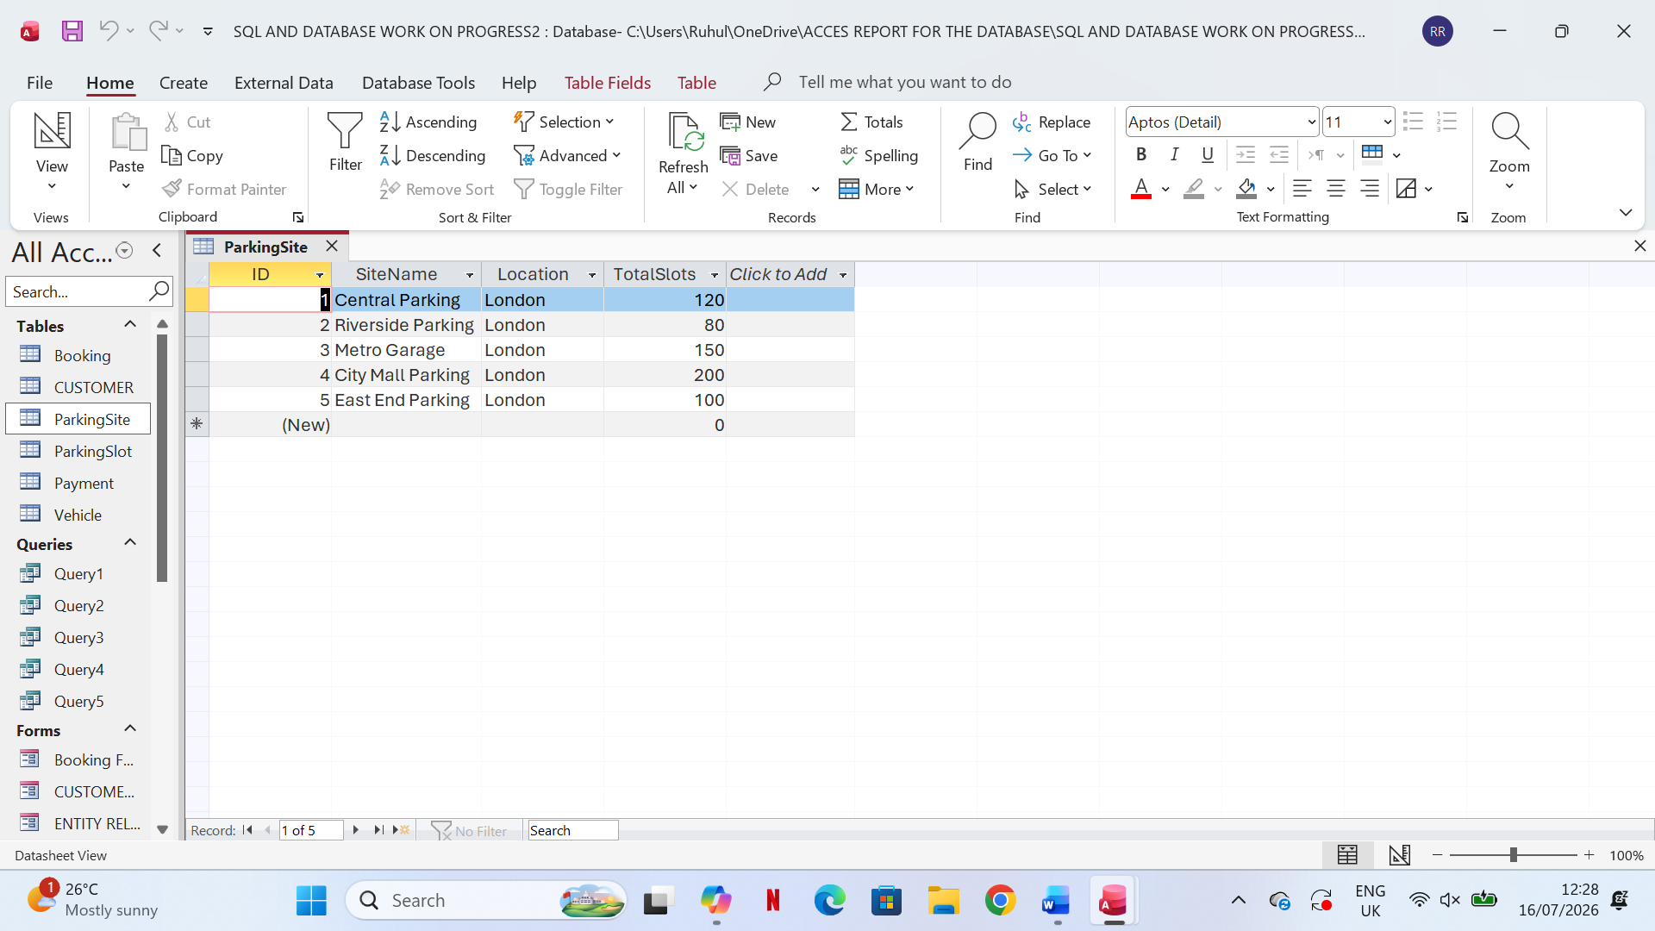

2. ParkingSlot
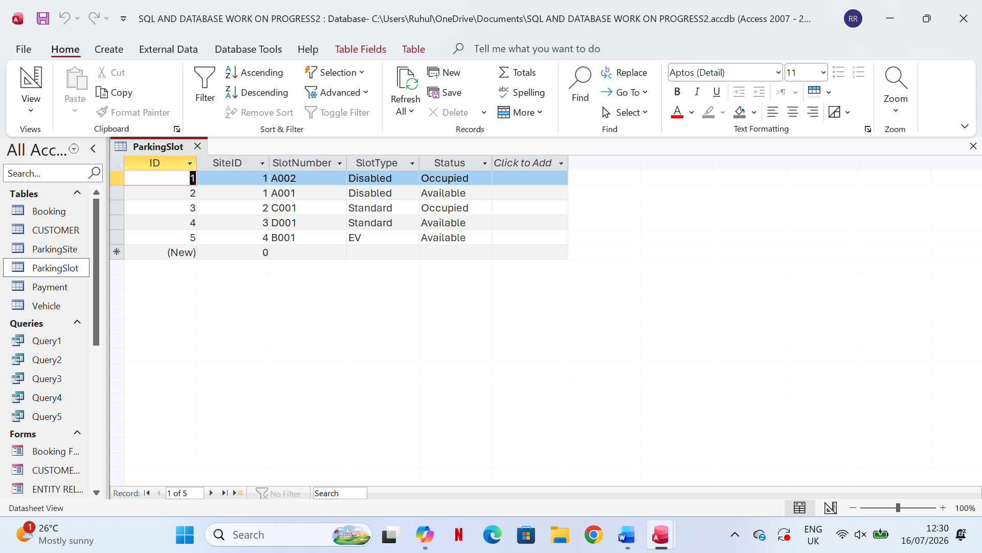
3.Customer
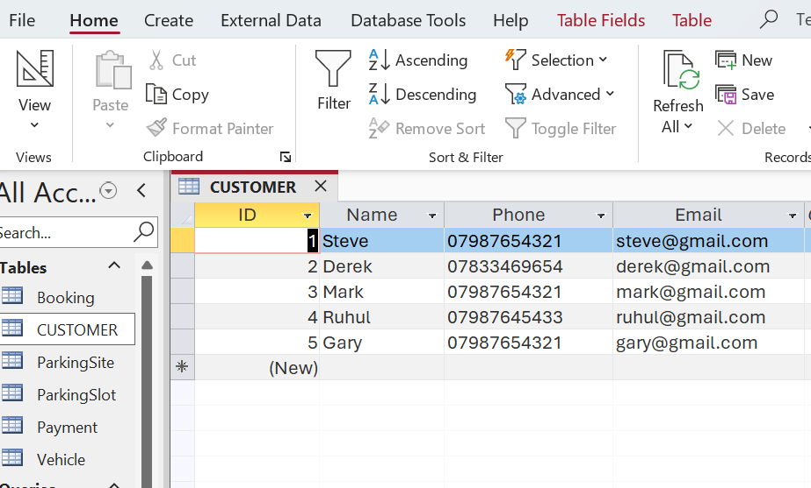
4.Vehicle
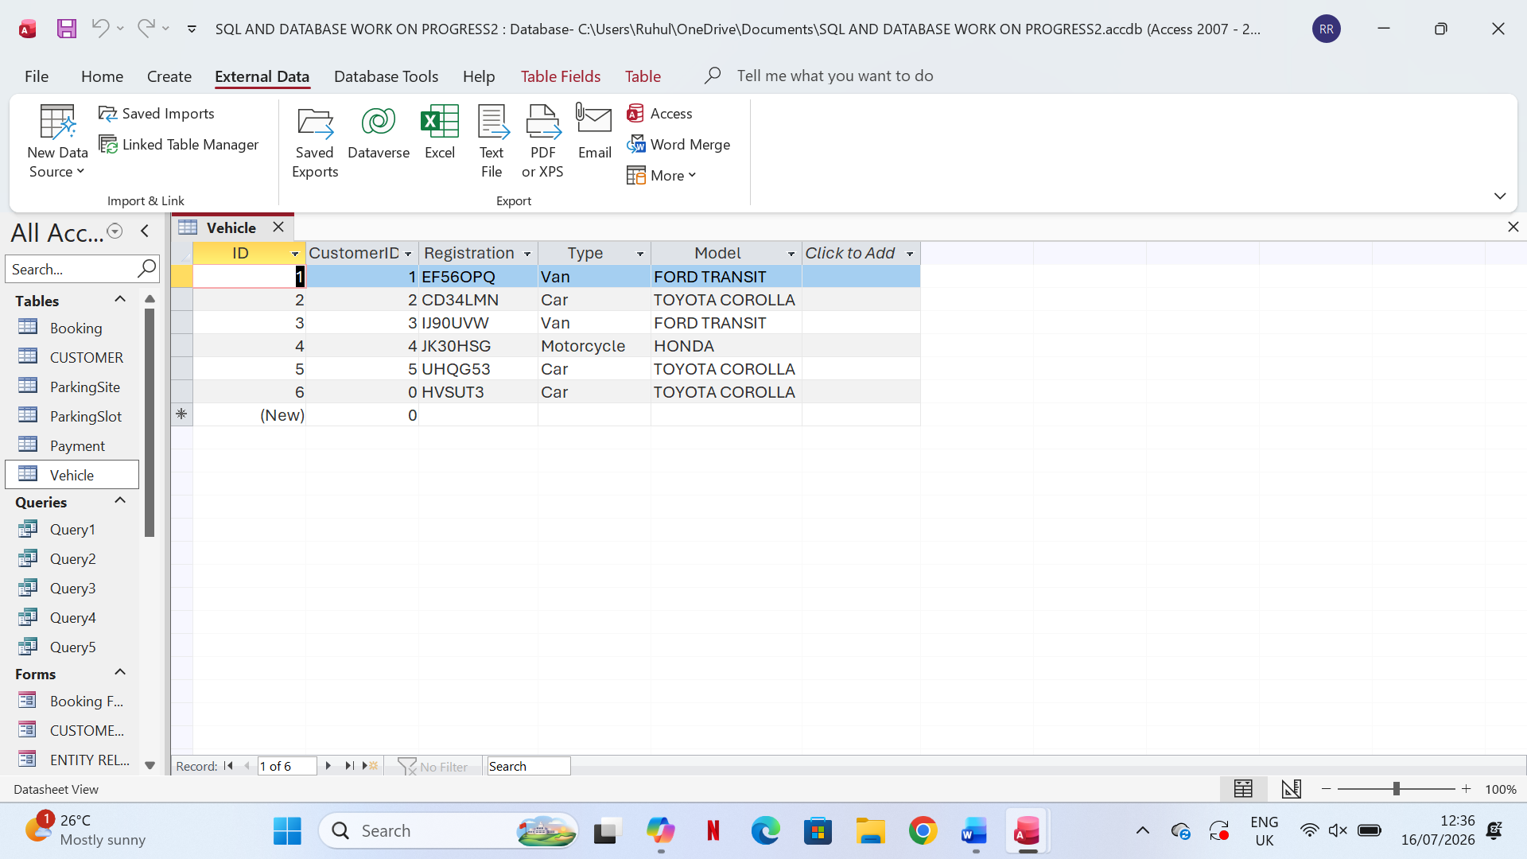

5.Booking
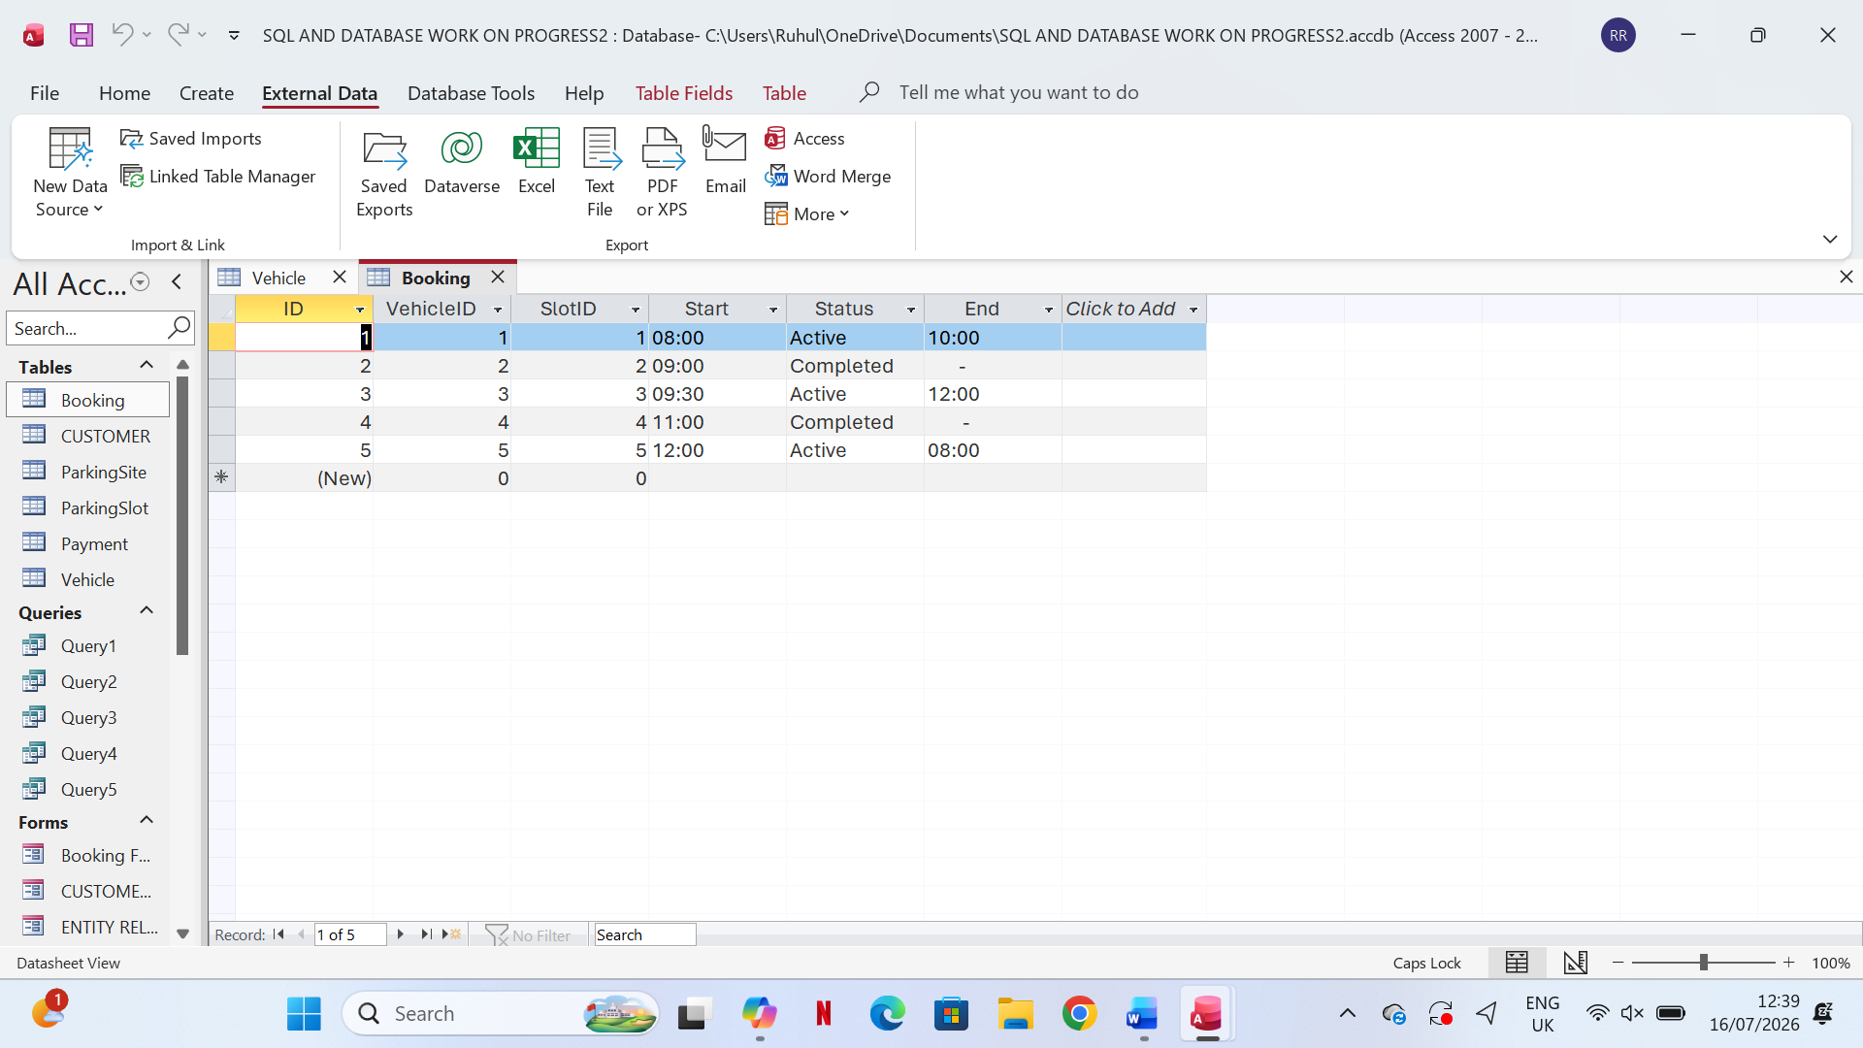

6.Payment
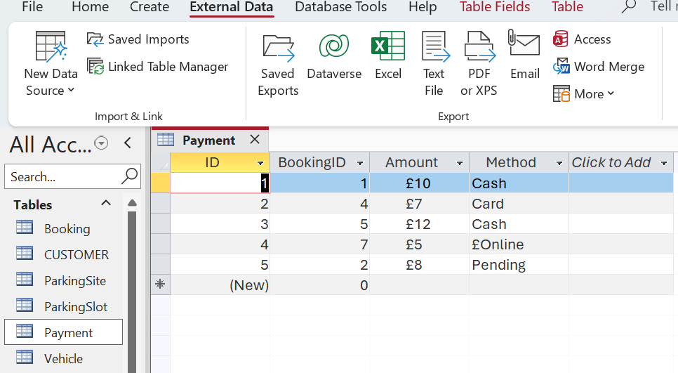

VII. Query Development (SQL)

- SQL — Available Parking Slots

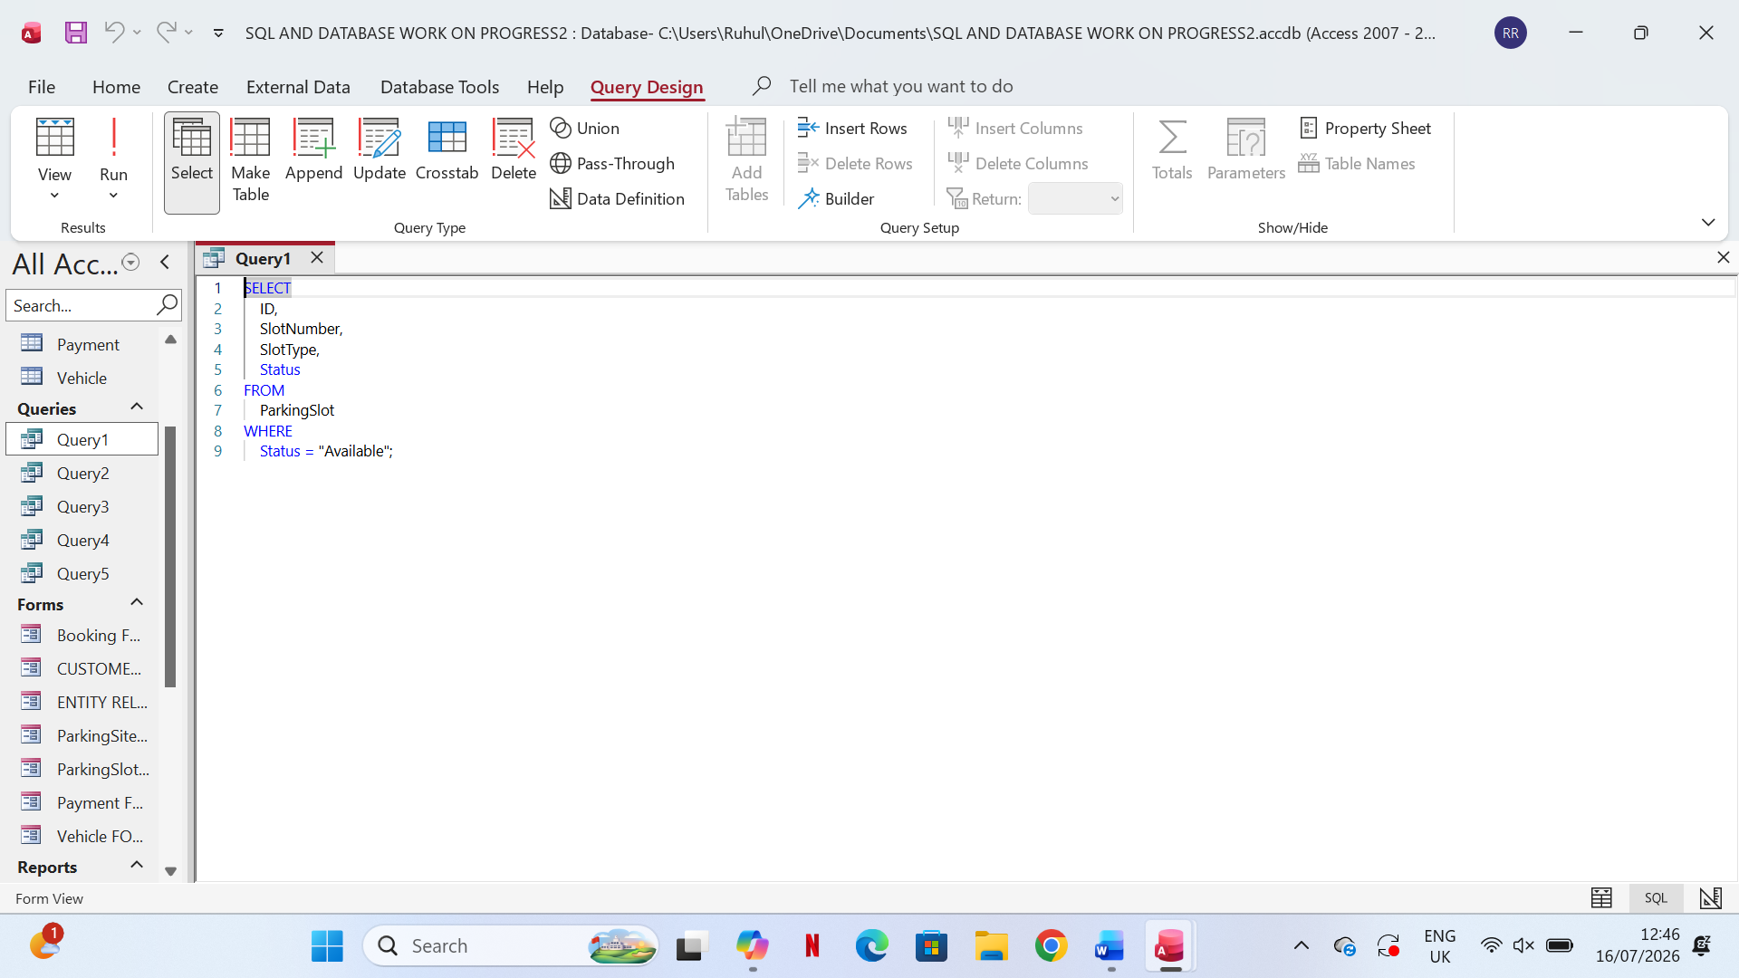
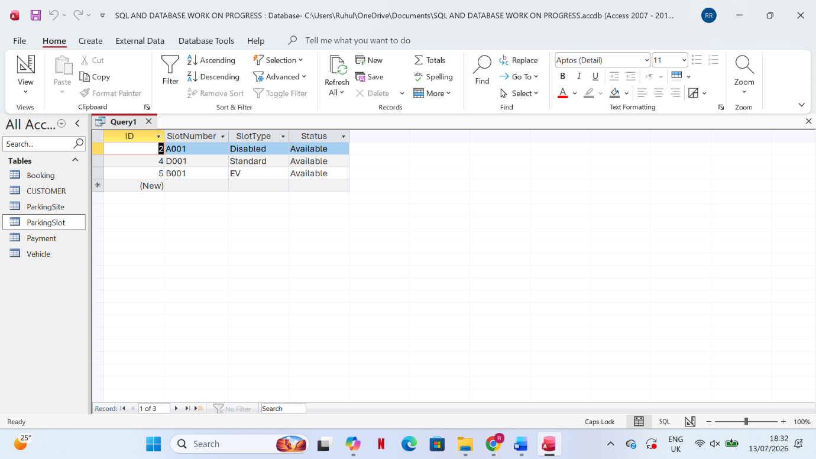

2. SQL — Active Parking Bookings

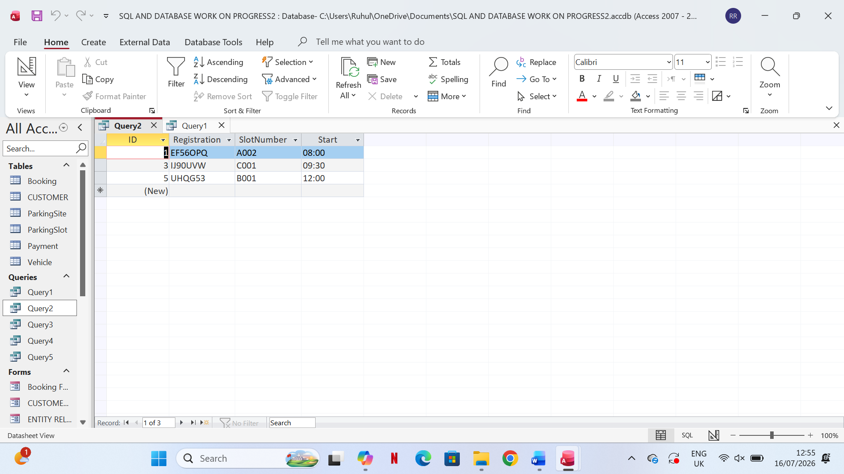
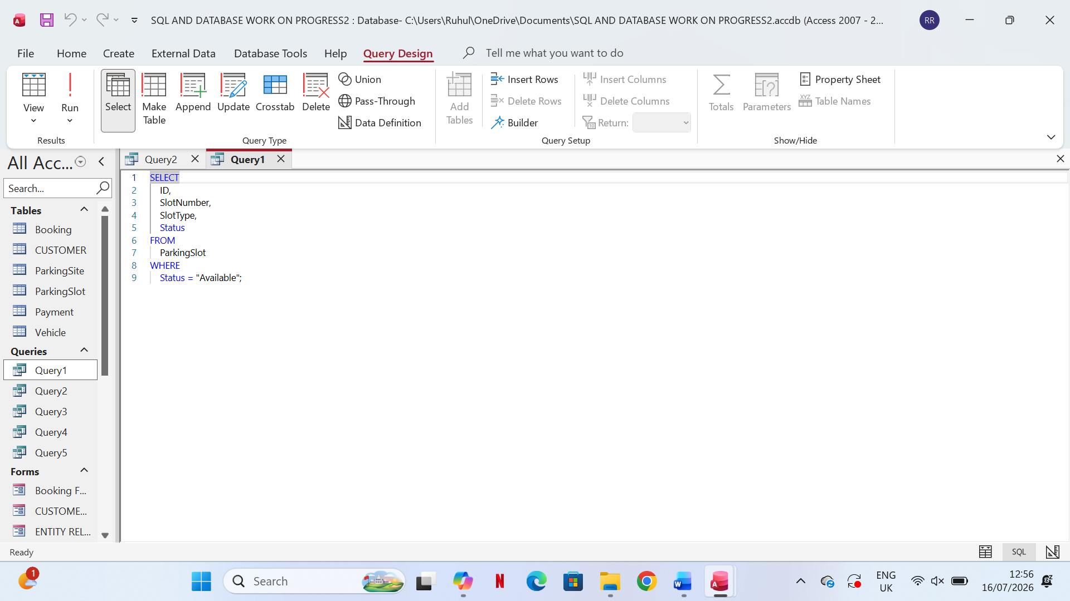

3. SQL — Total Revenue
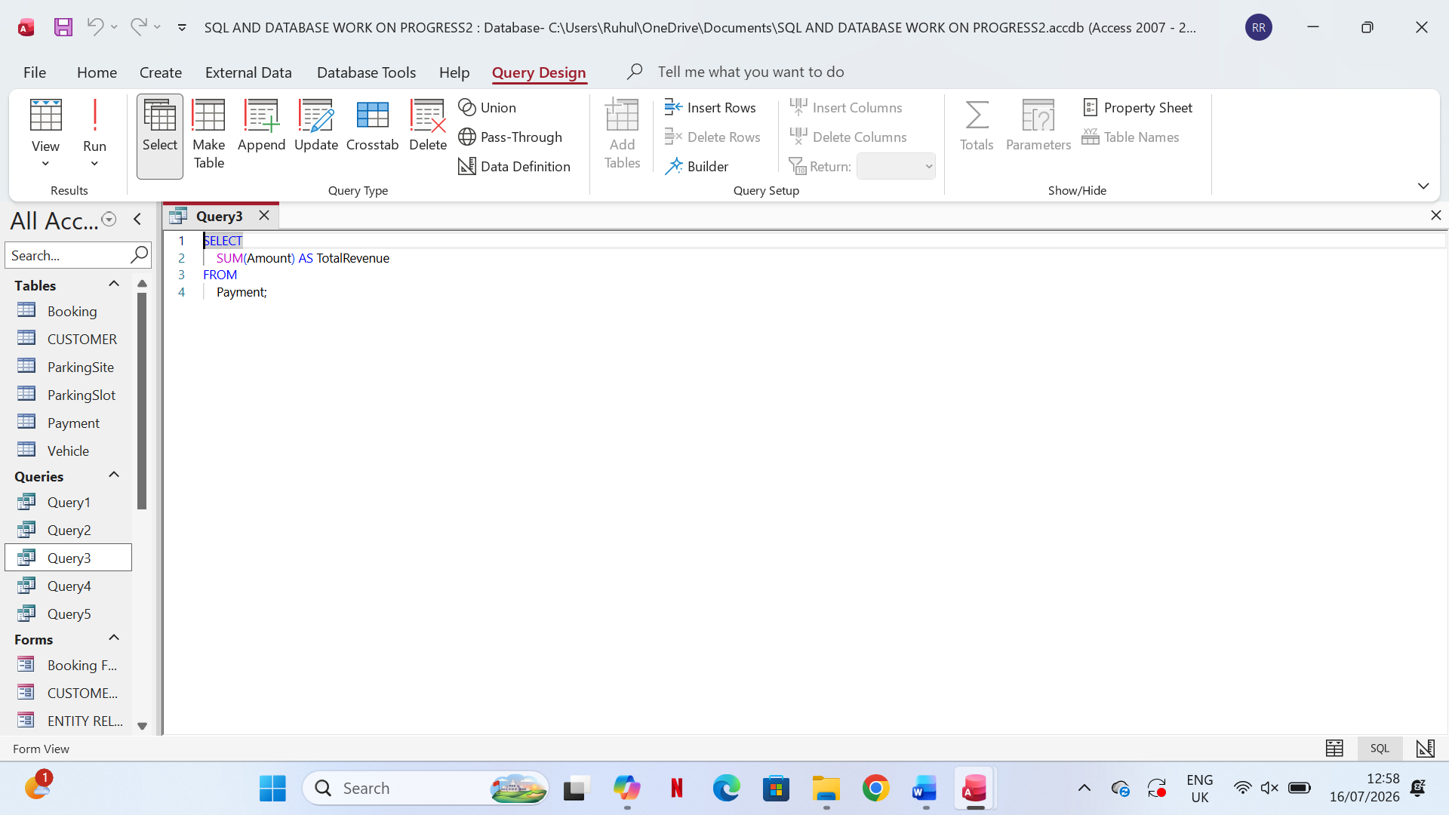

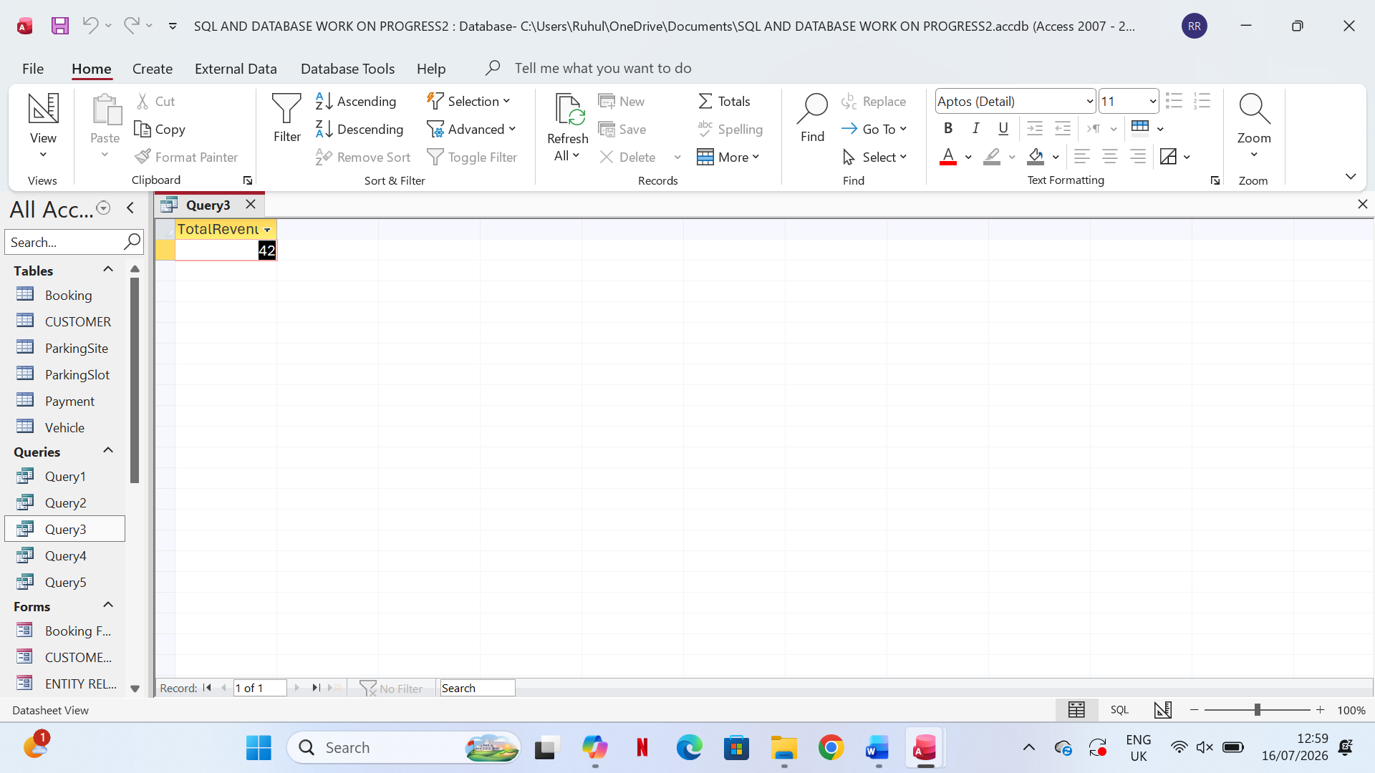

4.SQL — Customer Parking History

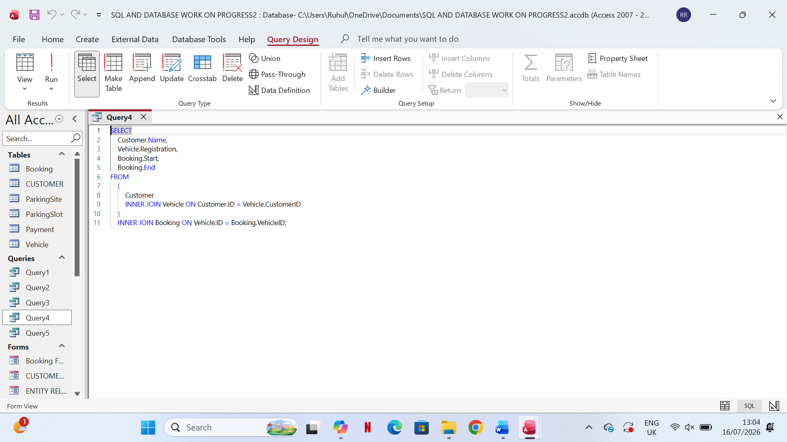

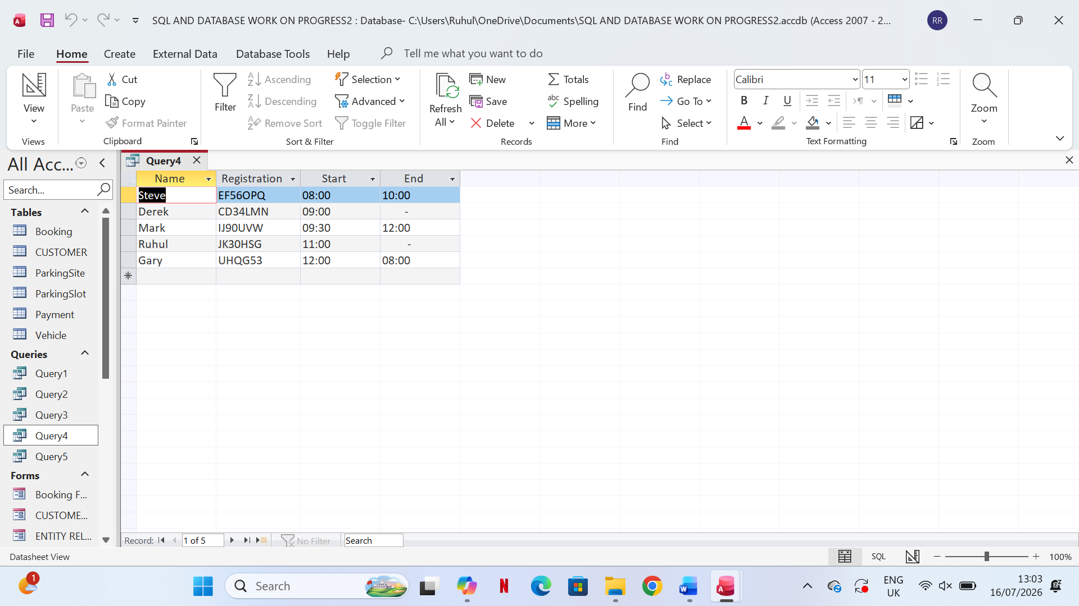
5 SQL — Frequently Used Parking Slots

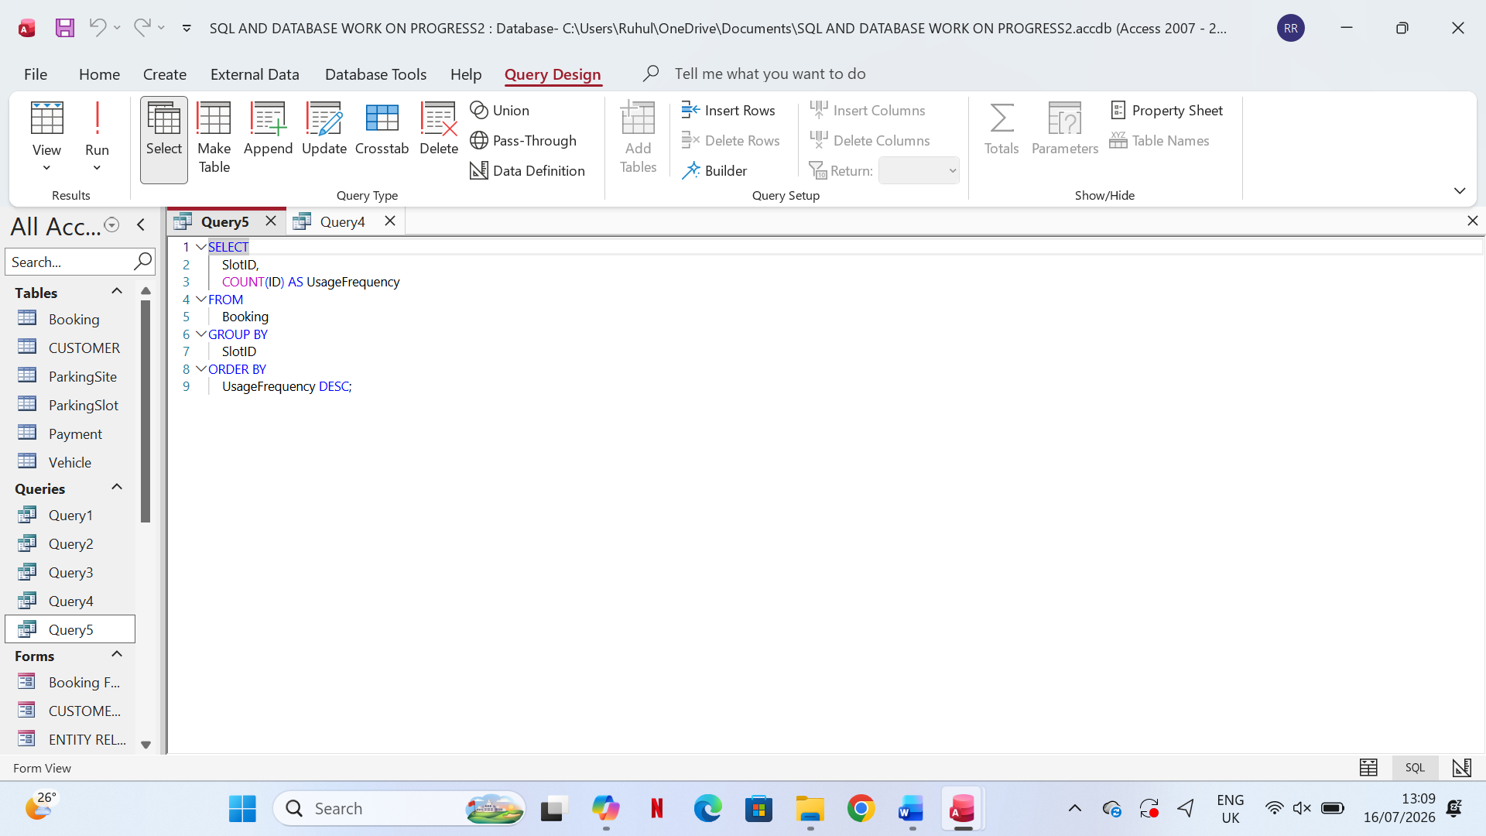
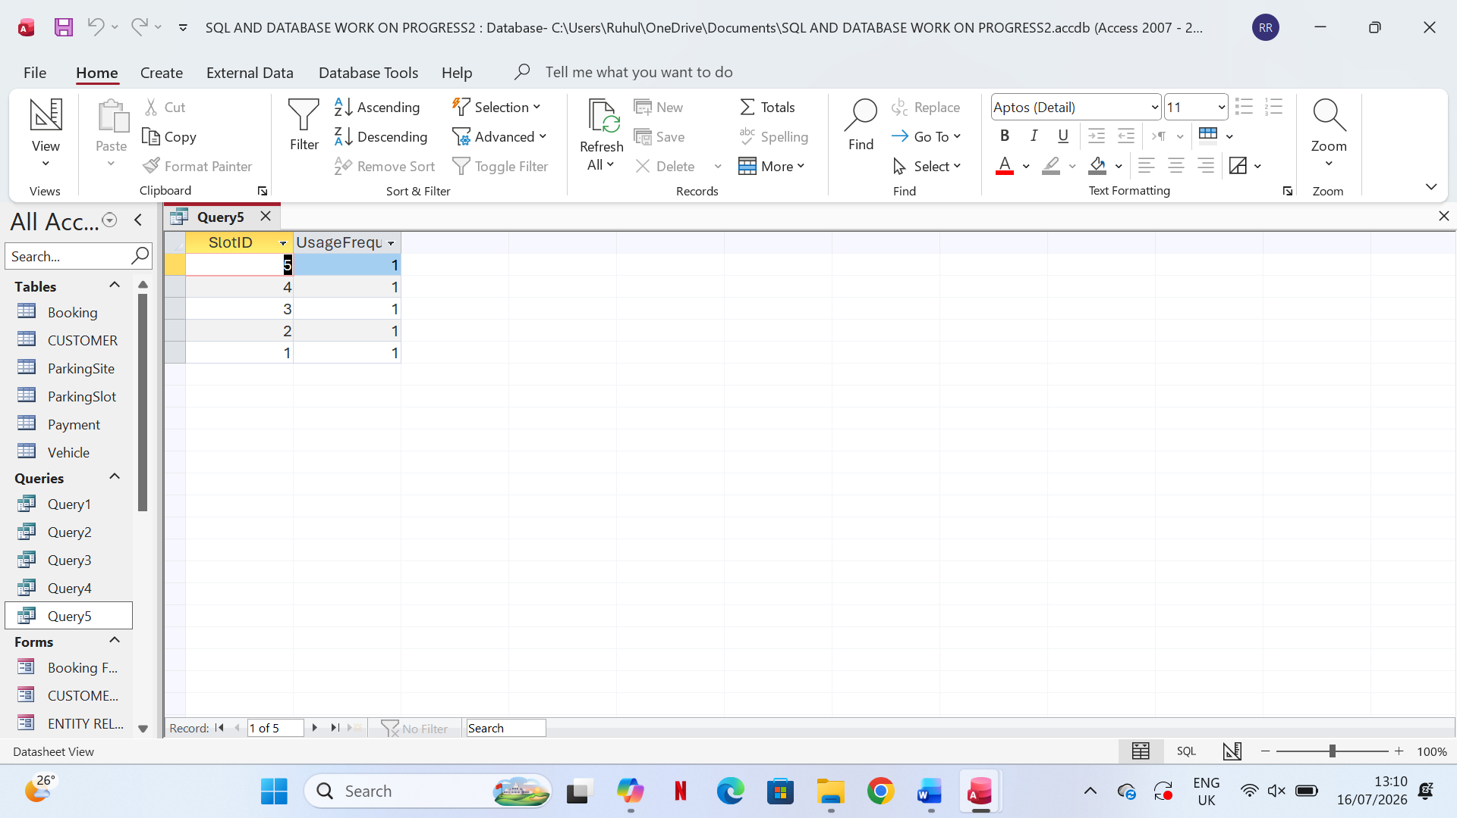

REPORT ADDED IN ACCES FILE BUT Database form BELOW
FORM-1
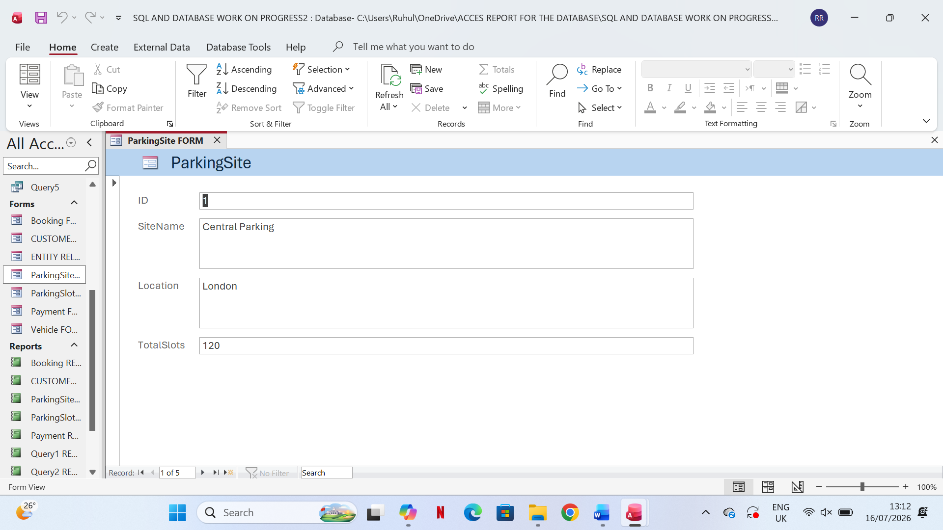
FORM-2
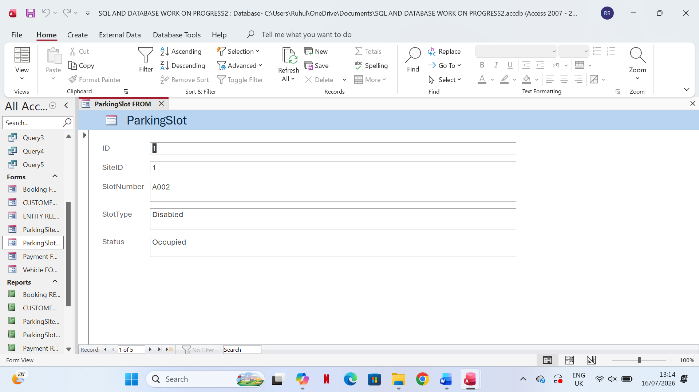

FORM-3
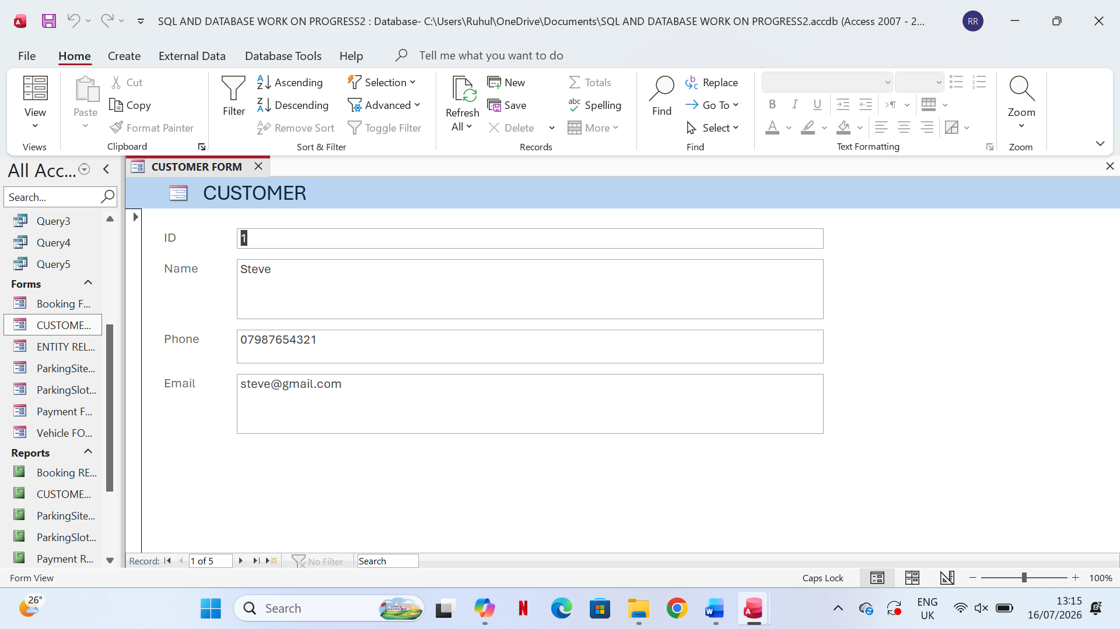

FORM-4
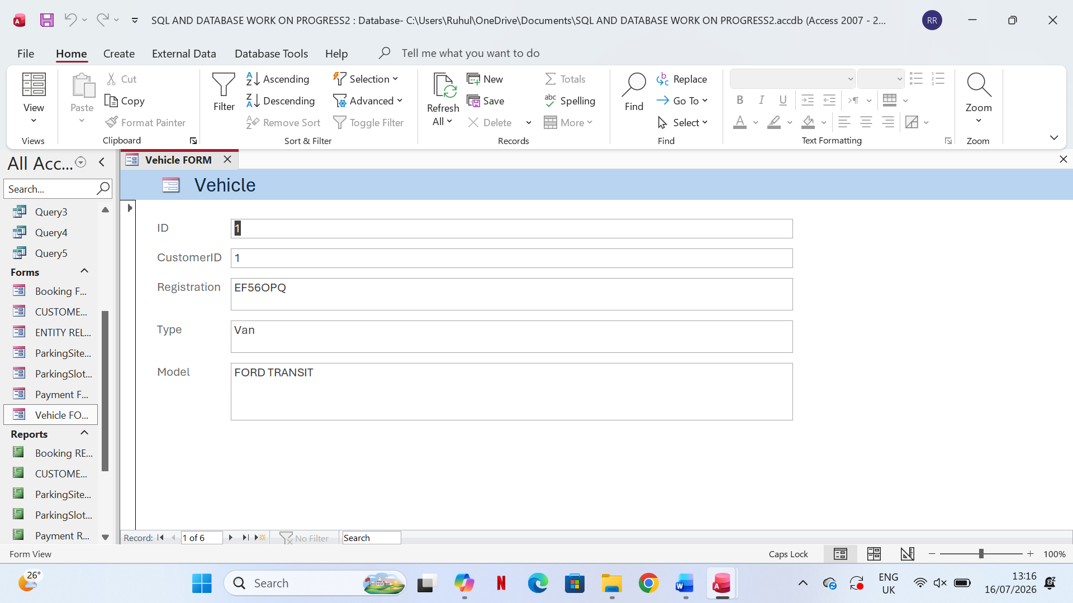
FORM-5
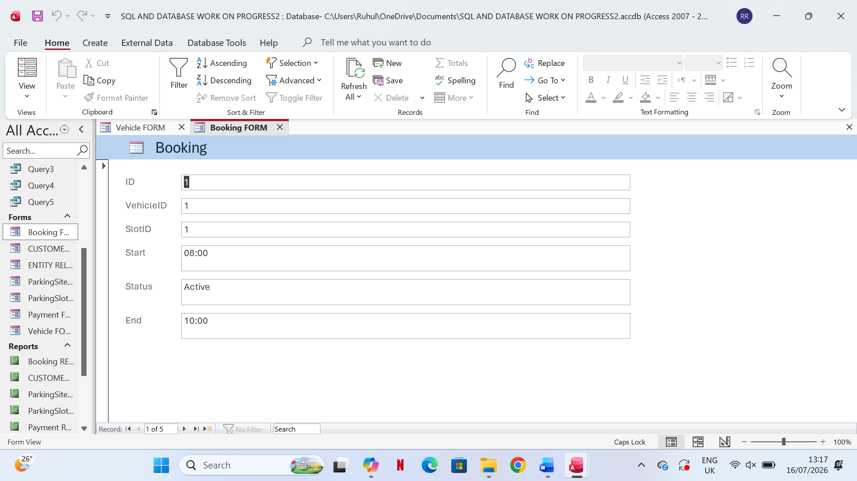
FORM-6
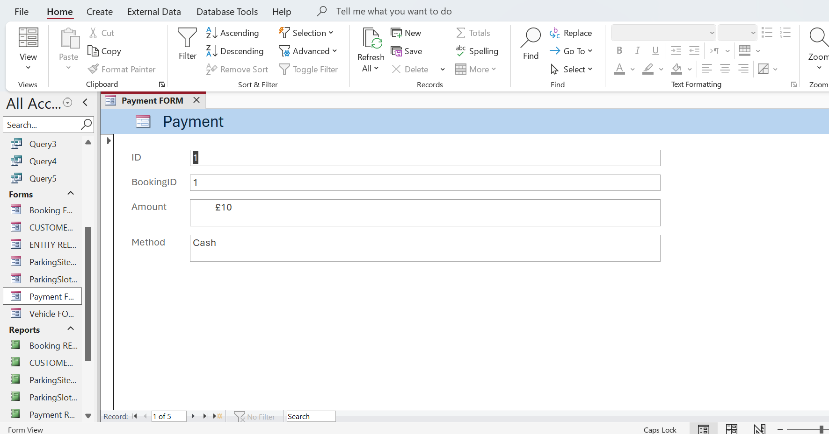
Microsoft Access allows users to retrieve information using SQL queries. These queries support operational monitoring, reporting, and decision-making.
Parking Spots Available
All parking spots with Status = "Available" are retrieved.
Reservations for Active Parking
shows the cars that are currently parked in AutoPark facilities.
Total Income
determines the total revenue received from parking sessions that are finished.
Parking History of Customers
displays each customer's past booking activity.
Parking Slots That Are Often Used
finds the parking spots that are most frequently used.
Management can analyze occupancy, customer behavior, and financial performance with the aid of these queries.
VIII. Testing and Validation
Testing verified that the AutoPark mechanism functions as intended.
Testing for functionality
Slot allocation, car connecting, customer registration, payment recording, and revenue reporting were all successful.
Testing Relationships
Referential integrity was confirmed by rejecting invalid entries, such as cars without clients or payments without reservations.
Testing for Validation
Inaccurate booking times, negative payments, and duplicate registration numbers were avoided.
Evaluation of Performance
Accurate results were obtained from queries, indicating effective information retrieval.
Design,Introspection,andAssessment
In order to preserve integrity across sites, slots, clients, cars, reservations, and payments, the AutoPark database uses a completely normalized relational structure with primary and foreign keys. The system's design emphasized the significance of ensuring referential integrity to prevent invalid records and separating entities to minimize redundancy. Determining the connections between Vehicle, Booking, and ParkingSlot was the most difficult aspect of development, but it was necessary for precise reporting. Evaluation verified accurate validation rules, dependable data entry, and effective query execution. Overall, the system enables scalable, precise parking management and conforms to suggested relational database standards.

Conclusion
A reliable substitute for manual parking management procedures is the AutoPark Management System database. AutoPark can more effectively handle parking spaces, clients, cars, reservations, and payments by putting in place a structured relational database in Microsoft Access. The database reduces redundancy and improves consistency by adhering to relational design principles, which include primary keys, foreign keys, validation rules, and 3NF normalization. Operational reporting is supported by SQL queries, and system dependability is verified through testing. Additionally, the database offers a scalable framework for upcoming improvements like smart analytics, automated reservations, mobile applications, and Internet of Things sensors [7]–[13].

References
[1] R. Iqbal, "An Intelligent Parking Management System Using IoT and Cloud-Based Data Analytics," Sensors, 2022. .
[2] M. Geng and Y. Cassandras, "New Smart Parking System Based on Resource Allocation and Real-Time Data Processing," IEEE Transactions on Intelligent Transportation Systems, 2021. .
[3] J. Lin, "A Smart Parking System Based on Wireless Sensor Networks and Data Analysis," IEEE Access, 2020. .
[4] S. Channamallu, "A Review of Smart Parking Systems," Transportation Research Procedia, 2023. .
[5] M. R. Alam, "A Survey on IoT-Driven Smart Parking Management System," IEEE Access, 2023. .
[6] T. -. Pham, D. -. Mai and X. -. Pham, "Smart Parking Services: An Overall Solution Based on Internet of Things and Fog Computing," IEEE Access, 2023. .
[7] P. Lubrich, "Smart Parking Systems: A Data-Oriented Taxonomy and a Metadata Model," Transp. Res. Rec., 2021. .
[8] T. Connolly and C. Begg, Database Systems: A Practical Approach to Design, Implementation, and Management. 2015.
[9] C. Coronel and S. Morris, Database Systems: Design, Implementation, & Management. 2019.
[10] A. Silberschatz, H. F. Korth and S. Sudarshan, Database System Concepts. 2020.
[11] Microsoft, "Database design basics," Microsoft Support, .
[12] Microsoft, "Guide to table relationships," Microsoft Support, .
[13] Microsoft, "Create, edit or delete a relationship in an Access database," Microsoft Support, .

