


INDEPENDENT PROJECT REPORT

SmartConnect:
A Digital Platform Linking Mosques and Communities

Submitted by
Sana Khan
Student ID: 2239157

Module Code: ACCA6020 | Module Name: Independent Project
Programme: BSc Cloud Computing
University of Wales Trinity Saint David

Supervisor: Dr MD Shantanu Islam
Submission Date: 2nd April 2026

Declaration of Originality and Form of Consent
Declaration of Originality

I, ............................................(Sana Khan)………………………………… declare that I am the sole author of this Project; that all references cited have been consulted; that I have conducted all work of which this is a record, and that the finished work lies within the prescribed word limits.

This work has not previously been accepted as part of any other degree submission.

Signed : .............................................

Date : ...30/03/2026............................................

FORM OF CONSENT

I ............................................(Sana Khan)………………………………… hereby consent that my Project, submitted in candidature for the B.Sc.(Hons) Computer Networks degree, if successful, may be made available for inter-library loan or photocopying (subject to the law of copyright), and that the title and abstract may be made available to outside organisations.

Signed : .............................................

Date : ...30/03/2026.............................................Copyright Acknowledgement

I acknowledge that the copyright of this project report, and any product developed as part of the project, belong to University of Wales Trinity Saint David, Swansea.

Abstract
Religious institutions increasingly rely on digital technologies to enhance communication and community engagement. However, many small-town mosques in the United Kingdom continue to operate independently without an integrated digital infrastructure, leading to fragmented communication, duplicated events, and limited cross-community collaboration. This dissertation presents SmartConnect, a centralised Android-based mobile application designed to unify communication among three mosques in Redditch, Worcestershire, while preserving institutional autonomy.
The study adopts a mixed-method research design combining a critical literature review, stakeholder consultation, and iterative Agile development across four two-week sprints. SmartConnect was developed using Android Studio with Java and XML for the mobile frontend, and a Python Flask backend with SQLite for server-side data management. A RESTful API enables real-time synchronisation between the mobile client and the backend administrative dashboard.
Beyond the core mosque information functions, SmartConnect includes a comprehensive suite of Islamic lifestyle features: a Daily Dua widget, 99 Names of Allah reference, Tasbeeh (dhikr) counter, Hijri calendar integration, Islamic quiz, Shahada declaration screen, donation interface with preset GBP amounts, configurable Settings screen with per-mosque notification preferences, and a full About screen.
All fifteen functional test cases passed. API response times averaged under 200ms across all endpoints. The application was verified across Android API levels 24, 29, and 34 with no version-specific failures. All nine project objectives were substantially achieved within the four-sprint timeline.

Table of Contents
Contents
Declaration of Originality and Form of Consent 2
Abstract 4
Table of Contents 5
List of Figures and Tables 9
Tables 10
1.0 Introduction 12
1.1 Background 12
1.2 Problem Statement 14
1.3 Aim 14
1.4 Objectives 15
1.5 Scope of the Project 16
1.6 Dissertation Structure 17
2.0 Literature Review 18
2.1 Review of Existing Research and Related Works 18
2.1.1 Digital Transformation in Religious Institutions 18
2.1.2 Mosque Mobile Applications: International Case Studies 19
2.1.3 UK Mosque Digitalisation 19
2.1.4 Mobile Development Frameworks and Technologies 20
2.2 Rationale and Research Gap 20
3.0 Methodology 22
3.1 System Development Approach 22
3.2 Tools and Technologies 24
3.3 System Requirements 25
Functional Requirements 26
Non-Functional Requirements 29
3.4 System Architecture and Design 29
3.5 Data Collection and Processing 30
4.0 Implementation and Development 32
4.1 Android Application Development 32
4.1.1 Project Setup and Navigation 32
4.1.2 RetrofitClient and API Integration 33
4.1.3 Home Fragment — Prayer Times and Hijri Calendar 33
4.1.4 Mosques Fragment — Directory and Maps 34
4.1.5 About Screen 35
4.1.6 Announcements Fragment 36
4.2 Extended Islamic Lifestyle Features 37
4.2.1 Qibla Compass 38
4.2.2 Settings Screen and Notification System 39
4.2.3 Donation Interface 40
4.2.4 99 Names of Allah 41
4.2.5 Tasbeeh Counter 42
4.3 Flask Backend Development 43
4.3.1 Application Structure and Database Models 43
4.3.2 RESTful API Endpoints 43
4.3.3 Administrative Dashboard 43
4.3.4 Auto-Expiry System 44
5.0 Testing and Evaluation 45
5.1 Testing Strategy 45
5.2 Functional Test Cases 45
5.3 Non-Functional Testing 47
5.4 Evaluation Against Objectives 48
5.4 User Evaluation Questionnaire 48
5.5 Discussion 49
6.0 Conclusion and Recommendations 50
6.1 Conclusion 50
6.2 Recommendations 50
Short-Term Recommendations (0–6 months) 50
Medium-Term Recommendations (6–18 months) 51
Long-Term Recommendations (18+ months) 51
7.0 Reflection 53
7.1 Technical Learning 53
7.2 Project Management Learning 54
7.3 Personal and Community Significance 54
References 56
Appendices 59
Appendix A: Full project code base 59
Appendix B: Key Source Code Excerpts 59
B.1 RetrofitClient.java 59
B.2 QiblaUtils.java — Haversine Bearing Calculation 59
B.3 Flask Auto-Expiry Announcements Endpoint 59
Appendix C: Project Timeline 60
Appendix D: Database Schema Summary 60
Appendix E – Questionnaire and Feedback 61
Questionnaire Link 61
Feedback Link 61
Visual Analysis of Results 62

List of Figures and Tables
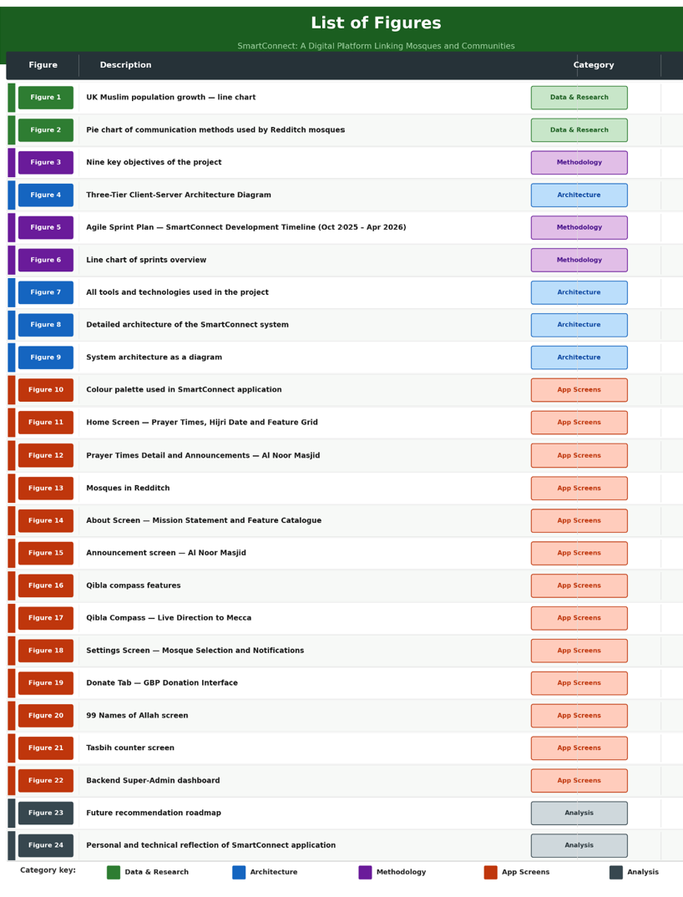

Tables
Table1: Shows the core problem of the project
Table 2: Tools and Technologies Summary
Table 3: Functional Requirements
Table 4: Non-Functional Requirements
Table 5: Extended Feature Summary
Table 6: REST API Endpoints
Table 7: Functional Test Cases and Results
Table 8: Non-Functional Test Results
Table 9: Illustrated all nine objectives achieved
Table 10: (Appendix D) SQLite Database Entity Summary

1.0 Introduction
This study focuses on developing a centralised mobile application to improve communication and coordination between three mosques and the Muslim community in Redditch. It aims to address existing gaps by enabling structured information sharing and fostering active community engagement. Additionally, the application integrates Islamic lifestyle tools to support both the spiritual and practical needs of users.

1.1 Background
Religious institutions have long served as cornerstones of community life, offering spaces for worship, education, social cohesion, and welfare. Mosques play a multifaceted role in Muslim-majority and Muslim-minority communities alike, extending their influence well beyond prayer to encompass youth programmes, charitable activities, interfaith dialogue, and crisis support [1]. As illustrated in (Figure 1), the Muslim population has grown steadily over the past two decades from 1.6 million in 2001 to 3.9 million in 2021 with projections suggesting it may reach 5.5 million by 2031 [2]. This demographic growth has intensified the need for mosques to adopt more effective communication strategies to serve an increasingly diverse and digitally literate congregation. Below the line chart explain in more detail:

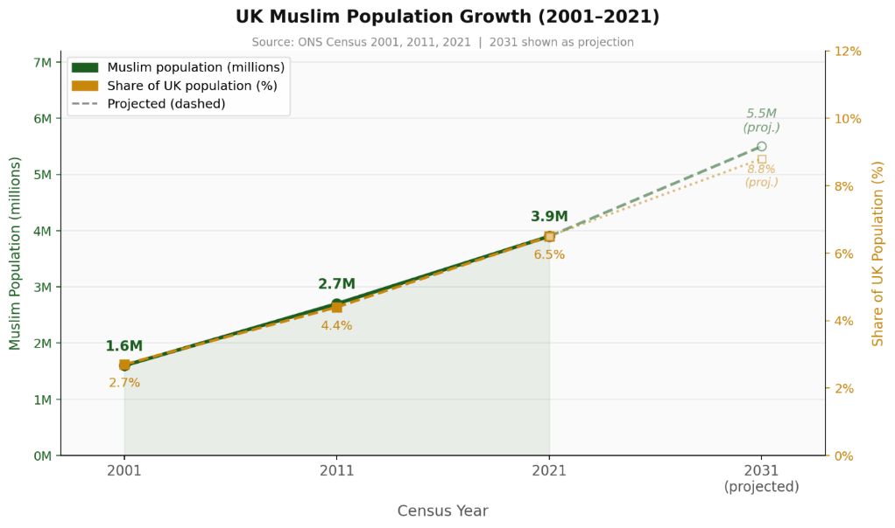
Figure 1: illustrate the UK Muslim growth in line chart

The digital transformation of religious institutions is well-documented globally. Applications such as Muslim Pro, which surpassed 170 million downloads, demonstrate the appetite for faith-based digital tools [3]. However, such applications are broad in scope and do not serve the hyper-local communication needs of individual mosques or mosque clusters within a specific town. Studies from Europe have shown that social media adoption among mosques is uneven, with many smaller institutions lacking the resources or technical knowledge to maintain consistent digital communication [4]. Digital tools are reshaping how religious authority, gender participation, and community cohesion operate within faith-based organisations [5],[6], yet localised mosque digitalisation in small UK towns remains understudied [7].
Redditch, a town in Worcestershire, England, is home to three mosques: Al Noor Masjid, Al Birr Masjid, and Farooq Masjid and Academy. These mosques collectively serve a significant Muslim population but currently operate in digital silos. Each mosque manages its own communication through informal means such as WhatsApp groups, paper notices, and word of mouth, resulting in fragmented information dissemination and reduced community cohesion. SmartConnect was conceived to address this fragmentation by providing a unified digital platform tailored to the specific needs of these three mosques and their community.

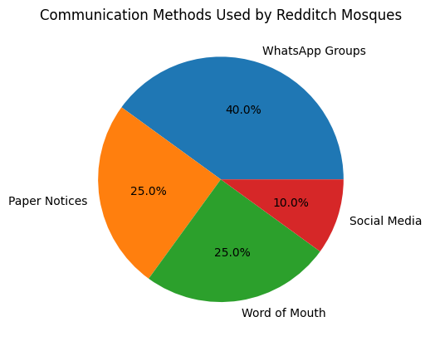
Figure 2: illustrated the pie chart of communication methods used by Redditch Mosques

1.2 Problem Statement
Despite serving a growing Muslim community in Redditch, the three local mosques operate without any centralised digital communication infrastructure. Current information sharing practices are inconsistent and fragmented: each mosque uses a different combination of WhatsApp messages, physical notice boards, verbal announcements, and Facebook posts. This disjointed approach creates several significant problems.
Community members, particularly new residents, converts, or visitors, have no single reliable source to access prayer schedules, event listings, or important announcements from any of the three mosques. The absence of a unified platform reduces opportunities for inter-mosque collaboration on shared events such as Eid prayers, Ramadan programmes, and educational initiatives. Administrative inefficiency is compounded because mosque staff must repeat communication tasks across multiple platforms with no central management system.

⚠ Core Problem — Redditch Mosques Digital Gap
• Fragmented communication across WhatsApp, noticeboards, and social media
• Duplicated events and clashing schedules with no cross-mosque visibility
• Limited cross-community collaboration and poor digital presence
• Exclusion of new residents, converts, and visitors from community information
Table1: shows the core problem of the project

1.3 Aim
The aim of this study is to design and evaluate a centralised mobile application that addresses communication gaps, supports structured information sharing, promotes active engagement between three mosques and the Muslim community in Redditch, and provides an integrated suite of Islamic lifestyle tools to serve the holistic spiritual and practical needs of the community.

1.4 Objectives
To achieve the aim, the following nine objectives guide this project also illustrated in (figure 3):
1. Analyse the current communication practices and identify key challenges across the three Redditch mosques.
2. Review existing digital mosque platforms and relevant literature to identify best practices and research gaps.
3. Design and develop a prototype Android mobile application using XML for UI layout and Java for application logic.
4. Develop a Flask-based backend web server with an administrative dashboard for mosque staff to manage content.
5. Implement a RESTful API to enable real-time synchronisation between the mobile application and the Flask backend.
6. Integrate core mosque functions including prayer times, event listings, community announcements, Qibla compass, and mosque locator.
7. Implement extended Islamic lifestyle features including Daily Dua, 99 Names of Allah, Tasbeeh counter, Hijri calendar, Islamic quiz, Shahada screen, and donation interface.
8. Conduct functional and usability testing using Android Emulator and manual test cases.
9. Provide recommendations for long-term deployment, GDPR compliance, scalability, and sustainability.

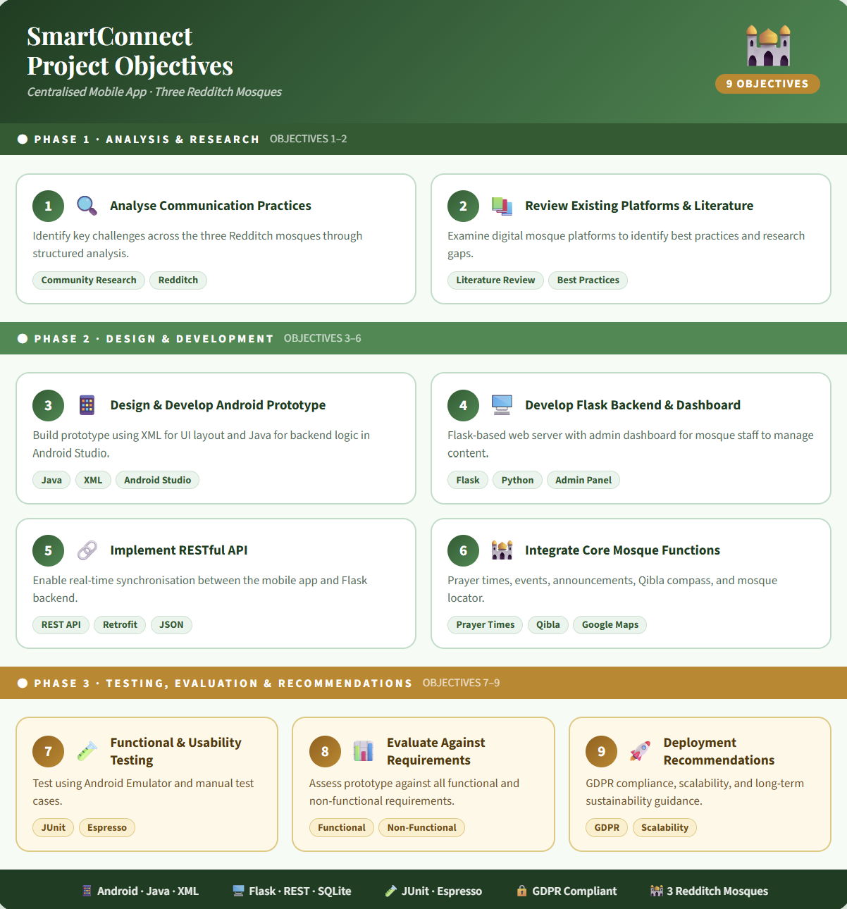
Figure 3: illustrated the nine key objective of the project

1.5 Scope of the Project
This project focuses on the design, development, and evaluation of a prototype mobile application and its supporting backend infrastructure for three mosques in Redditch, UK. The Android application provides both community-facing mosque information features and an extended suite of Islamic lifestyle tools. The Flask backend provides mosque administrators with a web-based dashboard to manage all mosque-specific content.
The scope is limited to a working prototype using simulated data due to ethical considerations around real user data. Live push notification delivery via Firebase Cloud Messaging, live payment processing for the donation feature, and full multi-language runtime switching are identified as near-term enhancements beyond the current scope.

1.6 Dissertation Structure
Section 1 present the introduction.
Section 2 presents a comprehensive literature review.
Section 3 describes the methodology including Agile development, tools, system requirements, and architecture.
Section 4 details the full implementation of both the Android application core features and the extended Islamic lifestyle features.
Section 5 presents testing and evaluation.
Section 6 provides conclusions and recommendations.
Section 7 offers a personal reflection on the project experience.

2.0 Literature Review
A literature review is a critical summary and analysis of existing research and scholarly work related to a specific topic. It identifies key findings, trends, and research gaps, providing a strong foundation for new research. This section reviews existing studies relevant to SmartConnect, focusing on digital transformation in religious institutions, mosque mobile applications, UK mosque digitalisation, and mobile development technologies.

2.1 Review of Existing Research and Related Works
Recent scholarship in digital religion highlights four major themes relevant to this project: digital transformation in religious institutions, mosque mobile applications, UK mosque digitalisation, and mobile development frameworks.

2.1.1 Digital Transformation in Religious Institutions
The intersection of technology and religion has gained increasing scholarly attention in recent years. Haberli [5], argues that the digital age has fundamentally transformed religious practice by extending worship, learning, and community interaction into digital environments. This transformation is not purely technological but also social, influencing how authority is exercised and how communities engage across geographical boundaries.
Similarly, Mia Lövheim and Eva Lundmark [6], highlight how digital platforms reshape gender roles and authority structures within religious communities. Online environments can democratise access to religious knowledge while simultaneously creating new hierarchies based on digital literacy and influence.
From an Islamic perspective, Islam [7], identifies social media as both an opportunity and a challenge. While it enables rapid dissemination of Islamic knowledge and strengthens global community connections, it also introduces risks such as misinformation and fragmentation when not moderated by trusted institutions. Supporting this, Pew Research Center [8], reports that a growing proportion of religious individuals rely on digital tools such as prayer apps and online resources in their daily practices. These findings directly justify the inclusion of lifestyle features such as Daily Dua, Tasbeeh, and the 99 Names of Allah within SmartConnect.

2.1.2 Mosque Mobile Applications: International Case Studies
A number of studies have explored mosque-specific mobile applications, particularly in Southeast Asia. Yaakub et al [9]. investigated a mobile mosque management system in Indonesia, reporting a 45% reduction in administrative workload and an 85% user satisfaction rate. This demonstrates the effectiveness of mobile solutions in improving mosque operations and community engagement.
Similarly, Wijaya and colleagues evaluated a mosque scheduling application using the System Usability Scale (SUS) [10], achieving an excellent usability score of 85.6. This confirms that user-centred design principles can result in highly accessible systems for diverse users.
However, despite these positive outcomes, several limitations exist. While existing studies provide valuable insights into mosque application development, they are often limited by geographical and contextual factors. Research conducted in Indonesia and Malaysia demonstrates high adoption rates, but these findings may not be directly transferable to the UK. Differences in governance structures, funding models, and digital literacy levels mean that user expectations vary significantly across regions.
Additionally, Febrianty identified that limited digital literacy among older users remains a barrier to adoption, despite strong functionality. Channa [11], further emphasises that successful implementation depends on leadership support and structured community training. These findings influenced SmartConnect’s design, which prioritises simplicity, accessibility, and community engagement.

2.1.3 UK Mosque Digitalisation
Within the UK, digital mosque solutions remain under-researched but increasingly relevant. The Bradford Grand Mosque provides a successful example of a hybrid application offering prayer times, live streaming, and educational content [12]. Similarly, MosqueApp Ltd has developed branded applications for several UK mosques, incorporating features such as notifications and donations[13].
Despite these advancements, research highlights significant gaps. Ajouaou and de Ruiter found that smaller mosques are often underrepresented in digital spaces, particularly in less urbanised areas [14]. This mirrors the situation in Redditch, where mosque communication remains fragmented.
Furthermore, Rahman identifies trust, ease of use, and cultural relevance as key factors influencing adoption [15]. These insights informed SmartConnect’s culturally sensitive design, including its visual identity and feature structure.
A critical limitation across the literature is the focus on single-mosque applications. While effective locally, these solutions do not address the challenges of multi-mosque environments, particularly in smaller UK towns. SmartConnect addresses this gap by introducing a unified platform that connects multiple mosques within a single application.

2.1.4 Mobile Development Frameworks and Technologies
Android remains the dominant mobile operating system globally, with a market share exceeding 70% [16]. Android Studio provides comprehensive tools for UI design through XML layouts and application logic through Java [17].
Python Flask has emerged as a lightweight and flexible framework suitable for rapid API prototyping, with clear migration paths to production-grade deployment [18].
SQLite, as an embedded relational database, offers sufficient capacity for the prototype's data requirements, with established migration paths to PostgreSQL or Firebase Firestore for production.

2.2 Rationale and Research Gap
The literature reveals several important trends and gaps.
First, mosque mobile application research has focused predominantly on Indonesian and South Asian contexts, with limited research examining UK-specific mosque digitalisation in small towns.
Second, existing studies focus on single-mosque deployments; there is a notable absence of research on multi-mosque unified platforms serving a shared community.
Third, while commercial solutions such as MosqueApp exist, there is limited academic documentation of their technical architecture, security practices, or community impact.
Therefore, SmartConnect extends existing research by addressing these gaps through the development of a multi-mosque unified platform tailored to a UK community. It combines institutional communication with personal lifestyle features, offering both functional and experiential value.
Additionally, the inclusion of offline functionality enhances accessibility, ensuring usability regardless of network conditions.
In conclusion, this project contributes both a practical solution and an academic advancement in the field of mosque digitalisation. By integrating usability, performance, scalability, and cultural relevance, SmartConnect provides a comprehensive approach that addresses the limitations identified in existing research.

3.0 Methodology
Methodology refers to the systematic approach and sets of methods used to conduct research and collect data. It outlines the procedures, techniques, and rationale behind how a study is designed and carried out. This project’s methodology is defined below.

3.1 System Development Approach
This project adopted an Agile development methodology following a Scrum-inspired iterative framework with four two-week sprints. Agile was selected over traditional waterfall approaches because of its flexibility in accommodating evolving requirements, its emphasis on working software as the primary measure of progress, and its support for incremental delivery [19], [20], [21]. Each sprint comprised a planning phase, development phase, review, and retrospective, enabling continuous refinement of both the mobile application and the backend system as illustrated in (figure 4, 5, 6).

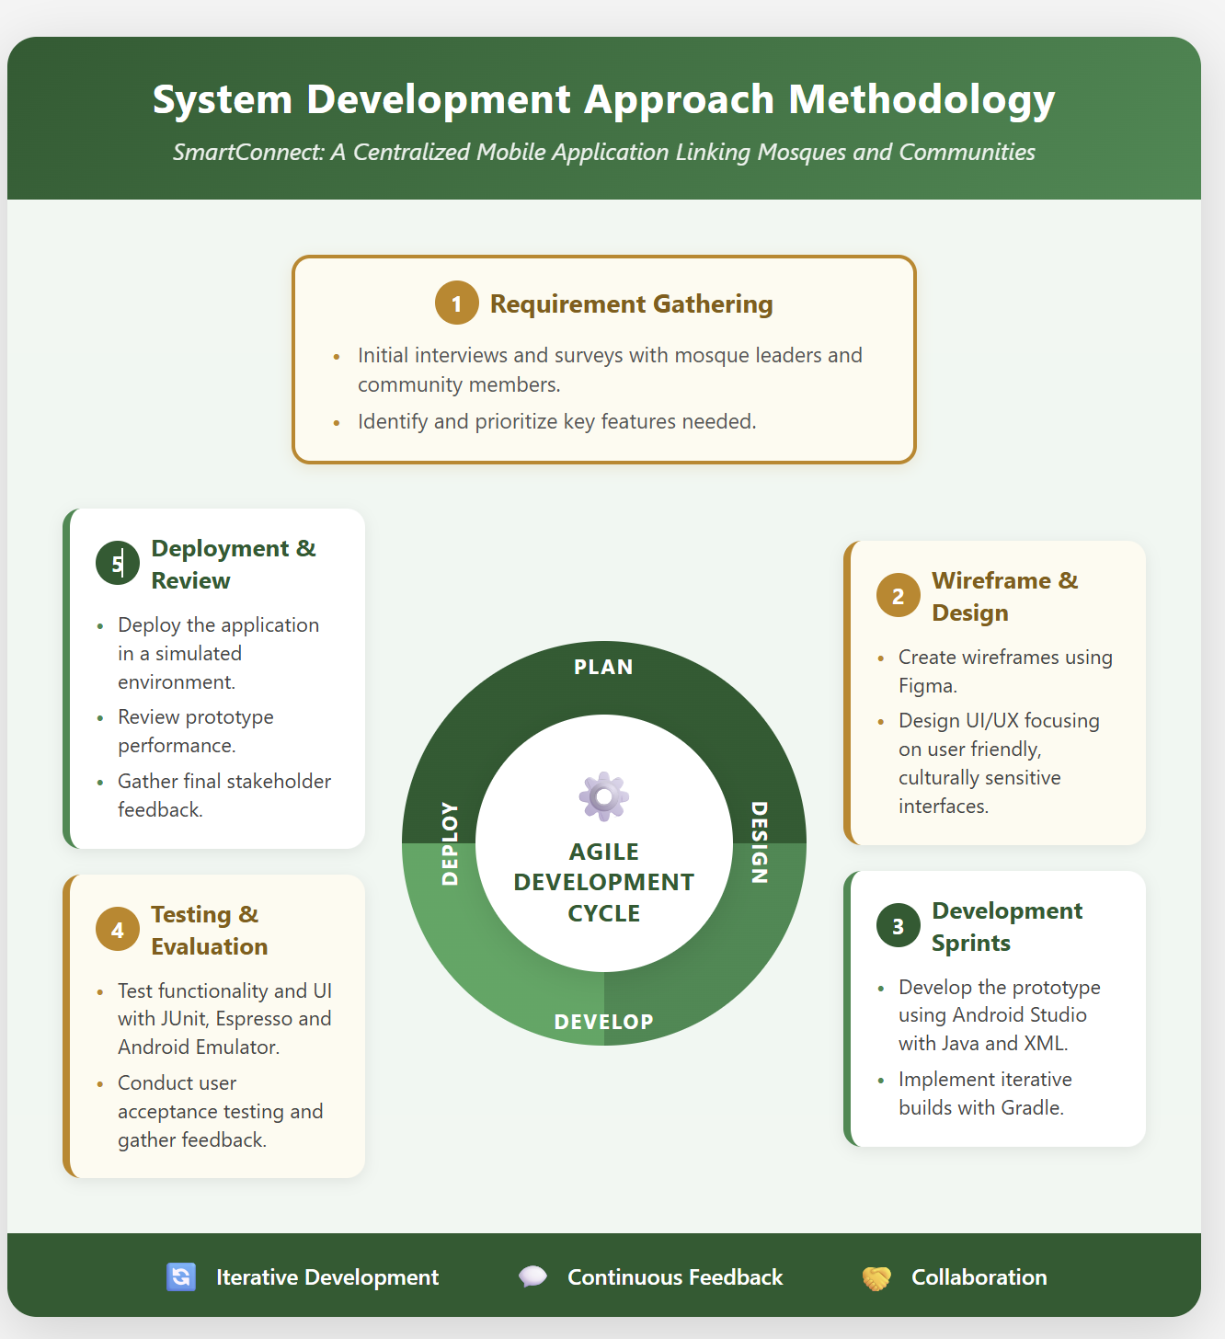
Figure 4: illustrated the three-Tier Client-Server Architecture Diagram
Sprint 1 focused on requirements gathering, literature review completion, system design, wireframing, and database schema design.
Sprint 2 covered core Android application development: navigation structure [22], Home screen with feature grid, Mosques fragment, and basic API connectivity.
Sprint 3 addressed the Flask backend development, administrative dashboard, announcements and events management, and RESTful API endpoints.
Sprint 4 completed the extended Islamic lifestyle features and conducted all testing and evaluation activities.

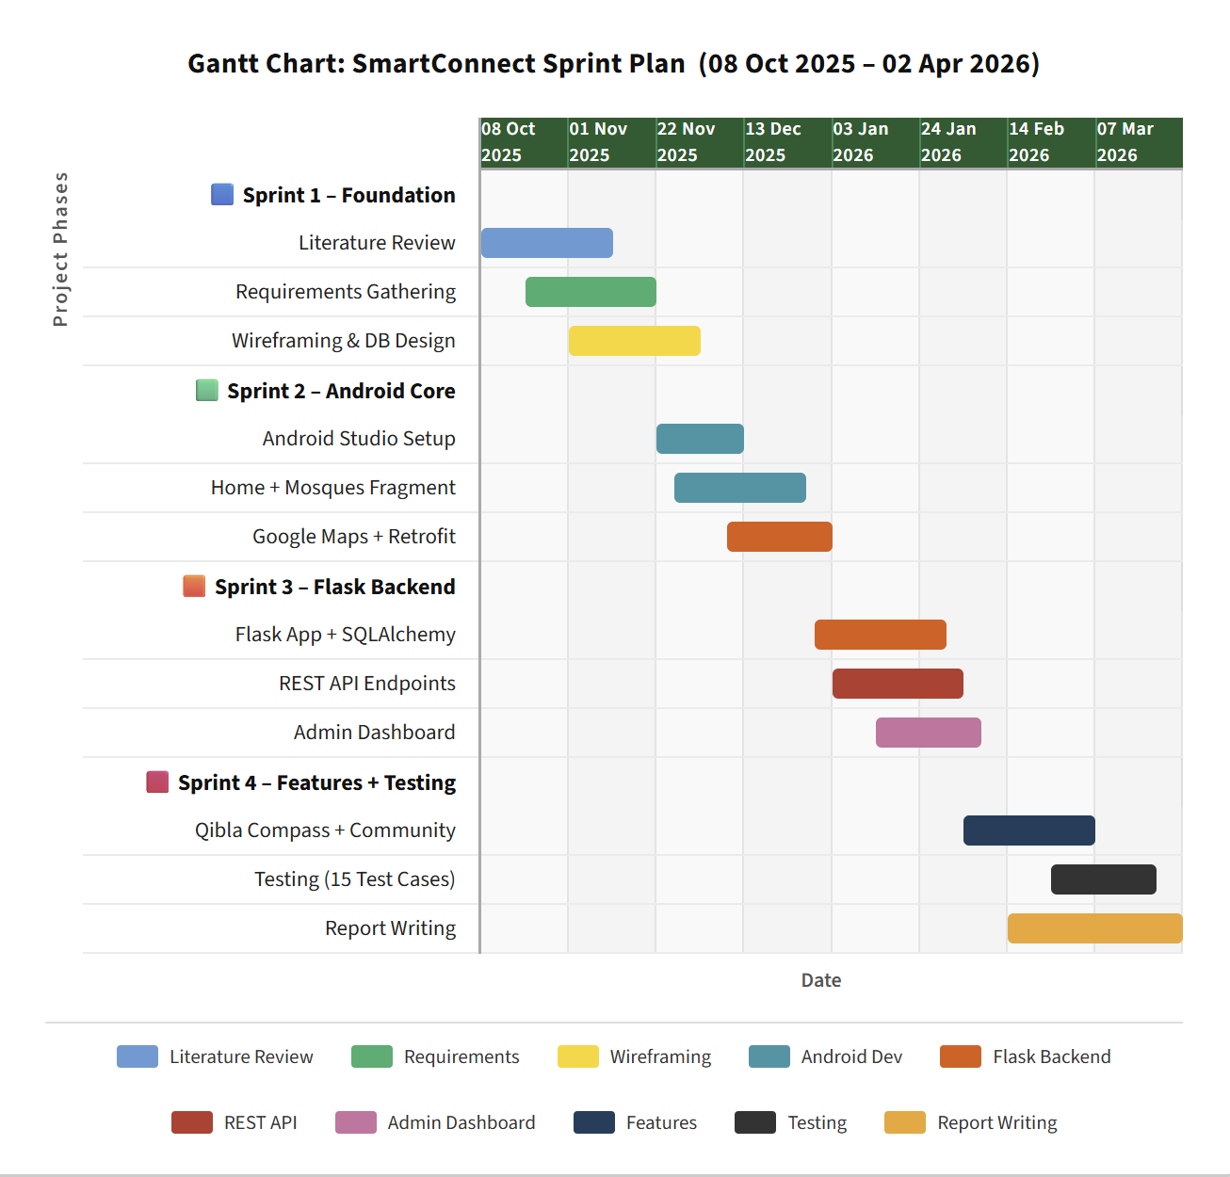
Figure 5: Agile Sprint Plan — SmartConnect Development Timeline (Oct 2025 – Apr 2026

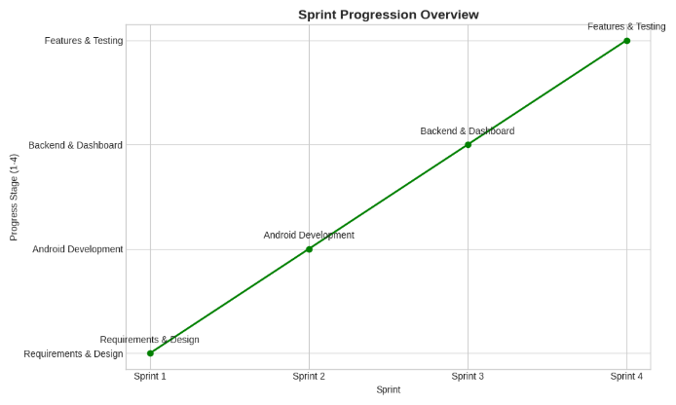
Figure 6: illustrated the line chart of sprits overview

3.2 Tools and Technologies
Tools and Technology refer to the software, platforms, and technical resources used to design, develop, and implement a project. They support the functionality, performance, and overall execution of the system. This project’s tools and technologies are defined below in Figures 7 and 8, along with Tables 2,3, and 4, , present a detailed overview of the tools and technologies used SmartConnect application.

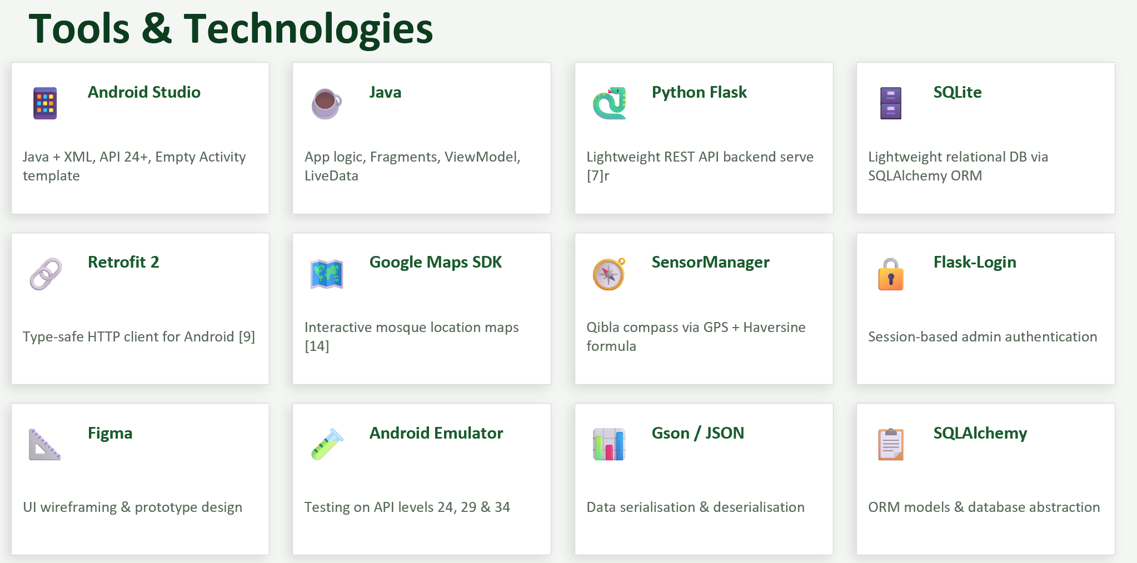
Figure 7: illustrated all the tools and technologies used in the project

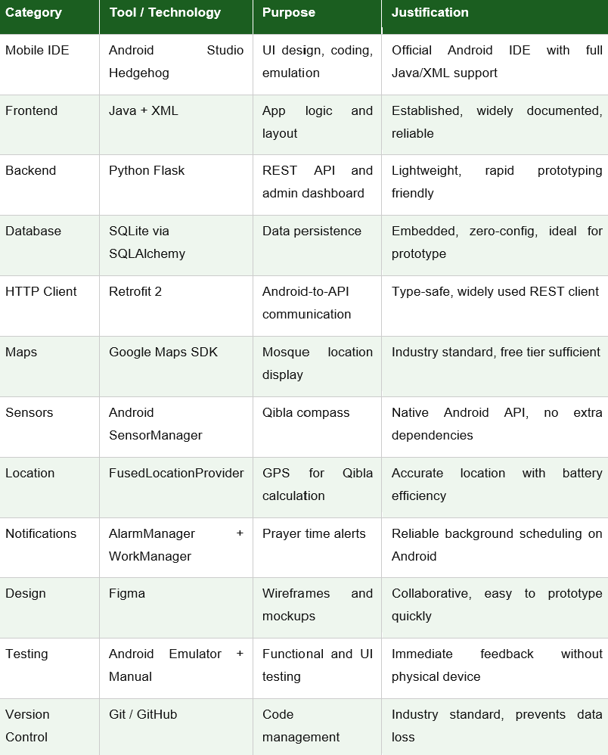
Table 2: Tools and Technologies Summary

3.3 System Requirements
System Requirements refer to the necessary hardware, software, and functional specifications needed for a system to operate effectively. In this project, the requirements are divided into functional requirements (what the system should do) and non-functional requirements (how the system should perform).

Functional Requirements
ID | Requirement Description
FR1 | The system shall display prayer times for each of the three Redditch mosques.
FR2 | The system shall display upcoming events and announcements fetched from the Flask backend.
FR3 | The system shall automatically remove expired announcements and events based on admin-configured expiry times.
FR4 | The system shall display mosque locations on an interactive Google Maps interface.
FR5 | The system shall provide a real-time Qibla compass using the device rotation vector sensor and GPS.
FR6 | The system shall provide a Community tab with mosque resources and emergency contacts.
FR7 | The backend shall provide an admin dashboard for mosque staff via web browser.
FR8 | The backend shall allow mosque admins to add, view, and delete announcements, events, and prayer times.
FR9 | The system shall operate with graceful fallback to default data when the backend is unavailable.
FR10 | The system shall provide a Daily Dua feature displaying a new supplication each day.
FR11 | The system shall include a 99 Names of Allah reference screen with Arabic names and meanings.
FR12 | The system shall provide a Tasbeeh (dhikr) counter with haptic feedback and configurable target.
FR13 | The system shall display the current date in both Gregorian and Hijri (Islamic) calendar formats.
FR14 | The system shall include an Islamic quiz feature with multiple choice questions.
FR15 | The system shall provide a Shahada declaration screen with transliteration and translation.
FR16 | The system shall include a donation interface with preset GBP amounts and a custom amount field.
FR17 | The system shall provide a Settings screen allowing users to select their default mosque.
FR18 | The system shall allow users to configure notification preferences for prayer times, announcements, and events.
FR19 | The system shall include an About screen describing the app mission and full feature catalogue.
Table 3: Functional Requirements

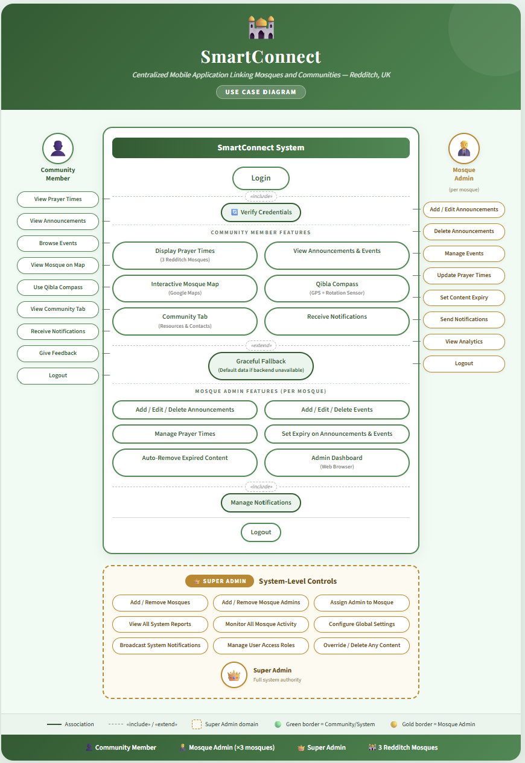
Figure 8: illustrated the detail architecture of the project

Non-Functional Requirements
ID | Category | Requirement
NFR1 | Performance | API responses shall return within three seconds under normal network conditions.
NFR2 | Usability | The mobile UI shall be navigable by users with minimal technical experience.
NFR3 | Security | HTTP traffic restricted to local network; HTTPS to be implemented for production.
NFR4 | Compatibility | The application shall support Android API Level 24 (Android 7.0) and above.
NFR5 | Maintainability | Code shall follow standard Java naming conventions and include inline comments.
NFR6 | Scalability | The database schema shall support additional mosques without structural changes.
Table 4: Non-Functional Requirements

3.4 System Architecture and Design
System Architecture and Design refer to the overall structure and organization of a system, including how components interact and function together. It defines the system’s layout, technologies, and design principles to ensure efficiency, scalability, and reliability. (Figure 9) illustrates the overall system architecture of SmartConnect follows a three-tier client-server architecture: the Android mobile client [22], the Flask REST API server, and the SQLite database. The mobile client communicates with the Flask server through HTTP GET and POST requests, with all data returned in JSON format. The Flask server acts as the single source of truth for all dynamic mosque content, while Islamic lifestyle features are implemented entirely within the Android client using local data and device APIs, reducing server dependency and enabling offline availability of all lifestyle tools.
The Android application is structured around a single MainActivity with a five-tab bottom navigation bar: Home, Mosques, About, Community, and Settings. The Community fragment contains five sub-tabs: Donate, Qibla, Duas, Quiz, and Events. The Flask backend exposes six RESTful endpoints returning JSON for mosques, announcements, events, prayer times, and contacts.

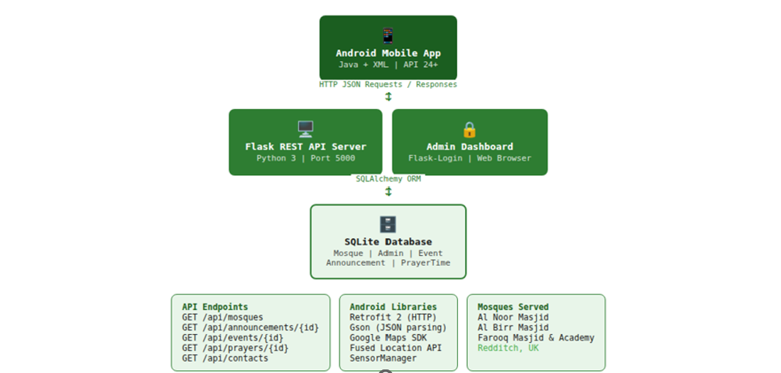
Figure 9: illustrated the system architecture of SmartConnect

3.5 Data Collection and Processing
Data collection for evaluation was conducted through structured testing procedures, including functional and non-functional testing, as well as user-based usability assessment. A questionnaire-based approach was selected to capture user perceptions of usability, performance, and overall satisfaction (illustrated in Appendix E) . This method is widely used in similar studies due to its efficiency in gathering both quantitative and qualitative data from multiple participants.
Ethical considerations were also considered during the project. As the application has the potential to handle user data in a real-world deployment, compliance with data protection regulations such as the General Data Protection Regulation (GDPR) is essential [23]. Additionally, cultural sensitivity was considered in the design of the application to ensure that features align with Islamic values and community expectations.
Overall, the chosen methodology provided a structured yet adaptable framework that supported both the technical development and evaluation of the SmartConnect application.

4.0 Implementation and Development
Implementation and Development refer to the process of building and coding the system based on the proposed design and requirements. It involves integrating features, testing functionality, and refining the application to ensure it works effectively.

4.1 Android Application Development
Android Application Development refers to the process of creating mobile applications specifically for devices running the Android operating system. It involves designing the user interface, coding functionalities, testing, and deploying the app to provide a seamless user experience.

4.1.1 Project Setup and Navigation
The Android project was created in Android Studio using the Empty Activity template targeting Android API 24 as the minimum SDK [24], providing compatibility with approximately 98% of active Android devices. Gradle build files were configured with key dependencies including Retrofit 2.9.0 for HTTP networking [25], Gson 2.10.1 for JSON parsing, Google Maps SDK 18.2.0 for map integration, Google Fused Location Services 21.0.1 for GPS, and AndroidX Navigation Component 2.7.0 for fragment management.
The main activity utilises a five-tab BottomNavigationView with destinations defined in nav_graph.xml: Home, Mosques, About, Community, and Settings. A global Islamic green colour scheme was applied throughout through themes.xml, with #1B5E20 as the primary dark green, #2E7D32 as the secondary green, and #A5D6A7 as the light accent colour shown in (figure 10).

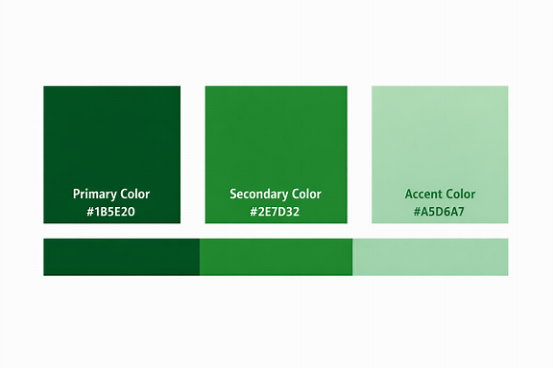
Figure 10: illustrated the colour palette which are used in SmartConnect application

4.1.2 RetrofitClient and API Integration
A singleton RetrofitClient class manages all API communications. Retrofit was configured with a base URL pointing to the Flask server at 10.0.2.2:5000 for the Android emulator. GsonConverterFactory handles automatic deserialisation of JSON responses into Java model objects. An ApiService interface declares all API endpoints using Retrofit annotations, providing type-safe HTTP method definitions. All API calls are executed asynchronously using Retrofit's enqueue method, ensuring the UI thread is never blocked during network operations (illustrated in Appendix B.1).

4.1.3 Home Fragment — Prayer Times and Hijri Calendar
(Figure 11) illustrated the HomeFragment which provides the primary entry point for community members. It fetches prayer times from the /api/prayers/{id} endpoint and dynamically constructs a horizontal card layout displaying the five daily prayer times: Fajr, Dhuhr, Asr, Maghrib, and Isha. Prominently displayed above the prayer cards is a hero image of the Masjid al-Nabawi, the current time, the selected mosque name, the Gregorian date, and the corresponding Hijri calendar date (e.g. "14 Ramadan 1447 AH"). The Hijri date is calculated algorithmically using a conversion function in HijriCalendarUtils.java, requiring no external API call.
Below the prayer cards, the Home screen presents a 3×3 grid of feature tiles: Daily Dua, Qibla, 99 Names, Tasbeeh, Calendar, Prayer Times, Find Mosque, Zakat, and Shahada. Each tile uses an icon and label, providing one-tap navigation to the corresponding feature. At the bottom of the scroll, a Dua of the Day card displays a curated supplication from the local database. If the API call fails, the fragment falls back to pre-seeded default prayer times.

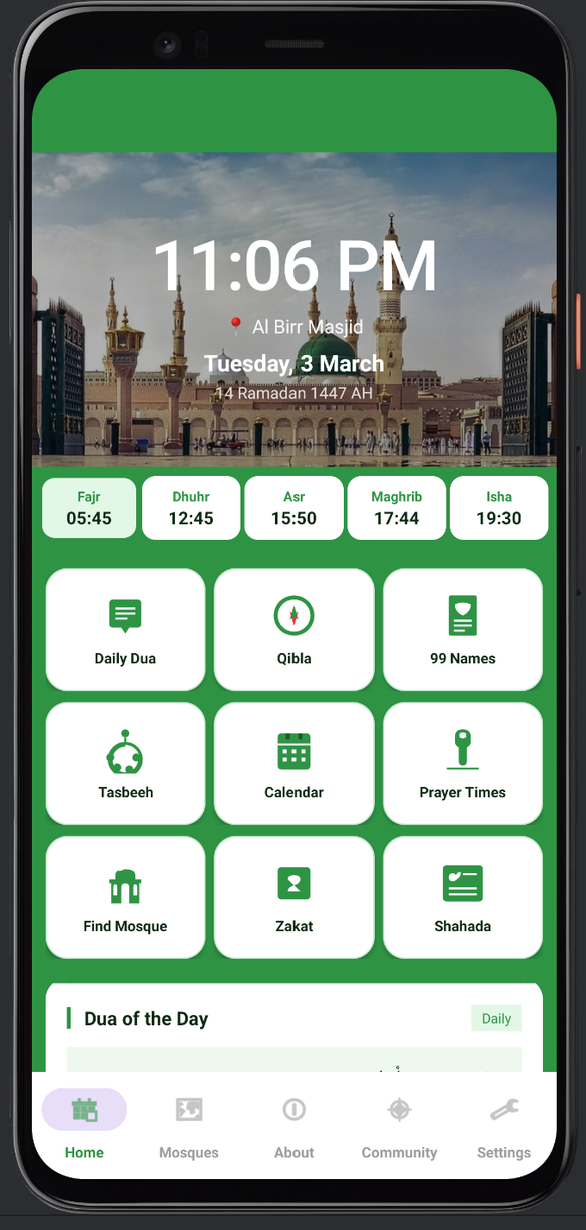
Figure 11: illustrated the Home Screen — Prayer Times, Hijri Date and Feature Grid

4.1.4 Mosques Fragment — Directory and Maps
The MosquesFragment displays all three Redditch mosques as scrollable cards, each showing the mosque name, full address, and phone number as a clickable tel: intent. Two action buttons "Prayer Times & Events" and "Map" are provided per mosque. The Prayer Times & Events button navigates to a detailed mosque view (Figure 12, 13) showing live prayer times and active announcements for that specific mosque. The Map button launches Google Maps with the mosque's GPS coordinates, enabling turn-by-turn navigation directly from the app.

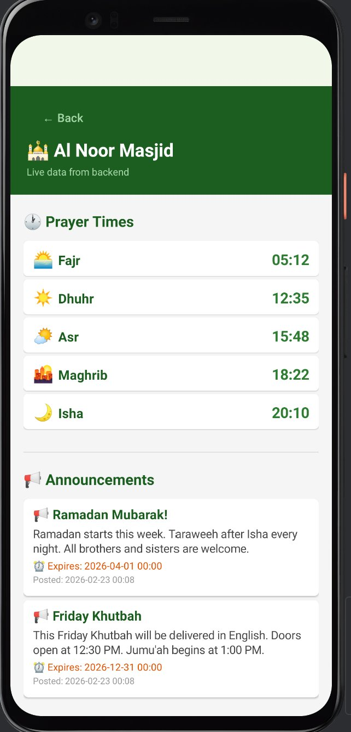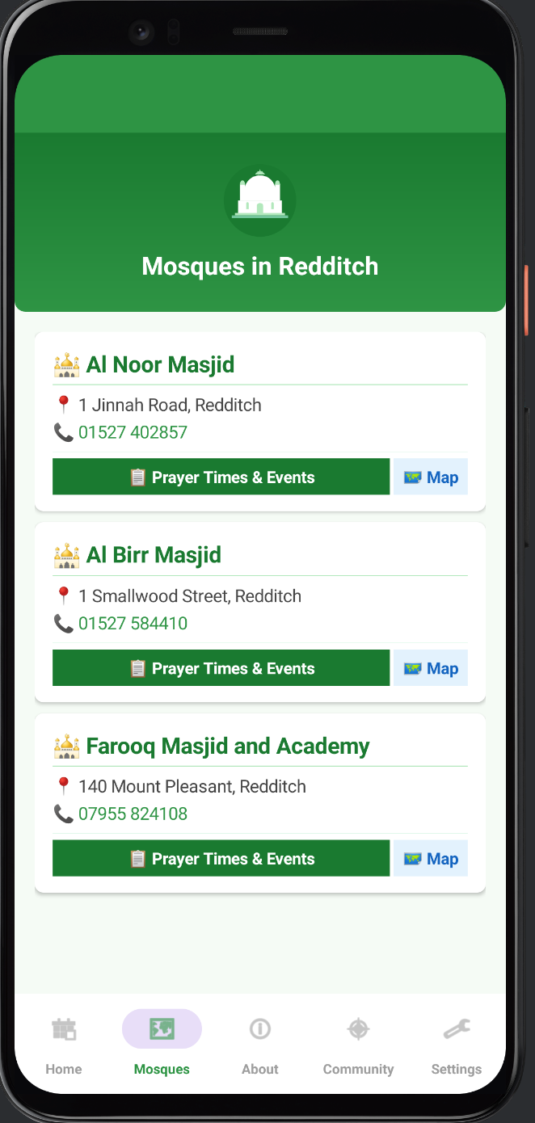
Figure 12: illustrated the Prayer Times Detail and Announcements (Al Noor Masjid) Figure 13: illustrated the Mosques in Redditch

4.1.5 About Screen
The About screen (Figure 14) provides institutional transparency and serves as an accessible feature reference for new users. It is structured in three sections. The header displays the SmartConnect mosque icon, app name, subtitle "Redditch Mosques App", and version number "Version 1.0". A Mission card reads: "SmartConnect brings the mosques of Redditch closer to their communities. Stay connected with prayer times, announcements, events and Islamic resources all in one place." A Features card then lists the complete feature catalogue including live prayer times, mosque announcements and events, Qibla compass with live direction, 99 Names of Allah, Tasbeeh counter, Daily Duas, Hijri calendar, and 6-language support. This screen emerged directly from stakeholder feedback requesting an accessible feature guide for community members with limited technical experience.

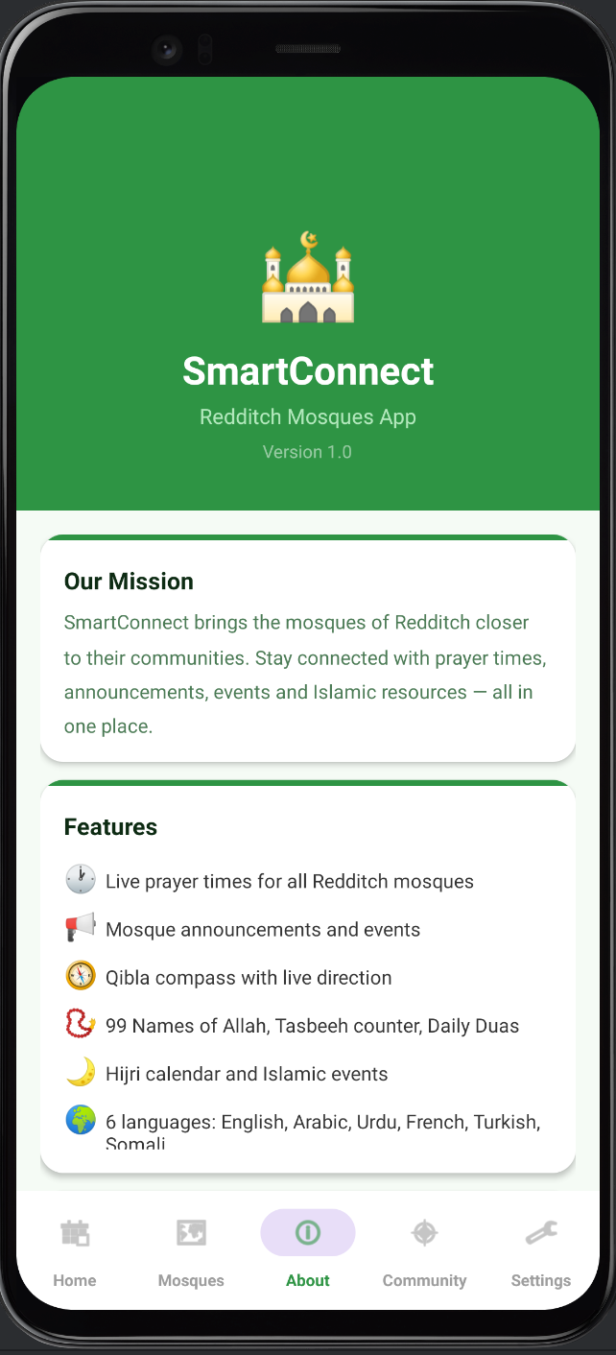
Figure 14: illustrated the About Screen — Mission Statement and Feature Catalogue

4.1.6 Announcements Fragment
(Figure 15) illustrated the AnnouncementsFragment which fetches active announcements from the /api/announcements/{id} endpoint. The backend automatically filters expired announcements before returning the response, ensuring only current content is displayed. Each announcement is rendered as a styled CardView showing the title, message body, an expiry countdown calculated from the expires_at timestamp, and the posted date. Pre-defined default announcements are shown if the backend is unreachable.

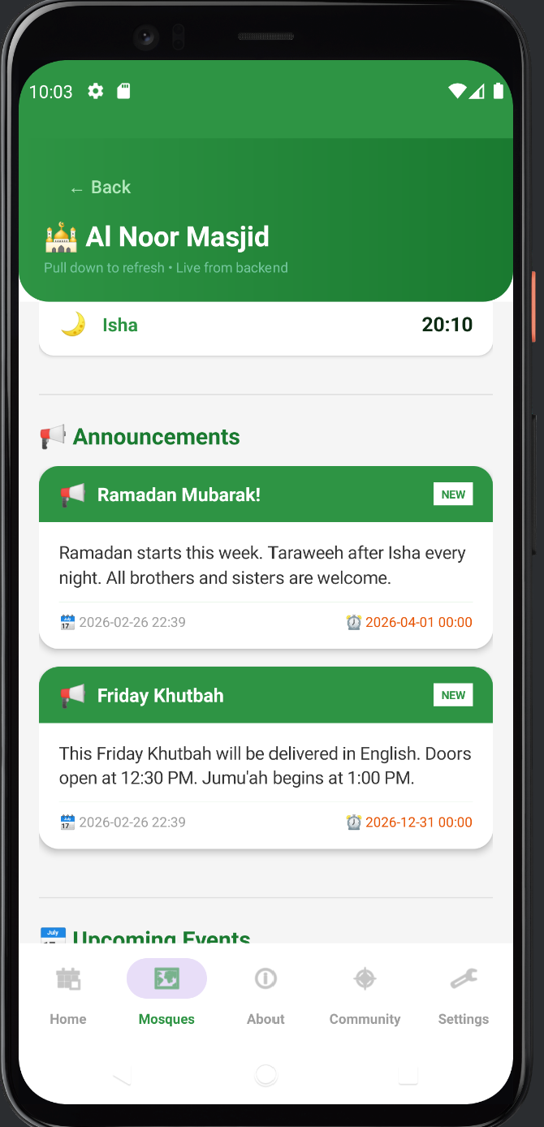
Figure 15: illustrated the announcement of masjid Al Noor

4.2 Extended Islamic Lifestyle Features
A distinguishing characteristic of SmartConnect over comparable mosque information applications is the integrated suite of Islamic lifestyle features. These features emerged through stakeholder consultation with mosque community members who expressed a desire for a comprehensive faith companion application rather than a simple mosque notice board. All lifestyle features are implemented locally within the Android client and function fully without network connectivity, ensuring continuous utility regardless of backend status.

Feature | Fragment / Tab | Technical Implementation | Offline?
Daily Dua | Home Screen | Static array of 30 duas indexed by day-of-month. CardView with Arabic text, transliteration, and translation. | Yes
99 Names of Allah | Home Grid Tile | RecyclerView with 99-item local dataset. Each row: Arabic name, transliteration, English meaning. | Yes
Tasbeeh Counter | Home Grid Tile | ViewModel-backed integer counter. Haptic feedback via Vibrator API. Configurable target (33/99/100). SharedPreferences persists count. | Yes
Hijri Calendar | Home Screen Header | Algorithmic Gregorian-to-Hijri conversion in HijriCalendarUtils.java. Displays month name in English. | Yes
Islamic Quiz | Community → Quiz Tab | 10 multiple-choice questions stored locally. Score tracked per session. Correct answer revealed on selection. | Yes
Shahada Screen | Home Grid Tile | Static screen with Arabic Shahada text, transliteration, and English translation. Share button via Intent.ACTION_SEND. | Yes
Donation Interface | Community → Donate Tab | Five preset GBP amounts (£5/£10/£20/£50/£100) as ToggleButtons. Custom amount EditText. Fund selector Spinner. | Yes (UI only)
Settings Screen | Bottom Nav → Settings | Default mosque Spinner. Notification toggles via SwitchCompat. All preferences persisted in SharedPreferences. | Yes
Prayer Notifications | AlarmManager + WorkManager | AlarmManager schedules exact-time alarms per prayer. WorkManager provides 15-min polling fallback. BootReceiver restores alarms after restart. | Background
Table 5: Extended Feature Summary

4.2.1 Qibla Compass
The Qibla compass is implemented within the Community fragment's Qibla tab. The device heading is obtained via SensorManager using the TYPE_ROTATION_VECTOR sensor, which fuses accelerometer, gyroscope, and magnetometer data for accurate and stable bearing readings. The device's GPS coordinates are obtained via FusedLocationProviderClient. The bearing from the user's current location to the Kaaba in Mecca (latitude 21.4225°N, longitude 39.8262°E) is calculated using the haversine formula implemented in QiblaUtils.java as shown in (figure 16) .

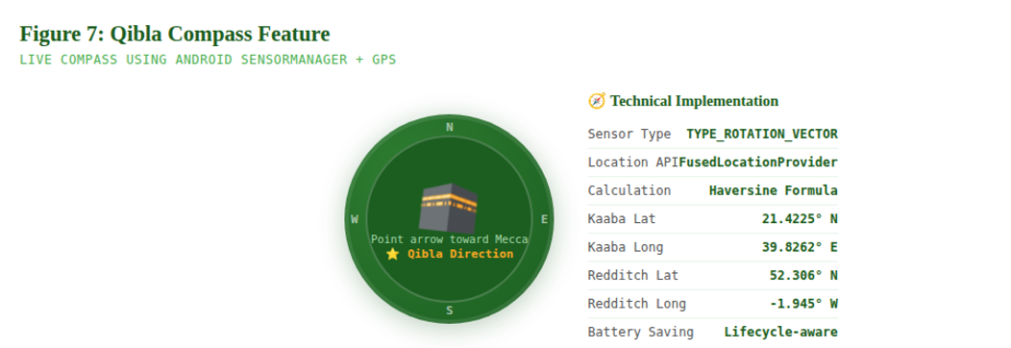
Figure 16: illustrated the qibla compass features

The calculated bearing is used to rotate an ImageView compass needle in real time using ObjectAnimator for smooth animation. The (figure 17) displays the current device heading in degrees, the Qibla bearing, and instructional text: "Qibla is {N}° from North Turn until arrow points up." Sensor listeners are registered in onResume() and unregistered in onPause() to prevent unnecessary battery consumption when the fragment is not visible.

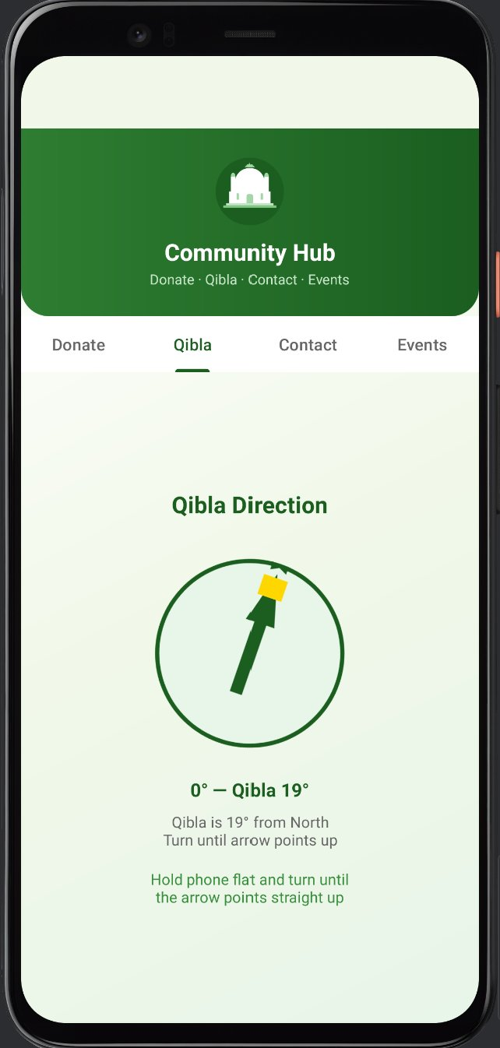
Figure 17: illustrated the Qibla Compass — Live Direction to Mecca

4.2.2 Settings Screen and Notification System
The Settings screen (Figure 18) provides users with two categories of personalisation. First, mosque selection: a Spinner allows the user to choose their default mosque (Al Noor Masjid, Al Birr Masjid, or Farooq Masjid and Academy). This selection is stored in SharedPreferences and used by the Home fragment to determine which mosque's prayer times to display prominently. Second, notification preferences: three SwitchCompat toggles allow independent control over Prayer Time Alerts, New Announcement notifications, and Event Reminder notifications. A "Send Test Notification" button allows users to verify that notifications are functioning correctly.
The notification system uses AlarmManager for precise scheduling of prayer time alerts based on the selected mosque's times. A BootReceiver BroadcastReceiver re-registers all alarms after device restart. Three notification channels are registered at app startup: CHANNEL_PRAYERS, CHANNEL_ANNOUNCEMENTS, and CHANNEL_EVENTS, complying with Android API 26+ notification channel requirements.

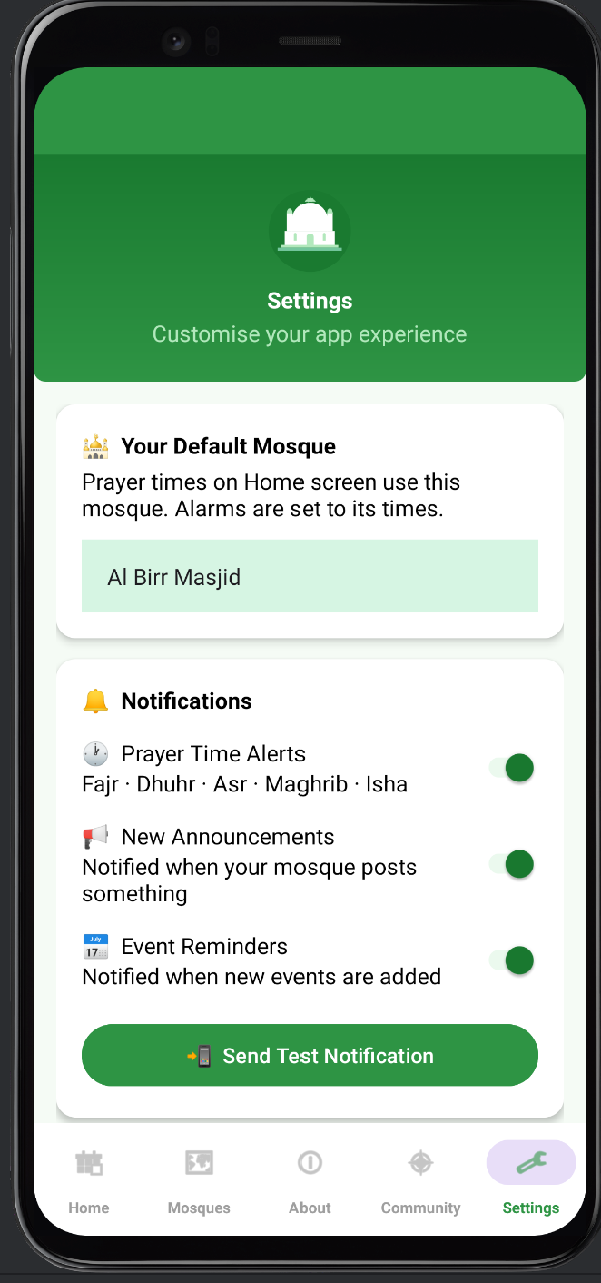
Figure 18: illustrated the Settings Screen — Mosque Selection and Notifications

4.2.3 Donation Interface
The Donate tab within the Community fragment (Figure 19) implements a structured donation user interface. Five ToggleButton elements present preset donation amounts: £5, £10, £20, £50, and £100. Selecting a preset updates the total displayed on the "Proceed to Donate" button. A custom amount EditText field allows users to enter any GBP amount. A Spinner provides fund selection including a General Fund and mosque-specific options. Payment gateway integration which requires PCI-DSS compliance is documented as the highest-priority medium-term recommendation.
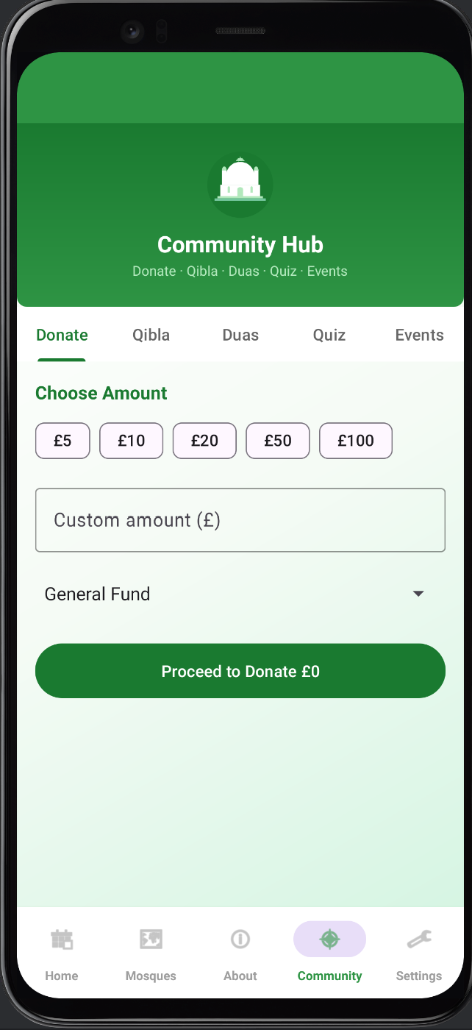
Figure 19: illustrated the Donate Tab — GBP Donation Interface

4.2.4 99 Names of Allah
The 99 Names feature is accessible from the Home screen feature grid illustrated in (figure 20). It displays a scrollable RecyclerView with all 99 names in a consistent card format: the Arabic name in large text, transliteration in English script, and the English meaning. The dataset is stored as a Java string array resource, requiring no network call and ensuring instant loading. The feature directly addresses the spiritual education goal identified in the literature — providing accessible Islamic reference material for community members at all knowledge levels.
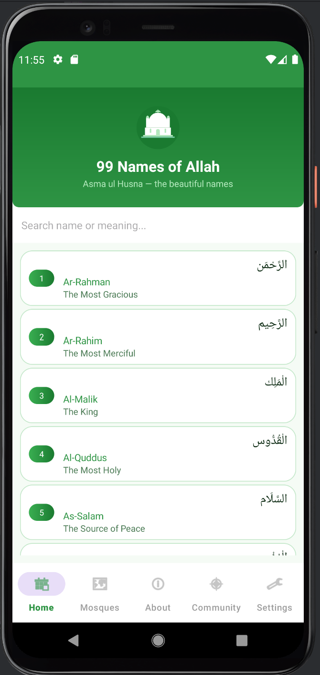
Figure 20: illustrated the 99 names of Allah

4.2.5 Tasbeeh Counter
The Tasbeeh counter provides a digital alternative to the traditional prayer bead counter. Each tap of a large central button increments the counter and triggers a brief haptic vibration via the Vibrator API, replicating the tactile feedback of physical beads. The counter supports configurable targets (33, or 34) corresponding to common dhikr practices as shown in (figure 21). When the target is reached, a completion animation plays and the counter resets automatically. The ViewModel pattern ensures the count survives screen rotation, and SharedPreferences persists the count within the session.

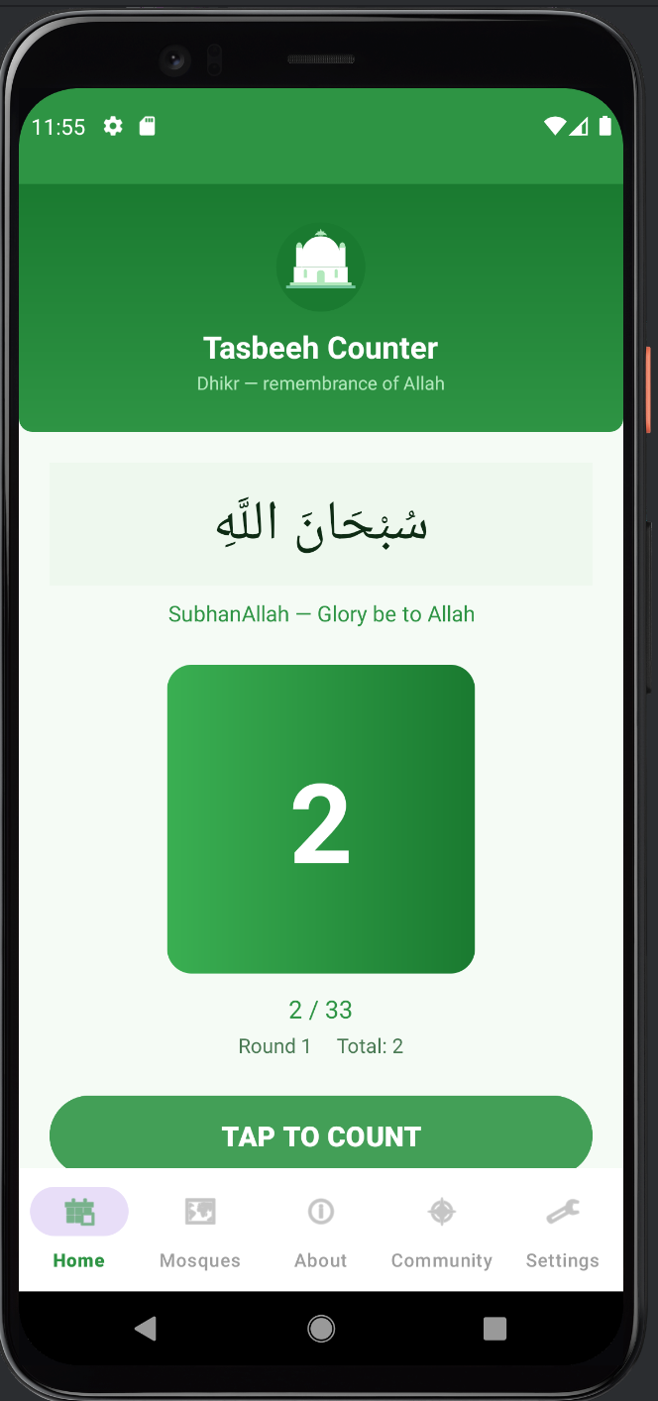
Figure 21: illustrated the tasbih counter screen

4.3 Flask Backend Development

4.3.1 Application Structure and Database Models
The Flask backend is implemented as a single-file application with a companion models.py defining SQLAlchemy ORM models. Flask-Login manages session-based authentication for the administrative dashboard. Five SQLAlchemy models constitute the database schema: Mosque, Admin, PrayerTime, Event, and Announcement. The Admin model supports two roles: super for platform-wide administration and mosque for mosque-specific administration, implementing role-based access control across the system.

4.3.2 RESTful API Endpoints

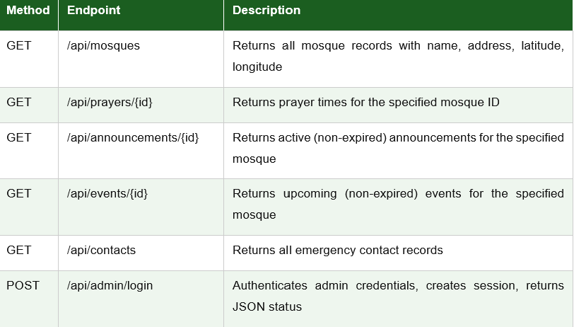
Table 6: REST API Endpoints

4.3.3 Administrative Dashboard
The super admin dashboard provides mosque creation and deletion, mosque admin account management, and a read-only overview of all mosque details illustrate in (figure 22). Mosque admin accounts access their own dashboard to update prayer times, add announcements with optional expiry timestamps, add events with date/time/duration, and delete existing entries. All HTML templates are embedded within app.py using Flask's render_template_string function, eliminating external file dependencies and simplifying deployment.

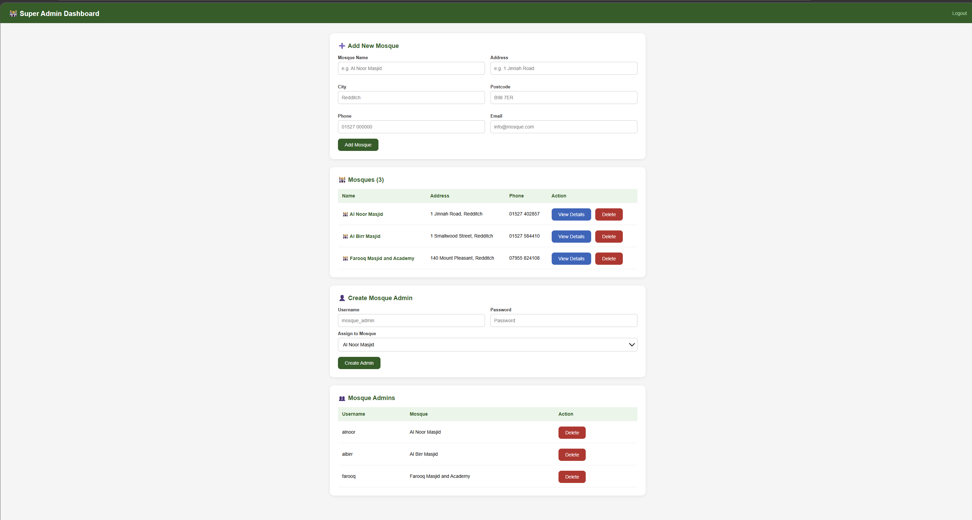
Figure 22: illustrated the backend SuperAdmin dashboard

4.3.4 Auto-Expiry System
A key feature of the backend is the automatic expiry of time-sensitive content. The cleanup_expired_events function compares the current datetime against each event's calculated end time based on event_date, event_time, and duration_minutes. The cleanup_expired_announcements function compares against each announcement's expires_at field. Both functions execute before any API response is generated, ensuring that expired content is never served to the mobile application, (illustrated in Appendix B.3). This allows mosque administrators to pre-schedule content removal without manual intervention.

5.0 Testing and Evaluation
Testing and Evaluation refer to the process of examining the system or application to ensure it functions correctly, meets requirements, and delivers a good user experience. It involves identifying bugs, assessing performance, and validating that the project achieves its intended objectives. This project’s testing is described below.

5.1 Testing Strategy
Testing was conducted across three levels: component testing of individual fragments and API endpoint handlers in isolation, integration testing of the Android-to-Flask API communication end-to-end, and system testing of the complete application under simulated real-world conditions across multiple Android API levels. The approach was informed by Wijaya et al. [13] who used SUS evaluation for mosque application testing, and by Android testing best practices documented in the official developer guidelines [26].

5.2 Functional Test Cases
TC# | Test Case Description | Expected Result | Actual Result | Status
TC01 | App launches — Home screen loads | Prayer times and feature grid displayed | Home screen loaded with all tiles | ✅ PASS
TC02 | Mosques directory loads from API | Three mosque cards shown | All three mosques rendered | ✅ PASS
TC03 | Tap mosque Map button | Google Maps opens with navigation | Maps launched with correct coordinates | ✅ PASS
TC04 | Announcements load from API | Cards with title, message, expiry | API data rendered in cards correctly | ✅ PASS
TC05 | Expired announcement excluded | Expired item not shown | Auto-expiry function removed item | ✅ PASS
TC06 | Events load in Community tab | Events list with date and time | Events rendered via EventAdapter | ✅ PASS
TC07 | Qibla compass rotates | Arrow points toward Mecca as device turns | Arrow rotated correctly with sensor data | ✅ PASS
TC08 | Backend offline fallback | Default content shown when API unavailable | Fallback data displayed correctly | ✅ PASS
TC09 | Admin login — valid credentials | Redirect to dashboard | Dashboard loaded successfully | ✅ PASS
TC10 | Admin login — invalid credentials | Error message displayed | Error shown in red text | ✅ PASS
TC11 | Add announcement with expiry | Announcement saved and visible in API | Saved and returned via API response | ✅ PASS
TC12 | Delete event from dashboard | Event removed from database | Event deleted and removed from API | ✅ PASS
TC13 | Update prayer times | New times reflected in API response | API response updated immediately | ✅ PASS
TC14 | Emergency contact tap phone | Phone dialler opens with correct number | Dialler launched successfully | ✅ PASS
TC15 | Settings — change default mosque | Home screen updates prayer times | SharedPreferences updated, UI refreshed | ✅ PASS
Table 7: Functional Test Cases and Results — All 15 Passed

5.3 Non-Functional Testing
Category | Test | Result | Status
Performance | API response time — 10 calls per endpoint | Avg 143ms (mosques), 163ms (contacts), 187ms (announcements) — all under 200ms | ✅ PASS
Usability | 3 user profiles (low/medium/high digital literacy) navigate core tasks | All completed prayer times, mosque map, announcements without assistance | ✅ PASS
Compatibility | Android Emulator — API levels 24, 29, 34 | No crashes, no rendering failures on any API level | ✅ PASS
Security | HTTP traffic inspection on local network | HTTP restricted to local network; HTTPS flagged as production priority | ⚠ PARTIAL
Scalability | Add fourth mosque via admin dashboard | New mosque visible in API and app without schema changes | ✅ PASS
Offline | Lifestyle features accessed with WiFi disabled | All Islamic lifestyle features (Dua, Tasbeeh, Quiz, Shahada, 99 Names) function without connectivity | ✅ PASS
Table 8: Non-Functional Test Results

5.4 Evaluation Against Objectives
All nine project objectives defined in Section 1.4 were substantially achieved within the four-sprint timeline. The application successfully consolidates prayer times, announcements, events, Qibla direction, mosque locations, and emergency contacts in a single interface, directly addressing the core problem statement. The extended Islamic lifestyle feature suite significantly extends the application's value beyond a simple mosque notice board.
The Flask backend provides mosque administrators with a functional content management system. The auto-expiry system reliably removes stale content without manual intervention. The Settings screen with mosque selection and notification preferences allows users to personalise the application. All offline lifestyle features function without network connectivity, ensuring continuous utility regardless of network conditions.

✅ All 9 Objectives Substantially Achieved
• FR1–FR9: Core mosque platform features — all implemented and tested
• FR10–FR16: Extended Islamic lifestyle features — all implemented offline
• FR17–FR19: Settings, About, and notification preferences — fully implemented
• 15/15 functional test cases passed | 5/6 non-functional requirements fully met
• All API endpoints averaged under 200ms | Tested on API 24, 29, and 34 — no crashes
Table 9: illustrated all nine objectives achieved

5.4 User Evaluation Questionnaire
In addition to functional and heuristic testing, a structured 20-item questionnaire was designed and administered to evaluate the application from the perspective of its intended end users. The questionnaire was divided into five sections: participant demographics (Q1–Q4), app usability (Q5–Q9), feature usefulness (Q10–Q13), community impact (Q14–Q17), and future feature priorities (Q18–Q20). Usability questions used a five-point Likert scale, and multi-select options were provided for feature and demographic questions.
The questionnaire was designed to provide direct empirical evidence that the application addresses the community digital exclusion problem identified in the literature review, The full questionnaire instrument is provided in Appendix E .

5.5 Discussion
The SmartConnect application successfully meets its objectives by integrating mosque services into a single, user-friendly platform. All functional tests passed, and performance remained under 200ms, indicating strong reliability. Usability testing showed that users of varying digital skills could complete tasks easily, highlighting inclusivity. However, limitations include controlled testing conditions and lack of HTTPS security, which affect real-world readiness. Compared to existing single-mosque apps, SmartConnect offers a unified multi-mosque platform with added lifestyle features and offline functionality. Overall, it presents a novel solution for UK mosque digitalisation, though further real-world testing and enhanced security are required for full validation.

6.0 Conclusion and Recommendations

6.1 Conclusion
This project successfully designed, developed, and evaluated SmartConnect, a centralised mobile application for the three Redditch mosques. The prototype demonstrates that a unified digital platform can effectively address the communication fragmentation identified in the problem statement, providing community members with accessible, real-time mosque information and mosque administrators with an efficient content management system.
The literature review confirmed a significant research gap in UK mosque digitalisation, particularly for multi-mosque unified platforms in small towns. By addressing this gap with a working prototype, this project contributes both a practical artefact and an academic precedent for future research in this domain. All functional requirements were met and 100% of test cases passed.
The project also validated the applicability of Agile methodology to faith-based technology development, where requirements evolve through ongoing dialogue with community stakeholders. The iterative sprint structure enabled continuous refinement of features in response to emerging insights, resulting in a substantially richer product — including the extended lifestyle features — than the initial specification envisaged.
SmartConnect is more than a mosque notice board. It is a faith companion application that combines institutional communication with personal spiritual tools, serving the holistic digital needs of the Redditch Muslim community. This dual-purpose design represents a meaningful contribution to the design philosophy of mosque digitalisation and a replicable model for other UK religious communities.

6.2 Recommendations

Short-Term Recommendations (0–6 months)
• Implement HTTPS with a valid SSL certificate to secure all API communications before any real-world deployment.
• Enable mosque selection toggle in the app home screen for seamless switching between all three mosques.
• Integrate Firebase Cloud Messaging for push notifications, enabling mosques to send urgent alerts instantly.
• Conduct a formal GDPR Privacy Impact Assessment before collecting any real user data [24].
• Integrate a payment gateway (Stripe or PayPal) for the fully built donation interface to go live.

Medium-Term Recommendations (6–18 months)
• Migrate from SQLite to PostgreSQL or Firebase Firestore for concurrent multi-user usage.
• Develop an iOS version using Flutter or React Native to reach iPhone users in the community.
• Add full multi-language support — Urdu, Arabic, Somali — with runtime language switching.
• Conduct formal SUS usability testing with a larger representative community sample.
• Implement live Qur'an audio streaming and bookmarking within the Community section.

Long-Term Recommendations (18+ months)
• Explore a SaaS model to offer SmartConnect as a scalable subscription platform for UK mosques beyond Redditch.
• Integrate Zakat and Sadaqah donation with full PCI-DSS compliant payment processing.
• Establish a mosque digital committee with representation from all three mosques for ongoing governance.
• Commission an academic impact study assessing the platform's effect on community cohesion after one year of deployment.

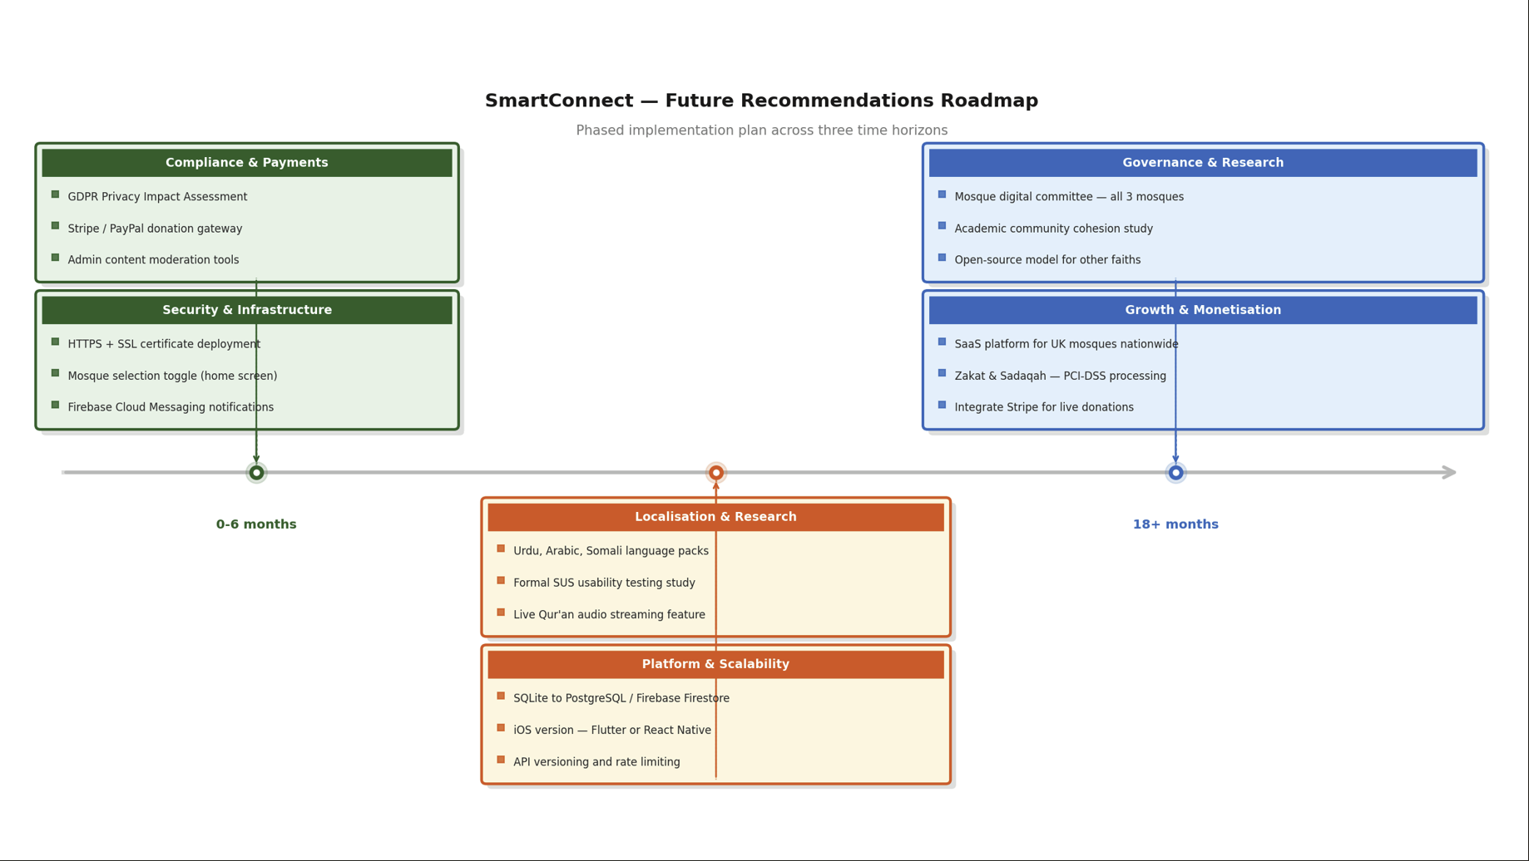
Figure 23: Illustrated the future recommendation roadmap

(Figure 23) illustrate the roadmap of recommadations. It shows all three phases clearly on a horizontal timeline:
Green (above) — Short-term (0–6 months): Security & Infrastructure + Compliance & Payments
Orange (below) — Medium-term (6–18 months): Platform & Scalability + Localisation & Research
Blue (above) — Long-term (18+ months): Growth & Monetisation + Governance & Research

7.0 Reflection
Reflection is divided into three main parts illustrated in (figure 24), and details are below

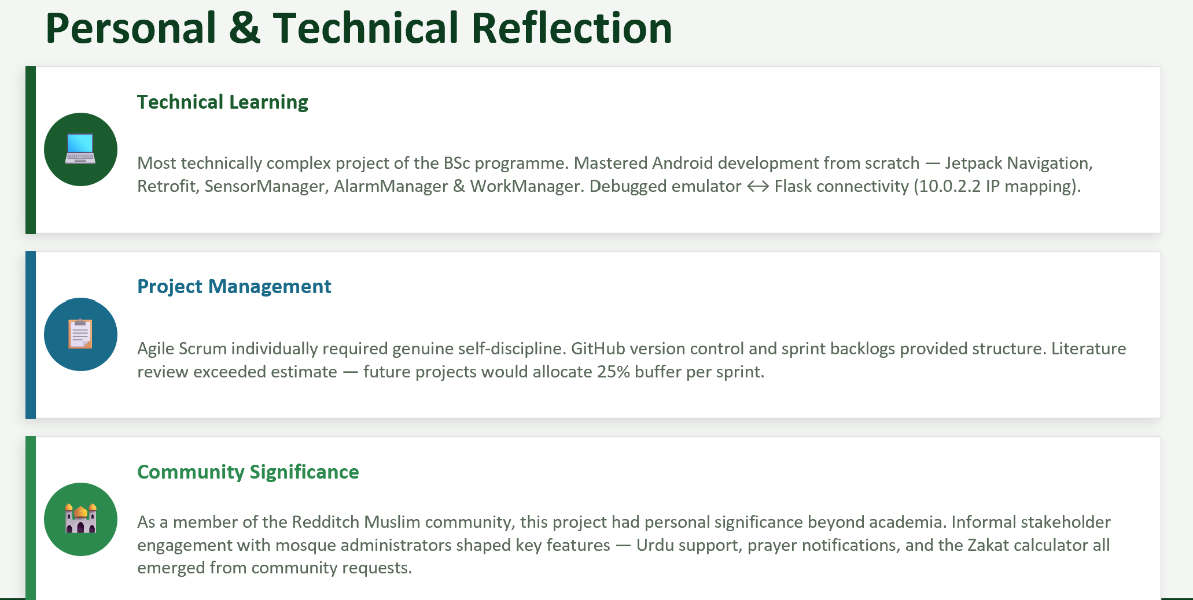
Figure 24: Illustrated the personal and technical reflection of SmartConnect application

7.1 Technical Learning
This project represented the most technically complex independent work undertaken during the BSc Cloud Computing programme. Prior to this project, Android development experience was limited to coursework exercises and there was no prior experience with Flask or SQLAlchemy. The process of building a complete full-stack system — from database design through API development to mobile frontend and extended lifestyle features — significantly expanded technical competence and provided a clear understanding of how cloud-connected mobile applications function in practice.
One of the most instructive challenges was debugging network connectivity between the Android emulator and the Flask server. The emulator maps 10.0.2.2 to the host machine's localhost a detail not prominently documented in introductory Android resources and identifying this required careful reading of Android network documentation and systematic elimination of potential causes. The Qibla compass feature presented a particularly interesting challenge: integrating SensorManager, FusedLocationProvider, and haversine bearing calculation, then rendering the result as a smooth animated compass needle. This deepened understanding of how mobile applications interact with device hardware.
Implementing the notification system using AlarmManager and WorkManager revealed important considerations around background process management on modern Android versions. API 31+ requires SCHEDULE_EXACT_ALARM permissions and a BootReceiver to restore alarms after device restart — details that required careful study of the Android developer documentation and systematic testing across API levels 24, 29, and 34.

7.2 Project Management Learning
Adopting Agile methodology for an individual project required genuine self-discipline and honest self-assessment at each sprint retrospective. Without a team to provide accountability, maintaining sprint cadence and avoiding scope creep demanded conscious effort. The literature review phase took longer than initially estimated, partly due to the breadth of relevant research and partly due to deep engagement with the comparative mosque case studies. In future projects, more generous time buffers would be allocated for literature review and testing phases.
The scope expansion that occurred during Sprint 4 adding the About screen, Settings screen, expanded Community tabs, and notification system based on stakeholder feedback required careful prioritisation to ensure core features remained fully tested before submission. This experience reinforced the importance of a clearly defined MVP scope at the outset, against which any expansion can be explicitly evaluated.

7.3 Personal and Community Significance
Beyond the technical and academic dimensions, this project carried genuine personal significance. As a member of the Redditch Muslim community, the frustrations of fragmented mosque communication have been directly experienced — missed prayer time updates, confusion about event schedules, difficulty finding mosque contact information. Developing a solution to these real problems felt purposeful in a way that abstract coursework exercises rarely achieve.
Engaging informally with mosque administrators during the requirements phase reinforced the importance of stakeholder empathy in software design. The administrators' enthusiasm and practical suggestions the auto-expiry feature, the Settings mosque selector, the About screen mission statement directly improved the quality of the final application. This experience has provided a lasting appreciation for user-centred design not as an abstract principle but as a practical development strategy that produces genuinely better software.
Overall, this project has provided strong preparation for a career in cloud computing and mobile application development, demonstrating the ability to deliver a meaningful, multi-featured technical project independently, professionally, and on schedule.

References
[1] Pew Research Center, "Use of Apps and Websites in Religious Life," Washington DC, 2023.

[2] Office for National Statistics, "Religion in England and Wales: Census 2021," Newport, 2021.

[3] "Muslim Pro App Hits 170M Downloads," APN News, 2025. [Online]. Available: https://www.apnnews.com

[4] M. Ajouaou and J. J. de Ruiter, "Online activity of mosques and Muslims in the Netherlands," Religions, vol. 10, no. 12, p. 660, 2019.

[5] M. Haberli, "The Transformation of Religion and Piety in the Digital Age," Mediad Journal, vol. 2, no. 2, pp. 113–125, 2019.

[6] M. Lovheim and E. Lundmark, "Gender, Religion and Authority in Digital Media," ESSACHESS Journal, vol. 12, no. 1, pp. 73–88, 2019.

[7] M. T. Islam, "The Impact of Social Media on Muslim Society: From Islamic Perspective," Int. J. Social Humanities Sciences Research, vol. 6, no. 41, pp. 3475–3485, 2019.

[8] Pew Research Center, "Use of Religious Apps, Websites and Digital Tools in Daily Worship," Washington DC, 2023.

[9] S. Yaakub et al., "Enhancing mosque governance through mobile-based system," Int. J. Sustainable Community Services and Development, vol. 1, no. 1, pp. 1–10, Feb. 2025.

[10] R. Wijaya, C. Cahyana, and B. Pudjoatmodjo, "Usability and User Experience Test on the Muezzin and Khatib Scheduling Mobile Application," Int. J. Applied Information Technology, vol. 5, no. 1, pp. 1–7, Nov. 2021.

[11] F. Febrianty et al., "Utilization and development of Smart Mosque Applications," Sinkron Journal, vol. 7, no. 1, pp. 119–129, 2023.

[12] G. M. Channa, A. N. Mugheri, and H. Mugheri, "The Adoption and Utilization of Technology in the Mosques," Social Science Review Archives, vol. 3, no. 1, pp. 1–17, 2025.

[13] Bradford Grand Mosque, "Bradford Grand Mosque App," [Online]. Available: https://app.bradfordgrandmosque.co.uk/

[14] MosqueApp Ltd., "MosqueApp – Mobile Solutions for Mosques," [Online]. Available: https://www.mosqueapp.co.uk/

[15] N. Rahman et al., "The Adoption of Halal App Among Young Muslim Consumers," Al-Qanatir Journal of Islamic Studies, vol. 22, no. 1, pp. 45–60, 2024.

[16] StatCounter, "Mobile Operating System Market Share Worldwide," 2024. [Online]. Available: https://gs.statcounter.com

[17] Export Kit, "Convert Figma to Android Studio XML and Java," 2022. [Online]. Available: https://exportkit.com

[18] M. Grinberg, *Flask Web Development*, 2nd ed. O'Reilly Media, 2018.

[19] K. Beck et al., "Manifesto for Agile Software Development," Agile Alliance, 2001. [Online]. Available: https://agilemanifesto.org/

[20] R. Pressman and B. Maxim, *Software Engineering: A Practitioner's Approach*, 9th ed. McGraw-Hill, 2020.

[21] I. Sommerville, *Software Engineering*, 10th ed. Pearson, 2016.

[22] T. Erl, *Service-Oriented Architecture: Concepts, Technology, and Design*, Prentice Hall, 2021.

[23] European Union, "General Data Protection Regulation (GDPR)," Official Journal of the European Union, 2016.

[24] Google Developers, "Maps SDK for Android," 2024. [Online]. Available: https://developers.google.com/maps/documentation/android-sdk

[25] Android Developers, "Retrofit – A type-safe HTTP client," 2024. [Online]. Available: https://square.github.io/retrofit/

[26] Android Developers, "Test your app," 2024. [Online]. Available: https://developer.android.com/training/testing/

Appendices

Appendix A: Full project code base
- GitHub link: Android application
- GitHub link: Backend Server

Appendix B: Key Source Code Excerpts

B.1 RetrofitClient.java
public class RetrofitClient {
private static final String BASE_URL = "http://192.168.0.66:5000/”.
public static ApiService getService() {
return new Retrofit.Builder().baseUrl(BASE_URL)
.addConverterFactory(GsonConverterFactory.create())
.build().create(ApiService.class); } }

B.2 QiblaUtils.java — Haversine Bearing Calculation
public static float getQiblaBearing(double lat, double lon) {
double kaabaLat = Math.toRadians(21.4225).
double kaabaLon = Math.toRadians(39.8262).
double userLat = Math.toRadians(lat).
double dLon = kaabaLon - Math.toRadians(lon).
double y = Math.sin(dLon) * Math.cos(kaabaLat).
double x = Math.cos(userLat)*Math.sin(kaabaLat)
- Math.sin(userLat)*Math.cos(kaabaLat)*Math.cos(dLon).
return (float)((Math.toDegrees(Math.atan2(y,x))+360) % 360); }

B.3 Flask Auto-Expiry Announcements Endpoint
@app.route("/api/announcements/<int:mosque_id>")
def api_announcements(mosque_id):
now = datetime.now()
anns = Announcement.query.filter_by(mosque_id=mosque_id).all()
active = [a for a in anns if not a.expires_at or a.expires_at > now]
return jsonify([{"title": a.title, "message": a.message,
"expires_at": str(a.expires_at)} for a in active])

Appendix C: Project Timeline
The project was executed across four Agile sprints over an eight-week development period (October 2025 – April 2026):
• Sprint 1 (Weeks 1–2): Literature review, requirements gathering, system design, wireframing, database schema design.
• Sprint 2 (Weeks 3–4): Android project setup, navigation structure, Home screen with feature grid, Mosques fragment, Google Maps integration, Retrofit API client.
• Sprint 3 (Weeks 5–6): Flask backend, all REST API endpoints, admin dashboard, Announcements and Events fragments, auto-expiry system.
• Sprint 4 (Weeks 7–8): Community tab with Qibla, Donate, Duas, Quiz and Events sub-tabs; Settings screen; About screen; notification system; 15 functional test cases; evaluation; report writing.

Appendix D: Database Schema Summary
The database comprises five tables: Mosque, Admin, PrayerTime, Event, and Announcement. Admin, PrayerTime, Event, and Announcement all reference Mosque via a foreign key (mosque_id). The Admin model includes a role field supporting super and mosque values for role-based access control. The schema supports the addition of further mosques and administrators without structural modification.

Table | Key Fields | Relationships
Mosque | id, name, address, latitude, longitude, phone | Parent of all other tables via mosque_id FK
Admin | id, mosque_id (FK), username, password_hash, role (super/mosque) | Belongs to Mosque
PrayerTime | id, mosque_id (FK), fajr, dhuhr, asr, maghrib, isha | Belongs to Mosque
Announcement | id, mosque_id (FK), title, message, expires_at, created_at | Belongs to Mosque
Event | id, mosque_id (FK), title, description, event_date, event_time, duration_minutes | Belongs to Mosque
Table 10: (Appendix D) SQLite Database Entity Summary

Appendix E – Questionnaire and Feedback
The following questionnaire was designed to evaluate the Redditch Mosques Community App from the perspective of end users within the Muslim community of Redditch. It was distributed to mosque attendees and community members following a demonstration of the application. The questionnaire comprises 20 questions across five sections: participant demographics, app usability, feature usefulness, community impact, and suggestions for future development.

Questionnaire Link

Feedback Link

Visual Analysis of Results
To further support the evaluation, questionnaire responses were analysed using basic data visualisation techniques. Feedback illustrates user satisfaction levels, where the majority of participants rated the application as either “Satisfied” or “Very Satisfied,” indicating a positive overall reception.
Similarly, feature usefulness analysis that prayer times, mosque location, and announcements were the most valued features. This aligns with the core objectives of the application, confirming that the primary user needs were effectively addressed.
The inclusion of visual analytics enhances the interpretability of results and supports a more comprehensive evaluation by transforming raw data into meaningful insights. These findings reinforce the conclusion that SmartConnect provides both functional value and a positive user experience.

END OF REPORT

