
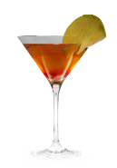
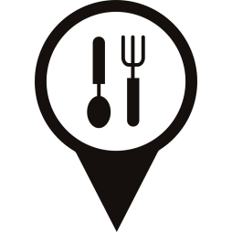

For Special Occasion
Trinity Delights
011.921.123
Trinity Delights @.com

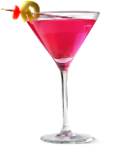
Truffle Infused Oysters: Freshly shucked oysters, enhanced with black truffle oil. £18.99
Foie Gras Terrine: Luxurious duck liver terrine with brioche and fig compote. £22.99
Sous Vide Lobster Tail: Tender lobster tail, slow-cooked to perfection, saffron risotto, and lemon beurre blanc. £45.99
Prime Angus Ribeye: 14-ounce dry-aged ribeye, truffle mashed potatoes, and red wine reduction.
£48.99
Decadent Chocolate Fondue: Belgian chocolate with strawberries, marshmallows, and biscotti.
£16.99
Crème Brûlée Trio: Vanilla, lavender, and Earl Grey-infused crème brûlée. £12.99
Wine Pairing: Expertly paired wines for each course £35
Signature Cocktails: Handcrafted "Love Elixir" and "Passion Sparkle." £12.99

Menu

