Task 1: Locating Sources
Identify and locate three different sources (a report, a journal article, and a website) related to the question
“What employability skills do business graduates need to succeed in the modern workplace?”
Show how you used keywords, search terms, and Boolean operators to find them, and explain how you know which type of source each one is and why it is appropriate for the research question.

Source Type & Why It Is Appropriate | URL/DOI | What search engine did you use? Google/Online Library/Library AI Assistant | Keywords/Boolean Operators Used
Jurnal article | https://librarysearch.uwtsd.ac.uk/permalink/  44WHELF_UWTSD/1bmis16/cdi_proquest_journals_2627838512 | Library | SKILLS  workplace
BOOK | https://librarysearch.uwtsd.ac.uk/permalink/  44WHELF_UWTSD/1gapa6h/alma99100633602802421 | Library | Employability  SKILLS
JURNAL ARTICLE | https://librarysearch.uwtsd.ac.uk/permalinK  /44WHELF_UWTSD/1bmis16/cdi_eric_primary_EJ1300705 | LIBRARY | GRADUATES SKILLS

Task 2: Evaluating Information (CRAAP Test)
Your colleague has forwarded you a source from a peer reviewed journal, and they are not sure whether it is appropriate to use and has asked for your help. Your task is to evaluate the source by using the CRAAP Test to assess its appropriateness.
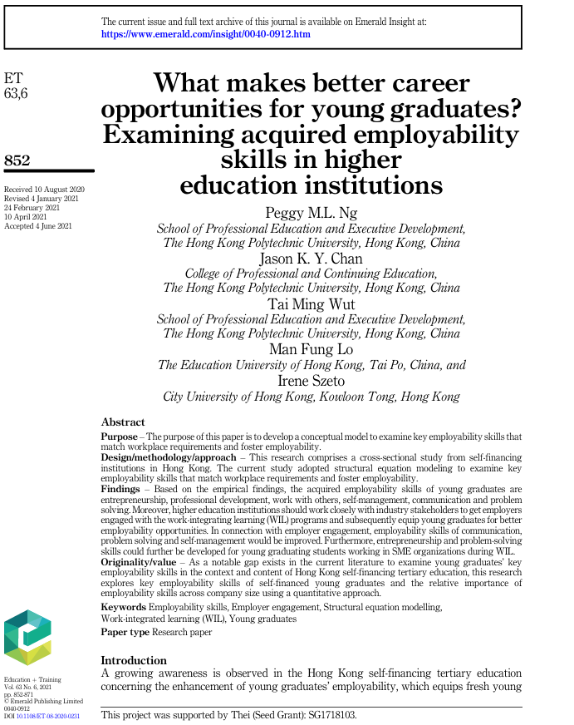

CRAAP Test
Currency | THE INFORMATION ON THIS JURNAL ARTICLE IT IS WRITTEN IN 2021 SO IT IS RECENT
Relevance | THIS JURNAL CONTAIN IMPORTANT INFORMATION ABOUT DEVELOPPING SKILLS FOR GRADUATES THAT WILL HELP THEM GET A GOOD JOB
Authority | THIS JURNAL ARTICLE IT IS WRITTEN BY ACADEMIC RELATED AUTHORS, ALL OF THEM WORKING AT DIFFERENT UNIVERSITIES. EASY TO CHECK THEIR CREDENTIALS WITHIN THE ACADEMIC COMMUNITY
Accuracy | THE JURNAL IT IS PEER REVIEWD BY EXPERTS SO THE INFORMATION IT IS RELIABLE AND ACCURATE.
Purpose | THE PURPOSE OF THIS JURNAL IT IS CLEAR TO DISCOVER THE SKILLS REQUIRED FOR GRADUATES TO MATCK THE EMPLOYABILLITY SKILLS REQUIRED AT A SPECIFIC WORKPLACE

Task 3: Source Analysis
Your manager has provided you with a short extract from a source and has asked you to analyse the source by Identifying one strength, one weakness, and providing a brief explanation of the strength and weakness identified.
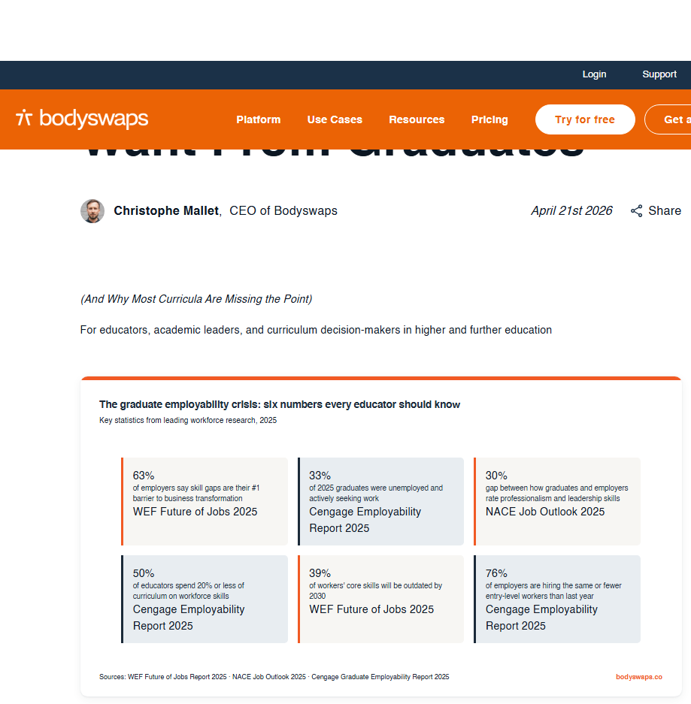
.

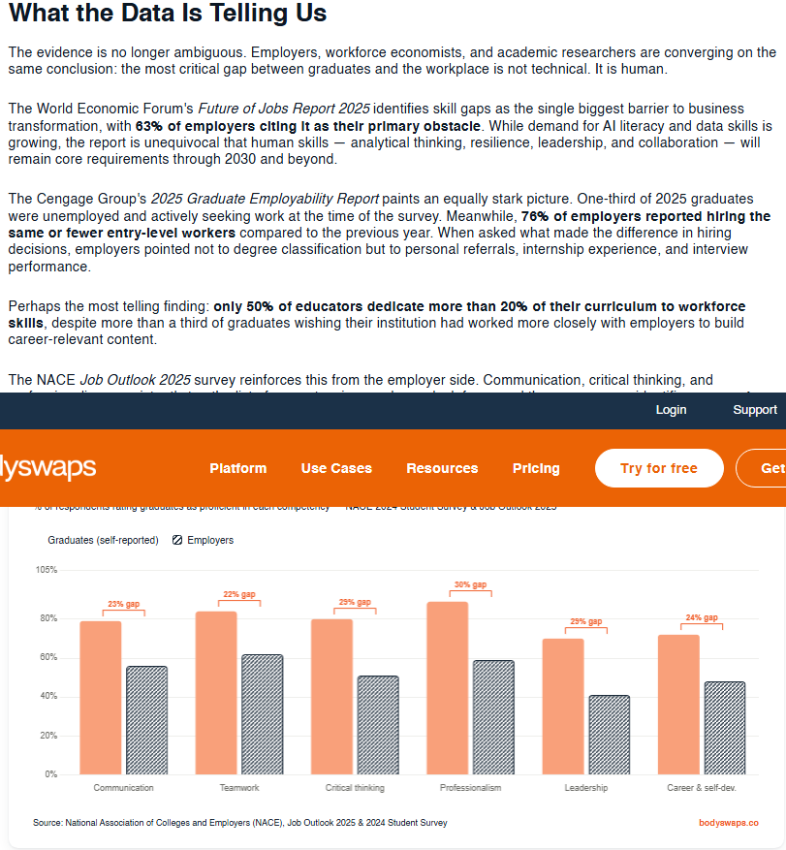

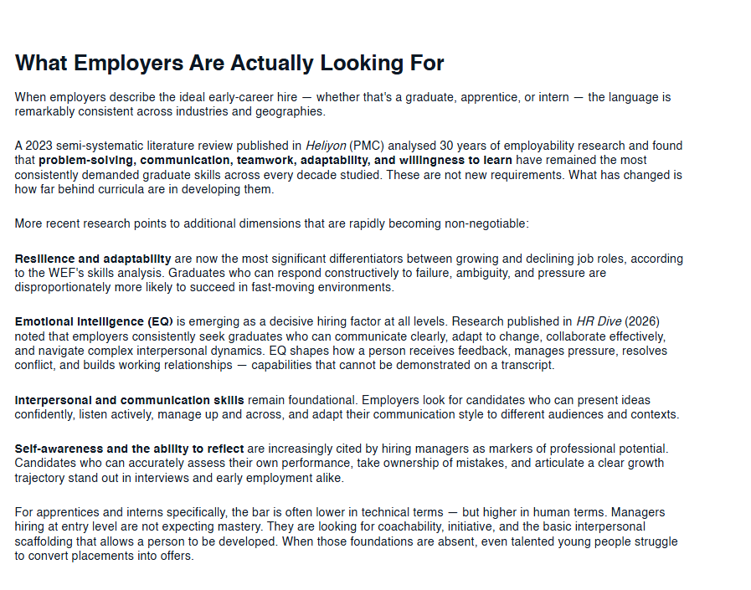

Please click the link, if you wish to read the article online.
What Employers Actually Want From Graduates

Strength of the Source:

CONTAINS RECENT DATA AND INFORMATIONS

Weakness of the Source:

MAY CONTAIN BIAS AS THE AUTHOR IT IS THE CEO OF A PRIVATE ORGANISATION

