Digital Skills and Research Methods
  - How employee motivation affects organisation performance

BMSK4003 How employee motivation affects organisation performance

SUBMITTED BY... SARAH EVANS KOKUNDA

STUDENT ID... 1711420

SUBMISSION DATE...30.08.2019

Executive Summary
The level of employee motivation is a key indicator of productivity and organisational success, hence why the subject of motivation is a concern for scholars and managers in both large and small corporations. However, motivating people within an organisation is a complex process due to various factors such as resources, management style and culture, etc.

In an effort to motivate employees and improve productivity, organisations deployed various strategies to motivate employees. For instance, annual appraisal is one technique employed by managers to evaluate and measure employees’ competences and achievements over time.

This study analysed and evaluated employees’ motivation at work and how this impact organisational success. The report has several sections including; background of the research topic, aims and objectives of the study, the structure of the research, discussion and recommendations. The study was conducted by issuing questionnaire to colleagues at my place of work, Leonara House, Westminster.

Contents
Executive Summary 2
1.0 Introduction 4
2.0 Background 5
2.1 Maslow Hierarchy of Needs Error! Bookmark not defined.
2.2 Herzberg’s two 7
2.3 Summary 8
3.0 Aims and objectives 9
4.0 Research methodology 10
4.1 Research Limitations 11
4.2 Structure of this study 11
5.0 Findings 12
6.0 Discussion 15
7.0 Recommendations 15
8.0 Conclusion 17
References 18
Appendices 19

Introduction
Employee motivation is a widely studied subject in the field of business management and a key determinant of success within organisations. Alongside this, due to intense competition and market unpredictability, employee motivation is critical for the success of any organisation and to continue to survive. Moreover, this relationship between employee motivation and organisation success have been highlighted in several studies. Therefore, organisations have developed various strategies to motivate their employees and to be successful in this volatile and competitive market.

However, many organisations tend to ignore or forget about the important role of human resource as a key asset, which is capable to led the organisation to success, or if not manage effectively, the organisation will unlikely to achieve its objectives and goals.

Simultaneously, every individual has needs. These needs are the reasons why people go to work. For instance, some people go to work to fulfil their physiological needs such as food and shelter, while others for achievement purpose. However, from an employer perspective, understanding the needs of employees is critical because, if managers are able to predict and control employee behaviours, then they are likely to know what they want from their jobs. By understanding the needs and expectations of employees, managers are able to meet these needs effectively. As noted by (Adi, 2000), organisation that consider the needs of employees and endeavour to increases their motivation by meeting their needs are likely to perform better.

Background
According to Bartol and Martin, (1988), motivation is a powerful tool that reinforces positive behaviour and encourages an individual to continue with the positive behaviour. It is essentially an internal drive of an individual to achieve a particular goal. Several scholars have suggested that when employees’ goals and objectives are aligned to the organisation, the organisation is likely to succeed in meeting their objectives and goals, because employees will continuously seek ways to improve their performance in other to be successful.

2.1 Maslow Hierarchy of Needs
There are several challenges trying to encourage employees to reach their full potential at work especially when the condition is stressful, however, this is sometimes achieved by motivating them. Abraham Maslow in his paper “A Theory of Human Motivation” otherwise known as the Maslow’s Hierarchy of Needs explained how this can be achieved. According to Maslow Hierarchy of needs (1943), there are five stages of human needs starting from the basic to the most complex needs. These needs include:

- Physiological Needs: this includes food, water, shelter, employment, etc.
- Security Needs: security, benefits, pension, fair work practices, safety, etc.
- Belongingness: intimate relationships, friends and colleagues at work
- Esteem Needs: prestige and the needs to accomplish higher status in society i.e. job title
- Self-Actualization Needs: achieving an individual’s full potential such as work autonomy

Maslow suggested that individuals seek to satisfy their basic level of needs and once these basic needs are met, they will then work harder to achieve the next levels of needs. The ultimate goal is to reach self-actualisation which is the highest level. For instance, as shown in figure 1 below, when physiological needs such as food, clean water, and shelter are satisfied, the individual will work harder to move to the next levels of needs.
Maslow’s Hierarchy of needs theory is an important motivation tool uses by managers to motivate employees to perform better. For instance, when most individual start a job, they are more likely to be concerned about the lower levels of needs such as salary, job security, benefits and pension. This is simply because every employee needs a good salary to look after their needs and that of their families. In essence, these employees seek secure and stable salary. When these lower levels of needs are satisfied, then according to Maslow’s hierarchy of needs theory, the employee will work harder to move to the next levels of needs,
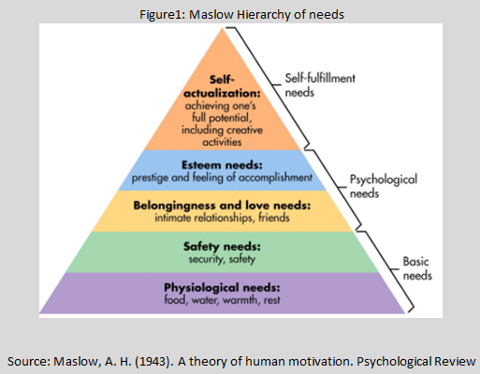

However, there are challenges in achieving this. For example, when cost reduction strategies are to be implemented that are likely to impact staff development and future remuneration, such decision if not manage effectively can cause the remaining employees within the company to feel threatened about the ability of the company to continue to meet their basic needs. It is therefore for managers to act humanly and to get the balance right between employees welfare and cost reduction.

2.2 Herzberg’s two
According to Herzberg’s two factors theory (1959), there are other factors rather than money that cause motivation or job satisfaction; likewise there are other factors that cause dissatisfaction. Herzberg suggested that, the absence of these two factors does not necessary cause motivation neither job dissatisfaction. However, Herzberg pointed out two elements that contribute to job satisfaction and dissatisfaction otherwise known as motivator factors and hygiene factors as illustrated in figure 2 above.
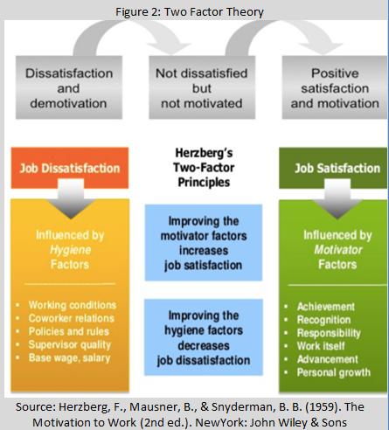

Herzberg refers to aspects such as: achievement, recognition, status, promotion, career opportunities, etc. as intrinsic factors (Herzberg, 1987a). These are the intangible factors and concern with the emotional needs of a person. For instance, an individual can be motivated by doing a job they enjoy doing. The motivating factors would be they enjoy what they are doing and therefore increase their commitment.

In addition, Herzberg identified hygiene factors responsible for dissatisfaction such as relationships, company policies, processes, employment condition, leadership quality, salary, benefits and work life balance. These factors he characterised as extrinsic factors. Unlike, the intrinsic factors, the extrinsic factors are tangible and can be classified as basic needs given it is doing something for a rewards such as salary and promotion (Herzberg, 1987b).

According to Herzberg, the absence of both intrinsic and extrinsic factors does not necessary cause dissatisfaction neither satisfaction. Ultimately, while hygiene factors will cause employees to work less, motivating factors will encourage and motivate employees to work harder when they are present. Herzberg’s two factor theory is helpful to managers because it acknowledges the important of providing hygiene factors adequately to the employees as a way of motivation and improving performance.

2.3 Summary
The two motivational models discussed above shared common characteristic, which is motivation derived from various intrinsic factors. Both Maslow and Herzberg are strongly inter-connected and aligned with this research hence they have been chosen for this study. Maslow put emphasis on the need to fulfil those basic psychological needs before moving to the next levels of needs, Herzberg’s two factors demonstrated that individuals are not necessary satisfy by the basic needs but rather by achieving those psychological need such as recognition, growth and opportunity, etc

Aims and objectives
The aims of this research are to:
To determine the drivers of employee motivations, identify the motivational factors used in improving productivity at work and to evaluate the connection between employee motivation and organisation success. Finally, the report provides recommendations to management of Leonara House management team on how they can better improve motivation at work.

Research methodology
According to Kothari, (1985a), “Research method is a way in which a research problem can be systematically investigated and resolved. It is a scientific process used by researchers to find solution to a specific problem. It is important for researchers to understand the pros and cons of research method and the relevance to the study’s objectives, its meaning, implications and the reasons for choosing a specific technique. Ultimately, understanding the theoretical background and variables of different research techniques allows researchers to decide the best method to use (Kothari 1985b).

4.1 Secondary data
The secondary data were collected using books, journal, and online materials. The information helped to address the literature concerning motivation and how this is linked to organisation performance.

4.2 Primary data
The primary research focused on collecting data using questionnaires on what motivate employees at my work place, Leonara House, Westminster. Twenty employees including 10 nurses and 10 care workers were randomly interviewed using questionnaires. The criteria used to select participants are that they have to be an employee of the organisation, registered nurse or healthcare professionals.

Participants were asked questions about what factors motivate them at work, age and years of service. At the top of each questionnaire, it is written in bold that private information such as names and contact number would be kept private and used solely for this study.

4.3 Research Limitations
Time, finance and the number of participants were major limitation to this study. More time and finance is required to carry out an in-depth study of motivation in my company to fully understand this phenomenon.

4.4 Structure of this study
This study has several sections as depicted in figure 3. The first section introduces the subject, while the second section gives background of the study and also is dealt with the key literatures of the topic. The following section is concern with the research methodology chosen and the limitations of the research, as well as it validity and reliability.
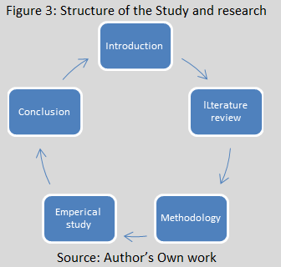
The following structure focuses on the empirical study, primary data collected are analysed in this section, displays in graphs, chart and tables. The final section is the conclusion and recommendations for the study.

5.0 Findings
Age group
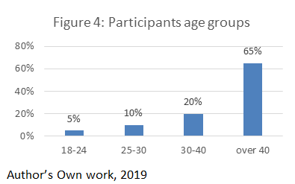

This question is about participants’ age was designed to gain understanding about their profile as shown in figure 4. 65% of participants fall within the age bracket of over 40, 20% between the age bracket of 30 to 40.

Duration of service
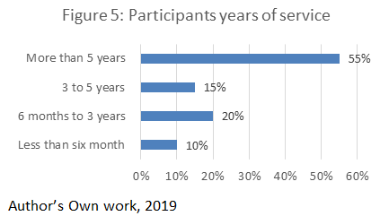

As shown in figure 5, 55% have been in the company for than five years, while 15% fall under three to five years, 20% between 6 months to three years and 10% for less than six months.

Motivation level
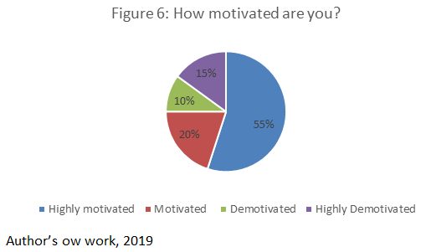

As presented in figure 6, 55% stated they were highly motivated at work, 20% rated themselves as motivated. However 10% indicated that they were demotivated at work, but most worrying is that 15% of participants stated that they were highly demotivated.

Do you think motivation is connected to your performance?
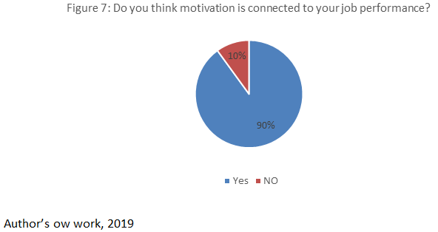

As shown in figure 7, 90% of participants indicated that they are motivated to work harder and excel at work when the company can fulfil their needs. However, 10% disagree with this.

Motivation factors
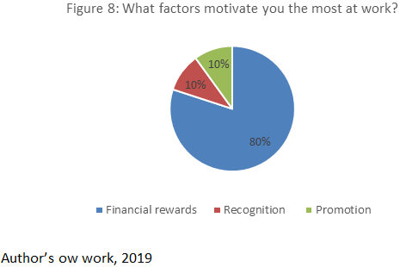

As shown in figure 8, 80% of participants selected financial rewards as the main factor that motivates them at work. 10% respectively selected recognition and promotion.

6.0 Discussion
The literature review revealed that there are factors that lead to employee motivation and factors that lead to low motivation. When employees are motivated, they become productive and the organisation is likely to achieve its goals and objectives. Consequently, companies with unmotivated employees are less likely to meet their objectives and goals. They are also vulnerable to competitors and other internal challenges. In essence, the present of motivation amongst employees can lead to higher productivity and organisational success.

Twenty participants were interviewed for this study. 80% indicated money as the main motivational factor because its enables the person to meet their basic physiological needs such as food, shelter and clothing. This result reflects the models discussed in the literature, whereby money is needed to fulfil individual basic needs. According to Maslow, once those basic needs are achieved, individual are then motivated to work harder to move to the next level of needs.

Moreover, the research and its findings highlighted the important of intrinsic motivation towards individual’s viewpoint at my workplace. 10% stated recognition and promotion as factors for motivation. This indicates that for these participants, to an extent there basic needs have been met and are now seeking to satisfy the next levels of needs. The 10% who voted for promotion and recognition respectively were over 40 years of age. This perhaps reflected their years of working experience and they are now seeking to fulfil higher levels of needs.

Ultimately, the results from the primary research is in parallel with the literature that motivated employees produces higher work performance in comparison to those who are demotivated. The study also revealed that there is a linkage between company performance and employee motivation based on the literature and the results from the primary findings.

7.0 Recommendations
From the data collected and the analysis, the company, Leonara House at Westminster can use this information to better understand how to motivate its people, increase morale and subsequently productivity. The following recommendations are based on the findings of this report. Leonara House should:
- Increase the wages of employees
- Implement job rotation
- Develop and promote employee from within the company
- Ensure that its people are receiving credit and recognition and provides ways for employees to develop their skills

These recommendations will enable the company to increase motivation amongst employees and benefit from higher productivity.

8.0 Conclusion
In conclusion, employees’ motivation is strongly connected to organisation ability to perform effectively. It is therefore essential for companies to understand what truly motivate their employees as this is a critical resource that needs effective coordination for long-term success. In this study, motivation factors derived from the inside of a person seemly related to their needs and desire to achieve higher status. These are factors that not only motivate employees at work but also tool for job retention.

References
Adi, D.Y., (2000). Motivation as a Means of Effective Staff Productivity in the Public Sector: A Case Study of Nigerian Immigration Service, Borno State of Nigeria. Unpublished MPA Thesis. School University of Maiduguri Nigeria
Maslow, A. H. (1943). A Theory of Human Motivation. Psychological Review, 50(4), 370-96
Herzberg, F., Mausner, B., & Snyderman, B. B. (1959). The Motivation to Work (2nd ed.). NewYork: John Wiley & Sons
Herzberg, F. (1987). One more time: How do you motivate employees? Harvard Business Review September–October, 109–120
Kothari, C. R. (1985). Research Methodology: Methods and Techniques. Wiley Eastern, New Delhi

Appendices
The purpose of this survey is to measure is to measure the level of motivation amongst employees at Leonara House, Westminster.


