

Assessment 1 – Reading Task Template
PART 1: Upload your photo of your A3 in-class notes here:
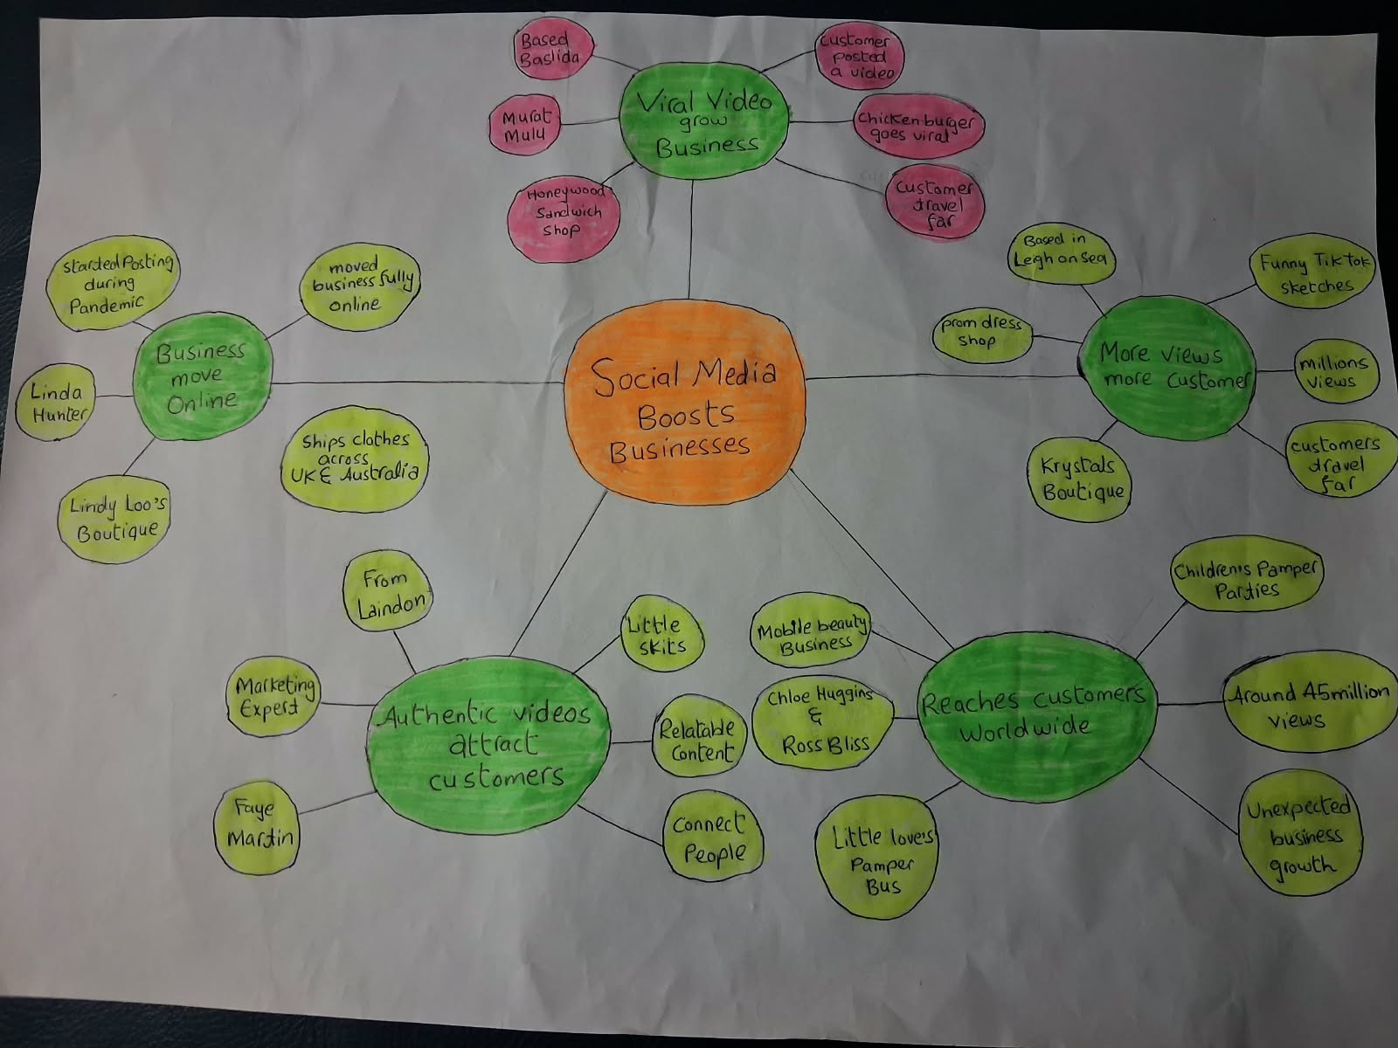

PART 2:
- Answer every question below in 1-3 full sentences.
- Use your own words. Do not use generative AI to answer these questions.
- Include a specific detail from the text when asked.
REMINDER
- The main idea is the overall message of the whole text.
- A key point helps to explain the main idea.
- A specific detail or example from the text shows that the key point is true.

- What is the main idea of the whole text?
The main idea of the text is that social media can boost small businesses. It can help small businesses to grow and become successful. A customer posted a video of burger shop, which went viral and attracted more customer.

- What is one key point that supports the main idea, and which specific example from the text shows this?
A key point is that social media platform such as Tiktok and Instagram can attract new customer to small businesses. They can help small businesses increase the sales and become successful. Posting videos by customer and owner both can help them to grow.

- What is a different key point that supports the main idea, and which specific example from the text shows this?
There is different key point is that social media can help business to attract the customers from far away their area. For example Little Love’s Pamper bus partners Chloe Huggins and Ross Bliss started posting videos gained million of views and attracted many customers. The social media boosted business much more than couple were expected originally .

- Which part of the text do you think is most important, and why?
The most important part is that authentic and relatable videos can attract and encourage more customer who are interested in business because the content feel genuine and relatable to them. Like Martin says little skits can show business authentic. This support main idea of article as well.

Reflection:
- What did you find difficult in this task (including in-class components), and why was it difficult?
The most difficult part to find key idea because there were many examples showing main idea. It was hard to find key point from the a lot of information and decide which information was important and supported the main idea.

- What helped you with this difficulty, and how did it help you?
An activity we did in class it taught me how to find main idea and key points. I read article many times and highlighted important information which made it easier to find main idea and key points. It helped me to find important information relevant to the main idea.

