Creativity and Value Creation Assignment 1
Part 1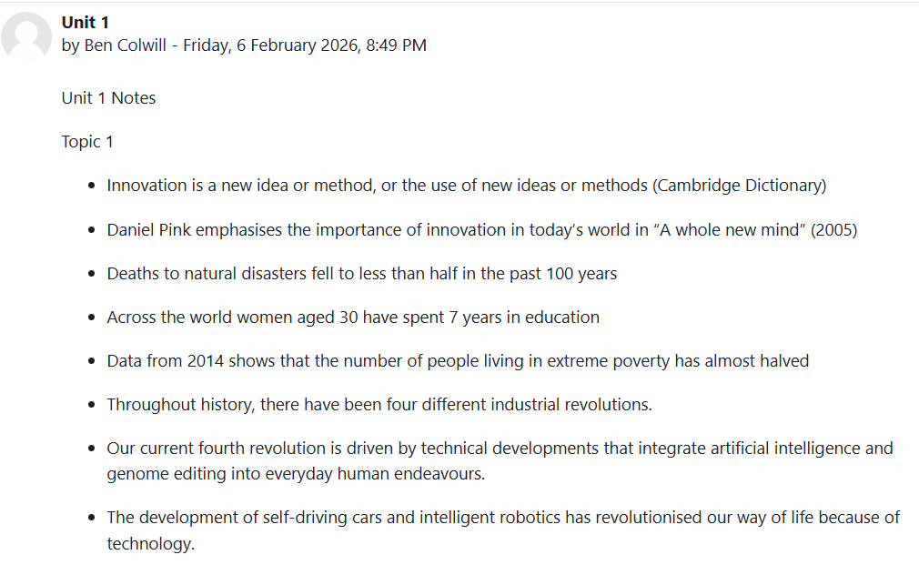
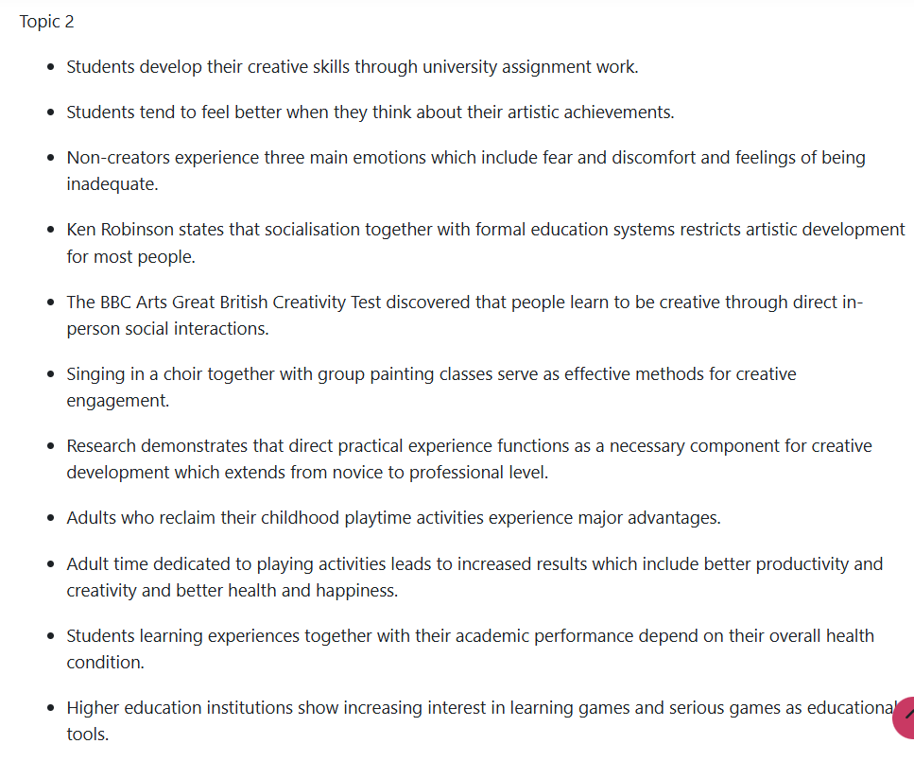

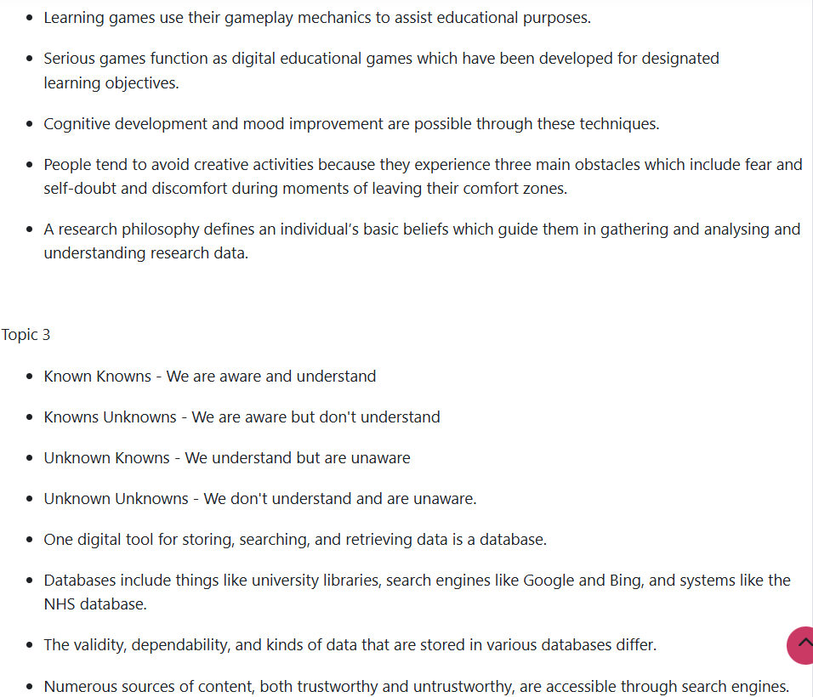
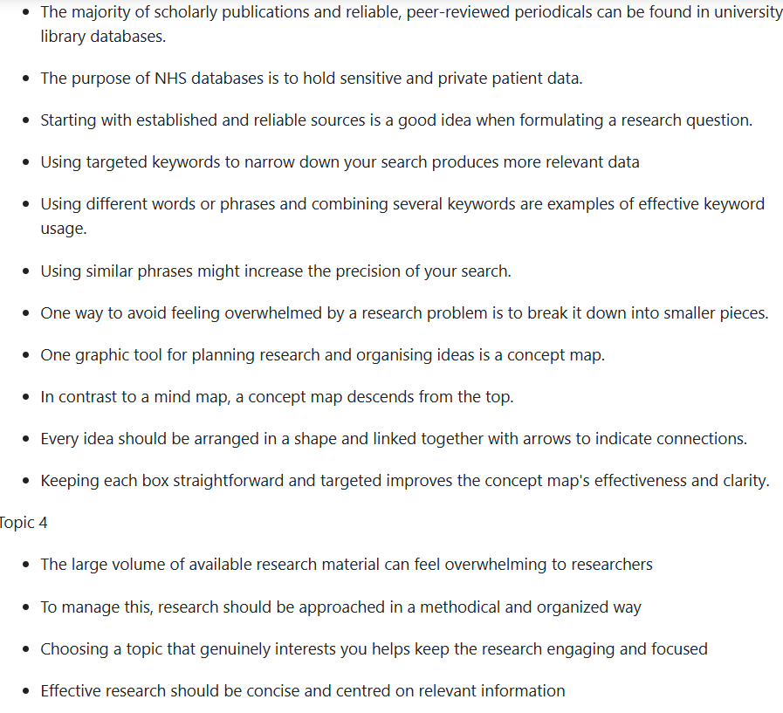
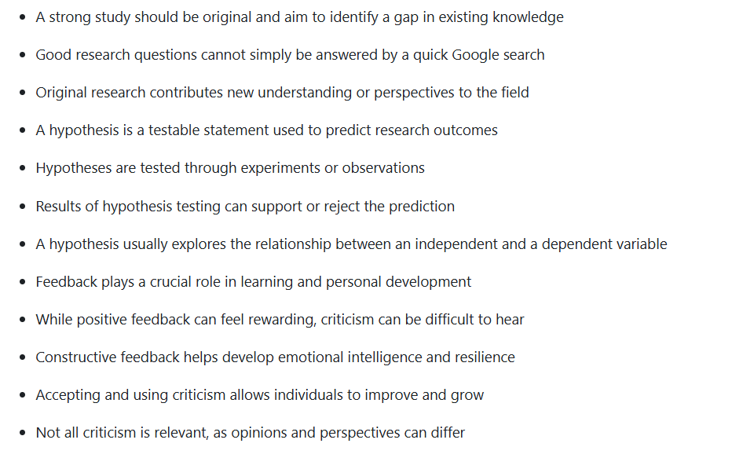


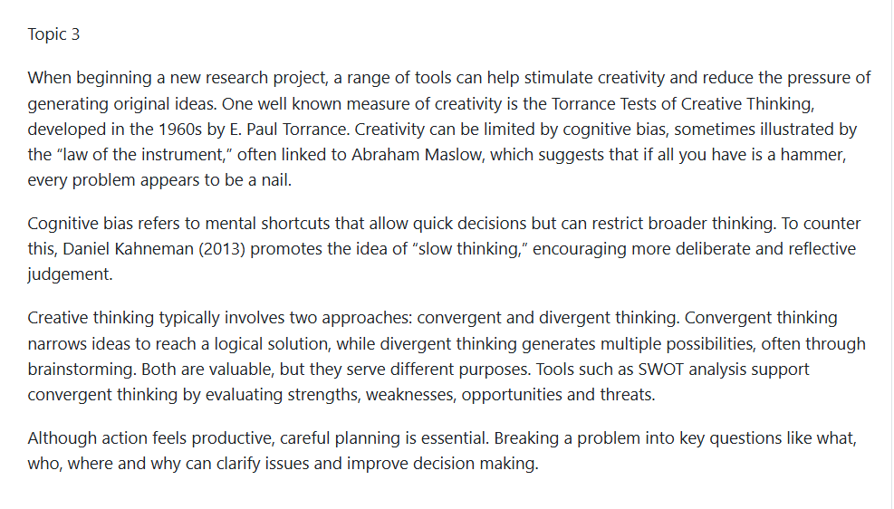
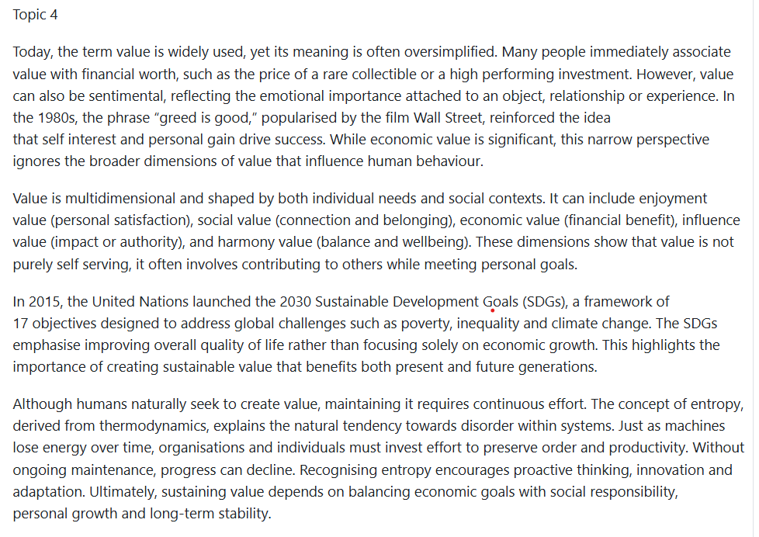

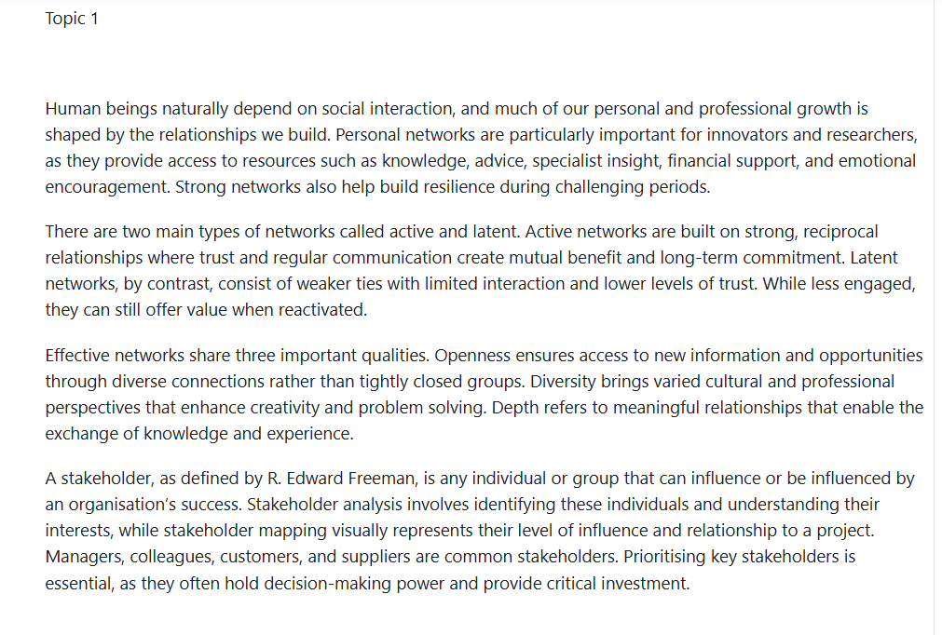


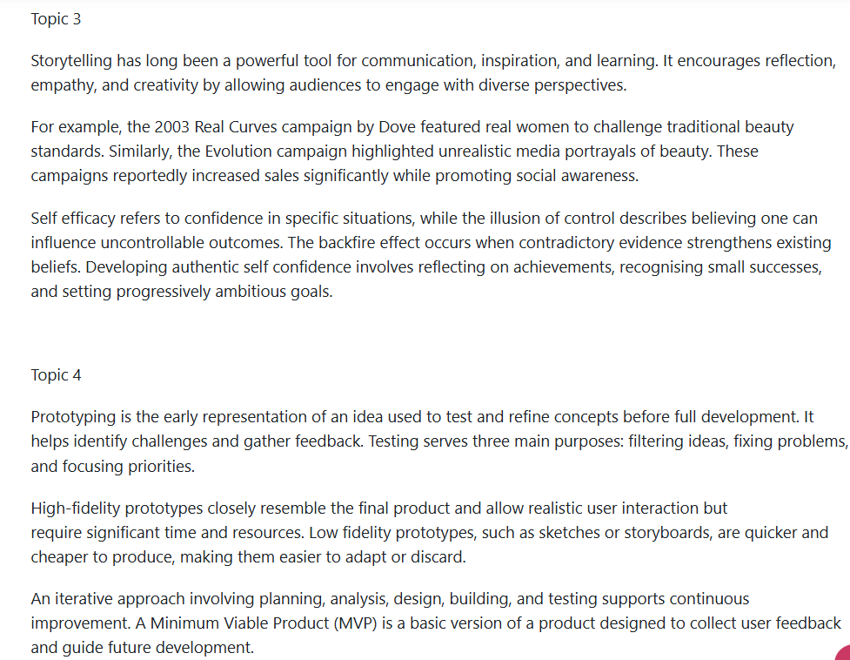


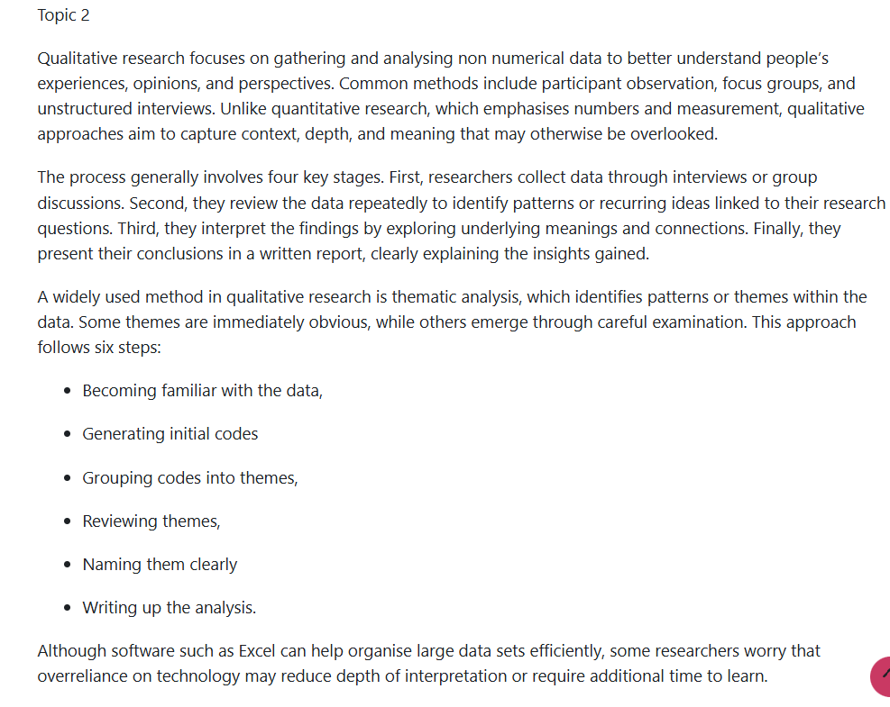

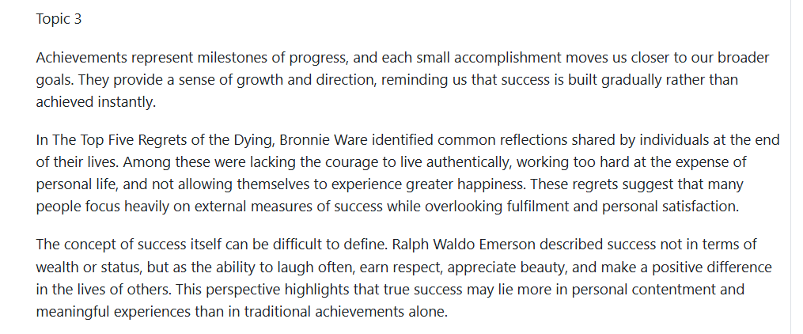
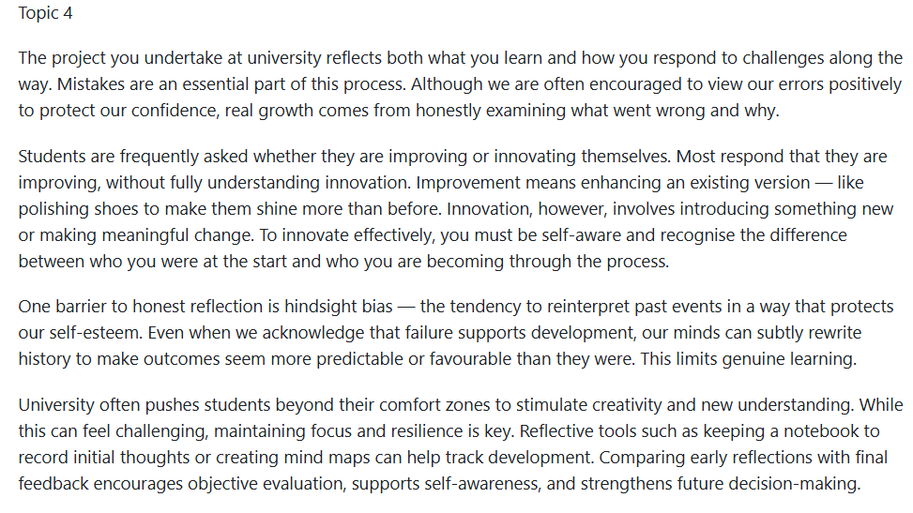










Part 2
Innovation, creativity and an enterprise mindset are increasingly important within modern professional sports organisations. Professional rugby union has become highly competitive, requiring clubs to develop new strategies that improve both on-field performance and off-field commercial success. Data analytics, technological innovation and strategic partnerships are now widely used across elite rugby environments to gain a competitive advantage. Within Welsh rugby, the regional system operates under financial pressures and strong expectations to develop local talent while remaining competitive in European competitions. Two of the most prominent Welsh regions, the Ospreys and the Scarlets, demonstrate different approaches to innovation and enterprise in response to these challenges. While both organisations show creativity in areas such as sports science, supporter engagement and sponsorship strategies, their innovation models and data collection methods vary significantly.
Ospreys are known for being an innovative organisation that incorporates digital innovation into operational decision making and performance management. The area has made significant investments in sports science devices over the last ten years that are intended to keep an eye on athletes during practice and competition. Wearable global positioning system (GPS) technology, which records distance travelled, acceleration, sprint frequency, and collision intensity, is one of the most used tools in elite rugby. According to Cummins et al. (2013), such information allows coaches and sports scientists to assess physical demands and make sure players can perform at their best while lowering their risk of injury. Because excessive training loads can greatly increase the risk of injury, workload monitoring is especially crucial in contact sports like rugby (Gabbett, 2016). Ospreys have embraced technologies that track player health and safety in addition to GPS systems aswell. The frequency and severity of head collisions during practices and games are being monitored by smart mouthguards and other impact monitoring equipment. These systems offer useful data for player welfare management and concussion monitoring, which have grown to be top priorities in the sport. To safeguard athletes and enhance safety procedures, governing bodies like World Rugby have promoted the adoption of enhanced injury surveillance and technological monitoring (World Rugby, 2021). Ospeys exhibit a data driven approach to decision making by combining physiological data with match analysis tools, where tactical planning and training regimens are guided by performance insights.
The enterprise mindset of Ospreys is also reflected in their commercial partnerships and technological experimentation. To upgrade the digital infrastructure at their home stadium, (Swansea.com Stadium) the club has partnered with telecom and data analytics firms. Faster real time data transmission during games is made possible by improved connectivity, which also enhances the matchday experience for fans. Improved mobile connectivity, streaming services, and interactive digital material can all help fans. From a business standpoint, these developments also give sponsors more chances to promote their brands online. This tactic is part of a larger trend in sports where technology is employed not only to enhance performance but also to generate new chances for fan interaction and economic value (Hopkins, 2017).
Scarlets on the other hand, have embraced an innovative approach that prioritises community involvement and research partnership. While the area also analyses player performance using sports science tools, collaborations with academic researchers and universities have a significant impact on their approach. The club supports rugby union research on match statistics, tactical indicators, and predictive modelling through joint projects. These collaborations enable the club to enhance their long term player development plans and incorporate academic knowledge into their coaching methods (Jones and Smith, 2018).
Scarlets gather a variety of performance data, such as movement tracking data, force plate strength tests, and wellness metrics that assess injury risk, fatigue, and recovery. These datasets are integrated with match statistics and video analysis to offer insights into team strategy and tactical performance. In contrast to Ospreys' emphasis on workload management and real time monitoring, Scarlets' strategy reflects a scientifically grounded approach that supports coaching decisions while also advancing greater scientific understanding.
Another key component of Scarlet’s enterprise ethos is regional involvement and community identification. In order to foster local youth rugby players' growth and increase supporter loyalty, the club maintains solid ties with grassroots rugby clubs around West Wales. In this environment, innovation is more typically about community focused projects and digital fan engagement tools than it is about just technology. For instance, the area has investigated social ticketing systems that let fans plan their attendance at games by integrating social media. The organization may better understand supporter behaviour and adjust marketing tactics by using data from ticket sales, community programs, and internet interactions. This strategy illustrates how crucial regional identity is to sports marketing and fan loyalty (Rein and Shields, 2007).
In conclusion, both Ospreys and the Scarlets show excellent instances of creativity and enterprise in professional rugby. Nevertheless, they use various strategic approaches to achieve these objectives. To improve performance and fan interaction, Ospreys place a high priority on digital analytics, technology infrastructure, and business collaborations. Scarlets, however prioritise community identity, research driven sports science, and academic cooperation. The most prestige oraganisations in the professional rugby scene may eventually combine these strategies, fusing cutting-edge technology with research knowledge and solid community ties to generate long term competitive advantages (Ratten, 2020).

