Leah Thomas
BMCP4001

FROM LEARNING TO EARNING

Table of Contents
Success in the workplace 2
CV 5
Covering letter 5
LinkedIn profile 9
Reference list 10

Success in the workplace
Achieving success in the workplace is a complex endeavour, requiring a combination of attributes and abilities that foster both personal and collective accomplishments. Essential among these are teamwork, honesty, resilience, and decision-making, which serve as foundational elements for thriving in professional environments (Furnham, 2012). This essay will delve into each of these qualities, emphasising their importance and their profound influence on both individual and workplaces.

According to Parker (2023), teamwork is crucial for success in any workplace. It involves collaboration, communication, and cooperation among team members to achieve common goals. In a team-oriented setting, individuals bring together their different skills, knowledge, and perspectives to solve problems and make decisions. Effective teamwork creates synergy, where the combined efforts of the team produce better outcomes than what individuals could achieve alone. This highlights the importance of teamwork in driving workplace success.

Trust is crucial for effective teamwork. Team members must believe in each other's abilities to fulfil their responsibilities, meet deadlines, and provide support when needed. Trust promotes unity within the team and enables open communication, constructive feedback, and the sharing of ideas. Additionally, teamwork establishes a culture of accountability, where individuals hold themselves and their peers responsible for the team's accomplishments, fostering a sense of ownership and dedication to its success (Yale University, 2023). This collaborative approach significantly contributes to workplace success by enhancing productivity, encouraging innovation, and improving overall workplace performance.

Integrity is crucial for success in professional settings (Geisler, 2019). It involves being transparent, ethical, and consistent in all interactions and decisions. Prioritising honesty builds trust among individuals, strengthens relationships, and helps resolve conflicts faster. Open and sincere communication fosters mutual respect and authenticity, where feedback is valued, and constructive criticism is encouraged. Embracing integrity contributes to workplace success by creating a positive work culture, improving teamwork, and enhancing overall organisational performance.

Moreover, honesty fosters a favourable workplace atmosphere wherein individuals feel comfortable voicing their viewpoints, expressing concerns, and undertaking calculated risks (Mayer, et al., 2012). Conversely, dishonesty corrodes trust, fractures relationships, and dampens morale, thereby impeding productivity and obstructing advancement. Thus, nurturing an environment steeped in honesty is crucial for fostering a vibrant and flourishing workplace setting. It cultivates trust, enhances communication, and promotes a positive organisational culture, contributing to higher employee satisfaction, increased productivity, and overall success in the workplace.

Resilience is the ability to adjust, persist, and bounce back when faced with challenges and setbacks. In today's fast-paced workplace, resilience is crucial for navigating uncertainty, handling stress, and overcoming obstacles (Luthans, et al., 2007). Those with resilience see challenges as opportunities for growth rather than insurmountable barriers.

Moreover, Masten (2001) highlights that resilience helps individuals maintain focus and motivation amidst adversity, allowing them to stay committed to their goals. Resilient teams come together during crises, providing support, and finding innovative solutions to complex problems. By fostering resilience, both individuals and teams can thrive in difficult situations, emerging stronger and more capable.

Ultimately, resilience plays a vital role in workplace success by enabling adaptation, innovation, and collaboration in the face of challenges. It cultivates a culture of perseverance and problem-solving, essential for achieving organisational objectives and sustaining productivity. Therefore, prioritising resilience enhances both individual well-being and overall organisational success.

Proficient decision-making is crucial for workplace success (Robbins & Judge, 2019). It involves carefully assessing data, considering options, and choosing the best path forward. Whether it's big-picture strategy or day-to-day operations, the ability to make thoughtful decisions is essential.

Effective decision-making relies on critical thinking and problem-solving (Barker, 2012). It means weighing risks, exploring different viewpoints, and predicting outcomes. It also involves seeking input from others and collaborating to find the best solutions.

In the end, good decision-making is key to achieving goals and adapting to change (Robbins & Judge, 2019). It boosts productivity, fosters innovation, and creates a culture of responsibility and growth. That's why making smart decisions is vital for long-term success in any workplace.
In summary, achieving success in the workplace relies on a harmonious blend of key attributes and competencies. These include teamwork, integrity, resilience, and effective decision-making, which collectively contribute to both individual and organisational growth. Success is not solely determined by individual achievements but rather by collective efforts guided by these essential qualities. By nurturing these attributes and integrating them into daily practices, individuals and teams can navigate challenges, achieve goals, and thrive in today's dynamic work environment.

CV

https://www.canva.com/design/DAF9UrlvVqg/UOT2tinpkjKO--K7N12EJQ/edit?utm_content=DAF9UrlvVqg&utm_campaign=designshare&utm_medium=link2&utm_source=sharebutton

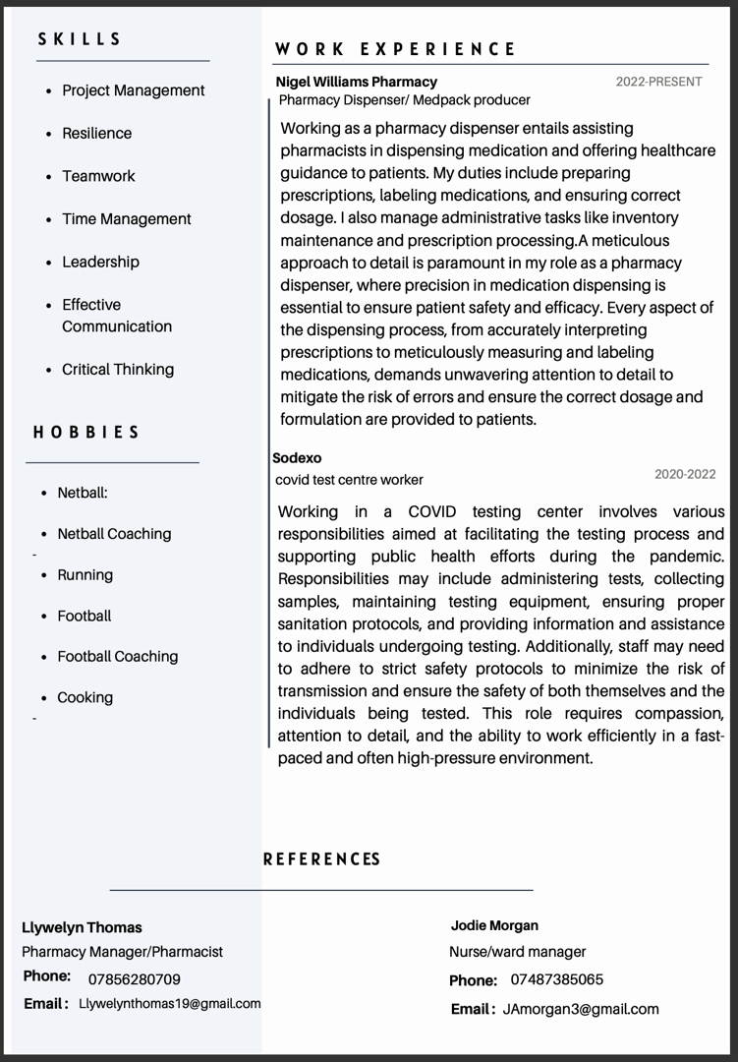
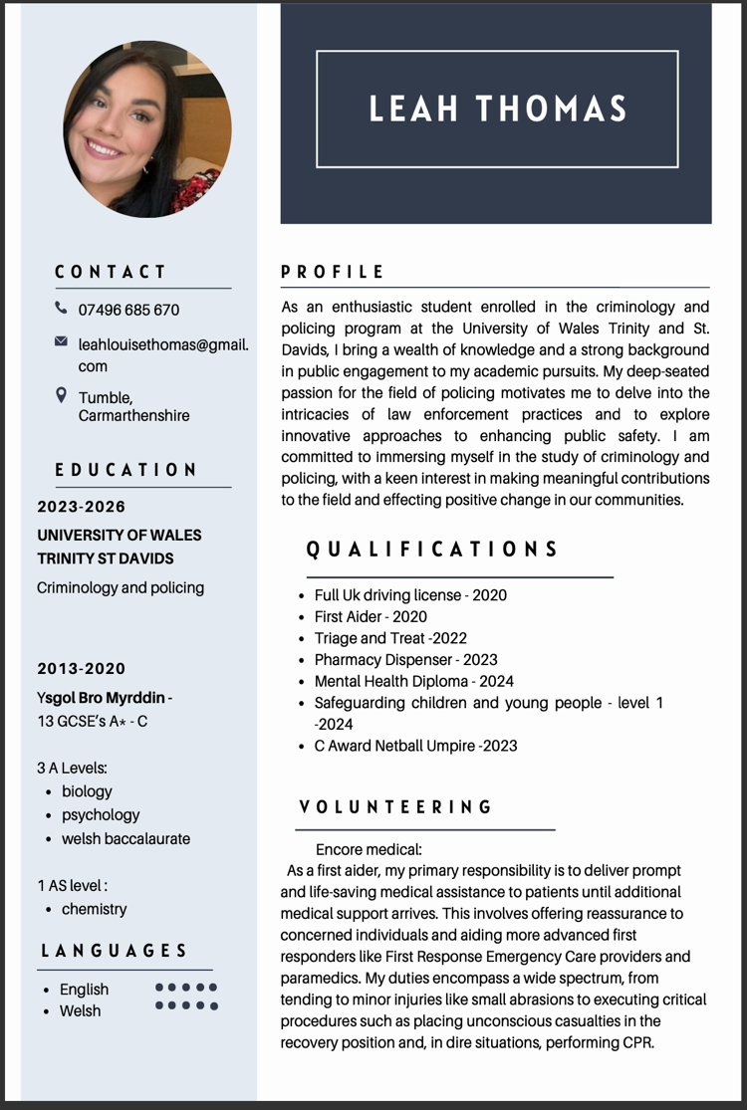

Covering letter
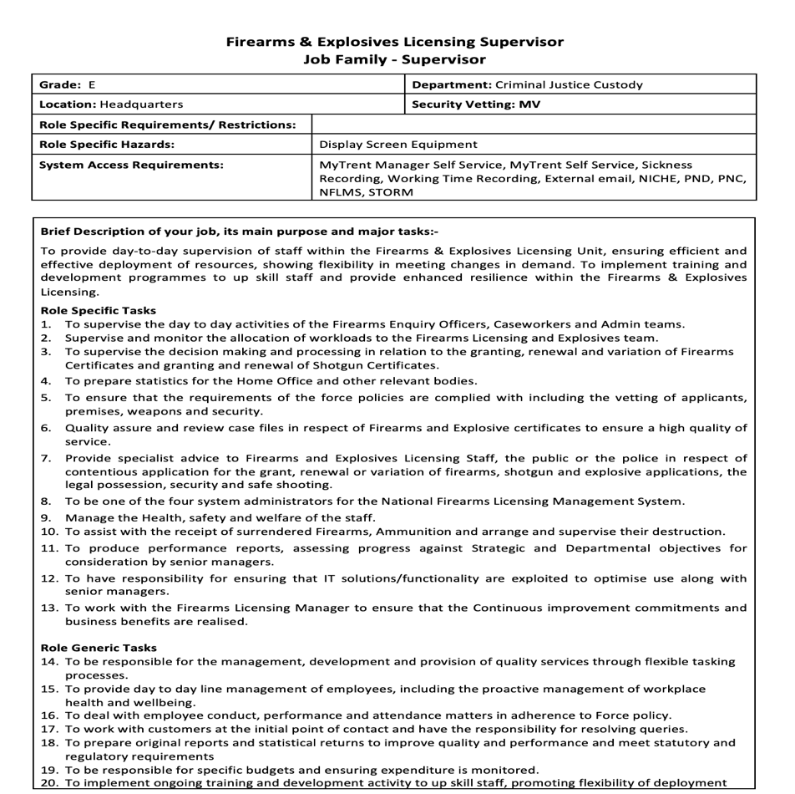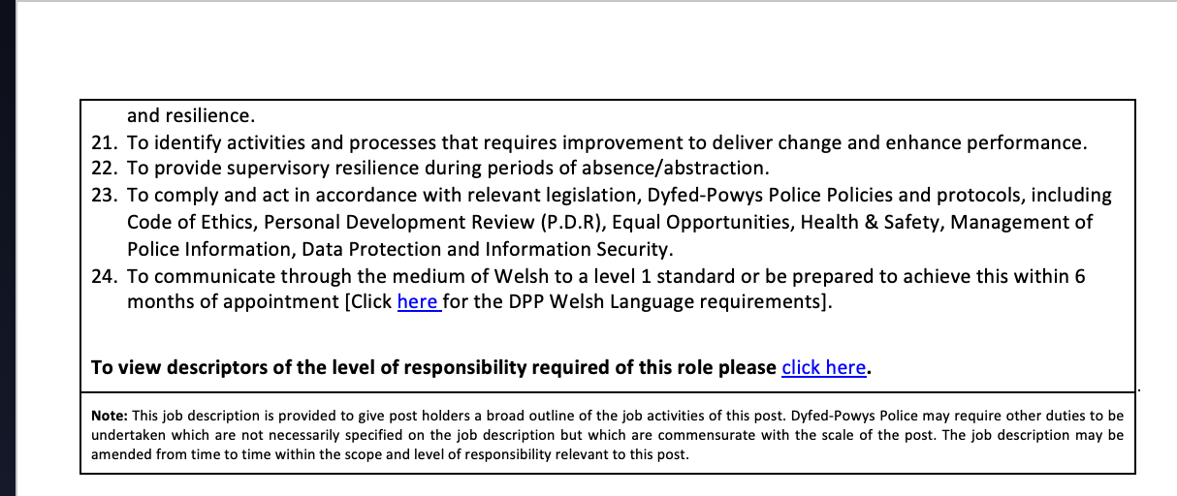

Leah Thomas

5 Pen Parc, Tumble, Llanelli, SA14 6EP

leahlouisethomas@gmail.com

07496685670

29th April 2024

Dyfed Powys Police
Foundry Road, Ammanford, SA18 2LS

I am writing to express my interest in the position within the Firearms & Explosives Licensing Unit, as advertised. With a strong academic background in criminology and policing from the University of Wales Trinity St David’s I am eager to apply my theoretical knowledge and skills to contribute effectively to your team.
The requirements outlined for this role align closely with my academic pursuits and personal interests. Though I may lack direct professional experience, my educational background has equipped me with a solid foundation in understanding criminal justice systems, law enforcement practices, and the importance of compliance with regulations and policies.

In my studies, I've explored firearms and explosives regulations, gaining both a deep understanding and a genuine passion for this field. The responsibilities outlined in the job description resonate with me as they provide an opportunity to apply my theoretical knowledge to practical scenarios.
With my academic background, I'm confident in quickly grasping the intricacies of supervising day-to-day activities in the Firearms & Explosives Licensing Unit. Whether it's workload allocation or ensuring compliance, I'm skilled at navigating complex regulatory frameworks and operational procedures. Additionally, my analytical skills enable me to anticipate challenges and develop effective strategies.

Furthermore, my coursework has honed my analytical and problem-solving skills, which I believe are essential for preparing statistics, reviewing case files, and providing specialist advice to both staff and the public. I am also proficient in utilising IT solutions to optimise processes, a skill that I am eager to apply as one of the system administrators for the National Firearms Licensing Management System.
Moreover, I am committed to promoting a culture of safety, well-being, and continuous improvement within the workplace. While I may not have direct experience in managing budgets or dealing with employee conduct, I am confident in my ability to learn quickly and adapt to new challenges.

I am excited about the opportunity to contribute to the Firearms & Explosives Licensing Unit and to further develop my skills in a dynamic and challenging environment. Thank you for considering my application. I am available for an interview at your earliest convenience and can be reached at 07496685670 or Leahlouisethomas@gmail.com.
Sincerely,
Leah Thomas

LinkedIn profile
www.linkedin.com/in/leah-thomas-ba52532b3

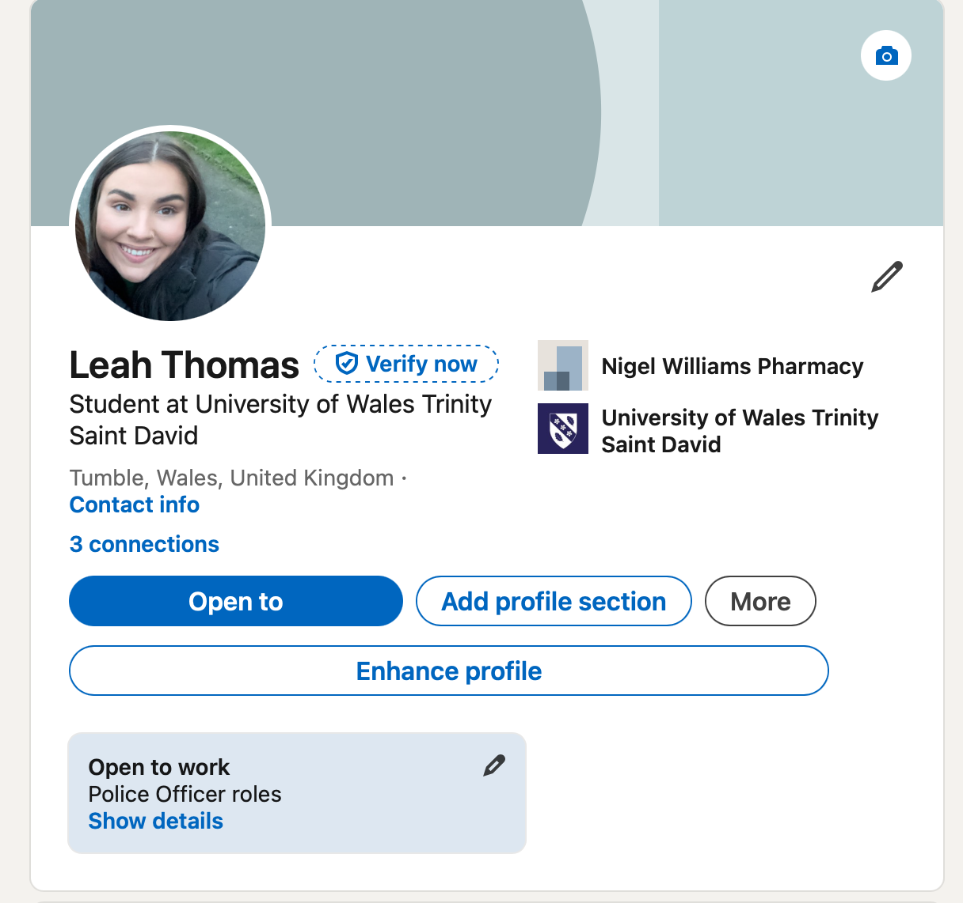

Reference list

Barker, M., 2012. Effective Decision Making: A Practical Guide for Decision Makers. 1 ed. s.l.:Kogan Page.
Furnham, A., 2012. The Psychology of Behaviour at Work: The Individual in the Organization.. s.l.:psychology press.
Geisler, J., 2019. Why prioritizing workplace integrity matters.. Healthcare Financial Management, 73(9).
Luthans, F., Avolio, B. J., Norman, S. M. & Avey, J. B., 2007. Positive psychological capital: Measurement and relationship with performance and satisfaction.. Personnel psychology, 60(3).
Masten, A. S., 2001. Ordinary magic: Resilience processes in development.. American psychologist, 56(3).
Mayer, D. M., Aquino, K. & Kuenzi, M., 2012. Who displays ethical leadership, and why does it matter? An examination of antecedents and consequences of ethical leadership.. Academy of Management Journal, 55(1).
Parker, G. M., 2008. Team Players and Teamwork. 2 ed. San Francisco: Jossey-Bass.
Robbins, S. P. & Judge, T. A., 2019. Organizational Behavior. 18 ed. United Kingdom: Pearson LTD.
Yale University, 2023. We Know Teamwork Is important, but How important?. [Online]
Available at: https://your.yale.edu/we-know-teamwork-important-how-important
[Accessed 30 04 2024].

