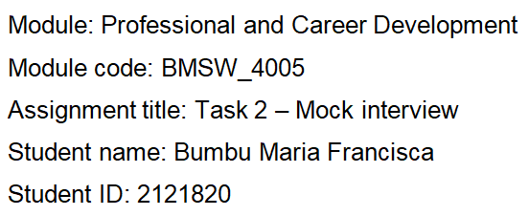

CV

Francisca Maria Bumbu
Tamworth, UK

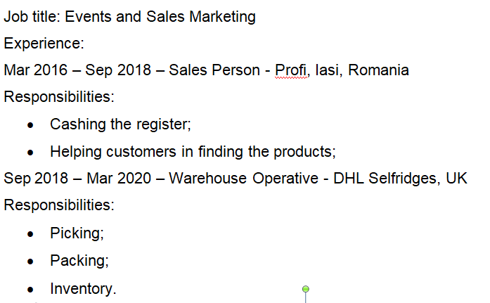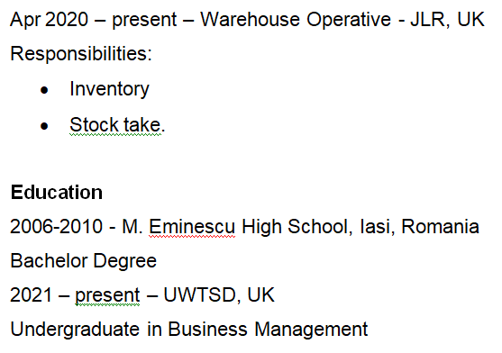

Cover letter

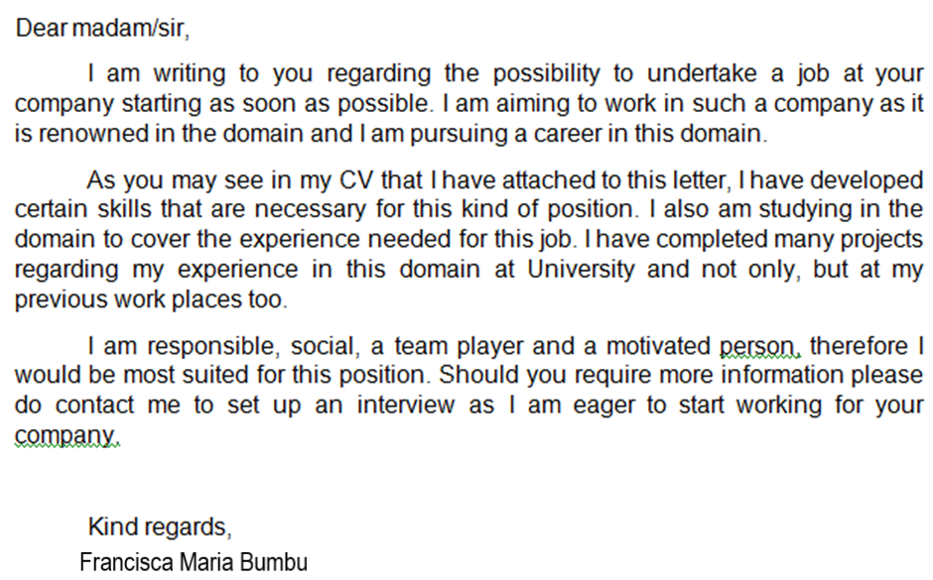

Job description

First Choice Marketing, a company that manages the advertising and development of marketing campaigns for a variety of well-known brands, recently posted a job posting for an Events Sales and Marketing Executive on Indeed. The company is adding new brands to their portfolio and is looking for new and different forces that can help them get new customers—brands that don't currently work with them—to sign contracts with them, which will increase both their brand portfolio and revenue.
I am extremely fortunate to have this chance to begin my marketing career. I applied for this position because it will help me advance in my marketing career and add experience to my resume. I am interested in this position due to the numerous opportunities for success as a marketing executive and the rapidly expanding field of marketing. It has to do with my possible choice, which is to work in marketing and eventually start a business selling goods and services.
This job opportunity is better for me because I can make money and learn new skills that will help me advance in my career and start my own company in the future. Additionally, it is associated with a field in which I have previously worked and am currently enrolled in a course. In addition, in contrast to other domains that are not as well positioned, this one has a long career and is well paid.
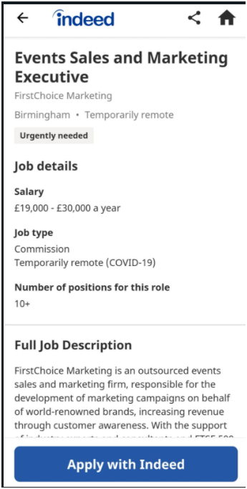
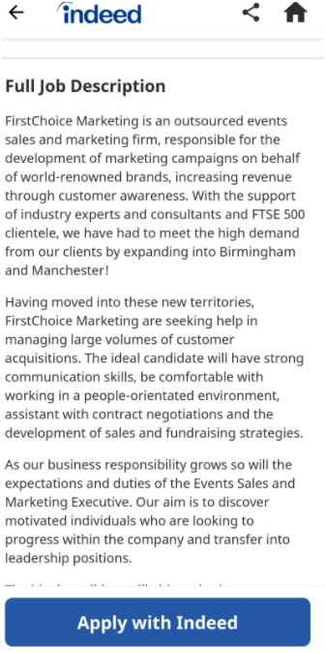
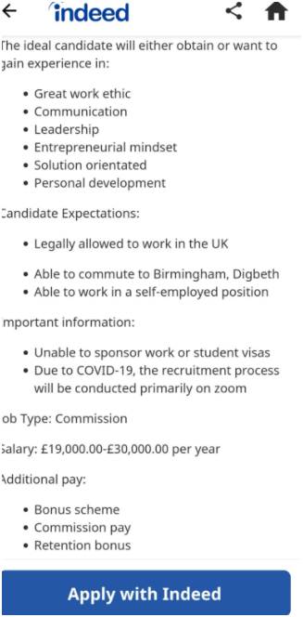
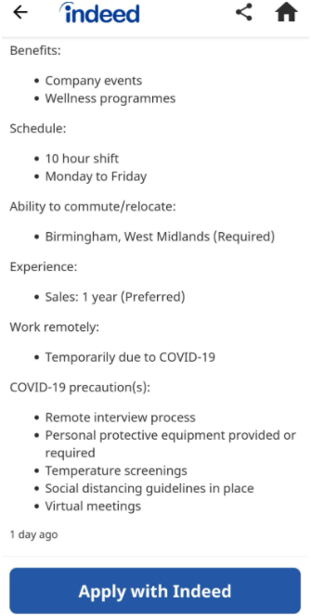
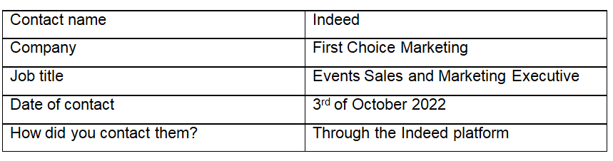
Question asked
- What relevant experience do you have as a sales executive?
- Would you be able to commute?
- Why do you want to work in sales?
- What makes you suitable for this position?

Summary of Response
- In my cover letter, I briefly explain that I am pursuing a degree in business management and that it is a relevant course that will assist me in filling this position, as well as my sales experience
- I am prepared to travel
- My response was that working as a Sales Executive is a great place to start if I want to succeed in the marketing industry
- My abilities in public speaking, marketing, and analytical thinking make me an ideal candidate for this position.

References



