Laura Glover Student ID: 2317639

Element 1

What is good time management?
(and how do we achieve it?)



As usual, I have sat here for the best part of a week worrying about my to-do list. There is work to be completed, did I reply to that email? What activities do the children have this week? And does my oldest have the correct ingredients for cooking? That’s without general housework and work commitments. The more worried I become, the less productive I feel like being and with that arrives the frustration towards myself for lack of productivity. However, like many others I find myself racing around in the final hour in an attempt to ‘be organised’. And personally, it just isn’t working for myself or my family. And I’ve been left wondering, what is good time management? And how can I be more productive with my time?

The phrase, ‘there aren’t enough hours in the day,’ is frequently used in all facets of life. Mothers, employees, students, teachers. We all find ourselves trying to beat the clock whilst completing our daily tasks and commitments. Whether it is work, home or school, life is complex, and our responsibilities increase with age, but it’s important to remember you’re not alone and support is available. a vast amount of our population struggles to effectively manage their time.
An employee study by acuitytraining.co.uk found, ‘Less than 1 in 5 people,’ of the 500 employees they interviewed, ‘have a proper time management system.’ Richardson.B. (2022) www.acuitytraining.co.uk. Further to this, they continue to reveal, ‘Over 20% (21%) feel that their work is either never under control or only under control 1 day per week.’ Richardson.B. (2022) www.acuitytraining.co.uk. These numbers are relatively high for such a small workforce; however, I believe studies in larger organisations wouldn’t differ greatly due to the overwhelming challenges people face personally and professionally every day.

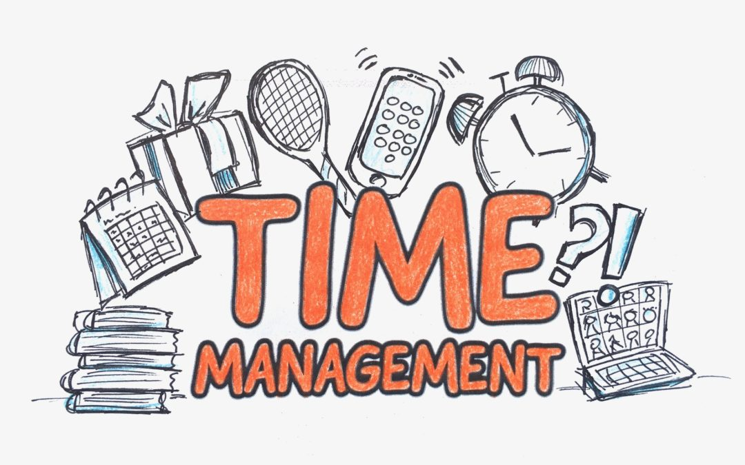

However, our ability, or lack of to manage our time effectively, doesn’t necessarily stem from a poor work/life balance or having our plates too full. Sometimes we are the product of our own downfall at the hands of procrastination. ‘Procrastination is the act of delaying something that must be done, often because it is unpleasant or boring’. Cambridge Dictionary (2023).
Procrastination is detrimental to good time management as it further distracts our already overwhelmed state.
So how do we avoid procrastination?
- Set yourself realistic goals- Making the task too big can be overwhelming and off putting. By making the goals smaller, they appear more manageable.
- Timetable- If you are an individual who responds to visual cues, a clear, well managed timetable is a productive method to assist in good time management. It promotes organisation which is effective in calming the feeling of overwhelm.
- Location, location, location- It isn’t always about the workload, sometimes it is down to your working environment. Procrastination is tempting in a familiar environment as the urge of distraction is too much. For example, there’s that boxset you’d like to finish, or TikTok’s to scroll through. It is important to be aware of these potential distractions and have a plan in place to avoid them.

So how can we avoid procrastination?

- Set realistic and small goals - Set yourself a timer, aim to complete 20 minutes without being distracted. Once you are into the flow of things you may find yourself want to continue with the task.
- Create a plan - Utilising your time can be the most productive way to avoid distractions, especially for visual learners. Having a clear, visual timetable can be less overwhelming and allow time to complete your asks and have the much desired ‘down time’.
- Assess your procrastination - Is it scrolling through TikTok’s to avoid the housework? Or finishing that boxset instead of completing your studies? Being aware of your problem areas is an opportunity to eliminate the issue. If being at home is problematic, maybe a library visit would be more productive? Or, if you find yourself scrolling the internet instead of working, then perhaps utilising your phones, ‘do not disturb’ feature during study time would be beneficial to you. Being aware of your behaviours and addressing them is a productive way of learning to manage your time effectively.

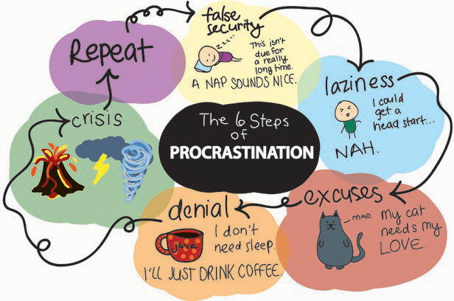

Ultimately, I believe it is down to the individual and their circumstances whether good time management is achievable. It is about having the discipline and desire to self-evaluate and make changes. Although there are many factors that can contribute to a person not having the ability to do these things, so it cannot always be a ‘blame game’ where time management is concerned. We must remember to take our time, plan, and priorities our tasks.

Can you commit to these changes? Start today. Decide on your action plan, hit ‘do not disturb’ and tackle your to do list!

Blog Reference List.

Cambridge Dictionary (2023). ‘Definition of Procrastination’. Available at: https://dictionary.cambridge.org/dictionary/english/procrastinate. [Accessed: 14.10.23].

Image taken from: ‘Time management tips for busy professionals’. Available at: https://woc.aises.org/content/time-management-tips-busy-professionals. [Accessed: 21.10.23].

Image taken form: ‘Maytum centre for student success’. Available at: https://sites.allegheny.edu/studentsuccess/time-management/. [Accessed: 23.10.23].

Image taken from: Piccadilly connects (2020). ‘The best time management tip.’ Available at: https://piccalillyconnects.nl/en/the-best-time-management-tip/. [Accessed: 23.10.2023]

Richardson.B. (2022) ‘Time Management Statistics & Facts (New 2022 Research)’. Available at: https://www.acuitytraining.co.uk/news-tips/time-management-statistics-2022-research/#:~:text=82%25%20of%20people%20do%20not,in%20their%20diary%20in%20advance. [Accessed: 15.10.2023].

Element 2

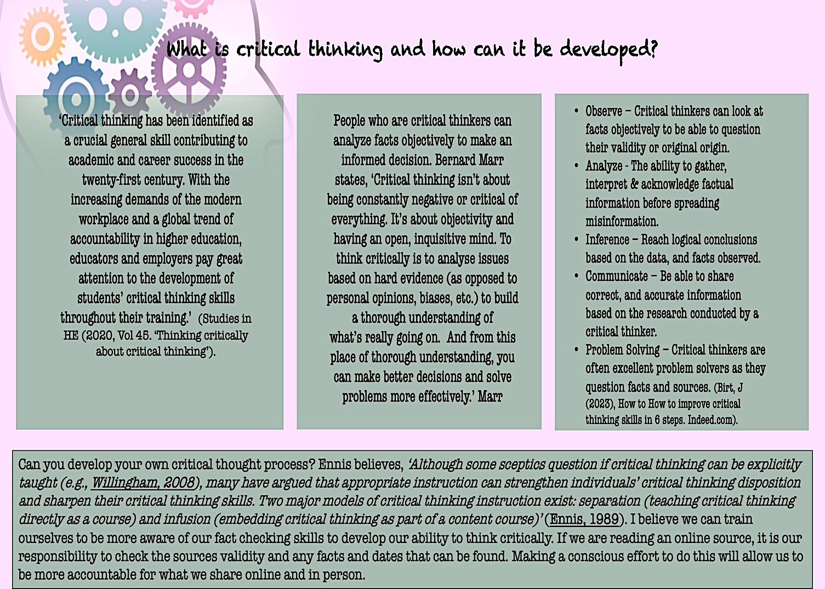

Element 2 Reference List.

Birt, J. (2023). ‘How to improve critical thinking skills at work in 6 steps.’ Available at: https://www.indeed.com/career-advice/career-development/how-to-improve-critical-thinking. Accessed on: [14.10.2023].

Cui, R., Teo, P. (2023). ‘Thinking through talk: Using dialogue to develop students’ critical thinking’. Available at:
https://www-sciencedirect-com.ezproxy.uwtsd.ac.uk/science/article/pii/S0742051X23000562?via%3Dihub [Accessed: 14.10.23].

Image from Google (2023). Available at: https://images.app.goo.gl/gXV7P5kdAxwQSGKH8 [Accessed: 14.10.23].

Marr, B. (2022). ’13 easy ways to improve your critical thinking skills’. Available at: https://www.forbes.com/sites/bernardmarr/2022/08/05/13-easy-steps-to-improve-your-critical-thinking-skills/?sh=bf3eef05ecd0. [Accessed: 14.10.23].

Shaw, Liu, O. L., Gu, L., Kardonova, E., Chirikov, I., Li, G., Hu, S., Yu, N., Ma, L., Guo, F., Su, Q., Shi, J., Shi, H., & Loyalka, P. (2020). ‘Thinking critically about critical thinking: validating the Russian HEIghten® critical thinking assessment. Studies in Higher Education (Dorchester-on-Thames), 45(9), 1933–1948.’ Available at: https://doi.org/10.1080/03075079.2019.1672640 [Accessed: 23.10.23].

